
Etienne BOSSER
Business & Marketing
2018 - 2019

The Human Resources Professional
Assessment 1- Portfolio

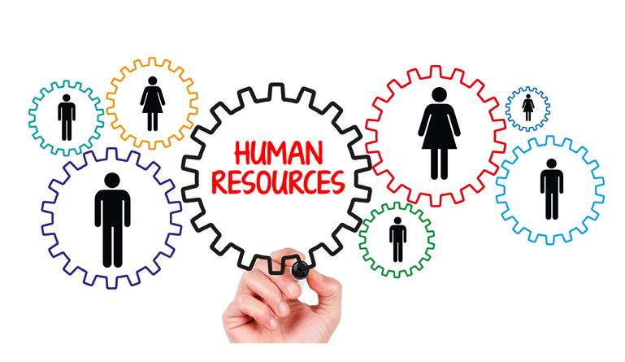

March 15th of 2019
Supervising tutor: Julie Hayward

Content page

Introduction 1
Activity 1: HR professional 2
Activity 2: Group dynamics 4
Activity 3: Project management 5
Activity 4: Self-assessment 7
References 8

Introduction

This report is all about issues of human resources and people management. Let’s see how companies manage this resource and how should they apply to face different situations. The first activity will introduce the subject by giving a definition of human resources and will talk about what does mean to be an HR professional. The second one will approach the conflicts that companies meet with human resources management and give advises to resolve them.
The third one will talk about project management and problem-solving and will be illustrate by one of my own experience in team work. This example could illustrate some ways to deal with conflicts when several people are working on the same project and need to reach the same goal. To finish, I will take another example from my professional experience to make a self-assessment in one area that I would like to improve on the activity 4.

Activity 1: HR professional

To introduce this first activity, here is a definition of Humane Resources (HR) by Armstrong (2016, p.52): “Human Resources includes the knowledge, skills, networks, and energies of people and, underpinning them, their physical and emotional health, intellectual capabilities, personalities, and motivations”. Talking about human resources is not considering that humans are resources, it is considering that humans have resources (Moisset and Plante, 2018). In an organization, the human resource department is dealing with people-related activities management and work on how to keep people working inside the companies. It is in charge to organise the recruitment, the selection of new employees, identify and solve problems, organise training, develop employee engagement, keep their good relationship and care about all organization's employees’ registration information (Cambridge, 2019; Thomas and Martel, 2019).
Today the managing people issues are changing. It is particularly due to the VUCA environment. A VUCA world is Volatile, Complex, Ambiguate, Uncertain and strategies, projects, priorities are changing quickly (Hohmann, 2017). Employees are playing an important role in the companies’ decisions to face these evolutions. To reach the objectives, it is essential for an organization to manage the human resources department as good as possible. This department must be able to plan strategies, take good decisions, deal with problems amongst other (Ryser, 2017; Healey-Benson, 2018). Armstrong (2016, p.53) defined human resource management (HRM) as “a strategic, integrated and coherent approach to employment, development, and wellbeing of the people working in organisations”. The aim of the HRM is to help the company by achieving its objectives, develop the organisation high culture performance and skills, create a positive climate between employees and management and encourage an ethical approach in their management.
Human resources management include four essential aspects:
- The context where HR take place,
- The impact on organisational performance,
- The ethical dimension,
- Special considerations in small and medium companies.
Begin a Human Resources professional means to contributes as well as possible to the ethical success of an organisation. “HR professionals have a special responsibility for guarding and promoting core values in the organization on how people should be managed and treated generally” (Armstrong, 2016, p.171). The ethical practicies are based on the ethical theory which provides a system of rules or principals that guide us in making decisions about what is right or wrong and good or bad in a particular situation.
All companies should take into consideration ethical practices as protecting the right, built a trusting relationship, promote professional behaviour or justice with their employees. To understand, safeguard and protect employees’ rights, it is important to ensure communication with all, have well management of information and keep confidentiality. To consider human behaviour, organisations should advise and promote individual leadership in order to increase personal benefits. Then, companies are responsible for promoting justice by respecting employees’ worth, treat them with compassion, equitably by giving them save professional opportunities (Gregg Learning, 2017).
To find their directions in the future, all HR professional can use the current Chartered Institute of Personnel and Development (CIPD) map (See figure1). This tool allows individuals and organisations to set out in detail the competencies they will need to success their activity and control the uncertainties. This model refers to the issues of core behaviours, core knowledge, and specialist knowledge. Each contains different professional competencies to:
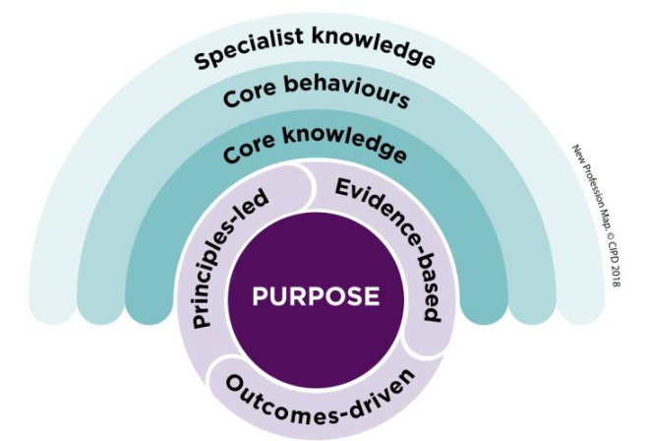
- Build our capacities in team and organisation,
- Build our capability in ourselves,
- Develop our expertise in new areas of practice,
- Drive organisational change, be more confident,
- Prove our value as an expert on people, on work and on change.
(CIPD, 2013; CIPD, 2019)
Figure 1 : CIPD (CIPD, 2018)

Activity 2: Group dynamics

Let’s start this second activity with a definition of what is a group dynamic. First, a group is “two or more individuals who are connected by and within social relationships”. The social relation dimension is important because it links member between each other by a common interest or same experiences. The group gives security, power, recognition, affiliation or status to those members. (Forsyth, 2018. p3&4; Mullins, 2010).
Now to talk about group dynamics, Devillard (2017) said that it is the collective intelligence which includes different elements characteristics such as communication, organisation, rigor, responsiveness, adaptability and even more, autonomy. The word “dynamic” means to be energic, powerful, strong while the group dynamics is “the influential interpersonal processes that occur in and between groups over time” (Forsyth, 2018. p18). In an organisation, employees and staff formed a group that creates interactions, shares informations, takes decisions and help each other’s. When they work as a team, their group dynamics means to create synergy, co-ordination, communication, productivity or even more trusting relationship between them. All those elements contribute to the success of a project realisation.
The team work allows a mutual achievement for motivational reasons but also increase professional skills and knowledge in business. Unfortunately, there are some disadvantages to work in a team. In fact, each person is different and a project achievement depends on the capacity of the team work to avoid conflicts. Sometimes, their members have disagreements, don’t respect the deadlines, are dominated by someone or fall in the groupthink trap. It could be due because of poor communication between them, personal problems, competition, a difference of personality or conflict of interest (Mullins, 2010). There are three types of conflicts: duties conflict, relationship conflicts, and value conflicts. That is the reason why companies need good HR management to solve these problems (Shonk, 2018). There are different resolution methods. Team work can use a Gantt diagram to plan tasks, make an active listening with questions to identify the team needs, communicate more, make feedback, find compromises, have brainstorming or use the SCAMPER method for example. The more useful is the “Design Thinking Process” which is a solution to solve complex problems by understanding human needs. It is dividing into 5 steps:
- Empathise, which consist to observe the persons and try to understand their experiences, their motivations, their needs, and their problem.
- Define the problem, that consists to analyse and synthesise the observations and then define the main problems.
- Generate ideas, to identify new solutions and find alternative ways to the problem, for example with a brainstorming or a brainwrite technics.
- Investigation on the prototype, which consists to find a way for the problem by identifying the best solution.
- Test, to finish by evaluating the decisions taken and find if there are problems.
(Dam and Siang, 2019)
To support these methods, let’s see two examples of conflicts resolution within an HR context. The first one refers to an exercise undertaken in class with a restaurant that had conflicts. One of them happened between the kitchen team and the front house team because of the menu. The kitchen team was unhappy about the menu that changed too quickly, they did not have time to adapt. To solve this conflict, both teams had made an active listen to see where does the problem comes from. Then, they found compromises to plan and agreed when the menu is changing.
The second example can be a relational conflict between two colleagues. Sometimes, there is disagreement because of a different personality, different style or tasks. Usually, in companies, employees are gathered to reach the same objectives. It is important to know each other’s better and tries to discover what do employees have in common that will help to focus on their different point of view. It allows to explain their position better and create empathy between them (Shonk, 2018).

Activity 3: Project management

To answer this activity 3, I will talk about a project I had in the second year of my Business and Marketing Techniques degree. This project called “Crea” consisted to work on a real company creation in a team all year long and concretize the project at the end. We were 7 students in my group, we already knew each other and that is the reason why we created this team work by ourselves, because of our friendly relationship. Our common issue was to help two cook’s chefs to open a bar-restaurant in Quimper (France). In the end, the project was a success, the restaurant opened in May 2018 and is today well known in the city.
The reason why I have chosen this project example is that during the creation of the project, we met some HR management problems. The main one was faced at the beginning because of the tasks repartition. Everyone had his comfort zone and preferences for each or each subject. Sometimes, two or three persons wanted the same one, which finally created tensions in the team and to solve the conflicts, we were forced to find compromises. The idea was to listening everyone, discuss our threats and weaknesses, which subject we think to be able to lead and finally, propose ideas of repartition, do some concessions and make sure that nobody is in a bad situation to succeed. These solution look easy but sometimes we were forced to call a mediator as a teacher to clarify some issues in between us.
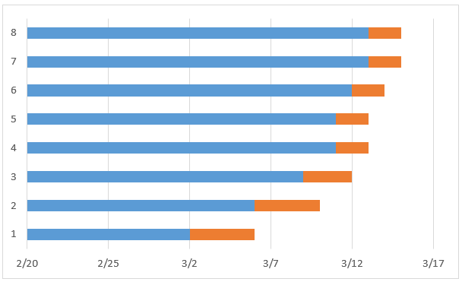
Every month, we had a presentation face to face to a commission of teachers and professionals. The aim was to show our work and see if it is in a good way. Every member of the team work worked differently and on a different rhythm and the conflicts we faced were about the deadlines. During two times, we finished at the last minute our part just before the presentation. The work has been done but we did not have that much time for oral training and professional could feel it during the presentation. Moreover, we all where stressed by the situation and losing our word face to them. The technic we used to treat the problem was a planification plan (See figure2). With reference to the Gantt diagrams, we had to fix our proper deadlines and make sur that everyone works his part and be able to present it to the rest of the group several days before the presentation. Then, we were more confidant and less stressed at the others presentations. We also invited the two chefs we worked with during these training presentations to orientate us, and see by outside looking if every part worked or must be improved.

Figure 2 : Smartsheet (2019) 2018)

These two conflicts resolutions could be categorised by Sharry (2015) as simple conflicts, there is a third one which has been more complex. Indeed, we had the mission to find the name of this new bar-restaurant. We obviously did not have the same opinion about it and we did not find the ideal name which might correspond perfectly to the project. This reflexion brought our working team to open our mind and realize a brainstorming to develop our creativity. The aim was to find something original which refers to a bar and to Brittan’s culture (where it is located). We left the task to think about it during a couple of months. Then, one member of the team has the brilliant idea to find a Breton word (local language) and associate it to another word which could refer to the activity of a bar-restaurant. After some propositions, we agreed on “Baravel” which correspond to “bar” for bar-restaurant and “avel” which means storm in Breton language, by reference to the weather in Brittany. Even if the team found those different conflicts, the project has been realized and it allowed us to have a first idea about working for a real business in a group with all those advantages and disadvantages.

Activity 4: Self-assessment

There are many areas that I would like to improve to be more competent but the main one could be: improve my negotiation skills. I’m learning business and marketing for now 3 years, and I had the chance to have a lot of professional experiences whether with the university or outside. All these experiences allowed me to practice what I learned and use my knowledge. The conclusion I have today is that sometimes, I couldn’t go through a harder negotiation because I didn’t have enough arguments. I had phone calling experiences, B to B and B to C experiences and sometimes, I didn’t succeed the jobs because I didn’t convince the person.
To illustrate this problem, I have chosen a example. It happened during my last year internship in April and May when I was working for a young Start-up called SportRIZER. This society is specialized in selling sports lessons online, especially oriented for water sports like surf, kitesurf, windsurf and more. My job was to call some surf school in Brittany to propose an appointment and then, present what would be the benefits for them to work with SportRIZER. This job looks easy at the beginning for me but in the end, it was a disaster. Indeed, I only had one training week with my manager. It wasn’t enough for me, that’s why I started the job with only a brief idea of the society filling and a poor vocabulary argument to persuade the professionals. Even more, we planned with him to have one feedback every Mondays to see together what happened the week before and what are the objectives of the new one. The problem was that we made only two feedbacks the two first weeks and after, he stopped and considered that I was allowed to run the job alone. As a result, I made a lot of mistakes during my phone calling and my appointments, I did not have so many tools to succeed so we lose some potential partners.
I learned a lot from this bad experience, I think that today I need different tools to succeed in this way. First of all, I have to improve my negotiation skills by having other professional experiences. I have to be prepared before by having training, by learning other negotiation technics and learn exactly how to understand the customer or the professional needs. Moreover, I need to gain in self-trust, it is important that the person I’m dealing with, feels I’m sure about what I’m saying. To conclude, the resources I will use to reach my objectives are negotiation lessons, feedbacks from professionals and training in different situations. When I will be able to applicate all my knowledge and be more convincing, I would have reached my success criteria.

References

Cambridge dictionary (2019) Human Resources definition, Available at: https://dictionary.cambridge.org/fr/dictionnaire/anglais/human-resources

CIPD (2019), Profession for the future - Our definitive roadmap to better work and working lives, Available at: https://peopleprofession.cipd.org/

CIPD (2018), The new Profession Map: the new way to make an impact, Available at: https://youtu.be/VWSeitwhuns

CIPD (2013), The CIPD profession map: a guide, Available at:
https://www.cipd.co.uk/Images/the-cipd-profession-map-accessible-format_tcm18-33362.pdf

Gregg Learning (2017), HR Basics: Human Resource Ethics, Available at: https://www.youtube.com/watch?v=QdQuzoHQt90

Healey-Benson, F. (2018) Lesson 1, introduction to AI in People Management, managing people module, Swansea business school UWTSD

Hohmann. C (2017), Qu’est-ce que VUCA ?, Available at: http://christian.hohmann.free.fr/index.php/prospective/a-propos-de-prospective/587-quest-ce-que-vuca

Hundley, HE, Hudson, ME, Wasan, AD, and Emerick, TD (2019). Analysis of the effectiveness of chronic pain clinics: optimization using the Gantt chart and visit diagnoses. Journal of Pain Research, 12, 1. Available at: https://www.ncbi.nlm.nih.gov/pmc/articles/PMC6301303/

J. J. Moisset, J. Plante, P. Toussaint (2018). La gestion des ressources humaines pour la réussite scolaire, PUQ, Available at: https://books.google.fr/books?hl=fr&lr=&id=IP5NDwAAQBAJ&oi=fnd&pg=PT6&dq=definition+ressources+humaines&ots=MMHTib61Qd&sig=_aq7klB80-fOlfX4d7-ENdKBPLg#v=onepage&q=definition%20ressources%20humaines&f=false

Katie Shonk (2018), Three types of conflicts and how to fix them, Harvard Law School. Available at:
https://www.pon.harvard.edu/daily/conflict-resolution/types-conflict/

Levi, D. (2015), Dynamique de groupe pour les équipes. Sage Publications. Available at: https://books.google.fr/books?hl=fr&lr=&id=l3tZDwAAQBAJ&oi=fnd&pg=PT18&dq=group+dynamics&ots=GlavWaZXe9&sig=C8B-wI03jmlGaLsoqYTSvVQYLkU#v=onepage&q=group%20dynamics&f=false

M. Armstrong (2016), Armstrong’s handbook of management and internship for HR, 4TH edition

Markman, A. B. (Ed.). (2016). Open innovation: Academic and practical perspectives on the journey from idea to market. Oxford University Press. Available at:
https://books.google.fr/books?hl=fr&lr=&id=WukmDAAAQBAJ&oi=fnd&pg=PP1&dq=Open+Innovation:+Academic+and+Practical+Perspectives+on+the+Journey+from&ots=rZUiLaIcQr&sig=q90S5a0Y0VsQZQRepYye4bQbNcw#v=onepage&q=Open%20Innovation%3A%20Academic%20and%20Practical%20Perspectives%20on%20the%20Journey%20from&f=false

Martory, B., & Crozet, D. (2016). Gestion des ressources humaines-9e éd.: Pilotage social et performances. Dunod. Available at: https://books.google.fr/books?hl=fr&lr=&id=4iVOCwAAQBAJ&oi=fnd&pg=PA1&dq=definition+ressources+humaines&ots=MG4Nk0k3wI&sig=oFRYgNpsPl9OTwaQPMX0TOI-kws#v=onepage&q=definition%20ressources%20humaines&f=false

Michael K. Thomas, Peter J. Martel (2019), Harvard University, Human Resource Management, Available at: https://online-learning.harvard.edu/course/human-resource-management

Mullins, J. L (2010), Management and organisational behaviour. 9th edn Harlow: Pearson Education Limited.

Patrick Sharry (2015), Simple, complex, complex, chaotic: What can your human resources department manage?, PageUp, Available at: https://www.pageuppeople.com/resource/simple-complicated-complex-chaotic-what-can-your-hr-department-handle/

Rebecca Shambaugh (2019), How to Unlock Your Team’s Creativity, Available at: https://moodle.uwtsd.ac.uk/pluginfile.php/235838/mod_resource/content/1/How%20to%20Unlock%20Your%20Team%E2%80%99s%20Creativity.pdf

Rikke Dam and Teo Siang (2019), 5 Stages in the Design Thinking Process, Available at:
https://www.interaction-design.org/literature/article/5-stages-in-the-design-thinking-process

Ryser, Ulrich (2017). Le tournant numérique commence dans votre entreprise. Recherche agronomique suisse 8.11 423-423. Available at: https://www.agrarforschungschweiz.ch/artikel/2017_1112_f_2338.pdf

Smartsheet (2019), How to create a Gantt chart in Excel, Available at: https://www.smartsheet.com/blog/gantt-chart-excel

Taylor. S and Woodhams. C (2016), Studying Human Resource Management, 2nd edition
(Taylor. S and Woodhams. C, 2016. P110)

Team Technology (2019), The difference between team and group dynamics. Available at: https://www.teamtechnology.co.uk/team/dynamics/performance-impact/

Vidya-mitra (2017), Managing Ethical Issues in Human Resource Management, Available at: https://www.youtube.com/watch?v=qEWVCQqXDhM

