Construction management
Gantt chart report
By
Morgan Davies
1910276@student.uwtsd.ac.uk

Table of Contents
Introduction 2
Incentivisation and motivation for contractors 2
Resource table 4
Cash flow 5
Time 6
Delay analysis 7

Introduction
Within this report a clear indication of the works will be carried out within a safe environment. The duration of the project will come down to the performance of the the workers on-site, good communication with the stakeholders to ensure there is no profit loss throughout the project. Within this project there is a delay within the concreting, in this report a table stating the delay will be showing whether the delays are usable or non-excusable. A non-excusable delay is when delays are foreseeable or within the contractor’s control. In each instance, the failure to perform must be beyond the control and without the fault or negligence of the contractor. Default indicates failure to make progress in the work to endanger performance. An excusable delay within the contract explains that those types of projects delayed that are unforeseeable at the time of contract award and that are also beyond the control of the contractor. A delay is an act of being late caused by events or circumstances that lead to failure to start or complete on time. When the delays occur an extension of time will be only specified for events which are beyond control of the contractor. This emphasises that the contractor must complete an application for an extension of time, this would imply that the contract administrator must follow specific procedures when considering the contractor’s application. As planned are for, only delays sue to one party are included within the programme. The difference wit the total delay at the end shows the responsibility of the other party. A collapsed as-build is very similar to an as-planned. The corresponding delays for one party are forever taken away. The resulting end of work is taken away from the actual. Within the project there will be the control process where the contractor will be analysing the performance of the workers so that it meets the budget for the whole project. Site records will also be kept present on site, this is necessary for establishing the basis of a claim for loss and expense, defending the counterclaim from the client, substantiating applications for extensions of time, claiming payment for extra work not included in the contract and this will conclude in progress meetings. Also within this site specific report with be analysis of the time, cost and resources by displaying graphs for each one. To conclude the report a review of performance for the work carried out will be discussed and how the contractors can incentivise the workers onsite so that the productivity is to a specific level.

Incentivisation and motivation for contractors
in which Describes a contract that defines the vendor’s contribution to the customer in terms of specific benefits to the customer’s business. Such a contract also defines the payment the customer will make according to the vendor’s performance in delivering those business benefits. Gain-sharing contracts require the development of a delivery paradigm that links a customer’s business metrics to a vendor’s IT solution. The key elements of this paradigm, in order, are:
1. Business metric definition and selection
2. Client metric benchmarking
3. Development of key performance indicators
4. Investment options evaluation
5. Gain-sharing contract development
6. Financial engineering
7. Delivery of services
8. Re-evaluation and adjustment of metrics
(Definition of Gain Sharing - Gartner Information Technology Glossary, n.d.)

A way of motivating the workers on-site would be to celebrate small things, such as completing a task before the projected time. By doing this the contractors should be given reward. Such as a health and safety award which is given out to the worker/workers who have maintained a safe workplace. A reward for this can be something such as a gift voucher. These types of rewards will motivate the workers to do their job in a responsible manner. Another way of motivating the workers is through making them feel a part of the team, and not treated disrespectfully, if the hierarchy engage with the workers this will make a more positive workplace. Another way of making the workers feel comfortable is through giving them a tidy workplace with the correct accessories. All these points make sure that all workers have a positive mentality when coming on to the site and will want to work for the contractors. To deliver the best work as possible.
If someone is tired you should not keep them working and let them rest for a reasonable amount of time as this can affect their mental and physical strength.

Resource table

The graphs here state the number of hours that the resources have taken up for working on this project. There is a multiple resources on this project as there are so many different jobs that need completing by different professionals. By looking at these graphs we can see that the civil engineer is heavily involved within the project. This is because the civil engineer needs to make sure that all the structures are placed in the correct position, a popular task that the civil engineer is involved is the making of concrete cubes. This is because when the concrete is poured, the civil engineer must make 4 concrete cube samples, to see whether the concrete is strong enough to withstand the load that sits on it. There are multiple different gangs on the project as they’re needed for different jobs such as concrete, steel reinforcement etc. we can see that most of the of the cost form the whole project comes from the work.
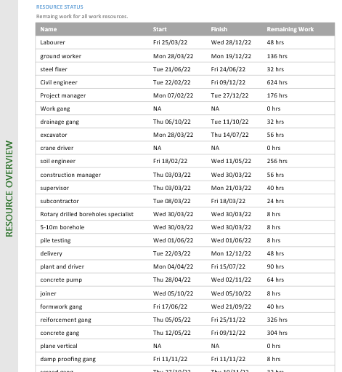
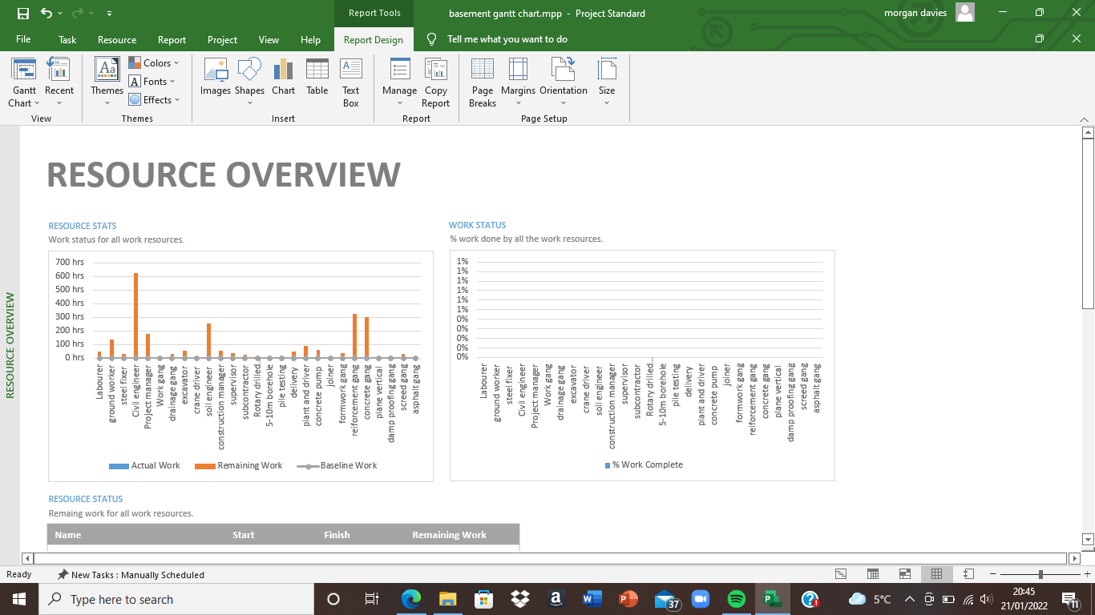

Cash flow
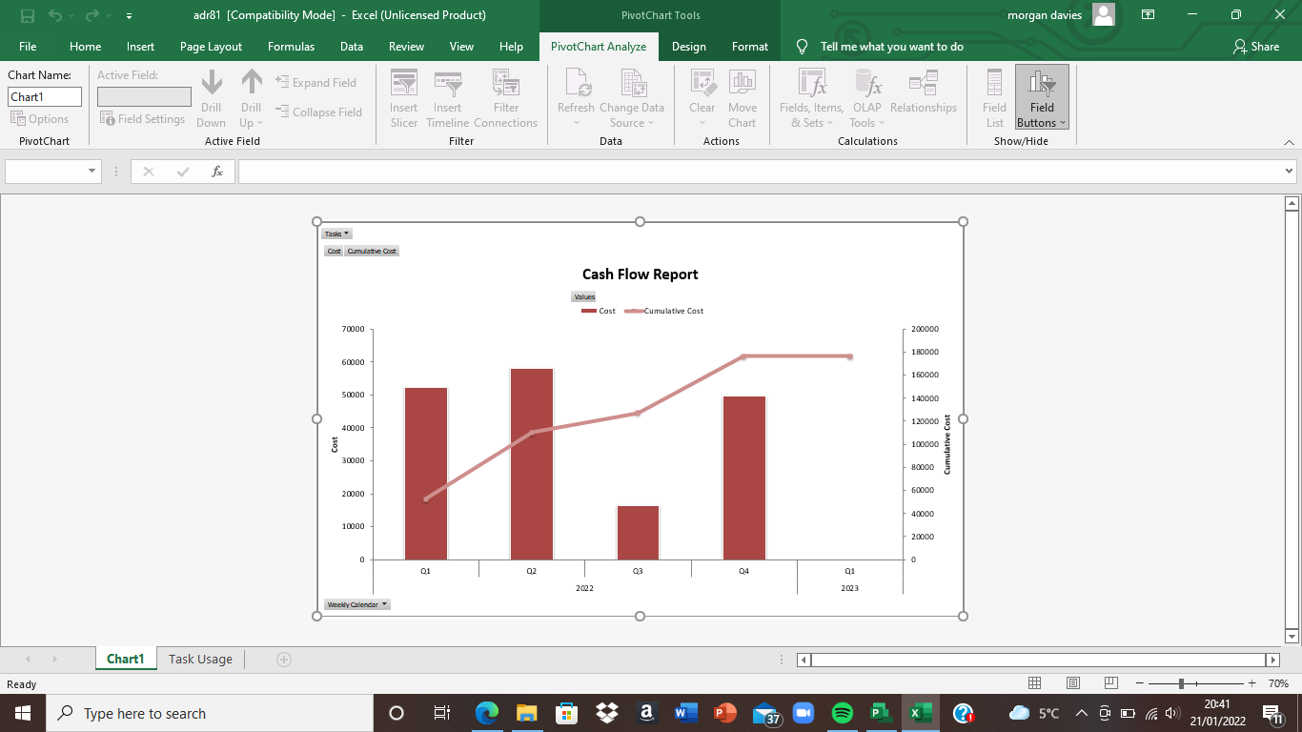
Throughout the project there are several different costs that occur from different material and work. The cost of this project is upwards of £175 thousand, due to the volume of work that needs to be carried out to ensure that the project finishes on time. As seen on the graph below the cumulative cost of this project is more than £180 thousand this means that the project is slightly over budget but through time this money will start to fall depending on the productivity of the workers on site. By looking at these graphs you can see that the site clearance is what costs the most, this is due to the amount of tasks within this summary task.

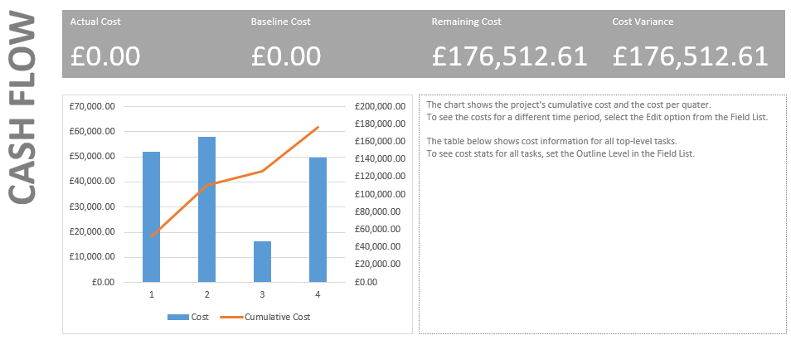

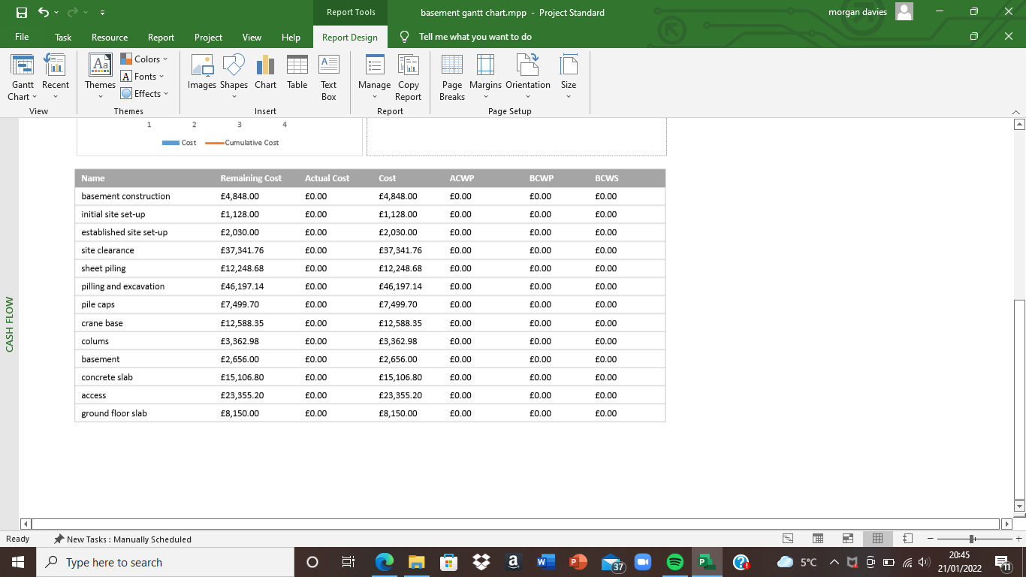

Time
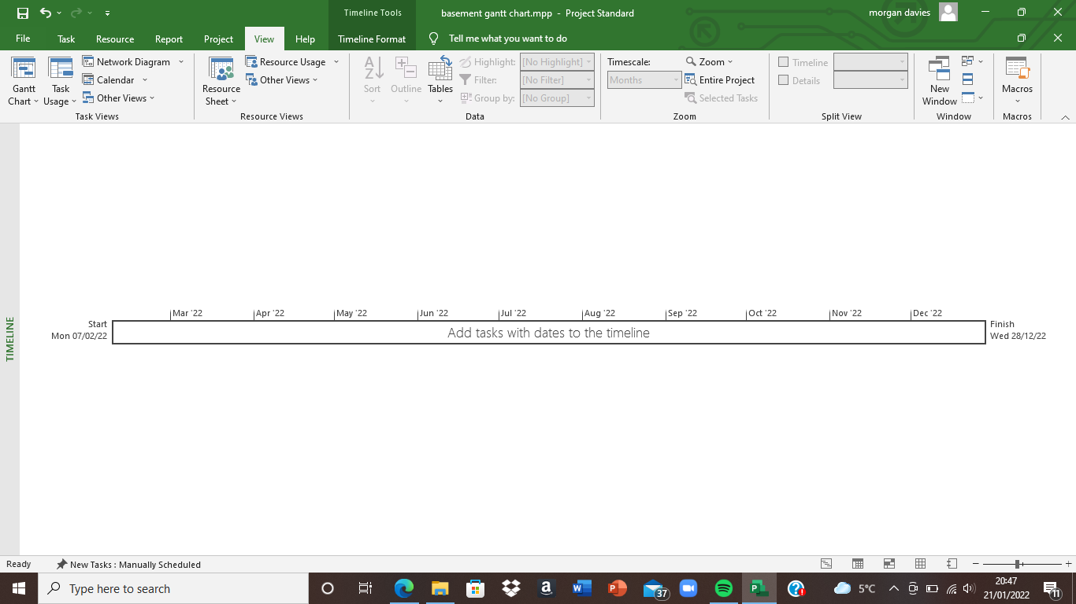
the expected time frame for this project is to be around 230 days. The deadline could be shorter but due to the volume of concrete that is being poured onsite this would not be possible as the curing of concrete takes 7 days and for something like formwork, this cannot be done unless the concrete has cured. The start date of this basement project is the 7th of February 2022 and is planned to finish with the ground floor slab placed correctly on the 28th of December. Workers will be off for Christmas and will return to work on the 27th to ensure that the project is finished just before the New year. This will then mean that the construction of the building can commence with the basement being completed.

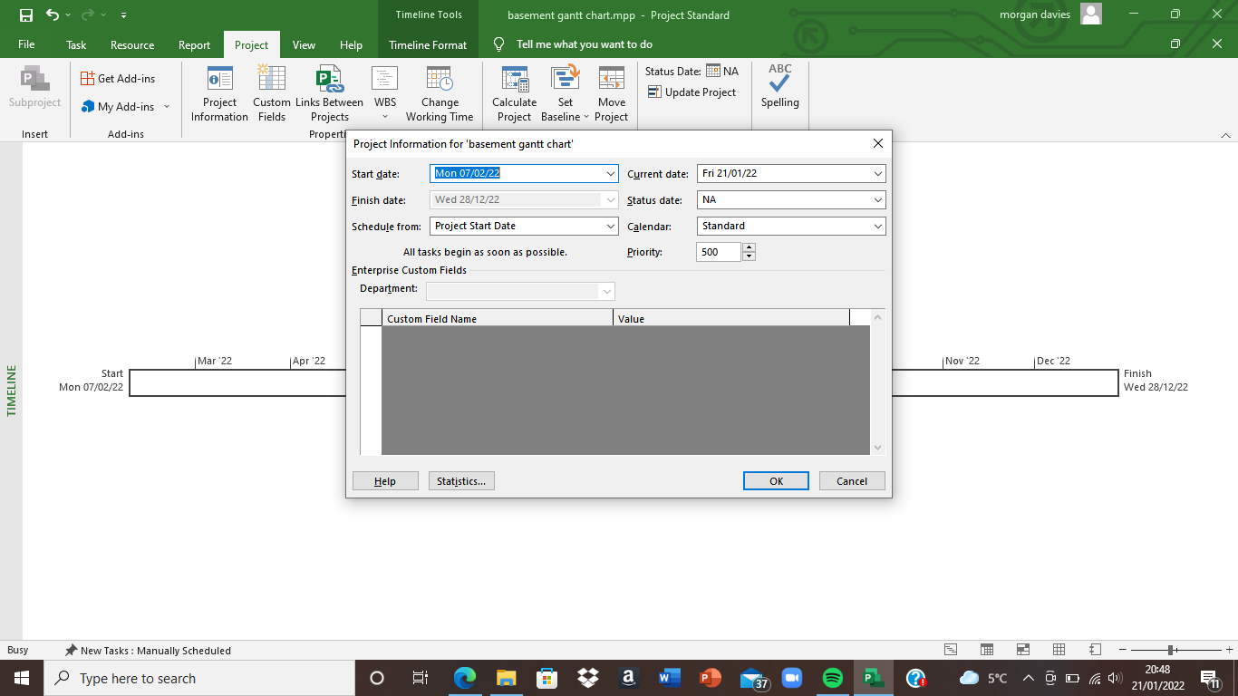

Delay analysis
Within this project there was unfortunately a strike within the concrete company and resulted in a loss of productivity on site while the issue was being brought up. There are many different types of analysis to be brought into consideration when looking at delay analysis as it can affect a project very badly. This was an as-planned delay. For this type of delay, we will be using the time impact analysis where it concentrates on a specific delay. This is when the schedule is updated at this period and the effect is analysed to establish a new completion date. It is very important to update to update the overall project schedule to account for the changes made, this analysis gives us the opportunity to increase the productivity on that one task that has changed the schedule, this analysis will make it easier to accurately plan the rest of the project out. To do this we must:
- Identify the current schedule
- Add the new work and analyse the impact, this is by correctly inserting the new task so that it links up perfectly with the rest of the project.
- After this we must recalculate the critical path. By using this method, we can see if it has originally impacted on the current critical path.
(Benarroche, 2019)

references

Gartner. n.d. Definition of Gain Sharing - Gartner Information Technology Glossary. [online] Available at: <https://www.gartner.com/en/information-technology/glossary/gain-sharing> [Accessed 21 January 2022].

Benarroche, A., 2019. Time Impact Analysis | Identifying the Impact of Extra Work. [online] Levelset. Available at: <https://www.levelset.com/blog/time-impact-analysis/> [Accessed 21 January 2022].

