

LOCATION: Swansea | LLEOLIAD: abertawe
LEVEL 4 | LEFEL 4
EXAMINATION PERIOD | CYFNOD ARHOLIADAU
January 2024 | 2024

MODULE CODE: ACDA4006
Electrical and Electronic Principles

TIME: 2 HOURS
Maximum Marks : 100
answer Any 4 questions

Equipment or materials required – Calculator, Graph sheet,
Adnoddau neu ddefnyddiau sydd eu hangen - Cyfrifiannell

ANSWER ANY 4 QUESTIONS

Question 1 [25 Marks]
- An indicator light requires a $330Ω$ resistor to limit current. The voltage across the current limiting resistor is 3V. What is current flowing through the resistor? Also, calculate how the current change if a $270Ω$ resistor is used instead? [4 Marks]
Solution:
Given, Voltage = 3V
Resistor = $330Ω$
Current flowing through the resistor = $\frac{V}{R}=\frac{3}{330}=0.0091A$ [2 Marks]
When the resistor is $270Ω$, Current =$\frac{V}{R}=\frac{3}{270}=0.0111A$ [2 Marks]
- A solar yard light has a solar collector that can provide 1.0W of power for charging the 3.0V batteries. What is the maximum charging current the solar collector could supply to the fully discharged 3.0V batteries? [2 Marks]
Solution:
$I=\frac{P}{V}=\frac{1}{3}=0.33V$ [2 Marks]
- Design an equivalent circuit with a single voltage source, for the circuit shown in fig.1, [7 Marks]
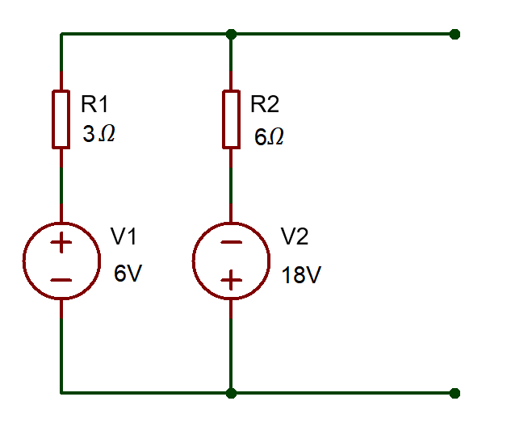
Fig: 1
Solution:
Convert the circuit into an equivalent current source circuit.
$I_{1}=\frac{V_{1}}{R_{1}}=\frac{6}{3}=2A$ [1 Mark]
$I_{2}=\frac{V_{2}}{R_{2}}=\frac{18}{6}=3A$ [1 Mark]
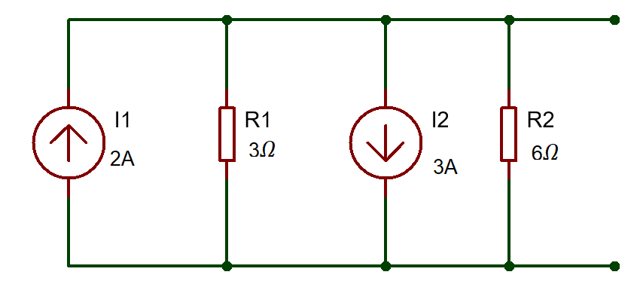
Simplifying the circuit.
$I=I_{2}-I_{1}=3-1=1A$ [1 Mark]
$R=\frac{3×6}{3+6}=\frac{18}{9}=2Ω$ [1 Mark]
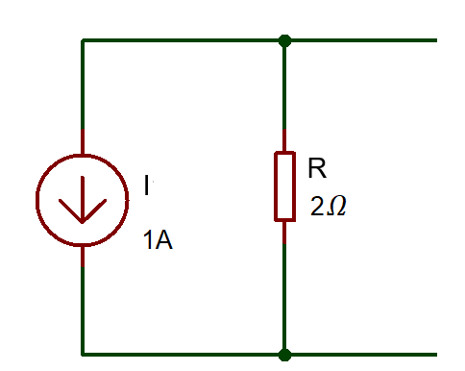
Equivalent circuit
$V=IR=2×1=2V$ [1 Mark]
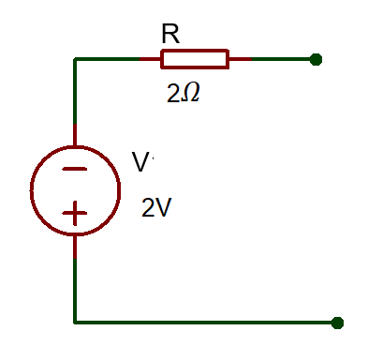 [2 Marks]
- For the circuit shown in fig.2, calculate the following.
- Equivalent Resistance, [6 Marks]
- Current flowing through $20Ω$ Resistor [2 Marks]
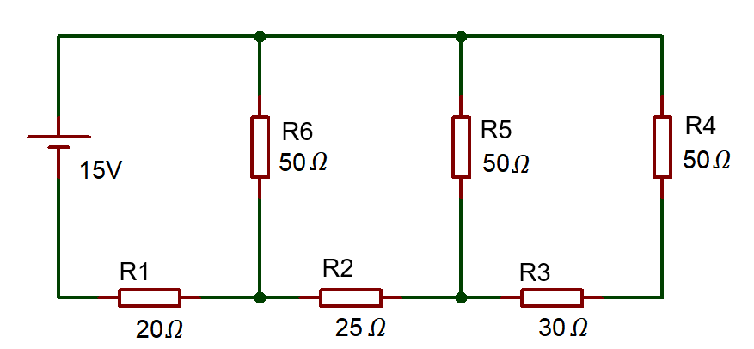
Fig:2
Solution:
- Equivalent Resistance
$\left(R_{4}+R_{3}\right)$ in parallel with $R_{5}$
$R_{eq1}=\frac{{(R}_{3}+R_{4})×R_{5}}{R_{3}+R_{4}+R_{5}}=\frac{\left(30+50\right)×50}{30+50+50}=30.369Ω$ [2 Marks]
$\left(R_{eq1}+R_{2}\right)$ in parallel with $R_{6}$
$R_{eq2}=\frac{{(R}_{eq1}+R_{2})×R_{6}}{R_{eq1}+R_{2}+R_{6}}=\frac{\left(30.369+25\right)×50}{30.369+25+50}=26.274Ω$ [2 Marks]
$R_{eq2}$is series with $R_{1}$
$R_{eq}=R_{1}+R_{eq2}=20+26.264=46.264Ω$ [2 Marks]
- Current flowing through $20Ω$ Resistor
$I=\frac{V}{R_{eq}}=\frac{15}{46.264}=0.324A$ [2 Marks]

- A certain power supply requires 25W of input power and produces an output power of 20W. Calculate its efficiency in percentage and the total power loss? [4 Marks]
Solution:
Efficiency =$\frac{P_{OUT}}{P_{IN}}= \frac{20}{20}=0.8$ [1 mark]
% Efficiency =$0.8×100=80\%$ [1 mark]
Total Power Loss $P_{Loss}=P_{IN}-P_{OUT}=25-20=5W$ [2 marks]
Question 2 [25 Marks]
- Determine the voltage across each resistor in the circuit shown in fig.3.
[3 Marks]
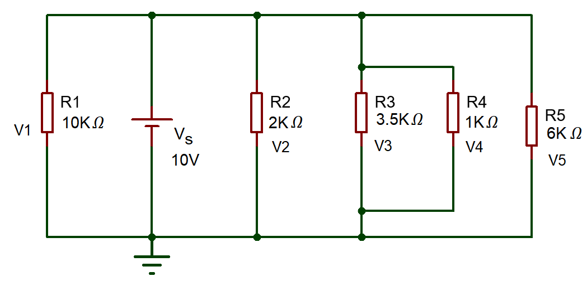
Fig.3
Solution:
As all the resistors are in parallel, the Voltage across the resistor is the same.
$V_{1}=V_{2}=V_{3}=V_{4}=V_{5}=10V$ [3 Marks]
- Three resistors ($R_{A} R_{B} and R_{c})$are connected in series to a 250V Voltage Source. Where, $R_{c}=50Ω, V_{B}=80V and$Total current = 2A. Calculate the following.
- Voltage across $R_{A}$ [2 Marks]
- Voltage across $R_{C}$ [2 Marks]
- Resistance value of $R_{A}$ and $R_{B}$ [4 Marks]
Solution:
- Voltage across $R_{A}$
$V=V_{A}+V_{B}+V_{C}$
$250=V_{A}+80+100$
$V_{A}=250-180=70V$ [2 marks]
- Voltage across $R_{C}$
$V_{C}=I×R_{c}=2×50=100V$ [2 Marks]
- Resistance value of $R_{A}$ and $R_{B}$
$R_{B}=\frac{V_{B}}{I}=\frac{80}{2}=40Ω$ [2 Marks]
$R_{A}=\frac{V_{A}}{I}=\frac{70}{2}=35Ω$ [2 Marks]
- Define the following terms
- Resistance [2 Marks]
- Impedance [2 Marks]
- Reactance [2 Marks]
- Doping [2 Marks]
- Voltage Rating [2 Marks]
Solution:
- Resistance
Opposition to flow of current. Unit is Ohm - DC circuit property [2 Marks]
- Impedance
Opposition to change of flow of current. Unit is Ohm- AC circuit property [2 Marks]
- Reactance
Vector sum of resistance and reactance – Describes total opposition to current – AC and DC circuit property. [2 Marks]
- Doping
It is process of adding impurities to the pure form of Semiconductor. [2 Marks]
- Voltage Rating
Maximum voltage an electrical or electronic appliances can withstand for a duration of time. [2 Marks]
- Differentiate Step- up Transformer and Step-Down Transformer (minimum of two differences) [4 Marks]
Solution:
Sl. No | Step-up Transformer | Step-down Transformer
1 | Input voltage is lower than the output voltage | Input voltage is higher than the output voltage
2 | Number of Secondary winding is higher than the primary winding | Number of Secondary winding is less than the primary winding
3 | 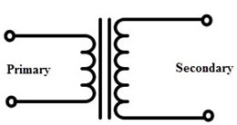 | 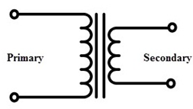
[Each difference two marks, Maximum of 4 marks]
Question 3 [25 Marks]
- Determine the current across each resistor in the circuit shown in fig.4, using mesh analysis (Kirchhoff’s Voltage Law) [17 Marks]
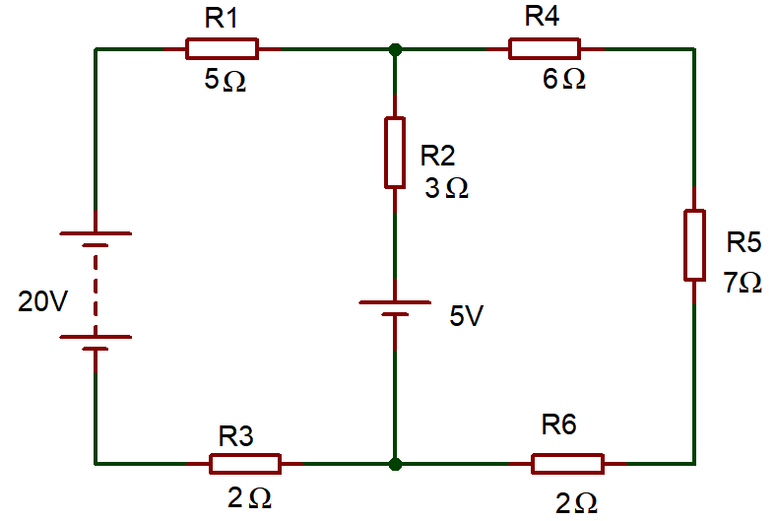
Fig.4
Solution:
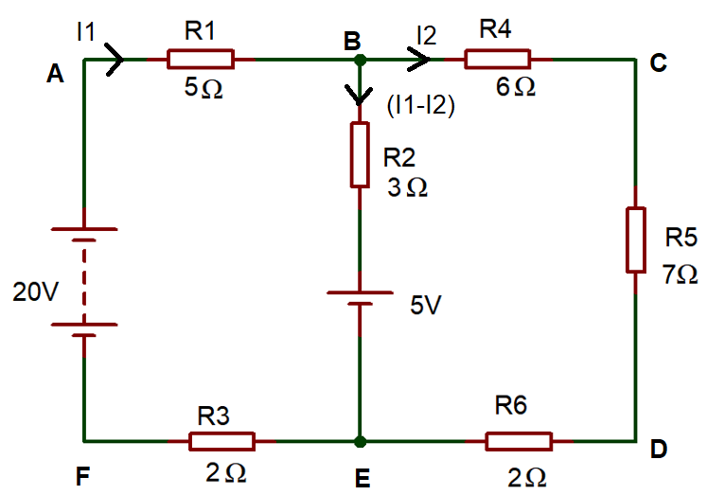
[1 Mark]
Apply KVL in ABEFA
$-5I_{1}-3\left(I_{1}-I_{2}\right)-5-2I_{1}+20=0$ [3 Marks]
$-10I_{1}+3I_{2}=-15$ …………(1) [2 Marks]
Apply KVL in BCDEB
$-6I_{2}-7I_{2}-2I_{2}+5+3\left(I_{1}-I_{2}\right)=0$ [3 Marks]
$-3I_{1}-18I_{2}=-5$ …………(2) [2 Marks]
Simplifying Equation (1) and (2)
$I_{1}=1.67A$ [2 Marks]
Substitute, $I_{1}$ in equation (1)
$-10 \left(1.67\right)+3I_{2}=-15$
$-16.7+3I_{2}=-15$
$3I_{2}=-15+16.7$
$I_{2}=\frac{1.7}{3}$=0.567A [2 Marks]
Current across branch BE
$I_{1}-I_{2}=1.67-0.567=1.1A$ [1 Mark]
Current Across $R_{1}and R_{3}=I_{1}=1.67A$

Current Across $R_{2}=I_{1}-I_{2}=1.1A$
Current Across $R_{4} R_{5} and R_{6}=I_{2}=0.567A$ [1 Mark]
- In the RC circuit shown in fig 5. Calculate the following.
- Capacitive Reactance ($X_{C})$ [3 Marks]
- Impedance (Z) [3 Marks]
- Current across the circuit. [2 Marks]
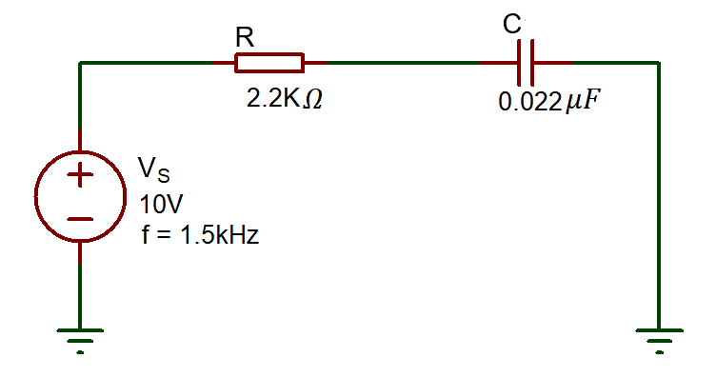
Fig. 5
Solution:
- Capacitive Reactance ($X_{C})$
$X_{C}=\frac{1}{2πfC}=\frac{1}{2π×1.5×1000×0.022×{10}^{-6}}$ [2 Marks]
$X_{C}=4.82KΩ$ [1 Mark]
- Impedance (Z)
$Z=\sqrt{R^{2}+X_{C}^{2}}=\sqrt{{(2.2×1000)}^{2}+{(4.82×1000)}^{2}}$ [2 Marks]
$Z=5.30KΩ$ [1 Mark]
- Current across the circuit.
$I=\frac{V}{Z}=\frac{10}{5.30×1000}$ [1 Mark]
$I=1.89mA$ [1 Mark]

Question 4 [25 Marks]
- The alternating current is given by $i=40 sin314t$. Determine the following
- Maximum Value of current [1 Mark]
- RMS Value of Current [2 Marks]
- Frequency [2 Marks]
Solution:
- Maximum Value of current
From the given equation, $V_{m}=40V$ [1 Mark]
- RMS Value of Current
$V_{RMS}=\frac{V_{m}}{\sqrt{2}}=\frac{40}{\sqrt{2}}$ [1 Mark]
$V_{RMS}=28.284V$ [1 Mark]
- Frequency
From the equation, $ω=314$
We know that, $ω=2πf$
$314=2πf$ [1 Mark]
$f=\frac{314}{2π}$=50Hz [1 Mark]
- Differentiate P-type and N-Type Semiconductor. [4 Marks]
Solution:
Sl.No | N type semiconductor | P type semiconductor
1 | Pentavalent impurities are added | Trivalent impurities are added
2 | Doping agent: Arsenic, Antimony | Doping agent: Gallium, indium
3 | Electrons- Majority charge carriers  Holes- minority charge carriers | Electrons- minority charge carriers  Holes- majority charge carriers
[Each difference 2 marks, Maximum of 4 marks]
- List any four types of Transistors. [4 marks]
Solution:
- BJT (Bipolar Junction Transistor) – NPN
- BJT (Bipolar Junction Transistor) – PNP
- N-Channel JFET (Junction Field Effect Transistor)
- P-Channel JFET (Junction Field Effect Transistor)
- N-Channel MOSFET (Metal Oxide Semiconductor Field Effect Transistor)
- P-Channel MOSFET (Metal Oxide Semiconductor Field Effect Transistor)
[1 mark each, Maximum of 4 Marks]
- What is the use of the circuit shown in fig.6? Describe the functions of each stage of the circuit with the necessary diagrams. [12 marks]
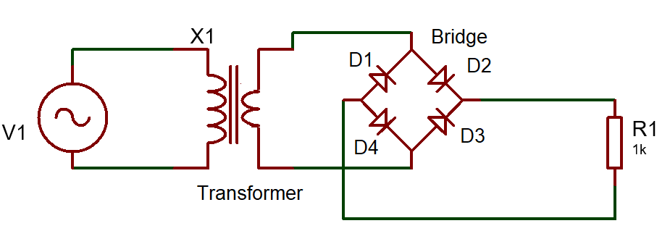
Fig.6
Solution:
The Circuit shown in Fig 6 is a Bridge Rectifier circuit, It is used to convert AC to DC. [2 Marks]
Transformer:
The input to the bridge rectifier is provided by a transformer. The transformer steps down the voltage from the mains to a suitable level. [1 Mark]
Diodes (4 Diodes):
A bridge rectifier consists of four diodes arranged in a specific configuration. [1 Mark]
Working Principle:
AC Input:
The alternating current (AC) input from the transformer is applied to the four diodes in the bridge rectifier circuit. [1 Mark]
Diode Operation:
Depending on the polarity of the input AC voltage, two diodes conduct during each half-cycle. [1 Mark]
When the voltage is positive, Diodes D2 and D4 conduct, and when the voltage is negative, Diodes D1 and D3 conduct. [3 Marks]
Output Voltage:
As a result, the output is a pulsating DC voltage that maintains the same polarity regardless of the input AC voltage. [2 Marks]
Waveform:
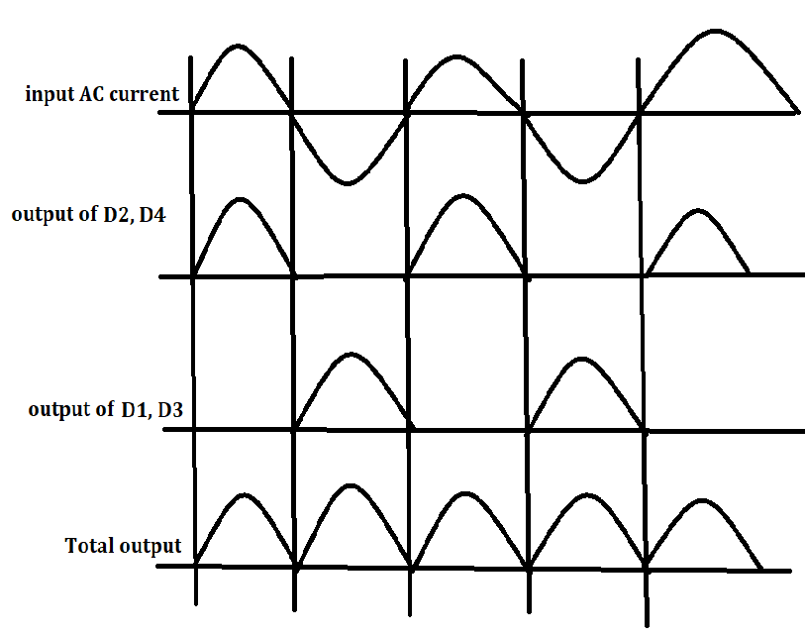 [1 Mark]

Question 5 [25 Marks]
- A 12 V Battery has an internal Resistance of 12Ω, Calculate the power dissipated by various load resistances given in the below table and complete the table. [15 Marks]
Load Resistance (Ω) | Load power (W)
4
8
12
16
20
- Plot a graph of the load Power against the load resistance, [8 Marks]
Solution:
Load Resistance (Ω) | Load power (W)
4 | 2.25
8 | 2.88
12 | 3
16 | 2.938
20 | 2.813
[3 marks for each, maximum of 15 marks]
- Plot a graph of the load Power against the load resistance,
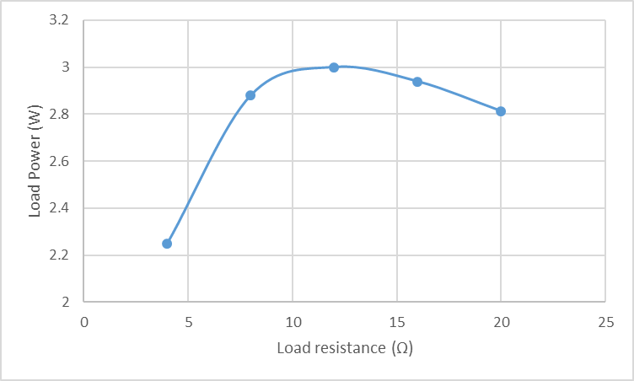
[labelling X axis, Labelling Y axis, title, scale – 1 Mark each, Plotting- 4 Marks]
- List any two applications of Transistor. [2 Marks]
Solution:
- Transistor as an amplifier [1 Mark]
- Transistor as switch [1 Mark]

Diwedd/End

