Design Patterns in Object Oriented PHP
Advanced Web Development
Jonathan Evans
p151713
18th January 2019

Introduction
Design patterns provide solutions to solving common re-occurring problems in object-oriented programming. This report will investigate design patterns. It will provide an overview of what design patterns are, and an analysis of two patterns used in an example, and how they relate to web application development, and in a web application created for this report.

Introduction to Design Patterns
Gang of Four (GoF) describe a design pattern as something that “names, abstracts, and identifies the key aspects of a common design structure that make it useful for creating a reusable object-oriented design.” [1, p. 13]
Programmers categorize design patterns into three categories - creational, structural, or behavioral. Each solve different types of re-occurring problems. Some of these are detailed below.

Creational
Creational patterns are concerned with details about how objects are instantiated. A singleton or factory pattern is a good example of a creational pattern. [1, p. 94]
Creational patterns - Singleton
A singleton is an object that only allows one instance of itself to be instantiated - this can be quite useful when the developer is certain that the given object needs to be instantiated only once - such as reading a line from console input, or carrying out a database interaction. [2]
Creational patterns – Factory
A factory class allows a developer to request an object to be instantiated by a factory class. [3] This may be useful in creating User objects from a UserFactory class.

Structural
Structural patterns are used to deal with matters pertaining to the structure of objects. An example of a structural pattern is the adapter pattern, and facade pattern. [1, p. 155]
Structural patterns - Adapter
The adapter pattern is used when one object needs to be adapted to work with another object. [4] This can be used in a situation where a programmer needs an object to have particular methods which it does not have, thus they can be adapted onto the object to meet the requirements to work with another object. This is discussed in the following sections where two design patterns (adapter and strategy) will be investigated in detail.
Structural patterns – Façade
The façade pattern consists of creating an object that “wraps” the lower-level functionalities of a system. [5] An example of this could be using façade to handle database queries, which will be used in coming sections to interact with data in a web application.
The benefit of façade in particular is that, implementing this would allow the developer to implement database calls, and change the underlying logic in one place. This kind of functionality is also used in the MVC (Model View Controller) pattern discussed later in this report.

Behavioral
Behavioral patterns are used to solve problems pertaining to object communication. GoF describes this as patterns that are “concerned with algorithms and the assignment of responsibilities between objects”. [1, p. 249]
The strategy pattern is an example of a behavioral pattern.
Behavioral pattern – Strategy
The strategy pattern uses an object that can be used to call a different algorithm pending on what algorithm was requested. [6] This is explained in more detail later in the following section (as well as the adapter pattern).

Investigation of two design patterns
This section will investigate two design patterns - adapter, and strategy. It will consist of a description of each pattern, and an implementation which shows how they are created, how they are used, and the resulting output in a browser.

Adapter pattern
The adapter pattern is a structural pattern which is used when the developer wants to use an object which is not compatible with a given use-case. This can be used to effectively append methods to an object at run-time.
The example below shows an adapter pattern that adapts a price object to include the priceWithVAT method.

Adapter class
The picture below shows two classes, a product class, and a ProductAdapter.
- Product class - The product class has one method: GetPrice() - which returns the price value supplied in the constructor. This may be suitable in some cases; however, a method may be desired to also work out what the price is with VAT.
- ProductAdapter class - The ProductAdapter class is used to supply the priceWithVAT method to the Product class. It takes the price, and multiplies it by the VAT percentage.
The difference between the adapter pattern and the similar decorator pattern (which aims add functionality to an object dynamically) is that an adapter is used to make an object match a specified type.
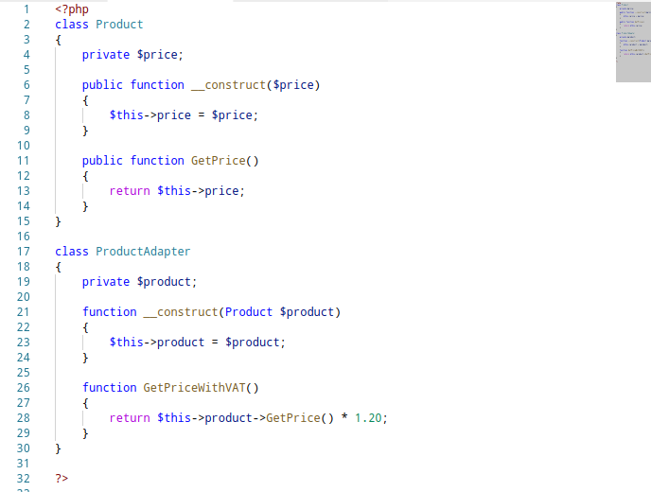
Figure 1 adapter.php
Using the adapter class
In order to use the adapter class, a product, and a ProductAdapter must be instantiated. The product object must be provided to the constructor of the ProductAdapter class.

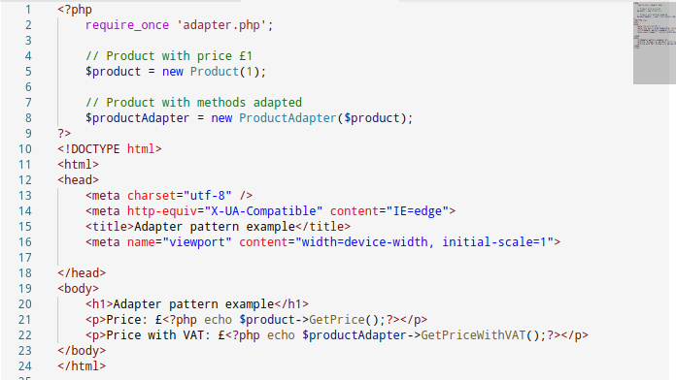
Figure 2 usingadapter.php

Output shown In-browser
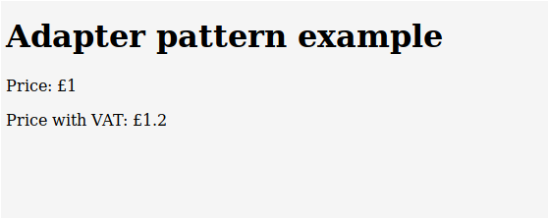

Strategy pattern
The strategy pattern is a behavioral pattern that the developer can use to choose an algorithm at run-time.
One particularly useful case for the strategy pattern is for sorting. For example, there are many kinds of sorting algorithms - bubble-sort, quick-sort, and others. Each sort will perform differently depending on the data provided. A strategy pattern can be used here to define which should be used based on the context.
Below are code snippets that illustrate how a strategy pattern can be used in the case of hashing. A developer may wish to do this as different hashing algorithm vary in computational load. Given the context, a developer may wish to use a stronger or weaker hashing algorithm depending on how computationally heavy the algorithm is.

The implementation of this algorithm consists of:
- IHashingStrategy - An interface that defines the functionality of a strategy.
- MD5Hash/SHA1Hash - Concrete classes that implement the IHashingStrategy interface.
- HashingContext - A class that is called to execute a given algorithm.

These are shown on the following page.

Strategy pattern code
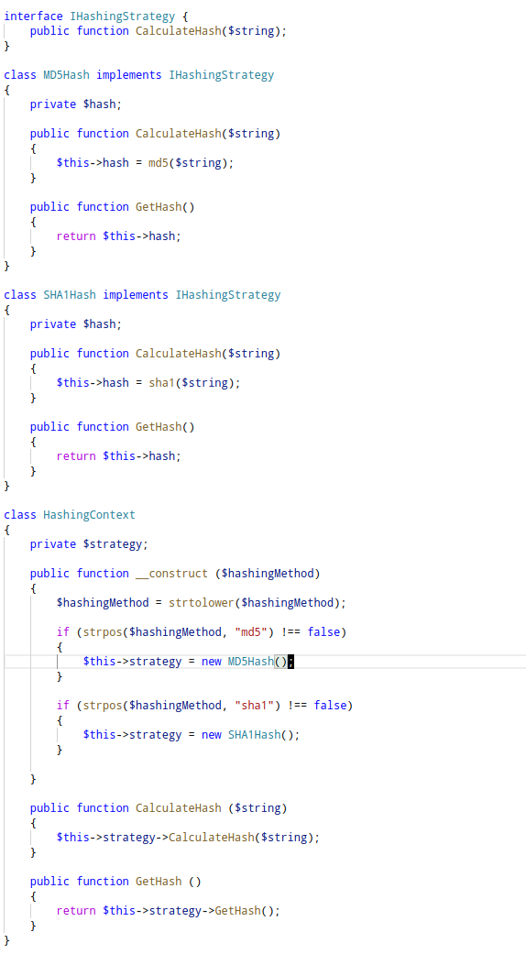
Figure 3 strategy.php

Using Strategy pattern
Below is a snippet that shows strategy pattern being used to create an MD5 and SHA1 hash.
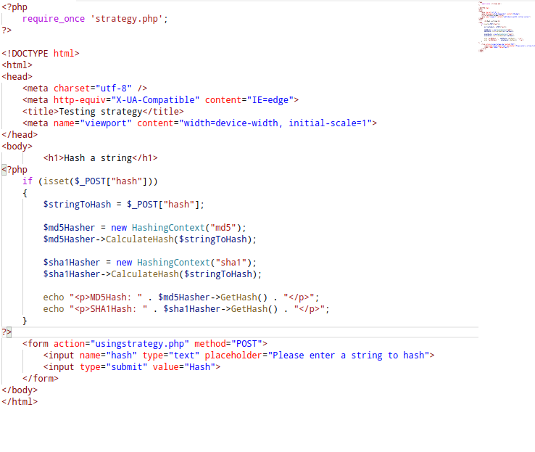
Figure 4 usingstrategy.php
Output shown In-browser
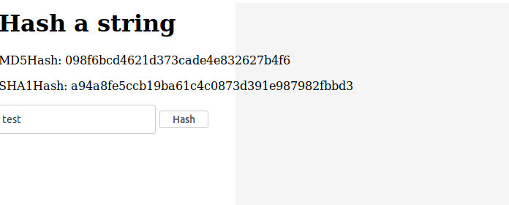

Design patterns in Web Applications
As well as the patterns already detailed, a prominent pattern used in web applications is known as the MVC (Model View Controller) pattern. This is concerned with the separations of three crucial components, each described below.
- Model – The Model is responsible for database models and how they are stored in a database. Common MVC frameworks such as Symfony, represent database items as objects in a web application. This makes use of an ORM (Object Relational Mapper) – which is responsible for creating a “virtual database” which allows for database functionality to be carried out other different kinds of systems.
In symphony, ORM functionality is utilized through a library known as Doctrine ORM. [7]

- View – The view is the display of the user interface of a web application.

- Controller – The controller is responsible for interactivity with the model, and view component of an MVC. It is responsible for tasks such as getting object data (from a virtual database), and displaying it in a view (which may make use of a templating language such as jinja2 - which allows developers to create interfaces that can call object properties from within HTML, without the requirement of opening php tags).

Web Application
This is the web application that has been created to demonstrate the use of various design patterns in object-oriented PHP. It is a computer component store that makes use of all CRUD (Create/ Read/ Update/ Destroy) operations, as well as making use of three design patterns – façade, singleton, and observer.
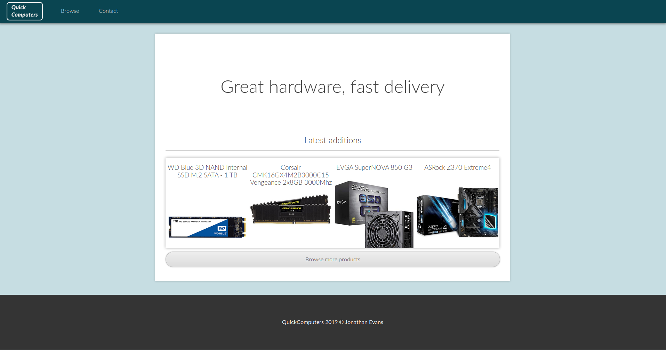
Figure 5 Web Application Home Page

Façade and Singleton pattern for database queries
As shown below, the façade pattern and singleton pattern has been used to retrieve objects from the database.
The object ComponentCollector has methods that allows the developer to retrieve objects from a database and write objects to a database. This can be used wherever required by including the object on a page. One flaw with this design is that it is specific to the component object (which are the components in the hardware store). This means that it can only be used for this purpose, making the object more specialized than it needs to be. It can be improved by making a more general-purpose object for database management.
The reasoning for making this object a singleton is that only one connection should be made to a database at a time. This may not be needed, but it serves as a convenient reminder for the developer that a ComponentCollector object may already be in use (if it is instantiated).
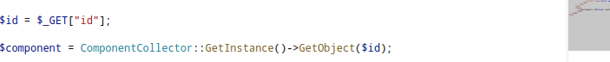
Figure 6 Using Facade Object
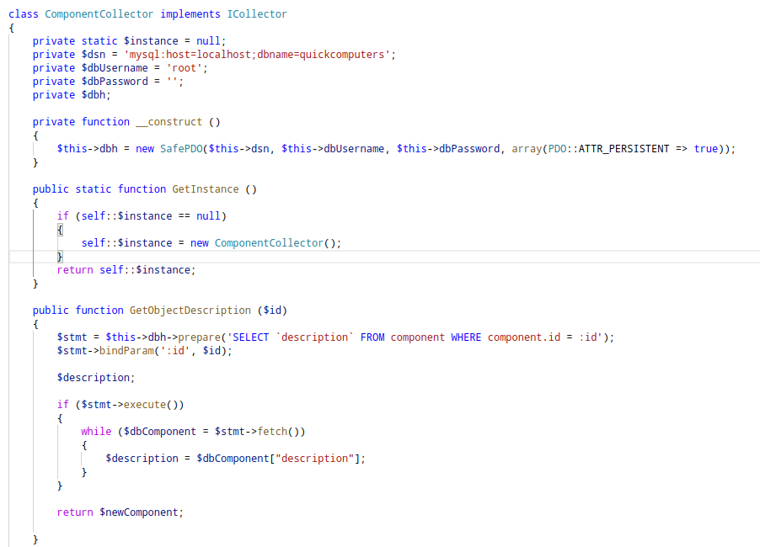
Figure 7 Collector class

Observer pattern
The observer pattern consists of observer objects, and a subject object. The subject object would update the observer objects when the state of the subject object changes.

In case of the web application created, this has been used to write logs to the database when an update occurs. Multiple observers can be attached and can report their logs using their given method (be that an update to the database, or to send an email to the server’s administrator).

Testing
This section will test the website by demonstrating what each page should display. Alternative methods of testing would include using unit tests, ideally making use of Dependency Injection (DI) to easily test individual components of the website.

Test 1 - Homepage
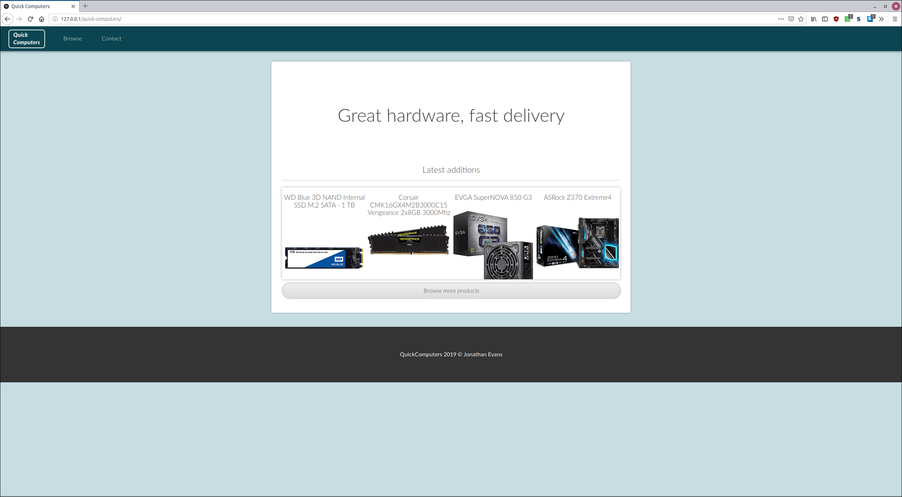
This is the homepage. It shows all the latest products which is displayed using the ComponentCollector object shown on the previous page. In particular, it uses a function to return the latest data items inserted into the database.
Test 2 – Browse page
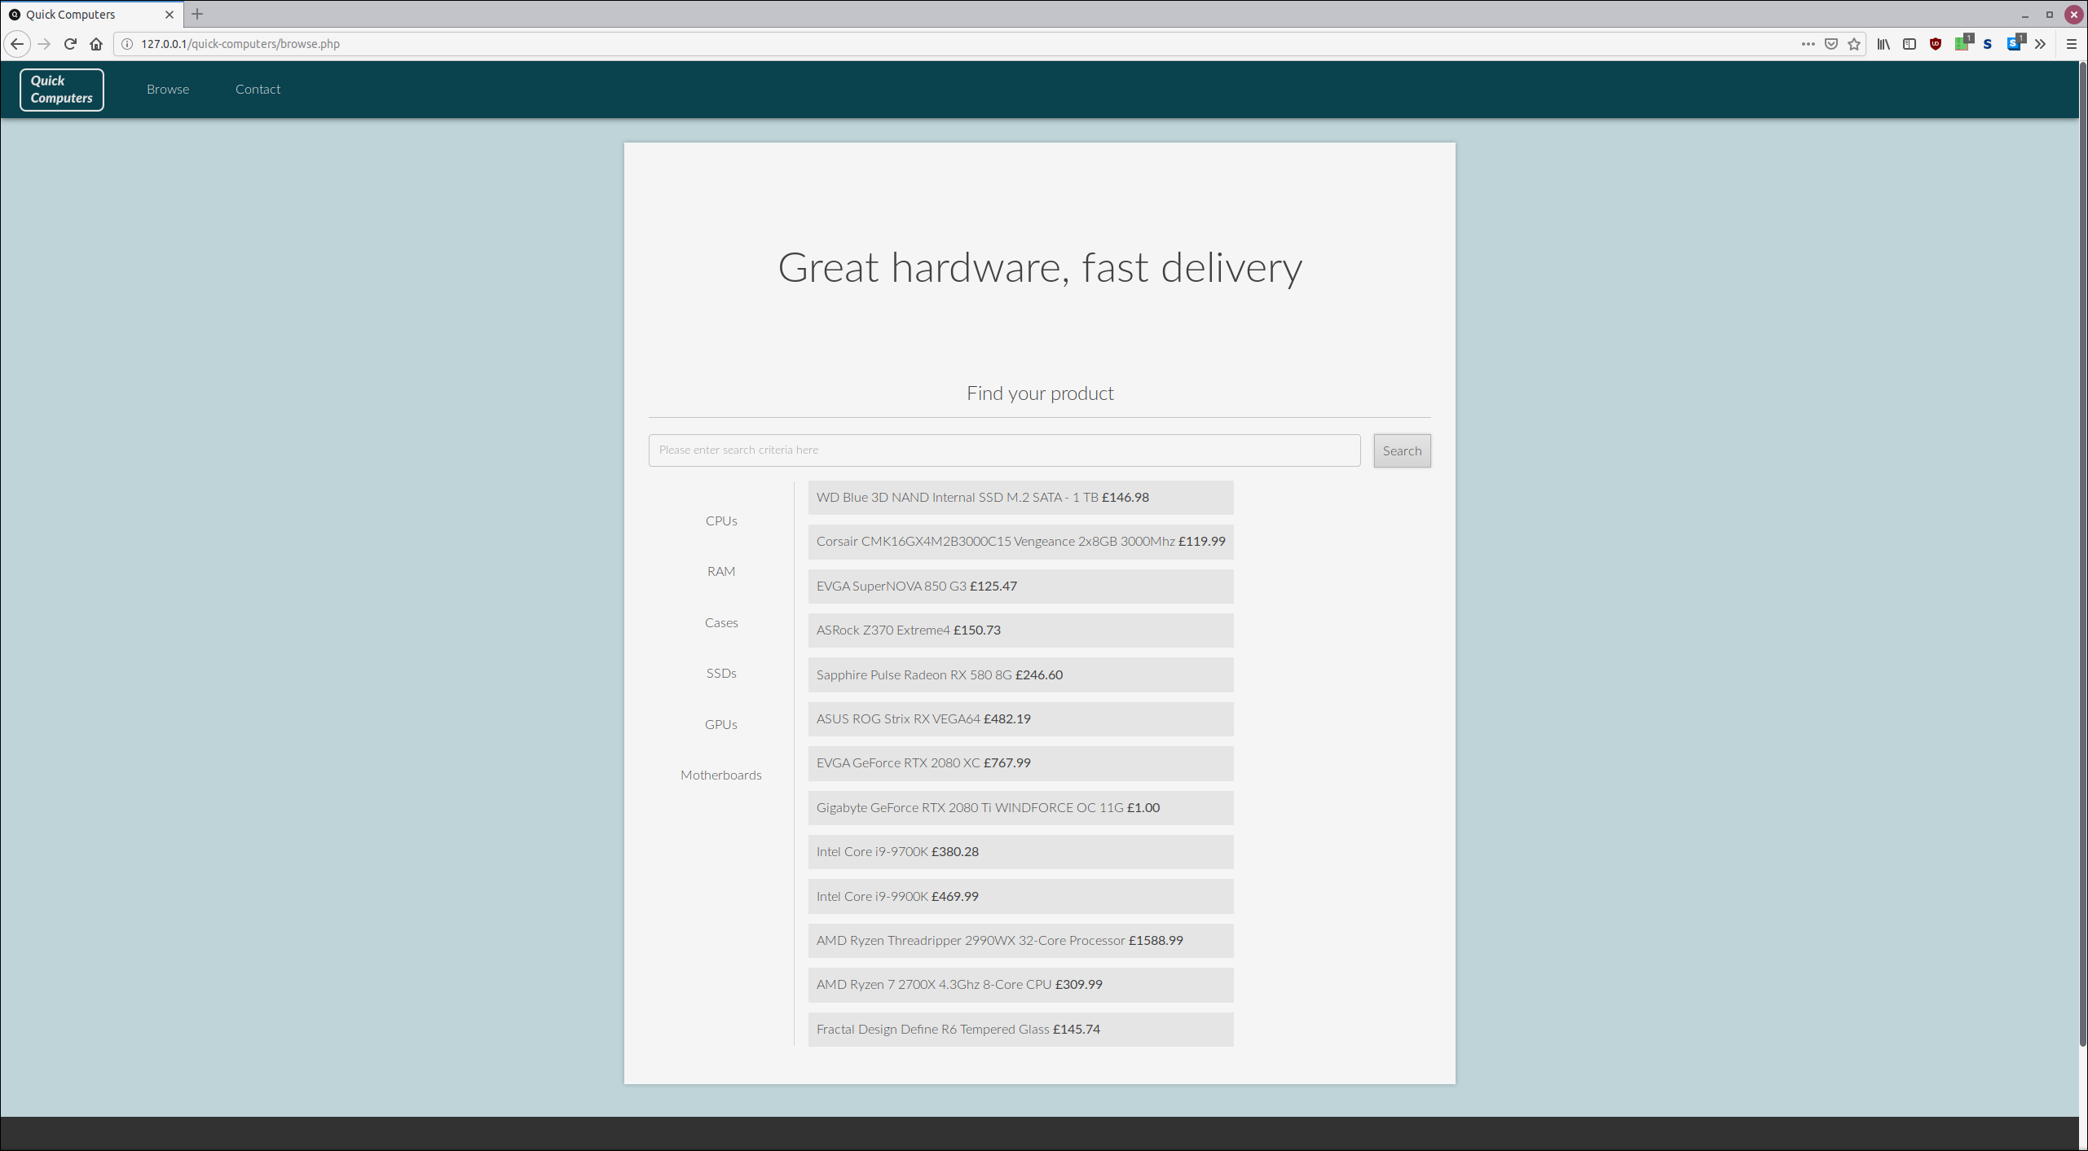
This is the browse page. It displays all the items in the database. This should ideally paginate the items, limiting display output.
Test 2.1 – Browse page Filters
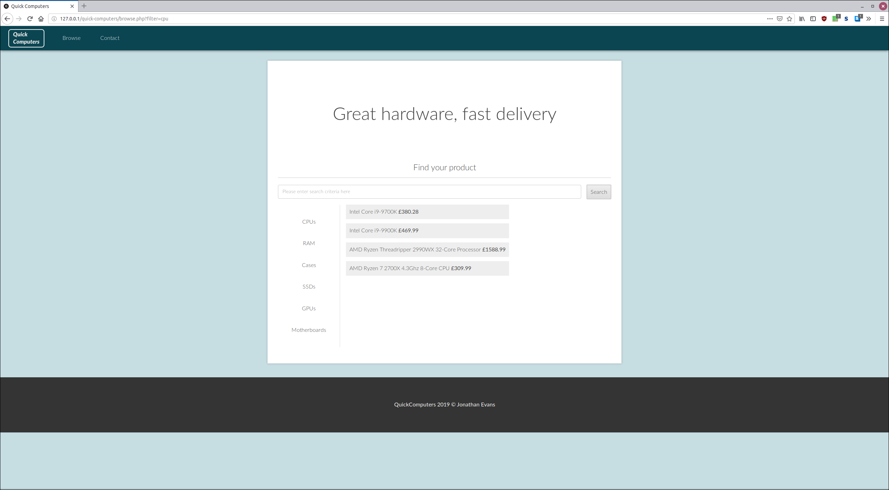
This shows the products being filtered by the “CPU” category. This uses the product ID to filter the products. CPU IDs are preceded with the “cpu” keyword (Cpu1, for example).
Test 2.2 – Browse page search
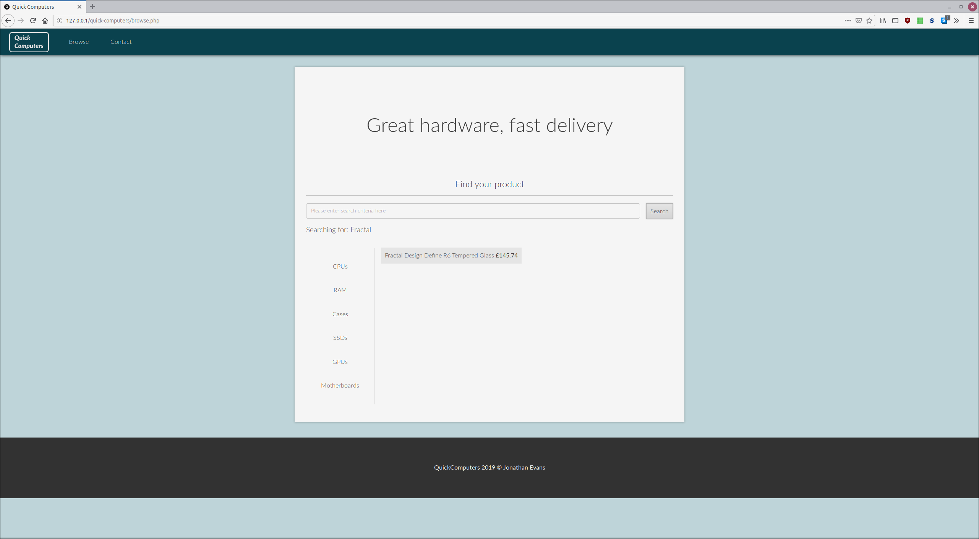
This shows the result of a search
Test 3 – Product page
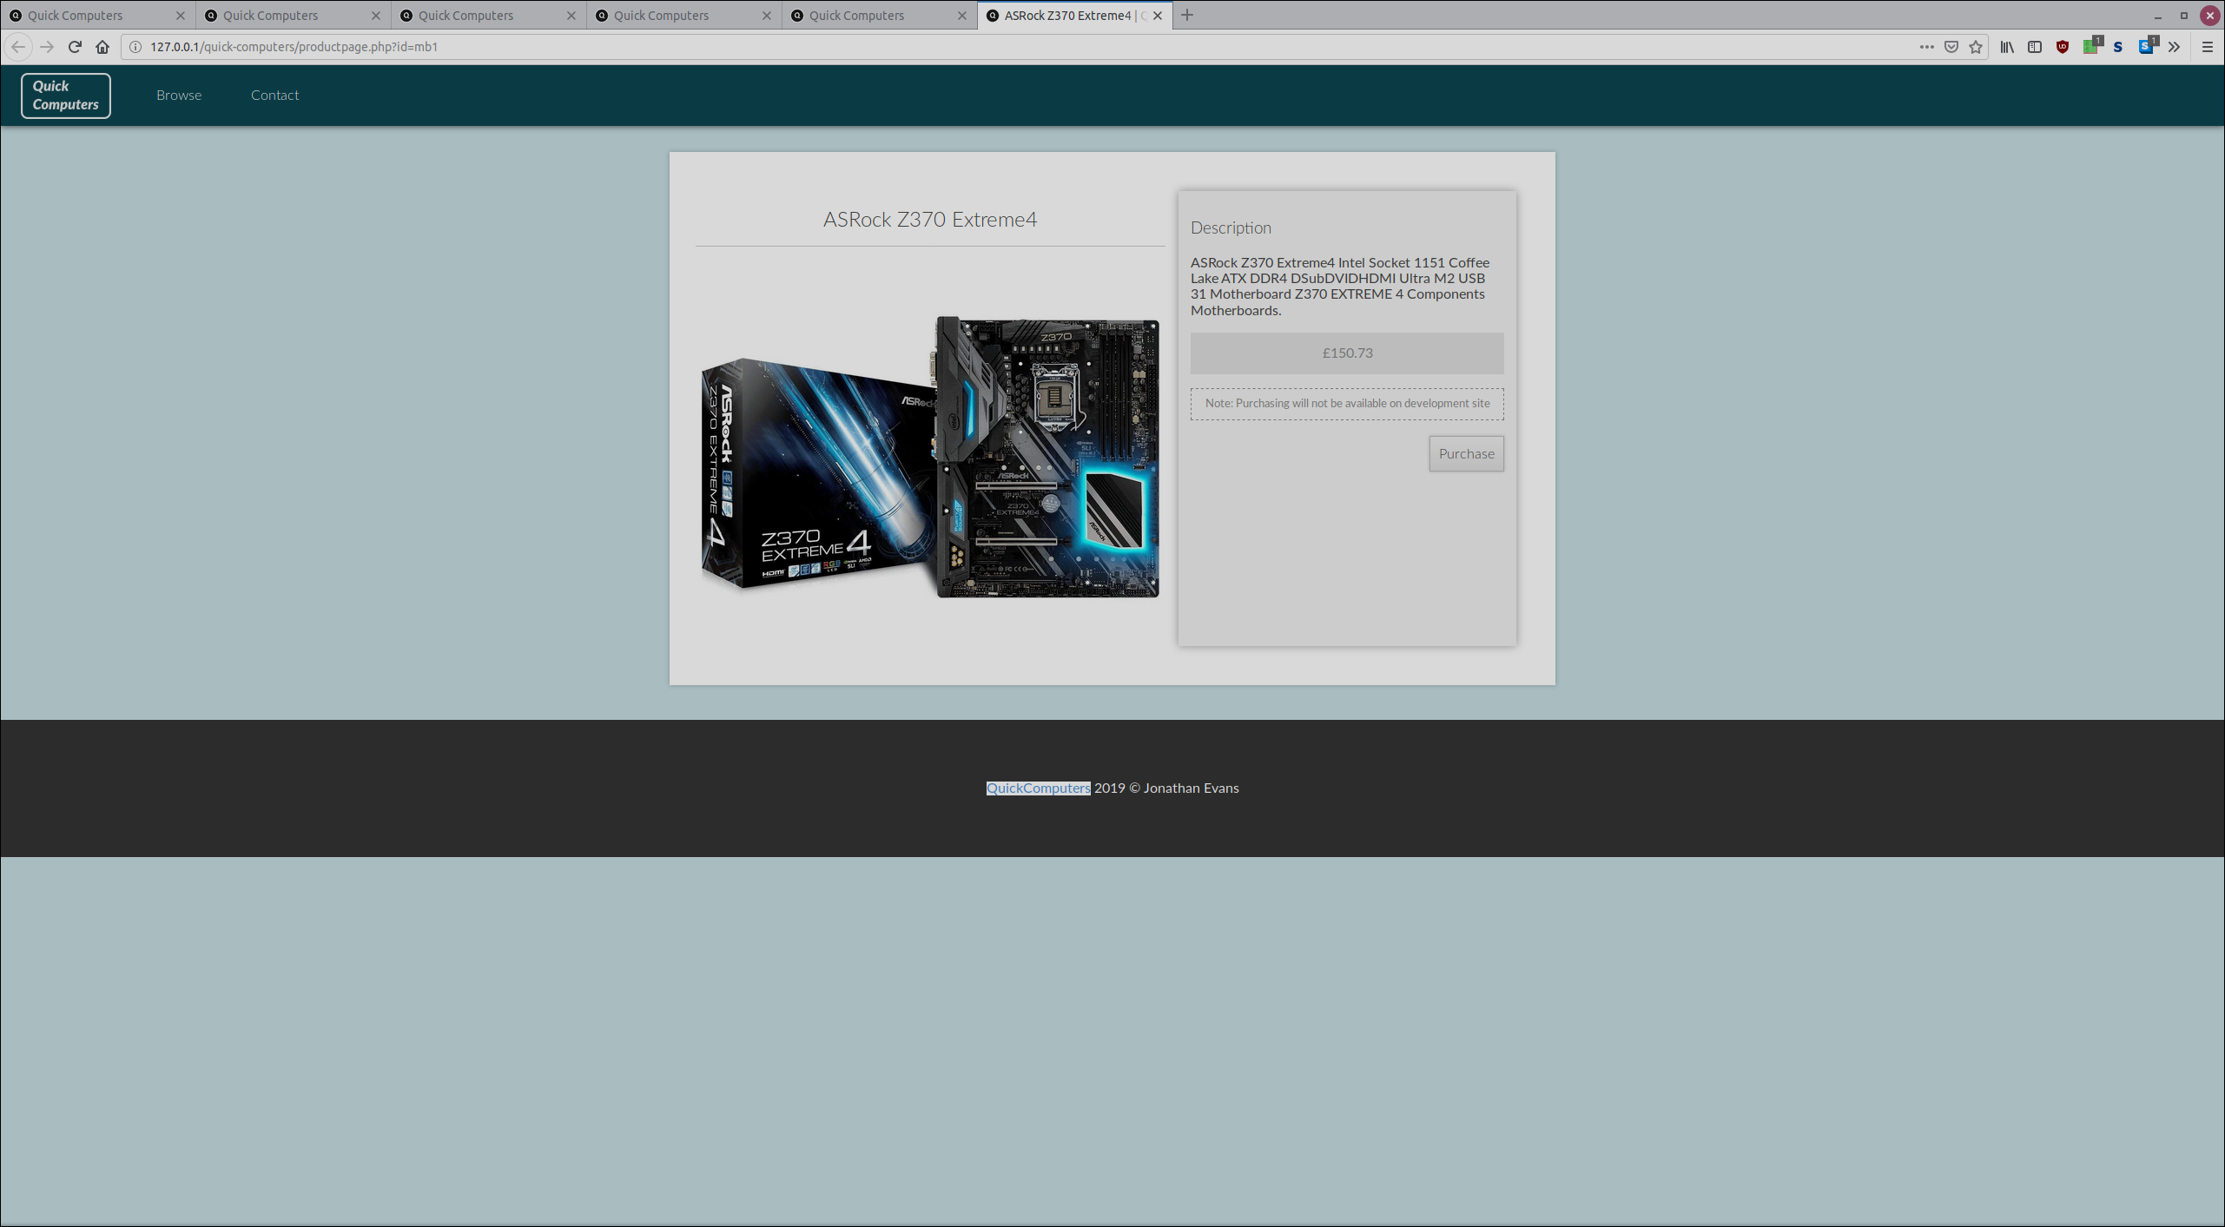
This shows the product page. It pulls in data from the component table in the database.
Test 4 – Admin – login-page

This is the login page. It uses a table to authenticate a user of the website. This stores a username and password. (Which has been stored in plain text for the time-being, however, in production, salting and hashing should be used when storing passwords to keep passwords unknown to anyone who may have access to the database.
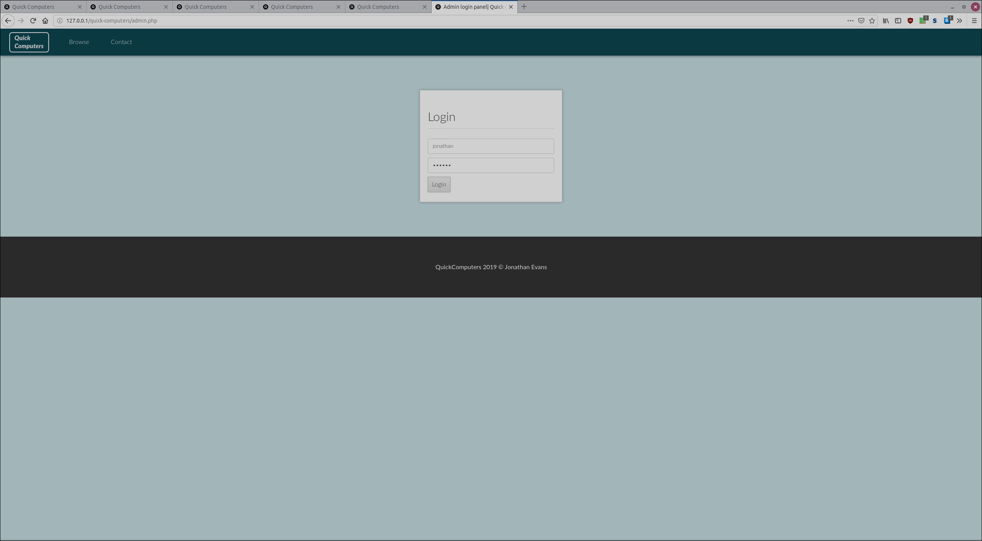
Test 4.1 – Browse page (admin view)
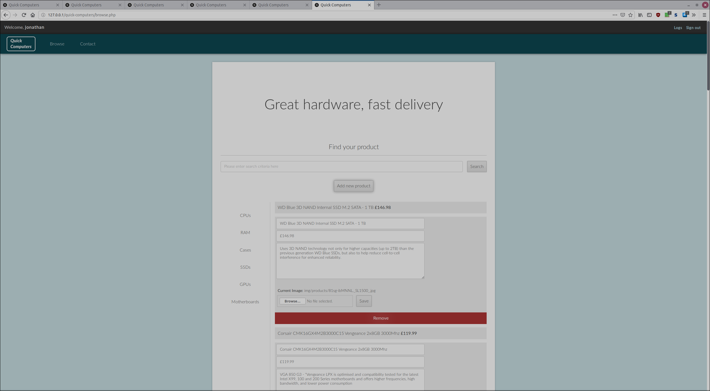
When an admin logs in, they are shown a modified version of the browse page which allows them to perform any CRUD (Create / Read/ Update/ Destroy) operation. This is done through session management, which stores a variable for the current session, indicating an admin is using the page. This is stored until the admin decides to press the logout button.
Test 5 Adding a record
This page shows the form for adding a record.
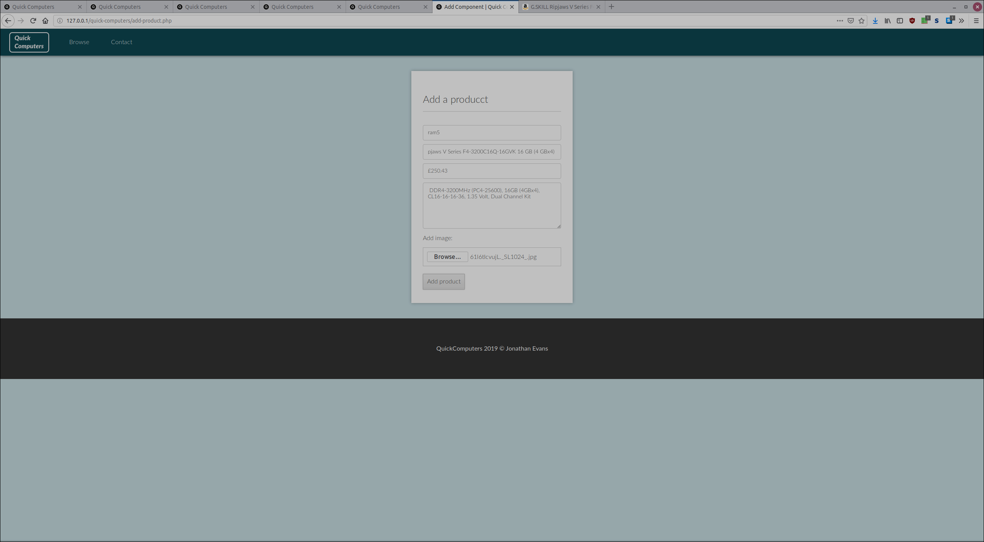

Test 5 result
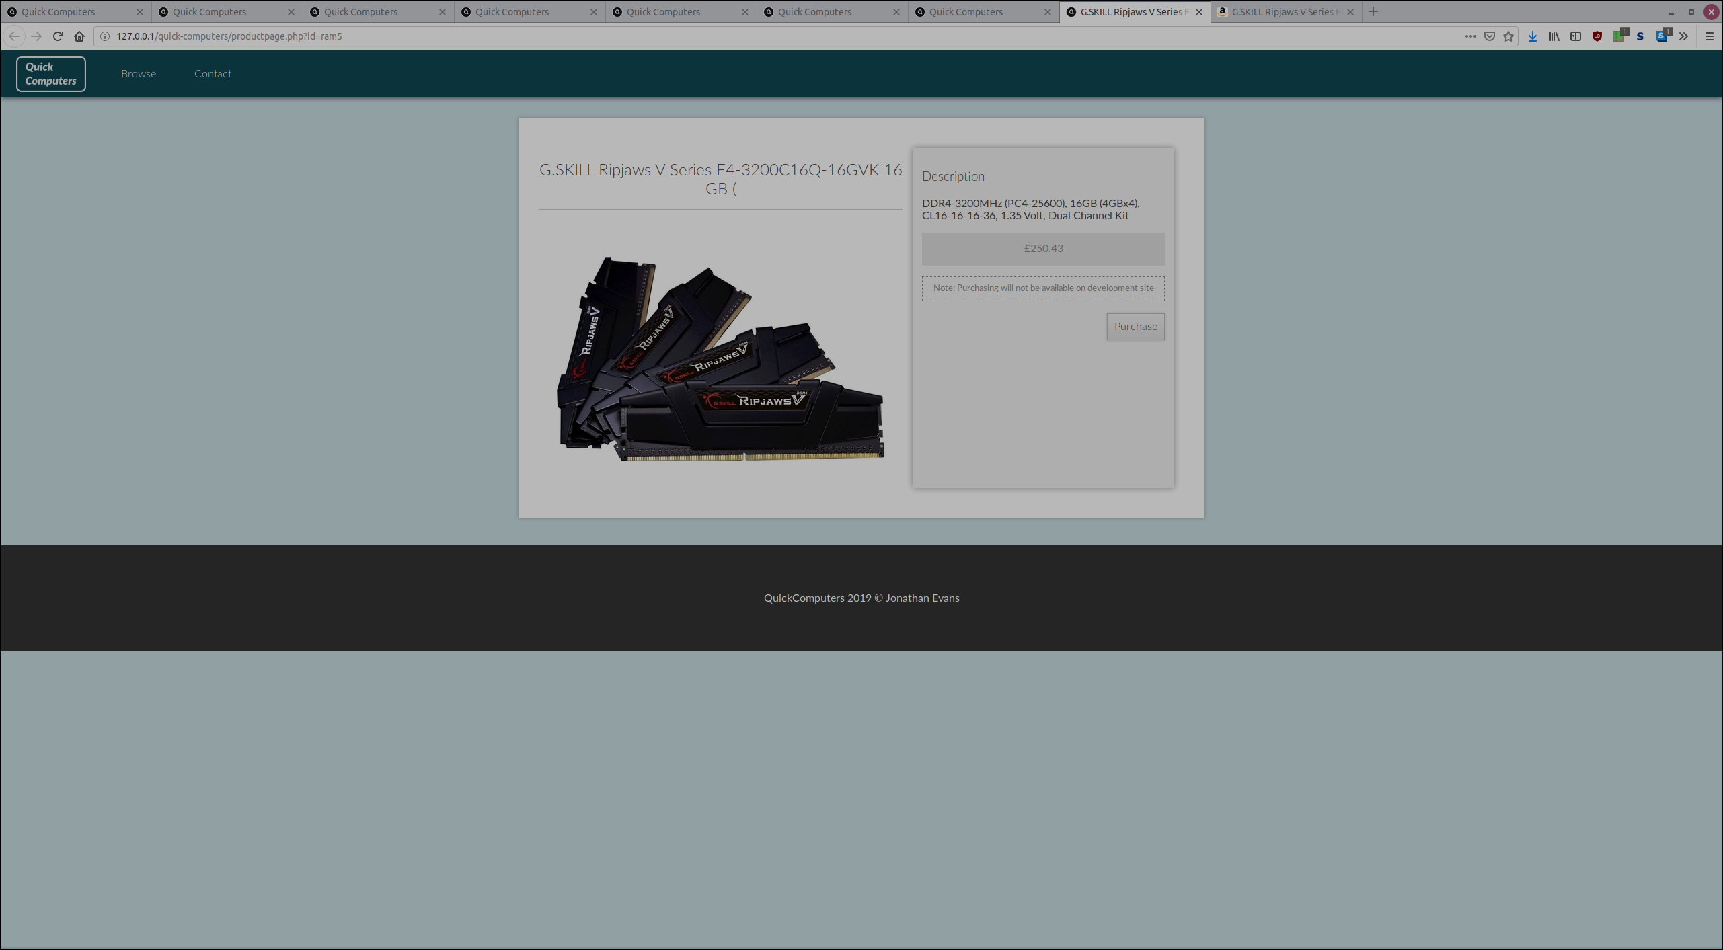
Product page
Test 6 Modifying a record
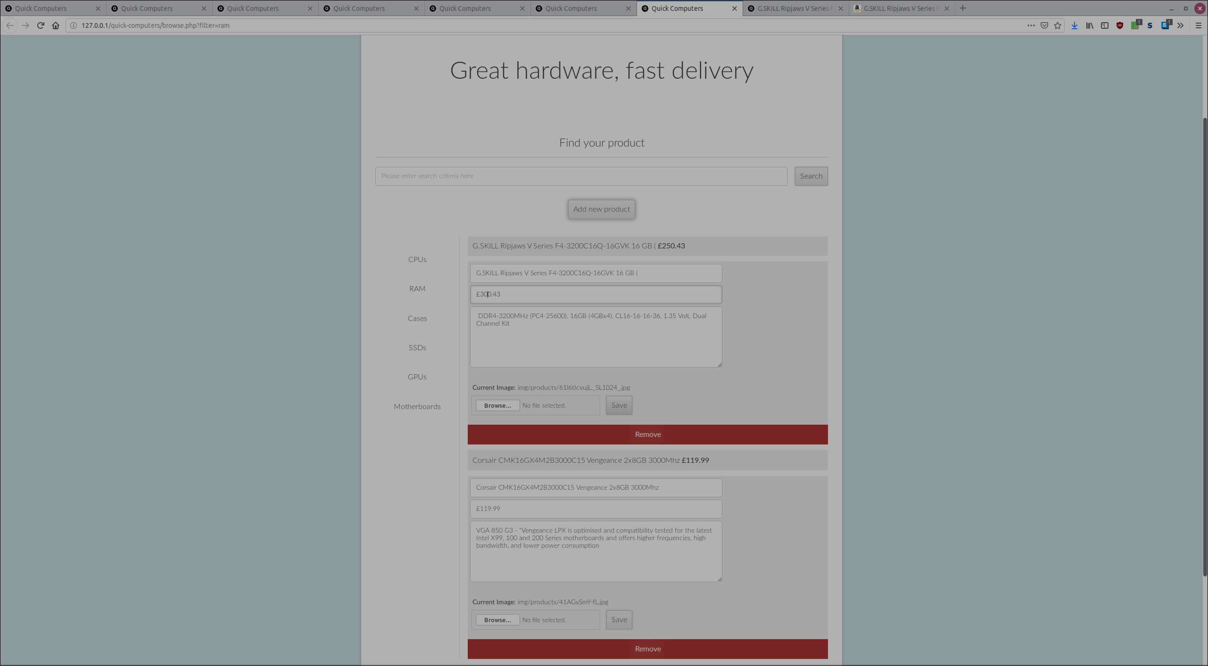
Before price is on the previous page
Test 6 – Modified record
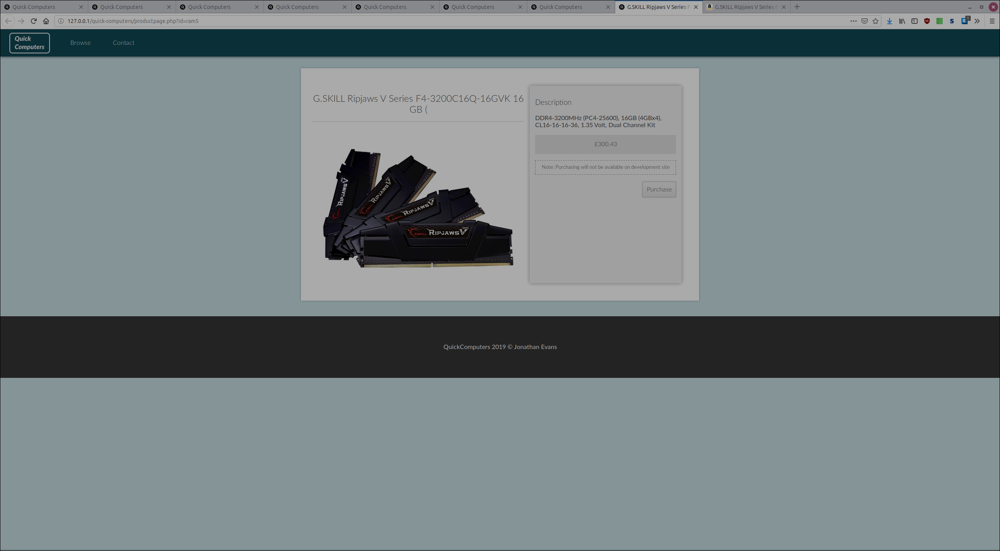
Test 7 – Removing a component
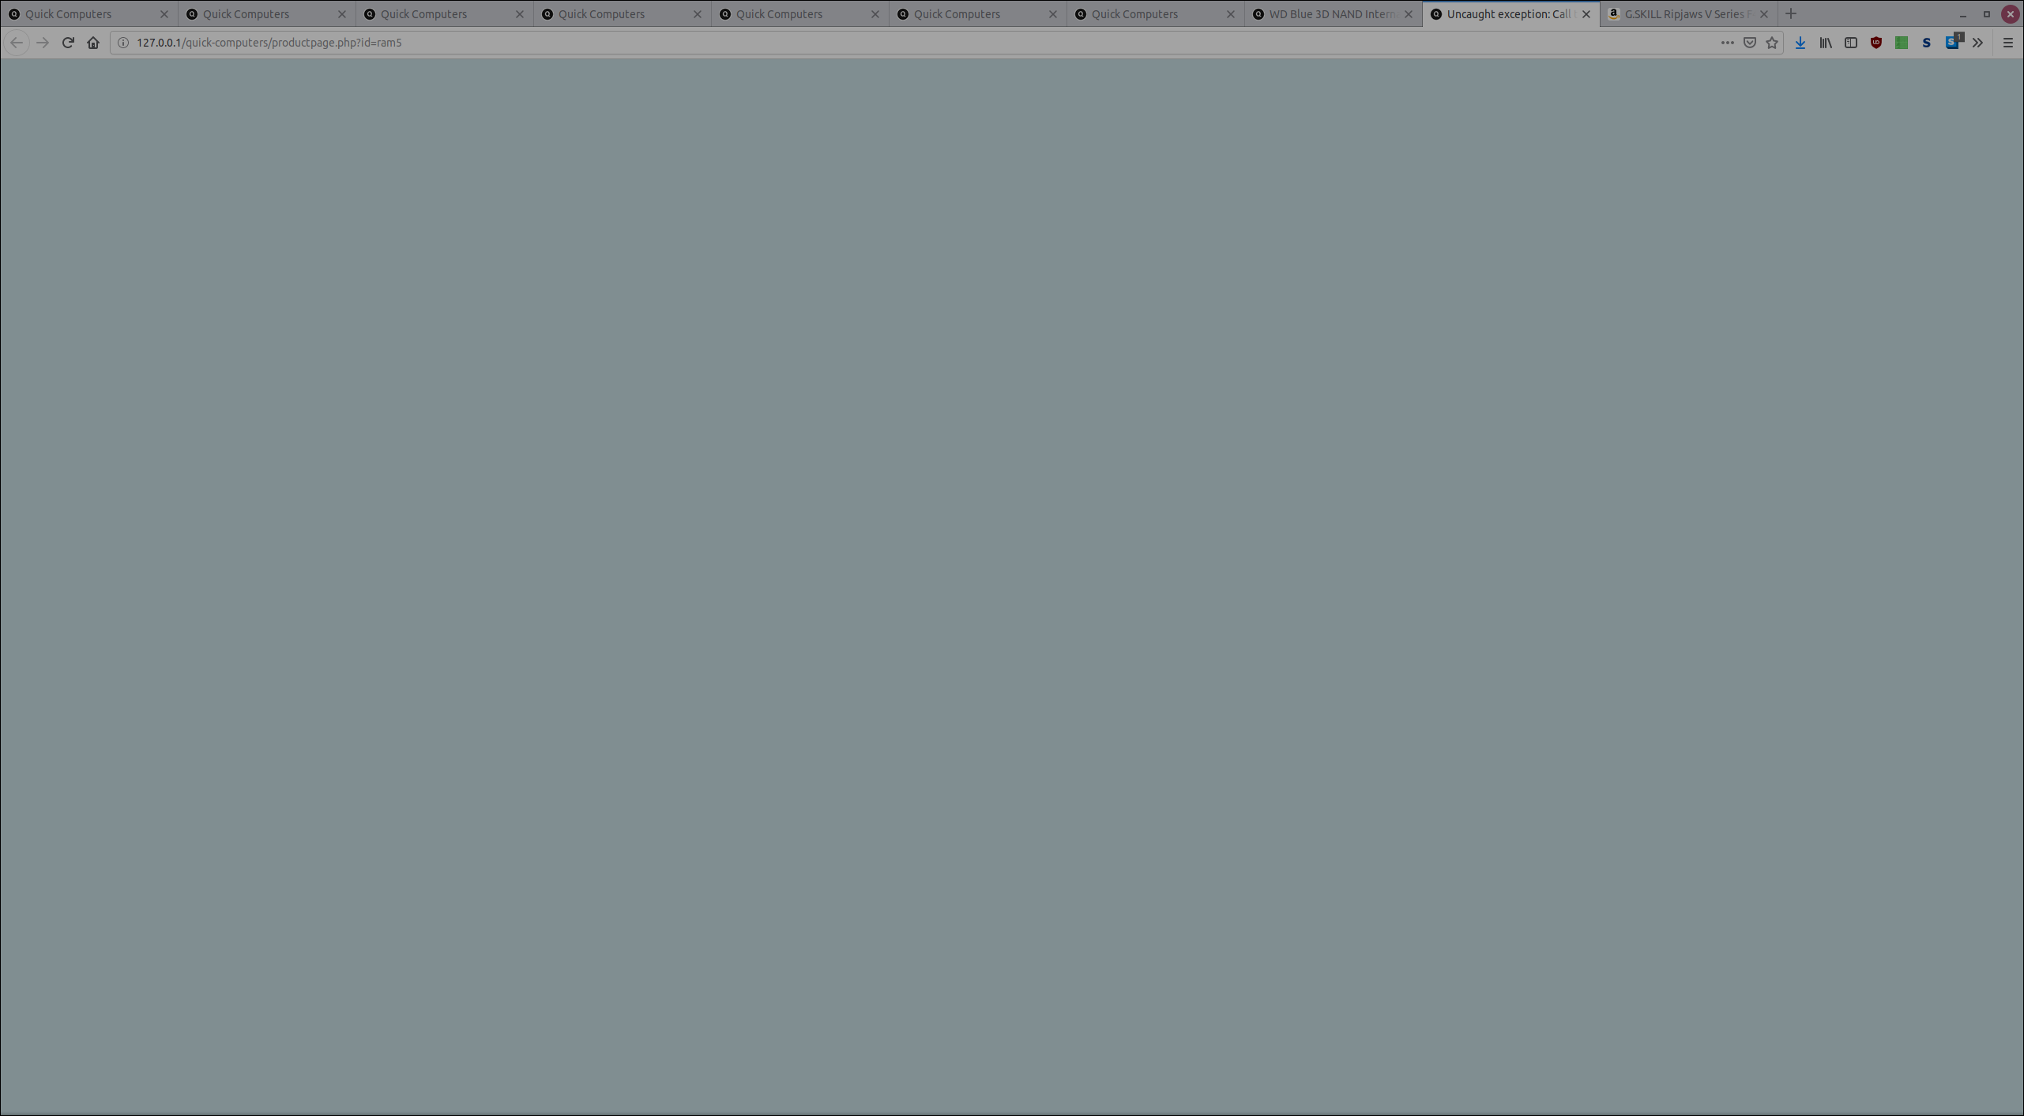
Using the browse page (admin view), a component was removed, thus nothing is displaying here. A 404 message may be useful to alert the user that there is nothing to see.
Test 8 – logging
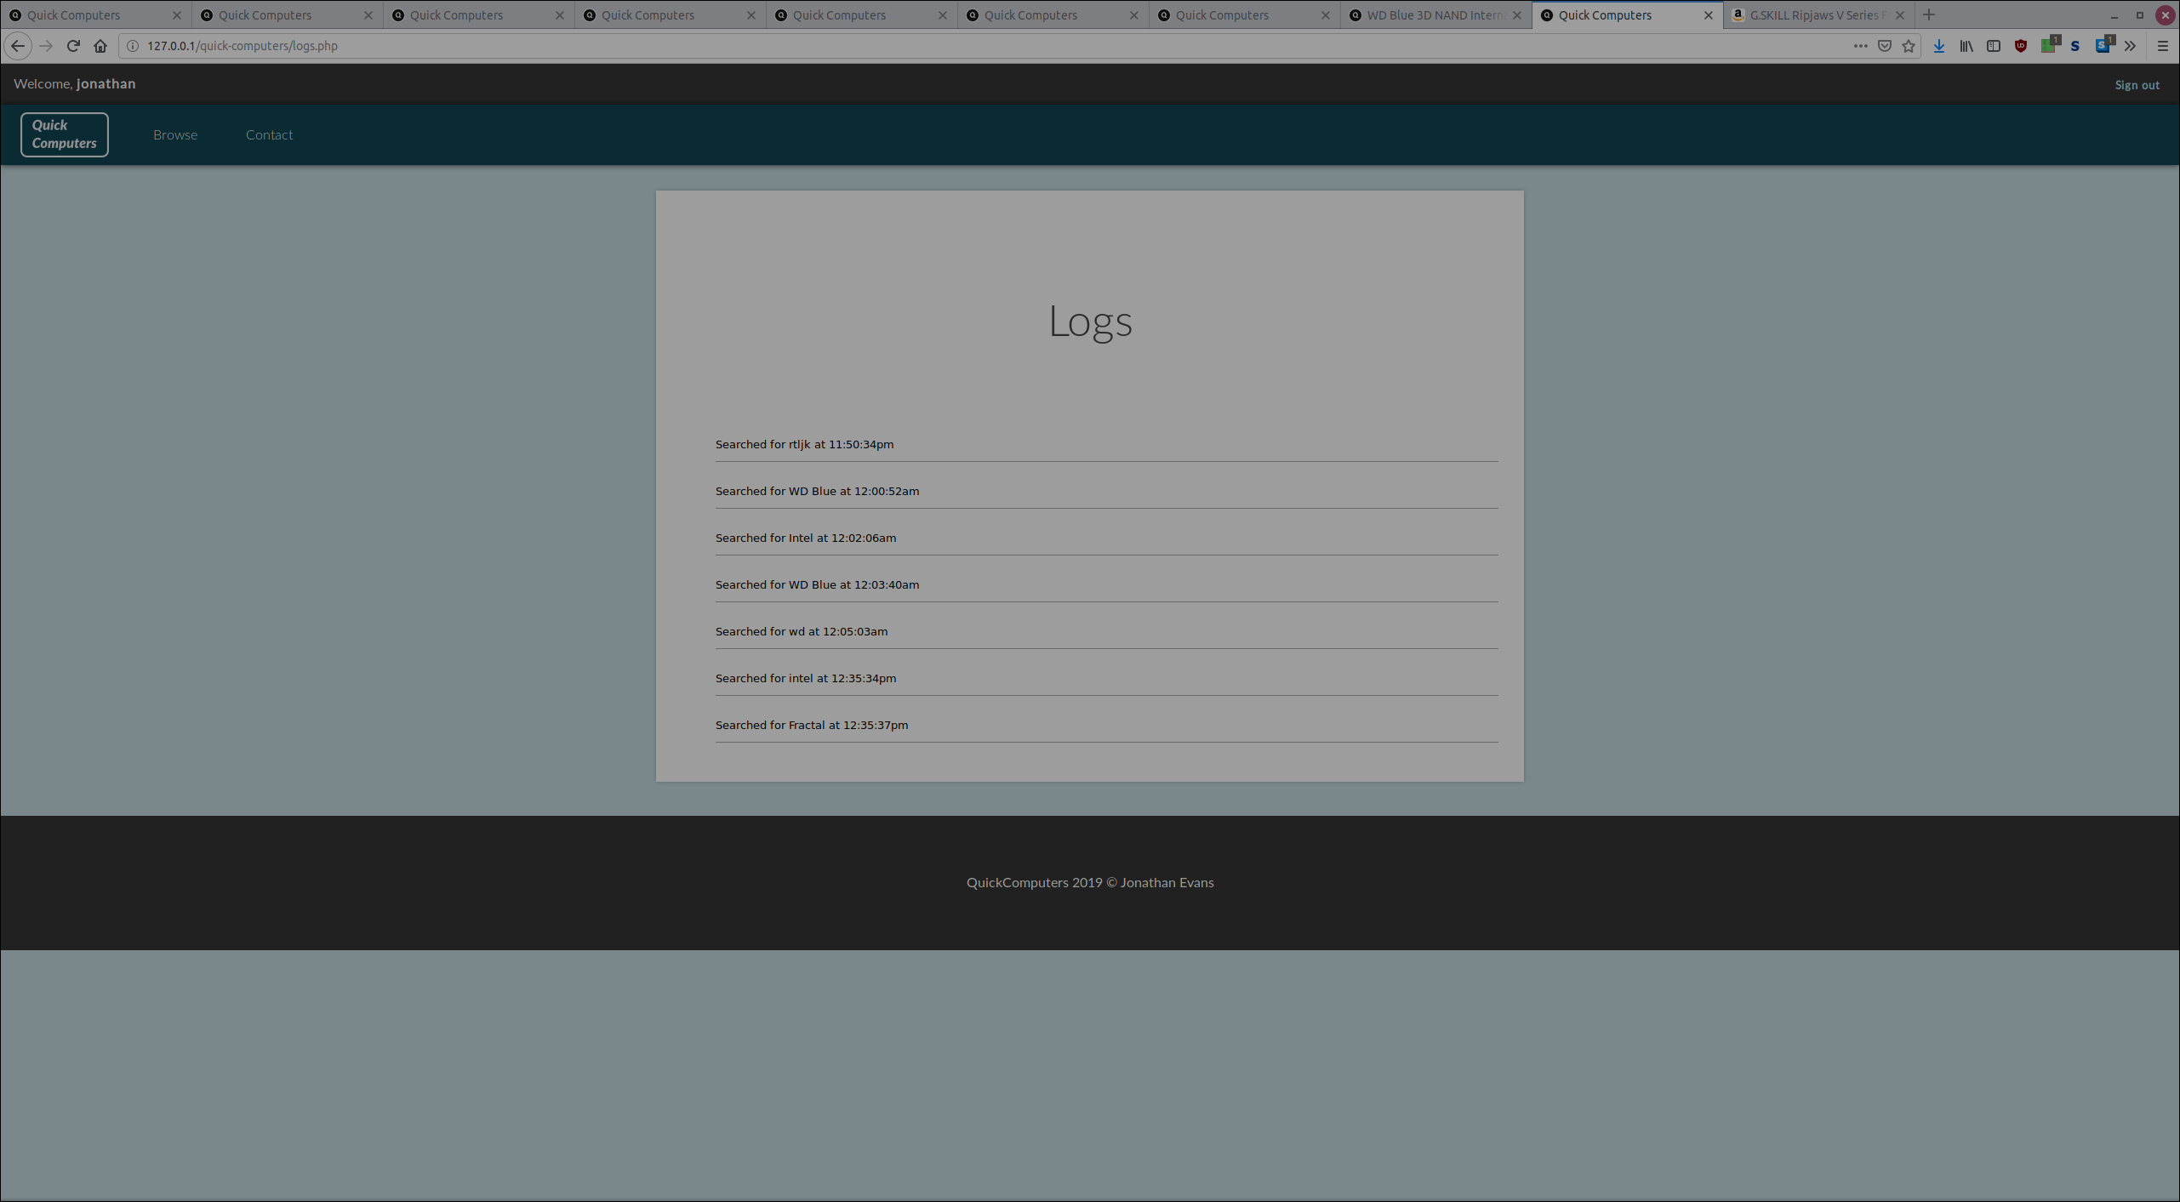
This is the logs recorded by every search carried out on the browse page.

References
[1] Erich Gamma, Richard Helm, Ralph Johnson, John Vlissides, Design Patterns Elements of Reusable Object-Oriented Software, 1st ed. Addison-Wesley Professional, 1994.
[2] Sourcemaking, “Singleton Design Pattern.” [Online]. Available: https://sourcemaking.com/design_patterns/singleton. [Accessed: 18-Jan-2019].
[3] Sourcemaking, “Factory Method Design Pattern,” Factory Method Design Pattern. [Online]. Available: https://sourcemaking.com/design_patterns/factory_method. [Accessed: 18-Jan-2019].
[4] Sourcemaking, “Adapter Design Pattern.” [Online]. Available: https://sourcemaking.com/design_patterns/adapter. [Accessed: 18-Jan-2019].
[5] Sourcemaking, “Facade Design Pattern.” [Online]. Available: https://sourcemaking.com/design_patterns/facade. [Accessed: 18-Jan-2019].
[6] Sourcemaking, “Strategy Design Pattern.” [Online]. Available: https://sourcemaking.com/design_patterns/strategy. [Accessed: 18-Jan-2019].
[7] “Databases and the Doctrine ORM (Symfony 3.3 Docs).” [Online]. Available: https://symfony.com/doc/current/doctrine.html. [Accessed: 17-Jan-2019].

