Component 1
Written Report
Student Name: Nnabuike Onyemauwa
Student Number: 2120203
Lecturer Name: Chloe Harries
Module code: BMHP6021
Module title: Health, Wellbeing and Sustainable Development.

Table of Contents
Introduction 2
Quality education 3
End poverty 3
Introduction to concepts 4
Health 4
Wellbeing 5
Social Well-being 6
Workplace Well-being 6
Societal Well-being 6
Sustainable Development 6
Sustainable Development Goals 7
‘Goal 1 – no poverty’ 7
Economic empowerment 8
UK Aid Connect 8
Social Protection 9
Inclusive education 10
UK’s Gender Equality Act 2014 10
Challenging inequality and unbalances in power 10
The National Action Plan on Women 11
Safeguarding Summit 2018 commitments 11
London Family Planning Summit in 2017 11
‘Goal 4 – quality education’ 12
Education Cannot Wait fund 13
Critical review, evaluation of progress and challenges of ‘no poverty’ 14
Recommendation 14
Critical review, evaluation of progress and challenges of ‘quality education’ 14
Recommendation 15
Conclusion 15
References 16

Introduction

The United Kingdom is a pivotal element in negotiating, determining and delivering the seventeen Sustainable Development Goals (SDG’s) of the United Nations and is devoted to their completion (GOV.UK, 2021). This report aims to bring attention to the development of the SDG’s ‘Quality education’ and ‘No poverty’ through a discussion of up-to-date information on current health care policy in the United Kingdom. By showing support for humanitarian efforts, promoting of human rights and boosting sustainable development the UK contributes to forming international order (GOV.UK, 2023). Along with addressing the needs of marginalised populations, the UK endeavours to provide high quality local services to ensure that children and young people are not left behind (GOV.UK, 2021). To facilitate investment for the Sustainable Development Goals the United Kingdom vows at the summit for the United Nations General Assembly that they would contribute to a bigger, better and fairer international financial system. The UK demonstrates a number of proposals, and their pledge comprises the following:

- As part of the country’s eleven point six-billion-dollar climate finance commitment until 2026, a two-billion-dollar commitment to the Green Climate Fund
- Over the course of the next five years the United Kingdom provides funding for finance facilities supporting climate in Asia and the Pacific, enabling additional one point two to one point eight billion dollars, brought forth by their original commitment of three-hundred-million dollars to the Innovative Finance Facility for Climate in Asia and the Pacific (IFCAP)
- Furthermore, the UK promised aid of up to a hundred-and-eighty-million pounds to the International Finance Facility for Education (House of Commons Library, 2023).

According to information sourced from the Organisation for Economic Cooperation and Development (OECD) the United Kingdom’s levels of aid place highly internationally as in the year 2021 the country contributes an equivalent of six-hundred-and-thirty-two million dollars in aid for education. Among OECD countries, Germany ranking first, followed by France and then the United States, the United Kingdom is in fourth place, making it the fourth highest contributor out of thirty-eight member countries.

Quality education
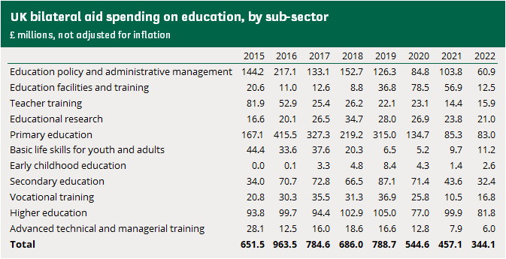
Figure 1: Aid spending on education, United Kingdom
As it is being presented in the above figure the UK’s bilateral aid spending (House of Commons Library, 2023) on education total varies over the given time period of seven years, ranging from 2015 to 2022. There is no remarkable trend in spending to behold, that is until 2019 when the table indicates a sudden decline in numbers, a trend which seems to be continuative. Since ever that same year the bilateral aid total drops and by 2022 the total is being less than half of the average between 2015 and 2019, which would amount to 387.3 (Rounded to one decimal place).

End poverty

Particularly, following the economic repercussions of the Covid-19 pandemic it is the country’s intention to improve their employment across the country. Key elements such as the recovery of the economy and creation of jobs are vital for the decline in poverty. In this context, efforts are in process to promote progression of individuals and families within the workforce, thereby growing financial resilience (GOV.UK, 2021).

The United Kingdom focuses on lending aid to the socially disadvantaged and danger exposed children, raising opportunities for employment, tackling poverty and guaranteeing the country’s well-being and resilience. The UK’s responsibility in accomplishing these goals lies in achieving them domestically and increase their engagement internationally (GOV.UK, 2019).

Introduction to concepts

Health

Dated from 1948 the World Health Organisation (WHO) defines health as ‘a state of complete physical, mental, and social well-being and not merely the absence of disease or infirmity’. This comprehensive definition provides clarity on the entirety of well-being and goes beyond just the absence of disease. Due to this definition’s overcoming of merely pointing out the absence of illness it’s considered groundbreaking because of its depth and aspiration, while also tackling mental, physical and social aspects. The UK government supports this viewpoint as they conceptualise health as a whole, encompassing mental, social, and overall wellbeing along with physical health (GOV.UK, 2010). Huber et al. (2011) argues that throughout decades the demography of populations changes along with patterns of illnesses making the above definition ineffective, if not counterproductive as it is subject to six decades long criticism with no adaption so far.
That development introduces the primary concern about the WHO’s definition of health, which lays strong emphasis on the term ‘complete’ since it is a rather absolute choice of wording supporting a medicalisation of society causing people to receive treatment they may not need. In fact, a constant insistence on complete physical well-being might lead to great amounts of people qualifying for screenings and costly interventions, resulting in an overall rising risk of medical dependency.
As previously mentioned, the events of aging populations and changing natures of diseases are developments that are to be addressed since the announcement of the definition in 1948 because a rise in chronic diseases challenges that meaning of health. According to Huber et al. (2011) large populations worldwide live with chronic disabilities and illnesses for decades and as a matter of fact it’s the healthcare system’s greatest expense as well. ‘Chronic’ for the

reason that under WHO’s definition of health people suffering from chronic medical conditions would be declared as inevitably ill, proving the definition to be definitely counterproductive.

This context raises the need of redefining the current definition of health as past policy proposals to the WHO are rejected, with the author emphasising that this issue is negatively affecting health policy in certain areas e. g. in prevent programmes and healthcare. Huber et al. (2011) identifies health as an approach to the ability of adaption and self-management. Thereby dividing the meaning of health into three domains namely a physical, mental, and social domain, it is the author’s intention to demonstrate health as a concept rather than a definition, free of boundaries and precise meaning attached to it.

Wellbeing

‘Well-being can be understood as how people feel and how they function, both on a personal and a social level, and how they evaluate their lives as a whole’ (Mental Health Foundation, 2015)

According to the Mental Health Foundation (2015) well-being defines itself as a state of comfort, happiness or health. However, it is significant to realise that well-being involves more than momentaneous happiness as along joyfulness factors such as satisfaction with life, a sense of purpose and feelings of control are included as well. In this regard the foundation highlights another definition of well-being emphasising emotions on, how people function, both on a personal and social basis and self-evaluation of their lives as a whole. Davis (2024) states that wellbeing is about more than prosperity and happiness, but also includes the ability to cope with stress as one might face hardships increasing it without the necessary know-how. One of the reasons Davies (2024) argues that well-being may be difficult to improve is because of its broad spectrum and thus a breakdown into different types goes as follows:

Social Well-being | Workplace Well-being | Societal Well-being
She emphasises on developing meaningful relationships with people and keeping contact with a network of support that supports overcoming solitude. | The ability to follow one’s interests, values, metrics, and purpose in life in order to gain enrichment and meaning in a professional environment. | The author (Davies, 2024) defines societal well-being as someone being capable of actively participating in a growing community, setting and culture.

Sustainable Development

Sustainable Development by The Global Academy of Agriculture and Food Systems (no date) at the University of Edinburgh is seen as a development that provides the needs of the present generation without impacting the ability of future generations to provide for their own needs. Essentially, it is about seeking an equilibrium between meeting vital needs, with particular focus on the impoverished and vulnerable, while realising that there are boundaries to natural resources. It is a disputed matter as there is no mutual understanding on the definition and how it can be implemented, with some viewing it as a competition for resources while others prioritise the protection of the environment and view it as a key component of sustainability. The UK Government (GOV.UK, 2015) supports this understanding of sustainability in their February 2011 published policy paper, highlighting that required actions towards implementation of environment protection and enhanced well-being need to be taken. In accordance with the goal of not utilising more resources than needed to avoid negatively impacting the ability of future generations to do the same. The National Planning Policy Framework (2011) outlines that sustainable development stands at the heart of the United Kingdom since it’s crucial to the country’s environmental, economic and social success. It is a principle that realises the importance of guaranteeing that every person has the opportunity to bring satisfaction to their basic needs and of an improved quality of living, both in the present and in the future.

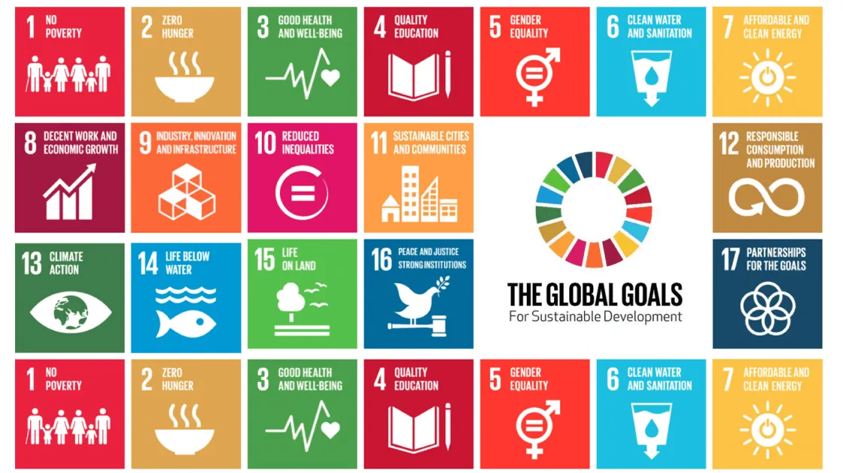
Sustainable Development Goals
Figure 2: United Nations, Sustainable Development Goals
Adopted back in 2015, the Sustainable Development Goals are an approach by the United Nations (2024) to bring an end to poverty, keep the planet from further harm to its environment and secure peace and prosperity to all people by 2030. The intertwined seventeen goals show that action in one goal can influence the outcome in another and in this respect the organisation seeks a balance between environmental, economic and social sustainability.

‘Goal 1 – no poverty’

Under ‘no poverty’ in collaboration with the United Nations (2023) the UK intends to bring about social protection for everyone, everywhere around the world, including the poorest and most vulnerable. The United Kingdom (2018) ensures that people with disabilities centralise the work towards a better future as more than a billion people worldwide suffer from disabilities, of which eighty percent populate in developing countries.
In this framework the UK (2018) develops several strategies, two of them being the Disability Inclusion Strategy and Strategic Vision for Gender Equality. While there are a number of so called ‘strategic pillars’ in the action plan, only the most relevant to the goal of no poverty and the contextual social protection are a subject of discussion.
The former strategy states the goal of tackling disabilities and by what means to achieve them, which is by mainly the following:

Economic empowerment

The UK (2018) declares their advance on the development of diagnostic tools to help them conduct stronger assessment and analysis on how economic growth affects the levels of poverty in communities living with disabilities. In addition to that, they support people with disabilities in their entry to employment and subsistence by a development programme which is inclusive of disabilities and worth thirty-seven-million pounds and set to achieve by 2023. It also enables up to forty-five-thousand people to raise their salaries and the government plans on reflecting from this undertaking as it takes place and evaluate is efficiency. Furthermore, the United Kingdom (2018) sees it as a mission to reach those affected by disorders or conditions and a need for improved livelihood in the countries Kenya and Bangladesh by UK Aid Connect.

UK Aid Connect

Through promoting collaboration and innovative change UK Aid Connect (GOV.UK, 2017) plays a part in pushing worldwide efforts to abandon impoverishment and approach the completion of the first Sustainable Development Goal. They provide support for consortia to bring about innovation to challenges in development and create a difference to poor people’s way of living. The Evidence and Collaboration for Inclusive Development (ECID, 2019) is an organisation, which closely collaborates with the previously mentioned fund for more importantly social inclusion and gender equality.
ECID also runs a four-year long programme under Christian Aid (2018) a charity that receives funds from the UK government in their mission to decrease poverty and better well-being in marginalised groups of Nigeria, Zimbabwe and Myanmar.

In this context of offering support, the UK backs people from India, Ethiopia, the Caribbean and Nepal in development of their proficiencies and skills for decent work. Since this strategy’s release the UK’s (2018) Department of International Development claims that good progression is underway for the reasons of passionate staff engagement, their huge efforts and commitment and the leadership of people with disabilities.

Social Protection

In the delivery plan the UK (2018) exhibits once again to administer assistance to partnered governments in forming policies regarding social protection and establish the development on engaging effectively on disabilities and social protection in developing countries. Along with the previous actions to be taken they expect to raise inclusiveness of people with disabilities through responding to stigma and prejudiced behaviour with social protection programmes. In this respect, strengthen social protection policies by raising consultative talks with people of special needs, in unison with the organisations that represent them. The further course of their action plan contains that the British government (2018) invests into research of challenges which impact the inclusion of disabilities in social protection systems to acquire a better understanding of what solutions aid the disabled and their struggle against discrimination. Lastly, the strategy lays out that they want to examine how to restructure the release of government policy to turn it more disability inclusive and gender responsive.

The authors McSweeney, Hayhurst, and McCullough (2022) highlight in chapter two that based on a report from 2015, published by the World Bank a ninth of the global population, which accounts to then percent lives critically impoverished on less than two dollars per day. Additionally, countries in sub-Saharan Africa are the primary focus in terms of extreme poverty as more than half of the population suffering from harsh living circumstances reside in that area. They spread the awareness that poverty continues to be a dire situation internationally, although its decrease from 1990 onwards by nearly thirty-six percent and hardly eleven in 2013, thus it remains a central point for the United Nations.

Inclusive education

The United Kingdom (2018) supports allied governments on their efforts for inclusive education, stabilisation on disability inclusion and gender across programmes in education, and include better attention to mental health and psychosocial support. Moreover, they plan to reach more than eighteen-thousand girls suffering from disabilities, aid in enabling other countries to deliver extensive and costly interventions and spend investment on research that effectively progresses the outcomes of learning in disabled and marginalised children.
The latter strategy, with the intention of creating fair chances for all women and men of all ages, has according to the UK government (2018) women and girls as its main focus. Highlighting that they are pioneers regarding the advance of empowerment in favour of women, they share history of addressing women’s and girls’ rights at the centre of their international release of policy. Inclusive of disabilities in the female gender the Strategic Vision for Gender Equality aims to continue current commitments on girls and women, particularly in times of war and crisis.

UK’s Gender Equality Act 2014

In relation to the Strategic Vision for Gender Equality, the Gender Equality Act 2014 (Legislation, GOV.UK, 2014) is influential legislation that fosters gender equality in the allocation of assistance in development and humanitarian aid from the UK to foreign countries. As the vision’s main focus lies on equitable treatment of women and girls, the act’s alignment with the strategy comes from their common ground of strong emphasis on gender equality in order to accomplish sustainable development. Ideally, the strategy of Strategic Vision of Gender Equality’s mission is to succeed in girls, women, boys, and men to be globally equal, safe and empowered, by laying out the following main actions:

Challenging inequality and unbalances in power

In enabling improved access to, and decision over jobs in job sectors with strong growth, and better working conditions the British government (2018) envisions to demonstrate their support

for the elevation of women’s economic empowerment. The report points out that the Department for International Development familiarises the notion of decreasing the amount of girls and women affected by modern slavery, human trafficking, and any thinkable form of violence.

The National Action Plan on Women

The UK Women, Peace, and Security National Action Plan by the UK government (GOV.UK, 2023) incorporates views on gender into its actions and policies, thereby contributing to the broad view of fostering sustainable development and eliminating poverty.

Safeguarding Summit 2018 commitments

Oxfam GB (2024) is a leading humanitarian organisation in the UK that in context to the United Kingdoms 2018 Safeguarding Summit commitments, subsequently remarks that the reason for the vulnerability of people around the globe is power imbalance, thus giving rise to poverty.
In the vision the UK (2018) briefs to proceed their continued pursuit in opposing discrimination against women and girls through contesting obstacles that hinder them from achieving their individual potential in a more systematic approach. Additionally, they mark their promised support for reproductive and sexual health for women and men, and guarantee the practice of them exercising their right of making their own, self-informed decisions. It includes education on sexually transmitted infections such as HIV, procreation, childbearing, non-dangerous abortion, family planning, and maternal health.
The British government’s (2018) arrangements are based on their vow to deliver on their promises at the London Family Planning Summit in 2017 and urge for these vital services to be regularly provided in humanitarian work and remote areas. Moreover, they claim to raise their focus on disabled girls which are strongly marginalised, inclusive of those affected by conflict, violence survivors, and the pregnant.

London Family Planning Summit in 2017

According to the news article by Edwards (2017), to help lower the costs of contraceptives and decrease the risk of product shortages the UK government announces an eighty-million-dollar funding pool at the summit of 2017.
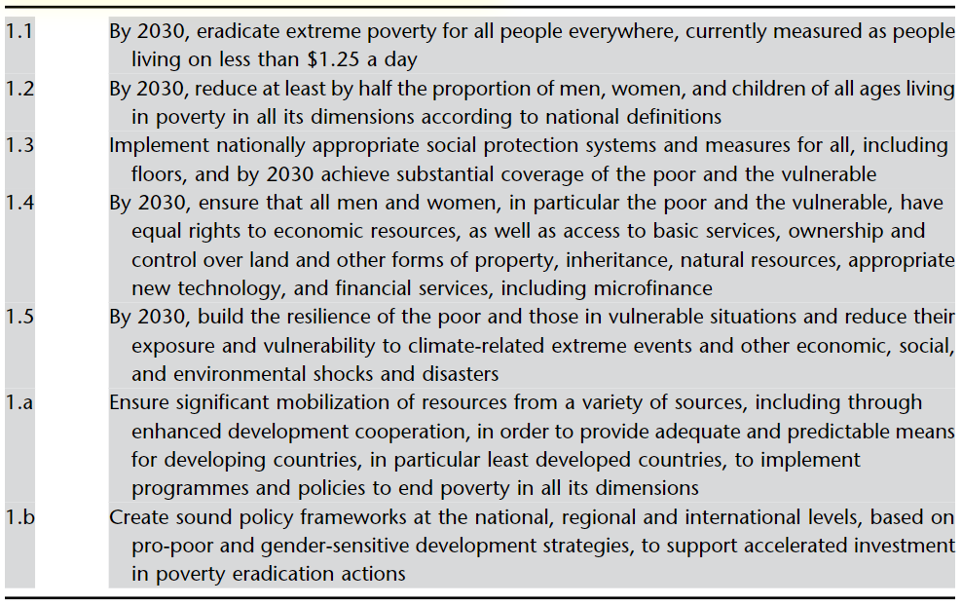
Figure 3: Targets for the first Sustainable Development Goal

In the book ‘The Routledge Handbook of Sport and Sustainable Development’ (McCullough, Kellison and Melton, 2022) the authors put strong emphasis on the first sustainable development goal and its targets in the previous illustration. Needless to say, the ambitions listed in the figure above, and the United Nations’s endeavours for achievement are aims which require a detailed work ethic from experts across various fields considering the large areas affected and need to be covered.

‘Goal 4 – quality education’

According to the United Nations Educational, Scientific and Cultural Organization (UNESCO, 2024) and their understanding of quality education the fourth goal is a crucial factor for a positive shift in education globally. Since education possesses the transformative power to create a more sustainable place of living around the world, the United Nations strive to ensure inclusive and equitable quality education and foster lifetime learning possibilities for all.
Based on UNICEF’s (2022) articles twenty-eight and nine, the significance of encouraging education is vital to the development of welfare in adolescents and children. In this sense, they consider that every child and young person is entitled to education, disregarding their race, gender, disability or status. CYPCS (2024) argues that in terms of international collaboration countries of higher wealth should support countries of lower prosperity in achieving the right to education. Additionally, in this context, the Department of Education (2023) assists in improvement of education in the UK through an initiative called ‘Family Hubs and Start for Life programme’.
With special attention to quality education, the Foreign and Commonwealth Office of the UK government (GOV.UK, 2020) comment that, primary education for every girl up to twelve years of age and contextually the transition to secondary school is of utmost importance. At the United Nations General Assembly in 2019 the UK Prime Minister provides updates on the strategy of an education investment of worth two-hundred-and-fifteen-million pounds in Africa. Along with this education quality programme another three-hundred-million pounds of investment into a new International Finance Facility for Education is underway. This commitment in turn helps to enable five-billion pounds of financial support for projects of education in nations with lower levels of middle income, making marginalised children the pivotal point of the investments.
However, according to the Bond (2022) network in the UK, UNESCO states that a gap of a hundred-and-forty-eight-billion pounds needs cover in low- and lower middle-income countries in order to meet up with the fourth goal in the 2030 agenda. Furthermore, considering the nature of this event, the financial deficiency could increase significantly, while education is not prioritised on donor lists and national budgets in the UK. In addition to that, seventy-five-million small children and children of adolescence in areas of conflict require support in education. Contrary to this negative development, the UK delivers aid to nations in aggravated education circumstances through the United Nation’s Education Cannot Wait (ECW) global fund.

Education Cannot Wait fund

The United Kingdom essentially supports the ECW (2024) fund by contributing to its work and ensuring education for children impacted by adversity has quality, and by doing so participate in assisting ECW in their relentless efforts to secure quality education for everyone.

Bond (2022) reports that cuts on programmes for education to the UK government are slowly, but progressively getting worse because analysis demonstrates that children from Bangladesh, Uganda, Tanzania, and DRC Congo are at risk of losing access to education.
The network Bond (2022) informs that by 2026 the United Kingdom announces to have forty-million more girls enter education in low- and lower middle-income countries, in response to their history of progress towards achieving improved learning outcomes for children.
Kioupi and Voulvoulis (2020) outline in their journal article that forty universities from the UK and Europe engaging in master’s programmes participate in their data analysis project on sustainability. The courses the universities study mainly thematise environment and sustainability, and the assessment tool’s analysis considers multiple criteria which consist of elements of the Sustainable Development goals, ranging from sustainable behaviour to health and wellbeing. All courses and sustainability development goals’ outcomes undergo comparison, and ranking in relation to their contribution to sustainability, and findings show that there is a necessity for the universities courses to reconsider their comprehension of and contribution to sustainability.

Critical review, evaluation of progress and challenges of ‘no poverty’

While the United Kingdom showcases with operations such as Aid Connect (GOV.UK, 2017) and their Disability Inclusion Strategy (2018) their engagement in pursuit of a non-impoverished future, other factors like serious poverty levels globally and gender gaps in disfavour of women on the job market are grave points for margin of errors.

Recommendation

It is to be recommended that, the UK should guarantee social protection programmes to consist of measures that target growth out of poverty more effectively to keep populations away from impoverishment gradually over time.

Critical review, evaluation of progress and challenges of ‘quality education’

As a matter of fact, the UK government (GOV.UK, 2020) contributes respectable amounts of funding to the advance in education worldwide, outlining investments amounting to millions of pounds. However, the plans for the development in education are as thriving as they are dire as a financial gap (Bond, 2022) requires settling, jeopardising the current progress on admission into education for children.

Recommendation

On consideration of the previous discussion, the United Kingdom should consider funding more wisely through tackling primary education in low- and lower middle-income countries as every financial stage that follows would inevitably rely on its success.

Conclusion

To conclude this report, due to various policies and measures regarding the first and fourth Sustainable Development goal, and the United Kingdom’s role in their completion on behalf of the United Nations, taking into account up-to-date information of health policies, one can determine that the UK’s pursuit in completion of these goals is progressively underway.
A number of strategies with the intent of alleviating the current state of affairs in global education and poverty could be identified and, in this regard, the United Kingdom demonstrates promising results for sustainable development in the hereby thematised Sustainable Development Goals one and four.
It is important to build on the positive progress made so far, but not become inconsiderate of the deficiencies that persist in the achievement of these ambitions.

References

- Bond (2022) The UK’s global contribution to the Sustainable Development Goals. Available at: https://www.bond.org.uk/resources/the-uks-global-contribution-to-the-sustainable-development-goals/ (Accessed: 17 July 2024).
- Children and Young People's Commissioner Scotland (2024) Article 28 - I have the right to an education. Available at: https://www.cypcs.org.uk/rights/uncrc/articles/article-28/ (Accessed: 20 July 2024).
- Christian Aid (2018) Evidence and Collaboration for Inclusive Development (ECID). Available at: https://www.christianaid.org.uk/our-work/programmes/evidence-and-collaboration-inclusive-development-ecid#:~:text=ECID%20is%20a%20four%2Dyear (Accessed: 21 July 2024).
- Davies, T. (2024) What Is Well-Being? Definition, Types, and Well-Being Skills. Available at: https://www.psychologytoday.com/gb/blog/click-here-for-happiness/201901/what-is-well-being-definition-types-and-well-being-skills (Accessed: 17 July 2024).
- Department of Health (2010) Our Health and Wellbeing Today. Available at: https://assets.publishing.service.gov.uk/media/5a7b9e86e5274a7318b8fd71/dh_122238.pdf (Accessed: 18 July 2024).
- Department of International Development (2018) DFID Strategic Vision for Gender Equality: Her Potential, Our Future. Available at: https://www.gov.uk/government/publications/dfid-strategic-vision-for-gender-equality-her-potential-our-future (Accessed: 15 July 2024).
- Department of International Development (2018) Disability Inclusion Strategy 2018 to 2023. Available at: https://www.gov.uk/government/publications/dfids-disability-inclusion-strategy-2018-to-2023 (Accessed: 17 July 2024).
- Education Cannot Wait (2024) Home. Available at: https://www.educationcannotwait.org/.
- Foreign and Commonwealth Office (2019) UK Aid Connect. Available at: https://www.gov.uk/international-development-funding/uk-aid-connect (Accessed: 21 July 2024).
- Foreign and Commonwealth Office (2020) Investing in education and accelerating action on the SDGs. Available at: https://www.gov.uk/government/speeches/investing-in-education-and-accelerating-action-on-the-sdgs (Accessed: 12 July 2024).
- GOV.UK (2021) Implementing the Sustainable Development Goals. Available at: https://www.gov.uk/government/publications/implementing-the-sustainable-development-goals/implementing-the-sustainable-development-goals--2 (Accessed: 12 July 2024).
- GOV.UK (2023) Family Hubs and Start for Life programme. Available at: https://www.gov.uk/government/collections/family-hubs-and-start-for-life-programme (Accessed: 15 July).
- GOV.UK (2019) UK Voluntary National Review of Progress Towards the Sustainable Development Goals. Available at: https://www.gov.uk/government/topical-events/uk-voluntary-national-review-of-progress-towards-the-sustainable-development-goals (Accessed: 17 July 2024).
- GOV.UK (2023) Delivering the UK’s international development strategy: 2023 progress update. Available at: https://www.gov.uk/government/publications/delivering-the-uks-international-development-strategy-2023-progress-update/delivering-the-uks-international-development-strategy-2023-progress-update (Accessed: 20 July 2024).
- House of Commons (2023) House of Commons Library. Available at: https://commonslibrary.parliament.uk/ (Accessed: 12 July 2024).
- Huber, M., Knottnerus, J.A., Lawrence, G., Henriette van der, H., Alejandro R, J., Daan, K., Brian, L., Kate, L., Maria Isabel , L., Jos W M van der, M., Paul, S., Richard, S., Chris van, W. and Henk, S. (2011) ‘How should we define health?’ British Medical Journal, 343(7817), pp. 235–237. Available at: https://www.bmj.com/content/343/bmj.d4163/ (Accessed: 12 July 2024).
- Kioupi, V. and Voulvoulis, N. (2020) ‘Sustainable Development Goals (SDGs): Assessing the Contribution of Higher Education Programmes’ Sustainability, 12(17), p.6701. Available at: https://doi.org/10.3390/su12176701.
- Legislation, GOV.UK (2014) International Development (Gender Equality) Act 2014. Available at: https://www.legislation.gov.uk/ukpga/2014/9/contents (Accessed: 18 July 2024).
- McCullough, B.P., Kellison, T. and E. Nicole Melton (2022) The Routledge Handbook of Sport and Sustainable Development. Routledge.
- Mental Health Foundation (2015) What is well-being, how can we measure it and how can we support people to improve it? Available at: https://www.mentalhealth.org.uk/explore-mental-health/blogs/what-well-being-how-can-we-measure-it-and-how-can-we-support-people-improve-it (Accessed: 12 July 2024).
- Ministry of Defence and Foreign, Commonwealth and Development Office (2023) UK women, peace and security national action plan 2023 to 2027. Available at: https://www.gov.uk/government/publications/uk-women-peace-and-security-national-action-plan-2023-to-2027/uk-women-peace-and-security-national-action-plan-2023-to-2027 (Accessed: 10 July 2024).
- Oxfam GB (2024) Safeguarding summit. Available at: https://www.oxfam.org.uk/about-us/tackling-abuse-information-and-updates/safeguarding-summit/ (Accessed: 22 July 2024).
- Rogerson, D. (2015) Government definitions of sustainability. Available at: https://www.gov.uk/government/publications/government-definitions-of-sustainability (Accessed: 15 July 2024).
- Sophie, E. (2017) Highlights from the London Family Planning Summit. Available at: https://www.devex.com/news/highlights-from-the-london-family-planning-summit-90666 (Accessed: 18 July 2024).
- The National Planning Policy Framework (2011) House of Commons - The National Planning Policy Framework - Communities and Local Government Committee. Available at: https://publications.parliament.uk/pa/cm201012/cmselect/cmcomloc/1526/152607.htm (Accessed: 12 July 2024).
- The University of Edinburgh (no date) What is sustainable development? Available at: topic_3_sustainable_development.pdf (Accessed: 3 July 2024).
- UK Aid Connect and Evidence and Collaboration for Inclusive Development (2019) UK Aid Connect -Evidence and Collaboration for Inclusive Development Cross-Programme Gender Equality and Social Inclusion (GESI) Strategy. Available at: ECID-Global-GESI-Strategy-SDDirect_FINAL.pdf (Accessed: 3 July 2024).
- UNDP (2024) Sustainable Development Goals. Available at: https://www.undp.org/sustainable-development-goals (Accessed: 15 July 2024).
- UNESCO (2024) Sustainable Development Goal 4 (SDG 4). [online] Unesco.org. Available at: https://www.unesco.org/sdg4education2030/en/sdg4.
- UNICEF (2022) The Right to Education - UNICEF UK. Available at: https://www.unicef.org.uk/rights-respecting-schools/the-rrsa/the-right-to-education/ (Accessed: 18 July 2024).
- United Nations (2023) Goal 1 - No poverty - U.K. Indicators For The Sustainable Development Goals. Available at: https://sdgdata.gov.uk/1/ (Accessed: 20 July 2024).

