Student Name: Nancy Leather
Student Number: 2404204
Program Study: Design Craft
Module: ADDA4022

Tasks in Order I Received them:
Manifesto: 514 Words.

Manifesto:
Successful Art is Driven by the Conflict Between Opposing Ideas. The Unity of Opposites.

Manifesto Points:
1) The luscious yet grotesque conflict within a human body.
2) To be successful is to be Unsuccessful
3) Between Dog and Wolf, is Art Our Friend or Foe
4) Dialectic of Opposites
5) To Make is to Not Create
6) The Death of something Old Brings the Life of Something New.
7) Speaking but with no Words
8) Realism vs Surrealism

2) To be successful is to be Unsuccessful.
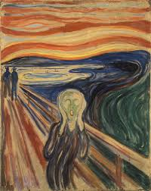
Figure 1, The Scream, Edvard Munch, 1893

Expression of emotion from a negative derivation is what makes artists so profoundly successful in their ability to provide a connection between the viewer and artist. “…(Could only have been painted by a madman!)” is said to be scratched into the red strip across the sky in Edvard Munch’s, The Scream (“Modern Art”, 2006, p.17). “…(Munch screams because the pain suffered is spiritual and projects its insanity outward into a physical expression.)” (Heller, 1973, p.87). Without Munch’s unsuccess, known as Munch’s insanity, or had it not been painted by a ‘madman,’ would ‘The Scream’ be as commercially successful? Emotions drive the intensity of art, pouring emotion and experience that comes with the unlucky hand that has been dealt into visual stimulations. Munch has been compared to modernism in the realms of literature as, similarly, Munch wants to work through memories, thoughts, emotions (usually of melancholy attributes) that are felt by himself and seen through art, rather than working from already existing visuals that are solely for aesthetic pleasure (“National Gallery”, 1993, p.38).
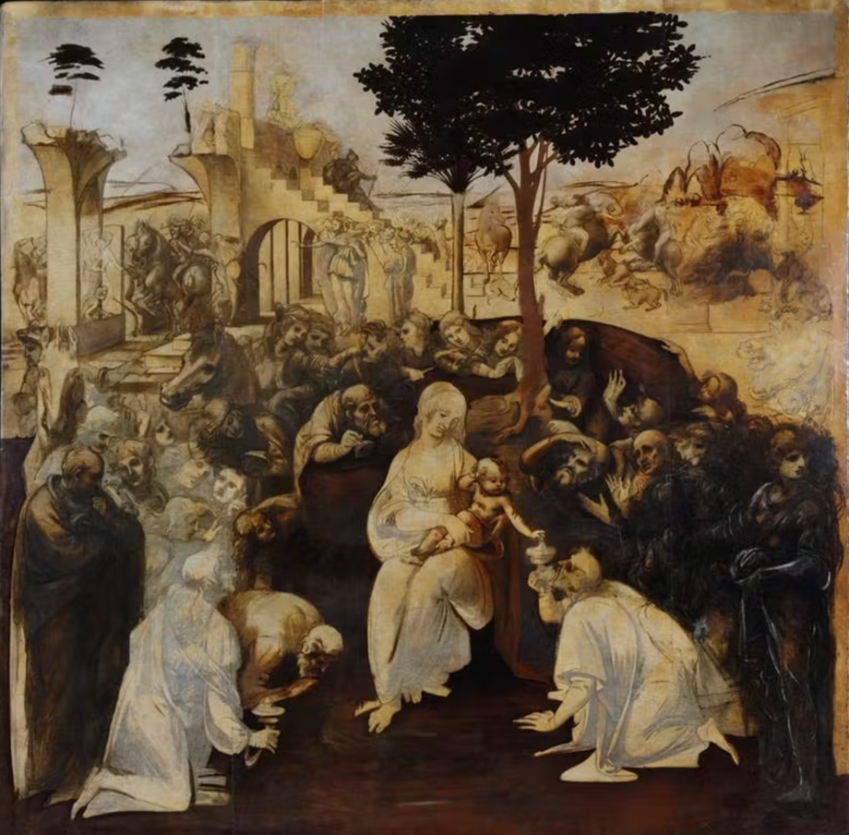
5) To Make is to Not Create.
Figure 2, adoration of the magi, Leonardo Da Vinci, 1481

“MAKING ART IS DIFFICULT. We leave drawings unfinished and stories unwritten.” (“Art & Fear, 2001, p.1). Mastering the visuals often means having to master the psyche, which we will never fully understand, to perfectly put into context of what we want to create and what we actually create. To make but not create. You, as an artist or creator or academic, consider yourself an ordinary person, then you must consider that other artists and creators are ordinary people having to overcome the universal experience of creative struggles (“Art && Fear,” 2001, p.4). Often perfection is an artist biggest enemy, not creating can often be the step needed to overcome expectations. Creating a finished product may be the most valuable external reason for creating art, but internally for the artist it is the journey, experiences, and technique that shape the work (“Art & Fear,” 2001, p.5). “Art is never finished, only abandoned” was said by Leonardo Da Vinci, who left many of his pieces, that are also considered his most famous pieces, unfinished, Adoration of the magi (Boland, B, 2021). Who decides there is any point n which art is finished; can more details not be indefinitely added? Is there any artwork that has been completely created?

6) The Death of something Old Brings the Life of Something New.
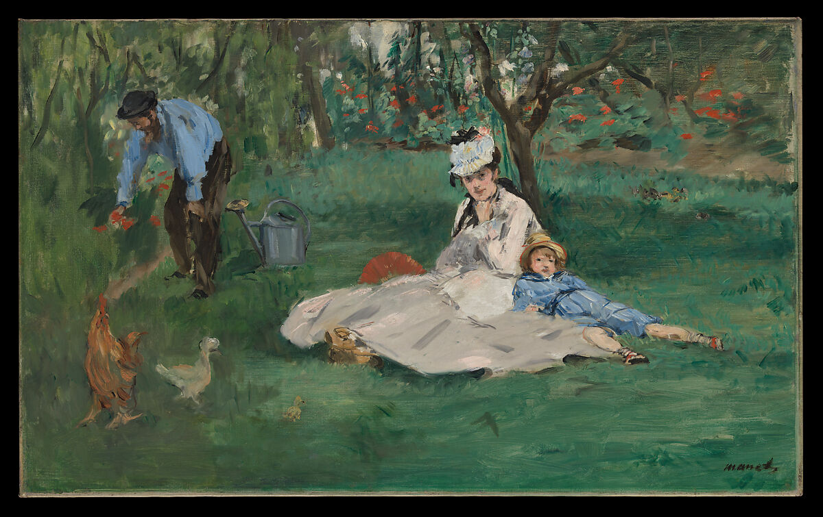
Figure Three, The Monet Family in Their Garden at Argenteuil, Edouard Manet, 1874

Modernism is the point at which historic and conservative values died within art and brought in life of individualism, experimentation, absurdity into the arts (Tate,). Manet is considered the founder or farther of the modernist period, who had a major impact and influence on impressionism, an early modernist art style (Artsper, 2022). While bringing life to painting and the french palette with opaque painting and Matt painting Manet simultaneously killed the obsession of oil paintings and the tradition values of art (keeping an eye open, 2015, p.72). “Even those who were on Manet’s side knew you cannot have the arrival of something old.” (Keeping and eye open, 2015, p.72). Though people appreciate and respect the place for traditional art mediums and ideologies nothing can live for eternity even an inanimate concept, life cannot exist without death.

Bibliography.
- Barrelli, A. (2023) The unity of opposites explained, Your Screenplay Guy. Available at: https://yourscreenplayguy.com/blogs/screenwriting-advice/the-unity-of-opposites-explained#:~:text=In%20screenwriting%2C%20the%20unity%20of,and%20drives%20the%20story%20forward. (Accessed: 25 October 2024).
- Jenny Saville (no date) Artnet.com. Available at: https://www.artnet.com/artists/jenny-saville/ (Accessed: 25 October 2024)
- (No date) Rufino Tamayo- Arts of the Americans. Available at: https://www.oas.org/artsoftheamericas/rufino-tamayo#:~:text=RUFINO%20TAMAYO%20b.,1991%20Mexico&text=Hombre%20contemplando%20a%20la%20luna,as%20a%20dialectic%20of%20opposites. (Accessed: 25 October 2024)
- Heller, R. (2006)’” Could Only Have Been Painted by a Madman”- Or Could It?’, in. Edvard Munch: The Modern Life of the Soul. New York, London: Museum of Modern Art: Thames & Hudson, distributor, pp. 17-34.
- Heller, R. (1973) ‘The Scream of Despair’, In Munch: The Scream London: Allen Lane Penguin Press, pp. 87-101.
- Lathe, C. (1993) ‘Munch and Modernism in Berlin 1892-1903’, in Edvard Munch: The Frieze of Life. London: National Gallery Publications, pp. 38-44.
- Bayles, D. and Orland T. (2001) ‘The Nature of the Problem’, in Art & Fear: Observation on the perils (and rewards) of Artmaking. Santa Cruz, CA: The Image Continuum, pp. 1-7.
- Mentler (2019) Nonfinito- the art of unfinished, The Society of Figurative Arts. Available at: https://tsofa.com/infinito/ (Accessed: 28 October 2024).
- Boland, B. (2021) Art is never finished, only abandoned, ArtsHub Australia. Available at: https://www.artshub.com.au/news/features/art-is-never-finished-only-abandoned-262096-2370305/#:~:text=There's%20a%20popular%20quote%20you,writers%2C%20and%20creatives%20would%20recognise. (Accessed: 28 October 2024).
- Barnes, J. (2015) ‘Manet: Black and White’, in Keeping an Eye Open: Essays on Art. London: Jonathan Cape, pp. 70-89.
- Witek, D. (2022) How Manet changed art history, Artsper Magazine. Available at: https://blog.artsper.com/en/a-closer-look/how-manet-changed-art-history/ (Accessed: 31 October 2024)
- Tate (no date) Modernism, Tate. Available at: https://www.tate.org.uk/art/art-terms/m/modernism (Accessed: 3 October 2024)
List of Figures
- Munch, E. (1893) The Scream. [Oil, Tempera, Pastel on Cardboard] Munch Museum, Oslo. Available at: https://www.edvardmunch.org/the-scream.jsp (Accessed: 25 October 2024)
- Da Vinci, L. (1481) adoration of the magi. [Oil on Wood] Available at: https://www.uffizi.it/en/artworks/leonardo-adoration-of-the-magi (Accessed: 28 October 2024)
- Manet, E. (1874) The Monet Family in Their Garden at Argenteuil. [ Oil on Canvas] The Metropolitan Museum of Art, New York. Available at: https://www.metmuseum.org/art/collection/search/436965 (Accessed: 31 October)

