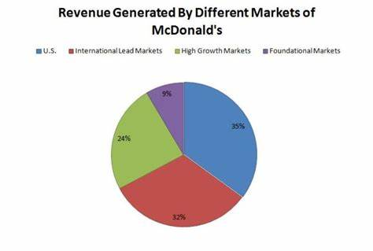  Management economics  Assessment 1 | Lecturer: TAYE OSADIYA  University of Wales Trinity Saint David  Written by Elena Nedelcheva  SN 2112413

Contents
Task A: Description of the business and its products 2
Business: McDonald’s (Fast food) 2
Product: Big Mac/ Hamburger 2
Task 2: Identify Demand and Market Equilibrium 3
Price of Substitutes 3
Price of Complements 4
Consumer Income 5
Consumer tastes and preferences 7
Consumer expectations of price 8
Demographics 9
Task 3: Big Mac’s Demand- Elastic or Inelastic 9
Substitution effects 9
Income effect 10
Recommended pricing policy 11
Conclusion 12

Task A: Description of the business and its products

Business: McDonald’s (Fast food)
In 1955, brothers Richard and Maurice McDonald opened the first McDonald's restaurant.
The year 1937 marked the beginning of the modern era in California.
Fast food giant McDonald's has become an international phenomenon thanks to the proliferation of its restaurant chains around the world. McDonald's, sometimes known as the McDonald's Corporation, is a major participant in the quick service restaurant business. McDonald's is well-known for its freshly prepared, hot hamburgers, French fries, and soft drinks, and it has approximately 30,000 stores in more than 199 countries. According to McDonald’s, nearly all McDonald's locations in the United Kingdom are franchises. A steady stream of consumers frequent McDonald's restaurants because of the company's well-established public image, which supports a fat-food lifestyle. McDonald's has done a good job of cultivating a brand identity that promotes a fast-food lifestyle and diet (McDonalds, 2022).

Product: Big Mac/ Hamburger
In this report I will examine McDonald's most famous sandwich, the Big Mac. In other words, a burger from McDonald's, a fast-food restaurant brand found in many countries throughout the world. It was initially released in 1967 for the Greater Pittsburgh area, but not nationwide until 1968. The item and the meal are both examples of the highest quality available from the manufacturer. I decided to go with one of McDonald's most famous items, the Big Mac, which the fast-food chain defines as "two 100% beef patties, lettuce, cheese, pickles, and onions, all atop a sesame seed bun”.

Task 2: Identify Demand and Market Equilibrium
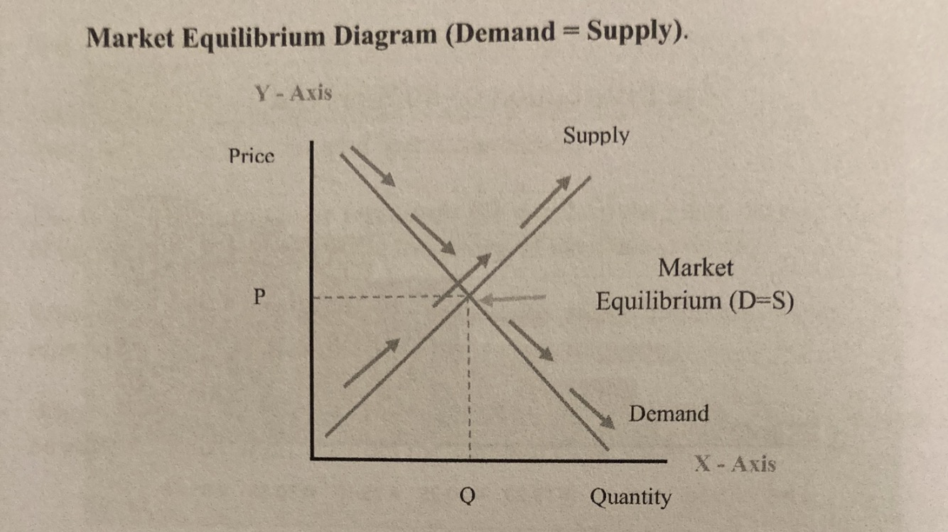
(Osadiya, 2023)

Price of Substitutes
In place of McDonald's world-famous Big Mac, Burger King's Whooper burger is a worthy alternative. The Big Mac has cost more than the Whooper in each of the years 2014, 2015, and 2016. Because of this, they were unable to compete with Burger King in the marketplace. Burger King implemented a price rise in 2016. In 2022 (Stocklight, 2022) a Big Mac will cost £4.09 and a Whooper from Burger King will cost £4.99. When the price of a product that can serve as a substitute drops, its demand rises while that of the product it is meant to replace falls. This is because the rival product has become more affordable. According to McDonald's (UK), Burger King's rivals in the UK market offer similar products and services at similar costs. Because of this, Burger King earned £594 million in the UK in 2021. Conversely, McDonald's is worth about £2.068 billion, or four times as much as Burger King (Stocklight, 2022).

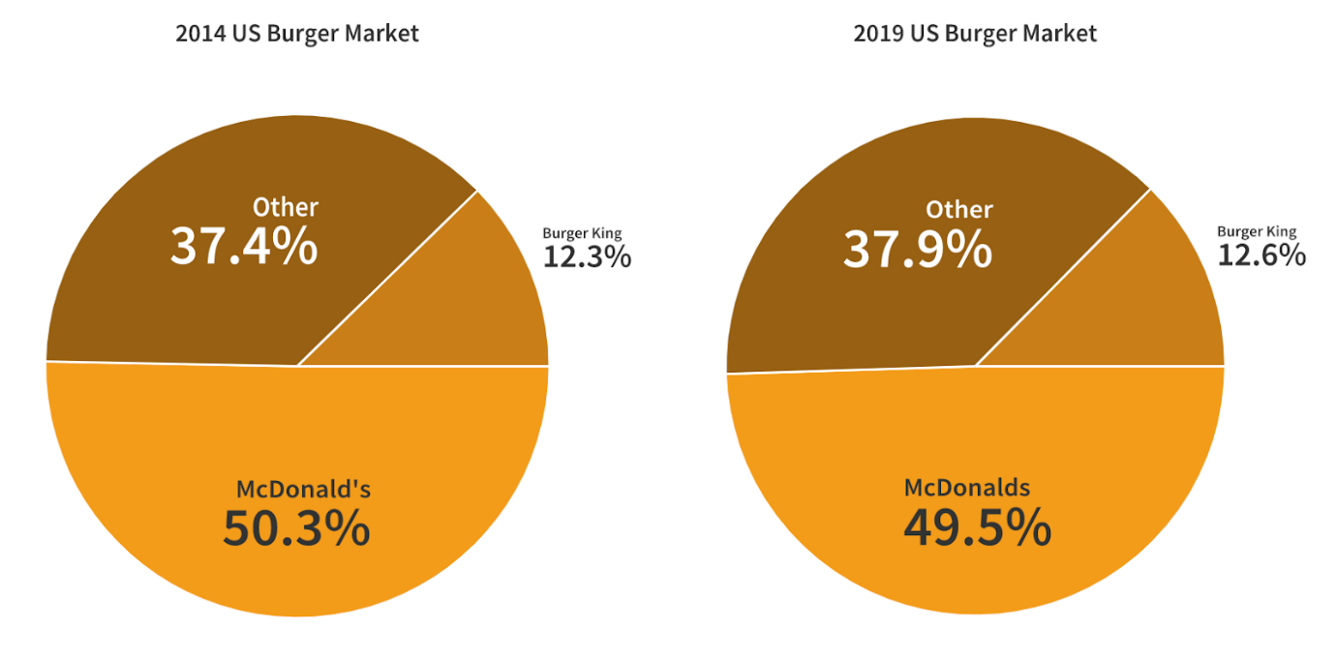
Source: (Scott, 2021)

Price of Complements
You can't go wrong with a Big Mac and some fries and a cold drink. It is well known that when the curves of demand and supply converge, the market price (P) and quantity (Q) are set. The slope of the DD curve is negative, while that of the SS curve is positive. There are numerous relationships between price and quantity requested (QD) on the DD curve, and between price and quantity supplied (QS) on the SS curve. Variables apart from price (P) also affect the shape of the demand curve (DD). A consumer's disposable money, their individual interests and preferences, the local climate, the availability of alternate or complementary items, etc. are all examples of such variables. The amount requested is the only factor in the price change (QD). It is thought that when two foods are eaten together, they enhance one other's flavor. It has been shown that when one product's price rises (falls) and the other's falls (rises), DD falls (rises) (Griffith, 2004).

Burgers and potatoes go together like cheese and buns. In the future, burgers and potatoes will be eaten at the same time. There has been an increase in the quantity of fries produced. That means less potatoes will be wasted in the making of french fries. Even if it's a burger, DD will pass. The demand curve for hamburgers will shift due to non-price impacts caused by a change in the price of a complementing item (Shapiro, 1987). The total amount of DD in the burger should decrease and the DD curve should shift to the left or the inside. Suppliers will lower their asking prices for hamburgers because of the stable supply. When supply and demand are equal, as they are when a market is balanced, prices tend to fall.

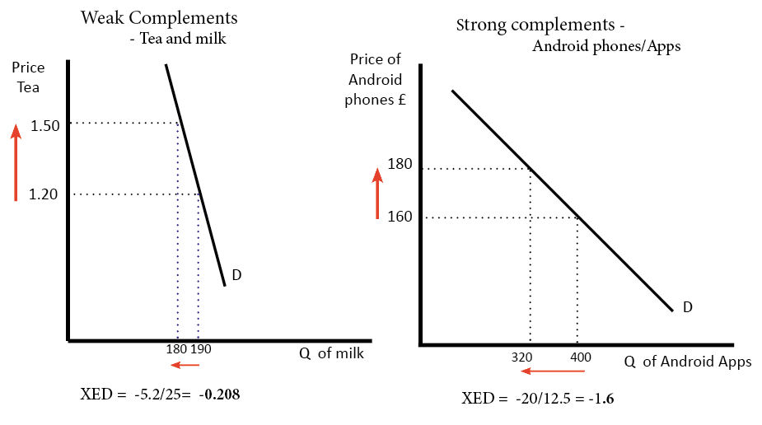
(Economicshelp, 2023)

Consumer Income
The Office of National Statistics predicted that the median household income in the United Kingdom would have been £31,400 in Fiscal Year 2021, which includes the first year of the coronavirus (COVID-19) pandemic. That's a 2% increase from the previous year's numbers. The median income increased by 2.0% from FY2020 to FY2021. Annual income growth averaged 14.2% from FYE 2012 to FYE 2021. While it increased by 10.1% from FYE 2012 to FYE 2021, the median income fell by 0.6% between FYE 2020 and FYE 2021 (Office for National Statistics, 2022).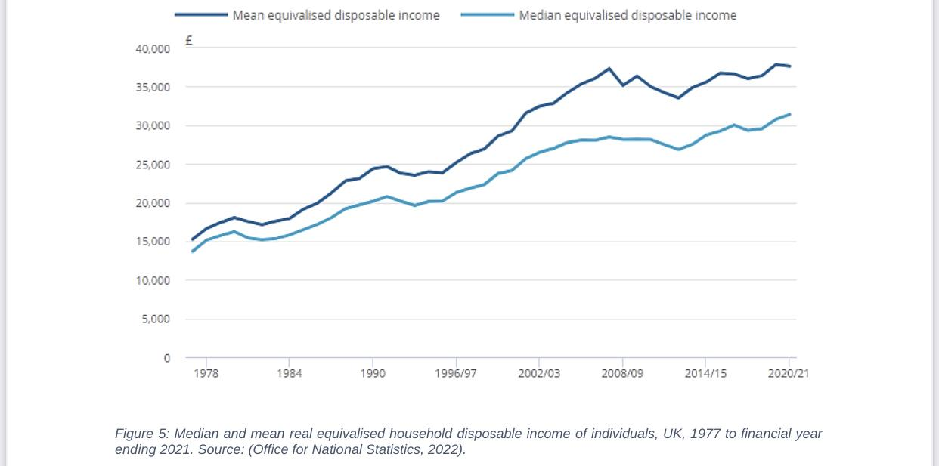
(Office for National Statistics, 2022)
As a result, the UK's standard of life improved.
Fast food restaurants are seen by individuals of lower socioeconomic position as "normal goods," whereas those of higher status see them as "inferior goods" (Andreyeva, et al., 2010). Full-service eateries, however, are considered "typical" among people of all socioeconomic backgrounds. The impact of rising income on Big Mac consumption will vary depending on the nature of demand.
Demand increases and decreases in lockstep with changes in disposable income, at least for relatively basic things. Regardless of the level of financial stability, this association persists. Commonplace objects include those that the public views as examples such as consumer products, technical devices, and leisure activities (EconomicsOnline , 2020).
As people's purchasing power grows, they have less need for cheap goods. Demand decreases as income rises (EconomicsOnline , 2020).

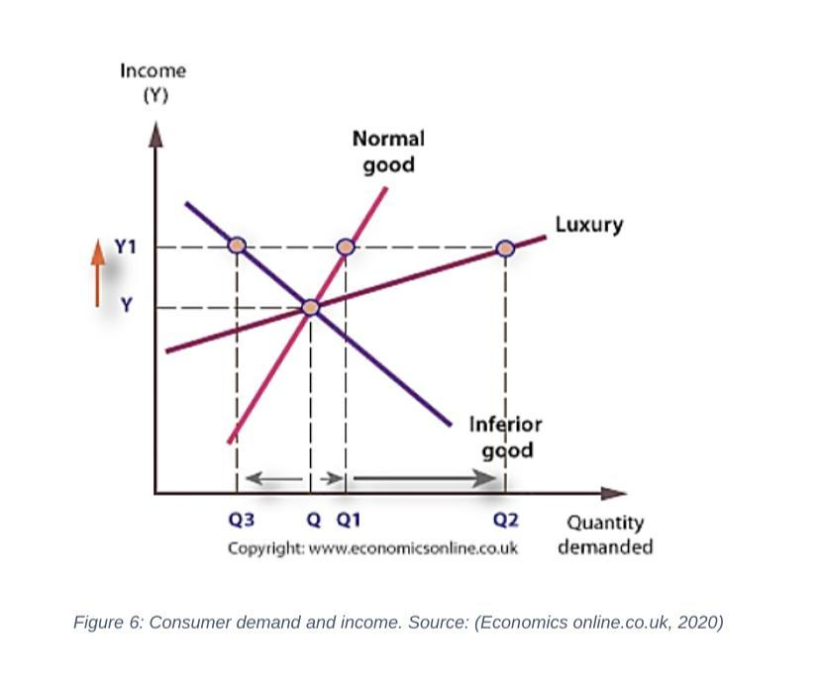
(EconomicsOnline , 2020)

Consumer tastes and preferences
The fact that fast food is now incorporated into the normal meal schedules of many people demonstrates how deeply it has become ingrained in contemporary culture. Consumer preferences fluctuate for a variety of reasons, one of which being the increased concern that individuals have towards their health. As a direct consequence of this, customers are being more selective when they shop for groceries. According to a number of studies, eating at fast food restaurants is associated with an increased risk of developing diabetes, high cholesterol, and obesity. Before bringing a product into their homes to share with their families, modern consumers pay careful consideration to its level of quality. Customers are concerned about the safety of the products and the cleanliness of the environment, which is causing them to delay making purchases. According to Shapiro's research from 1987, consumers are willing to pay more money for higher-quality food goods. People are becoming increasingly concerned about the effects of pollution and the presence of potentially harmful components on their health, which has led to an increase in the amount of money spent on meals of a higher quality. The speed with which a customer's wants are satisfied has little bearing on whether or not they are satisfied. The examination is plainly having a negative impact, which is also having an effect. According to Griffith (2004), healthy persons under the age of 40 do not require to be concerned about their diet.
According to CDC (Centers for Disease Control and Prevention) , eating at fast food restaurants, drinking sugary beverages, and drinking carbonated beverages is related with an increased risk of overall calorie intake. Although a growing number of fast-food restaurants now offer healthier menu alternatives, the common perception among consumers is that fast food still has a higher overall calorie count and may contain items that could be harmful. As a result, McDonald's profits from the sale of Big Macs and other types of fast-food meals are unaffected by shifts in the demand from customers.

Consumer expectations of price
Customers frequently request that merchants lower their rates. The fact that the cost of basic necessities like paper clips and hamburgers has risen shows that inflation is having an impact. Most customers anticipate a price drop, which will cause the demand curve for fast food to shift to the left. It is well-known, however, that when people delay buying a product in the hopes that its price will drop, demand for that product falls. Consumers who anticipate a hike in pricing in the near future may be disappointed. It's unlikely that this will boost sales, though, because of the nature of the product (fast food) (Cranfield, 2020). Big Mac sales will drop dramatically if costs keep rising at this rate.
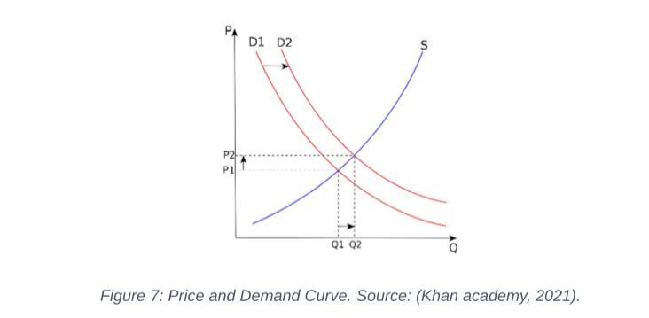
Source: Khan Academy, 2021

Demographics
The annualized number of Big Macs sold around the world is nearly 900 million, or more than 2.4 million every day. According to McDonald’s, over 1.5 million Big Macs are eaten every day in the UK. More and more people sign up to become their customers daily.

Task 3: Big Mac’s Demand- Elastic or Inelastic

Substitution effects
In this context, price elasticity of demand is superseded. If it were easier to discover a comparable substitute, customer demand for products would be more flexible when the price of an item climbed. A product's price fluctuates less when there are few or no alternatives. If you really need it, it doesn't matter how much it costs. According to Griffith (2004), a luxury item is anything that is nice to have but not essential to one's wellbeing.
A product's inelastic quality grows as its necessity does so because there are fewer substitutes available when demand is strong. It has been found that the luxury goods market is more malleable and responsive than the mass market (Andreyeva, et al., 2010).
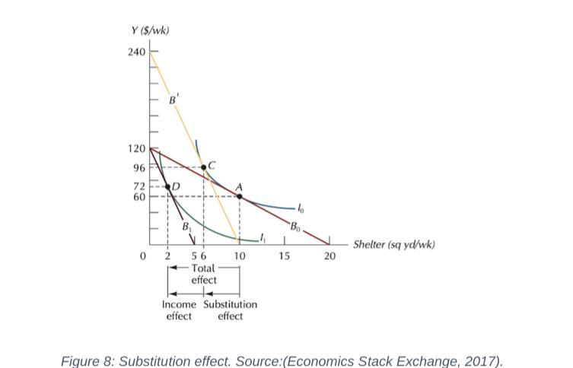
Source: (Economics Stack Exchange, 2017)

Goods that can be manufactured by just one company have inelastic demand, while those that thrive in a market that promotes, and rewards innovation are subject to elastic market pressure. Supply price elasticity is often lower in the long run than in the short run (Aigner-Walder, 2015) because customers have more time to respond and more opportunities to try different products. This is because, as time goes on, people become increasingly accustomed to price adjustments. Alterations in output may not necessarily be proportional to changes in price. Price inelastic growth tends to rise when consumers spend less of their disposable money on a product. This is because increased levels of competition provide greater variety for the consumer.
We sell Big Macs in highly competitive markets where a major price rise would cause a drop in demand that would offset any gains in revenue. Companies will charge the most amount possible when demand is inelastic. Profits can be maximized by lowering the price of elastic commodities as demand rises. One may make the case that Big Mac consumption is more elastic as a result.

Income effect
People who make more money are less likely to allow the price of a product or service to influence their decision to buy that product or service. This is because people who have previously established themselves financially are typically less affected by shifts in the cost of living. However, changes in the prices of commodities can have a disastrous effect on those people who are most susceptible to the repercussions of these changes. This provides a direct explanation for why consumers with low incomes have such a sensitive response to changes in price. The decrease in the median income of households has led to a precipitous drop in sales of Big Macs.
The size of prices is also a factor that can influence price elasticity. Because customers are sensitive to fluctuations in price, the demand for fast food items like the Big Mac is extremely elastic. However, inelastic demand exists for low-priced commodities such as needles, matchboxes, and other things of a similar nature because the effect of price changes on total demand is relatively small. Customers who are willing to spend a significant amount of money on a service indicate that they place a high value on that service. In most cases, new prices are implemented at regular and calculable intervals. As a direct consequence of this, the amount of time required for the elasticity to change can range anywhere from one year to one month to one week to one day. According to Griffith (2004), demand is frequently inelastic in the short run. Consumers who are slow to adapt to changes in pricing by switching brands are responsible for this phenomenon. When the price of a product that is regularly purchased by consumers rises, buyers have the capacity to quickly transfer to alternatives that cost less because to the better adaptability of long-term supply.

Recommended pricing policy
Pricing is highly valued by marketing experts since it indicates their assessment of customers' willingness to pay. Price levels that are too high or too low may also stifle economic growth. A drop in sales and a corresponding decrease in cash flow are possible outcomes of inappropriate pricing (Aigner-Walder, 2015).

McDonald's, the Big Mac's parent business, can choose to charge whatever it costs to produce the fast-food item. The cost-plus method of pricing is the one that a company should use. Both the variable and fixed costs of a product can be calculated using the cost-based purchasing paradigm (Heien & Pompelli, 1989). Managers calculate the expected gross profit per unit by first totaling the costs of the goods and services and then adding a markup of five to ten percent. From a purely financial vantage point, success is reached when sales are sufficient to cover all manufacturing and distribution costs. Managers can continue forward with the process of defining pricing strategies after examining business price objectives such boosting long-term and short-term profitability, stabilizing expenses, expanding working capital, and battling competition.

Managers should factor in market conditions when determining pricing strategies and settle on rates that are fair given the existing market (Griffith, 2004). Pricing that considers the market, the product, the competitors, and the different sorts of customers is more likely to result in success. Pricing often entails establishing that the premium consumers are prepared to pay for a product to establish the desired production volume. If McDonald's can nail down its target demographic, the fast-food chain will have a far better chance of succeeding in either the high-end market, where quality and service are valued highly, or the low-end market, where price is the driving factor (Cranfield, 2020). McDonald's will be able to use this data to narrow down their target customer base. There is no room for guesswork in this method of assessing costs; rather, only accounting and financial data need be analyzed. Demand, rivalry, and other factors that could affect pricing are ignored by this model (Andreyeva, et al., 2010). Using easily accessible internal data, managers may reap the benefits of a tried-and-true strategy like cost-based pricing. A company that bases its prices on inflation needs to show that it can make a sufficient surplus profit after covering its production and distribution costs (Aigner-Walder, 2015).

Conclusion
The present study has examined the determinants of demand and market equilibrium for McDonald's Big Mac. The findings suggest that the price of alternative products, such as Burger King's Whopper burger, can exert a significant influence on consumer demand for the Big Mac. The inverse relationship between the price of another product and the demand for it is well-established in economic theory. Specifically, as the price of a substitute decreases, the demand for it tends to increase, while the demand for the product it is intended to replace tends to decrease. Furthermore, the pricing strategy of complementary products such as beverages and side dishes can have an impact on the demand for the Big Mac. A reduction in the cost of fries may result in a rise in the desire for burgers. The demand for the Big Mac can be influenced by consumer income, particularly as the standard of living experiences an improvement. Hence, it is imperative for enterprises to consider these variables when formulating pricing and promotional strategies for their merchandise to uphold market equilibrium and fulfill consumer needs.

