

University of Wales Trinity Saint David

Level 7 Assessment

Programme: MSc Advanced Manufacturing (Industry 4.0)

Module: Advanced Industry 4.0

Module Code: ACPA7000

Assignment Title: Assessment 1

Author: Mike Davies

Student Number: 213189

Submission Date: April 2023

TASK DESCRIPTION
This report investigates the different types of business models implemented by companies introducing industry 4.0 techniques and technologies, it also reviews the possible expansion of a company’s operations to increase productivity and realise new value streams.

Summary
This report investigates the benefits of introducing industry 4.0 techniques and technologies.
These technologies have given rise to new business models such as pay-per-use, product-as-a-service, subscription, on-demand business model. Industry 4.0 has also opened up new value sources such as predictive maintenance, real-time monitoring, data analytics, digital twin. Implementing Industry 4.0 technologies can significantly improve efficiency, productivity, and agility, but businesses must choose the right model and strategy and ensure they are adequately prepared for the changes.
During the research the two areas that were constantly highlighted, were:-
- Cyber security,
With the research identifying this as major growth area, as connectivity through industry 4.0 technologies increases, which has given rise to a rapid expansion in the cyber security service sector.
- Servitisation,
Which is transforming a company's products into services and is included in all the business models, researched to a greater or lesser degree.
This is different than the Product-as-a-Service Model, which is in place from product/ service launch, whilst servitisation is the systematic transfer of current products, which started as the sale of product business model into sale of service items.

Description | Page No.
Title Page | 1
Assignment Task | 2
Summary | 3
Contents Page | 4
Introduction | 5
Industry 4.0 Business Models | 7
Conclusion | 11
List of Figures | 12
Reference List | 13

Introduction
Industry 4.0 is a term that refers to the fourth industrial revolution, and it is associated with a range of technological advancements that are transforming various industries. These technological advancements include-
Autonomous robots
Simulation
Horizontal and Vertical integration
The industrial internet of things (IoT)
Cybersecurity
Cloud computing
Additive Manufacturing
Augment reality
Big Data & analysis

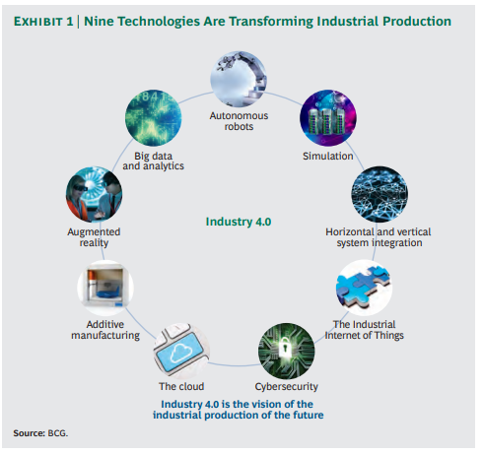
Fig. 1 (BCG, 2015)
These technologies have created new business models and operational advancements that are key drivers to the future success of companies.

This report has been split into two sections
Section one will look into the key business models that are implemented within Industry 4.0, many of which are innovations either to the company or the whole industry in which a company works and as such could be considered as disruptive innovations as outlined by Clayton M Christensen in his seminal book The innovator's dilemma.
Section two will look into new value sources. Values sources can be classed as cost reductions -reducing the financial burdens of current activities, or process and productivity improvements, which would optimize systems or introduce greater control via use of data monitoring or using predictive & simulation methods to increase processes throughput and reduce downtime.

Section One
Industry 4.0 New Business Models
Industry 4.0 New Business Models
New business models have been created by Industry 4.0 technologies and are changing the way businesses work. Industry 4.0 technologies have led to the promotion of the business models:
Pay-per-Use Model
With the pay-per-use model customers only pay for the services they use. This model is made possible by IoT technologies allowing products and services usage to be tracked. For example, a company can track the time a machine has been used and charge customers based on the number of hours.
(Höhn, 2022)
Product-as-a-Service Model
With the product-as-a-service model customers pay for the performance of a product or using equipment rather than owning the product/ equipment. The Supplier keeps ownership of the product/ equipment and is responsible for its maintenance and upgrades. This model uses IoT technologies to track the performance of their products/ equipment and provide proactive maintenance and upgrades.
(Grenacher, 2018)

Subscription Model
With the subscription model customers pay a monthly or yearly fee for access to a product or service and is commonly used in the software industry, with examples of Microsoft office 360 and adobe photoshop and lightroom programs being supplied for a monthly fee. In Industry 4.0, the subscription model can be used in the manufacturing industry, where customers pay a fee for access to a range of services, such as maintenance, upgrades, and training.
(Günther et al, 2020)
On-Demand Model
With the on-demand model customers request a product or service whenever they need it. This model uses IoT technologies that allow businesses to track the availability of their products and services in real-time. For example, a logistics company can use IoT sensors to track the location of their trucks and provide on-demand delivery services to customers
(SAP, 2023)

Servitisation

Servitisation is the business model that involves transforming a company's products into services. This model aims to maximise customer value by providing a range of services that complement a company's products, and all of the above business models include a version of servitisation.
(Satell, 2017)

Section Two Industry 4.0 New Values Sources
Industry 4.0 has opened up new avenues for operational advancement that can help businesses realize new sources of value. The following are some of these advances:-

Predictive Maintenance
Predictive maintenance is a new approach to maintenance that uses IoT technologies to predict when a machine is likely to fail. By using IoT sensors to collect data on machine performance, businesses can identify patterns and anomalies that indicate a machine is likely to fail. This allows them to schedule maintenance before the machine fails, reducing downtime and increasing efficiency.
(Sahba et al, 2021)
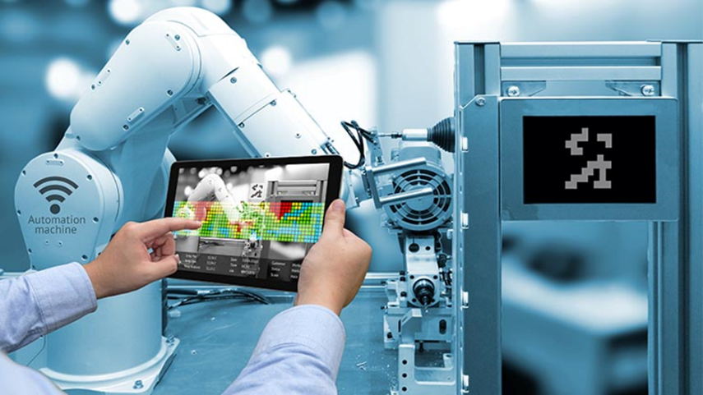
Fig. 2 (avnet, 2022)
Real-time Monitoring
Real-time monitoring uses IoT technologies to provide real-time data on machine/ equipment Performance. By using sensors to collect live data from machines, performance can monitored and problems can be identified as they happen. This allows immediate corrective action to be taken, and trend analysis can be conducted to predict failure frequencies, reducing downtime and increasing efficiency.
(DOD Technologies Inc., 2020)
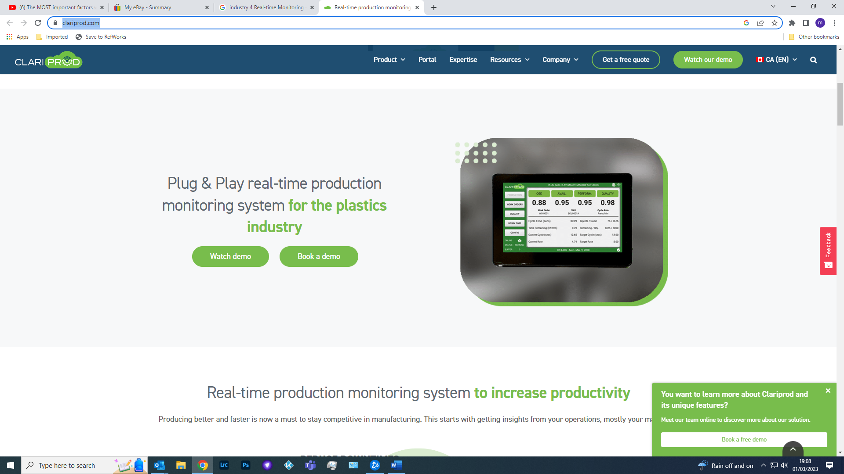
Fig. 3 (claripod, 2023)

Data Analytics
Data analytics uses AI and big data technologies to identify patterns and anomalies in data. By analyzing data on machine/ equipment performance, trends and patterns can be identified that can help them improve their processes and identify opportunities for improvement.
(Genpact, 2021)
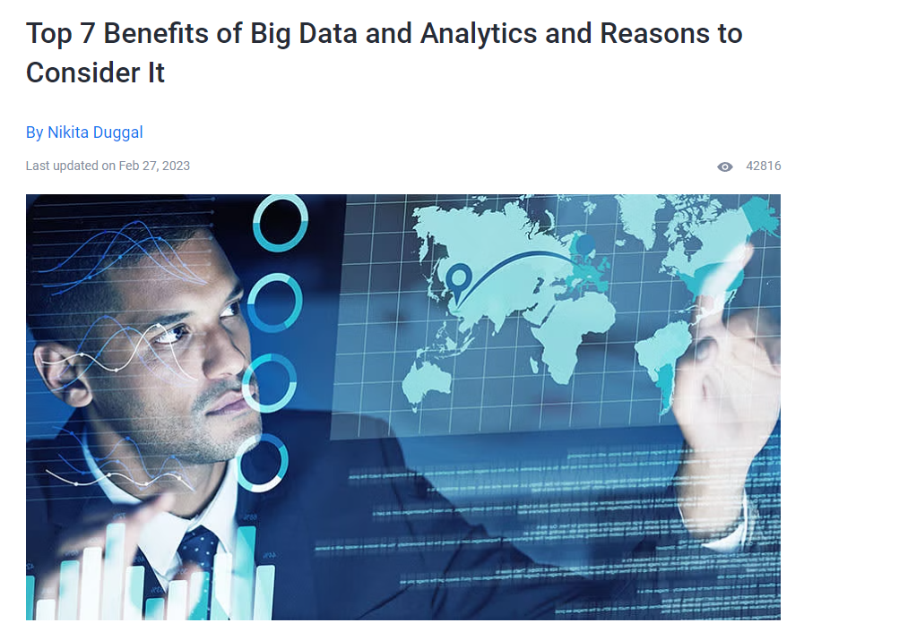
Fig. 4 (simplilearn, 2022)

Digital Twin
A digital twin is a virtual replica of a physical asset or process that allows businesses to simulate and optimize their operations. By creating a digital
(Siemens, 2022)
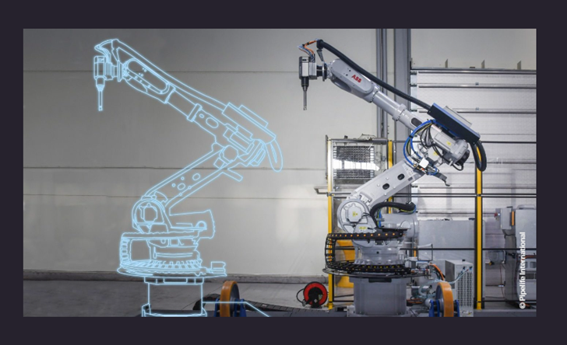
Fig.5 (wienerberger, 2022)
Servitisation
Servitisation lets companies use the data generated by their products to provide better services to their customers. For example, a company that produces industrial machinery can use data from the machines to offer predictive maintenance services. This model increases customer loyalty and can create new revenue streams. Examples such as:-

Microsoft offering its Office suite of programs as a service rather selling individual programs as done historically

IBM’s Watson AI for business, Which offers AI generated solutions to business problems companies present to IBM for solving. This not only gives solutions to the customer, but generates a new business avenue for IBM and improves Watson’s data and knowledge for future analysis.

Rolls-Royce has changed its business model from a manufacturing company to offering services, such as maintenance, repair, and equipment overhaul. Using data from their engines to predict maintenance problems, allowing them to offer better customer services.
GE Healthcare offers maintenance, remote monitoring and data analysis to their customers. By using data generated by their products, they can identify issues before they occur, which has led to better performances.
Siemens offer a range of services, such as energy management, optimization, and monitoring services.

Conclusion
Implementing Industry 4.0 technologies can deliver significant benefits in terms of improved efficiency, productivity, and agility.
However, businesses need to choose the right model and strategy for implementing the technologies and ensure they have a strong foundation and understanding of the appropriate industry 4.0
It has been stated; that some companies are introducing industry 4.0 technologies for prestige reasons and it is felt that industry 4.0 technologies should be a driver for change and not the reason for change. For the benefits of these industry 4.0 technological advances to be fully realised, there needs to be a culture change by all stakeholders, to adapt new working methods, processes and procedures.
(Davies, 2023)

The most critical of the industry 4.0 technologies must be considered cyber security, as this impacts all other technological classes, and it is expected that there will be a major growth in joint ventures contracts between large OME companies and specialist cyber security companies with the required computer programming skills.
(bitsight, 2022).

The trend for servitisation, transforming a company's products into services, is a major innovative step that many of the most successful companies have embarked upon.

List of Figures

Fig. 1 BCG, 2015 Nine foundational technology advances available from https://www.bcg.com/publications/2015/engineered_products_project_business_industry_4_future_productivity_growth_manufacturing_industries reviewed 01/03/2023

Fig. 2 avnet, 2022, Predictive Maintenance available from https://www.avnet.com/wps/portal/abacus/solutions/markets/industrial/predictive-maintenance-iot/ reviewed 01/03/2023
Fig. 3 claripod, 2023, Real-time Monitoring available from https://clariprod.com/ reviewed 01/03/2023
Fig. 4 simplilearn, 2022, Data analytics available from https://www.simplilearn.com/benefits-of-big-data-and-analytics-article reviewed 01/03/2023
Fig. 5 wienerberger, 2022, Digital Twin available from https://www.wienerberger.com/en/media/press-releases/20221205-Industry-4-0-Wienerberger-at-the-Leading-Edge.html reviewed 01/03/2023

Reference List
bitsight, 2021. 16 At-a-Glance Cybersecurity KPIs to Add to Your Dashboard- blog. [Online]
Available at: https://www.bitsight.com/resources/16-cybersecurity-kpis-to-add-to-your-dashboard
[Accessed 22 August 2022].

Christensen, C. M. (1997). The innovator's dilemma. Harvard Business Review Press.
Davies, M. 2022 Industry 4.0 communication – The machines are talking -why aren't the people, research proposal for MSC in Industry 4.0 Advanced Manufacturing University of Wales Trinity Saint David presented Dec. 2022
DOD Technologies Inc. 2020, Industry 4.0 And Real-Time Monitoring, available from https://dodtec.com/news/industry-40-and-real-time-monitoring.html reviewed 01/03/2023
Genpact, 2021. Your guide to Industry 4.0: How data analytics and cloud technologies are enabling the factory of the future, whitepaper available from https://www.genpact.com/insight/your-guide-to-industry-4-0-how-data-analytics-and-cloud-technologies-are-enabling-the-factory-of-the-future reviewed 02/03/2023
Grenacher, M. 2018, Industry 4.0, The Smart Factory And Machines-As-A-Service available at Forbes Technology Council available at https://www.forbes.com/sites/forbestechcouncil/2018/04/11/industry-4-0-the-smart-factory-and-machines-as-a-service/?sh=5e5648bb1dff reviewed 28/02/2023
Höhn, T. Feb 15, 2022 available at https://www.inno-focus.com/en/2022/02/15/pay-per-use-as-a-business-model-for-the-manufacturing-industry/ reviewed 28/02/2023
Sahba R., et al, 2021, Development of Industry 4.0 predictive maintenance architecture for broadcasting chain, Advanced Engineering Informatics, Volume 49, 2021, 101324, ISSN 1474-0346,
SAP, 2016, Industry Week Whitepaper-Industry 4.0, A guide for digital transformation in manufacturing, available at https://www.sap.com/uk/products/scm/industry-4-0.html downloaded from file://gbllsv18xfilea/UserData/ceu013847/2016/Downloads/IndustryWeek%20Whitepaper-Industry%204.0,%20A%20guide%20for%20digital%20transformation%20in%20manufacturing.pdf reviewed 28/02/2023
Satell, G. (2017) Mapping Innovation: A Playbook for Navigating a Disruptive Age. USA. McGaw Hill
Schuh, G. et al.2020, Outcome Economy: Subscription Business Models in Machinery and Plant Engineering, Procedia CIRP, Volume 93, 2020, Pages 599-604, ISSN 2212-8271,
Siemens IDC Whitepaper Feb 2022, Digital Twins: Potential Of Constant Optimization In The Consumer Product Industry available from https://resources.sw.siemens.com/en-US/white-paper-product-optimization-consumer-goods-digital-twin?gclid=CjwKCAiAjPyfBhBMEiwAB2CCIg4LPU-L5NkKhbY6q6KqY_k-gA5nMgpHnRA7_jm3oepwi45J9quQYRoCFLwQAvD_BwE, Downloaded & reviewed 02/03/2023

