
The event exPerieNce
Halloween Party at The Marriott Hotel

13th november 2017
University of Wales Trinity Saint David

Executive Summary
The purpose of this report is to analyse an event attended at the Marriott Hotel Swansea. It will produce a report suitable to give to the event managers of the event attended. It will discuss all factors that can influence the overall event experience. It will also give the event managers a couple of recommendations that they could take into consideration when planning another event.

Table of Contents

Executive Summary……….........................2

Introduction…………………………………………4

Main Body

Pre-event………………………………………………………….5

Venue……………………………………………………………….5-7

The Event………………………………………………………….7

Satisfaction ………………………………………………………8

Recommendation……………………………………………..8

Conclusion………………………………………….9

References………………………………………...10

Appendix 1………………………………………...11

Appendix 2 ………………………………………..12-14

Introduction

In order to demonstrate why customer satisfaction is important to event managers, a Halloween event has been reviewed to assess how successful and meets the needs of the consumer. The purpose of the report is to focus on the events experience. It will that into consideration how the travel experience can affect an overall opinion of the event. It will look at the facilities at the event and discuss whether they meet basic needs required.

Pre-Event
To promote an event and get the word out the organisers need make posters and post on social media. Due to the event being aimed at the staff of the Marriott, they need to target the social areas to arrange posters. They need to arrange posters for all to see leaving no one out. This will insure all feel welcome. As said by O’Brien,(2012) “Getting a personal invite makes a customer feel special”.

Additionally O’Brien, (2012) also talk about the importance of pre-purchase tickets sales. It is important to know numbers of guests attending an event, especially if the organisers are supplying food. In this case the Marriott supplied free food for the guest. They used the ticket sale numbers to work out how much food they needed. They also used the numbers to adapt room size and seating. Though this they have ensured the guests are satisfied by supplying enough food and space for a comfortable night.

Venue
The event will be at the Marriott Hotel Swansea, the Hotel is a great place to hold an event. It has 5 function rooms, ranging from 10 people to 300 people. The building is close to the heart of Swansea and a 5 minute walk to town. The Hotel is over looking the beach, with great views.

Furthering the hotel being a 5 minute walk to town, Swanseas bus station is based in the town centre. This makes traveling to the event convent. There is a bus stop directly outside the entrance of the Hotel. The Hotel also has parking available for 70 vehicles, if parking becomes short there is also a 200 plus council car park opposite the Hotel. All in all traveling to and from the event is hassle free. This helps the over all event experience, by cutting out the stress to get there. As stated by Bowdin, (2002) pp 221 “ The first and last impression of an event will be the parking facilities and the traffic control”

It is important that the venue has accessibility that suits many different people. The venue for this event was The Marriott Hotel. The Hotel has disabled access at 6 points of the building. It also has close bay disabled parking. This makes the venue accessible for all who may want to attend the event without restrictions. As states by (Un.org. The ) “it is important to be barrier free” with this access Marriott becomes ‘barrier free’. The Hotel also has a large range of facilities suitable for disabled access, they have ground floor rooms available close to the event. The restaurant and functions rooms were all fully accessible to.

The venue has key facilities for a guest attending an event. Including parking for over 70 vehicles. They have toilets a few feet away from the function rooms, for the convince for the guest. The Hotel has a direct phone to the local taxi company which saves call charged for attendees. There is a restaurant within the venue where food and drink can be purchased and taken into the event. The Hotel also has a second bar especially for events which is also accessible. A venue needs to have sustainable facilities as stated by Koukiasa, (2011) by Marriott having their facilities built in rathe than higher by a separate company makes them sustainable.

There was no security at the event. The event was for work colleagues and close friends, the organisers did not feel the need for security. However there are cameras throughout the venue for security purposes.

To build atmosphere there was a horror movie displayed on a projector screen, thriller music and dark lighting. There was an addition of up lights coloured orange and green. Added props gave a spooky vibe in the dark room, they were activated on movement which added to the fright. The atmosphere in an event is key to keep the attendees drawn in as cited by (Culinary Academy of Las Vegas. 2017). Entertainment in the event helped build up on the atmosphere and keep attendees interested. There was a bar tender mixing spooky cocktails interacting with the guest, giving free tastes with the option the buy.

Furthermore there was free food supplied at the event, it was a buffet. It contained finger food, easy to eat and carry. There was vegetarian options as well, this suited all guests attended. Food was hot and was placed on hotplates with an addition of heat lamps to contain the heat and keep the food safe. There was access to the buffet on 2 sizes which saved long queues. Similarly Bowdin,(2002) feels the wait for food could affect an overall event experience if waiting to long.

The Event
The typology of the event would categories under corporate sector. As Bowdin, G (2002) pp52 says “corporate entertainment”. The event was made purely for the staff of Marriott Hotel. There was an addition of close friends and family but for the interaction between colleagues. The event is classed as local because the size is small and minimal impact. As shown in appendix 1 a graph created by Bowdin, (2002) pp16.

In addition to targeting staff at the Hotel, they would also be the target audience/typical consumer. This event was aimed at all staff within the Hotel as a social night. This will get new and old staff to interact and build friendships which would overall improve the work environment. As explained by Riordian, (2013) staff are happier in work when they have friendships. Through Marriott staff attending this event they have the chance to build new friendships in the workplace, leading to consumer satisfaction as they will be happier going to work.

The theme for the event was Halloween, as said by (History 2017) it is a annual holiday celebrated the end of October, Halloween is now mainly used for gatherings, costumes and treats. All guest were required to dress up as part of the fun. This is a fun theme you can recreate easily, Torkildsen, (2005) p.472 if an event has “appeal they can capture the imagination”. This gives the event that extra appeal, for the fun dressing up.

Satisfaction
The event had everything needed to keep the consumer satisfied. According to Maslow, A, H. (2012), the basic need is physiological needs. This includes food, water and shelter, the venue supplied all of these needs to each attendees (see comments in criteria, appendix 2 -12, 16, 17). Furthering on Maslow the event also supplied security in the form of CCTV and service staff. Another of Maslow’s needs were met for those guests who brought friends and family they would have felt love and belonging.

Recommendations
A strong recommendation for the event is to be better planned. On the night the guests split into their own groups not interacting with other. After about half hour games started and everyone was laughing, having fun. However that half hour was unpleasant for new staff at the Hotel with no one. If the managers had planned a quicker start it would have been a lot smoother through the event.

Conclusion

In conclusion to the event, all the evidenced showed the consumer should have had a great event experience. All basic needed were met, with an addition of security and belongings with close friends and family around. The travel experience would have been convenient due to the easy forms available. The venue was very accessible to minimise any stress of accessing the event. The facilities were all close and easy to access at anytime. The location was only a 5 minute walk from the heart of Swansea, making access to the city centre trouble free. The event included food at no additional cost, it was all included in the pre-ticket fee of £5. The food was a buffet so the attendees can eat until satisfied. For entertainment there was a horror movie projected on to large screen, there was also background music to build atmosphere. The event was promoted well through posters and social media posts, this ensured the word got out. While the target audience was the staff at the Hotel, there was an exception of up to 2 additional guest per staff member to boost numbers. In brief the criteria checklist looked at an attendees point of view. Although the event was classed as corporate it was also local because it was a small event. All these factors contributed to the event experience, many things can add to or take away from an overall experience. All in all an event manager can only do so much to satisfy individual people, but mainly target to satisfy the majority.

References

Bowdin, G. (2002). Events Management. London: Routledge.

Culinary Academy of Las Vegas. (2017). Why you venues atmosphere is important. [online] Available at: http://theculinaryacademy.org/atmosphere-of-your-venue/ [Accessed 11 Nov. 2017].

Koukiasa, M. (2011), “Sustainable Facilities Management within Event Venues”, Worldwide Hospitality and Tourism Themes, vol.3 , no. 3, pp.217-228

O’Brien, K. (2010), “Key steps to Event Marketing”, Franchising world, vol. 42, no. 2, pp. 48-50

Riordan, C, M. (2017). We all need friends at work. [online]. Harvard Business Review. Available at: http://hbr.org/2013/07/we-all-need-friends-at-work [Accessed 12 Nov. 2017]

Torkildsen, G. (2005). Leisure and Recreation Management. 5th Edition. London : Routledge

Un.Org. (2017). Accessibility for the Disabled. – Introduction. [online] Available at: http://www.un.org/esa/socdev/enable/designs/intro.. [Accessed 11 Nov. 2017]

Van den Wagen, L and White, L. (2010) Events management, 4th Edition, South Wales : Pearson

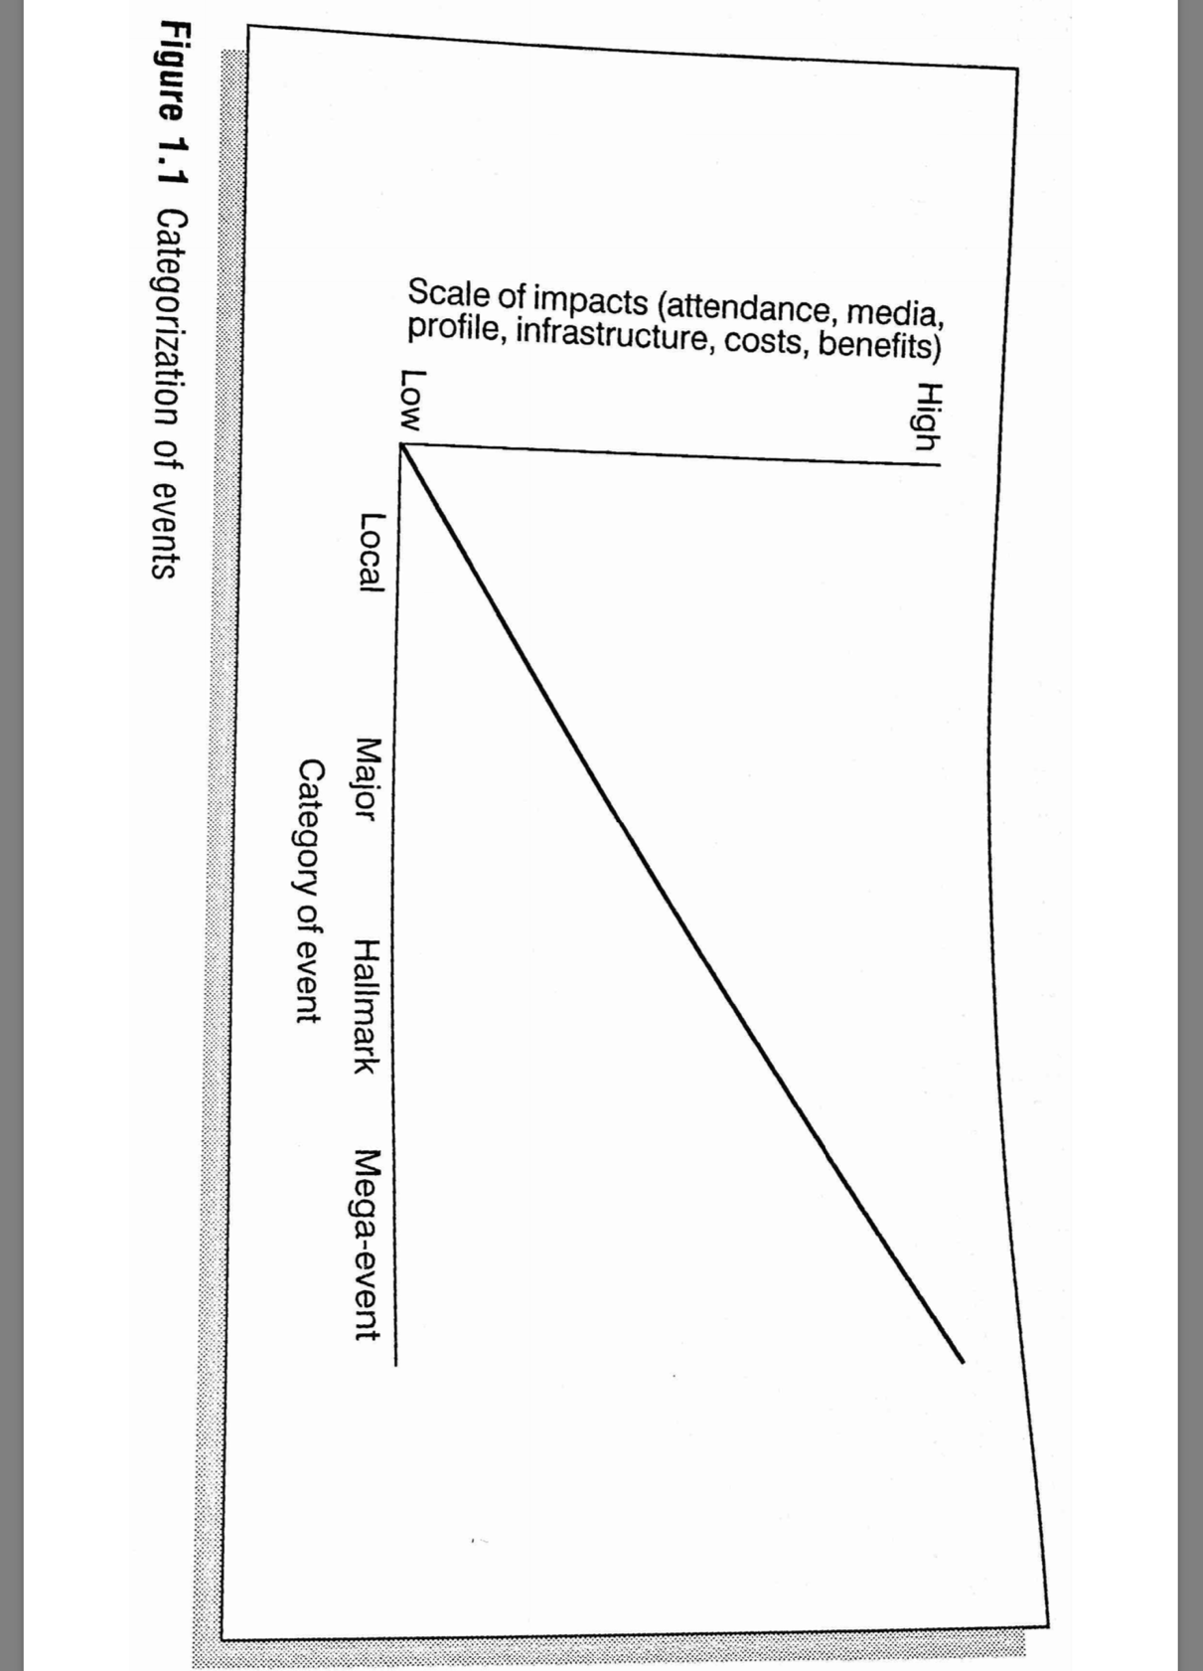
Appendix 1 - Bowdin, G. (2002). Events Management. London: Routledge

Appendix 2

The Event satisfaction Criteria edited from Van Der Wagen, L and White, L. 2010 p. 497-498

Event satisfaction Criteria | Notes and comments
- What was the name of the event? | Halloween party
- What type of event was it? | Local/corporate
- Who was the audience in this event? | Marriott Hotel staff
- What type of pre-promotion have been done? | Raffle and offering cheap alcohol
- Has there been a system of pre-event ticket purchase? | Yes, started 3 weeks before the event took place
- What is included in the event program? | Games, drinks, food, music, movies and lots of fun.
- What do you see as the main purpose of the event? | To bring Marriott staff together in a social environment to help grow and build friendships in the work place.
- Accessibility of venue? | Very accessible, 6 points of Hotel has ramps for wheelchair access.
- Parking? | Available for up to 70 vehicles plus outside parking opposite the venue.
- Public transportation? | 5 minute walk from Swanseas major bus station and bus stop outside entrance of venue.
- Access for emergency vehicles? | Yes with 2 driveways.
- Location, size, type of entry and exits? | Swansea Marriott Hotel, rooms 130, function rooms 5, from 10-300 people. Public entry at front and size of Hotel. Exits at sides, back and front.
- Cooling and heating? | Full multi air conditioning
- Décor and furnishings? | Bit dated in areas but lounge area very modern
- Lighting? | Very good, included spot lights, wall lights, coloured up lighters.
- Catering provision? | Food was provided at no additional cost, made by kitchen staff at the Hotel.
- Beverage provision? | There was a light up bar in the room.
- Food storage? | Industrial fridge and freezers in Hotel.
- Toilets? | Yes, 5 women, 4 men and a disabled access.
- Seating? | Seating for 50
- Sound? | Speakers were used and attendees controlled music
- Uniform? | Staff was in all black with clean aprons. Addition of kitchen staff bringing food in were in full chef whites.
- ATM access? | Yes in the entrance of the Hotel there was a cash machine with a charge of £1.85
- Safety/hazards? | Leads behind protector easy to access, balloons on the floor

Overall experience was very enjoyable, got to interact with new staff and build on friendships with other colleagues.

