The following reflective journals have been organized in chronological order, aiming to appoint the progression of the practice.

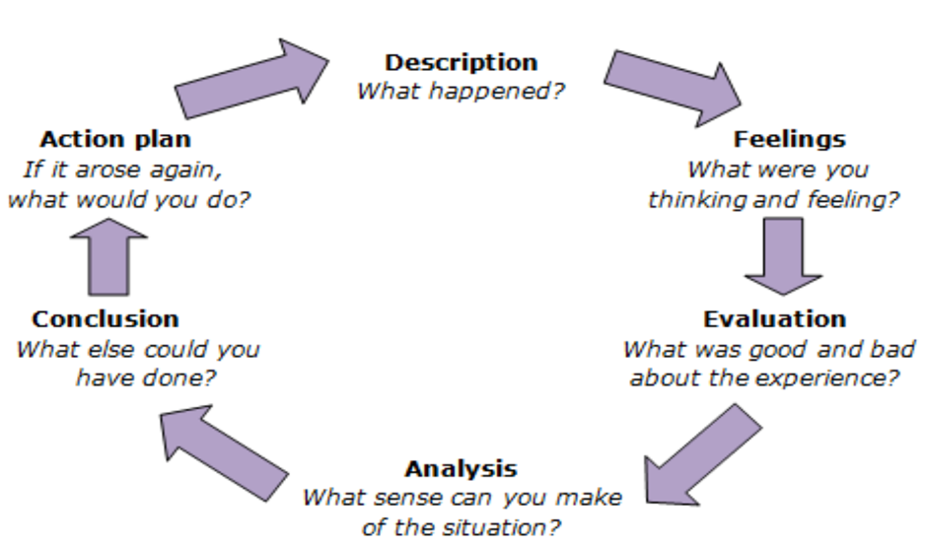

Reflection 1.

- What happened?
- What were you thinking and feeling?
- What was good and bad about the experience?
- What sense can you make of the situation?
- What else could you have done?
- If it arose again, what would you do?

During and after the session, I have been asked to reduce the engagement with a specific young person, by colleagues at YouToo. This young person seemed to have interests in me outside the Youth Work settings, and I did not step immediately back. After having been appointed, I recognised the Safeguarding matter.
Initially I felt overwhelmed by disappointment, from being asked to act differently. I felt disappointed with myself, from doing something wrong, even if I disagreed with them. After having taken a few minutes to reflect, I understood their point.
Good, was the ability (thanks to other youth workers) to recognise what I perform wrong, letting this young person believe she could get closer to me, crossing the relationship young person – youth worker.
I think this has been a fundamental experience I needed to face, for my development as a better practitioner.
I could have ended the conversation earlier, even it remained informal and respectful all the time.
I will recognise the risk in time, and professionally step back, prioritizing the safeguarding of both myself and the young person.

Reflection 2.

- What happened?
- What were you thinking and feeling?
- What was good and bad about the experience?
- What sense can you make of the situation?
- What else could you have done?
- If it arose again, what would you do?

The session of last Friday was centred on movie night, with tables organized with card and board games. The evening went well and YouToo gained one more young person.
I was very happy as I played one of my favourite board game. In addition to this, I was pleased to not be the only one who liked that game, so I had the chance to play and engage in youth work at the same time.
Only good aspects. I really enjoyed the moments of gaming shared with young people, and I found myself more relaxed when engaging with people around me.
I realise that when I was doing something that I actually enjoy, I was the best version of me with the young people. There was no challenge, in my practice of youth work that evening.
I think there is nothing I could have added, as I personally think the evening went extremely well. All the people at YouToo seemed happy and safely engaged.
If it will arise again, I would like to engage with even more people, using the positive feelings from the experience.

Reflection 3.

- What happened?
- What were you thinking and feeling?
- What was good and bad about the experience?
- What sense can you make of the situation?
- What else could you have done?
- If it arose again, what would you do?

I found myself fighting between my desire of helping someone, and the duty to respect boundaries. One young person approaches me sharing a personal problem, I listened but I did not act to solve her problem. I just, listened.
I felt helpless. I was aware of her problem (eating disorder), or at least I was able to detect it through varied sessions together. I was supposed to listen, report if necessary. That is all. I felt I could have helped her, as I lived similar experiences in the past.
The feeling of being powerless, was the worst. I wished Youth Work could have done more in term of practical help, instead of just active listening.
That for a few moments, I doubted my place in Youth Work.
I think I could have done nothing more, as I let her talk, explore her problem and providing her a person able to listen.
I hope, to be able to help her for real. Not only advising a better expert.

Reflection 4.

- What happened?
- What were you thinking and feeling?
- What was good and bad about the experience?
- What sense can you make of the situation?
- What else could you have done?
- If it arose again, what would you do?
Last week we had at YouToo some international students and we all tried to make them feel welcomed. We decided to play card games, then some quizzes of general culture. During the quiz, we have set little groups of mixed young people, aiming to include everyone. But from the beginning, I realised that the questions were too specific on our British culture compared to theirs, and I felt embarrassed by the stubbornness of some of my colleagues to continue, despite the silence when time of answers was.
I felt angry, because I wished to shout to change activity, seeing the uncomfortable silence but I was just able to sit and continue the quiz.
I felt that the whole situation was not right, at least not functional to the young people we had.
I was crossed, and I wanted to stand up. But I tried to understand the dynamics. And I continue the session, keeping the disappointment for myself. I think maybe, as everybody left happy, maybe it was just a feeling.
Pretty much nothing, as I did not run the activity.
I would try to talk to my colleagues and ask for an explanation, before getting angry for something that maybe does not deserve attention.

Reflection 5.

- What happened?
- What were you thinking and feeling?
- What was good and bad about the experience?
- What sense can you make of the situation?
- What else could you have done?
- If it arose again, what would you do?

We had another movie night, where we provided the last Lion King movie to watch all together. A member of YouToo brought a new young person interested on our evening, all of us engage with her and I personally spend time with her during a short session of painting before the movie. She looked shy and introvert at first, as she did not know a lot of people around the University. Me and the team made her feel welcome. What happened, was that I felt disputed two young persons.
I felt unformattable, as I never felt before two asking my attention during the session. I tried to share myself between the twos, keeping myself in a safe position.
I think my behaviour remained professional, providing attention and support to all the young people at YouToo. I welcome the new ones, and I ensured to maintain intact the relationships between me and former young people.
The situation felt unusual, where for the first time my approach was ‘requested’ from multiple young people. I feel my informal, funny and trustworthy approach guaranteed me young people to support effectively.
Maybe, asked for some extra support from other members.
I will behave quite similarly, applying an equal amount of support to all the young people.

Reflection 6.

The session of yesterday, was about board games and painting. We had in total 3 young people, outside the members of YouToo. Nothing worth to be mentioned happened, apart my usual anxiety on what to do, and how. After having offered a hot beverage to all, I joined the table addressed for the painting session, sitting next to a young person. We had a lovely conversation, I complimented with her about her painting and we kept talking and painting for about 45 minutes. I think she had a good time, as she did not look uncomfortable with me around. I think I could have asked her to join me also to a board game with the others, but I felt to putting too much pressures on her after our painting. She looked shy and introvert, so I did not want to ruin everything. I don’t think I misjudged her, so I hope I have built a lasting connection with the young person.

Reflection 7.

This evening, I have spent pretty much all the duration of YouToo, with this young person. The room was set with tables about board games and creative writing, after me and the other members discussed ideas for the session, on our WhatsApp group. She immediately asked for my attention, engaging an informal conversation from the very start. We played games, chat and laughs and I felt pleased by it, as I was succeeding on engaging with someone so naturally. I personally enjoyed the time with her as one to one, because it was varied, and we laughed pretty much all the time. Going to the end of the session, I started to feel guilty of being absent for the other young people at YouToo. I was worried about doing something I was not supposed to do, or not being professional. My fear was starting to manifest as anxiety, looking back at the other members of YouToo, waiting for a negative feedback to arrive to me. It didn’t, but I would like to address this, hopefully in the next sessions, with the older members, to ask their honest opinion about this evening. I really enjoyed the time with her, as young person, and I do not feel bad about it.

Reflection 8.

Last Wednesday, YouToo organized Pumpkins Carving to celebrate Halloween. The session went extremely well, where I challenge myself trying something that, despite the importance here, has never been so relevant in my home country. I took the responsibility to advertise the event on social media, and YouToo gained 6 new young people, specifically arrived for the activity promoted. I felt good, doing something that I have never done before. It was fun to talk and compliment other young people their talents, working on both their and my self-esteem. We took pictures (after consent), we enjoyed snacks and hot beverages. I felt unusually good, surprised by the good feelings from trying new things. This way, I personally acknowledged and see the application of the theory I am study day after day at the Course. I do not think there was something more to do or add, as the evening was a success.

Reflection 9.

This reflection is about the time spent yesterday at YouToo. The evening was about card games, and quizzes. The evening went well, with the addition of two new young people coming. What happened, was after the session. As always, the team brought all the equipment from their homes, and some of it which we store it in a room inside the University. I personally took the responsibility of it, so I go and get it before each session, and I bring it back every after. The team leaves together after each session, after helping each other’s cleaning and tidying the room we use for YouToo. On the way back, this young person asked me if I needed help to carry things and I did not see anything wrong, so I said yes. I took that offer, as a chance to keep building a trustworthy connection with her after she seemed quite concerned about personal matters, during the sessions. We walked down the room, we stored safely the equipment and we walked our way back to the Accommodations. She lives at the campus as me, but in different buildings. We stayed outside the car park, talking, when suddenly she asked my opinion in relation to the personal matters mentioned above. The conversation went well, and we said bye before heading back to our flats. In those moments, I felt flattered to be asked to join a conversation outside the YouToo settings; I felt that as a positive result of my engaging with here during the sessions. But I feared to be unprofessional, spending a chat with her, outside the session. The concept of boundaries has been a corner of mine, from the beginning.

Reflection 10.

During the usual session on Wednesday, we were surprised by the unexpected arrive of international students, coming from different parts in China. They arrived in the University from 2-3 days, and our project has been advised from the International Support Office. They were young people between 18 and 21 we presumed, all males with one older figure who was the teacher or responsible for the group. Later on, two young girls joined us, timidly. They were from China as well, and they found our project thanks the ISO. Me and a colleague were playing cards game with the boys, when we saw the young girls arrive. As I saw them like lost and timid, I immediately try to engage with them, offering a hot beverage and painting with them. Everything went smoothly, sharing myself between the card games on one table, and an informal chat to keep the girls involved. When the moment of saying bye arrived, I spontaneously tried to ensure that everybody felt welcomed, with the positive aim to see all, again, in the following session. As I perceived shyness from the two girls, I maybe wrongly, offered myself as a support around the campus. The meaning of the ‘offer’ was to help them knowing the surrounding, and giving them a person, they could trust and rely on, even just to contact for attending the following session.
My action was spontaneously driven, by positive feelings. Saying this, I meant no harm. What I felt, was a projection of what were my fears at that age, about being shy, misunderstood and not welcomed. So, I spontaneously acted like a sort of saviour, crossing every boundary, putting a risk myself and the young people I tried to help and support. The aim was exclusively to ‘save’ them, from exclusion.
During the self-analysis, a bad aspect of the experience was the amount of possible risks I lived, the possible negative outcomes and consequences. A good aspect was the discovery of my passion for this profession. It is possible to argue that, acknowledging my constant need to improve, my principles are strong and prioritize the young people.
This experience can be evaluated as one more reason to learn, how to not project myself, in other people. With the aim, to safeguard them and myself.
I personally wanted to do more, like helping them giving my personal contacts and show them the campus and around. I felt the desperate need to be helpful, as soon as I recognised a small sign of shyness. Doing this, I exposed them and myself, risking my professionality. Even if they looked to appreciate my behaviour, I am aware that was not the best option. Instead of that, I could have simply reminded them the next session, hoping for them to come back.
In the eventuality that a similar situation may happen again, I am aware of the tools I have to tackle and welcome shyness, without forcing any additional feeling. Simply making the session memorable, will positively reminding young people, they were welcomed and there always will be, a safe place.

