

BA (Hons) Leadership and Management Skills for the Workplace

Module: Developing Innovation and Creativity for Business Advantage

Module code: BMSW 6102

Student: Rupia Hussain-ID: 2010133

Lecturer: Charles Nwaogwugwu

Assignment Title- Individual Report on: Development of innovative product OR unique service proposition

Executive summary

In the current volatile economic situation, businesses are facing numerous challenges, and the Brick & Mortar (B&M) business model is no exception. With changing consumer behaviour and increasing competition, it is crucial to innovate and leverage technological advancements to create new and saleable products. In this report, we will discuss an innovative product jewellery holder online business that takes advantage of technological advancements. The online jewellery holder business is a rapidly growing market, with significant demand for unique and innovative designs. As with any business, competition is fierce, and it is vital to analyse the competition to stay ahead of the game. we will explore the potential for a small jewellery holder product and the steps necessary to set up an online business to sell it. Discuss some finance options and suggestions to help get this business off the ground. We will conduct a competitor’s analysis of the online jewellery holder business, followed by strategic solutions, 4Ps innovation options, and 4Ps marketing mix directions. The report also projects how the innovation can sustain and expand the product life cycle. The product shows a potential unique way of use to extend the use of the innovation “putting it to different use”. An evaluation of the payment system using PayPal. The fundamental Data Protection Act 2018, Compliance with the GDPR and PECR is necessary to protect customer data and prevent regulatory violations. Privacy and data protection are essential for any online business.

Table of Contents

1. Introduction
2. Innovation Thinking Process
3. Innovative Jewellery Holder
4. E-commerce Site: Using SaaS
5.1. Using a Marketplace
5.2. Statistics Website
6.1. Online Store: available at Shopify: - Nit&Tidy
6.2. Creating Content
7.1. PCI-DSS Compliance
7.2. Payment System
8. Financing the Innovation
9.1. Market and Customer
9.2. Customer Segment
9.3. Product Positioning
9.4. Marketing
10. Online Business Analysis and Strategic Solutions

11. 1. 4Ps Innovation Options

11.2 4Ps Marketing Mix Directions:

12. Feasibility of the online business

13. Gain Competitive Advantage

14. Sustainability of products and business

15. Value Chain of Online Business

16. The Life Cycle of Online Business

17. Putting it to Another Use
18.1 GDPR/Privacy and Data Protection
18.2. Privacy and Electronic Communication Regulations (PECR):
18.3. The Need for Consent:
18.4. Provision of Facility to "Opt Out" of Marketing Communications:
  - The Need to Support Rights such as "the Right to Erasure":
  - Security and the Importance:

Conclusion
- Reference
- appendix

Innovative Product: Cup/Mug Holder to Jewellery Holder

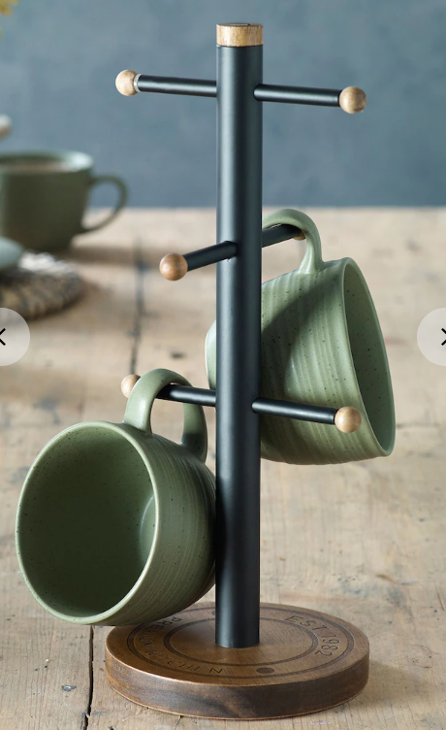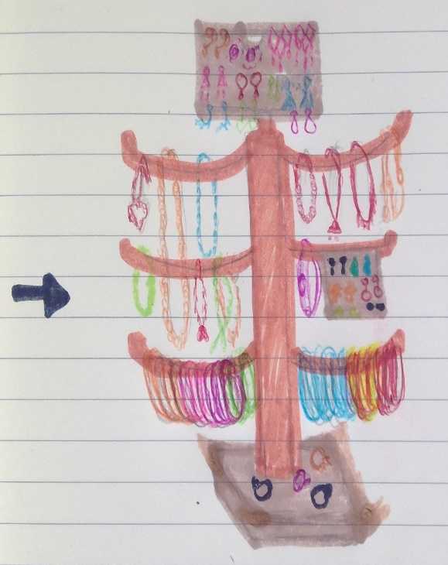
(Image: Amazon, 2023) (Image: Author, 2023)

Introduction

Innovating a cup/mug holder: seeking to create a product that has commercial potential and can generate revenue. The development of an innovative product involves the process of creating a new or improved product that provides unique value to customers and sets itself apart from existing products in the market. This process typically involves several stages, including idea generation, research, design, development, testing, and launching of the product. Innovation may include taking parts off from an existing product, adding parts to it or even modifying the whole design to make it better and more efficient for the same use or putting it to different use totally (Trott, 2016).
 (Image: 42courses, n.d.)
A theory “Six Thinking Hats” by De Bono used during the idea generation phase, individuals wear 6 different coloured hats to brainstorm and identify new product concepts based on market research, customer feedback, or their insights. Once a promising concept is identified, the research phase begins, which involves collecting information about the target audience, competitors, industry trends, and potential barriers to entry (The de Bono Group, 2019).
The cup/mug holder is a widely used product in households and offices to hold cups and mugs. It is a simple and functional product that serves its purpose well. However, there are some limitations to the cup/mug holder, such as it only serves one purpose and is not suitable for holding other items.
To address the limitations of the cup/mug holder and provide more value to customers, the thinking process innovated to a jewellery holder. The concept is to repurpose the design of the cup/mug holder and modify it to hold jewellery. The jewellery holder is designed to hold a variety of jewellery, including necklaces, bracelets, earrings, and rings.

Innovation Thinking Process

Creative thinking and problem-solving are critical parts of creation, turning new ideas into innovations. A method used in creative thinking the SCAMPER technique aims to provide seven different thinking approaches to find innovative ideas and solutions (Cox, 2020).
S – Substitute- a new idea to change the arms design to hold and support jewellery.
C – Combine- Add a mixture of materials, wood and plastic. Reposition arms.
A – Adapt- feature adding and removing the arms and repositioning to create different width shelves.
M – Modify- the circular base can be changed to a square base to give more stable standing support
P – Put to another use- with the above changes the new design will help to put the cup holder to put in alternative use.
E – Eliminate- by taking the top off and redesigning the top to give more usage
R– Revers- rearranging the attached arms can improve the product and put it back to its original use.
Innovating an old cup holder stand into a jewellery holder has several advantages:
- Cost-effective: a way to repurpose an item that might have been thrown away or left unused, saving money, and reducing waste.
- Environmentally friendly: By reusing an existing item reduces the number of resources needed to create a new product, which helps to reduce the planet's carbon footprint.
- Customizable: tailor the design of the jewellery holder to specific needs and preferences, creating a unique piece that reflects one’s style.
- Space-saving: Jewellery can take up a lot of space if not meticulously organized. By using a stand, a person can keep their jewellery in one place, freeing up space on the dresser or countertop.
- Easy to access: A stand allows easy to see and access the jewellery, making it easier to find the pieces you want to wear and reducing the likelihood of items getting tangled or lost.
The design phase begins, which involves creating prototypes and designing the product's features, functions, and overall appearance. The development phase follows, which involves building the product and refining its features and functionality. During this phase, testing is conducted to ensure that the product meets the required standards and functions as intended.
Finally, the product is launched, and its success is measured through customer feedback, sales performance, and other metrics. Throughout the entire process, innovation and creativity are essential to creating a product that meets the needs and desires of the target audience and stands out in a crowded market.

Innovative Jewellery Holder

The jewellery holder has a thick square base that is stable and sturdy with a deep centre. The base is designed to hold the weight of the jewellery and prevent it from tipping over. The holder has hooks and hangers that are strategically placed to hold several types of jewellery. The hooks are designed to hold necklaces and bracelets, while the base is designed to hold earrings/studs and rings.

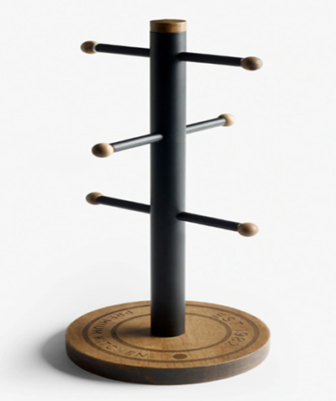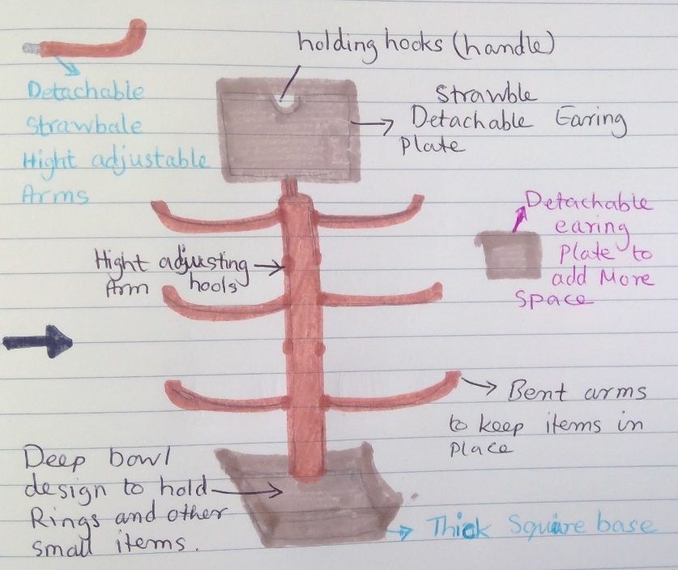
(Image: Amazon, 2023) (Image: Author, 2023)

E-commerce Site: Using SaaS

According to Future Market Insights (FMI) (2023), “Jewellery organizer market is projected to reach a valuation of US$ 27.5 billion in 2023 and is projected to exhibit a CAGR of 8% from 2023 to 2033 and reach US$ 69.25 billion in 2033” as results inventors are producing jewellery organizers with more security boost anti-theft systems with digital and manual key locks. (Future market insights, 2023)
E-commerce sites such as Etsy, and Wayfair offer a wide range of jewellery holders for customers to choose from. The popularity of jewellery holders on Etsy is reflected in the fact that the site has over 10,000 listings for jewellery holders. On Wayfair, jewellery holders are categorized under the "decorative accents" section, indicating that customers view them as a decorative accessory rather than just functional items (Sadia, 2023).
One of the best ways to gauge jewellery holder demand is by looking at e-commerce sites' sales data. Amazon.com, the world's largest e-commerce platform, offers a vast range of jewellery holders from various brands and materials. A quick search on the Amazon website using the keyword "jewellery holder" shows over 5,000 results. The site also features customer reviews, which provide insight into customer preferences and buying behaviour (Amazon, n.d.).

Using a Marketplace

Amazon, Shopify, and eBay are popular marketplaces that provide a large customer base for eCommerce businesses. Listing the innovative jewellery holder on these platforms can increase visibility and potentially attract more customers. But these platforms may also result in increased competition and potentially lower profit margins due to marketplace fees.
One of the best-selling jewellery holders on Amazon is the SONGMICS Jewellery Box, with over 30,000 customer reviews and a 4.7-star rating. The product is a multi-functional jewellery holder that can hold rings, earrings, bracelets, and necklaces. The high number of reviews and high ratings indicate that the demand for this type of jewellery holder is high (Amazon, n.d).

5.2. Statistics Website

According to a report by Statista (2019) the global jewellery market was valued at $278.5 billion in 2018 and is expected to reach $480.5 billion by 2025. The report also indicates that the demand for jewellery holders is on the rise due to the growing popularity of jewellery among consumers. The demand for jewellery holders is expected to increase in line with the growth of the jewellery market (Statista, 2019).
Another report by Grand View Research (ltd, n.d.) indicates that the demand for jewellery storage is expected to grow at a CAGR of 5.1% from 2020 to 2027. The report cites factors such as increasing disposable income and the growing preference for designer jewellery as drivers of the demand for jewellery holders.
Shopify is a popular SaaS platform that provides an easy-to-use and feature-rich interface for building an eCommerce website. With Shopify, the setup process is simple and quick, allowing the website owner to focus on the product and marketing aspects of the business. Shopify also provides a range of useful features, such as inventory management, shipping, and payment processing, which make running an eCommerce store more manageable. (Shopify, n.d.)
 (Image: Shopify, n.d.)

Online Store: available at Shopify: - Nit&Tidy

Innovation is the driving force behind any successful business venture, and the jewellery industry is no exception. A small innovation in the form of a jewellery holder product could attract new customers. Most people still use traditional jewellery boxes or other outdated methods to keep their jewellery organized, which can be cumbersome and inefficient. This product can make a substantial difference. The steps necessary to set up an online business to sell will require stable financing to help get this business off the ground. Some of the steps and options are available which can be considered as follows:
First, step brand name and logo that will help stand out from the competition. Product name "JewelHolder" Next, designing a website that highlights the product and makes it easy for customers to purchase. This will involve choosing a website builder or hiring a web developer, creating product pages and a shopping cart, and setting up a payment system.
Software as a service (SaaS) e.g., Shopify, Amazon or eBay SaaS companies can provide needed business services at a low cost, with due diligence will help ensure the user experience matches expectations and promises (Brook, 2020). Using Software as a service (a software distribution model in which a cloud provider hosts applications and makes them available to end users over the internet) (Chai, n.d.). “Quick Answer: Which Cloud Model Refers to Distribution of Software” AWS (Amazon Web Services) is a comprehensive, evolving cloud computing platform. However, Amazon has a mixture of infrastructure-as-a-service (IaaS), platform-as-a-service (PaaS) and packaged-software-as-a-service (SaaS) to support any business (Barney and Gillis, 2022).
Considering all the available companies, the Shopify platform would be the ideal site to showcase the store and product. As Shopify is one of the most known, established, and popular companies giving great offers for new entrants selling for £1 a month for 3 months, a great trialling period for new products and also, other benefits like:
- Create and customize an online store.
- Sell in multiple places, including web, mobile, social media, online marketplaces, brick-and-mortar locations, and pop-up shops.
- Manage products, inventory, payments, and shipping.
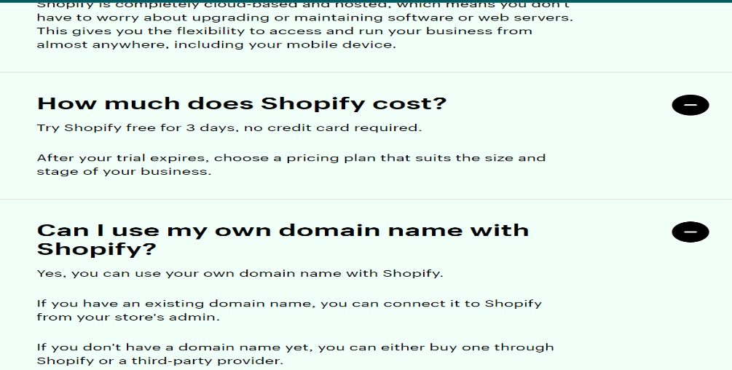 (Image: Shopify, n.d.)
To appeal to customers will propose an online retail store called Nit&Tidy that is user-friendly and easy to navigate. The jewellery holder online business is an excellent opportunity to leverage technological advancements and create a saleable product. The online retail store will be user-friendly and features a personalized recommendation system. This business model provides a unique and personalized shopping experience that is sure to appeal to customers.
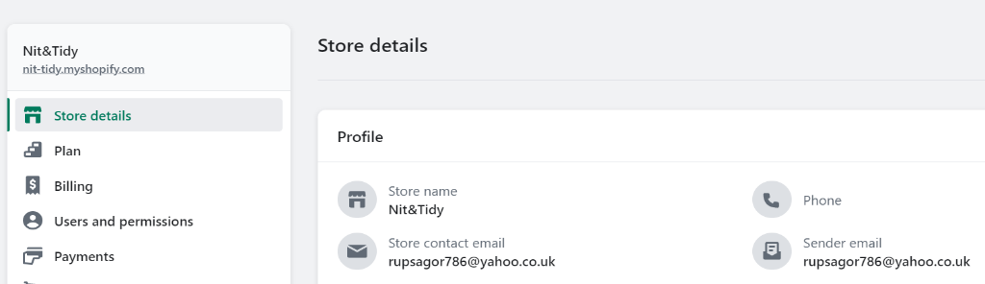
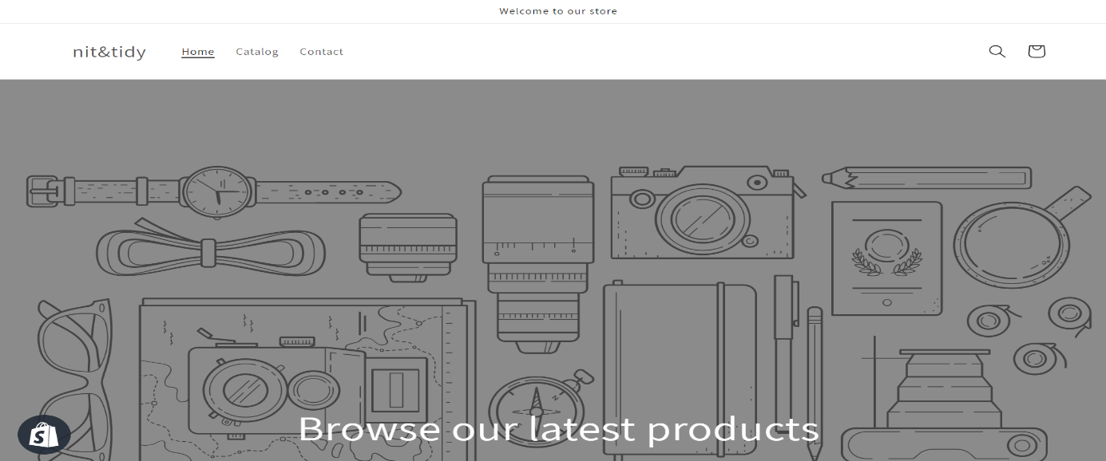

  - Creating Content
Content creation is an essential aspect of any eCommerce business. Includes creating high-quality copy and photography that highlights the innovative jewellery holder and its unique features. Display clear images of the jewellery holder from various angles, concise, and informative, highlighting the benefits of the product and addressing any potential customer concerns.
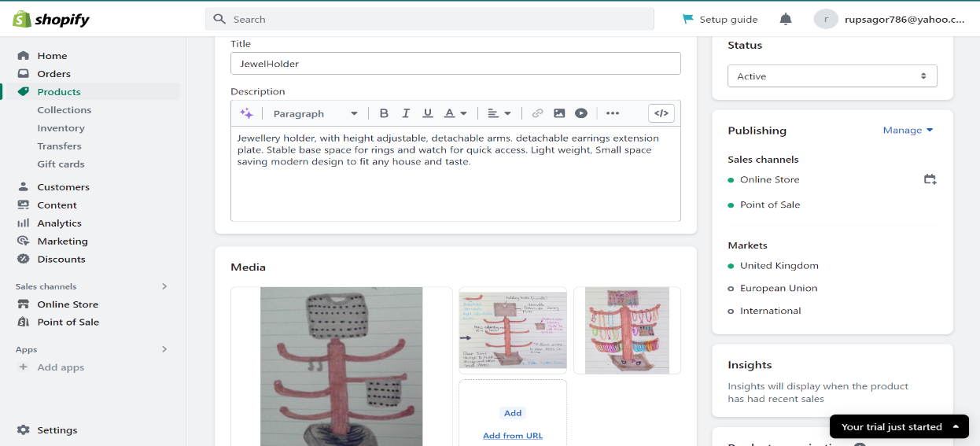
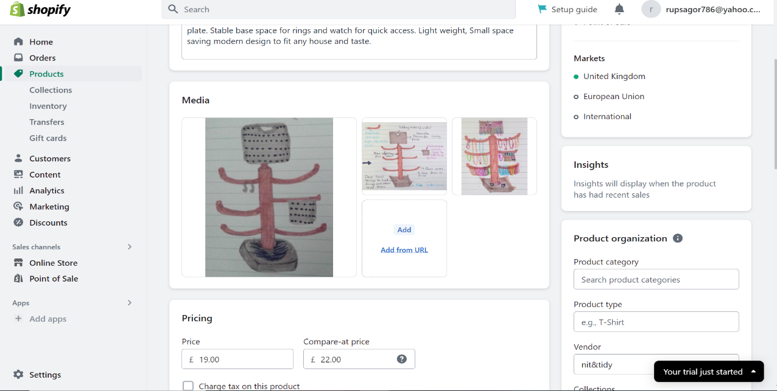

PCI-DSS Compliance

PCI-DSS (Payment Card Industry Data Security Standard) is a set of security requirements for businesses that accept credit card payments. Compliance with PCI-DSS is necessary to protect customer data and prevent potential fraud. It is important to ensure that the eCommerce website meets all PCI-DSS compliance requirements, such as using secure payment gateways, protecting customer data, and implementing regular security checks (Businesses, 2022).

To register for PCI-DSS compliance in the UK, the online business must follow these steps:
- PCI-DSS compliance levels are determined based on the number of transactions processed per year. The business must determine which level of compliance they fall into (Businesses, 2022).
- Complete a Self-Assessment Questionnaire (SAQ): designed to assess the business's compliance with the PCI-DSS standards. The form will be completed in the SAQ that corresponds to the business level of compliance.
- Submit the SAQ: submit it to their merchant bank or payment processor by the business owners.
- implement security measures: including firewalls, anti-virus software, encryption, and secure data storage. The security measures placed will be according to compliance with the PCI-DSS standards.
- Schedule regular audits: To maintain PCI-DSS compliance, schedule regular audits to ensure that business security measures remain up to date. To maintain customer card details (Businesses, 2022).

  - 7.2. Payment System
Accepting payments through PayPal is a secure and convenient way to conduct online transactions. PayPal is a well-established payment system that is widely accepted and trusted by consumers and businesses alike. Customers can make payments using their PayPal account or credit/debit card, and the business can easily receive and manage payments through its PayPal account. Convenient for small businesses like Nit&Tidy.
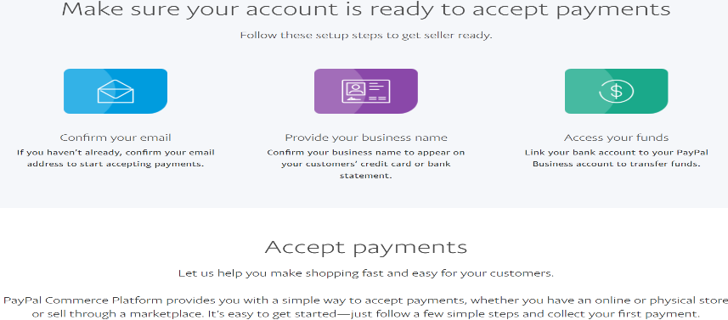 (PayPal, n.d.)
To register the business with PayPal, need to make an account using an email address, and provide the business name in the way it should appear on the customer's account. Also, add credit card details. To access the fund business bank account will be linked with a PayPal account (PayPal, n.d.).

Financing the Innovation

Setting up an online business to sell products will require careful planning and financing, but with the right approach, it could be a profitable and rewarding venture. One of the biggest challenges when starting a new business is financing.
There are several finance options and suggestions to consider when setting up an online business.
Personal savings or borrowing from friends and family. This is often the easiest and least expensive option, but it does come with some risks, if things do not go well could potentially lose all personal savings or damage relationships with loved ones (Transmit Startups, n.d.).
Another option is to seek funding from angel investors. This could include investors or venture capitalists who are interested in investing in innovative startups. This will be required to create a formal prospectus document (pitch deck) and present the business idea to potential investors, highlighting the potential for growth and profitability. This can be a challenging process, but if successful, it could provide the funding needed to get the business started (Lane, 2021).
Applying for a small business loan. Many banks and financial institutions offer loans specifically for small businesses, which could be a good option if you have a solid business plan and financial projections. However, this option does come with interest and fees, so it's important to carefully consider whether it's the best option for your specific situation (Transmit Startups, n.d.).
After exploring the options, the best way to start this small venture would be to use personal savings followed by borrowing from friends and family if later required. Using personal savings would be wise, if any loss does occur the impact will be less straining compared to borrowing from a third party.

Market and Customer

The jewellery holder market has experienced significant growth in recent years, driven by a combination of changing consumer preferences and an increased demand for organization and convenience. Jewellery holders are used to store and displaying jewellery and can range from simple and functional designs to elaborate and decorative pieces. By organizing their jewellery in a holder, consumers can reduce the time and effort it takes to find the pieces they want to wear, as well as prevent damage or loss of their favourite pieces (Larsson, 2021).
Another factor driving growth in the jewellery holder market is the rise of online shopping. With the ease and convenience of online shopping, consumers have access to a wider variety of jewellery options than ever before. As a result, they are more likely to purchase multiple pieces and need a way to organize and store them. Jewellery holders offer a practical and visually appealing solution to this problem (Larsson, 2021).

9.2. Customer Segment
The customer base for jewellery holders is also diverse and varied. Women are the primary customers for jewellery holders, although men are also starting to use them to organize their accessories. According to Classy Women Collection (2023), Customers range from young adults to seniors, with different age groups preferring diverse types of jewellery. For example,
- Most active shoppers: Married 25-34-year-old women with an average salary buy the most jewellery.
- Biggest spenders: High-income people in the age group 45-54 spend the most money on jewellery, consuming $304.6 worth of jewellery every year.
- Younger consumers: prefer more modern and colourful designs, while older consumers may prefer more classic and traditional designs.
- Jewellery collectors: Individuals who own an enormous collection of jewellery may be interested in a jewellery holder as a way to keep their pieces organized and easily accessible (Classy Women Collection, 2023)
- Fashion enthusiasts: People who are interested in fashion and accessories may be drawn to a stylish and unique jewellery holder that complements their style.
- Gift buyers: For occasions such as birthdays, anniversaries, or holidays. Customers who are looking for a practical and thoughtful gift may consider a jewellery holder for their loved ones.
- Travellers: Individuals who frequently travel and bring their jewellery with them may find a jewellery holder useful.
- Minimalists: People who prefer a minimalist lifestyle may appreciate a simple and functional jewellery holder that helps them keep their space clutter-free while still providing a practical storage solution for their jewellery (Classy Women Collection, 2023).
In terms of purchasing habits, customers typically buy jewellery holders either as a practical solution for organizing their jewellery or as a decorative item to add to their home décor.
  - Product Positioning
The price point would be competitive with other jewellery holders in the market while also reflecting the value provided by the innovative design. The product can be priced at a premium if it is made from high-quality materials such as solid wood or metal. Alternatively, it can be priced affordably if made from more economical materials such as plastic or acrylic.
As the target market ranges between young adults 25 years to 54 years mature people. Young professional, average to high-end salary customers. To catch the market, to begin with, it will be wise to price the innovative product at the mid-range of £18-22 to make it affordable to everyone.
These days from very young to old adults everyone uses digital platforms such as popular majority social media sites. To promote this product, the following suitable marketing strategies will be implemented.
9.4. Marketing
Social media platforms like Facebook, Instagram, and Pinterest will be used to promote the product. This strategy will include creating engaging content that displays the features and benefits of the product. This will be done by registering on the sites, posting images of the product in use, customer reviews, and promotions.

Online Business Analysis and Strategic Solutions

4Ps Innovation Options

To stand out in the market, Urgency to produce 4Ps innovation options:
- Product: introduce new materials for jewellery holders, such as sustainable materials, to appeal to environmentally conscious customers.
- Price: place a subscription service for customers who frequently purchase jewellery holders, offering discounts and exclusive products.
- Place: partner with popular influencers to promote brands and products on social media platforms.
- Promotion: create engaging and interactive social media campaigns to promote products and increase brand awareness. Paid Search Engine Advertising: Pay-per-click advertising on Google will be utilized to target potential customers searching for jewellery storage solutions. This strategy will involve bidding on keywords related to jewellery storage and targeting specific demographics and geographical areas (Patel, 2020).

  - 4Ps Marketing Mix Directions:
To effectively market the product, inevitability needs to focus on the 4Ps marketing mix:
- Product: crucial to ensure that the products are of high quality, unique, and meet the needs of the targeted market segment.
- Price: fundamental to ensure the pricing is competitive and offers value for money to the customers.
- Place: it is a requirement for product sell to ensure items are available on various online marketplaces and websites, making it easy for customers to purchase.
- Promotion: as an online business it’s vital to invest in digital marketing strategies such as search engine optimization, social media advertising, and email marketing to increase brand awareness and drive traffic to the website.
The online jewellery holder business is a highly competitive market, and staying ahead of the competition requires strategic solutions, innovative 4Ps options, and effective marketing mix directions. By focusing on unique designs, enhancing the customer experience, investing in marketing, and ensuring price competitiveness, a business can successfully compete in the market and increase market share (Patel, 2020).

Feasibility of the online business

The proposed online business will specialize in selling jewellery holders. The business will operate entirely online, with a website where customers can browse and purchase products which accept payment through PayPal. The business will use a drop shipping model, products will be shipped directly from the manufacturer to the customer. This will eliminate the need for a physical warehouse, reduce overhead costs, and allow the business to offer a wider variety of products without the need for a large inventory.

Gain Competitive Advantage

The online business will focus on providing high-quality products at affordable prices. The cost of product design, manufacturing, marketing, and customer service needs to be kept low to ensure profitability. Needs of establishing a strong partnership to ensure a reliable supply chain and a robust marketing strategy. The key resource for an online business is a strong online presence. The target customers will be given high priority to customers' urgent need for the product with fast shipping. The revenue streams for business will be coming from various sources such as the sale of jewellery holders, subscription-based services, and online advertising revenue. The sale of jewellery holders can be the primary source of revenue for the business. The value proposition is to provide customers with a convenient and easy way to store their jewellery and responsive customer service. The business will try to continuously innovate and design new products to stay ahead of the competition.

Sustainability of products and business

The jewellery holder market is a highly competitive industry with various already established companies in the market. Therefore, for a new entrant, it is essential to identify strategies that can help sustain a business overall. To sustain an innovative jewellery holder online business, it is a requirement to know its weaknesses and its competitor’s strengths and their selling strategies, and how to differentiate from them to gain competitor's advantages. Swot's business model will help establish the pro and cons of the innovation idea (Sagaran, 2021).

14.1 Swot Analysis
The competitors such as The Container Store, Amazon, and Etsy. These competitors have established market positions and loyal customers.
To differentiate from competitors, innovative and unique strategies need to be adapted:
a) Developing a unique design that is not available in the market.
b) personalized jewellery holders can attract customers who are looking for unique products.
c) Offering high-quality products can differentiate from competitors who offer low-quality products.
d) Offering eco-friendly jewellery holders can attract customers who are conscious of the environment.
Therefore, sustaining an online business in the jewellery holder market requires a unique selling proposition, active customer engagement, and continuous improvement. Competitors in the industry can be differentiated through quality and sustainability.
1) Developing a Unique Selling Point (USP): A USP is essential and will help sustain an online business.
2) Engagement with customers: This will be achieved through social media marketing, email marketing, and prompt customer service.
3) Upselling is a technique of selling premium products to customers who are already buying. Cross-selling is a technique of selling complementary products to customers. These techniques can be used to increase sales and revenue.
4) To create a seamless shopping experience, the online store will have a virtual try-on feature that allows customers to see how the jewellery holder looks in their home. Customers can upload a picture of their room, and the virtual try-on feature will superimpose the jewellery holder onto the image. This will give customers a better idea of how the holder will look in their home before they make a purchase.
5) To sustain a business, it is necessary to continuously improve products and services based on customer feedback. Understanding the competitors' strategies can help develop an effective marketing plan for a new entrant (Sagaran, 2021).

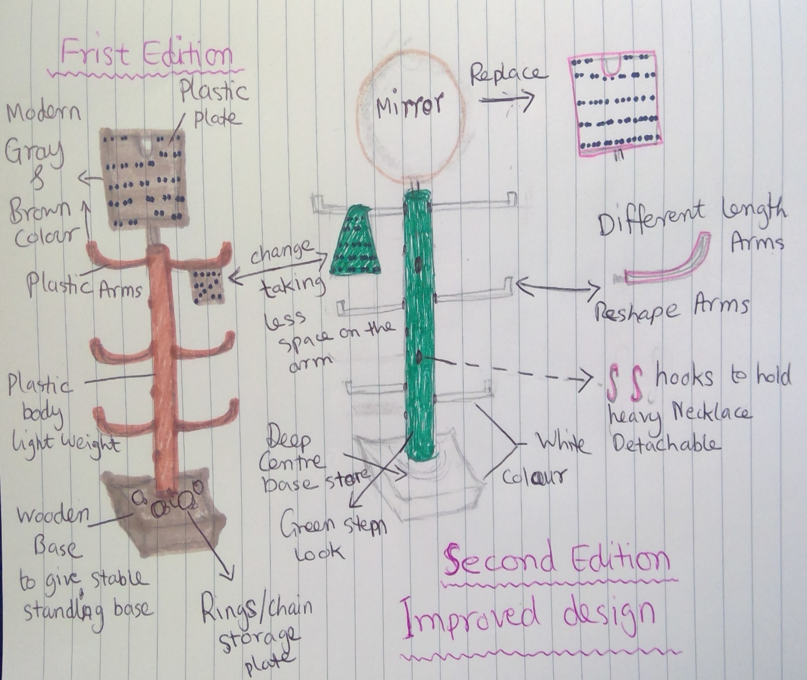
(Image: Author, 2023)

Value Chain of Online Business

The value chain of a jewellery holder online business includes many aspects:
Designing-product to meet customer needs cost-effectively. As the jewellery holder is an improvement of an existing product will have less cost to manufacture, which can be available to the customer at a low price.
Sourcing- existing materials will be sued any additional materials will be plastic/acrylic minus the cost (Sagaran, 2021).
Manufacturing- modifying, cutting and shaping the Jewel Holder from the cupholder will be done in an efficient and cost-effective not wasting material but maintaining a high-quality finish.
Marketing- as it is an online business majority of the targeted customers are noticeable on the online social platform. Online advertising, social media, and influencer marketing are common tactics used to promote.
Selling- having the product available for purchase online, through third-party marketplaces such as Shopify. Providing fast and reliable shipping is crucial at this stage.
Delivering- products to customers in a timely and secure manner. This includes managing inventory, shipping logistics, and handling any returns or exchanges promptly.
Throughout the value chain, keeping and maintaining strong relationships with suppliers, partners, and customers is crucial to maximizing profits and building a successful business. Additionally, regularly analysing and optimizing customer activities will help the value chain can identify areas for improvement and ensure continued growth (Sagaran, 2021).

The Life Cycle of Online Business

- Planning, developing and launching – conducting research using an online platform on target customers such as 25-54 years of age will be the targeted customers. The online shop will have the designs to get the attention of a diverse audience with relevant content. Launching promotions and offers to persuade the customer to buy.
- Growth - essential to have enough jewel holders and human resources available for customer's demand and prompt shipping and delivery (MerchantYard, n.d.).
- Maturity- by analysing the buying habits of customers loyal customers would be established to give extra attention to their needs to give them happy, maybe start modifying new designs to further the innovation.
- Decline- new designs will be used and additional products would be promoted along the Jewel Holder to complement new market strategies will be launched to stay on the market as the competition and customer habits change (Merchant Yard, n.d.).

Putting it to Another Use

The jewellery holder can be used in other diverse ways to give a longer life span for the product. Furthermore, applying SCAMPER theory.
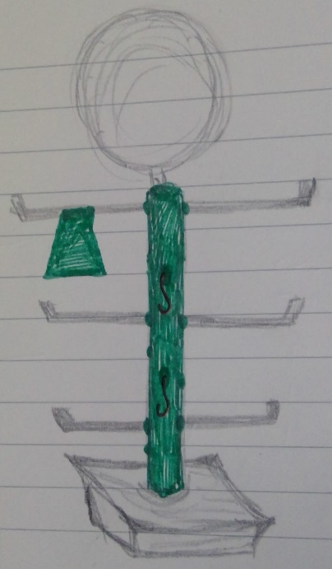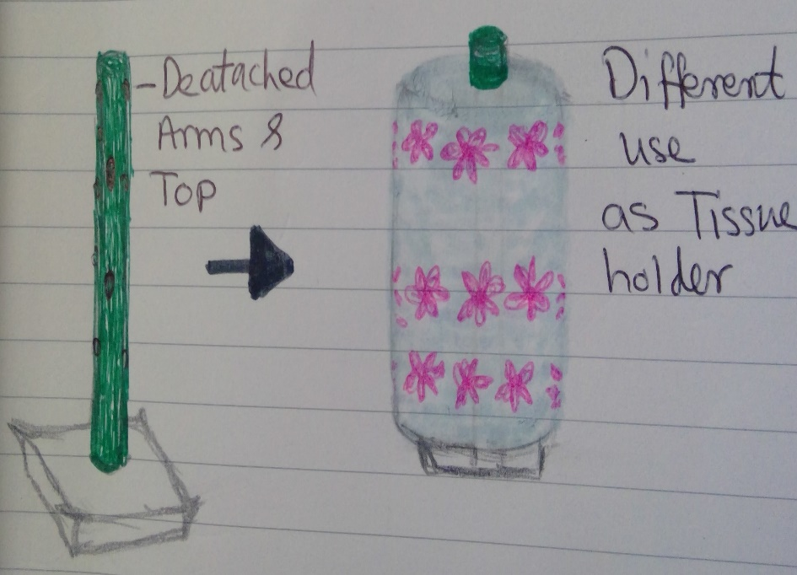
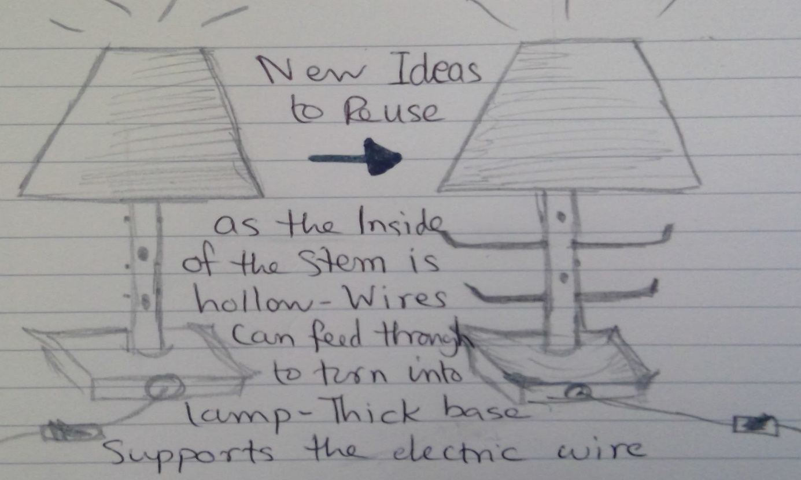(Image: Author, 2023)
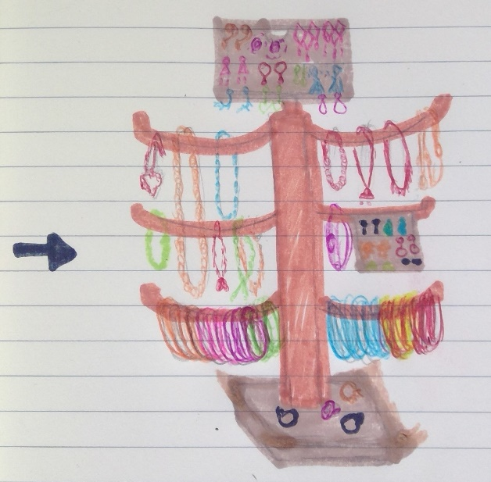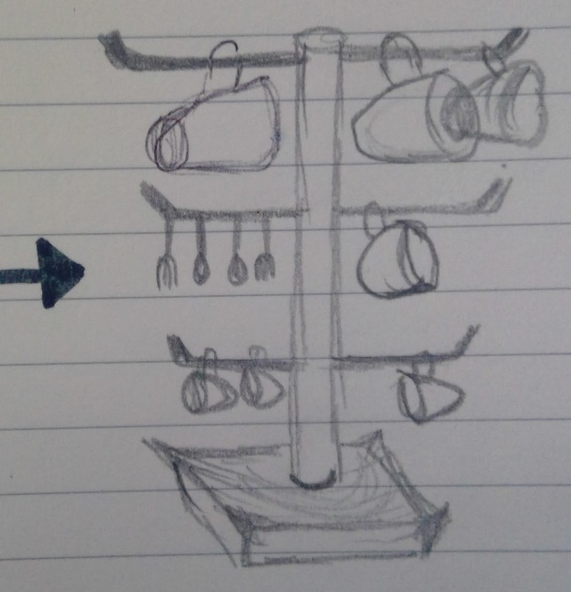
(Image: Author, 2023)

18.1. GDPR/Privacy and Data Protection

As online businesses continue to grow and thrive, privacy and data protection are becoming increasingly important. To protect the sensitive information of customers and comply with relevant regulations, businesses need to be aware of the UK GDPR/Data Protection It covers the UK General Data Protection Regulation tailored by the Data Protection Act 2018 and Privacy and Electronic Communication Regulations (PECR). The annual fee depends on your size and turnover. According to Government Digital Service (2012), fees start from £40 or £60 for most organisations, including charities and small and medium-sized businesses. Larger businesses with high employees and a high annual turnover fee can rise to £2,900.
18.2. Privacy and Electronic Communication Regulations (PECR):
The PECR governs the use of electronic communication, including email, text messages, and cookies. Companies must obtain consent before sending marketing communications and must provide a clear and effortless way for customers to opt out of receiving such communications. It is also important to note that cookies, which are used to track website activity, must be disclosed to users (Govuk, 2018).
18.3. The Need for Consent:
One of the key requirements of both the GDPR and PECR is the need for consent. Businesses must obtain valid and informed consent from customers before collecting and processing their data or sending marketing communications. Consent must be freely given, specific, and informed, customers must understand what they are consenting to and be given the option to refuse (GOV.UK, 2018) will be visible on the online site for customers to choose from.
18.4. Provision of Facility to "Opt Out" of Marketing Communications:
A clear and straightforward way for customers to opt out of receiving marketing communications. This will be achieved through an unsubscribe link in emails. Customers must be able to opt out at any time, after a customer decides to opt-out, marketing communications will not be sent (GOV.UK, 2018).
  - The Need to Support Rights such as "the Right to Erasure":
Under the GDPR, customers have the right to request that their data be deleted. This is known as the "right to erasure". By law, organisations must have processes in place to respond to such requests and must ensure that any personal data is securely deleted (GOV.UK, 2018).
  - Security and the Importance:
Security is of utmost importance when it comes to privacy and data protection. The online store will adhere to compliance rules to secure access to the customer cloud provider and sensitive data is not accessible by default. Regular changes to access rights can also help to prevent unauthorized access. Encrypting traffic both in transit and at rest can also help to protect against data breaches and cyber-attacks (GOV.UK, 2018).

Conclusion

In conclusion, privacy and data protection are essential for any online business. Compliance with the GDPR/Data Protection Act 2018 and PECR is necessary to protect customer data and prevent regulatory violations. Consent, the provision of an opt-out facility, the right to erasure, and security measures are all critical components of a comprehensive privacy and data protection strategy. By taking the necessary steps to protect customer data, businesses can build trust and loyalty with their customers.
The demand for jewellery holders is increasing due to their functionality, aesthetic appeal, and the increasing trend of people owning more jewellery (Future market insights, 2023). Online research from eCommerce sites, statistical websites, and the value chain of jewellery holders indicates that the demand for jewellery holders is expected to continue to grow. Using various marketing channels to reach them and considering the customer journey to optimize the marketing strategy. By implementing these strategies, the product is likely to gain increased visibility and generate sales. Placing an easy-to-use platform like Shopify, listing the product on popular marketplaces like Amazon and eBay, creating high-quality content, and ensuring PCI-DSS compliance, the eCommerce store can attract more customers, increase sales, and provide a secure and ensure long-term success. Accepting payments through PayPal will provide a secure and convenient payment system for both the business and its customers. The proposed online business of selling jewellery holders and using PayPal as a payment system is a feasible and potentially profitable venture.

Reference
42courses.com. (n.d.). Six Thinking Hats. [online] Available at: https://blog.42courses.com/home/2018/6/13/six-thinking-hats [Accessed 20 Apr. 2023].
Amazon.co.uk. (2023). Amazon.co.uk : Mug Holders. [online] Available at: https://www.amazon.co.uk/Mug-Holders/b?ie=UTF8&node=3313572031 [Accessed 7 Apr. 2023].
Barney, N. and Gillis, A.S. (2022). What is AWS (Amazon Web Services) and How Does it Work? [online] SearchAWS. Available at: https://www.techtarget.com/searchaws/definition/Amazon-Web-Services#:~:text=AWS%20(Amazon%20Web%20Services)%20is [Accessed 10 Apr. 2023].
Brook, C. (2020). What is a SaaS Company? [online] Digital Guardian. Available at: https://www.digitalguardian.com/blog/what-saas-company [Accessed 10 Apr. 2023].
Businesses, F., The Federation of Small (2022). How to become PCI compliant. [online] www.fsb.org.uk. Available at: https://www.fsb.org.uk/resources-page/how-do-i-become-pci-compliant.html [Accessed 20 Apr. 2023].
Chai, W. (n.d.). What is SaaS (Software as a Service)? Everything You Need to Know. [online] SearchCloudComputing. Available at: https://www.techtarget.com/searchcloudcomputing/definition/Software-as-a-Service#:~:text=Software%20as%20a%20service%20(SaaS)%20is%20a%20software%20distribution%20model [Accessed 10 Apr. 2023].
Classy Women Collection. (2023). Jewelry Market Statistics. [online] Available at: https://classywomencollection.com/blogs/fashion-guide/jewelry-market#:~:text=Biggest%20spenders%3A%20High%2Dincome%20people [Accessed 19 Apr. 2023].
Cox, A. (2020). Use This Ideation Brainstorming Technique. [online] Netmind. Available at: https://netmind.net/en/scamper-technique-reduce-reuse-recycle-or-reinvent/#:~:text=The%20SCAMPER%20Technique%20is%20a [Accessed 20 Apr. 2023].
Gov.Uk (2018). Data Protection. [online] gov.uk. Available at: https://www.gov.uk/data-protection#:~:text=The%20Data%20Protection%20Act%202018%20is%20the%20UK [Accessed 14 Apr. 2023].
Gov.Uk. (n.d.). Finance and support for your business. [online] Available at: https://www.gov.uk/business-finance-support?types_of_support%5B%5D=finance [Accessed 13 Apr. 2023].
Government Digital Service (2012). Data protection register: notify ICO about personal data. [online] GOV.UK. Available at: https://www.gov.uk/data-protection-register-notify-ico-personal-data [Accessed 20 Apr. 2023].
Larsson. J, (2021). Why are Jewellery Boxes Important? [online] Jacqui Larsson Fine Jewellery. Available at: https://www.jacquilarsson.com/why-are-jewellery-boxes-important/ [Accessed 20 Apr. 2023].
Lane, M. (2021). 6 easy ways to get finance for your business | money.co.uk. [online] www.money.co.uk. Available at: https://www.money.co.uk/business-loans/6-easy-ways-to-get-finance-for-your-business [Accessed 13 Apr. 2023].
ltd, R. and M. (n.d.). Jewelry Market Research Reports. [online] www.researchandmarkets.com. Available at: https://www.researchandmarkets.com/tag/jewelry?ac=true [Accessed 12 Apr. 2023].
Merchant Yard. (n.d.). E-Commerce Business Life Cycle. [online] Available at: https://www.merchantyard.com/blog/e-commerce-life-cycle [Accessed 20 Apr. 2023].
Nandi, S. (2023). Boost Your Business: Digital Marketing Strategies for Home Service Providers. [online] Techno FAQ. Available at: https://technofaq.org/posts/2023/03/boost-your-business-digital-marketing-strategies-for-home-service-providers/ [Accessed 14 Apr. 2023].
Patel, N. (2020). The 4 Ps of Marketing: A Step-by-Step Guide (With Examples). [online] Neil Patel. Available at: https://neilpatel.com/blog/4-ps-of-marketing/ [Accessed 20 Apr. 2023].
Pumpo, A. (2019). SCAMPER Technique for Creative Thinkers. [online] Europass Teacher Academy. Available at: https://www.teacheracademy.eu/blog/scamper-technique-for-creative-thinkers/.
Sadia, S. (2023). 6 Best Marketplaces To Sell Jewelry Online and Increase Sales. [online] rextheme.come. Available at: https://rextheme.com/marketplaces-to-sell-jewelry-online/ [Accessed 13 Apr. 2023].
Sagaran, R. (2021). 5 Tips for Becoming a Sustainable and Ethical Jewelry Brand. [online] Picup Media. Available at: https://picupmedia.com/blog/5-tips-for-becoming-a-sustainable-and-ethical-jewelry-brand/ [Accessed 20 Apr. 2023].
Shopify. (n.d.). Create your online store today with Shopify. [online] Available at: https://www.shopify.com/uk/free-trial?term=shopify%20jewelry%20stores&adid=565806899920&campaignid=15439902872&branded_enterprise=1&BOID=brand&gclid=CjwKCAjw586hBhBrEiwAQYEnHcAJCJ1NRt2MQPrOir7yWmRq3caWmtjyw7aPhAR9bctctBqLnakcABoCXj8QAvD_BwE&cmadid=516586848 [Accessed 10 Apr. 2023].
Statista. (2019). Statista - The Statistics Portal. [online] Available at: https://www.statista.com/markets/ [Accessed 10 Apr. 2023].
Trott, P. (2016) Innovation Management and New Product development. Sixth edition. Pearson Education.
The de Bono Group (2019). Six Thinking Hats – De Bono Group. [online] The de Bono Group. Available at: https://www.debonogroup.com/services/core-programs/six-thinking-hats/ [Accessed 20 Apr. 2023].
Transmit Startups. (n.d.). Guide to funding a new business | Business Start Up Loans & Mentoring. [online] Available at: https://www.transmitstartups.co.uk/guides/guide-to-funding-a-new-business [Accessed 13 Apr. 2023].
Transmit Startups. (n.d.). How much does it cost to start a business? | Business Start Up Loans & Mentoring. [online] Available at: https://www.transmitstartups.co.uk/business-planning/how-much-does-it-cost-to-start-up-a-business#:~:text=Sole%20trader%20%2D%20registering%20as%20a [Accessed 25 Apr. 2023].
www.amazon.co.uk. (n.d.). https://www.amazon.co.uk/Jewellery-Boxes-Holders-Stackers-Hangers/b?ie=UTF8&node=197340031. [online] Available at: https://www.amazon.co.uk/Jewellery-Boxes-Holders-Stackers-Hangers/b?ie=UTF8&node=197340031 [Accessed 10 Apr. 2023].
www.futuremarketinsights.com. (2023). Jewelry Organizer Market. [online] Available at: https://www.futuremarketinsights.com/reports/jewelry-organizer-market [Accessed 10 Apr. 2023].
www.paypal.com. (n.d.). How to set up a PayPal Business account | PayPal UK. [online] Available at: https://www.paypal.com/uk/business/getting-started [Accessed 19 Apr. 2023].

