University of Wales Trinity Saint David.
School of Computing.
Nicholas Jones, P149676
11/01/2018
Electrical & Electronic Principles (ACDA4002).
Lecturer, Dr Stephen Mosey.

Assignment 1.



Abstract.

Contents
Abstract. i
1 Introduction. 1
1.1 Aims. 1
1.2 Objectives. 1
2 Background research and theory. 2
2.1 Schematic, component values and abbreviations used. 2
2.2 Reactance (X). 3
2.3 Impedance (Z). 3
2.4 Resonant frequency. 3
2.5 Quality factor (Q-factor). 5
3 Theoretical measurements for this RLC circuit. 6
3.1 Resonant frequency. 6
3.2 Reactance at resonance. 6
3.3 Q-Factor. 6
4 Real components, building and testing. 7
4.1 Results, real components. 8
4.1.1 Results populated in Excel. 8
4.1.2 Vlc response curve created in Excel (Real). 9
4.1.3 Q-Factor, real components. 9
4.1.4 Comparison of theoretical and actual measurements (real components). 10
4.1.4.1 Theoretical and measured resonant frequency. 10
4.1.4.2 Theoretical and calculated ‘Q’. 10
5 Proteus simulation, building and testing. 11
5.1 Results, Proteus simulation. 11
5.1.1 Results populated in Excel. 11
5.1.2 Vlc response curve created in Excel (Proteus). 12
5.1.3 Q-Factor, Proteus. 12
5.1.4 Comparison of theoretical and actual measurements (Simulation). 13
5.1.4.1 Theoretical and measured resonant frequency. 13
5.1.4.2 Theoretical and calculated ‘Q’. 13
5.1.5 Proteus results using response curve from Capacitor. 13
5.1.5.1 Response curve from all measured voltages and currents. 14
5.1.5.2 Q-Factor, using Capacitor response curve (Proteus). 14
5.1.5.3 Comparison of results. 15
6 Conclusion. 16
7 References. 17
8 Bibliography. 17

Figure 1 Schematic used. 2
Figure 2 Q response curve formula. 5
Figure 3 Vlc response curve created in Excel (Real). 9
Figure 4 Vlc response curve created in Excel (Proteus). 12
Figure 5 Vrlc response curve created in Excel (Proteus). 14

Table 1 Real components results. 8
Table 2 Proteus components results. 11

Introduction.

Aims.
The aim of this assignment is to gain experience, knowledge and an understanding in measurement and data analysis of a circuit.
Conducting tests in a simulation environment and with real components will be done, results will be analysed and compared against theory.

Objectives.
The circuit provided will be built in Proteus and voltage measurements across the components will be taken at differing frequencies from an AC power source, the results will be logged in a table format and a graph will be produced. The results will be analysed to determine the resonant frequency and the Q-factor and compared with theoretical and real component results.
The same circuit will be built using real components and the same tests will be conducted where results will be analysed to determine the resonant frequency and Q-factor these results will used for analysis.
Research into AC circuits and the behaviour of components being used will be done. Then theoretical calculations for the assigned circuit will be completed, the results will be used firstly to determine the boundaries needed when using simulation and real components and then for comparison with results gained from simulation and real component test.

Background research and theory.
Before proceeding with real tests and measurements research into AC circuits and how they should behave theoretically was done. By understanding how each component behaves within the circuit will help with the understanding and the analysis of the results.

Schematic, component values and abbreviations used.
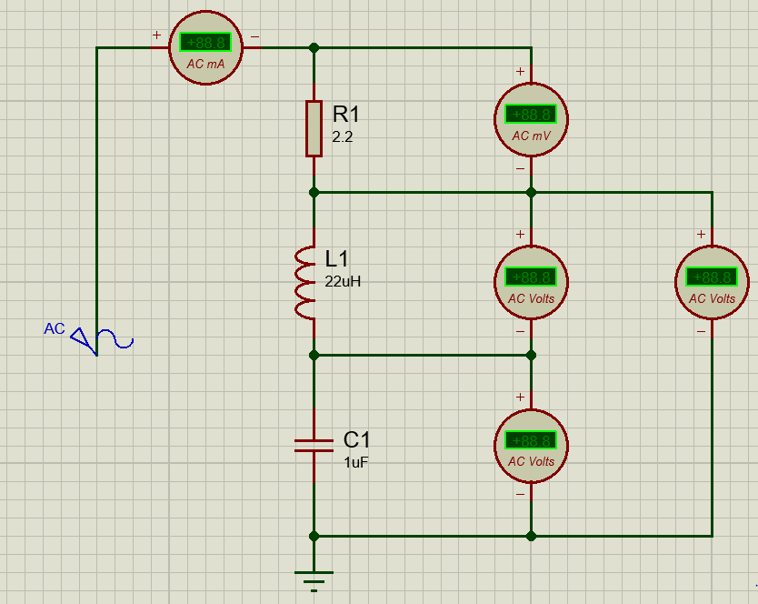
Figure 1 Schematic used.
- Resistor = 2.2Ω
- Inductor = 22µH (22x10⁻⁶)
- Capacitor = 1µF (1x10⁻⁶)

- R = Resistor in Ohms (Ω)
- X = Reactance in Ohms (Ω)
- Z = Impedance in Ohms (Ω)
- f = Frequency in Hertz (Hz)
- L = Inductance in Henrys (H)
- C = Capacitance in Farads (F)
- I = Current in Amps (A)

Reactance (X).
When a capacitor or an inductor is used in an AC circuit they inhibit some resistance to current flow this is called reactance, like a resistor reactance is measured in ohms but unlike a resistor the magnitude of current flowing is dependent upon the value of capacitance or inductance and the frequency of the applied voltage. [1, p. 72] Reactance is represented by an ‘X’ when working with equations and abbreviations.
When there is both capacitive and inductive components total reactance (X) within an AC circuit is the sum of inductive reactance (X_{L}) minus capacitive reactance (X_{C}).
Inductive reactance formula.
X_{L} = 2π f L
Capacitive reactance formula.
X_{C} = $\frac{1}{2π f C}$

Impedance (Z).
Impedance represented by a ‘Z’, is measured in ohms and exist when an AC circuit has both resistance and reactance components to it. [1, p. 74] Impedance can be thought of as total overall resistance of an AC circuit. Pythagoras theorem is used to calculate impedance by the following formula.
$$Z= \sqrt{R^{2}+X^{2}}$$
Note: Impedance is equal to R when circuit is at resonance.

Resonant frequency.
The circuit to be analysed is a series Resistor Inductor Capacitor (RLC) circuit.
When a circuit contains a Capacitor and an Inductor it has both inductive and capacitive reactance, these types of circuits are also known as ‘tuned circuits or resonant circuits’. This type of circuit has a certain frequency to which it is resonant, that is inductor reactance is equal to capacitor reactance. [2, p. 2.54]

To establish theoretical resonance of the circuit then a mathematical formula (below) is used.
$f= \frac{1}{2π\sqrt{CL}}$
Note: The amplitude of applied voltage does not affect the resonant frequency.

Quality factor (Q-factor).
Q-factor is used to measure the quality of a resonant circuit. If the Q-factor is high, then the circuit has a narrow bandwidth resulting in a sharper response curve on the other hand a low Q-factor will have a wider bandwidth with a flatter response curve. The higher the Q-factor the more desirable it is to have when being used in circuits. Q-factor has no unit associated with it and “is the ratio of power stored to power dissipated in the circuit”. [3]
To calculate Q-factor from a response curve the bandwidth is needed, to establish bandwidth a -3dB of the peak value on the response curve must be found from there the lower and upper cut off frequencies is used, bandwidth is then equal to the sum of the upper frequency minus the lower frequency. Once the bandwidth is known Q-factor can be calculated.
The image below shows the formula for Q-factor and a response curve.
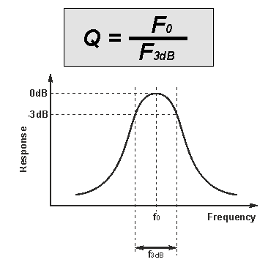 [4]
Figure 2 Q response curve formula.

Theoretical measurements for this RLC circuit.

Resonant frequency.
$f= \frac{1}{2π\sqrt{CL}}$
Square root of CL = √22x10⁻⁶ x 1x10⁻⁶
Square root of CL = 4.69x10⁻⁶
f = 1 / (2 x π x 4.69x10⁻⁶)
f = 33934.96Hz
Expected resonant frequency is just under 34KHz.

Reactance at resonance.
X_{L} = 2π 33934.96 x 22x10⁻⁶
X_{L} = 4.6908Ω
X_{C} = 1 / (2π 33934.96 x 1x10⁻⁶)
X_{C} = 4.69Ω
X = 0.0008Ω
Note: $\sqrt{\frac{L}{C}}$ = Reactance of either Xc or Xl at resonance. (4.69Ω)

Q-Factor.
Theoretical Q-factor for this circuit can be calculated using the following formula.
Q = $\frac{1}{R}$ x $\sqrt{\frac{L}{C}}$
Q = 0.4545 x √22
Q = 2.1318

Real components, building and testing.
The circuit was built on a breadboard, components used was one resistor of value 2.2Ω, one inductor of value 22µH and one capacitor with a value of 1µF. The position of the components where such as to make a series ‘Resistor Inductor Capacitor’ (RLC) circuit. A function generator was used to provide an AC sine wave with a constant amplitude at various frequencies. A two-channel oscilloscope was used to measure voltages within in the circuit where channel one was connected to the output of the function generator and channel two connected across the relevant components.
The assignment brief asks for test conditions to be conducted using the following setup of the function generator, an amplitude of 12 VRMS with a starting frequency of 5KHz and a maximum frequency of 18KHz. During setting up and testing of the oscilloscope it was found that the function generator was only capable of outputting 3.3VRMS. As the amplitude of the voltage does not affect the resonance of this circuit then 3.3VRMS was sufficient to proceed with the experiment. During the theory investigation it was determined that this circuit should be resonant at approximately 34KHz so maximum testable frequency was extended beyond this.
During this part of the lab exercise and as instructed the voltage drop was measured across the Inductor and Capacitor (LC). The tests were conducted with a starting frequency of 5KHz and a step size of 5KHz was then used when adjusting the output frequency of the function generator, when the frequency reached 40KHz the logged results were analysed to determine at what point within the frequency range needed fine tuning i.e. smaller step sizes to determine the resonant frequency. The results table below shows that fine tuning started to take place between 30 and 35KHz with a further narrowing down between 32 and 34KHz. When plotting a graph of voltage over frequency it was seen that the frequency range needed to be extended to make it easier to determine the Q-factor, maximum frequency was then extended to 90KHz resulting in 28 measurements being taken in total.

Results, real components.

Results populated in Excel.
Table 1 Real components results.

Vlc response curve created in Excel (Real).
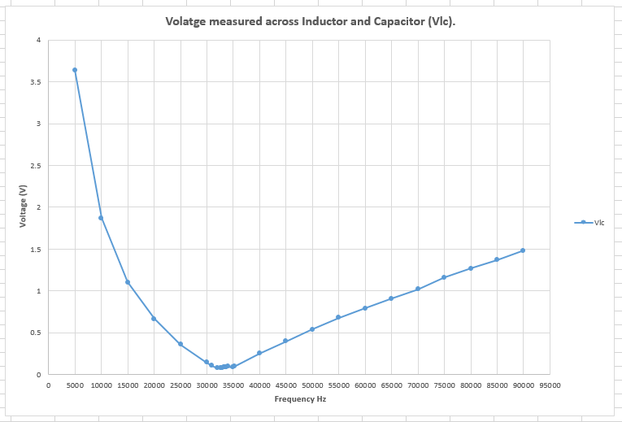
Figure 3 Vlc response curve created in Excel (Real).

Q-Factor, real components.
To determine the Q-factor from the graph in figure 3 then a +3dB of the voltage at resonance was needed.
+3dB = 0.075 / 0.707
+3d = 0.106082 V
Frequency low and frequency high was determined by using the oscilloscope and measuring the voltage across the Inductor and Capacitor whilst altering the frequency below and above resonance the lower and upper frequencies were found when the voltage across the two components equalled 106mV.
Frequency low (Fl) = 30800 Hz
Frequency high (Fh) = 34600 Hz
Frequency centre (Fc) = 32600 Hz
Bandwidth (BW) = Fh – Fl
BW = 3800 Hz
Q-factor = Fc / BW
Q-factor = 8.578947

Comparison of theoretical and actual measurements (real components).

Theoretical and measured resonant frequency.
Theoretical resonant frequency was calculated to be 33934.96 Hz where by actual resonant frequency when tested with real components was 32600 Hz.
Actual resonant frequency was measured to be 1334.96 Hz lower than the calculated theory, there are many factors as to why there is a difference of just over 1.3 KHz. When using real components their actual values due to tolerances when manufactured would differ slightly to the exact values used when calculating resonant frequency using theory practice also when testing real components it was difficult to get the function generator to output the exact frequencies needed for each measurement there by introducing a certain percentage of error.
Given more time, when logging results instead of rounding the output frequency of the function generator to the nearest thousand the actual output frequency could be logged to 4 or 5 decimal places which could yield slightly different results whether they be worse i.e further away from calculated resonant frequency or better by being closer to calculated resonant frequency could be something that would need further testing and investigation.

Theoretical and calculated ‘Q’.
Q-Factor when calculated theoretically was 2.1318, A Q-Factor of 8.578947 was determined when using real components, the higher the ‘Q’ the narrower the bandwidth and usually is preferred in rlc circuits.
Resistance in an rlc circuit plays a role in the bandwidth there by it determines Q-Factor, when calculating ‘Q’ using the formula in chapter 3 there is an exact value of a resistor (R1) and an exact value of reactance which means no tolerances have been taken into account, when calculating ‘Q’ from real test there are many unconsidered and unknown variables such as component tolerances and test equipment tolerances which cannot be accounted for in theory calculations.

Proteus simulation, building and testing.
The circuit shown in figure 1 was used when taking measurements, the component values were the same as listed above, it can be seen that there is a total of four Volt meters and one Ammeter, the AC power source was fixed at 3.3 Vrms with a starting frequency of 5KHz, as with the breadboard exercise a step size of 5KHz was used and fine tuning around resonance frequency was adopted.
As there was four voltmeters and an ammeter then the results table was populated with the values from each of the meters. To be consistent with the real component test a graph was plotted using the voltage drop across the Inductor and Capacitor and the Q-factor was calculated from these results.

Results, Proteus simulation.

Results populated in Excel.
Table 2 Proteus components results.

Vlc response curve created in Excel (Proteus).
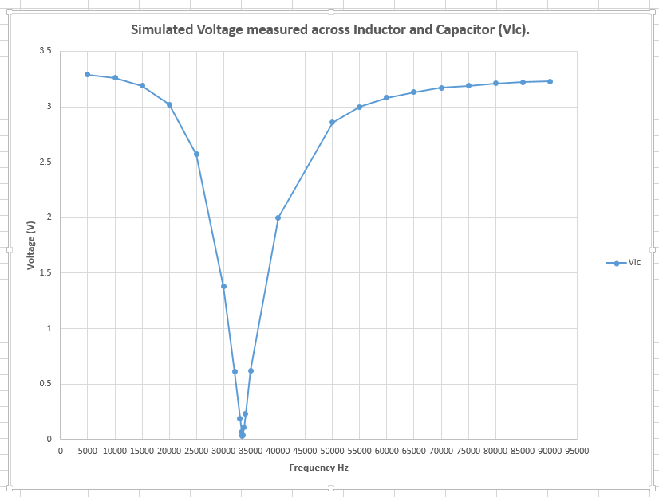
Figure 4 Vlc response curve created in Excel (Proteus).

Q-Factor, Proteus.
As with the real component results the response curve from Vlc was used to calculate the Q-Factor.
+3dB = 0.0313 / 0.707
+3dB = 0.04427157 V
By formatting the scaling of the axis of the Vlc graph plotted within excel frequency high and frequency low was determined.
Frequency low (Fl) = 33500 Hz
Frequency high (Fh) = 33400 Hz
Frequency centre (Fc) = 33450 Hz
Bandwidth (BW) = Fh – Fl
BW = 100 Hz
Q-Factor = Fc / BW
Q-Factor = 334.5

Comparison of theoretical and actual measurements (Simulation).

Theoretical and measured resonant frequency.
33934.96 Hz was the calculated theoretical resonant frequency, after analysing the results of the simulation from Proteus it was found that 33450 Hz is the frequency at resonance.
Simulated resonance was slightly lower by 484.95 Hz this is slightly better when compared with the real components, with a simulated environment the value of components are exact meaning no tolerances in manufactured components may have been included, for a simulation to work then many theoretical calculations are done within the program which may be the reason why the results are closer together. Also when using simulation it is easier to control in this case the applied frequency there by possibly yielding more accurate results.

Theoretical and calculated ‘Q’.
2.1318 was the theoretical calculated Q-Factor, when calculating Q-Factor from simulated results it was determined to be 334.5, clearly there is a big difference between these two numbers and thus hard to explain the reason why, one option would be to contact support for Proteus to see if they could provide an explanation in case it was an issue with the program setup, it was decided because this is for educational purposes then no further action would be taken.
Whilst analysing results in Excel a graph was populated with all measured results, it was seen visually that the Q-factor could be lower if using the measured bandwidth from a single component. Below details results when analysing the response curve from the Capacitor.

Proteus results using response curve from Capacitor.
As the Q-Factor from Proteus Vlc response curve wass extremely high when compared to theoretical and real component testing it was decided to draw up a graph within Excel using all measured voltages and currents then analyse and compare the results.

Response curve from all measured voltages and currents.
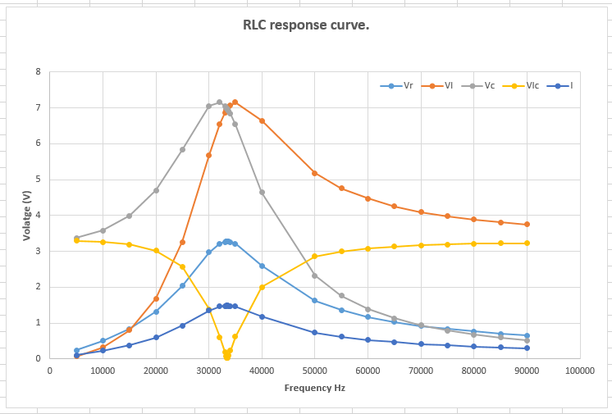
Figure 5 Vrlc response curve created in Excel (Proteus).

Q-Factor, using Capacitor response curve (Proteus).
Visual inspection of the graph in figure 5 shows there is a difference in the sharpness of the response curve of Vlc and Vc. It is clear that Vc has a wider bandwidth which will result in the Q-factor being lower than what was calculated when using Vlc.
As the response curve of Vlc and Vc are inverse to each other then a -3dB of the maximum voltage across the Capacitor is needed to calculate the Q-factor.
-3dB = 6.97 x 0.707
-3dB = 4.92779 V
After manipulating the axis scaling within excel frequency low and frequency high was determined.
Frequency low (Fl) = 20900 Hz
Frequency high (Fh) = 39270 Hz
Frequency centre (Fc) = 33450 Hz
Bandwidth (BW) = Fh – Fl
BW = 18370 Hz
Q-factor = Fc / BW
Q-Factor = 1.820904

Comparison of results.
It is clear that the Q-Factor when determined from the response curve of the Capacitor is a lot lower compared to the response curve created from Vlc at this time there is no exact explanation for this other than being as it was done in simulated environment then factors relating to how the program operates could have an influence with the results gained. Possibly further testing by use of different values and settings used within the program could be adopted in future experiments.

Conclusion.
Whilst working on this assignment a lot of knowledge has been learned and understood, when designing and creating an rlc circuit it would be good practice to start of by using calculated theory within Excel to give an idea of expected results. The use of simulation is quick, and it could be a more cost-effective way of testing the circuit theory and application before committing to prototyping a real component build.
As can be seen with the results, there is differences between each of the testing and calculating stages throughout the whole of this exercise so in real world design more time, more precise measurements further testing, research and investigation is suggested.

References.

[1] | M. Tooley, Electronic Cicuits, Fundamentals and Applications, Third ed., Oxford: Elsevier Ltd, 2006, p. 430.
[2] | ARRL, The ARRL Handbook for radio communications, 89th ed., H. W. Silver, Ed., Newington: American Radio Relay League (ARRL), 2012.
[3] | Q and Bandwidth of a Resonant Circuit | Resonance | Electronics Textbook.
[4] | Quality Factor Tutorial | Q Factor | Radio-Electronics.com.

Bibliography.

[1] | M. Tooley, Electronic Cicuits, Fundamentals and Applications, Third ed., Oxford: Elsevier Ltd, 2006, p. 430.
[2] | ARRL, The ARRL Handbook for radio communications, 89th ed., H. W. Silver, Ed., Newington: American Radio Relay League (ARRL), 2012.
[3] | Q and Bandwidth of a Resonant Circuit | Resonance | Electronics Textbook.
[4] | Quality Factor Tutorial | Q Factor | Radio-Electronics.com.
[5] | F. Mims, Getting started in Electronics, USA, 1983.

