
APPENDIX GA36d
LEVEL 7 ASSESSMENT SPECIFICATION

Student name: | Artiben Rupeshkumar Shailar | Student ID number: | 2532580
Programme: | Master of Business Administration
Module: | Strategic Management
Module code: | LCMB7003 | Contribution to  Overall Module Assessment (%): | 100%
Lecturer: | Amare Desta Zulf Khan | Internal Verifier: | Vasilios Tavlaridis  Hoang Nguyen
Assignment Title: | Assessment component - Individual report | Word count (or equivalent): | 5,000 (± 10%)
Submission deadline: |  | Return date of provisional marks & written feedback: | 9th September 2026
Submission method: | All written assessments, where practical and possible, must be submitted via Turnitin unless otherwise instructed by the Lecturer. (Please DO NOT put this assessment specification into Turnitin or it will match many similarities with other students’ submissions.)  Alternative submission method (if applicable):  Late submission of the assessment will result in a late penalty mark:.  Work which is submitted up to 1 week late will be capped at 50% for the first attempt and will be awarded a mark of 0% for re-assessment. Late submission penalties may be lifted only if there is an approved extenuating circumstances claim.  Work submitted more than 1 week late will be considered as a non-submission and will not be marked. The work may be considered as a submission for reassessment if offered by an Examining Board or if there is an approved extenuating circumstances claim.
Academic honesty / referencing: | Academic honesty is required. In the main body of your submission you must give credit to authors on whose research and ideas your work is based.  Append to your submission a reference list that indicates the books, articles, etc. that you have used, cited or quoted in order to complete this assessment.
Module Learning Outcomes (from module syllabus)
Upon the successful completion of this module, the student should be able to demonstrate the ability to:
- synthesise the relationship between the external and internal environments of an organisation and their impact on its strategies;
- critically evaluate competitive and development strategies, in the context of contemporary strategic management issues;
- assess the factors that must be considered in strategy implementation

Table of Contents
SECTION 1 – Strategic Management Analysis 4
1. Organisational Context and Overview 4
1.1 Organisational Background 4
1.2 Historical Development, Mission and Vision 4
1.3 Business Model and Value Proposition 4
1.4 UK Grocery Industry, Competitors and Market Position 4
2. External and Internal Analysis 5
2.1 External Environment: PESTEL Analysis 5
2.2 Industry Competition: Porter's Five Forces 8
2.3 Internal Environment: VRIO 10
2.4 SWOT Analysis 12
3. Comprehensive and Holistic View of Tesco 13
3.1 Corporate Social Responsibility 13
3.2 Balanced Scorecard 15
4. Strategic Choices and Implementation 16
4.1 Business-Level Strategic Choices 16
4.2 Evaluation of Strategic Alternatives 17
4.3 Recommended Strategy and Competitive Advantage 19
4.4 Strategy Implementation and Risk Mitigation 20
SECTION 2 – Reflective Account 22
5. Reflective Account 22
5.1 Description 22
5.2 Experience and Feelings 22
5.3 Evaluation 22
5.4 Critical Analysis 23
5.5 Conclusion 23
5.6 Action Plan 23
Reference List 25

SECTION 1 – Strategic Management Analysis

1. Organisational Context and Overview

1.1 Organisational Background
Tesco PLC is a big grocery business in the United Kingdom and chosen organisation for this report. This analysis is specifically based on Tesco's grocery retail business in the UK and not its global business. Tesco is appropriate for strategic analysis as it has a long operating history, a strong position in the UK market, extensive physical and online operations, and has the ability to have customer data. The scale causes strategic problems with price competition, customer value, technology, sustainability and efficiency, which all allow for strategic management analysis (Mccall 2024).

1.2 Historical Development, Mission and Vision
Tesco began in 1919 when Jack Cohen began selling groceries at a London market stall and the company eventually became a large supermarket chain. It took a long time to develop, which demonstrates how Tesco has responded to customer needs over the years. Tesco's mission is to make a little difference to customers, communities and planet every day. It's current approach focuses on value, convenience, digital capability, efficiency and sustainability. This is reflected in its Clubcard focus, online retail and sustainability commitments. But it is a constant challenge for Tesco to keep that goal in mind while also being competitive on price (Wolniak & al. 2024).

1.3 Business Model and Value Proposition
Tesco adds value by providing a grocery offer via supermarkets, convenience stores and online. It's based on scale, its supplier partnerships, its products under its own brand, its digital services, its Clubcard loyalty ecosystem. The Clubcard enables Tesco to gain insight into its customers' buying habits and offer a more personalized value for the same, whilst its extensive store base offers convenience and availability. The pairing will create a stronger link between Tesco and its customers and enable Tesco to be more competitive in value and service. But the model must also be highly efficient as customers can easily check the prices with their rivals and the discounters like Aldi & Lidl (The Strategy Institute 2024).

1.4 UK Grocery Industry, Competitors and Market Position
The UK grocery market is highly competitive, where big supermarket and discount grocery businesses are competing on the basis of price, quality, convenience and customer loyalty. Tesco topped the market share with a 28.7% share for the 12 weeks to 28 December 2025, while Sainsbury's was second with 16.3%, with both Aldi and Lidl important discounters. It is an enviable role, providing Tesco with scale and brand strength, but not taking away the competitive pressure. Meanwhile, discount retailers Lidl and Aldi continued to pressure sales as they both achieved market share gains, according to Kantar (Abbas 2025).
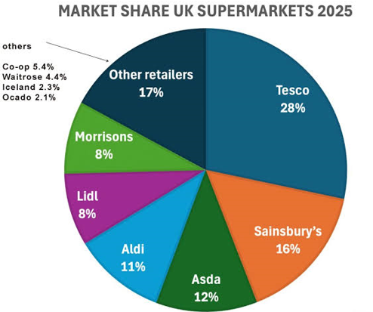
Figure 1: UK Grocery Market Share

2. External and Internal Analysis

2.1 External Environment: PESTEL Analysis
2.1.1 Political Factors
Political issues that impact Tesco are shown in Figure 2 to include government policy, taxation, employment policy, and trade and competition regulation. The grocery industry is a key area of focus for UK competition policy. Aldi and Lidl are under consideration to be classified as 'large grocery retailers' by the Competition and Markets Authority. This puts pressure on Tesco to comply, and the more competition is transparent, the more likely customers will trust. Political factors thus pose a threat and an opportunity for Tesco to show responsible market behaviour (Jim Makos 2024).
2.1.2 Economic Factors
The economic conditions are an important influence on Tesco as identified in Figure 2. Grocery demand and profitability are directly affected by inflation, food prices, and wages and purchasing power of consumers. In 2026, prices for non-alcoholic goods and beverages in the UK were still up, and many consumers are still being mindful of their purchases. Tesco has responded with value-led offers, such as Clubcard Prices and Aldi Price Match. It allows for the possibility of improving customer loyalty, but can lead to a decrease in margins due to intense competition. Cost of labour, energy and operating expenses increases. Therefore, Tesco must be able to come up with competitive pricing and productivity and cost control. The challenge is to maintain the customer perception of value without eroding profitability through price competition. The economic climate is therefore one of the biggest external threats to Tesco.
2.1.3 Social Factors
The social factors in Figure 2 are related to changing consumer preferences, health, wellbeing, sustainability and population change. Convenience, competitive prices, healthier options, personalised offers are increasingly expected by UK customers. Tesco has reacted by introducing Clubcard and online shopping, and by switching to healthier products. It is an opportunity to create customer loyalty by having the products that complement the changing lifestyle. When the price or product selection of your supermarket isn't so good, though, it's easy to switch up. So, Tesco should be able to offer value and convenience, as well as quality. Social change is neither a benefit nor a detriment, it's a chance for Tesco to turn around the new expectations of customers and foster greater loyalty and repeat purchases (Wallström & al. 2023).
2.1.4 Technological Factors
Technology is one of the key opportunities for Tesco as seen in Figure 2. Customers are shopping differently with the introduction of online grocery shopping, the presence of artificial Intelligence, data analytics, automation, and personalised recommendations. In 2025/26, Tesco saw online sales of over £7 billion in the UK, highlighting the significance of its digital sales platform. With technology, Tesco can analyse customer behaviour, enhance their product suggestions, track inventory and boost their efficiency. But, digital investment has cybersecurity, privacy, and implementation and cost risks as well. Tesco must, therefore, make sure that technology delivers tangible benefits to customers and to business. The best it can do is to be able to bring digital capability together with the Clubcard data and its physical store network. This holistic approach can be the key to developing an experience which smaller competitors may struggle to replicate.
2.1.5 Environmental Factors
The environmental factors shown in figure 2 are climate change, emissions, waste and sustainable sourcing. Tesco has pledged to achieve ‘net zero' by 2050 and ‘net zero' across its own operations by 2035. Such pledges have the potential to build reputation, minimize resources used and address consumers' increasing expectations. But it has to be implemented and cooperates from suppliers. Environmental responsibility is thus an opportunity and a cost driver. Tesco must make "measurable progress" on emissions, food waste and sustainable sourcing to help build its reputation, in addition to making its operations more efficient, the retailer said (Tesco PLC 2025).
2.1.6 Legal Factors
Consumer protection, employment law, food safety and competition and environmental requirements are all legal factors listed in Figure 2. The employment cost change is important for Tesco as the grocery retail is labour intensive. The UK National Living Wage will rise to £12.71 per hour from April 2026, adding to the pressure on labour costs. This means that Tesco needs to ensure that its compliance procedures are robust and effective, whilst enhancing productivity. Compliance with the law is a risk if it signifies an escalation in costs or complexity of operations but can also uphold Tesco's reputation and customer trust. Legal monitoring should therefore be continued as a form of the strategic risk management process within Tesco (Li & Zeng 2024).
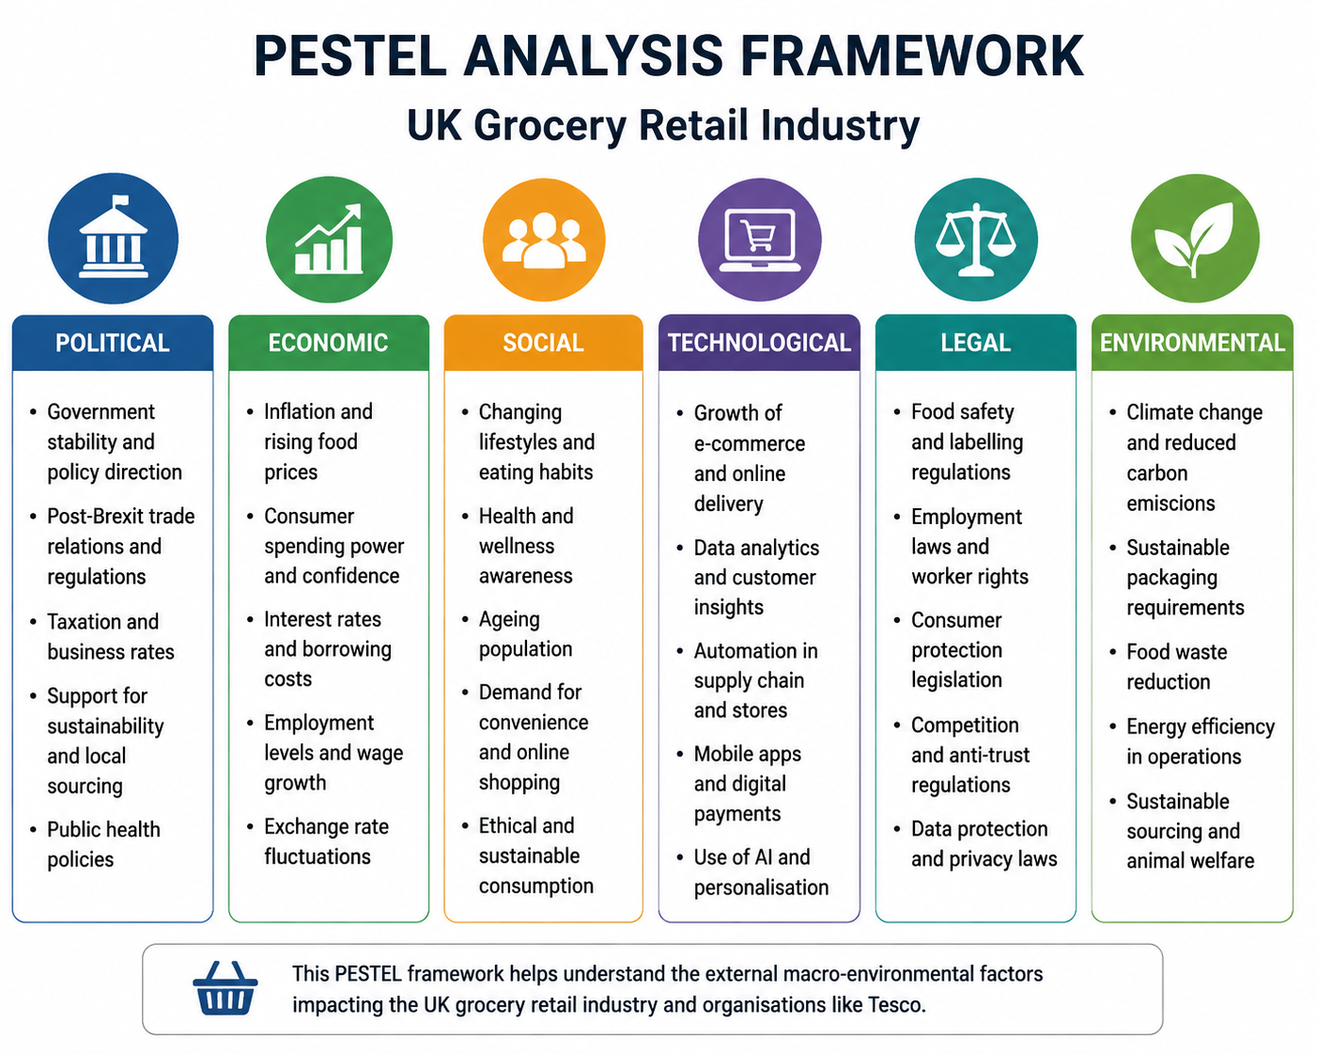
Figure 2: Tesco PESTEL Strategic Environment

2.2 Industry Competition: Porter's Five Forces
2.2.1 Competitive Rivalry
The degree of competition is very high as illustrated in figure 3. Tesco faces competition from Sainsbury's, Asda and Morrisons, and is facing strong price pressure from Aldi and Lidl. Retailers promote to compete, they produce their own products, they offer loyalty schemes, convenience and internet services. Tesco's dominance in the market gives them scale, but not the elimination of competition. However, the force of rivalry is the strongest one and Tesco has to continually enhance value, efficiency and customer experience in order to maintain its market leadership (Czeczotko & al. 2022).
2.2.2 Buyer Power
Figure 3 also emphasises that the buyers have a high level of power due to the availability of numerous supermarket options, and the ease of comparison and price checking. Aldi and Lidl put the pressure on switching. This power can be diminished through reward schemes such as Tesco's Clubcard and personalised offers to promote loyalty. Tesco is still price sensitive and will need to continually prove out its overall value for money, however (Tesco PLC 2024).
2.2.3 Supplier Power
Supplier power in Figure 3 can be considered moderate. While Tesco's purchasing power may be quite strong, specialist products and supply constraints, coupled with increasing input costs, can help to empower suppliers. Tesco thus requires effective links with suppliers, and product availability, quality and price competitiveness.
2.2.4 Threat of Substitutes
The substitute threat represented in Figure 3 is comparatively high as the customers have a number of choices available such as discount stores, convenience stores, specialist stores and online grocery shopping. Tesco counteracts this by offering a wide variety of products, convenience packaging, the internet and lightning-fast delivery. The challenge is to make sure these services deliver value to keep customers.
2.2.5 Threat of New Entrants
According to Figure 3, the threat of large new entrants is relatively low, as grocery retail is a capital intensive industry that needs a large store, logistics, supplier relationships, technology and customer trust. There are high entry barriers due to Tesco's scale. Smaller opportunities can be found for digital businesses and specialist retailers though, so Tesco will need to remain alert to new comers (Fu 2024).
2.2.6 Overall Industry Attractiveness
The overall picture in Figure 3 is hard going, primarily due to the level of rivalry and buyer power out there. While the scale of the Tesco is a protection, with the course of success comes efficiency, loyalty, differentiation, and innovation.
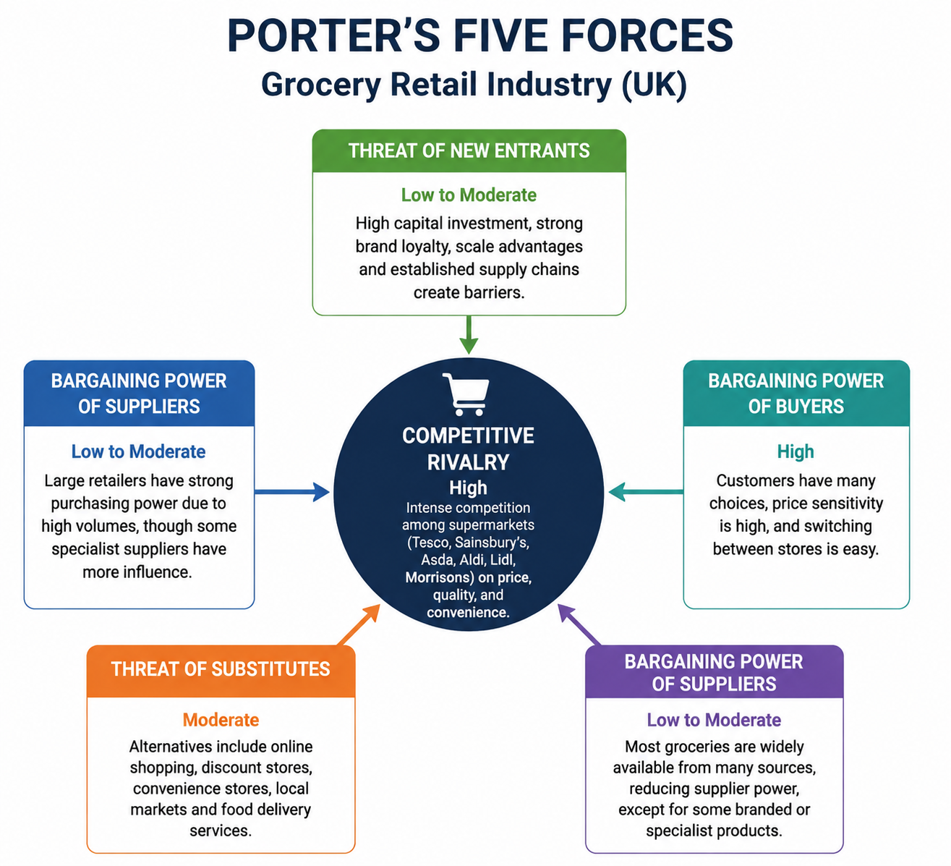
Figure 3: Porter's Five Forces Analysis

2.3 Internal Environment: VRIO
2.3.1 Tesco's Key Resources
In Figure 4, the resources evaluated are Tesco's brand, large network of stores, supply chain, digital capability and its Clubcard customer data and workforce. These resources are beneficial as they enable customer reach, convenience, availability and personalisation. The scale of its online business in the UK, which is run by Tesco, is also illustrative of its digital muscles. Importantly, these resources are not independent, but collaborative. For instance, Clubcard data can be used to enable offers tailored to each person's needs, and stores offer hassle-free pick-up and delivery options. Hence, Tesco's strategic advantage is that they are able to merge their physical, digital and customer resources into a single retail system (Umbrex 2026).
2.3.2 VRIO Evaluation
When the four dimensions in Figure 4 are applied, it is seen that the advantage that Tesco's resources offer varies from one level to another. Tesco has a strong brand and trusted brand; however, there are also strong competing brands, which means that it is primarily supporting competitive parity. The value of its extensive store network is that it gives reach and conveys convenience to the buyer yet other big supermarkets have large networks.
There is more distinctive data for Clubcard. It gives Tesco a detailed knowledge of their customers which it can use for personalised offers, recommendations and marketing. It's hard to produce quickly, and worth it, as it is created from long-term customer interaction and significant transaction details. Tesco is also structured to make use of this resource in its digital ecosystem. This implies Clubcard capabilities hold potential for enhanced competitive advantage in the future (Li & Zeng 2024).
Tesco's scale in the supply chain is beneficial to ensure availability and cost efficiency. But with a large competitor it is possible to acquire similar skills, and the resource may only be a short term advantage. Additionally, digital capability is useful as Tesco can integrate online purchasing with AI and customer data. In general, Figure 4 shows that the synergies of the resources are the most important on the side of Tesco's strengths, not any one resource in isolation.
2.3.3 Strategic Strengths and Weaknesses
The brand, market, Clubcard data, store network, supply-chain capability and digital infrastructure are the VRIO findings in Figure 4 that mark the strongest resources that Tesco possesses. These all contribute to customer loyalty, value and convenience. The analysis does, however, show weaknesses. The vast physical network adds complexity and expense to the business, and powerful rivals can copy single things like discounts and promotions. Tesco can thus not rely solely on its size. Its main strategic thrust should be to build up the resources that are most difficult to copy, such as customer information, the integration of digital and, crucially, organisational ability (Ocran 2023).
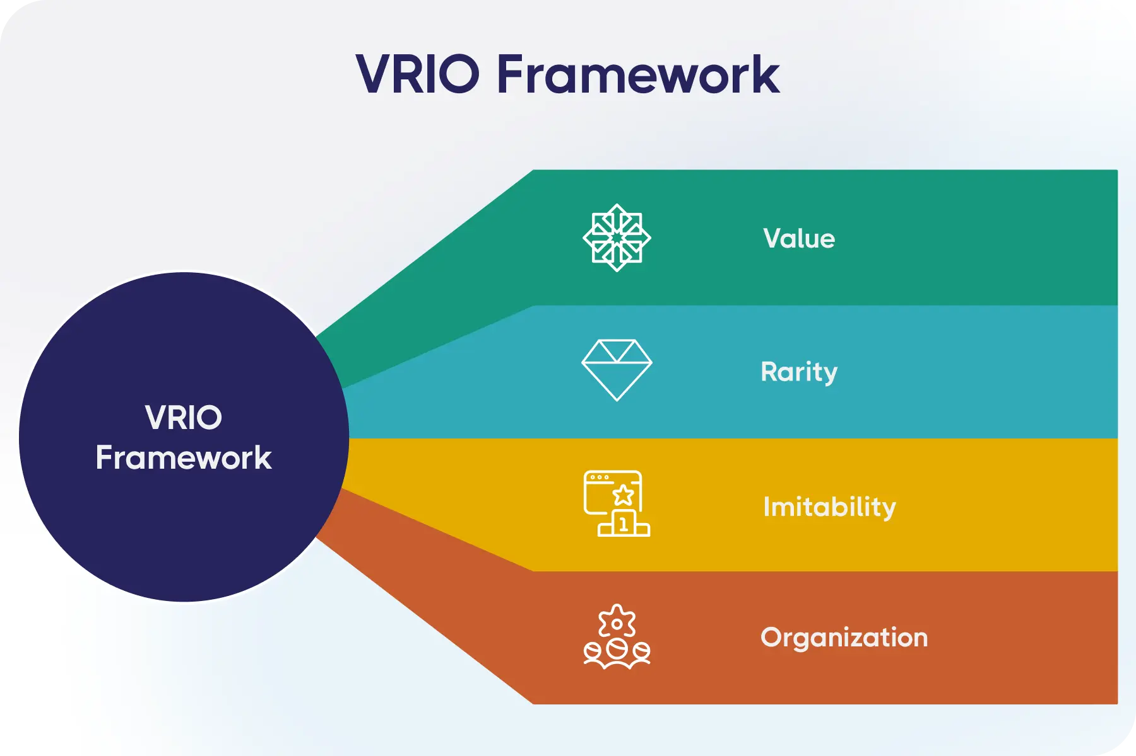
Figure 4: VRIO Framework Competitive Advantage

2.4 SWOT Analysis
2.4.1 Strengths
Tesco's biggest assets are its dominant position in the UK market, its powerful brand, its size and presence, its Clubcard information and digital expertise. These resources provide Tesco with scale, insight and convenience with regard to the customer. The large customer base also creates a great foundation to support value and loyalty efforts for it (Kumar & Agrawal 2024).
2.4.2 Weaknesses
Its main drawbacks are the complexity and expense of Tesco's vast brick-and-mortar stores, as well as the high price competition it faces. Large operating base can put pressure on costs, and cut margins due to price competition. Tesco can't just copy, it must be original, so there is no dependence on scale (Taiwo & Oluwafemi Oloruntoba 2024).
2.4.3 Opportunities
The opportunities of Figure 5 are primarily technology, changing customer expectations and sustainability. The Clubcard data and AI can help Tesco tailor offers, enhance predictive power, and boost customer retention. Its sustainability efforts can also generate value in reducing operating costs and waste.
2.4.4 Threats
Competition from Aldi and Lidl, high buyer power, shifting customer expectations, the pressure of operating costs and regulation are the primary risks. This is a threat in particular because it is easy for customers to change retailers.
2.4.5 Strategic Implications
Based on the SWOT, the suggested strategy for Tesco is SO (Sustainable Opportunities): “Increase personalised value and customer loyalty to existing proposition by leveraging Clubcard data, scale and digital capability”. An ST strategy must be based on the scale and productivity of supply-chain to cope with discounter pressure. A WO strategy should leverage AI and automation to cut the complexity of operations, and a WT strategy should focus on efficiency and not on continuous price wars. The SWOT thus directly feeds into the later proposed recommendation of value-led market penetration of digital personalisation (George 2025).
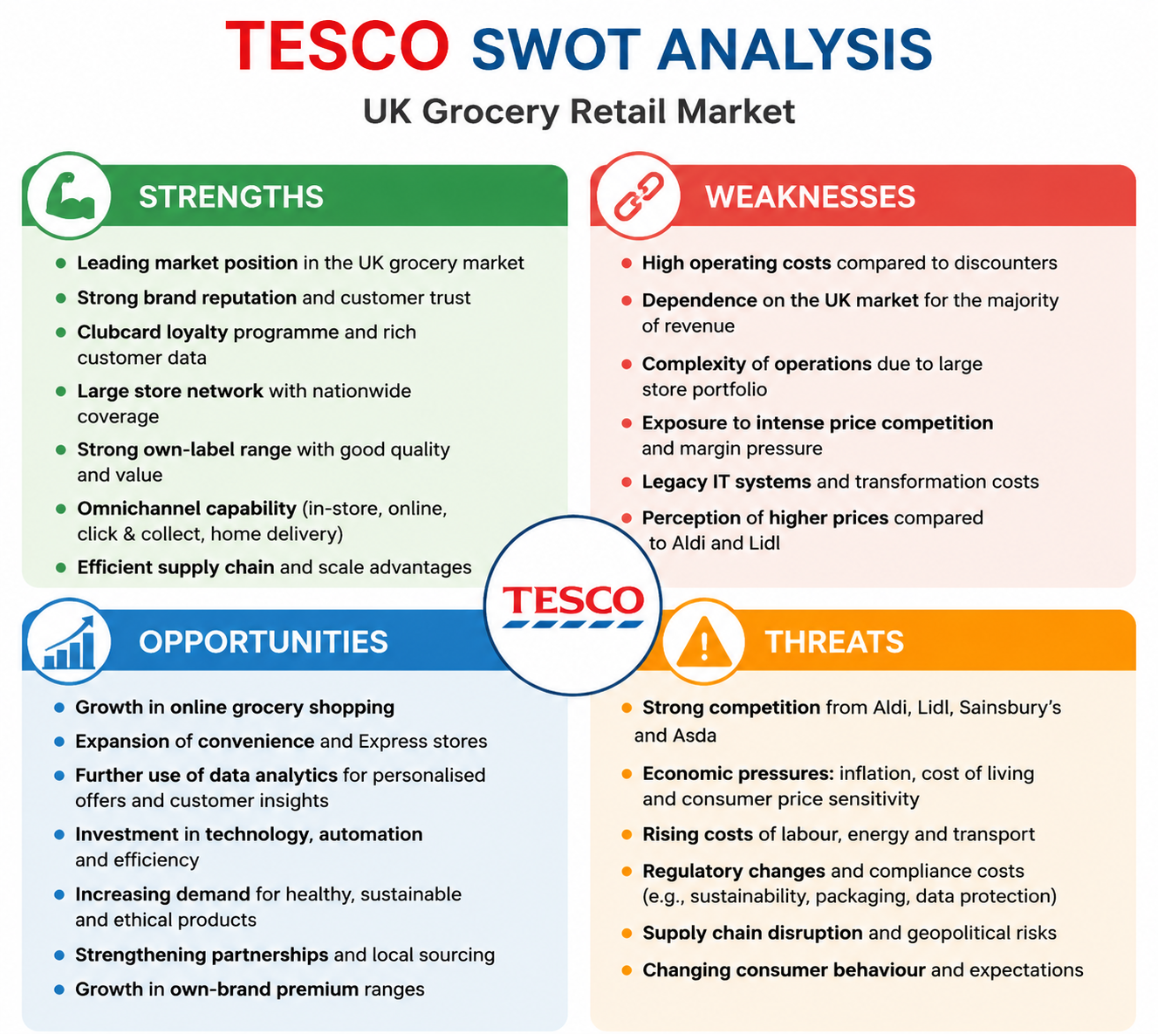
Figure 5: Tesco UK SWOT Analysis

3. Comprehensive and Holistic View of Tesco

3.1 Corporate Social Responsibility
3.1.1 Current CSR Strategy
In Figure 6, Tesco's CSR strategy includes Planet, Health, People and Communities, therefore CSR is not just given as a charitable act, but as part of their broader business. Tesco's emissions from its operations are 68% lower than its 2015/16 baseline. It also revealed 65% of food sold in the UK and ROI was considered 'healthy' and over £123m food was donated to charities, community groups and colleagues. The results suggest that Tesco's CSR activities encompass the items of environmental, health and social concerns (Tesco PLC 2026).
3.1.2 CSR and Business Objectives
The activities in Fig. 6 can assist Tesco's business goals when they deliver both stakeholder and business value. Examples of strategies for achieving this include energy and food reduction, which will increase energy efficiency and lower operating costs, respectively. By integrating AI into its order management systems, Tesco optimizes store orders, minimizing food waste and ensuring availability, thereby connecting sustainability and efficiency. Tesco managed 142,503 tonnes of food surplus, which was donated to charities, communities and colleagues, in 2025/26. Customer value can also be served through health initiatives: Tesco stated that sales of fruit and vegetables have risen 10% since 2022 amidst initiatives on value, quality and availability.
3.1.3 Critical Evaluation of CSR
But there is an important limitation indicated in Figure 6. CSR is not necessarily a source of competitive advantage. Having to invest in technology, transport, stores and suppliers, and at the same time keep prices competitive, can be challenging for sustainability initiatives. What is more important is that Tesco did not reach the target of reducing food waste in its own operations by half by December 2025, but rather reduced it by 24%, which was an improvement from the year before. This demonstrates why it is not enough to make a promise, if the company is to assess its CSR performance.This illustrates why measurable results should be used to measure CSR, not promises. In general, CSR is strategically useful if it can make the implementation more efficient, gain customer trust, and strengthen the value of the product or reduce risks. Tesco should thus persist in aligning CSR KPIs with commercial and operational results and not consider sustainability to be something distinct (Zhou 2024).
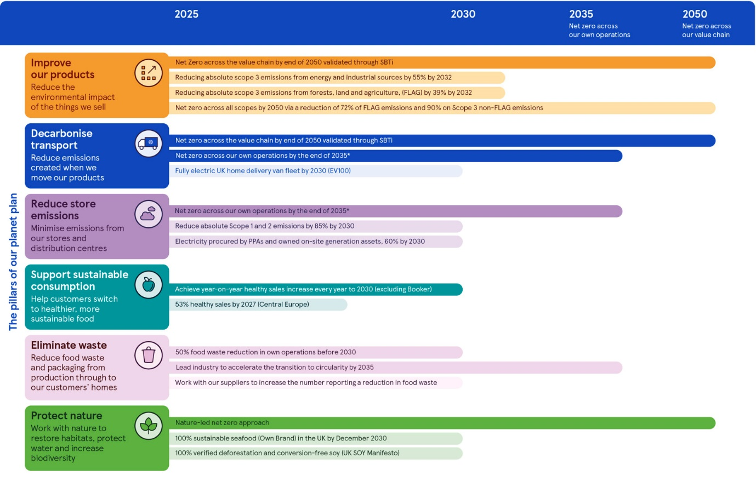
Figure 6: Tesco Sustainability Strategy Framework

3.2 Balanced Scorecard
3.2.1 Financial Perspective
Tesco's financial goal is to grow profitably and sustainably, and deliver high value to customers. Examples of appropriate KPIs are sales growth, adjusted operating profit, free cash flow and operating margin. In terms of size, Tesco's Group sales in 2025/26 were £66.6 billion and it topped the adjusted operating profit at £3.152 billion. The goal should be to preserve a positive sales and profit growth with an interest in protecting margins from inflation and from price competition. Some of the most important activities are productivity gains, cost reduction, pricing and investing in high-value digital channels. Hence, the financial aspect is concerned with the need to gain a balance of affordability and profitability for Tesco rather than focusing on sales (Gan & Yan 2023).
3.2.2 Customer Perspective
The customer goal should be to build customer loyalty through delivering clear value, quality and convenience. Customer satisfaction, market share, Clubcard engagement, online market share and customer retention are key KPIs. Tesco can pursue further market share expansion, increased customer satisfaction and increased digital interaction. The Clubcard ecosystem has a special significance as personalised offers can convince customers that Tesco knows their needs. Seemingly affordable prices for Clubcards and other value schemes can enhance affordability perception. This attitude is of particular significance in a context of high buyer power, as it enables a buyer to move freely among different retailers. Thus, the success of the company's financial performance must be supported by customer loyalty and value, not just by reducing prices (Rashid & al. 2020).
3.2.3 Internal Business Processes
The objective of the internal process should be to enhance efficiency, product availability, digital fulfilment and sustainability. Examples of appropriate KPIs include product availability, online-order performance, food waste, delivery efficiency and operating-cost savings. Tesco should strive to further increase productivity and minimize waste and emissions. This can range from AI-driven scheduling systems to optimizing the supply chain, automating tasks, enhancing online fulfillment to managing food waste. The 68% reduction in operational emissions is also evident in Tesco's results, which shows the power of operational improvements to help meet environmental goals. This illustrates cost and CSR efficiency can be achieved through internal processes.
3.2.4 Learning and Growth
Learning and growth goal should be to build employee capability, technology skills and innovation. Training participation, employee engagement, internal promotion, digital capability, flexible working measures are examples of KPIs. A total of 82% of colleagues could work flexibly, and there are over 340,000 colleagues working across the Group. Its £200m investment in workforce development of hourly paid employees in the UK further highlights the importance of workforce development. Therefore training and digital-skills development, leadership development and employee wellbeing should be key initiatives. As seen in Figure 7, the relationship between the four perspectives is that the greater the employees' competence, the better the internal processes, the better the value for the customers, and the stronger the financial performance (Subramanian 2018).
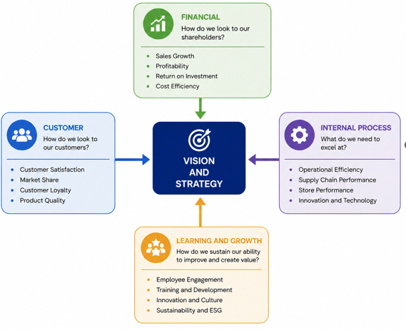
Figure 7: Balanced Scorecard Four Perspectives

4. Strategic Choices and Implementation

4.1 Business-Level Strategic Choices
4.1.1 Cost Leadership
The UK food market is price sensitive and this can enable Tesco to go for cost leadership. It already has value initiatives like Everyday Low Prices, Clubcard Prices and Aldi Price Match. Tesco took Everyday Low Prices to 3,000 lines and adopted Aldi Price Match on over 600 products in 2025/26. This can appeal to price-conscious buyers and aid in retaining market share. But, when prices go on a downward spiral, margins can suffer. Thus, the goal of cost leadership should be on boosting productivity and supply-chain efficiency and technology rather than just the price reduction (Fatricia 2024).
4.1.2 Differentiation
Differentiation would enable Tesco to play competition on a customer experience basis as well as price. The club card data, personalised offers, product innovation, healthier products, online services and quick delivery can create more value for the customers. Whoosh sales surpassed £400m and Tesco's UK online sales surpassed £7bn in 2025/26. These features can enhance the convenience and personalisation aspect. Digital investments, however, are expensive and the service features can be copied by competitors. The solution for Tesco is to provide differentiation through the combined use of data, stores and digital capabilities.
4.1.3 Focus Strategy
The focus strategy would focus on certain customer needs instead of the total market. Tesco might target value-driven households, health-driven consumers and customers who are looking for ease of digital shopping. This could help build loyalty but may lead to too many segments and unnecessary complexity. So, the focus should be a part of Tesco's broader UK market strategy not its value proposition (Davey 2025).

4.2 Evaluation of Strategic Alternatives
4.2.1 Ansoff Matrix
In figure 8, the Ansoff Matrix is used to show the different growth strategies that Tesco can use. The food and grocery market, where Tesco is already a player, is the least risky option, as Tesco can increase its market share with better Clubcard customer loyalty programme, competitiveness and customer experience of the food and grocery market. This report concentrates on the UK market and market development is less applicable, as it may involve searching new markets and customers for Tesco's existing product range. Some opportunities for product development are healthier food, premium Finest products, new own brand ranges and additional services. Marketplace, clothing, pharmacy and financial services are just a few of the other sectors that offer new revenue streams, but come with more risk. Market penetration and product development are more suitable to Tesco's current situation (Palmer 2005).
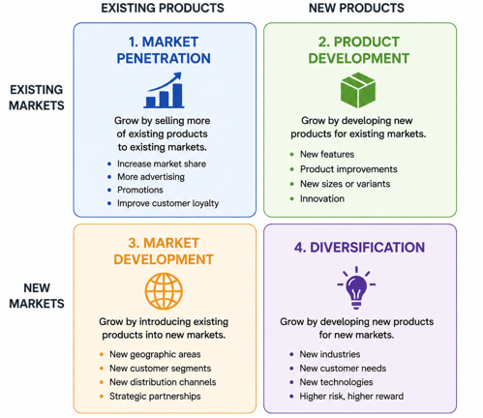
Figure 8: Ansoff Matrix Growth Strategy Options
4.2.2 SAFe Analysis
Suitability: Market penetration is suitable as it is directly addressing the threats identified with the PESTEL, Five Forces and SWOT. Tesco has high buyer power and has to compete with other retailers pricewise, therefore, enhancing value and loyalty can help to protect the market position. Tesco's 28.5 per cent market share in the UK gives them a good platform of customers from which to grow.
Acceptability: There are benefits to customers through improved value and increased sales and customer retention for shareholders, the strategy is therefore acceptable. Competition with others could mean fewer profits however. Therefore, it is important for Tesco to implement pricing policies along with productivity and efficiency improvements rather than solely reducing prices (Ozan 2024).
Feasibility: The strategy is viable as the resources that Tesco has identified using the VRIO analysis are in place; they have Clubcard data, store network, size of their supply chain and digital capacity. It also has proven online customer engagement skills, with over £7 billion sold in the UK online.
4.2.3 Preferred Strategic Option
The preferred option is to penetrate the market with differentiation, based on the personalisation via the internet and value for the customer. It is responsive to high buyer power and high intensity competition and it utilises Tesco's VRIO resources. Personalised offers combined with convenience and competitive value can help to create a more loyal customer base and offer a more defensible position than price.

4.3 Recommended Strategy and Competitive Advantage
4.3.1 Strategic Recommendation
For Tesco, a market penetration strategy with a focus on value would be more appropriate, with digital personalisation. But, rather than being based on price alone, Tesco can use Clubcard data, Artificial Intelligence, online grocery offering and their physical store footprint to offer a more personalised value. This may encompass personalised healthy-product suggestions, enhanced online shopping and faster fulfilment, among other targeted Clubcard offers. The recommendation is in response to the analysis above: value has become more important due to the economic pressure, while customer loyalty is hard to come by, given high buyer power, and technological changes open the door for personalisation. This serves to support the direction of existing focus of Tesco placed on value, quality, service and digital capability (Alonso 2022).
4.3.2 Competitive Advantage
All of these can help enhance Tesco's competitive edge as other retailers may emulate each one of these promotions or digital methods, but it's a bit harder to replicate the scale of Tesco's operations, the Clubcard data, the store network and the digital platform and supplier partnerships. Tesco's customer insight powers their personalised shopping on the Clubcard network, which includes over 23 million UK Clubcard households. This can help to build customer relationships, decreasing switching. The approach, therefore, isn't about building a new business model for Tesco, but the extension of the existing one.
4.3.3 Theoretical and Real-World Support
Porter's differentiation logic underlines the need to compete on the basis of customer value, not price alone, and the Ansoff Matrix highlights lower risk growth strategies such as market penetration. The stock is driven by the targets set by Tesco: in the UK, the company's market share is 28.5% in 2025/26 and online sales have surpassed £7bn. Thus, a value, convenience and digital personalisation can aid Tesco in their competitive position (Roy 2024).

4.4 Strategy Implementation and Risk Mitigation
4.4.1 Implementation Challenges
As illustrated in Figure 9, it is not enough just to decide on a strategic direction to implement; it will be necessary to take coordinated action. There are a number of challenges for Tesco. Firstly, it must continually be profitable, but also competitive in pricing, especially given the pressure that Aldi and Lidl place on them. Secondly, the upfront costs of investing in AI, digital systems and online fulfilment can rise. Third, there is increased privacy and cyber security risks with the increased use of the Clubcard data. Fourth, workers must be able to operate new systems appropriately. Lastly, competitions have the ability to react promptly to Tesco's pricing and also service initiatives. This is likely to require a phased approach with careful tracking of their results and their ability to scale back their investments where they don't believe they are seeing the customer and/or financial outcomes that they expected.
4.4.2 Mitigation Strategies
These risks should be addressed by a staged implementation programme by Tesco. Productivity, cost of supply chain efficiencies, etc., should provide the improvement in funding for customer value initiatives—margin reduction should not be the sole source of funding. Pilots are required in the implementation of digital investments before they are expanded. Clubcard data should be safeguarded with robust data governance and cybersecurity measures. Co-workers need to be trained with the introduction of new technologies. It is also important for Tesco to keep an eye on the price of other retailers and on switching and changes in market share on a regular basis. These actions match the agility, efficiency and digital capability that Tesco is focusing on (Aldossary & Agag 2026).
4.4.3 Implementation Priorities
The implementation priorities are also evident in figure 9. The first thing that needs to be done is to improve value and productivity, followed by broadening personalised digital services and finally, building wider innovations. Management needs to track market share, customer satisfaction, online sales, margins, customer loyalty at each stage. Regular review of performance to identify if initiatives need to be continued, adapted or abandoned.
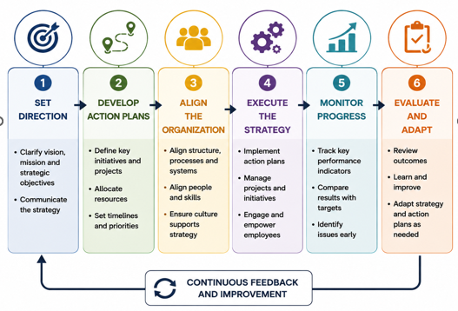
Figure 9: Strategic Management Implementation Process

SECTION 2 – Reflective Account

5. Reflective Account
I will analyse my own experience of researching, analysing and preparing the Tesco strategic management analysis using Gibbs' Reflective Cycle. In addition to what I did, I am reflecting on the success of my approach, the strengths and weaknesses of the strategic frameworks used, and how I can use them better in my future strategic decision making.

5.1 Description
I started the analysis by setting the Organisation to be Tesco PLC and the specific scope to be the grocery retailing market in the UK. I then conducted a search for evidence from Tesco's corporate reports, sustainability information, market evidence and credible external sources. I have explored the external environment in detail using the PESTEL model, the industry competition using Porter's Five Forces and the external resources and capabilities of Tesco using the VRIO model. These findings I aggregated with SWOT and then studied CSR and the Balanced Scorecard. Last, I performed the Ansoff and SAFe analyses and came up with a recommendation. The following process enabled me to progress from describing Tesco to building my evidence-based argument for strategy (Tino 2026).

5.2 Experience and Feelings
Initially, I struggled to keep up with all the information about Tesco. Tesco provides information through annual reports, sustainability reports, investor information and others, and external sources provide alternative information. It was also difficult to determine which information was strategically relevant as there may have been numerous elements in each framework. The toughest aspect of the task was not giving a simple description of the models. I realised that a good analysis should not only provide the reasons why a factor was important to Tesco, but also should include the implications it would have for their strategy. As I went along, I gained confidence in finding evidence and linking the various elements of the analysis (Jowsey & al. 2021).

5.3 Evaluation
There were a number of aspects of my approach that made sense. The use of Tesco's corporate information was useful in understanding their current strategy, performance and sustainability concerns and external market evidence was useful in not relying solely on the Tesco view of the world. It was especially helpful to use the combination of PESTEL, Five Forces and VRIO as each framework looked at a different strategic question. My first draft might have been too descriptive, though, as I had been trying to address all of the factors. I enhanced this by prioritising the most significant issues and associating them with opportunities, threats, strengths and weaknesses. This was a helpful confirmation of the earlier evidence that was gathered (Djulbegovic & Guyatt 2019).

5.4 Critical Analysis
The strategic frameworks were beneficial as there were various views of Tesco's position. PESTEL was used to highlight external pressure factors like economic, technological, social and environmental. The 5 Forces have been instrumental in understanding the significance of competition and customer power in grocery retailing. VRIO has facilitated me to see the difference between the resources/capabilities which Tesco has and the ones which may offer better competitive advantage. SWOT then assisted in amalgamating these findings. But I knew there was nothing "total" in any framework. PESTEL can be over-ambitious, Five Forces can stress the constant evolution of digital competition and VRIO can be somewhat subjective when determining the rarity and the difficulty of imitating a resource. I thus employed the frameworks in combination, rather than as singular solutions. If there were any differences in information, I looked at the date, credibility and purpose of the sources and placed more importance on recent, credible information. Helped me with my analytical thinking (Kelly & al. 2025).

5.5 Conclusion
The strategic analysis gave me insight into the importance of more than gathering information or using models in strategic management. The key takeaway from the learning was the significance of linking evidence. The competitive threats are not eliminated by the strong market position of the Tesco but the value of its resources will only be realised in the long term if they are put into place and developed properly. I also found that recommendations are more effective when they address problems identified in the previous analysis. Overall the process enhanced my ability to take the view of the evidence and make more considered strategic judgements.

5.6 Action Plan
In the future, I think before gathering a lot of information, I should think about my research criteria. I would look at the most critical strategic questions first then choose evidence that would address these questions. I would also compare the information from more independent sources of information with the information provided by the company to decrease the reliance on a single source of information. I think I would start to be more concerned with the strategic implications and not so much the description when applying frameworks. Last but not least, I would have a more explicit evidence matrix that would relate external factors, internal capabilities, strategic alternatives and recommendations, and would help me to make quicker and more consistent strategic decisions (Shatilo 2020).

Reference List
Abbas 2025. Strategic analysis and its role in formulating appropriate future strategies. 3, 3, pp. 01–19. URL: https://doi.org/10.61132/rimba.v3i3.1836. Accessed: 8 August 2026.
Aldossary, M. & Agag, G. 2026. Data-driven agility in the UK retail sector: How SMEs innovate in dynamic environments through experimental evidence. Journal of Retailing and Consumer Services, 90, pp. 104716. URL: https://doi.org/10.1016/j.jretconser.2025.104716. Accessed: 8 August 2026.
Alonso, T. 2022. Strategy study: How Tesco became the biggest retailer in the UK. URL: https://www.cascade.app/studies/tesco-strategy-study. Accessed: 8 August 2026.
Czeczotko, M., Górska-Warsewicz, H. & Zaremba, R. 2022. Health and non-health determinants of consumer behavior toward private label products—A systematic literature review. International Journal of Environmental Research and Public Health, 19, 3, pp. 1768. URL: https://doi.org/10.3390/ijerph19031768. Accessed: 8 August 2026.
Davey, J. 2025. Tesco’s UK sales growth accelerates in ‘intensely competitive’ market. Reuters. URL: https://www.reuters.com/world/uk/tescos-uk-sales-growth-accelerates-first-quarter-2025-06-12/. Accessed: 8 August 2026.
Djulbegovic, B. & Guyatt, G. 2019. Evidence vs consensus in clinical practice guidelines. JAMA, 322, 8, pp. 725. URL: https://doi.org/10.1001/jama.2019.9751. Accessed: 8 August 2026.
Fatricia, R.S. 2024. Strategic analysis of Tesco supermarket. Jurnal Manajemen Terapan dan Keuangan, 6, 2, pp. 69–86. URL: https://doi.org/10.22437/jmk.v6i2.4046. Accessed: 8 August 2026.
Fu, R. 2024. Analysis of business operation mode and marketing strategy of British mainstream supermarket: Case study of Tesco. Journal of Education Humanities and Social Sciences, 43, 1, pp. 279–285. URL: https://doi.org/10.54097/895tzt69.
Gan, W. & Yan, C. 2023. Financial analysis and development study of Tesco PLC. Darcy & Roy Press Co. Ltd. URL: https://www.researchgate.net/publication/370713310_Financial_Analysis_and_Development_Study_of_Tesco_PLC. Accessed: 8 August 2026.
George, B. 2025. Towards purposeful strategic planning: A mixed research synthesis across disciplines. Long Range Planning, 58, 4, pp. 102563. URL: https://doi.org/10.1016/j.lrp.2025.102563.
Jim Makos 2024. PESTLE analysis for Tesco discusses its business environment. URL: https://pestleanalysis.com/pestle-analysis-tesco/. Accessed: 8 August 2026.
Jowsey, T., Deng, C. & Weller, J. 2021. General-purpose thematic analysis: A useful qualitative method for anaesthesia research. BJA Education, 21, 12, pp. 472–478. URL: https://pmc.ncbi.nlm.nih.gov/articles/PMC8606608/. Accessed: 8 August 2026.
Kelly, M.O., Budescu, D.V., Dhami, M. & Mandel, D.R. 2025. The effect of source reliability and information credibility on judgments of information quality in intelligence analysis. Judgment and Decision Making, 20. URL: https://doi.org/10.1017/jdm.2025.10007. Accessed: 8 August 2026.
Kumar, S. & Agrawal, R. 2024. Developing customer convenience and experience through increased competency and efficiency: A strategic approach to retail operations mastery. Heliyon, 10, 16. URL: https://doi.org/10.1016/j.heliyon.2024.e36395. Accessed: 8 August 2026.
Li, Le & Zeng, J.H. 2024. Strategic Analysis of Tesco’s international purchasing and supply chain management: Challenges, opportunities, and future directions. International journal of science and business, 35, 1, pp. 132–143. URL: https://doi.org/10.58970/IJSB.2360.
Mccall, A. 2024. Strategic management and competitive advantage. URL: https://www.researchgate.net/publication/386050766_Strategic_Management_and_Competitive_Advantage. Accessed: 8 August 2026.
Ocran, J. 2023. The Tesco Group and Sustainable Operations Management House no. PB44, community 25, Tema, Ghana. J Ear Environ Sci Res, 5, 12, pp. 1–6. URL: https://doi.org/10.47363/JEESR/2023(5)212. Accessed: 8 August 2026.
Ozan, S. 2024. Tesco’s strategic price cuts: A winning formula for growth. URL: https://www.reportlinker.com/article/8261. Accessed: 8 August 2026.
Palmer, M. 2005. Retail multinational learning: A case study of Tesco. International Journal of Retail & Distribution Management, 33, 1, pp. 23–48. URL: https://doi.org/10.1108/09590550510577110.
Rashid, Md.H.U., Nurunnabi, M., Rahman, M. & Masud, Md.A.K. 2020. Exploring the relationship between customer loyalty and financial performance of banks: Customer open innovation perspective. Journal of Open Innovation: Technology, Market, and Complexity, 6, 4, pp. 108. URL: https://doi.org/10.3390/joitmc6040108.
Roy, B. 2024. Digital transformation strategies in traditional retail industries: A case of Tesco. URL: https://doi.org/10.13140/RG.2.2.35757.40168.
Shatilo, O. 2020. The impact of external and internal factors on strategic management of innovation processes at company level. URL: https://www.researchgate.net/publication/338516546_The_Impact_of_External_and_Internal_Factors_on_Strategic_Management_of_Innovation_Processes_at_Company_Level. Accessed: 8 August 2026.
Subramanian, K.R. 2018. The connection between your employees and customers. unknown. URL: https://www.researchgate.net/publication/327386528_THE_CONNECTION_BETWEEN_YOUR_EMPLOYEES_AND_CUSTOMERS. Accessed: 8 August 2026.
Taiwo, S.O. & Oluwafemi Oloruntoba 2024. Margin erosion analysis in consumer-packaged goods supply chains: Drivers, impacts, and strategic responses. International Journal of Scientific Research in Humanities and Social Sciences, 1, 2, pp. 986–1000. URL: https://doi.org/10.32628/IJSRSSH242776. Accessed: 8 August 2026.
Tesco PLC 2025. Sustainability. www.tescoplc.com. URL: https://www.tescoplc.com/sustainability. Accessed: 8 August 2026.
Tesco PLC 2024. Serving our customers, communities and planet a little better every day. market share gains and return to positive volume growth as customers shop more at Tesco. Performance highlights (on a continuing operations basis). URL: https://www.tescoplc.com/media/j4chef55/tesco-plc-preliminary-results-2324-100424.pdf. Accessed: 8 August 2026.
The Strategy Institute 2024. VRIO framework: Unlocking competitive edge for your business. URL: https://www.thestrategyinstitute.org/insights/vrio-framework-unlocking-competitive-edge-for-your-business. Accessed: 8 August 2026.
Tino 2026. Tech transforms Tesco: The digital future of the retail giants. Digital Society. URL: https://medium.com/digital-society/tech-transforms-tesco-the-digital-future-of-the-retail-giants-b63f66b5a5cc. Accessed: 8 August 2026.
Umbrex 2026. Tesco strategy and business model. URL: https://umbrex.com/resources/company-profiles/tesco-plc/. Accessed: 8 August 2026.
Wallström, S., Lidholm, S.H. & Sundström, M. 2023. Retailers view on customer loyalty – a social resource theory perspective. The International Review of Retail, Distribution and Consumer Research, 34, 4, pp. 1–18. URL: https://doi.org/10.1080/09593969.2023.2287998.
Wolniak, R., Stecuła, K. & Aydın, B. 2024. Digital transformation of grocery in-store shopping-scanners, artificial intelligence, augmented reality and beyond: A review. Foods, 13, 18, pp. 2948. URL: https://doi.org/https://doi.org/10.3390/foods13182948.
Zhou, L. 2024. Exploring the role of corporate social responsibility strategies for business success - taking Tesco as an example. Advances in economics, management and political sciences, 78, 1, pp. 200–205. URL: https://doi.org/10.54254/2754-1169/78/20241709.

