2D Diffusion Equation model using the Explicit Finite Difference Method
Conducted by Kieran Cassidy.





Contents
Table of Figures 2
1. Introduction 3
2. Equation 3
3. Numerical Method 4
3.1 Explicit Finite Difference Method 4
3.2 Linear equations derived from Taylor series. 4
3.3 EFDM Grid Spacing 5
3.3.1. EFDM Grid Spacing Formula 5
Temporal discretisation 5
3.3.2 Discretised formula used in the equation 6
3.4 Stability Criteria 6
4. Initial, boundary conditions and analytical solution. 6
5. Code details 9
6. Validation of the code 14
7. Analysis of the code results 16
8. A discussion as to the limitations of the model 16
9. Suggested improvements to the model and future developments. 17
10. Conclusion 17
11. References 17
12. Appendix 19

Table of Figures
Figure 1 Grid Spacing 5
Figure 2 An example of a boundary condition not solvable by analytical equation 6
Figure 3 Initial Boundary Conditions 7
Figure 4 Analytical Solution Matrix 14
Figure 5 Comand Window Prompting User for Correct Grid Spacing 15
Figure 6 Checking for the Stability of the Code 15

Introduction
The heat equation is an instrumental part of industrial day-to-day life playing a crucial role in many fundamental product designs and practical systems. A basic contemporary luxury such as air conditioning relies on the heat equation during the design phase. The aim of this report is to describe and analyse a code applying a numerical solution to determine the temperature diffusion through a 2D aluminium plate, calculating the amount of time until thermal equilibrium is reached. The user will be able to supply a range of inputs such as the length and width of said plate, along with the time step size and boundary temperature. This code will then be compared to an analytical approach to solving the same criteria. The aim is to introduce the numerical solution while addressing the limitations, results and possible optimisations. The explicit finite difference method (EPDM) method that will be implemented is versatile making it suitable for a wide range of engineering applications (Svetislav and Djordjevich, 2020).

Equation
The heat equation describes how heat diffuses through a given area over time, its origin is made up of a partial differential equation (PDE). PDE’s are used widely to describe many scenarios such as heat conduction, fluid flow, electromagnetic fields, and wave propagation. A PDE is an equation that involves a function that is unknown (i.e. what will be found), for example temperature. A Partial derivative, measures how the function changes with respect to one variable while others are constant, for example temperature changing while moving in one direction (L. Bergman et al., 2011). Finally independent variables are what the function depends on, for example time and position.
The heat equation is fundamental to understanding and predicting how heat diffuses through material over time. This is applicable to a vast array of engineering practices and fields, geographical queries, mathematical and thermodynamic science. Engineering applications such as heating, ventilation, and air conditioning count on the heat equation for initial designs of the systems. This is also applicable to metal casting and plastic moulding, both crucial points of many mass production industries. Notably the heat equation plays a key role during weather and climate predictions. Meteorologists use the equation to model heat transfer in the atmosphere and oceans.
Heat Equation:
$$\frac{∂u}{∂t}=α \left(\frac{∂^{2}u}{∂x^{2}}+\frac{∂^{2}u}{∂y^{2}}\right)$$
$$u=Temperture at positions \left(x,y\right)$$
$$t=Time$$
$$\frac{∂u}{∂t}=Rate of change of temperature with respect to time$$
$$\frac{∂^{2}u}{∂x^{2}} \& \frac{∂^{2}u}{∂y^{2}}=Second partial derivatives of u with respect to x and y coordinates$$
$$describing how temperature changes in space.$$
$$α=Thermal diffusivity of the material, a constant describing how quickly heat$$
$$spreads through the material.$$

Numerical Method

3.1 Explicit Finite Difference Method
The Taylor series is fundamental in defining the explicit finite difference method, it provides the mathematical foundation for approximating the derivatives in each partial differential equation. The Explicit Finite Difference Method (EFDM) is not based on Taylor series but uses approximations derived from the Taylor series. The approximations replace the derivatives in differential equations with discrete finite differences.
Effectively the Taylor series is used to approximate functions using polynomials, which is often used to compute and analyse easier. The series is a mathematical representation of a function as an infinite sum of terms. These will be used to derive the linear approximations used throughout the code. The explicit finite difference method equations use central difference approximations for second-order derivatives, enabling temperature distribution to be solved numerically across mesh nodes (Patankar, 2018).
General form of the Taylor Series
$$f\left(x\right)=f\left(a\right)+f^{'}\left(a\right)\left(x-a\right)+\frac{f^{''}\left(a\right)}{2!}(x-a)^{2}+\frac{f^{\left(3\right)}\left(a\right)}{3!}(x-a)^{3}+…$$

3.2 Linear equations derived from Taylor series.
First derivative Forward difference:
$$\frac{∂T}{∂x}=\frac{T\left(x_{0}+h\right)-T(x_{0})}{h}+O(h)$$

First derivative Backward difference:

$$\frac{∂T}{∂x}=\frac{T\left(x_{0}\right)-T(x_{0}-h)}{h}$$
First derivative Central difference:
$$\frac{∂T}{∂x}=\frac{T\left(x_{0}+h\right)-T(x_{0}-h)}{2∙h}+O(h)$$

Second derivative Central difference:
$$\frac{∂^{2}T}{∂^{2}x}≈\frac{T\left(x_{0}+h\right)-2∙T\left(x_{0}\right)+T(x_{0}-h)}{h^{2}}$$

3.3 EFDM Grid Spacing
The EFDM is based on using the first derivative forward difference and the second derivative central difference.
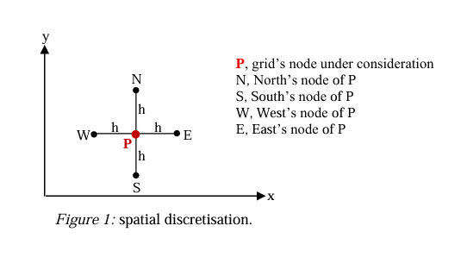
Figure 1 Grid Spacing
Figure one shows a domain discretisation that will be used during the numerical equation. The temperature cannot be calculated at an infinite number of points on the plate. Therefore, a mesh will be utilised to determine each node the calculation can be applied to.

3.3.1. EFDM Grid Spacing Formula
$$\frac{∂^{2}Tp}{∂ x^{2}}=\frac{T_{E}-2 Tp+T_{w}}{h^{2}}+O{(h)}^{2}$$

$$\frac{∂^{2}Tp}{∂ y^{2}}=\frac{T_{N}-2 Tp+T_{s}}{h^{2}}+O(h)^{2}$$

h = the distance between each node.
The above equations accounts for the grid spacing allowing the heat equation to be added at each location of the plate, eliminating the problem of infinite calculations.

Temporal discretisation
$$\frac{∂t}{∂t}=\frac{T_{p}^{t+∆t}-T_{p}^{t}}{∆T}+∂(∆t)$$
$$T_{p}^{t}=The temperature at the location P at the current time$$
$$T_{p}^{t+∆t}=The temperature at the location P at the next time step$$

3.3.2 Discretised formula used in the equation
$$T_{p}^{t+∆t}=(T_{E}+T_{W}+T_{N}+T_{s}-\left(h-\frac{1}{F_{0}}\right)T_{p})∙F_{0}$$
This formula will represent the equation in the code that will be implemented to apply the formula at each node of the panel.
$$F_{0}= \frac{∞+∆t}{h^{2}}$$
The Fourier number is defined as the ratio of heat conduction rate to thermal energy storage rate, measuring how heat diffuses through the panel over time. A small $F_{0}$represents the early stages of heat diffusing with a high temperature gradient. A large $F_{0}$represents a more uniform distribution as thermal equilibrium is reached. The Fourier number is used as a stability criteria in the code maintain <$\frac{1}{4}$ for the code to initiate.

3.4 Stability Criteria

$$0<F_{0}≤ \frac{1}{4}$$

Initial, boundary conditions and analytical solution.
The conditions specify a Neumann boundary condition applied to both left and right edges, meaning there is no heat flux. This shows the temperature gradient is zero on this edge, implying thermal insulation. To implement an analytical solution to the heat equation there has to be specific boundary conditions, without which the formula the equation would be unsolvable. The conditions in the brief show that the analytical equation is solvable, therefore comparable to the numerical equation implemented.

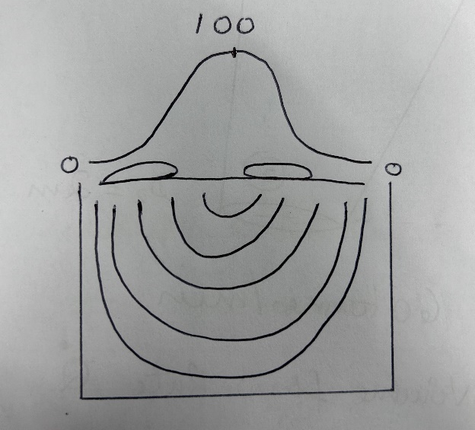
Figure 2 An example of a boundary condition not solvable by an analytical equation
The task involves calculating the temperature distribution within an aluminium plate through time. The temperature calculations will be based on the EFDM. The calculations will be done considering a 2-dimensional aluminium plate covered by a uniform structured grid, where the grid spacing is ℎ = ∆𝑥 = ∆𝑦.
The Aluminium properties to be considered are:
• Conductivity: k = 143 W/m.C
• Density: d = 2.8 x 103 kg/m3
• Specific Heat: c = 795 J/kg.C

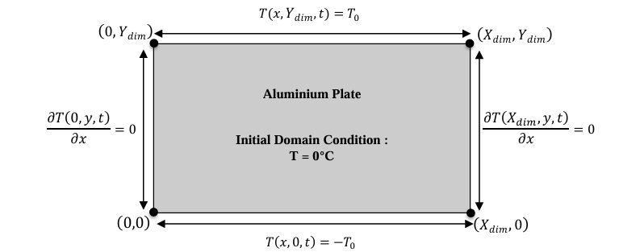
Figure 3 Initial Boundary Conditions
The initial boundary conditions are summarised in figure 2, the width X and height Y of the plate, the grid spacing h and the time step ∆t will be the choice of the user and therefore inputted as such.
Temperature
The temperature of the entire aluminium plate starts with the initial unform temperature of 0 degree Celsius.
$$T\left(x,y,0\right)=0°C$$
Top Edge
The temperature along the top edge is fixed at a constant value, this will be determined as an input via the user.
$$T\left(x,Ydim,t\right)=T_{0}$$
Bottom Edge
The temperature along the bottom edge is fixed to the opposite of the top edge ($T_{0}$).
$$T\left(x,0,t\right)= -T_{0}$$
Left Edge
A Neumann boundary condition is applied, there is no heat flux. This means the temperature gradient is zero on this edge, implying thermal insulation.
$$\frac{∂T(0,y,t)}{∂x}=0$$
Right Edge
Similar to the left edge, a Neumann boundary condition is applied. This also indicates no heat flux maintaining thermal insulation on the right edge.
$$\frac{∂T(Xdim,y,t)}{∂x}=0$$

The code will be tested against the following analytical solution of the temperature at thermal equilibrium.
$$T\left(x,y\right)=-T_{0}+\frac{2∙T_{0}}{Y_{dim}}∙y+\sum_{k=1}^{∞}{\left(\frac{1}{(100∙k∙π)^{2}}∙\left[1-(-1)^{k}\right]∙\frac{sin\left(\frac{k∙π∙y}{Y_{dim}}\right)}{sinh\left(\frac{k∙π∙X_{dim}}{Y_{dim}}\right)}∙\left[cosh\left(\frac{k∙π∙x}{Y_{dim}}\right)-cosh\left(\frac{k∙π∙(x-X_{dim})}{Y_{dim}}\right)\right]\right)}$$
Constant offset
$$-T_{0}$$
The term $-T_{0}$ is a constant offset, determining a baseline temperature offset across the panel. This term acts as a reference point representing the temperature distribution with a specific boundary condition.
Linear term
$$\frac{2∙T_{0}}{Ydim}∙y$$
The linear term above describes the linear temperature gradient along the vertical axis, determining a gradient from top to bottom or bottom to top of the panel.
The most important part of the equation comes from the multiple end terms adding higher order corrections to the temperature distribution. This ensures the solution satisfies the boundary conditions at all the edges.
$$\frac{1}{(100∙k∙π)^{2}}∙[1-(-1)^{k}]$$
The above term ensures that the solution focusses on the dominant, large-scale features of the temperature field. While also filtering out even modes, this ensures the solution considers the boundary conditions.
$$Sin \left(\frac{k∙π∙y}{Ydim}\right)$$
This term captures how the temperature changes vertically along the y-axis, the sine wave oscillates along the y-axis.
$$\frac{1}{sinh\left(\frac{k∙π∙Xdim}{Ydim}\right)}$$
This term ensures that higher-order oscillations (which describe finer details in the temperature distribution) have a smaller effect on the overall solution.
$$cosh\left(\frac{k∙π∙x}{Ydim}\right)-cosh\left(\frac{k∙π∙(x-Xdim)}{Ydim}\right)$$
The final term describes horizontal variations of temperature, the first part of the term depends on x and it represents one edge of the domain. While the second part of the term depends on x-Xdim ensuring symmetry and satisfying boundary conditions.

Code details
The complete code can be found in the Appendix below.
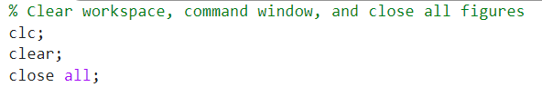
The code starts with a three clear commands clearing the workspace, command window and closing all figures. This creates a blank canvas and instils the protection from previous condition interfering with results and or code.
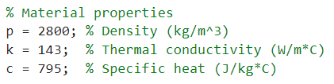
The material properties are added to the code, these were given in the initial conditions and will later be used during specific equations that will be implemented.
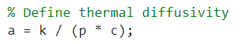
The initial properties will be used to define the thermal diffusivity, this can later be used to solve the Fourier number helping determine the stability.
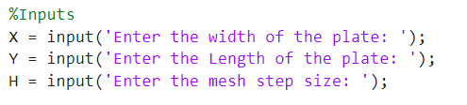
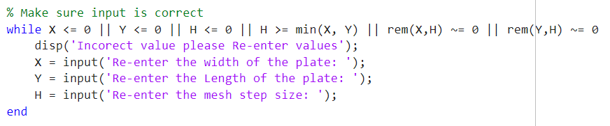
The above section of the code allows the user to input the width, length and mesh step size of the plate. These will be needed throughout the equation and will be required to gain a solution. The code ensures the user can not enter negative or zero values for the width, length and mesh step size of the plate. Also, the mesh step size can not equal the minimum of both width and length or not be divisible by both.
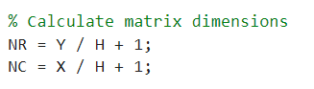
The number of rows and number of columns of the matrix is then calculated so it can later be implemented into the code.
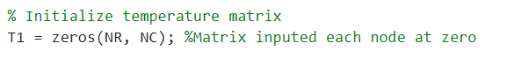
A Matrix is then initialised this will later be filled with the solutions for each node.
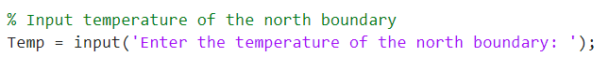
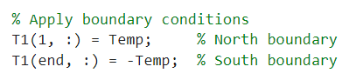
The code asks the user to implement the temperature for the north boundary, the opposite will be implemented into the south boundary as the initial boundary conditions state.
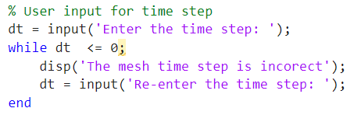
The code will then ask the user to input a time step, ensuring that no negative or zero values can be inputted, breaking the code.
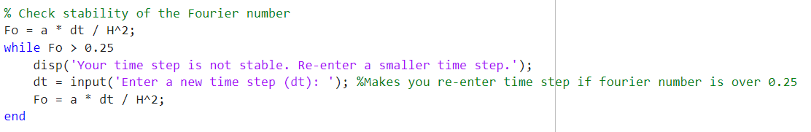
This section of the code checks the Fourier number, showing if the stability and requesting a new input if unstable.
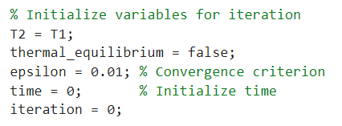
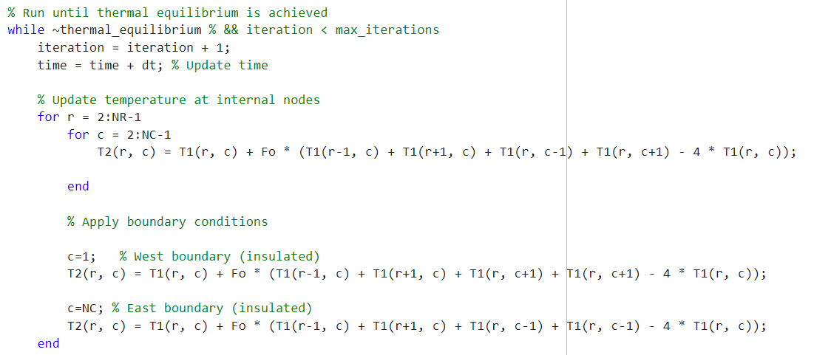
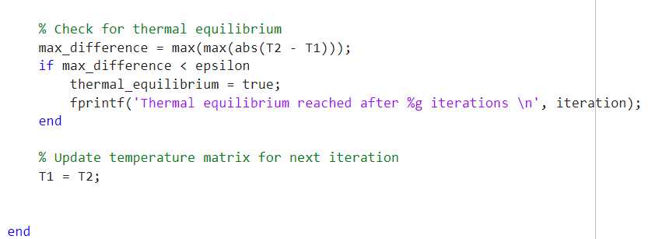
This section of the code applies the numerical equation to each node within the matrix, representing the mesh, calculating the diffusion of temperature and counting the iterations until thermal equilibrium is reached.

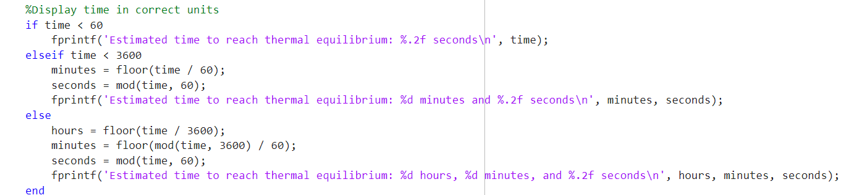
To ensure the user understand the calculation, the time to reach thermal equilibrium will be displayed in the correct unit.
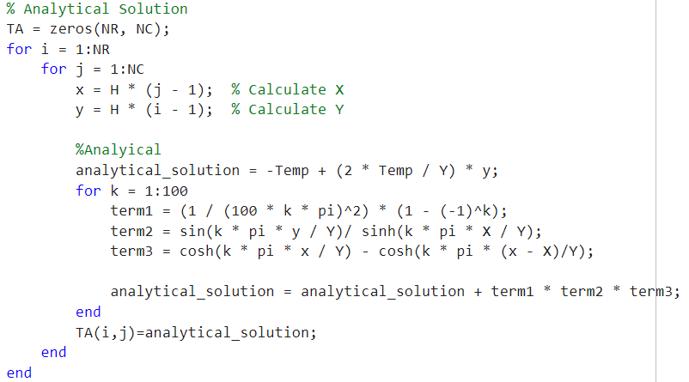
The code then calculates the analytical solution, this can then be compared against the numerical solution.
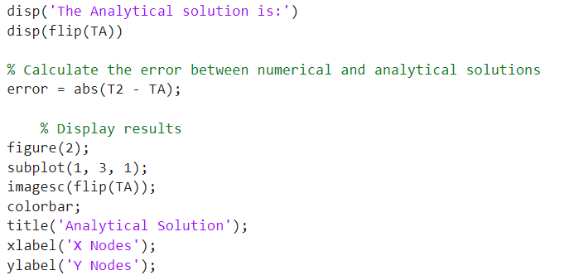
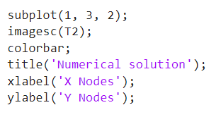
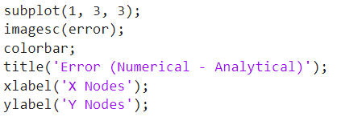
Finally, the code represents the results in three separate figures showing the user the analytical solution, numerical solution and the Error tolerance between both. Also, in the command view the time and iteration after which thermal equilibrium was reached will present. The user will then have multiple sources of information showing them the solution to their diffusion queries.

Validation of the code
After the below figures were entered in the code thermal equilibrium was reached after 60 hours and 72 iterations.
Plate Width: 10
Plate Length 10
Mesh Step Size: 1
Temperature of the North Boundary: 50
Time Step: 3000
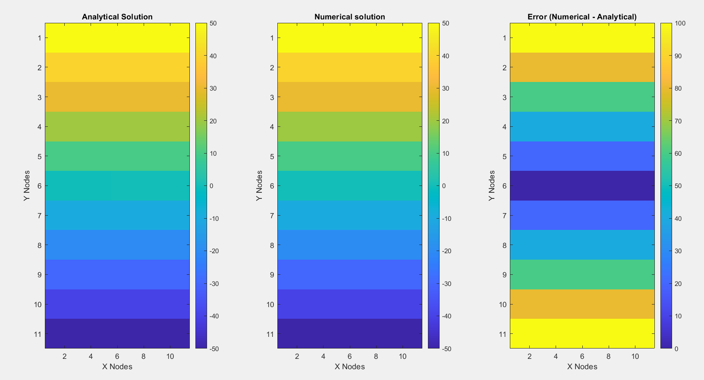
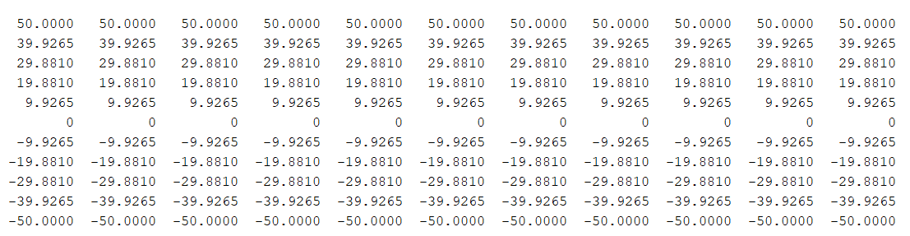
Figure 4 Charts showing the Analytical Solution, Numerical Solution and the Error between both
Figure 5 Numerical Solution Matrix

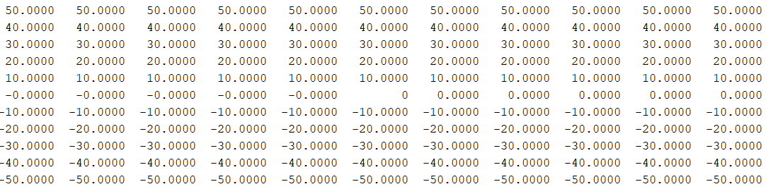
Figure 4 Analytical Solution Matrix
The results show a tolerance of error. This was expected due to the assumptions in the numerical method when deriving with the Taylor series, the final figure represents the error between both of the solutions mentioned. Both charts clearly show the range of temperatures at each node, displaying the diffusion of temperature from the north and south boundary.

Analysis of the code results
The grid spacing is crucial to the stability of the code, the size of the grid will determine the stability of the code. Selecting an appropriate grid spacing and avoiding large aspect ratios in the design is crucial to a stable code (Yogesh Jaluria, 2017). An incorrect grid spacing will result in the code prompting the user to re-enter the input allowing the code to re-check the stability and implement the grid spacing into the equation. Too small finite grid spacing will cause a multitude of calculations at a mass number of nodes. Due to the number of calculations the round off error will increase, creating a more inaccurate solution and affecting the accuracy of the results (Müller, 2021).
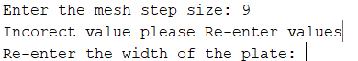
Figure 5 Comand Window Prompting User for Correct Grid Spacing
The numerical solution will be compared to the analytical solution to show the correlation and minute tolerance difference. This will instil a confidence that the numerical equation has reached thermal equilibrium with the input of the users criteria.
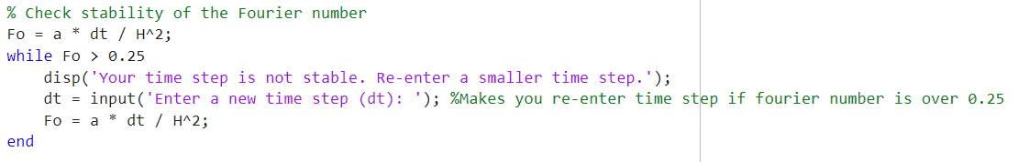
Figure 6 Checking for the Stability of the Code
The time step can also be crucial to the code stability, a low time step will result in a high number of equations. In tern also increasing the round off error and therefore the accuracy of the code. Numerical errors can degrade the accuracy and reliability of computational results (A Iserles, 2009). Achieving thermal equilibrium is essential, however the accuracy in the numerical equation compared to the analytical equation is interesting. It is essential that thermal equilibrium is reached however due to the error factor within the numerical equation, achieving the accuracy of the analytical equation would often be impossible (Stakić, Banjac and Urošević, 2011).

A discussion as to the limitations of the model
The truncation error is a result of the Taylor series expansion used to derive the approximations; the goal should be to decrease these errors. The truncation error heavily influences the stability and has an impact on the accuracy and convergence of numerical solutions (Chapra, 2008). To decrease the truncation error the time step needs to decrease. However, when implementing more time steps it increases the number of calculations. Due to the nature of the numerical code implementing an error at each calculation, an increased number of calculations result in a round of errors increasing (Wang and Teixeira, 2004). This is also true when discussing grid spacing, the mesh is responsible for each location the calculation is solved at. A fine mesh results in an increased number of calculations directly effecting the number of round-off errors instilled into the code (Enomoto, Hirakami and Tarui, 2006).
Thermal equilibrium is measured by comparing the temperature differences between two successive temperature maps, to a tolerance factor. This does not lead to a good representation of physics as there is a lack of reference. For example, the tolerance factor checks for relative differences between successive iterations, ignoring if the distribution of temperature has physical meaningful gradients. As a result of the numerical stability small differences might occur between successive steps. The EPDM method is recognised for its simplicity, however, inherits stability issues during additional successive errors (Ohwadua, 2023). Also, the required inputs such as time step dependence, gird spacing and material properties could heavily impact the stability of the code, this could be seen as a limiting factor. The primary limitation of the EPDM method is grid spacing, effecting the stability of the code (Majchrzak and Mochnacki, 2016).

Suggested improvements to the model and future developments.
Defining thermal equilibrium is essential to gaining a correct result from the numerical equation. However a true like for like between the analytical and numerical equation will never be met. Therefore, the tolerance between both analytical and numerical solutions needs to be small enough to be accurate to work and produce a correct solution. However, not so close that the code is too precise and will incur a substantial number of calculations. This solution may never be solvable due to the error instilled with the numerical code itself. Some suggestions for improving the model would be to implement a temperature gradient and involve AI to gain a more concise thermal equilibrium.
Implementing a temperature gradient would involve introducing a smoothing term that depends on the temperature gradient to reduce numerical oscillations. This would be particularly beneficial in regions where rapid changes occur (Daramola, 2025). Involving AI to gain a more concise thermal equilibrium could consist of using reinforced learning to dynamically adjust the time step based on the current state of the system. This would ensure the stability of the system while improving efficiency as it avoids overly conservative time steps. Also, AI has the ability to represent numerical discretization’s and achieve solutions based on the EFDM equations, further advancing the method (Phillips, et al., 2023).

Conclusion
The numerical equation based on explicit finite difference method produced a clear accurate solution and shared the time taken to reach thermal equilibrium with the user. This was the original aim of the code. Meeting this, ensured all clear requirements were met. The analytical approach produced a more accurate solution. This was expected and also a direct necessity, meaning the tolerance between both analytical and numerical was correct, and ensuring an accurate result without mass amount of calculation introducing round off errors. One key aspect during the analysis was ensuring the boundary conditions were capable of producing a final calculation. This was embedded onto the foundation of the code and was instrumental during the final analysis of calculations. The overall results and analysis were successful, and therefore beneficial to a wide range of scenarios and applications. The EPDM method is applicable to many industries and specific problems, with a straightforward implementation (Deka and Sarma, 2023).

References
A Iserles (2009). A first course in the numerical analysis of differential equations. Cambridge ; New York: Cambridge University Press.
Chapra, S.C. (2008). Applied Numerical Methods with MATLAB for Engineers and Scientists. McGraw-Hill Science/Engineering/Math.
Daramola, A.D. (2025). Predicting Thermal Stress and Failure Risk in Monoblock Divertors Using 2D Finite Difference Modeling and Gradient Boosting Regression for Fusion Energy Applications. Plasma Physics and Controlled Fusion, 67(2), p.025021. doi:https://doi.org/10.1088/13616587/adaa18.
Deka, H. and Sarma, J. (2023). A Numerical Investigation of Modified Burgers’ Equation in Dusty Plasmas With NonThermal Ions and Trapped Electrons. Nanosystems Physics Chemistry Mathematics, 14(1), p.512. doi:https://doi.org/10.17586/222080542023141512.
Enomoto, M., Hirakami, D. and Tarui, T. (2006). Modeling Thermal Desorption Analysis of Hydrogen in Steel. Isij International, 46(9), p.13811387. doi:https://doi.org/10.2355/isijinternational.46.1381.
L. Bergman, T., S. Lavine, A., P. Incropera, F. and P. DeWitt, D. (2011). Introduction to heat transfer. 6th ed. Hoboken, Nj: John Wiley & Sons.
Majchrzak, E. and Mochnacki, B. (2016). DualPhase Lag Equation. Stability Conditions of a Numerical Algorithm Based on the Explicit Scheme of the Finite Difference Method. Journal of Applied Mathematics and Computational Mechanics, 15(3), p.8996. doi:https://doi.org/10.17512/jamcm.2016.3.09.
Müller, P. (2021). Numerical Algorithms. p.135149. doi:https://doi.org/10.1007/9783030884864_6.
Ohwadua, O. (2023). Stability of Finite Difference Solution of TimeDependent Schrodinger Equations. Journal of Advances in Mathematics and Computer Science, 38(7), p.167180. doi:https://doi.org/10.9734/jamcs/2023/v38i71782.
Patankar, S. (2018). Numerical Heat Transfer and Fluid Flow. Taylor & Francis.
Phillips, E, H.C., Boyang, C., Buchan, G. and C, P.C. (2023). Solving the Discretised Neutron Diffusion Equations Using Neural Networks. doi:https://doi.org/10.48550/arxiv.2301.09939.
Stakić, M., Banjac, M. and Urošević, T. (2011). Numerical Study on Hygroscopic Material Drying in Packed Bed. Brazilian Journal of Chemical Engineering, 28(2), p.273384. doi:https://doi.org/10.1590/s010466322011000200012.
Svetislav, S.M. and Djordjevich, A. (2020). Explicit Finite Difference Solution for Contaminant Transport Problems With Constant and Oscillating Boundary Conditions. Thermal Science, 24(3 Part B), p.22252231. doi:https://doi.org/10.2298/tsci190722422s.
Wang, S. and Teixeira, F.L. (2004). GridDispersion Error Reduction for Broadband FDTD Electromagnetic Simulations. Ieee Transactions on Magnetics, 40(2), p.14401443. doi:https://doi.org/10.1109/tmag.2004.824904.
Yogesh Jaluria (2017). Computational Heat Transfer. Routledge.

Appendix
% Clear workspace, command window, and close all figures
clc;
clear;
close all;

% Material properties
p = 2800; % Density (kg/m^3)
k = 143; % Thermal conductivity (W/m*C)
c = 795; % Specific heat (J/kg*C)

% Define thermal diffusivity
a = k / (p * c);

%Inputs
X = input('Enter the width of the plate: ');
Y = input('Enter the Length of the plate: ');
H = input('Enter the mesh step size: ');

% Make sure input is correct
while X <= 0 || Y <= 0 || H <= 0 || H >= min(X, Y) || rem(X,H) ~= 0 || rem(Y,H) ~= 0
disp('Incorrect value please Re-enter values');
X = input('Re-enter the width of the plate: ');
Y = input('Re-enter the Length of the plate: ');
H = input('Re-enter the mesh step size: ');
end

% Ensure mesh step size divides plate dimensions evenly
while rem(X, H) ~= 0 || rem(Y, H) ~= 0
disp('Grid must be spaced evenly between X and Y.');
H = input('Enter step size again: '); %Makes you re-enter step size if not even
end

% Calculate matrix dimensions
NR = Y / H + 1;
NC = X / H + 1;

% Initialize temperature matrix
T1 = zeros(NR, NC); %Matrix inputted each node at zero

% Input temperature of the north boundary
Temp = input('Enter the temperature of the north boundary: ');

% Apply boundary conditions
T1(1, :) = Temp; % North boundary
T1(end, :) = -Temp; % South boundary

% User input for time step
dt = input('Enter the time step: ');
while dt <= 0;
disp('The mesh time step is incorrect');
dt = input('Re-enter the time step: ');
end

% Check stability of the Fourier number
Fo = a * dt / H^2;
while Fo > 0.25
disp('Your time step is not stable. Re-enter a smaller time step.');
dt = input('Enter a new time step (dt): '); %Makes you re-enter time step if Fourier number is over 0.25
Fo = a * dt / H^2;
end

% Initialize variables for iteration
T2 = T1;
thermal_equilibrium = false;
epsilon = 0.01; % Convergence criterion
time = 0; % Initialize time
iteration = 0;

% Run until thermal equilibrium is achieved
while ~thermal_equilibrium % && iteration < max_iterations
iteration = iteration + 1;
time = time + dt; % Update time

% Update temperature at internal nodes
for r = 2:NR-1
for c = 2:NC-1
T2(r, c) = T1(r, c) + Fo * (T1(r-1, c) + T1(r+1, c) + T1(r, c-1) + T1(r, c+1) - 4 * T1(r, c));

end

% Apply boundary conditions

c=1; % West boundary (insulated)
T2(r, c) = T1(r, c) + Fo * (T1(r-1, c) + T1(r+1, c) + T1(r, c+1) + T1(r, c+1) - 4 * T1(r, c));

c=NC; % East boundary (insulated)
T2(r, c) = T1(r, c) + Fo * (T1(r-1, c) + T1(r+1, c) + T1(r, c-1) + T1(r, c-1) - 4 * T1(r, c));
end

% Check for thermal equilibrium
max_difference = max(max(abs(T2 - T1)));
if max_difference < epsilon
thermal_equilibrium = true;
fprintf('Thermal equilibrium reached after %g iterations \n', iteration);
end

% Update temperature matrix for next iteration
T1 = T2;

end
%Display time in correct units
if time < 60
fprintf('Estimated time to reach thermal equilibrium: %.2f seconds\n', time);
elseif time < 3600
minutes = floor(time / 60);
seconds = mod(time, 60);
fprintf('Estimated time to reach thermal equilibrium: %d minutes and %.2f seconds\n', minutes, seconds);
else
hours = floor(time / 3600);
minutes = floor(mod(time, 3600) / 60);
seconds = mod(time, 60);
fprintf('Estimated time to reach thermal equilibrium: %d hours, %d minutes, and %.2f seconds\n', hours, minutes, seconds);
end
T2

% Analytical Solution
TA = zeros(NR, NC);
for i = 1:NR
for j = 1:NC
x = H * (j - 1); % Calculate X
y = H * (i - 1); % Calculate Y

%Analytical
analytical_solution = -Temp + (2 * Temp / Y) * y;
for k = 1:100
term1 = (1 / (100 * k * pi)^2) * (1 - (-1)^k);
term2 = sin(k * pi * y / Y)/ sinh(k * pi * X / Y);
term3 = cosh(k * pi * x / Y) - cosh(k * pi * (x - X)/Y);

analytical_solution = analytical_solution + term1 * term2 * term3;
end
TA(i,j)=analytical_solution;
end
end
disp('The Analytical solution is:')
disp(flip(TA))

% Calculate the error between numerical and analytical solutions
error = abs(T2 - TA);

% Display results
figure(2);
subplot(1, 3, 1);
imagesc(flip(TA));
colorbar;
title('Analytical Solution');
xlabel('X Nodes');
ylabel('Y Nodes');

subplot(1, 3, 2);
imagesc(T2);
colorbar;
title('Numerical solution');
xlabel('X Nodes');
ylabel('Y Nodes');

subplot(1, 3, 3);
imagesc(error);
colorbar;
title('Error (Numerical - Analytical)');
xlabel('X Nodes');
ylabel('Y Nodes');

