

Student name: Bushra Ayub
Student ID: 2512516

Module name: Introduction to Health and Social Care
Module code: LCHS4003
Lecturer name: Muhammad Aliyu
Assignment title: Portfolio – Two Tasks
Task 1: Community Mental Health Services poster
Task 2: Pharmacy Services essay

Submission Date: 23 March 2026

Contents
Element 1: Poster 3
Element 2: Essay – Pharmacy Services 4
References 6

Element 1: Poster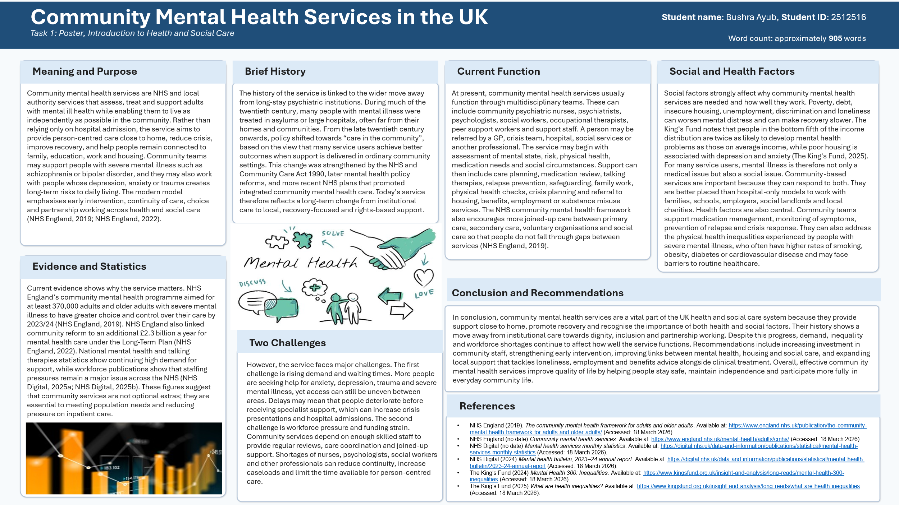

Element 2: Essay – Pharmacy Services
Pharmacy services are a very important part of primary care in England. They give people access to medicines, treatment and health advice in their local community. Community pharmacies have been connected to the NHS since it began in 1948. At that time, free prescriptions made it easier for people to obtain medicines, which increased the amount of work community pharmacists did. In the early years, pharmacist where mainly responsible for preparing and dispensing medicines. However, over time, their role shifted to focus more on patient care and safety (Connelly, 2018).
The development of pharmacy services reflects the growth of the NHS and the increasing use of medicines in modern healthcare. As the health service expanded, pharmacies became one of the easiest places for people to access care. This evaluation can inspire the audience by showing how pharmacy roles have expanded from dispensing medicines to advising patients, checking the safety of medicines, and supporting understanding of treatments. Today, pharmacy services in England work under the community pharmacy contract table framework, which demonstrates that community pharmacy is now a structured and recognised part of NHS care (NHS England, 2025a).
Today, pharmacy services do much more than many people think. In addition to dispensing prescriptions, pharmacies support public health and offer a wide range of services. The King's Fund explains that community pharmacy is one of the four main parts of primary care in England. Many pharmacies now provide blood pressure checks, contraception, vaccinations, urgent repeat medicines, support for minor illnesses and referrals to order NHS services (The King’s Fund, 2025). Pharmacy 1st is a good explanation after the modern row. NHS England states that this service builds on the Community Pharmacist Consultation Service, which began in October 2019. Since 31 January 2024, community pharmacies have been able to manage 7 common conditions through clear clinical pathways. This helps patients get treatment more quickly without always needing a GP appointment (NHS England, 2025b).
One of the key strengths of pharmacy services is their accessibility, which can reassure the audience about the convenience of local health care options. Pharmacies are located in local areas, making them easier to reach than many other health services. According to the King's Fund, around 90% of people in England live within a 20-minute walk of a pharmacy, although access is lower in some areas (The King’s Fund, 2025). This proximity allows many people to get help quickly and close to home, fostering trust in community healthcare. Pharmacy services also reduce pressure on GPs and hospitals by addressing common health problems and medication-related questions in the community. This improves the speed of care and makes the NHS more efficient.
However, there are also some challenges. Although pharmacies are being asked to provide more services, the sector still faces problems such as funding pressure, workforce shortages and some pharmacy closures. These issues can affect the amount of support pharmacies can provide in the future. There is also an inequality issue, because people living in rural areas may not have the same level of access as those in towns and cities (The King's Fund, 2025).
Overall, pharmacy services are very important in improving the quality of life of service users. They help people get medicines safely, manage long-term conditions, receive advice quickly and prevent small health problems from becoming more serious. For many people, the local pharmacy is the easiest and fastest way to get NHHS support. The history of pharmacy services shows a clear move from simply supplying medicines to providing person-centred care. Today, pharmacy services are essential, but their future success will depend on continued support, funding and enough trained staff.

References
Connelly, D. (2018) ‘NHS70: major moments in pharmacy 1948–2018’, The Pharmaceutical Journal, 22 June. Available at: https://pharmaceutical-journal.com/article/infographics/nhs70-major-moments-in-pharmacy-1948-2018 (Accessed: 18 March 2026).
NHS England (2025a) Community Pharmacy Contractual Framework 2019–2024. Available at: https://www.england.nhs.uk/primary-care/pharmacy/community-pharmacy-contractual-framework/ (Accessed: 18 March 2026).
NHS England (2025b) Pharmacy First. Available at: https://www.england.nhs.uk/primary-care/pharmacy/pharmacy-services/pharmacy-first/ (Accessed: 18 March 2026).
The King’s Fund (2025) Community pharmacy explained. Available at: https://www.kingsfund.org.uk/insight-and-analysis/long-reads/community-pharmacy-explained (Accessed: 18 March 2026).

