

Name | Jacqueline Messam
Student ID Number | 1712441
Module Name | Understanding and Engaging in the Customer Experience
Module Number | BMSW5003
Lecturer | Charled Oham
Program Director | Dr Gladuis David Kuloyhungan

Contents
Introduction 2
The Customer 2
Customer Value 3
Customer Relationship Management Systems 5
SERVQUAL Model 6
Customer Journey Mapping 9
Conclusion 10
References 13

Introduction

In this essay I will focus on the customer value within my workplace, I will be critically analyzing how my organization maximizes customer value. I will be using theoretical frameworks such as the SERVQUAL model and customer journey mapping to support and illustrate my findings as well as to identify what can be done in order to maximize customer value.

The Customer

A customer can be defined as an individual or business that acquires a service or goods from another business. A majority of public- facing businesses are competitive with each other to attempt to expand their customer base. Bloomenthal (2019)
I work for a company called Look Ahead Care, Support and Housing which is a charity housing organization which is a not-for-profit organization. Look Ahead supports thousands of individuals across the United Kingdom. Look Ahead’s mission is “Working with individuals to make choices, achieve goals and take control of their lives through high quality care, support and housing” (Look Ahead Care, Support and Housing 2019)
The service that I Manage within Look Ahead supports Ex-Offenders, Street Homeless, Individuals with Drug and Alcohol Abuse and Complex needs. To be able to support and provide for our customers it must first be identified what our customer groups are. There are three customer groups that apply to the company that I work for. Firstly, we only support males aged between 18 and 65 years of age with any of the issues outlined above. We need to ensure that we have and understanding that the customers that will be referred to our service have varied backgrounds but most of them would have been somewhat institutionalized causing them to have a set view of what to expect when using the service. This is where we need to sell the service to our perspective residents as they could turn down our service and opt to go for another organization. Ensuring that we highlight all the benefits that our service provides and identifying our unique selling point is essential. Allowing potential residents to meet other residents who have benefited from our service will allow potential residents to connect with individuals that may have been in the same position as them. This is a kind of “success story” angle where we can outline to potential residents what we are able to offer and do for them. We provide a tour of our building in which has been adapted to have a more “at home” feel is key to breaking the perception that our service will be an institutionalized establishment.
The second customer base that is applicable is the commissioners who are from the local authority. They are the ones who fund the service and approve our support and housing contracts in order to have potential customers referred. In the healthcare and support sector there are a range of companies competing to secure contracts with local authorities in order to receive the most business. Therefore, it is very important to meet the commissioner's expectations and needs. The commissioners are the most important customer as they are at the root of our business, without their contracts we wouldn’t be able to receive any referrals for perspective housing and support customers. My organization has very competitive prices which gives us that edge above our competitors, we also undergo audits where our commissioners attend our service and speak with staff members, Housing customers, have a look at our customer files and analyze our key performances this shows our sustainability and need in the market as well as how proactive we have been with our residents. .
Lastly, we have the individuals that refer potential residents to us. They can be;
probation officers – For our ex offender and customers
care coordinators – For any mental health or complex needs customers
Outreach Workers – For any street homeless customers
These professionals identify prospective residents and refer them to us once referred we receive housing benefits from the local council for their rent and the customers pay a weekly service charge. The strategy used for our professional customers is building a rapport with them by having great communication, ensuring that we have a great response rate to their referrals and assessing prospective residents within our advertised timeframe and ensuring that we advertise vacancies.

Customer Value
Customer Value can be defined as the “The perception of what a service or product is worth to a customer versus the possible alternatives. Worth means whether the customer feels they got benefits and services over what they paid” Mahajan (2016)
Bain and Company identified “30 Elements of Value” these identified values fall into four categories which are;
- Functional
- Emotional
- Life changing
- Social Impact
Bain and company designed an “Elements of Value Pyramid” in which they outlined what the thirty elements. The “Elements of Value Pyramid” is said to be an extension of “Maslow's Hierarchy of Needs” Almquist, Senior and Bloch (2016)
The elements of value pyramid have been described by Almquist, Senior and Bloch (2016) as a more of a heuristic model which is more practical rather than theoretical in which the most powerful forms of value live at the top. “In order to be able to deliver on those higher-order elements, a company must provide at least some of the functional elements required by a particular product category. But many combinations of elements exist in successful products and services today” Almquist, Senior and Bloch (2016)

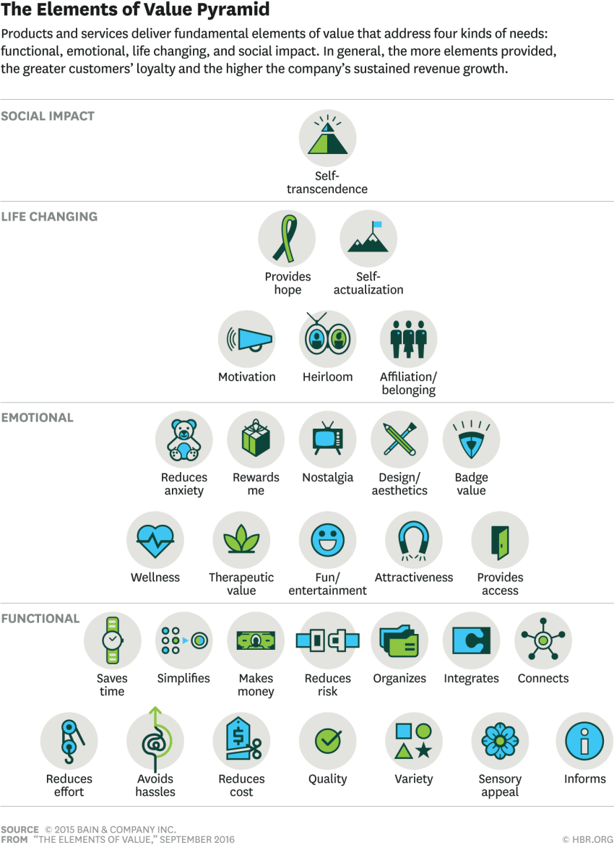

Given we have three customer groups all these elements would be applicable to our customers is some way. Regarding our residents the most applicable elements would be in the Social Impact, Life Changing and Emotional categories as we are supporting them to lead independent lives. The commissioner and professional customer values would be mainly functional due to the nature of our working.
Although we provide services and try to adapt what we feel that our customers will value, it doesn’t depict a truthful reflection of how customers value the service. In order to ascertain how our customers, value our service we often send our evaluation questionnaires to see how we are performing, there are also monthly customer meeting that we hold to discuss any complaints, concerns and suggestions. The challenge that our organisation faces with our resident customers especially is that there are many rules and regulations that prevents us from meeting their needs. For example; I had a customer approach me to complain as his daughter was not allowed to come to his room in his hostel she is ten years of age and was unable to enter the hostel due to our restrictions, this upset our customer and caused him to complain about our service. As much as the organisation attempts to make our services have an “At home feel” due to the nature of resident's rules, such as no visitors under eighteen years of age and visiting hours between 10:00am and 19:00pm restrict customers and limits the extent that we can cater to our resident customer's needs.

Customer Relationship Management Systems

Customer Relationship Management can be defined as a technology that manages the relationships between customers or potential customers and a business. An example of a Customer Relationship management system is Salesforce which is also one of the systems used in the organisation that I work in. “A CRM solution helps you focus on your organization’s relationships with individual people including customers, service users, colleagues, or suppliers throughout your lifecycle with them, including finding new customers, winning their business, and providing support and additional services throughout the relationship” Salesforce (2019)
The salesforce system that I currently use in my workplace enables me to store all customer details on the system, store all potential customers data on the system, identify the ranges of customers that we have in our service, create reports on our progress and deal with customer complaints. Look Ahead also have their own website where customers can gain information and contact different parts of the organisation. Although the system that we currently use is great for managing our customers I don’t feel like it builds or creates a relationship with them. Our system focuses more on the monitoring aspect of the business which is important when reporting to professionals and the commissioners but leaves out the much-needed relationship with our residents, potential residents, commissioners and professionals. I think there needs to be more focus on creating apps to contact our customer base. Having this app could build and strengthen the relationship between our customers and the business. Things such as customers being able to pay their rent online, make a complaint, raise a query, report a repair or simply receive information updates and reminders from us would make all the difference. I regularly receive complaints that we are not modernized enough and lack necessities like free Wi-Fi.
Haselmayr (2014) gave seven benefits as to why businesses should have their own mobile apps, Haselmayr (2014) believes mobile apps will be a normal part of any business in the future and being one of the first will set a great foundation for any business. I will identify what the potential benefits could be for Look Ahead.
- Be visible to customers at all times - The visibility and availability is vastly important. People spend a lot of time on their mobile phones. Hymas (2018) wrote that “The average person in the United Kingdom spends more than one-week online” being that people are spending all this time on their mobiles there's more chance for a business to get noticed. “Our mind unconsciously records every image and text it comes across” Haselmayr (2014) this supports my thesis that having an app promoted or in the view of individuals could be a great marketing strategy. Look Ahead having their own app for its customer will also enable customers to contact the organisation anytime of the day and create convenience such as reporting repairs or paying their rent.
- Create a direct marketing channel – This provides a platform of push information such as sending vacancies to our professionals, reminding potential resident customers of their assessment and viewing dates, reminding residents of rent payment dates and meeting with their support workers.
- Provide value to your customers – This would be in relation to loyalty points or rewards for customers. As Look Ahead are unable to provide loyalty points there could incentives such as vouchers that would be donated from our local stores. This could be implemented as a reward system for customers that have kept a good rent account and ones that may be moving on to other accommodations. Another vale that could be added is information about free activities in the local area and other charities that support homeless individuals with housing items.
- Build Brand and recognition – This could enable Look Ahead to be one of the most noticed charitable organizations which could improve the commissioners view of the organization resulting in multiple long contracts. Potential resident customers will also recognize the brand and be more inclined to choose our service.
- Improve customer engagement – We often speak with customers face to face or via the telephone there is rarely any internet-based communication which poses some inconvenience for some of our customers. The resident customers in our service must pay their rent over the counter which they sometimes find intrusive and time consuming whereas having an app where they could simply click a button enter some details and pay online wherever they are would prove more convenient for them.
- Stand out from the competition – Having an app especially in the charity sector would be a great leap as technology is taking over. This could enable Look Ahead to be noticed above the rest for being modernized and more accessible.
- Cultivate customer loyalty – Being so accessible may encourage customers to be more open about what they want, being accessible all the time builds a great relationship with the customer and creates a sense of trust if their queries are dealt with efficiently. Making connections with our customers would be key and ensuring that they are recognized.

SERVQUAL Model

The Service Quality Gap Model (SERVQUAL) also known as the “RATER Model” is a measure of service quality and identifies the gaps between the customers expected service and the actual service.
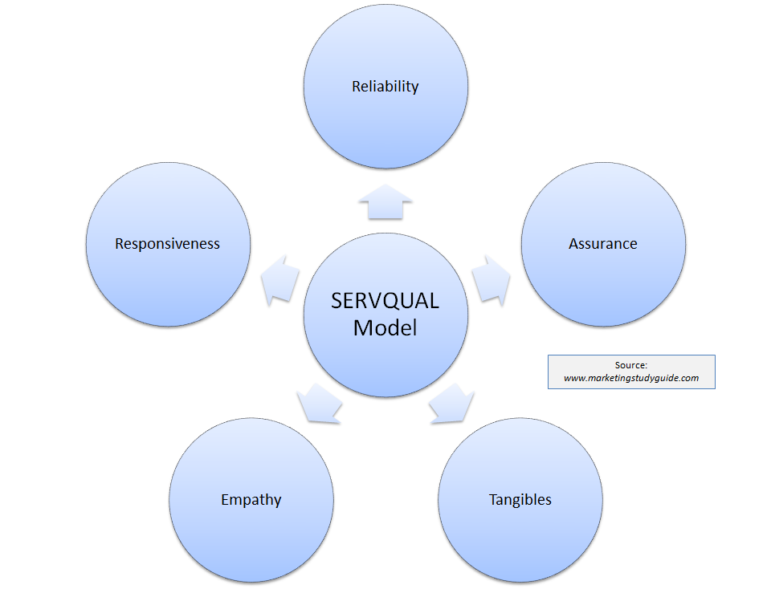
There are five dimensions to the SERVQUAL which are;
- Reliability – This relates to the company's service and the willingness to help and support the customer. For example; one of our resident customers requested that we support him with his move on in which we referred him to another agency, supported him to viewings, explained the procedures to him, supported him with change of address for housing, supported him with securing a loan and goods for his new property and ensured that he was completely prepared for his move on. This is an example of the end support that we provide to a customer which I believe is as important as the start of their support journey. This shows resident customers that we are reliable and will support them till the end of their journey with us. This is a possible marketing opportunity as this resident customer will recommend us to individuals that may also need help.
- Assurance – Is the confidence and trust that customers feel in the staff due to their extensive knowledge. For example, when our commissioners perform their audits, they speak with staff individually and question their knowledge about certain procedures such as reporting. Ensuring that every staff member is trained and knowledgeable about the policies and procedures is vital and assures our commissioners that the trust that they are instilling in the organization is viable.
- Tangibles – This is regarding the actual physical facilities that the company provides. For example, with the service that I manage we provide a common room with a tv and sofas for resident customers to engage with each other we also provide computers for customers to browse the internet, apply for jobs and check emails. A way in which we could improve is providing free WI-FI for our service as customers often have their own laptops and phones and often wish to use them in their rooms.
- Empathy – I the caring nature and understanding that staff pay to each individual customer. In my organization we work towards “Person Centered Care” which means seeing each customer as an individual and supporting them how they require us too. Empathy plays a big part in the role of the company as we deal with various vulnerable adults with varied backgrounds.
- Responsiveness – Is the way in which the company responds to perform the service correctly and efficiently. Staff at Look Ahead are put through extensive training and must achieve a “Care Certificate” which is a basic health and social care qualification. Having all the training and achieving this qualification doesn’t always mean that all staff will perform up to standard and it's up to the company and the managers to monitor and ensure that staff are providing the best service.
There is always room for companies to improve and although staff believe that they work to their best abilities there may be expectations that the customer had from the service that the organization were unable to provide. I carried out a survey on five residential customers in my service to demonstrate any possible service gaps, I based the answers from one to five, one being Strongly disagree and five being strongly agree. Below I have evidenced my questions and findings.
Reliability
R1 – Staff always do what they say
R2 – Staff always attend scheduled appointments
R3 – A staff member is always available when needed
Assurance
A1 – I feel confident in the staff members
A2 – Staff are always able to resolve my queries
A3 – Staff are always polite
Tangibles
T1 – The service has up to date equipment
T2 – The service is clean
T3 – The interior decorations re visually appealing
Empathy
E1 – Staff gives me individual attention
E2 – Staff understands my needs
E3 – Staff care about my issues
Responsiveness
R1 – Staff are always willing to help me
R2 – Staff are quick with their response
R3 – Staff make information easily accessible

Dimension | Total of all answers out of 25
Reliability
R1 | 20
R2 | 15
R3 | 20
Assurance
A1 | 15
A2 | 20
A3 | 20
Tangibles
T1 | 10
T2 | 10
T3 | 15
Empathy
E1 | 20
E2 | 15
E3 | 15
Responsiveness
R1 | 15
R2 | 15
R3 | 20

Looking at my results the biggest gap in our service is the Tangibles dimension although I expected a higher result it's understandable that our lack of technology and modernized décor is a factor that needs action. Another finding was that customers where mostly neutral in regard to empathy and responsiveness suggesting that more work needs to be done to assure customers that we understand and empathize with them and are willing to deal with any of their queries. The highest scoring points were reliability and assurance which suggests that our resident customers feel that we are there for them when needed and are confident in our processes.
Customer Journey Mapping
“A customer journey map is an illustration that identifies all of the sample touchpoints at an organization that the customer encounters when attempting to complete a task, it highlights all the emotions that they may experience during their journey” Davey (2018)
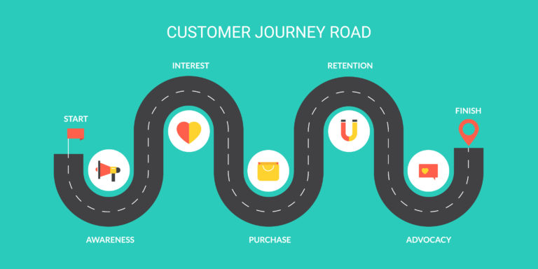
Creating a customer journey map is meant to be a true reflection of the journey a customer has. Davey (2018) highlights the importance of doing research to get to know the customers and stresses that no shortcuts should be taken when undergoing research into a customer group. Understanding the customers behavioral stages in the perspective of the customer is needed.in order to illustrate what a customer will be feeling at each stage of their journey. I will demonstrate the beginning of a customer journey map based on my organization's ex offender resident customers in my service.
The firstly the customer will have been advised by their probation officer about our service and informed that we have a vacancy. A staff member from my service will contact the potential resident customer to arrange a date of assessment. At this point the customer may be feeling anxious, confused, overwhelmed and curious as they would have just been released from prison, and they haven't been in society for a while. At this point it important for staff to be friendly, reassuring and informative as the customer will need to feel a sense of confidence in the service.
This is a short section of the customer journey mapping, but it demonstrates the importance of getting to know customers actions, feelings and thoughts as it will enable a truer reflection of the customer journey map. The downside to the customer journey mapping is that the customers actions, feelings and thoughts are being created by the company and are not factual representation of the true customers journey.

Conclusion

To conclude A customer can be defined as an individual or business that acquires a service or goods from another business. A majority of public- facing businesses are competitive with each other to attempt to expand their customer base. Bloomenthal (2019) my organization “Look Ahead Car, Support and Housing” has three customer bases that applies to my service which are Commissioners, Professionals and residents who all contribute to the successfulness of the organization. There are five identified sections of the “Elements of values pyramid” but thirty identified values. “The perception of what a service or product is worth to a customer versus the possible alternatives. Worth means whether the customer feels they got benefits and services over what they paid” Mahajan (2016) The different groups of customers that use the service all demonstrate different values for the service with the commissioners and the professionals dominating the functioning factors the resident customers value the social impact, life changing and emotional factors. The main section that I identified that will contribute to my organization improving on customer value is our Customer Relations Management Systems. I believe that If my organization create an app it would relate to all our customer groups on a different level and provide a significant edge above our competitors. Haselmayr (2014) believes mobile apps will be a normal part of any business in the future and being one of the first will set a great foundation for any business and provided seven benefits to having a mobile app for any business. Hymas (2018) wrote that “The average person in the United Kingdom spends more than one-week online” suggests that having a mobile app would be beneficial to any business and boost marketing. I spoke about the “SERVQUAL Model” also known as the RATER model in which there are five dimensions. I created a survey and presented it to five customers in relation to these dimensions and found that the parts of the service that most need improvement was tangibles, this suggested that there is a need for a modernization within my organization in which a phone app could contribute to as well as WI-FI within our establishment. Lastly, I spoke about customer journey mapping and identified that although effective journey mapping is based on what we believe to be the customers perception not the factual evidence which may cause a misrepresentation of what the customer journey is. My organization needs to focus on the construction of a business app to improve the customers experience and value of the service.

References

Almquist, E. Senior, J. Bloch, N. (2016) The Elements of Value. Available at: https://hbr.org/2016/09/the-elements-of-value (Accessed on: 20/08/2019 )
Davey, N (2018) Customer Journey. Available at: https://www.mycustomer.com/experience/engagement/nine-sample-customer-journey-maps-and-what-we-can-learn-from-them (Accessed on:20/08/2019)
Haselmayr, M. (2014) Here's why your Business needs its own Mobile App. Available at: https://www.forbes.com/sites/allbusiness/2014/11/17/heres-why-your-business-needs-its-own-mobile-app/#3228bdfe327f (Accessed on: 20/08/2019)
Hymas, C. (2018) A decade of smartphones: we now spend an entire day every week online. Available at: https://www.telegraph.co.uk/news/2018/08/01/decade-smartphones-now-spend-entire-day-every-week-online/ (Accessed on: 20/08/2019 )
Kotler, P. (2017) Customer Value Management. Available at: https://journals-sagepub-com.ezproxy.uwtsd.ac.uk/doi/full/10.1177/2394964317706879 (Accessed on: 20/08/2019)
Look Ahead Care, Support and Housing (2019) Our Missions and Values. Available at: https://www.lookahead.org.uk/about-us/our-mission-and-values/ (Accessed on: 20/08/2019)
Mahajan, G (2016) What is Customer Value and How Can You Create it? Available at: http://customerthink.com/what-is-customer-value-and-how-can-you-create-it/ (Accessed on: 20/08/2019)
Marketing Study Guide (2015 –2019) Understanding the SERVQUAL Model. Available at: https://www.marketingstudyguide.com/understanding-the-servqual-model/ (Accessed on: 20/08/2019 )
Salesforce (n.d) What is CRM. Available at: https://www.salesforce.com/crm/what-is-crm/# (Accessed on: 20/08/2019 )

