

Global Business Environment

Name : Bianca Petronela Paunescu

Student ID : 2024896

Date & Time : 14.01.2022

Table of Contents

By March 2020, the number of hospital admissions and deaths had reached alarming levels. The first countrywide shutdown was implemented to stop the virus from spreading. The COVID-19 pandemic has had a quick and devastating impact on sectors all around the world. When COVID-19 first appeared in China in December 2019, there was an immediate impact on the local car sector, with plants closing temporarily.
With China accounting for more than 80% of the global automotive supply chain, The disruption of Chinese parts imports, large-scale manufacturing disruptions across Europe, and the closure of assembly plants in the United States has put a lot of strain on an industry that is already coping with a decline in global demand. The car market collapsed as a result of the required closure of all outlets other than essential retail. All of these closures began to result in production constraints for global original equipment manufacturers (OEMs).
In April 2020, the Society of Motor Manufacturers and Traders (SMMT) reported a 97.3 percent reduction in new car sales compared to last year. The UK motor industry's gradual recovery from the pandemic continued after the first lockdown, with sales still much below pre-Covid-19 levels. New car sales for the year were 48.5 percent lower than the same period the previous year. As a result, there were 240,000 fewer private dealings, resulting in a £1.1 billion VAT loss. New car registrations decreased by 34.9 percent in June alone.
By late October, new car sales had made a substantial comeback. To help stop the virus's spread, the country was placed under a second countrywide lockdown in early November. Sales of gasoline and diesel vehicles fell 39.9% and 59.8%, respectively, during the month, while sales of battery electric, hybrid, mild hybrid, and plug-in hybrid vehicles increased by 73.3 percent. In December, output declined -2.3 percent to 71,403, with border restrictions and resulting component supply worries affecting some businesses. This closed off a disastrous year for UK automakers, the worst since 1984, with the pandemic having a significant influence in the drop.
Governments have been pondering how to re-start economies while maintaining population protection. Automobile production, like many other businesses, cannot continue to operate remotely; humans must be present on-site in facilities to produce vehicles.Although production surged in response to the reopening of the domestic market in the summer of 2020, the SMMT says that nine out of ten vehicles built in the UK are for export markets, the majority of which reopened before the UK.
Manufacturing activity was significantly disrupted throughout 2020, with output reduced by industrial lockdowns and social distancing measures, Brexit uncertainty lasting until Christmas Eve, and low market demand in key export markets. In 2020, production for international clients declined by 29.1% to 749,038 units, while output for the UK dropped by 30.4 percent to 171,890 units. Exports continued to underpin UK vehicle production despite the global epidemic, with more than eight out of ten automobiles being shipped. The EU continues to be the UK's most important export market, emphasising the necessity of avoiding 'no deal' tariffs. In November, six out of ten autos were delivered to Europe. Meanwhile, Asia accounted for 15.6 percent of UK auto exports, the US for 13.4 percent, and Australia for 1.2 percent.

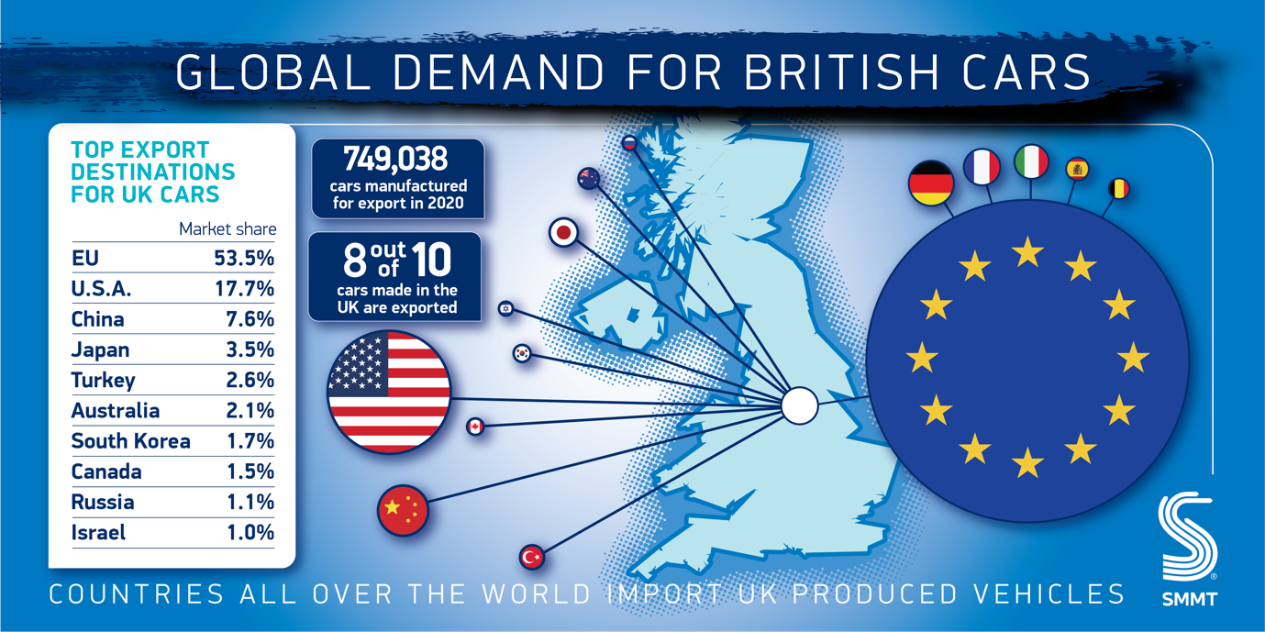

Clearly, the coronavirus lockdowns have had a significant impact on how we live and work. However, while many people still have no choice but to go to work, many more have been working from home for the most of the year. There has been a considerable reduction in total miles driven due to the absence of a commute. In addition to causing a shift in our working life, the epidemic has polarised opinions on public health, especially air quality. While the production of electric vehicles, particularly the batteries, has environmental implications, there is no other option that will have such a direct impact on reducing local transportation-related pollution.
In 2020, overall car sales fell by 28 percent in the first half of the year, while electric vehicle sales fell by only 14 percent. Battery-powered electric car sales rose to 19,800 in June, accounting for 10.7% of total sales. The Covid-19 recovery incentives granted by six European countries, including Germany, have boost sales even more. Sales of electric vehicles climbed by 9.1% in France and 7.6% in Germany. Tesla led the electric car market with 142,000 Model 3 vehicles delivered until June 2020, followed by Renault Zoe with 38,000 and Nissan Leave with 24,000 units.
Some automakers have been upgrading their facilities in order to produce COVID19 ventilators with spare parts. Engineers at Ford, GM, and Tesla, for example, constructed ventilators using parts from their respective vehicle models. Essentially, automakers store parts for final assembly in order to avoid any manufacturing line disruptions caused by a single missing part. Some automotive engineers adhered to this principle by including as many auto parts as feasible into these support devices. Tesla's ventilator, for example, employs the Model 3 infotainment system to power a Model 3 car computer, which regulates an airflow manifold. As an oxygen mixing chamber, a suspension air tank was used. The team employed a Model 3 touchscreen as the controller for the final healthcare device, among other things. Ford Motor Company manufactured 50,000 medical ventilators. The company reconfigured its Michigan operation to offer all of the workstations and medical oxygen supplies that the new production facility would require. Ford, like Tesla, collaborated with GE Healthcare to enhance ventilator production while also developing health equipment, respirators, and face shields using its own resources. GM planned to manufacture ventilators at a plant in Indiana, and they had been producing 50,000 masks every day. Carmakers all around the world have proved, like they did during World War II, that they can readily transition to mass production of this critical weapon in the struggle against this invisible foe.
Production of battery electric, plug-in hybrid, and hybrid vehicles in the United Kingdom reached a record high, accounting for more than a third (32.7%) of all vehicles built in the month and more than a quarter (25.5%) year-to-date. Battery electric vehicle production increased by 52.9 percent to 10,359 units in November, reaching a new high of 13.7 percent of overall output, more than double the level of a year ago.
Electric cars, also known as electric vehicles, are battery-powered automobiles that operate entirely on electricity. Electric automobiles, unlike gasoline, diesel, or hybrid vehicles, do not have a combustion engine; instead, they employ an electric motor and a rechargeable battery. A normal electric car can go between 100 and 200 miles on a single charge, with luxury models such as the Tesla Model S or the Polestar 2 capable of travelling approximately 300 miles before needing to be recharged. The phrase "electric vehicle" is used to describe a variety of automobiles. These aren't all all-electric vehicles.
Electric cars can be:
• Pure electric vehicles (EVs) - These automobiles are powered only by an electric battery and have a range of 100 to 200 miles.
• Plug-in hybrid cars (PHEVs) - Unlike electric vehicles, plug-in hybrid vehicles use a combination of energy and fossil fuels to power them (petrol or diesel). Because PHEVs have a smaller battery than pure electric cars, their maximum electric range is 15 to 30 miles. When the battery is depleted, the car is powered by the combustion engine until the battery is replenished.
• Hybrid electric vehicles (HEVs) - Pure electric vehicles can only travel a few kilometres. Instead of having a plug, a hybrid car absorbs energy during braking and utilises it to replenish its battery while driving.
Vehicles with internal combustion engines, such as gasoline, diesel, and hybrids with a battery, continue to be the most popular. However, sales of battery vehicles are rapidly increasing since the UK government decided that all combustion engines will be prohibited by 2030. 74,000 pure battery cars were sold in the first half of the year, accounting for 8% of all vehicle sales. 156,000 diesels and mild hybrids (cars with a modest battery) were sold, on the other hand.
In the United Kingdom, there are 16395 public electric vehicle charging stations. Many electric cars come with 'rapid' 50kW chargers, which can add 100 miles to the range in just 35 minutes. Scotland has the most electric vehicle charging devices per 100,000 people (47), followed by England (36), Wales (29) and Northern Ireland (29) in the United Kingdom (29). A typical electric car will take eight hours to charge from empty at a fast 7kW charging station. There were 39.2 million licenced vehicles in the UK at the end of June 2021, with roughly 300,000 of them being electric vehicles. With 190,727 new EV registrations in 2021, electric vehicles accounted for 11.6 percent of all new automobile registrations.

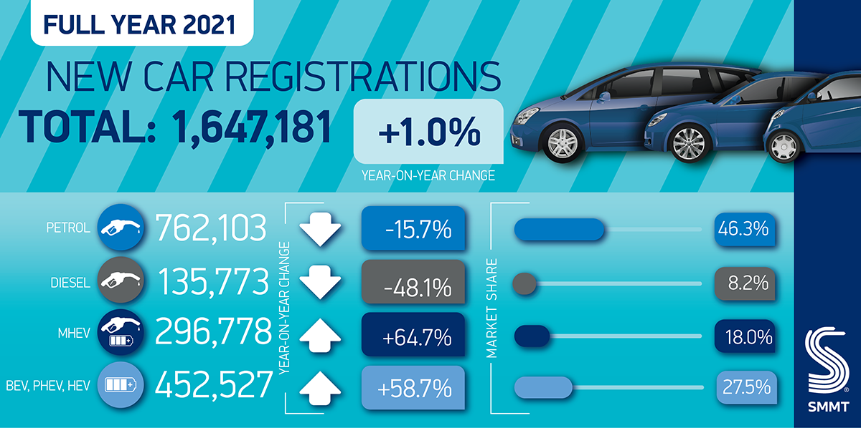

Growing demand for electric cars, according to the UK car industry, was the sector's single "bright light" last year. More new battery electric cars (BEVs) were registered in 2021 than in the previous five years combined, making it the most successful year in history for electric vehicle adoption. In 2021, the United Kingdom was the third-largest European market for new car registrations, but the second-largest by volume for plug-in vehicles and the second-largest by volume for battery electric vehicles.
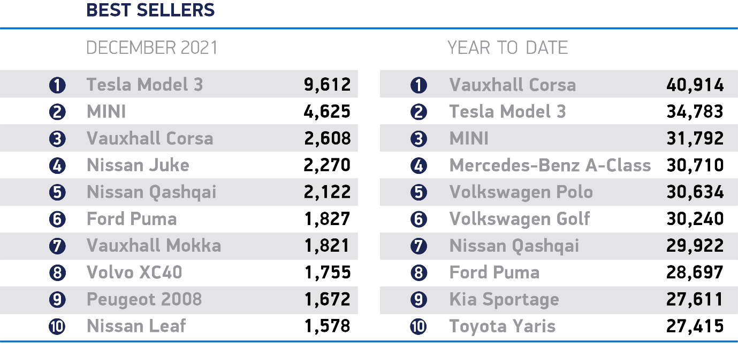

All of this means that the year 2021 will be remembered as a turning point in the transition to electric automobiles. Tesla has struggled to meet rising demand for its vehicles, and we may expect them to increase manufacturing capacity even more in 2022. Importantly, buyers will have an easier time than ever before locating an electric car that fits their lifestyle and budget.
As the market for electric vehicles grows, so do the problems. The ratio of vehicle charge points to plug-in autos fell by 31% in 2020, according to a new study by the SMMT. According to the findings, 11 plug-in vehicles might share a single public charging station capable of charging both BEVs and plug-in hybrids by the end of 2019. (PHEVs). However, by the year 2020, the ratio had fallen to one charger for every 16 plug-ins. Among the top 10 global electric car markets, the UK has one of the lowest ratios of plug-in vehicles on the road to standard public chargers.
However, between January and September 2021, only one new standard public charge station is being installed for every 52 new electric cars registered, compared to 212,181 new plug-in car registrations, a rate insufficient to improve the user experience. Investments in public charging are being made, with the Government's Rapid Charging Fund allocating £950 million to rapid and ultra-rapid charge points, £620 million for zero-emission vehicle grants and infrastructure announced in the Net Zero Strategy, and a commitment to include an electric vehicle charging point in all new build homes.
Following the trends of the new lifestyle, a life with COVID amount us, we are able to see the path lying in front of us. New technologies emerge as we speak, ways to make life safer and easier.

Reference list:

- Buckley, J. (2020). How coronavirus plagued the UK car market in 2020. [online] Driving.co.uk from The Sunday Times. Available at: https://www.driving.co.uk/news/features/coronavirus-plagued-uk-car-market-2020/ [Accessed 5 Jan.]
- Kemp, E. (2020). COVID-19 and the future of the automotive supply chain - KPMG United Kingdom. [online] KPMG. Available at: https://home.kpmg/uk/en/home/insights/2020/06/covid-19-and-the-future-of-the-automotive-supply-chain0.html [Accessed 5 Jan. 2022].
- Levin, T. 2021 was a massive year for electric cars. 2022 will be even bigger. [online] Business Insider. Available at: https://www.businessinsider.com/electric-cars-2022-models-market-tesla-ford-gm-lucid-rivian-2021-12?r=US&IR=T [Accessed 9 Jan. 2022].
- Powell, D. (2021). Electric car statistics - data and projections [Updated Oct 2021] | heycar. [online] heycar.co.uk. Available at: https://heycar.co.uk/blog/electric-cars-statistics-and-projections [Accessed 9 Jan. 2022].
- SMMT. (2021a). Car charging point numbers fall behind as plug-in vehicles surge. [online] Available at: https://www.smmt.co.uk/2021/11/car-charging-point-numbers-fall-behind-as-plug-in-vehicles-surge/ [Accessed 9 Jan. 2022].
- SMMT. (2021b). Output falls -28.7% despite electric vehicle boost. [online] Available at: https://www.smmt.co.uk/2021/12/output-falls-28-7-despite-electric-vehicle-boost/ [Accessed 8 Jan. 2022].
- SMMT. (2021c). UK car production down -29.3% as coronavirus slams brakes on sector. [online] Available at: https://www.smmt.co.uk/2021/01/uk-car-production-down-29-3-as-coronavirus-slams-brakes-on-sector/ [Accessed Jan. 5AD].
- SMMT. (2022). Covid stalls 2021 UK new car market but record EV sales show future direction. [online] Available at: https://www.smmt.co.uk/2022/01/covid-stalls-2021-uk-new-car-market-but-record-ev-sales-show-future-direction/ [Accessed 9 Jan. 2022].
- The Guardian. (2021). All new buildings in England to have electric car charge points from 2022. [online] Available at: https://www.theguardian.com/environment/2021/nov/21/all-new-buildings-in-england-to-have-electric-car-charge-points-from-2022 [Accessed 10 Jan. 2022].
- Trovao, J.P. (2020). Automotive Electronics Under the COVID-19 Shadow [Automotive Electronics]. IEEE Vehicular Technology Magazine, 15(3).

