
2021
Student name: Dylan Huw Davies Student ID number: 2100937 Programme: BEng & HND Motorsport Engineering Module: Engineering design and materials Submission deadline: 21/03/22

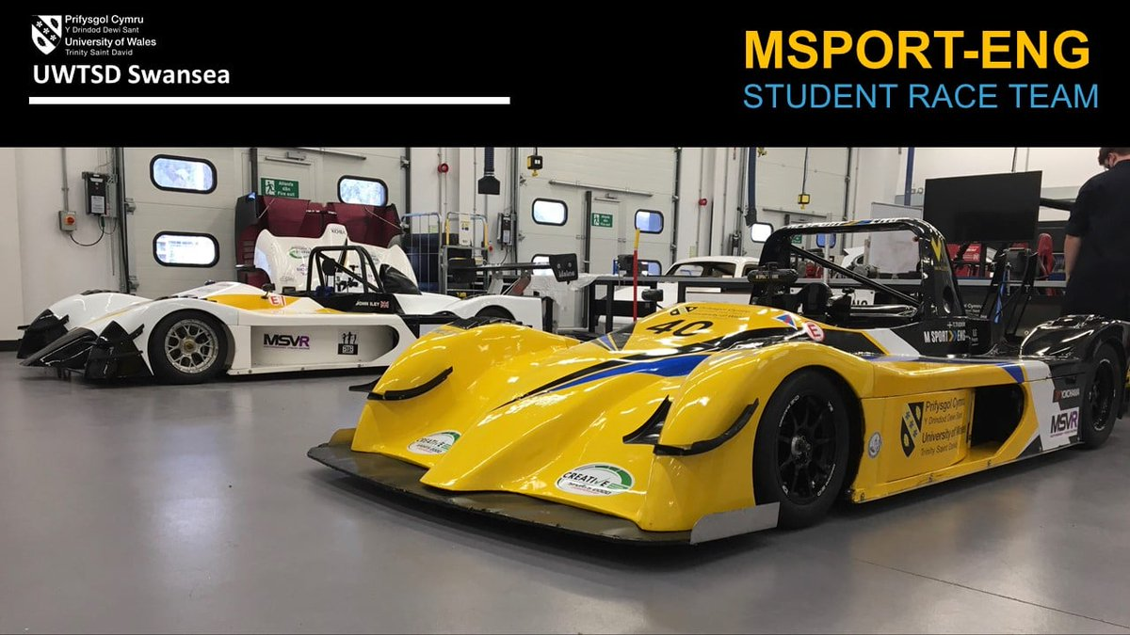
Material Selection Report & GD&T Drawings
[Grab your reader’s attention with a great quote from the document or use this space to emphasize a key point. To place this text box anywhere on the page, just drag it.]

Contents page
Contents
Contents page 1
1.0 Introduction 2
2.0 Material Properties 3
2.1 Required Properties list 3
2.2 Explanation of required properties 3
3.0 Material selection 4
3.1 What are pistons made from 4
3.2 Advantages and disadvantages of cast iron pistons 4
3.2 Advantages and disadvantages of aluminium alloy pistons 4
3.3 Advantages and disadvantages of carbon steel pistons 4
4.0 Manufacturing Processes 5
4.1Industrial production techniques 5
4.2 Different types of manufacturing processes used for pistons 5
4.3 Casting manufacturing processes 5
4.4 Cold forging 6
4.5 Warm forging 6
4.6 Hot forging 6
5.0 conclusion 7
6.0 Reference list 8

1.0 Introduction
In this technical report I will be researching different material properties for a piston plus, the application of the piston and the environment its used in. I will consider a range of different materials and suitable ways a piston can be manufactured. I will also state in my conclusion a final choice of material and manufacturing process. I will support my choice with research and included Harvard Referencing to back up my choice.

2.0 Material Properties

2.1 Required Properties list
- Low density
- Temperature resistance
- Simple net-shape fabrication
- Easy machinability
- High reliability
- Adaptability to operating temperatures
- High static and dynamic strength
- Low friction coefficient
- Low Wear resistance

2.2 Explanation of required properties
A piston must have a low density as this results “in a small inertia forces and inertia torques “and if you want or need to change rpm quickly, inertia is a problem. Another reason why the piston must have a low density is because more weight is harder to accelerate and decelerate which then causing more stress on components. Temperature resistance is very important because exhaust gases temperatures range from 850 Celsius to 1050 Celsius for gasoline engines and the “piston crown is exposed to hot combustion gas” meaning the piston must be able to withstand these high temperature without changing shape or even breaking under high loads. I know this as I found out from my research that “temperature resistance is also very important in the view of the thermal loads”.” Near net shape (NNS) manufacturing is a term given to processes that aim for the initial fabrication of a component to be close in size and shape to the finished product. “this is a very important property for a material being used for a piston as it must be accurate with a high quality finish, or problems may occur in the cylinder. The piston may be too big or even small, piston rings may not fit etc. Easy machinability is an important quality as they material must be easy to cut and easy to obtain a good finish at low cost but also without wearing down equipment. High reliability is very important as you want the material to last along time and be reliable in keeping its strength and shape over time. You want the material to be reliable overtime, so the part doesn’t need to be replaced often or even when the vehicle has outlived itself. High static and dynamic strength is very important because “strength of material is crucial for the load carrying capacity of the piston” so the greater the load the piston will receive the more stress the piston will receive meaning it will have to be able to resist these forces. Basically, strength in a piston Is very important as it should have enormous strength to withstand the high pressure. You want the material to have a low wear resistance so it last longer and doesn’t wear straight away from friction or heat.

3.0 Material selection

3.1 What are pistons made from
“Pistons are made from either a low carbon steels or aluminium alloys” Pistons are mainly made from these types of material because of their properties that suit the extreme conditions of modern-day engine. Pistons can also be made from cast iron.

3.2 Advantages and disadvantages of cast iron pistons
Cast iron is a group of non-carbon alloy that have a certain carbon content more than 2%. Even though cast iron doesn’t dominate in piston usage, it is still used today by certain manufactures. The reason why cast-iron piston are used less is because of there weight and that you need a much higher temperature to hot forge it. “forging temperature for cast iron is within the range of 800 to 1000℃”. There are still many advantages to cast iron like hardness, which then can be increased by heating and then sudden cooling. Cast iron is tough and has tensile strength. More problems with cast iron pistons Is that they create carbon deposits in lube oil and needs a special designed lube oil.

3.2 Advantages and disadvantages of aluminium alloy pistons
“An aluminium alloy is a composition consisting mainly of aluminium to which other elements have been added”. Aluminium is the more used material in piston manufacturing today and there is a very good reason why. Properties of aluminium consist of nonmagnetic, corrosion resistance, easy to cut, high thermal conductivity and most importantly is very low weight. “As a light alloy with high thermal conductivity, aluminium is ideal for use as a piston material” The properties of aluminium just seem to suit the high and extreme load of a modern-day engine. The problem with just having unalloyed aluminium is its strength is too low, so it is wear resistance is too low. There have been many processes to make aluminium stronger like a process called natural aging. This process increases the strength and gives the material greater hardness however, this can be reversed by low temperatures. This is why aluminium silicon alloys are a better idea, with properties such as excellent wear resistance, high strength at high temperature good thermal conductivity, high corrosion resistance and a very low thermal coefficient of thermal expansion. This is known because aluminium high in silicon improves wear resistance, compared to low concentrations. Alloys such as 356 and 390 grades contain low compositions of silicon.

3.3 Advantages and disadvantages of carbon steel pistons
“Carbon steel has a carbon content of up to 2.5%.”. There are many advantages in using carbon steel, improved strength being one. Carbon makes steel stronger by shuffling around its crystal lattice, which makes it very useful for a piston as high strength is needed. The main issue with using carbon steel is its strength as this make is so hard to shape or mould. Carbon steel also corrodes, to stop steel corroding they add chromium. “Carbon steel doesn’t contain chromium, however, so it may rust when exposed to moisture for long periods of time.”

4.0 Manufacturing Processes

4.1Industrial production techniques
- one-off production
- batch production
- mass production
- continuous production
One-off production “can be used for testing and in user trials.” However, they cost a lot to make and are expensive to buy. Batch production is where the products are made in certain groups or amounts with a set time. Mass production is when products are made in huge amounts and high tec is used to make the product. The main thing with a mass product, is that it cost a lot to start. To make things cheaper you would bulk buy material as well. Continuous product is when the making of the product never stops. It can used to create a large number of products at a cheap price. Product for continuous product is very expensive to set up and you are limited to certain products you can make.

4.2 Different types of manufacturing processes used for pistons
- Gravity die casting
- Sand casting
- Investment casting
- Forging (cold, warm hot etc)

4.3 Casting manufacturing processes
There are three different types of casting that could be used to manufacture a piston, being gravity die casting, sand casting and finally investment casting. “In sand casting, molten metal is poured into an expendable sand mould cavity by gravity or force, where it solidifies to form the cavity shape part.” Sand casting can be used to build very complex cored shapes however, it will always require finishing and tight tolerances can not be made. Sand casting is a very simple process, very low moulds and even lower production costs. “Gravity Die Casting is a permanent mould casting process, where the molten metal is poured from a vessel or ladle into the mould.” The only force used in die casting is gravity. The filling is controlled by tilting the die. Advantages of using gravity die casting is the allowance of tight tolerances which give the product very good accuracy. Gravity die casting also gives the product a high-quality finish. Aluminium, magnesium and cast iron can all be used in this process which makes it perfect for piston manufacturing. The main disadvantage of gravity die casting is that is cost more than sand casting because of tooling. Finally, investment casting is when a “wax pattern is used to shape a disposable ceramic mould”. The advantages of using investment casting is its low cost for small productions, its not limited by size and it’s easy to change the product design. The main disadvantages of using investment casting is the high cost in large product runs, parts are less complex and a finish will have to be applied.

4.4 Cold forging
Cold forging is when a bar of metal is inserted into a die and is then squeezed into a second closed die. This process is all completed at room temperature as well.
Advantages
- Tight tolerances
- High quality surface finish
- No need for another heat treatment after finish
- Material saving
- High production rates
Disadvantages
- Metals are less ductile
- “grain structure that gives the material its strength, residual stress may occur.”
- Can’t be used on certain steel grades.

4.5 Warm forging
Warm forging is when a metal is heated to a temperature that is above its Harding temperature but below a temperature where the scales form. The most common material used are steel alloys. Warm forging produces a good surface quality and increases steal ductility. Warm forging is also very flexible in shapes. Dies should also be well maintained during this process as appropriate tooling must be used to improve cost saving. The main disadvantages of warm forging is that its less accurate than cold forging and the process requires skilled engineering to design tooling.

4.6 Hot forging
There are seven stages to hot forging being heating, Hammering, upsetting, pressing etc. The die is heated to prevent any loss in temperature doing the process, to make sure crystallization doesn’t occur. When the pressure of the die squeezes the material into more fine grain. They heat the metal to three quarters of its melting point as well. Hot forging produces good ductile materials and leave excellent surface finishes. Hot forging is also mainly used in the automotive industry as well however, additional cost for heat treatment is needed and its less precise than the other types of forging. Finally, there is a risk of wrapping when hot forging which can be a very huge problem.

5.0 conclusion
From my research I have come to the final decision that aluminium silicon alloys are the best choice a piston and that the best manufacturing processes are batch production and hot forging. I have come to this conclusion as aluminium silicon alloy ahs excellent wear resistance, high strength at high temperatures, good thermal conductivity, high corrosion resistance.” Aluminium alloys are the preferred material for pistons both in gasoline and diesel engines due to their specific characteristics: low density, high thermal conductivity, simple net-shape fabrication techniques “All these quality’s fit the harsh environment of a modern-day engine allowing the piston to last a long and healthy life. Batch production would be a ideal option for piston manufacturing as only a set amount on a set time/period will have to be made as the piston type would only run until the engine its needed for is being sold. Hot forging would be the correct manufacturing process as it gives the material more of a fine grain and higher ductility. Hot forging also produces a high-quality finish which is need for a piston. Hot forging is also used in most automotive industry’s already which makes it the perfect match.

6.0 Reference list
Article title: | Why are pistons made of aluminium alloy?
Website title: | Moviecultists.com
URL: | https://moviecultists.com/why-pistons-are-made-of-aluminium-alloy

Article title: | Advantages & of Disadvantages Cold Forging
Website title: | Delishi Machinery Technology Co., Ltd
URL: | https://www.dlshydraulicpress.com/info/advantages-of-disadvantages-cold-forging-44832856.html

Article title: | What is wax pattern? – Theburningofrome.com
Website title: | Theburningofrome.com
URL: | https://www.theburningofrome.com/helpful-tips/what-is-wax-pattern/

Article title: | Gravity Die Casting | The Metal Company
Website title: | Themetalco.com
URL: | https://www.themetalco.com/casting/gravity-die-casting

Article title: | Sand Casting Process, Defects, Design
Website title: | Custompartnet.com
URL: | http://www.custompartnet.com/wu/SandCasting

Article title: | Pros and Cons of Carbon Steel: What You Should Know - Monroe Engineering
Website title: | Monroe Engineering
URL: | https://monroeengineering.com/blog/pros-and-cons-of-carbon-steel-what-you-should-know/

Article title: | Pros and Cons of Carbon Steel: What You Should Know - Monroe Engineering
Website title: | Monroe Engineering
URL: | https://monroeengineering.com/blog/pros-and-cons-of-carbon-steel-what-you-should-know/

Website title: | Yuanfaraluminum.com
URL: | https://www.yuanfaraluminum.com/what-are-aluminum-alloys.html

Article title: | Aluminium or Aluminium Alloys - List
Website title: | ThoughtCo
URL: | https://www.thoughtco.com/aluminum-or-aluminium-alloys-603707

Year published: | 2016
Book title: | Pistons and engine testing
City: | Wiesbaden
Publisher: | Springer Fachmedien Wiesbaden

Year published: | 2008
Book title: | Aluminium alloys
City: | Weinheim
Publisher: | WILEY-VCH

