

University of Wales Trinity Saint David
School of Engineering
Applying Lean Techniques
Faith Over
1904483
Manufacturing Systems Engineering
29/07/2022
ACEA 6002 – Manufacturing Systems and Simulation

Contents Page

Contents
Contents Page ii
1.0 Introduction 1
1.1 Current Process 1
2.0 Waste & Lean 2
2.1 TIM WOODS 3
2.2 What creates value for the customer 4
3.0 Issue Current State 4
3.1 Process Flow 4
3.2 Current Issues 4
4.0 Desired Future State 5
4.1 Recommended Improvements 5
4.1.1 Reduce the frequency of need to fill the pick face. 5
4.1.2 Reduce the cycle time of the VNA 6
4.1.3 Flatten the workload for the VNA 6
4.1.4 Streamline the warehouse processes 6
4.1.5 Stagger the warehouse shift times 7
4.1.6 Review automation to complete tasks 7
5.0 Conclusions 8
9. References 9
References 9

Introduction
This report will review a factory’s pick-face system and material feeding system into manufacturing final assembly cells, with the aim to reduce waste and improve efficiencies and service to the production final assembly cells.

Current Process
The production and warehousing areas of the factory are separated by what is known as the “pick face”. This is a wall of racking whereby warehouse operatives back feed the shelving and production material handling operatives “pick” the components from the “front” side of the racking facing, which is facing the production cells.

This process has been in place in the factory for 10+ years and is designed to limit the movement of material handling operatives which feed the manufacturing cells with raw materials. The area is designed so that components are stored close to the point of use.

On the warehouse side of this pick face, materials are stored in a “first in first out (FIFO) allocation of location bays. When the pick face is empty/ requires material, a Very Narrow Aisle forklift truck (VNA) will drop material from the designated racking location and a warehouse operator will make sure the pick face is stacked with boxes. The VNA is manually operator driven but guided by wire guides embedded into the floor which assist in navigating the truck in confined aisles.

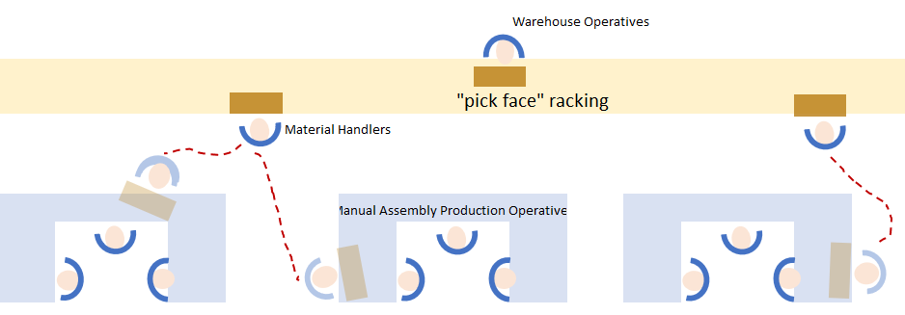
Figure 1: Diagram of pick-face layout

Waste & Lean
Lean production is the focus of eliminating waste form a process.
Lean production is about meeting customer demand with minimum investment, cost and maximum operational efficiency through waste elimination (Shah & Ward, 2003). This approach includes a wide variety of concepts, such as; Just-in-Time, visual management, Kanban systems, cellular manufacturing, etc.(Holweg, 2007). The aim of lean production is to transition from the actual, current state to an ideal future state which meets the most preferable demands (Zhang, et al., 2019).
“Lean means that you only use the minimal amount of human labour, the minimum amount of utilities, the minimal amount of direct/ indirect materials, the minimal amount of space etc. that is required to produce a service to the expected customer”
(Kelly, 2018)
The concept of lean is based upon the practice of separating all tasks and processes into categories of value add and non-value add. The simple description of this is that a value-add activity is one in which transforms a product and is a process the customer is willing to pay for. Everything else is categorised as wate. Lean initiatives work on reducing and removing as much of this waste as possible. Though non-value add activities can be split into those which are required/ needed and those which are simply wate. The table below summarises the differences between these three categories:
Table 1: Value Add Categories
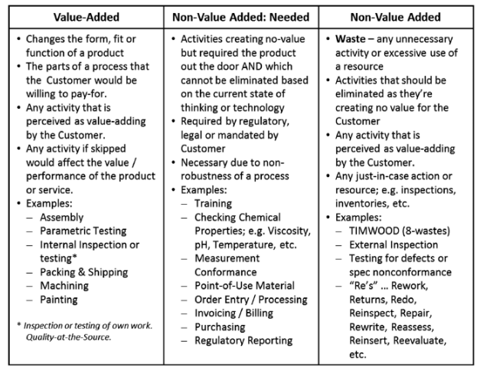

(Kelly, 2018)

TIM WOODS
Waste is the usage/consumption of any resources more than the minimum required to produce a product or service to the expectations of the customer. Wastes are commonly referred to as the acronym TIM WOODS, this acronym provides a framework for finding waste in any process (4Ward Consulting , 2022).
A summary of each of the TIM WOODS elements can be found in the table below
Table 2: TIM WOODS Framework
Waste | Definition
Transportation | Unnecessary movement of work, a warehouse example of this would be frequent movement of pallets to different locations.
Inventory | Any goods at any stage of transformation; as work-in-process, or waiting raw / finished goods. This is a common waste seen in warehouses, where often too much inventory is present.
Motion (Excess) | Unnecessary movement of people (often caused by workplace layout). This occurs commonly in warehouses where frequently used materials are stored too far from the workstations where it is used. The idea of a pick-face system was implemented to reduce this waste.
Waiting | Any delay between when one process step/activity ends, and the next step/activity begins. If a supply chain attempts to operate “too lean”, with not enough safety stock and there is a delay in logistics, production may often wait for the warehouse to book goods in, process them, and put them away before they can access the components to start the designated build
Over Producing | Producing more goods than required, or sooner, or faster than is required by the next process. This will increase inventory waste
Over Processing | Trying to add more value to a service/product than what your customer will pay for. In a warehouse this can be from over labelling of products or over processing through excess transactions to ensure traceability of stock movements
Defects (correction) | Any aspect of the service that does not conform to the customer needs. In this example it would be providing production (the customer) with the wrong materials.
Skills (Unused Employee Creativity) | Loosing ideas by not engaging or listening to employees, or not utilising employees’ full potential by lack of training and/or delegation.

What creates value for the customer
The customer for this process is the next step of the overall value stream: the manual final assembly production area. This process is designed to feed the cells with the necessary components in the fastest and most lean and efficient way. This means the process must:
- Require the minimum number of operatives to feed the cell
- Ensure the right items are always sufficiently stocked
- Ensure the final assembly manufacturing cells are never on stop due to lack of materials
- Ensure the materials are always in the right place
- Ensure materials are laid out in an easy to find manner to reduce the cycle time of material handling operatives
- Ensure the correct materials are always on the cell

Issue Current State

Process Flow
The process flow of the current state is as follows:
Figure 2: Process flow for feeding material to production
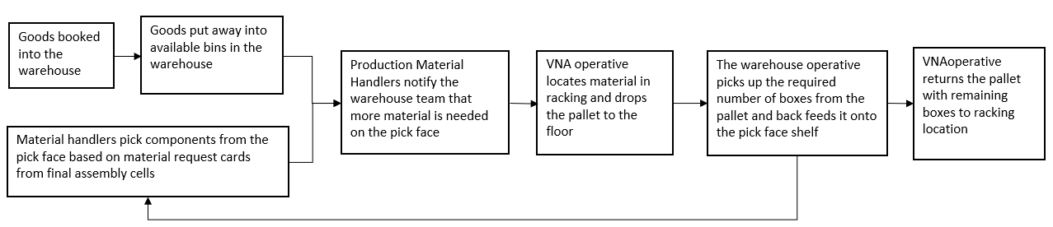

Current Issues
This process for feeding cells was put in place over ten years ago where the was less throughput through the process. As demand has increased, both the processes and physical infrastructures have not changed in any way. This has led to the following issues:
- The VNA has become a significant bottle neck
This vehicle is required to put away after book in, feed components to the cell and move pallets of finished goods made by production out to delivery areas
- The frequency of production downtime due to waiting for parts to be delivered to the production cells is following an increasing trend. Therefore, the waste of waiting has increased.
Though new machinery was purchased in the production area to increase production output, the business has not yet invested or re designed the feeding processes to the cellular production area. This feeding process has thus become a bottleneck, delaying all products which flow though the warehouse into the production area.

Desired Future State
Though the business recognises the VNA as a bottleneck, it is not willing to purchase a second VNA due to an increased risk to pedestrians & truck collisions as the warehouse area in which the trucks will be driving and turning is small. There is also significant variation to the requirements for the VNA in a month, production peaks with more outbound goods at the end of the month and supply chain peak with more containers of material to process in at the beginning of the month.
Investments into the infrastructure of the business is possible but must have a payback term of less than 5 years for the business case to be approved.
Reviewing overall inventory stocking policies is out of scope for this report as the business is based in the electronics market which is incredibly volatile thus multiple “last time buys” and “strategic purchases” of obsolete and excess components have been purchased to ensure the longevity of the business and the servicing levels for larger project based customer solutions.

Recommended Improvements
The following actions are recommended to reduce the VNA bottleneck to aid the flow of products through the business’ entire value stream and increase overall business output:

Reduce the frequency of need to fill the pick face.
It is recommended the business reviews the pick face stocking policy and standardise this as a bi-annual process to ensure the limited high value space next to the cellular manufacturing area is only consumed by component which are used daily. Lower moving components which will require less than 1 trip a day from a material handler to collect will be moved deeper into the warehouse, to a different rack, which still easily accessible within minutes.
An analysis found that 34% of spaces on the pick-face racking were consumed by products which were “picked” less than once a day, some even only once a month. Moving these products to an area which would double the transit time for a material handler from 2 minutes to 4 minutes up to a maximum of three times a day. However, this additional space allowed for more boxes of heavily consumed components to be stocked, thus reducing the number of replenishment requests by 20%. Current cycle time for a VNA operator to find, drop a pallet, wait for the warehouse operator to break the pallet apart and move the required number of boxes onto the pick face shelf, and then re wrap and return the pallet to the higher-level locations is approximately 7.5 minutes.
This will reduce the transportation and motion waste of the warehouse operatives and the VNA operators.

Reduce the cycle time of the VNA
The entire warehouse works on an SAP managed first in first out system. This means that component locations are always changing, some locations are quite far from the pick-face racking. It is recommended that the business creates set locations only for the pick face rack. The bottom three shelves of the pick face racking are accessible by material handlers. All goods stored in the racking above this location is only accessible by the VNA truck. It is recommended to store pallets of replenishment materials for the pick-face on the racks above the pick-face shelves. In essence, widget A on the pick face will be sat under racks of pallets full of widget A. Therefore, the cycle time of feeding the highest running goods will drop from an average of 7.5 minutes to 4 minutes. This reduces the waste of transportation.

Flatten the workload for the VNA
The symptom of this bottleneck which is causing issues to the production team is that the manufacturing cells are often on stop whilst waiting for their order of materials. This is more frequent when large containers of deliveries are being processed and put away as the truck can only put away or drop material. It is recommended that the business limit their goods in capacity to one 20ft container a day. This however is not feasible due to current market conditions with container availability. This wouldn’t reduce a lean waste but reduce variation in the workload so that it is more manageable.

Streamline the warehouse processes
If pallets of components were to be broken apart and fed onto the pick-face shelves straight away before being moved into the designated area in the higher racking locations, the number of trips the VNA requires to do before a component reaches manufacturing cells would be dramatically reduced. This would therefore reduce motion and transportation waste. This is possible for non-perishable components such as plastic parts. Unfortunately, this is also not feasible with current market conditions of uncertain container lead times and the business’ current supplier based in China. It cannot be guaranteed what day let alone what hour components will arrive therefore it is not possible to plan production in line with container delivery time slots.

Stagger the warehouse shift times
Staggering the VNA driver shift times would reduce the headcount in the warehouse at specific overlap windows, thus may cause pinch points when containers come in. However, this would increase the VNA operating windows before and after production allowing for pre work/ catch-up work to be conducted and reduce peaks when production start-up. It is recommended that the business combats the reduction in team count during busy times by pulling production operators to assist inn unloading containers. Additional pump trucks may be needed, and training will be required for the production operators which would be temporarily assisting.

Review automation to complete tasks
To further reduce the workload of the VNA, investigations have been conducted to review what technology exists to enable the automation of these tasks. These will be further future state improvements, as significant investments in both the technology and the up skilling of the current workforce will be required to manage and maintain the newly acquired technology.
There is an offering by Swisslog for a unit which can pick multiple different components and palletise goods (Swisslog Holding AG, 2022). This works by combining a KUKA robotic COBOT with their software and specialised gripper heads enabling the robot to pick anything from small components to entire pallets. Their ACPaQ solution integrates with their conveyor system and light goods conveyor system which enables a mixed pallet to be created. This can be useful for feeding the cell, creating pallets or small trollies of each of the different components each cell needs for every order, however this requires a complete warehouse system redesign, whereby the pallets are offloaded into a conveyor system and automatically put away into designated locations by the conveyor system.
This has high risk as the entire warehouse then becomes automated and though a large proportion of warehouse operatives can be removed with this system, they would need to be replaced with an increase in maintenance engineering operatives to maintain the system and ensure it stays running. Thus, the system is arguably not as lean nor as flexible as the engineering employees will cost the business more and likely have less flexible contracts than warehouse operatives (full time vs part time/ temporary), and the increased reliability in service to the customer (production) is not guaranteed as both the technology and the engineering employees needed for the operation to work would be new to the business, with very little freedom to operate outside of the tightly enclosed automated racking system.
WDX offer a similar automated pallet conveyor system which completely automates the pallet put away and retrieval system. Here an operator can call a pallet to be dropped to the production area in a similar fashion (WDX, 2022). As with the risks and constraints mentioned in the Swisslog solution analysis above, this also leaves the business in a high-risk situation.
Neither solution offers a feedback system whereby unused items left on the pallet are fed back into the racking system. Even if this feedback loop could be implemented, this would then lead to a build up of only partially filled pallets, which would lead to poor space utilisation within the warehouse as pallet locations could be consumed by pallets with only 1 box left on them for example.

Conclusions

To conclude, the demands of the process has changed, and the increased demands combined with a lack of ability to increase resources or equipment into the process has led to the need of significant waste and variation elimination to enable the process to adequately service production. (the customer).
This report finds the following actions will reduce transportation and motion waste; reducing pick-face feeding cycle times by changing warehouse layout, and reducing bottle necks in the warehouse by; reducing the number cycles required by the VNA through batching, thus increasing the amount of components the VNA feeds into the pick face in a trip. This report also recommends reducing variation in the workload of the VNA by increasing it’s operating window through staggered shift times and where possible reduce the size of sea freight containers.
At the time of writing this report there were no fully suitable solutions available which did not hinder space constraints on increase vulnerability risks due to the lack of inhouse skills in future technology.

9. References

Table 1: TIM WOODS Framework 3

Figure 1: Diagram of pick-face layout 1

References
4Ward Consulting , 2022. Lean Thinking Means No Waste: No Tim Woods. [Online]
Available at: https://4wardconsult.com/lean-thinking-means-no-waste-no-timwoods/
[Accessed 16 07 2022].
Brown, C., 2018. Why and how to employ the SIPOC model. Journal of Business Continuity & Emergency Planning, 12(3), pp. 198-210.
De Koning, H. & De Mast, J., 2006. A rational reconstruction of Six Sigma’s Breakthrough Cookbook. International Journal of Quality and Reliability Managent, 23(7), pp. 766-787.
Holweg, M., 2007. The genealogy of lean production.. Journal of Operations Management, 25(2), pp. 420-437.
Kelly, R., 2018. The Myths and Truths of Lean Transformations. 1st ed. New York: Productivity Press.
Mast, J. & Lokkerbol, J., 2012. An analysis of the Six Sigma DMAIC method from the perspective of problem solving. International Journal of Production Economics, 139(1), pp. 604-614.
McAdam, R. L. B., 2004. A multilevel case study critique of Six Sigma: statistical control or strategic change?. International Journal of Operations and Production Management, 24(5), pp. 530-549.
Shah, R. & Ward, P., 2003. Lean manufacturing: context, practice bundles, and performance.. Journal of operations management, 21(2), pp. pp.129-149..
Soundararajan, K. & K., J. R., 2019. Cost-reduction and quality improvement using DMAIC in SMEs. International Journal of Productivity and PErformance Management, 68(8), pp. 1528-1540.
Swisslog Holding AG, 2022. Robot-based picking & palletizing for higher warehouse performance. [Online]
Available at: https://www.swisslog.com/en-gb/products-systems-solutions/picking-palletizing/robot-based
[Accessed 16 07 2022].
Tartell, R., 2017. Who does what? Use RACI to figure it out. Training, 54(4), pp. 12-12.
WDX, 2022. Offer. [Online]
Available at: https://wdx.eu/offer/conveyor-transport-and-automation/pallet-conveyor-systems/#offer
[Accessed 12 07 2022].
Zhang, K. et al., 2019. IoT-enabled dynamic lean control mechanism for typical production. Journal of Ambient Intelligence and Humanized Computing, 10(3), pp. 1009-1023.

