Donna Macdonald 2413460
Word count: Part one: 2617 Part two: 931

Evidence-Based Practice in People Management: A Guide for People Practice Graduates
Introduction
In today’s increasingly complex and competitive workplace, making data-driven, well-informed decisions is critical. EBP ensures that organisational practices are not only effective but also aligned with strategic goals and grounded in reliable evidence (Briner et al., 2018).
To succeed, HR professionals must navigate challenges such as talent acquisition, employee engagement, and workforce strategy while applying tools and techniques that support evidence-based approaches. These practices not only enhance organisational performance but also build credibility for HR functions (Armstrong & Taylor, 2017). This guide aims to provide you with insights into how evidence-based practice can support sound decision-making, highlight critical thinking strategies, and ensure ethical and impactful people management.
As you embark on your journey in human resources and people management, it’s essential to understand how evidence-based practice (EBP) can guide your decision-making and shape your career. In today’s increasingly complex and competitive workplace, making data-driven, well-informed decisions is critical. As a new graduate entering the world of HR, you’ll likely be faced with challenges in areas like talent acquisition, employee engagement, and workforce strategy. Understanding how to apply evidence-based practice will help you navigate these challenges effectively and make more objective, impactful decisions.
This guide aims to provide you with a clear understanding of what evidence-based practice is, why it’s important in people management, and how you can use it to make decisions that benefit both employees and your organisation. We will also explore the tools and methods that can assist you in analysing data, along with the ethical considerations that play a vital role in your decision-making process. By integrating EBP into your day-to-day work, you will be better equipped to contribute to strategic HR initiatives and support business goals.

1. The Concept of Evidence-Based Practice in People Management (AC 1.1)
Evidence-based practice (EBP) involves systematically gathering, evaluating, and applying reliable evidence to make informed decisions. This approach integrates four main sources of evidence: academic research, practitioner expertise, organisational data, and stakeholder values (Briner, 2015). By using these sources, HR professionals ensure decisions are well-rounded and contextually relevant.
For example, consider addressing employee turnover. Using EBP, HR teams might review industry research, analyse internal exit interview data, and consider employee feedback to identify retention strategies. By aligning these insights, EBP ensures decisions are both effective and sustainable (CIPD, 2020). Moreover, frameworks like the six-step process of asking, acquiring, appraising, aggregating, applying, and assessing evidence help structure EBP practices systematically (Rousseau, 2018).
The benefits of EBP extend beyond individual decisions, fostering a culture of continuous improvement and organisational learning. For instance, integrating EBP in performance management enables organisations to design systems that are fair, transparent, and aligned with business goals (Armstrong, 2016).
As a people practice graduate, you will soon realise that decision-making is a key part of your role. Whether you’re handling recruitment, employee relations, or training programmes, evidence-based practice (EBP) provides a systematic approach that helps ensure your decisions are grounded in solid data rather than personal biases or outdated practices. In simple terms, EBP involves gathering, evaluating, and applying the best available evidence to inform decisions.
The process of evidence-based practice includes several important steps:
- Asking: Define the problem or question you want to solve. For example, “What factors contribute most to employee turnover in my organisation?”
- Acquiring: Gather relevant evidence from multiple sources, such as academic research, internal surveys, or HR analytics.
- Appraising: Critically evaluate the quality of the evidence you’ve gathered to ensure its relevance and reliability.
- Aggregating: Combine the evidence to identify patterns and draw meaningful conclusions.
- Applying: Use the evidence to inform your decisions, whether that’s revising recruitment strategies or launching a new wellbeing programme.
- Assessing: Reflect on the impact of your decision, using feedback and data to refine your future approaches.
By following these steps, you can make more informed, objective decisions in your work. For example, when tasked with recruitment, using data like psychometric test results, industry trends, and past performance metrics will help you make more targeted, effective hiring decisions. This approach also ensures that your decisions are aligned with broader organisational goals, such as diversity and inclusion, and are not influenced by unconscious biases or traditional assumptions.
Briner (2015) emphasises the importance of using high-quality evidence to make decisions. As a graduate, adopting this practice will help you build a strong foundation for your HR career and ensure that your decisions lead to tangible, positive outcomes for both the organisation and its employees.
2. Analysis Tools and Methods in People Management (AC 1.2)
Analytical tools like PESTLE and SWOT are invaluable for diagnosing challenges and identifying opportunities. PESTLE analysis examines external factors—such as economic or technological trends—that may impact HR strategies (Perera, 2018). For instance, shifts towards remote work necessitate adopting flexible policies, guided by insights from PESTLE findings.
Conversely, SWOT analysis evaluates internal factors, balancing strengths and weaknesses against opportunities and threats. For example, a workforce’s strong technical skills might offset risks posed by emerging competitors. Together, PESTLE and SWOT provide a comprehensive view, ensuring decisions are both strategic and evidence-based (CIPD, 2020).
As you begin to develop your HR career, familiarising yourself with key analytical tools will be essential for making informed decisions. Two commonly used frameworks in people management are PESTLE analysis and SWOT analysis. These tools help you assess both the internal and external factors that affect your organisation’s people management practices.
PESTLE Analysis
PESTLE analysis is a strategic tool that helps you understand external factors that could influence people management decisions. By examining the Political, Economic, Social, Technological, Legal, and Environmental factors, you can gain a better understanding of the broader context in which your organisation operates. For instance, changes in labour laws (Legal), shifts in societal expectations about work-life balance (Social), or advancements in recruitment technology (Technological) all have significant implications for how HR strategies should be shaped.
As a graduate, using PESTLE analysis will allow you to anticipate external trends and adjust your people practices accordingly. For example, if there is a rise in demand for flexible working arrangements (Social), you may need to help implement policies that address this shift.
However, it's important to remember that while PESTLE analysis provides valuable insights into the external environment, it should be combined with internal analysis tools like SWOT to create a more complete picture (CIPD, 2020).
SWOT Analysis
SWOT analysis focuses on evaluating internal factors. By assessing the Strengths, Weaknesses, Opportunities, and Threats within your organisation, you can identify areas for improvement and leverage your organisation’s strengths to drive HR success. For example, you might use SWOT to evaluate an existing performance management system. You could identify strengths like a highly skilled workforce, weaknesses such as inconsistent feedback practices, opportunities for development such as leadership training, and threats like increased employee turnover.
For you as a graduate, using SWOT analysis will help you identify gaps and opportunities within your organisation's current people management strategies. It’s a valuable tool to help you focus on improving specific HR practices and aligning them with both organisational goals and employee needs (Perera, 2018).
3. Critical Thinking in People Management (AC 1.3)
Critical thinking involves evaluating ideas logically, identifying biases, and ensuring decisions are grounded in sound reasoning. For HR professionals, this skill is crucial when resolving conflicts or designing policies. Techniques such as questioning assumptions and evaluating alternative perspectives foster clarity and objectivity (CIPD, 2016).
For example, when implementing a wellbeing programme, HR teams must critically assess whether it meets employees’ needs or merely aligns with superficial trends. Objective analysis prevents costly missteps, ensuring initiatives deliver measurable benefits (Armstrong & Taylor, 2017).
As a people practice graduate, one of the most valuable skills you can develop is critical thinking. In people management, critical thinking allows you to evaluate different HR strategies and decisions from multiple perspectives, question assumptions, and ensure that decisions are based on logic and sound reasoning rather than personal biases or emotional responses. It also helps you separate facts from opinions, ensuring that the evidence you use is relevant and reliable.
Key principles of critical thinking include:
- Objectivity: Approach problems without bias, ensuring that your decisions are based on evidence rather than personal feelings.
- Rationality: Make decisions based on logical reasoning and sound evidence, rather than relying on assumptions or gut feelings.
- Clarity: Define the issues or challenges clearly, so that you and others can evaluate potential solutions effectively.
Critical thinking helps you avoid errors in judgment that can arise from cognitive biases like overgeneralisation or anchoring. For instance, when evaluating an employee wellbeing programme, critical thinking helps you assess whether the programme is truly effective or if you’re simply relying on surface-level indicators, like positive feedback from a small group, without considering the broader impact on overall employee satisfaction (CIPD, 2016).
By developing these critical thinking skills, you will be able to make more well-rounded, evidence-based decisions that support both the organisation’s goals and the wellbeing of its employees (Armstrong & Taylor, 2017).
4. Decision-Making Processes (AC 1.4)
Decision-making models like De Bono’s Six Thinking Hats and Future Pacing provide structured frameworks for tackling complex challenges. These models encourage diverse perspectives, promoting balanced and well-informed outcomes (De Bono, 1999). Future Pacing, for instance, helps visualise the long-term impact of decisions, ensuring sustainability and alignment with organisational goals (Edward, 2020).
Effective decision-making is at the heart of people management, and as a graduate, you’ll soon realise that HR decisions can have significant long-term impacts. Two useful decision-making models to explore are De Bono’s Six Thinking Hats and Future Pacing. These models help you think about problems and decisions from different angles, leading to more balanced and thoughtful outcomes.
De Bono’s Six Thinking Hats
De Bono’s Six Thinking Hats encourages you to approach problems from multiple perspectives. The six ‘hats’ represent different ways of thinking:
- Blue Hat: Focuses on the thinking process and decision-making framework.
- White Hat: Concentrates on facts, figures, and objective data.
- Red Hat: Considers feelings, emotions, and intuition.
- Black Hat: Looks at risks, challenges, and potential negative outcomes.
- Yellow Hat: Focuses on the positives, benefits, and opportunities.
- Green Hat: Stimulates creativity and new ideas.
As a graduate, using this model will allow you to think about a situation in a more rounded way. For example, when evaluating a new performance appraisal system, you might wear the White Hat to focus on the data, the Black Hat to consider any potential drawbacks, and the Yellow Hat to explore the positive outcomes that the system might bring. This helps you make decisions that are informed, creative, and considerate of all potential outcomes (De Bono, 1999).
Future Pacing
Future pacing is a technique that encourages you to imagine the long-term consequences of a decision. As a graduate, this can help you consider how the decisions you make today will affect the organisation and its employees in the future. For example, when introducing a new HR policy or initiative, future pacing helps you think about its potential impact on employee morale, engagement, and productivity.
By visualising the future consequences of a decision, you can make more informed choices that account for both immediate and long-term outcomes, ensuring that your decisions are sustainable and beneficial for both employees and the organisation (Edward, 2020).
5. Ethical Perspectives in Decision-Making (AC 1.5)
Ethical perspectives guide HR professionals in navigating dilemmas and upholding integrity. While deontological ethics focuses on fairness and consistency, utilitarianism considers the greatest good for the greatest number (Rousseau, 2018). By balancing these perspectives, HR teams can address competing interests while maintaining organisational trust (Armstrong, 2016).
As you move forward in your HR career, you’ll face ethical dilemmas that require you to make decisions that are not only legally sound but also morally responsible. Two key ethical perspectives that can guide your decisions are Deontological Ethics and Utilitarianism.
Deontological Ethics (Kantianism)
Deontological ethics focuses on following rules and duties. It emphasises the importance of treating people fairly and consistently. In people management, this means applying the same principles to all employees, regardless of personal circumstances. For example, when promoting employees, deontological ethics requires you to follow a consistent set of criteria for all candidates to ensure fairness (Armstrong, 2016).
However, it’s important to note that deontological ethics doesn’t always account for individual needs or exceptional situations. This is where the Utilitarian perspective becomes relevant.
Utilitarianism
Utilitarianism is a consequentialist ethical theory that focuses on achieving the greatest good for the greatest number of people. In people management, this may involve making decisions that benefit the majority of employees, even if they cause harm to a smaller group. For example, introducing a company-wide cost-cutting initiative might negatively affect a few employees, but if the result is job security and increased benefits for the majority, it could be deemed ethical from a utilitarian standpoint.
Balancing deontological ethics with utilitarianism will require careful consideration, ensuring that your decisions respect individual rights while also promoting the welfare of the majority (Rousseau, 2018).
6. Measuring Performance and Impact of People Practices (AC 3.1 & AC 3.2)
HR practices contribute significantly to the overall success of an organisation, and it is crucial to measure their effectiveness through both financial and non-financial performance indicators.
Financial Performance
Financial metrics, such as gross profit, return on investment (ROI), and employee-related costs, provide valuable insights into the economic health of an organisation. These metrics allow HR professionals to assess the financial impact of people management strategies. For instance, tracking the ROI of training and development programmes can help demonstrate how HR investments directly contribute to increased productivity or sales (Terpiłowski, 2022).
Non-Financial Performance
Non-financial indicators, such as employee engagement levels, turnover rates, and employee satisfaction surveys, provide deeper insights into the effectiveness of HR practices. High engagement levels often correlate with improved job performance, lower turnover, and greater organisational commitment. For example, employee engagement surveys can help HR identify areas where employee satisfaction can be improved, such as in leadership development or benefits packages (Wickens, 2023).
By measuring both financial and non-financial performance, HR professionals can demonstrate the tangible impact of their strategies on both organisational success and employee wellbeing.

Conclusion
In conclusion, evidence-based practice provides a crucial foundation for effective people management. By systematically gathering and applying reliable evidence, HR professionals can ensure decisions are fair, transparent, and aligned with organisational objectives. As a graduate entering the HR field, integrating evidence-based strategies into your work will not only enhance your ability to navigate complex challenges but also establish your credibility as a practitioner committed to ethical and impactful decision-making.
The use of analytical tools such as PESTLE and SWOT equips you with the ability to evaluate both internal and external factors influencing HR practices. These tools allow for strategic, data-driven insights that ensure your recommendations are grounded in reality and aligned with broader organisational goals. Meanwhile, decision-making models such as De Bono’s Six Thinking Hats and Future Pacing enable you to explore problems from multiple perspectives, ensuring that solutions are well-rounded, innovative, and sustainable.
Moreover, ethical frameworks are indispensable for resolving dilemmas and balancing competing interests. By employing deontological principles and utilitarian approaches, HR professionals can uphold fairness while making decisions that deliver the greatest good. Measuring performance through financial and non-financial metrics further validates the effectiveness of HR initiatives, demonstrating their contribution to organisational success and employee wellbeing.
Ultimately, adopting these evidence-based practices creates a culture of continuous improvement, fostering trust and engagement across the workforce. As you advance in your HR career, embracing these methods will position you as a thoughtful, strategic leader capable of driving meaningful change. By aligning your work with data-driven insights, ethical considerations, and a commitment to excellence, you will support both the success of your organisation and the satisfaction of its employees.

Part 2

AC 2.1

Chart one

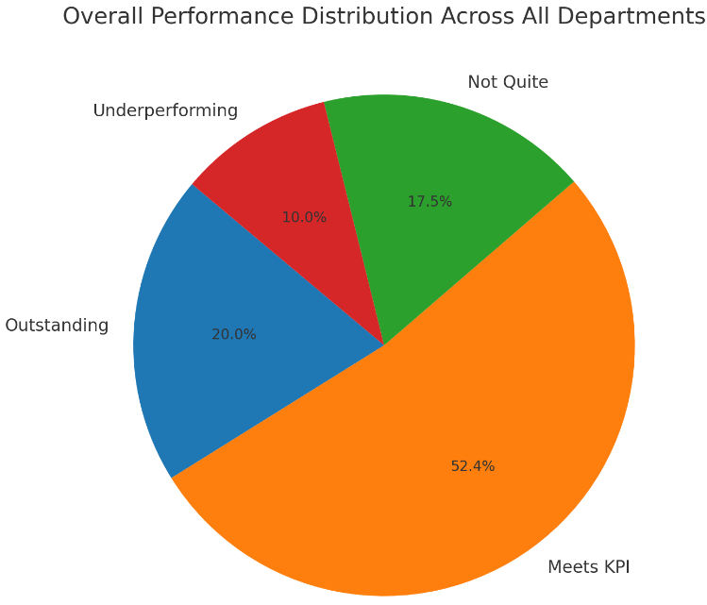

The pie chart depicts the overall distribution of performance ratings (Outstanding, Meets KPI, Not Quite, and Underperforming) across all departments and quarters combined. It shows the proportion of employees falling into each performance category. Key observations include:

Meets KPI: This category dominates the chart, indicating that a majority of employees are meeting baseline performance standards.

Outstanding: A smaller portion of the chart is attributed to Outstanding, reflecting the limited number of employees exceeding expectations. Research & Development significantly contributes to this figure.

Not Quite and Underperforming: These categories occupy moderate segments of the chart, highlighting areas where performance improvement interventions are necessary. Departments such as Administration and Logistics contribute heavily to these categories.

AC 2.2

Chart Two

The second chart illustrates the distribution of performance ratings (Outstanding, Meets KPI, Not Quite, and Underperforming) across four departments (Administration, Sales, Logistics, and Research & Development) over two quarters. Each performance category is represented as a percentage of employees within the department.

Key Observations:

Administration Department: A decline in Outstanding ratings from 18.18% in Q1 to 9.09% in Q2. However, employees meeting KPIs improved significantly (18.18% in Q1 to 36.36% in Q2).

Sales Department: Consistent 100% Meets KPI ratings across both quarters, but no Outstanding ratings in either.

Logistics Department: Improvements in Outstanding ratings (20.00% in Q1 to 25.00% in Q2) and reductions in underperformance.

Research & Development: Consistently the highest proportion of Outstanding ratings, increasing from 30.00% in Q1 to 50.00% in Q2. This department exhibits strong top-tier performance.

Implications: The data highlights strengths in departments like Research & Development but underscores inconsistencies and areas for improvement in recognising and rewarding high performance in other departments.

Recommendations

Enhance Communication on Performance Expectations

Issue:

Sales lacks Outstanding ratings despite strong Meets KPI results, suggesting unclear expectations.

Action:

Conduct quarterly sessions to clarify performance categories.

Provide examples of behaviours linked to Outstanding ratings.

Set Clearer and Measurable KPIs

Issue:

KPIs in Sales fail to encourage exceptional performance.

Action:

Redesign KPIs to challenge employees and incentivise excellence.

Align KPIs with organisational and departmental goals.

Ensure Fair and Transparent Reviews

Issue:

Variability in outcomes (e.g., Logistics) may stem from inconsistent assessments.

Action:

Standardise evaluation frameworks and introduce rubrics.

Implement 360-degree feedback for broader perspectives.

Train managers to minimise biases and improve consistency.

Support Underperforming Employees

Issue:

Administration and Logistics have high Not Quite and Underperforming ratings.

Action:

Develop structured improvement plans for underperformers.

Launch mentorship programs to enhance skills and morale.

Monitor Performance Trends Continuously

Issue:

Persistent underperformance lacks real-time insights.

Action:

Use dashboards to track performance trends regularly.

Share reports with teams to promote accountability and progress.

Recognise and Reward High Performers

Issue:

Sales lacks recognition for top performers despite strong KPI achievement.

Action:

Offer incentives and recognition for Outstanding ratings.

Provide non-monetary rewards like development opportunities.

Adopt Technology for Efficiency

Issue:

Manual performance tracking is inconsistent and inefficient.

Action:

Implement performance management systems for automation.

Use data analytics to identify trends and spotlight top performers.

Overview of Performance Data

The performance review data for employees was analysed across four departments: Administration, Sales, Logistics, and Research & Development. Each department’s performance was evaluated over two quarters using four criteria: Outstanding, Meets KPI, Not Quite, and Underperforming. These outcomes were calculated as percentages, offering insights into individual and departmental performance trends.

Chart 3

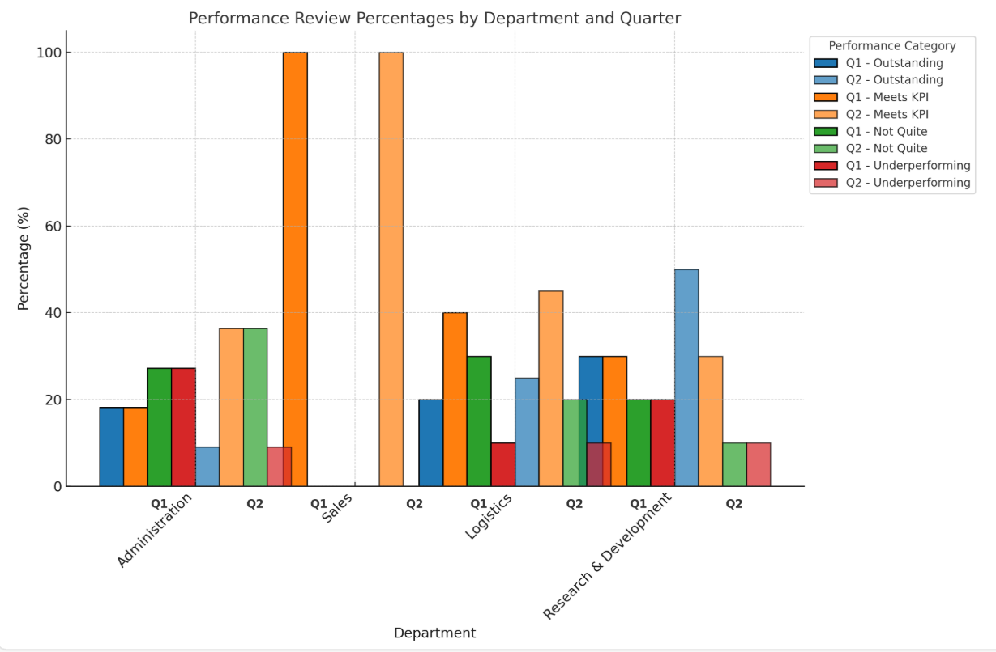

Performance Analysis by Department

Administration: In Q1, 18.18% achieved Outstanding, with 27.27% rated Not Quite or Underperforming. In Q2, Outstanding dropped to 9.09%, while Meets KPI rose to 36.36%. These results suggest progress in meeting expectations but a need for more focus on high performance.

Sales: While 100% of employees consistently met KPIs, no employees achieved Outstanding. This uniformity points to potential gaps in setting ambitious performance goals or recognising top-tier achievements.

Logistics: The department showed improvements, with Outstanding ratings increasing from 20% in Q1 to 25% in Q2, while Underperforming decreased from 10% to 0%. These trends suggest effective interventions.

Research & Development: This department led in Outstanding ratings, improving from 30% in Q1 to 50% in Q2. However, Not Quite and Underperforming ratings remained consistent, highlighting ongoing underperformance challenges.

Bonus Calculations

Employees rated Outstanding were eligible for a bonus of 4% of their annual salary. Total bonuses were £10,450 in Q1 and £10,320 in Q2, amounting to £20,770 overall. Departments with higher Outstanding ratings, particularly Research & Development, incurred greater bonus costs, reflecting their strong performance.

2.3

Survey Insights on Performance Monitoring

Patterns

Preparation Time: While 64% agreed they had sufficient preparation time for appraisals, 31% disagreed, highlighting resource gaps that impact their effectiveness.

Confidence in Appraisals: A split response saw 52% expressing confidence and 48% uncertain, suggesting training needs.

Rating Application: Confidence is strong, with 82% agreeing they apply ratings effectively.

Assessing Contributions: While 58% felt confident, 40% expressed uncertainty, indicating inconsistencies in assessment methods.

Recommendations

Support High Performers: Focus on recognising and rewarding exceptional achievements, especially in departments like Sales, where Outstanding ratings are absent. Implement goal-setting workshops and reward systems to motivate employees.

Address Underperformance: Departments like Administration and Logistics should implement mentorship, upskilling, and performance improvement plans.

Refine Assessment Frameworks: Ensure consistent evaluation practices by standardising performance criteria and providing clear guidance to managers.

Allocate Resources for Preparation: Provide dedicated time and tools for managers to prepare thoroughly for appraisals.

Promote Continuous Feedback: Establish ongoing monitoring to reduce reliance on annual appraisals and foster real-time performance improvements.

Facilitate Peer Learning: Create mentoring programs where experienced managers can guide less confident peers.

References
- Armstrong, M. (2016). A Handbook of Human Resource Management Practice. 14th ed. London: Kogan Page.
- Briner, R.B. (2015). Principles of Evidence-Based Practice in Human Resource Management. [Online]. Available at: www.cipd.co.uk. [Accessed 10 November 2024].
- Briner, R.B., Denyer, D. and Rousseau, D.M. (2018). Evidence-Based Management: Concept Cleanup for Clarity and Impact. Academy of Management Perspectives, 32(4), pp. 349–363.
- CIPD (2016). Critical Thinking and Problem Solving in HR. [Online] Available at: www.cipd.co.uk. [Accessed 10 November 2024].
- De Bono, E. (1999). Six Thinking Hats. London: Penguin.
- Edward, A. (2020). Decision-Making in HR: The Future Pacing Approach. HR Quarterly, 12(4), pp. 65–72.
- Perera, T. (2018). SWOT Analysis for HR Practitioners: A Strategic Tool for Success. HR Management Review, 11(1), pp. 15-27.
- Rousseau, D.M. (2018). Ethics in HR: Balancing Deontological and Utilitarian Perspectives. Journal of Business Ethics, 148(2), pp. 357–369.
- Terpiłowski, R. (2022). Return on Investment in HR: Measuring the Financial Impact of HR Initiatives. Human Resource Development International, 24(5), pp. 439-454.
- Wickens, C. (2023). Non-Financial Indicators of HR Performance: Engagement, Satisfaction, and Wellbeing. International Journal of HRM, 18(2), pp. 121-134.

