

A report focussing on:

Management and Quality Management in Construction

Prepared for:

Dr. Deborah Hughes

Created by:

Rhydian Preece

Word Count (Excluding References and Graphs) – 2,173

Date Completed:
January 29th, 2021
Table of Contents
Page Number
1.0 Introduction 3
2.0 Management Procedure 3
3.0 Quality Management Procedure 6
4.0 Conclusion 13
5.0 References 14
6.0 Bibliography 15

- Introduction
In this report, one will be explaining the Management and Quality Management Procedure during a construction project. The main topics that will be discussed in this report are communication and quality.

- Management Procedure
Site Manager
According to Stargatt (2017), “a Site Manager within the construction industry is responsible for overseeing operations of the whole site on a day-to-day basis and that a project comes in on time and in budget”. The site manager has major responsibilities to ensure they lead the various parties to success. The responsibilities can be found in the table below.
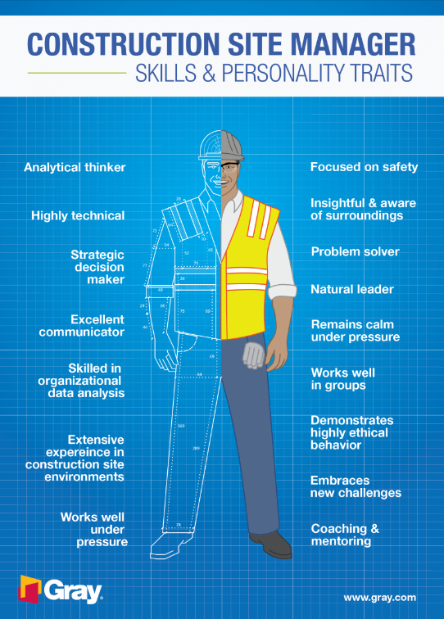
Site Manager – Responsibilities
- Advise and assist in overall planning.
- Supervision and management of all site-based staff employed by the company to ensure that the project is delivered within their contractual obligations.
- Monitor and control progress and quality.
- Provide feedback and reports to the client.
- Ensure that all aspects of the project are carried out by following statutory requirements and company policies.
- Help negotiate contracts and secure permits and licences.
- Make safety inspections and ensure construction and site safety.

Figure 1 – Picture on the right showing site manager’s skills & personality traits

Site manager responsibilities provided from Designing Buildings (2020). The site manager is important to the overall success of the project and the table above showcases how important their responsibilities are. They ensure that communication and the quality of the project stay at a high level.

Traditional Procurement
This project will follow a traditional procurement approach. A description of the approach and a flow chart will be shown to describe the communication.
The traditional procurement route involves separating the design and construction stages. It comprises a tripartite arrangement involving the client, consultants, and contractor. The client firstly appoints consultants to design the project in detail while ensuring cost control and inspecting the construction works as they proceed. Once the design has finished, the contractors are invited to submit tenders for the construction of the project on a single-stage competitive basis Designing buildings 2020. This type of approach is a long procurement route, high cost but high quality due to the amount of planning involved.
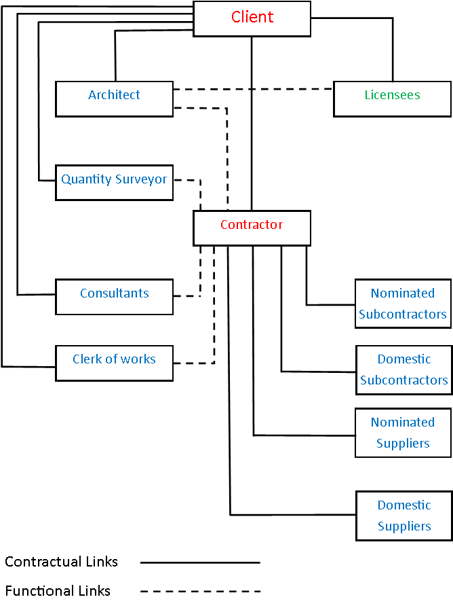
Figure 2 – Flowchart showing communication in traditional procurement
Communication in Traditional Procurement
The flowchart shows the contractual links between each party but can also be used to show the communication between the various parties. The client will start by approaching the architect to design the project. Communication between these two parties will be in the form of drawings via email. The architect keeps a link to the licensees while designing the project. The client will decide if they want to make any changes, if not, the project will move to the contractors where tendering will take place. The architect, quantity surveyor, consultants, and clerk of works, have no contractual link with the contractor but they must stay in contact in case any of the parties have questions to ask relating to the project. The clerk of works plays a big part in the overall quality of the project by taking progress reports from the contractor and feeding that back to the client. The subcontractors and suppliers will only have to report back to the main contractor. During the project, communication can take place from regular meetings. The meetings between the various parties can ensure that everyone is up to date, to share status, allows the team to solve problems together, and allow the team to set targets. Those targets which were set can then be discussed in the following meeting.
Pros and Cons of Traditional Procurement
Traditional Procurement
Pros | Cons
- As the client, you retain control of the project and can make any changes to the design. | - The client must deal with much more people (unless the architect is hired as a project manager).
- The client can select different professional consultants and other specialists that will increase the overall quality of the project. | - You may also have less certainty about your costs, as each stage of the project will produce different sums of money.
- The tender process allows the client to pick their builders based on their choice whether they want the lowest price, the best quality, or a combination of both. | - The client is at high risk as it's their design and the contractor can claim for any changes that have to be made.

Urban Architecture (2020) provided me with the pros and cons of traditional procurement.

3.0 Quality Management Procedure
Documents that will be generated for the Quality Management System
Hayes (2019), states that “Quality management is the act of overseeing all activities and tasks needed to maintain a desired level of excellence. This includes the determination of a quality policy, creating and implementing quality planning and assurance, and quality control and quality improvement”. For the quality management system, many documents must be presented to ensure high quality stays throughout the project. These will be discussed below.
Checklists
Checklists are lists of items that must be carried out to complete a set task. The list also shows if there was a delay or if the task was completed as planned. Design Buildings (2020) say that “When managing others, checklists can remind supervisors to ensure sub-contractors are fully briefed, standard procedures are in place, tools and materials are checked for adequacy, and appropriate personal protective equipment is in use. In this way, the checklist can be used both for planning an activity and coaching supervisors in standardised procedures”. As everyone knows what they’re doing and what has been completed from these checklists, they can move on with work efficiently, in turn improving the quality of their work. The workers that are completing these checklists should be receiving regular management training and feedback, this is so they can appreciate the value of the data that their collecting. If management is not provided to the workers, then it can result in a “tick box” mentality, which can lead to poor data and in turn quality risks to the organisation.
IS0 9000 and 9001
ISO 9000 is the standard that’s used as the basis for quality management systems and quality assurance. There is a whole family of standards under ISO 9000 and according to Hayes (2019), these “standards were developed to help manufacturers effectively document the quality system elements that need to be implemented to maintain an efficient quality system”. ISO 9001 is internationally recognized as the Quality Management System (QMS) standard. This standard, that businesses can have certified, is designed to be a business improvement tool and can help you to do many things, such as:
- Continually improve, streamline operations and reduce costs.
- Win more business and compete in tenders.
- Satisfy more customers.
- Be more resilient and build a sustainable business.
- Show you have strong corporate governance.
- Work effectively with stakeholders and your supply chain.
In practice, this standard is based on several quality management principles and looks to have a strong customer focus, implication of top management, the process approach, and continual improvement. In traditional procurement, the client has full control of the design, so this ISO standard will ensure that the project is of high quality and that the client is of strong focus to the contractors.
ISO 9001 Case Study
This case study focuses on a long-established British Engineering and construction group called Costain. This company has said that from adopting ISO 9001, customer satisfaction has improved and embedded an ethos of continual improvement. Meaning that everyone knows that they’re a reputable company and can be relied on when it comes to providing high-quality services. After carrying out customer satisfaction surveys, it was found that there was 84% customer satisfaction and 90% repeat orders. These figures are very high and have come from adopting the ISO 9001 standard. This case study proves just how important it is to be certified under ISO 9001 and how it can improve quality and client satisfaction.

Process Map

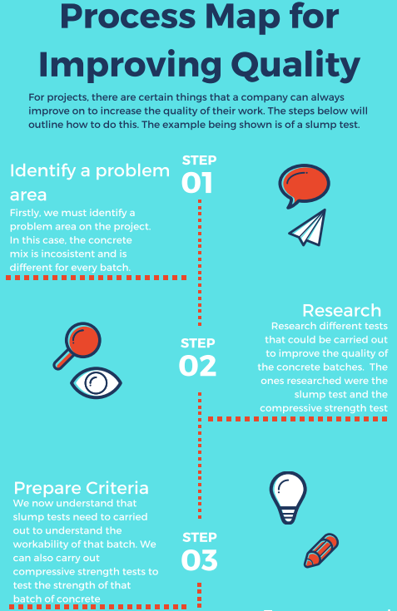

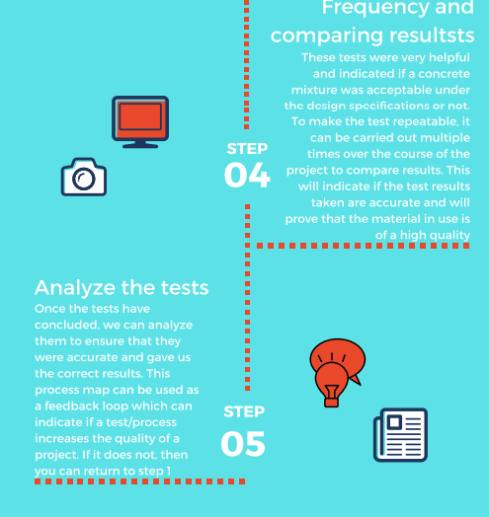

Figure 3 – A process map created on Canva

The process map above shows how feedback and different processes can increase the quality of the project. The process map above shows how we would carry out a slump test. Firstly, we identified a problem area, then researched it, prepared criteria, showed frequency, and compared results, then we analyzed those results. The process map can help us to see if the material test was effective and if it helped the project at all. It can be shown that the slump test was very effective and helped to ensure the right concrete was being used according to the design specifications.

Procedure for QA to improve quality standards
One of the most common procedures to improve quality standards would be material testing. Hofer (2018) describes materials testing as the “measurement of the characteristics and behaviour of such substances as metals, ceramics, or plastics under various conditions”. The data obtained from these results can help to understand the suitability of said material for its specified application. For example, if we were using concrete on-site, various tests could be done to ensure it is of high quality. The main tests that should always be carried out are slump tests and compressive strength tests. For the slump test, after batching the concrete, a sample shall be taken for where the concrete will be assessed on whether the correct amount of water has been added to the mix and the overall consistency to ensure it complies with the mix design.
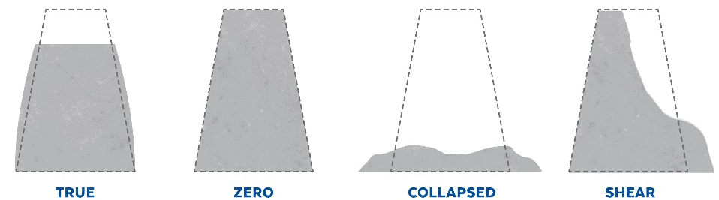
Figure 4 – Picture showing a slump test

Slump Test Results | What they mean
True | The concrete mass has slumped evenly all around without disintegration
Zero | The concrete has no change after removing the slump cone, showing that there is a stiff and dry mix.
Collapsed | The sample has collapsed due to excessive water.
Shear | One half of the concrete mass has slid down the other. Therefore, there is a leam mix.

For the compressive strength test, three samples of cubes shall be taken and tested over 28 days where the concrete should achieve its maximum strength. Instead of waiting for 28 days, we can test the concrete in intervals to predict the target strength as waiting can cost a lot of money. These tests are very important to ensure the materials being used on the project are of high quality, and that there is a minute amount or no defects after handover.
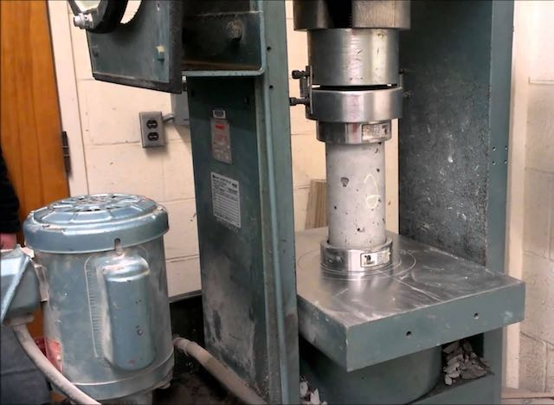

Figure 5 – Picture showing a compression test on concrete
Many other procedures can be implemented to improve quality standards, and these can be found in quality policy and procedure documents. These documents do not create quality work but give workers information and guidelines on how total quality management should be maintained. These quality control procedures are a code of guidelines that set and establish quality standards and norms, which in turn, ensure consistent quality across the company and any projects that are being worked on. Hodgson (2020) outlines some of the information and guidelines that you should find in these quality control procedure documents:

- Physical quality guidelines.
- Inspections, approvals, and certifications.
- Methods and sequence of tests.
- Acceptance and rejection criteria.
- Visual Quality.
- Key control points.

When workers implement these procedures into general processes when working on a project, the quality of the work will be of a very high standard.

After-sales Procedure

The after-sales procedure for any company is very important not just for customers but for the company itself. The after-sales procedures that your company provide, make sure that clients are satisfied with the project that has been handed over to them. By providing good services, the clients can spread a good word which can play an important role in advertising the company. There are many different services that a business can provide, and this part of the report will explain the different after-sales procedures.
Latent Defects
Latent defects are something that commonly happens and will come under the after-sales procedure. This type of defect is one that was not visible straight away and may not even appear in the 12-month defect period. This defect has come from an incorrect construction process or material used. If the client can prove that it has happened due to a mistake during the construction, the contractor/subcontractor or supplier must rectify the mistake. This is a form of an after-sale procedure and can show that the contractor has care for the client’s satisfaction.
Maintenance
Most construction companies will hold maintenance of their project as a big responsibility in the contract. The companies will ensure that they make regular site visits after the handover period, ensuring that there are no mistakes, and everything is working. Concerning the latent defects, they may find defects while inspecting and will then ensure to rectify mistakes to ensure the client has a positive experience.
BIM and Soft Landings
BIM or Building Information Modelling can be described as “a process for creating and managing information on a construction project across the project lifecycle” NBS (2016). The model is created on a collaborative scale and enables the people that interact with it to understand all the key aspects. BIM is a way in which we can improve the quality of the flow of information in the after-sales period. Instead of the client asking back to back questions on the project via email, they can easily open the model and interact with it, so they can understand it much more. Soft landings ensure that the transition from construction to occupation is ‘bump-free’, which means that the client is happy and understands how everything works. BIM can play a big part in soft landings and helping the client to understand how their project works. For example, they may have automatic windows or doors and not understand how to turn the automatic switch off. By simply using BIM, they can go onto the model and move it around to understand how all the different processes work. To ensure the client has a good transition, they should employ an architect that utilises BIM, as this process can benefit everyone during the construction project.
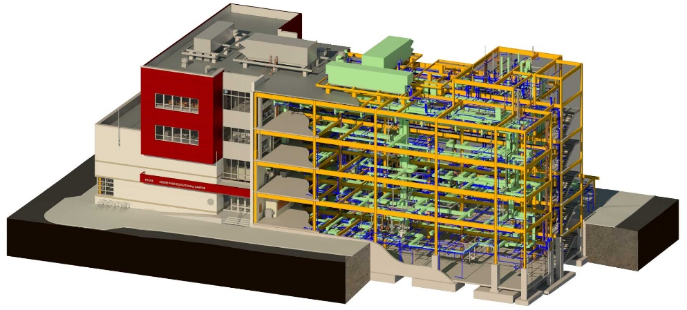
Figure 6 – Picture of a BIM Model

4.0 Conclusion
To conclude, one has covered many topics during this report. In the management procedure, a description was given of how the site manager would lead the various parties, and a description of the traditional procurement approach and the communication required during the project. For the Quality Management Procedure, documents were shown that would be generated for the quality management system, a process map was shown, the procedure for QA to improve quality standards was explained and a description of the after-sales procedure was given. During the project, if everyone follows the communication that one described and ensures that they are following the correct procedures to ensure high quality, the project will be a big success.

- References

- BSI Group – ISO 9001 Quality Management. Available from: https://www.bsigroup.com/en-GB/iso-9001-quality-management/

- Designing buildings (2020) – Site manager for construction sites. Designing buildings.

- Designing buildings (2020) – Traditional Procurement Method. Designing Buildings.

- Figure 1 – Picture showing site manager’s skills & personality traits. [Online]. [Accessed 25 January 2021]. Available from: https://www.gray.com/insights/gray-site-manager-kendall-kluttz-exposes-the-truth-about-working-in-construction/

- Figure 2 - Figure 2 – Flowchart showing communication in traditional procurement. The website attached provided me with information to complete the flowchart. https://www.constructionforum-myanmar.com/2014/11/building-procurement-method-traditional.html

- Figure 3 - A process map created on Canva

- Figure 4 – Picture showing a slump test. [Online]. [Accessed 26 January 2021]. Available from: https://www.totalconcrete.co.uk/news/concrete-slump-tests-measuring-the-workability-of-concrete/

- Figure 5 – Picture showing a compression test on concrete. [Online]. [Accessed 26 January 2021]. Available from: https://www.aboutcivil.org/method-process-compression-test.html

- Figure 6 – Picture of a BIM model. [Online]. [Accessed 29 January 2021]. Available from: https://drgaia.com/building-information-modeling-bim/

- Hayes, A. (2019) – ISO 9000. Investopedia.

- Hodgson, L. (2020) – Quality control procedures in construction. Sitemate.

- Hofer, K.E. (2018) – Material Testing. Britannica.

- ISO – ISO 9000 Family Quality Management. Available from: https://www.iso.org/iso-9001-quality-management.html

- NBS (2016) – What is Building Information Modelling (BIM)? NBS.

- Stargatt, D. (2017) – Site Manager Job Description. Project Resource.

- Urban Architecture (2020) – Traditional Procurement vs Design & Build: Which One is Better?

- Bibliography

- BSI Group – Provided me with information on a ISO 9001 case study. [Online]. Available from: https://www.bsigroup.com/Documents/iso-22301/case-studies/Costain-case-study-UK-EN.pdf?epslanguage=en-GB

- Daily Civil – Provided me with information on different types of slumps after the slump test. [Online]. Available from: https://dailycivil.com/concrete-slump-test-1/

- Designing Buildings – Provided me with information on Quality Checklists. [Online]. Available from: https://www.designingbuildings.co.uk/wiki/Quality_checklist

- Designing Buildings – Provided me with information on Soft Landings. [Online]. Available from: https://www.designingbuildings.co.uk/wiki/Soft_landings

- Quality Engineers Guide – Provided me with information on slump tests. [Online]. Available from: https://www.qualityengineersguide.com/top-6-important-quality-tests-of-concrete

