Bernadette Horton
Student No: 1800006
Module: HPEN 5017

English Independent Project

Title

An exploration of the importance of the Guilds to the York cycle of mystery plays in the
fourteenth to sixteenth centuries,
and whether the Guilds have a role to play
in the revival of the York Plays in modern times.

1. Introduction

Religion, class and social hierarchy in the Middle Ages were important factors in the emergence of a new order of civic drama. The Three Estates in medieval England of social hierarchy/class were: The Clergy as First Estate, Nobles as Second Estate and Peasantry as the Third Estate. Dr. Debora Schwartz comments that in the fourteenth century there was also ‘a mercantile class […] an urban middle class as well as a subdivision of the clergy; intellectuals trained in literature and writing.’ As the old feudal system went into decline, a new system emerged. Katie Normington states, ‘ The old system of the rural landlord and indentured peasant was […] replaced by a variety of town structures, including that of the guild […] whose function was to both protect and develop skills of their craft.’ These skills, and it could be argued promotion of a guild’s craft, were seen in the enactment of ‘Mystery Plays’ and the largest of these productions and processions was seen in medieval York.
Varying, at different periods throughout their two-hundred-year medieval enactment, anything from sixteen to fifty different pageants or plays were performed. These were all of a biblical and religious nature, depicting scenes from the Creation to the Last Judgement. Fast forward to 1951, and after a four-hundred-year hiatus, the York Plays were revived to mark the Festival of Britain. The modern guilds, however, differ from their medieval counterparts in terms of number of guilds and their place in York society. The modern guilds are seen as just one section of York’s community groups. Margaret Rogerson states that E. Martin Browne who was brought in to oversee the 1951 revival ‘sought to foreground the York Guilds, thus making a statement about the plays, past and present, in the formal structures of local community.’ The modern guilds served as an historical link to the guilds of medieval York.
This project will examine civic drama in York after the Black Death of 1349, and its liturgical connection to the feast of Corpus Christi. I will examine differences between the trade, craft and religious guilds in medieval York who enacted and financed the plays in existence, in the medieval and modern eras. The project will explore the social and economic function of guilds, their numbers, and the production and procession of the plays and their organisational development. Additionally, I will look at how a particular play lent itself to be performed by a certain guild. The scholarly critical edition of The York Plays by Richard Beadle will be used as a primary source for the guilds from the medieval era, and Margaret Rogerson’s Playing a part in History: The York Mysteries 1951-2006, as the primary source of the plays and role of the guilds in the modern era.
Moving forward, I will examine how the guilds financed the plays in medieval England, and whether they are still financed by guilds today. I will question whether the guilds were happy to provide this support. I will briefly outline the effect the Reformation had on the cycle of plays. I will also look at whether Marxist literary theory can shed light on how the literary mode of production may have influenced civic drama through the original manuscripts of the York Plays, and whether literary history can be an aid to the modern-day plays. I will draw conclusions about the role of the guilds in connection to the plays, summarising observations and assessment made, based on the evidence found.

2. How Civic Drama came about
‘Survival from plagues and other disasters has traditionally moved communities to great acts of collective expression’ comments Beadle. This could be said of York, after the Black Death of 1349. Although the disease ravaged England, and approximately 45% of the population were killed as a result, York emerged well, as new buildings were built in the city financed by the local civic authority and the early guilds. Prior to this date, church-based drama had been performed in churches in the twelfth century, and was written by educated members of the clergy, such as monks and clerics. They were purposefully didactic in nature, so had a biblical doctrine to put forward to the church congregation. Terry Eagleton asserts
The medieval author is typically a cleric, part of an ideological apparatus. But his literary production is an aspect of this function rather than identical with it […] A voluntary and amateur mode of exercising his priesthood.
Eagleton arguably demonstrates that church drama, written by a cleric, will espouse all the religious doctrine that the Catholic church of the day wanted to get across to its brethren, as a form of control. The uneducated peasants of the time under the old feudal system, would not question anything written by an educated man of the church. Equally, they would obey the messages given out in the drama which included giving alms to the church. Eagleton goes on to show how the Literary Mode of Production (LMP) in the Middle Ages originated by word of mouth storytelling, ‘In Medieval England […] much of the “written” LMP consists in committing to manuscript form products of the “oral” mode (of production). It could be argued the York Plays manuscripts depicting biblical stories which were passed down by word of mouth through the ages, could be enacted in a particular way that benefitted the medieval church in York. After 1300 and leading up to the Black Death says R.B. Dobson
The majority of townsmen in York […] were primarily identified […] in terms of their trade or occupation […] no less than 75% of York’s citizens were given a trade description when their names were entered in the great York Freemen’s Register.’
Although uneducated peasants still existed, more men were keen to learn a skill and trade. Thus, craft and trade groups emerged to apprentice young men, who would spend as long as seven years learning their craft. These groups were known as ‘gilds’ with their own structures within towns and their own civic responsibilities. Thus, ‘Drama of the church […] evolved into drama performed outside the church and then into drama performed away from the church, in the town’ says Bevington, once the fourteenth century began. But how did the cycle of York Mystery Plays come about and did religion link the plays to the guilds?

2.1 The Significance of the Feast of Corpus Christi.
Before focussing on the relationship between the feast of Corpus Christi, the York plays and Guilds, it is essential to understand some terminology from leading scholars. ‘Mystery Plays’ ‘The York Cycle’, ‘The Corpus Christi Play’, ‘York Pageants’ ‘The York Plays’ are just some of the terms used to describe the enactment of biblical stories in York in the fourteenth century. I will use the terminology of leading scholar, Richard Beadle who refers in his critical edition work to ‘The York Plays.’ It is worth noting that Pamela M. King extracts the term ‘pageants’ as ‘ a series of “pageant” […] to describe individual episodes’ (of the entire play cycle). The word ‘Mysteries’ comes from the medieval ‘misteries’ which was another name for medieval guilds, thus providing a direct link from guilds, to the term “York Mystery Plays”.
The church feast of Corpus Christi when the York Plays were performed did not actually become a feast day until ‘it was authorised by the papacy for universal use in 1264.’ The feast day was celebrated ‘on the last Thursday after Trinity Sunday, which could be anytime between 23 May and 24 June.’ The timing of the feast was often a period of good weather so festivals and events were held in towns across England and were holidays for the townspeople. However, although there appeared to be a version of the plays in York occurring in the late 1300’s ‘Meg Twycross suggests in relation to the Ordo Paginarum of 1415, we cannot be certain whether the local guilds were presenting fully fledged plays […]or some other dramatic display’ before 1379. The Ordo Paginarum documenting the pageants and organisation of the plays was entered into the A/Y Memorandum book, still kept in York City Archive today, and lists the pageants and guilds associated with them. It wasn’t until the late 1400’s that the York Plays were handwritten in various anonymous manuscripts.

These manuscripts are described by Beadle.
They are (i) London British Library, Additional MS 35290 (known from early times as the Register) which contains the bulk of the cycle […] (ii) York City Archives, Acc. 104/G.I (known as the Sykes manuscript)[…] and (iii) the Towneley Manuscript […] some of them connected with the town of Wakefield.

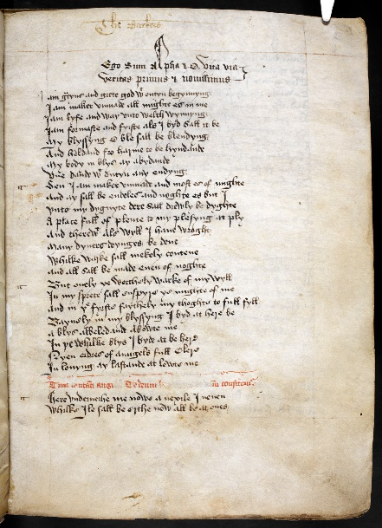
York Mystery Plays, British Library Manuscript Collections – ‘The Register’. http://www.bl.uk/manuscripts/Viewer.aspx?ref=add_ms_35290_fs001r

Beadle goes on to say that the year 1476 is significant. ‘The year 1476 appears to be something of a turning point […] the Play in relation to the Corpus Christi procession was finally settled, with the Play coming to occupy the Thursday of the liturgical occasion itself’. Although the Plays were likely written by ecclesiastical clerics, the procession outside of the church to celebrate the elevation of the host, was very much a community affair. King comments
The line-up of groups accompanying the Host, also reflected civic hierarchies […] the laity according to the hierarchy of central civic government […] and secondly confraternal organisations […] Manufacturing and trading activity was controlled through the exclusive trade and craft guilds. These guilds […] took responsibility for production of the individual pageants in the York cycle.
Therefore, as the plays emerged to be performed in early summer as a civic holiday with a didactic religious theme in the Middle Ages, was the feast of Corpus Christi still significant in the modern revival of the plays?
The York Plays were revived as part of the Festival of Britain programme occurring throughout Britain in 1951 as a boost for citizens after years of war. The 1951 exhibition of the plays in York was indeed performed during the original Corpus Christi period as the Festival Programme in the City of York archive tells us (3-17 June 1951)
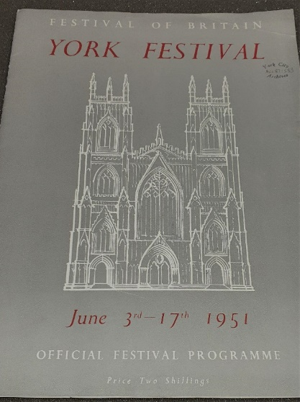
York City Archive, York Festival Programme 1951, PUR/23/2.
E. Martin Browne, the director of the York Festival in 1951 was an admirer of the German, Oberammergau Passion Play and wanted to revive the medieval York Plays which he hoped would rival their German counterpart. Rogerson comments, ‘The mysteries were admired in 1951 because they belonged to the past; they were also admired as sacred theatre.’ Religion, although not strictly celebrating the Feast of Corpus Christi itself in the way the medieval Plays did, was certainly at the core of the 1951 and subsequent modern revivals. ‘Their openings have been marked by services in the Minster; official chaplains have been attached to them; and post performance prayers have been available […] the local guilds are moreover “all inspired by a Christian ethic”. comments Rogerson.
However, I argue that when the plays ceased in 1569 and the Catholic Corpus Christi feast day was abolished, it would not have been an important feature to replicate the worship of that feast day in 1951 in an England where the Head of the Church is still the monarch. The likelihood, in my opinion, is that the festival was both reaching back in nostalgia to the medieval era so Corpus Christi was used as a link, and simply that June is a perfect month to be assured of mostly decent weather for enactment and tourism purposes. Upon further research I found that Sarah Beckwith in her work, Signifying God, thought that the modern revival of the plays ‘are an unavoidable part of a commodified heritage industry’ and had thus lost their link to the medieval church. Therefore, they no longer resemble the sacred York Plays of the medieval era, and their revival in the main, has been for tourism and heritage purposes.

3. Trade, Craft and Religious Guilds of York
It is important to distinguish that the ‘gilds’ were not formed purely on the basis of their trade, as is widely assumed. King states ‘ Pre-dating the evolved trade-and-craft guild system was a network of religious confraternities […] Their membership […] also included members of the secular clergy’. In fact, Alexandra F. Johnson explains that there were two religious guilds who performed two different plays, quite separate from the York Plays. ‘The Corpus Christi Guild was responsible for the Creed Play and the Pater Noster Guild (later the St. Anthony’s Guild) was responsible for the Pater Noster Play.’ The Corpus Christi Guild was founded in 1408 and was abolished, due to the Reformation in 1546. The plays were both didactic in nature. Johnston comments ‘from the account roll of the Corpus Christi guild for 1449 -51 we learn that the play was one of instruction and information of the Christian faith.’ while the Pater Noster Play was slightly different.
In 1388-89 [the Pater Noster Guild made a return to Richard II’s council] this return makes it clear the play predated the guild and that the guild was founded for the specific purpose of being the custodian of the play.
The Pater Noster is the Lord’s Prayer in Latin, and so the play evolved around the prayer, educating the townspeople through enactment. The membership of these guilds was mostly made up from the clergy. The Corpus Christi Guild and the Pater Noster Guild did, however, take part in the procession of the York Plays.
Urban communities, forming boroughs in the Middle Ages, set up their own guilds. These guilds were based around trade and crafts. ‘York’s gild merchant first explicitly authorised by Henry II can be shown to have existed in Henry I’s time’ (1068-1135), state Miller and Hatcher. As mentioned previously, R.B Dobson states that 75% of York’s citizens were identified by their trade description by 1350. Fraternities were established and by 1390 registration of the guilds ordinances were required to be registered with the city. Dobson goes on to argue that could ‘the emergence of ambitious sequences of plays, actually initiated craft organisation, that the Corpus Christi plays brought a sophisticated craft structure into being?’ This could have been the case, as up until this period it was impossible to know just how many craft and trade guilds or fraternities existed in York. The plays were big productions demanding finance, time and effort but were also promoters for specific crafts and trades that were assigned to each of them. It was prestigious to take part. It could be argued that early guilds structured themselves in order to enact a specific play that related to their craft or skill.
The local civic hierarchy consisted of the mayor, various aldermen, bailiffs and counsellors as municipal development prospered. Craft guilds were distinguished by their skill e.g. The Baker’s Guild, whilst trade guilds were guilds such as the mercers and woolbrokers. The class system, inherent under the old feudal system, did not change considerably under the new civic hierarchy or indeed within the guilds. Normington quotes the medieval historian, Jacques Le Goff “the traditional opinion that the medieval town patriciate wrenched the peasant from servitude to the land to tie him to servitude in the workshop remains true in its essentials” The guilds often supplied officers to the hierarchy of civic government too.
It could be argued that as the guildsmen were so intrinsic to the running, finance, production and enactment of the York Plays, the actual interpretation of the plays from the manuscript from members of a more educated skilled class, meant they could have deliberately targeted their own didactic promotional messages to the largely uneducated townspeople of York. Eagleton says, ‘The theatrical mode of production in no sense merely ‘mediates’ the text; on the contrary its practices and conventions ‘operate’ the textual materials according to an internal logic of their own.’
Due to the fact that by 1951 all but three guilds (The Merchant Taylors, Merchant Adventurers, Butchers) had ceased to function, it is perhaps more appropriate to discuss the modern guilds in the next segment of the project.

3.1 The Social and Economic Function of Guilds in Medieval and Modern York.
Medieval ‘gilds’ in York existed from the 1100’s in some form. By the 1400’s and when the York Plays were an annual occurrence there were as many as 96 guilds active in the city. Miller and Hatcher state that
Master craftsmen engaged in specific branches of trade or manufacture for the defence of their common interests […] to defend the good repute of their craft and products, […] what the gild members got in return were common privileges, a monopoly of a craft or trade for the gildsmen, a “closed shop”.
Guildsmen were thus part of a ‘trade club’ where they paid a financial contribution to participate and receive benefits from membership. Benefits included a set fair wage for the craft and financial aid given in times of sickness and death. It could be said they were the initial architects of modern-day trade unions. Each member’s craft or trade interest was protected and promoted by the collective guild within the city as there were restrictions in place as to whom could practise the craft or trade. They operated apprenticeships under the master craftsmen so were organisations of education too. However, both medieval and modern-day guilds have a benevolent function. In the Middle Ages ‘York Mercers[built] a hospital for the poor, aged and sick of their crafts’ and Andrea Bobec comments ‘ [There was] a theme of work for a higher purpose. The rich Mercers displayed their power and status in the procession of pageant wagons but they also renegotiate their relationship to the poor.’while the modern York Butchers Gild have a charitable trust set up in 1992 whereby, they donate funds
for the furtherance of Civic, Gild, and Gild Church Life in the city of York
for the benefit of persons in training and education in the butchers’ trade, meat and food industry, and allied trades; for the relief of people in need
for the advancement of arts and crafts and the appreciation of arts.
for the provision and maintenance of buildings and facilities for the purpose of education, recreation and leisure

The Guild of Weavers, Spinners and Dyers formed in 1960 also has an educational aspect to its membership, ‘The knowledge of traditional crafts is kept alive and standards are maintained.’ as found in a pamphlet in the York City Archive.
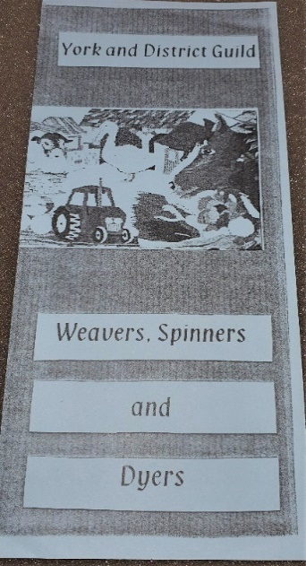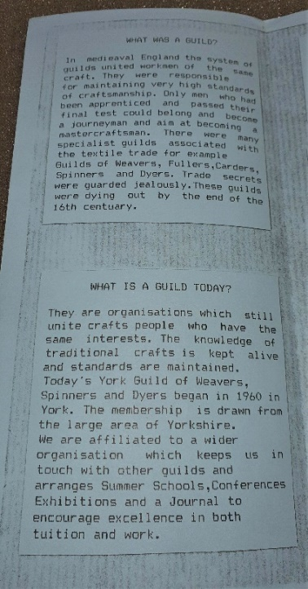
York City Archive : York and District Guild of Weavers, Spinners and Dyers Leaflet, DYE/7/14.

Whilst the numbers ran into thousands in the medieval era of membership of the 96 craft guilds, perhaps because of the protective and economic benefits of belonging to a craft, this has not been the case in the modern era. Jane Oakshott lists the numbers of membership in the seven active guilds in York operating in 1998, ‘Merchant Adventurers, 150, Merchant Taylors, 89, York Butcher’s Gild, 65, Cordwainers, 52, Scriveners, 56, Freemen, 500 and York Building Guild, 160. As only three guilds out of the seven were in operation in 1951 in the city, when the York Plays were revived, it seems there was a vast decline in membership between the medieval and modern day era.

3.2 List of Pageants in the York Plays and Responsible Guilds
Richard Beadle and Pamela M. King have researched the approximate definitive list of pageants which were performed by guilds within the York Plays in the medieval period in their work, York Mystery Plays: A selection in Modern Spelling. They list 50 separate pageants, although other scholars suggest forty-seven or forty-eight was the total number. I attach the 50 pageants and Guilds as an appendix. Beadle and King state,
The Manuscript containing the text of the cycle […] in the handwriting of an unidentified scribe probably executed the work between 1463 and 1477. [This was] known as the ‘Register’ [and] constituted the city’s official record of the content of the cycle and was the property of the corporation
Beadle and King also comment ‘The Register was compiled from copies of the individual plays held by craft guilds.’ This was in the era when the Plays were an annual event, causing much preparation and excitement among guild members and townspeople. However, before that The Ordo Paginarum of 1415 which translates as ‘Order of Pageants’ lists the guilds and their responsibility for the individual biblical pageants which made up the cycle. The Guilds were allotted individual pageants and were responsible for their finance, enactment, costume and responsibility for engineering pageant wagons on which to perform the plays at twelve stations around the city walls. It was an incredible feat of organisation due to the fact that the pageants were performed on just one day on the feast of Corpus Christi. Beadle states ‘The Play […] was authorised at a meeting of the city council early in Lent whereupon the common clerk issued the billets to the individual crafts’ Therefore, the pageants and their organisation came from civic hierarchy to the guilds, and there was no religious clerical involvement.
Some guilds crafts lent themselves to certain pageants, e.g., The Shipwrights were responsible for The Building of the Ark, The Vintners were responsible for The Marriage at Cana and The Bakers for The Last Supper. The Merchant Adventurers (The Mercers) were the wealthiest guild and chose to have responsibility for the final pageant, The Last Judgement, which they still have responsibility for today. Justice comments ‘The connection between guild and subject was not entirely arbitrary […] a craft dedicated to a particular biblical event […] staged a pageant on the same subject.
In 1951 only three guilds still existed from the medieval era so it was not possible to replicate either the pageants or the staging of the York Plays as they were in medieval times. In fact, it wasn’t until as recently as 1998 that the seven guilds existing in York were heavily involved again in the production of the York Plays. In 1951 the Plays had been performed statically in the Museum Gardens over a period of four hours each evening across 15 days and remained there until 1988. They then moved indoors again to the Theatre Royal in 1992 and 1996. It was only Oakeshott’s vision for 1998 to revive the pageants performance at stations on pageant wagons throughout York, that saw a more historically linked and in-depth role for the guilds. This was very unlike the 4.30am until midnight productions on moving pageant wagons across the twelve stations in the city, on one day only in medieval times. However, the original processional route was followed in 1951-1996 without the pageant wagons, as pictured in Eileen White’s pamphlet .
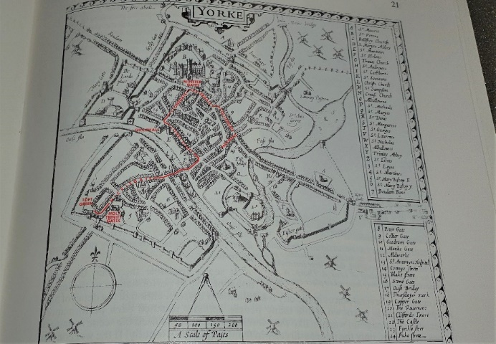
Eileen White, The York Mystery Play, York City Archive 822.051 (YPM).

Interestingly as E. Martin Browne the director of the 1951 play revival wanted to link the present to the past, the original proclamation announcing the commencement of the York Plays was made. A transcript of the medieval proclamation is also in the City Archive. ‘And all manner of craftsmen shall bring forth their pageants’
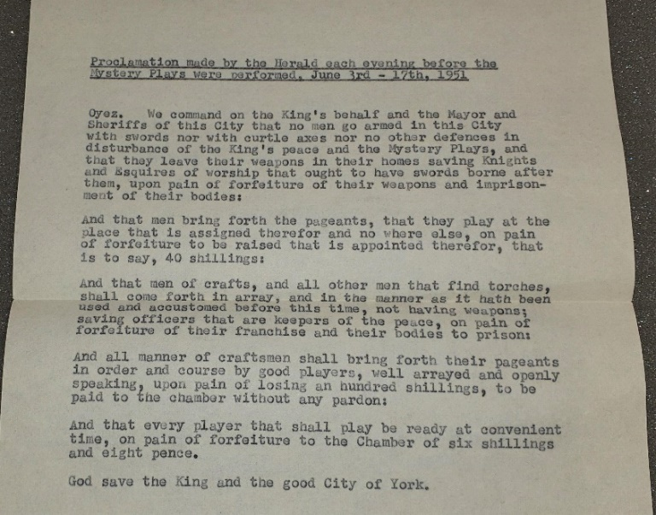
Proclamation made each evening before the Mystery Plays were performed, 3rd June-17th 1951, York City Archive, Y822.1 EPH/2/3107.
Jane Oakshott commenting on the 1998 York Plays gives an insight as to how guilds are still the centre of community in York and how as director that year, she wanted the guilds to play a more prominent role by putting the concept of ‘community’ at the heart of the production. In 1998
The modern Guilds had clearly defined reasons for deciding to become involved in a production of the Mystery Plays: the identification with Guild traditions; a concern for education and heritage; a wish for the Guild to contribute to the life of the city; fun; and the opportunity to raise the Guilds’ profile in York and beyond.
The Guilds brought in community groups to help them with the production of their plays and it took two years to finance, for the enactment in July 1998. Following the successful reintegration of the Guilds into the York Plays four yearly performances, it was decided to continue with this tradition into the new millennium.
Interestingly, Hans Jauss and Elizabeth Benzinger in their work, speak about Literary History, rather than Literary Theory. It could be argued that the medieval York Plays and the modern interpretation of the original manuscripts are linked by the audience reception and understanding of them. ‘The historical life of a literary work is unthinkable without the active participation of its audience’ They argue that historical literature is viewed by literary theorists focussing on production and representation but ‘this should be widened to include an aesthetics of reception and impact [in order to understand]the historical sequence of literary works as a continuity of literary history’.
Of course, with a medieval audience having a more reverent attitude towards the established church, the Plays impact would differ from a modern-day audience, who have a variety of different faiths and non-faith. However, the Plays had to get over their central message quickly as medieval audiences were often bawdy and drunken as it was a holiday from the grind of their daily work. The Plays invited audience reaction and comedy was mixed to good effect with the central didactic message of the individual pageant. It could be argued both eras audiences share the joy of the enactment, drama and spectacle, but the modern day better educated audience, can appreciate the drama and question what is being enacted before them.

4. The Financing of the York Mystery Plays
In the medieval era it was a considerable financial undertaking to build the pageant wagons which were valuable assets to the individual guilds. As each guildsman contributed a subscription to his guild this money went towards the building of the wagons, but more money was needed. Each guild appointed a ‘pageant master’ to handle all the guild’s organisational details for the day itself. ‘Pageant masters were in effect producers of the pageants collecting financial contributions (pageant silver) from the members of the craft’ state Beadle and Fletcher. Numerous items had to be paid for, like costumes and props plus the storage of the pageant wagon throughout the year. Some actors were paid for their performances. Rogerson comments ‘[Pageant Masters also arranged] for a “reckoning dinner” held on the occasion [at a later date] of the presentation of their accounts.’ Although the pageant procession promoted the guild and its standing in the city some scholars suggest that the financial burden was not altogether welcome.
Clifford Davidson says ‘craft guilds ordered [by the council] to contribute to others pageants were often unenthusiastic […] there were heavy fines if they did not pay their allotted shares.’ It has to be understood that during the 200 years the plays ran for, York had its fair share of disease and sickness, so some years were a lot harder than others for the guilds to shoulder the entire cost of the plays. I argue that due to the religious aspect of the plays and the predominant reverence amongst people to the Church, some Guilds grudgingly paid their pageant silver even if they could not afford to, in order not to offend the church or thought of as mean spirited in front of the town’s citizens. There are some individual finances from guilds held in the A/Y memorandum book in York, but not full accounts.
There is, however, an account of the finance for the York Festival in 1951. By this time only three guilds were in existence so the finance was burdened entirely by the civic council of York through sponsorship, admission charges and fundraising. This was a total contrast to the medieval era of guilds shouldering all the financial responsibility for their pageant. A finance estimate is lodged in the civic archive of the entire festival cost in 1951 of £29, 895 as the plays were not financed as a separate entity.
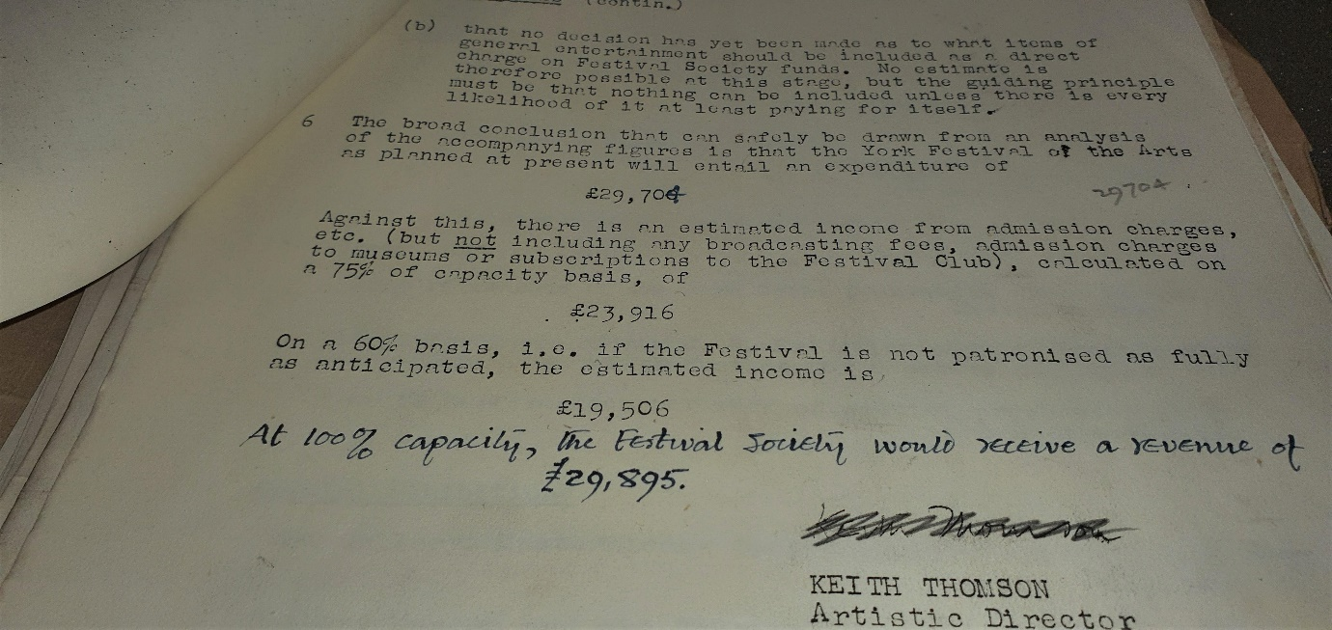
York City Archive, Finance Estimates York Festival 1951, Y/CUL/1/1/1.

5. The effect of the Reformation on the York Plays
The last recorded performance of the York Plays in the medieval era was in 1569, although Beadle informs us ‘the feast [Corpus Christi] having been officially expunged from the calendar in 1548’ saw the abolition of the Virgin Mary (Marian) pageants as a result. However, despite extensive research I cannot find any declaration or law from the crown in this period that ‘abolished’ the production of the entire play cycle. Considering that only a year previously, before his death in 1547, books were burnt, monasteries destroyed and many declarations from King Henry VIII were made, there is no evidence that the plays were officially told to halt by the guardians of Edward VI, other than the abolition of Corpus Christi.
Leading scholars such as Beadle and King, among others, concur that the Reformation period was the reason the York Plays ended owing to immense pressure from the crown. Yet why were the Marian pageants abolished and not simply the whole play cycle? The Plays were performed for twenty-one years after the abolition of Corpus Christi, and were not stopped immediately in 1548, as one would expect. Whilst there was obviously pressure from the Crown to abolish the Marian pageants and ultimately the feast of Corpus Christi, could the York Plays have died a natural death through lack of finance, lack of interest or even local civic wrangling between council and guilds?
I discovered one scholarly work by Bing D. Bills who speaks of a ‘suppression theory’ surrounding the plays and shares the same concern I have for the lack of official evidence to abolish the plays. Whilst he acknowledges the role of the Church during the Reformation, he states ‘ what can be said about how these plays were perceived by sixteenth century Englishmen? [and what does this mean in connection to] the disappearance of the plays?’ He goes on to comment, ‘none of the official documents used as evidence [by other scholars, such as proclamations, statutes] ever specifically refer to [ the abolition of] the cycle plays.’
This area in my opinion, requires further extensive research and to date, has no definitive answer as to the effect of the Reformation on the York Plays.

6. Conclusion and Summary
From the outset, this topic had more material to be researched than is possible within the scope of this project. However, it illustrated just how vital the York guilds were in the medieval period to the plays and how an emphasis on community drama was important in both medieval and modern periods. Community in the Middle Ages came together from all aspects of society to witness the York Plays as a significant event in the calendar, enjoying the holiday, the spectacle, the didactic messages, and the sense of comradeship in promoting and having pride in their city. In 1998 the Master of the Gild of Freemen commented ‘This July [1998] the Mystery Plays were reclaimed by the people of York.’ The traditional staging of procession across the twelve stages in the city was revived, so everyone in the community could enjoy the performances, not just those who in previous years were limited in numbers to indoor venues. Therefore, a marked similarity, is the shared sense of community between the medieval citizens of York, and their modern-day counterparts.
An observation I have made is that guilds have not only had social, economic, and educational functions but have also been catalysts of a cultural function in society too as promoters of the arts. They have produced, staged, acted, built and costumed the York Plays to an audience of thousands. In the modern era this audience comes from countries around the world to witness the four-yearly cycle of the plays and the performances market York as a tourist destination to the rest of the world. The Plays that were written in the medieval period can still attract a less religious global audience nearly five hundred years later, as there is a shared sense that historical theatre must be preserved.
The interesting mix of overlapping subject areas to research has been fascinating too with English literature, Literary theory, History, Theatre history, Religion, and Sociology, all playing a part in this project. When I first embarked upon this project, I did not realise just how many subject areas I would be researching to get an all-round opinion on the role of the Guilds.
I have also learnt that there are areas of research concerning the guilds and the York Plays in both periods that are underdeveloped and need further scrutiny. Why the Plays came to an abrupt end in 1569, the four-hundred-year hiatus, and why did the guilds vastly decline in number by 1951 in York? On reflection, I have drawn out unanswered questions with my research, and I hope to be able to address these issues in future study.

7. Appendix : List of Pageants in the York Plays and Responsible Guilds
Beadle and King 2009 Those pageants marked † are no longer in existence. Those pageants marked * are performed in the modern-day plays.

(As listed in the ‘Register’)

*The Barkers The Fall of the Angels
The Plasterers The Creation
The Cardmakers The Creation of Adam and Eve
The Fullers Adam and Eve in Eden
*The Coopers The Fall of Man
The Armourers The Expulsion
The Glovers Cain and Abel
*The Shipwrights The Building of the Ark
*The Fishers and Mariners The Flood
The Parchmentmakers and Bookbinders Abraham and Isaac
*The Hosiers Moses and Pharoah
The Spicers The Annunciation and Visitation
*The Pewterers and Founders Joseph’s Trouble about Mary
*The Tilethatchers The Nativity
The Chandlers The Shepherds
*The Masons; The Goldsmiths Herod and The Magi
St. Leonard’s Hospital The Purification
*The Marshals The Flight into Egypt
*The Girdlers and Nailers The Slaughter of the Innocents
The Spurriers and Lorimers Christ and the Doctors
The Barbers The Baptism
*The Smiths The Temptation
† The Vintners The Marriage at Cana
The Curriers The Transfiguration
† The Ironmongers Jesus in the house of Simon the Leper
The Cappers The Woman taken in Adultery/The Raising of Lazarus
*The Skinners The Entry into Jerusalem
*The Cutlers The Conspiracy
The Bakers The Last Supper
The Cordwainers The Agony in the Garden and the Betrayal
*The Bowers and Fletchers Christ before Annas and Caiaphas
*The Tapiters and Couchers Christ before Pilate (1) :The Dream of Pilate’s Wife
*The Litsters Christ before Herod
The Cooks and Waterleaders The Remorse of Judas
*The Tilemakers Christ before Pilate (2) : The Judgement
The Shearmen The Road to Calvary
*The Pinners The Crucifixion
*The Butchers The Death of Christ
*The Saddlers The Harrowing of Hell
*The Carpenters The Resurrection
The Winedrawers Christ’s Appearance to Mary Magdalene
The Woolpackers and Woolbrokers The Supper at Emmaus
The Scriveners The Incredulity of Thomas
The Tailors The Ascension
The Potters Pentecost
The Drapers The Death of the Virgin
† The Linenweavers The Funeral of the Virgin
The Woollenweavers The Assumption of the Virgin
The Hostelers The Coronation of the Virgin
*The Mercers The Last Judgement

Bibliography

Archive, City of York.
Beadle, Richard, ‘The York Corpus Christi Play’ in The Cambridge Companion to Medieval English Theatre (NY, USA: Cambridge University Press, 2008).
Beadle, Richard, The York Plays: A Critical Edition of the York Corpus Christi Play as recorded in British Library Additional MS 35290 Vol.1, 1st edn (NY: Oxford University Press, 2009).
Beadle, Richard, The York Plays: A Critical Edition of the York Corpus Christi Play as recorded in British Library Additional MS 35290 Vol.2, 1st edn (NY: Oxford University Press, 2009).
Beadle Richard, and Pamela M. King, York Mystery Plays: A selection in Modern Spelling, Reissue edn (NY: Oxford University Press, 2009).
Beckwith, Sarah, Signifying God : Social Relation and Symbolic Act in the York Corpus Christi Plays (USA: University of Chicago Press, 2001).
Bevington, David, Medieval Drama (USA: Houghton Mifflin Co., 1975).
Bills, Bing D. 'The "Suppression Theory" and the English Corpus Christi Play: A Re-Examination', Theatre Journal, Vol.32.2, (1980).
Bobec, Andrea, 'Lay Performances of Work and Salvation in the York Cycle', Kalamazoo, Vol. 43.2, (2009).
Davidson, Clifford, 'York Guilds and the Corpus Christi Plays: Unwilling Participants?', Early Theatre, Vol.9.2, (2006).
Dobson, R.B, 'Craft Guilds and City: The Historical Origins of the York Mystery Plays Reassessed', in The Stage as Mirror : Civic Theatre in Late Medieval Europe, ed. by Alan E. Knight (Bury St Edmunds: D.S.Brewer, 1997).
Eagleton, Terry, Criticism and Ideology: A Study in Marxist Literary Theory, New edn (London: Verso, 2006).
Gild, York Butcher’s, Charitable Trust http://www.yorkbutchersgild.co.uk/charitable-trust.html [accessed 3 April 2020].
Jauss, Hans Robert and Elizabeth Benzinger, 'Literary History as a Challenge to Literary Theory', New Literary History, Vol.2.1, (1970), 7 -37 (p. 8). JSTOR, www.jstor.org/stable/468585 [Accessed 18 April 2020]
Johnston, Alexandra, F. 'The Plays of the Religious Guilds of York: The Creed Play and the Pater Noster Play', Speculum, 50.1, (1975).
Justice, Alan D. 'Trade Symbolism in the York Cycle', Theatre Journal, Vol. 31.1, (March 1979), 47-58.
King, Pamela M. The York Mystery Cycle and the Worship of the City, 1st edn (Cambridge: D.S.Brewer, 2006).
Library, The British, Online. The York Mystery Plays MS35290 <http://www.bl.uk/manuscripts/Viewer.aspx?ref=add_ms_35290_fs001r> [accessed 8 April 2020].
Miller, Edward and John Hatcher, Medieval England: Towns, Commerce and Crafts 1086-1348 (USA: Longman Group Ltd, 1995).
Normington, Katie, Medieval English Drama (Cambridge : Polity Press, 2009).
Oakshott, Jane, 'York Guilds’ Mystery Plays 1998: the rebuilding of dramatic community', in Drama and Community: People and Plays in Medieval Europe, ed. by Alan Hindley (Turnhout : Brepols Publishers, 1999).
Rogerson, Margaret, Playing a part in History : The York Mysteries, 1951-2006 (Toronto : Toronto University Press, 2009).
Rogerson, Margaret, The York Mystery Plays : Performance in the City, ed. by Margaret Rogerson, 1st edn (Woodbridge: York Medieval Press, 2011).
Schwartz, Dr. Debora B. The Three Estates <http://cola.calpoly.edu/~dschwart/engl430/estates.html> [accessed 17 April 2020].

Dr Debora B. Schwartz, The Three Estates <http://cola.calpoly.edu/~dschwart/engl430/estates.html> [accessed 17 April 2020].
Katie Normington, Medieval English Drama, 1st edn, (Cambridge : Polity Press, 2009), p . 11.
Margaret Rogerson, Playing a part in History : The York Mysteries, 1951-2006, 1st edn, (Toronto : Toronto University Press, 2009), p . 69.
Richard Beadle, 'The York Corpus Christi Play', in The Cambridge Companion to Medieval English Theatre, ed. by Richard Beadle and Alan J. Fletcher, 2nd edn. (NY, USA: Cambridge University Press, 2008), p. 100.
Terry Eagleton, Criticism and Ideology: A Study in Marxist Literary Theory, New edn (London: Verso, 2006), p. 53.
Eagleton, pp.45-46.
R.B Dobson, 'Craft Guilds and City: The Historical Origins of the York Mystery Plays Reassessed', in The Stage as Mirror : Civic Theatre in Late Medieval Europe, ed. by Alan E. Knight (Bury St Edmunds: D.S.Brewer, 1997), p. 98.
David Bevington, Medieval Drama (USA: Houghton Mifflin Co., 1975), p. 228.
Richard Beadle, The York Plays: A Critical Edition of the York Corpus Christi Play as recorded in British Library Additional MS 35290 Vol.1, 1st edn (NY, USA: Oxford University Press, 2009), p. Preface.
Pamela M. King, The York Mystery Cycle and the Worship of the City, 1st edn (Cambridge: D.S.Brewer, 2006), p. 4.
King, p. 7.
King, p. 7.
Margaret Rogerson, The York Mystery Plays : Performance in the City, ed. by Margaret Rogerson, 1st edn (Woodbridge: York Medieval Press, 2011), p. 5.
The British Library Online, Photograph, The York Mystery Plays MS35290 <http://www.bl.uk/manuscripts/Viewer.aspx?ref=add_ms_35290_fs001r> [accessed 8 April 2020].
Beadle, The York Plays, p. xi.
Beadle, The York Plays, p. xii.
King, pp.10 - 11.
York City Archive, York Festival Programme 1951, PUR/23/2.
Rogerson, The York Mysteries, 1951-2006, p. 15.
Rogerson, The York Mysteries, 1951-2006, p.16.
Sarah Beckwith, Signifying God : Social Relation and Symbolic Act in the York Corpus Christi Plays (USA: University of Chicago Press, 2001), p. 190.
King, p. 11.
Alexandra F. Johnston, 'The Plays of the Religious Guilds of York: The Creed Play and the Pater Noster Play', Speculum, 50.1, (1975), 55 -90 (p. 55).
Johnston, p. 57.
Johnston, p. 71.
Edward Miller and John Hatcher, Medieval England: Towns, Commerce and Crafts 1086-1348 (USA: Longman Group Ltd, 1995), p. 291.
Dobson, p .103.
Normington, p. 11.
Eagleton, p .66
Miller and Hatcher, p. 369.
Miller and Hatcher, p. 373.
Andrea Bobec, 'Lay Performances of Work and Salvation in the York Cycle', Kalamazoo, Vol. 43.2, (2009), 247-271 (p. 247).
York Butcher's Gild, Charitable Trust http://www.yorkbutchersgild.co.uk/charitable-trust.html [accessed 3 April 2020].
York City Archive : York and District Guild of Weavers, Spinners and Dyers Leaflet, DYE/7/14.
Jane Oakshott, 'York Guilds’ Mystery Plays 1998: the rebuilding of dramatic community', in Drama and Community: People and Plays in Medieval Europe, ed. by Alan Hindley(Turnhout : Brepols Publishers, 1999), pp. 270-289.
Richard Beadle and Pamela M. King, York Mystery Plays: A selection in Modern Spelling, ed. by Richard Beadle and Pamela M. King, Reissue edn (NY: Oxford University Press, 2009), p. xiv.
Beadle and King, p. xiv.
Beadle, Richard, The York Plays: A Critical Edition of the York Corpus Christi Play as recorded in British Library Additional MS 35290 Vol.2, 1st edn (NY: Oxford University Press, 2009), p.xxvi.
Alan D. Justice, 'Trade Symbolism in the York Cycle', Theatre Journal, Vol. 31.1, (March 1979), 47-58 (p. 47).
Eileen White, The York Mystery Play, York City Archive 822.051 (YPM).
Proclamation made each evening before the Mystery Plays were performed, 3rd June-17th 1951, York City Archive, Y822.1 EPH/2/3107.
Oakshott, p. 271.
Hans Robert Jauss and Elizabeth Benzinger, 'Literary History as a Challenge to Literary Theory', New Literary History, Vol.2.1, (1970), 7 -37 (p. 8). JSTOR, www.jstor.org/stable/468585 [Accessed 18 April 2020]
Jaus and Benzinger, p. 8.
Beadle and Fletcher, p. 108.
Rogerson, The York Mysteries, 1951- 2006, p. 21.
Clifford Davidson, 'York Guilds and the Corpus Christi Plays: Unwilling Participants?', Early Theatre, Vol.9.2, (2006), 11-33 (p. 11).
York City Archive, Finance Estimates York Festival 1951, Y/CUL/1/1/1.
Beadle, The York Plays Vol. II, p. xxxiv.
Bing D. Bills, 'The "Suppression Theory" and the English Corpus Christi Play: A Re-Examination', Theatre Journal, Vol.32.2, (1980), 157-168 (p. 158).
Bills, p. 158.
Oakshott, p.270. Master of the Gild of Freemen, concluding the formal part of the ‘Post Plays Do’ (de-briefing and party), Merchant Adventurers’ Hall, 15 September 1998.
Beadle and King, p. xii- xiv.
The Appendix lists the 50 different pageants performed on the feast of Corpus Christ in medieval York, and those performed in the modern era, as detailed by Richard Beadle and Pamela M. King.

