ryanwilkinswilliams@gmail.com
1702928@student.uwtsd.ac.uk
Ryan Peter Royston Wilkins-Williams
Module Tutor: Michael Dacey
Programming ii
ACCA4006

Contents
No table of contents entries found.

Introduction
In this assignment it will show the understanding of syntax, and semantics of a high-level programming language, and the development of programs using good programming techniques. It will also show basic software constructs using simple algorithms in the development to a solution.

Part A – Problem Solving Technique
The first good step to problem solving in programming is too write down and ensure that you understand what you are required too do. Then break it down into small sections, you may not understand the full problem but there is a chance you are able to a part of it, you can this however you feel best, be it pseudo code or something simple like a spider diagram.
Once you have these small sections you can then expand on each of them to meet the required function, what this will then do is give you a piece of code working and as you gradually add to it you already know which code is working and what will need changing.
If you come to another problem along the course of making the program, pen and paper will be your best friend, write this problem down, analyse it and then break it down as you did the whole problem to find out what you can already do and expand on it.

Part B – Test
A program was provided in the appendix of the assignment, the following is testing for each problem delivered in the assignment brief.

Entering text instead of numbers.
When choosing an option from the menu if the user enters text instead of numbers the following error will occur “Unknown option value entered”.
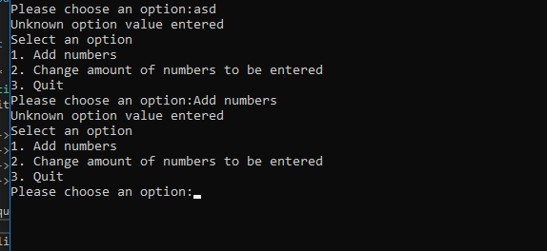

#1 | Text instead of number
Description |  | The user will try to enter text for their option rather than a number.
 |  | Test Steps:
1 | Begin the program
2 | Enter text as your option
3 | Check program response

Response |  | When text is entered the program should not allow the user to proceed through the program and ask them to enter and option value again.
Status |  |  | Date |  |  | Description
Pass |  |  | 20/3/18 12:13 |  |  | An error message occurs stating “Unknown option value entered” This prevent the user from continuing and asks the user the enter their choice again as in the above screenshot.

User quitting the program.
#1 | Test Name
Description |  | When the user is asked if they would like to quit, the only way they can say yes is by entering YES.
 |  | Test Steps :
1 | Start the program.
2 | Select the quit option
3 | Enter a Value other than YES

Response |  | When a variation of Yes is entered the program should quit.
Status |  |  | Date |  |  | Description
Fail |  |  | 20/3/18 14:02 |  |  | The program restarts and asks the user to enter an option again.
Pass |  |  | 20/3/18 15:00 |  |  | The program now accepts all variations of the word yes to allow itself to quit.
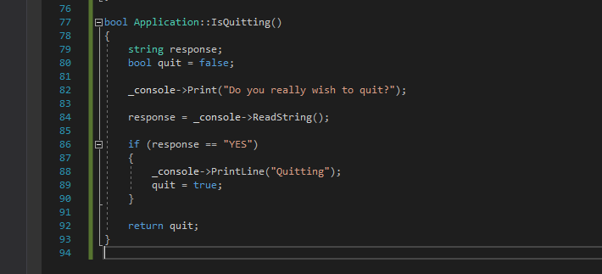
The problem for this code lies here, a coding program takes everything as a literal so where the response says “YES” treats it as the only value it will quit too.
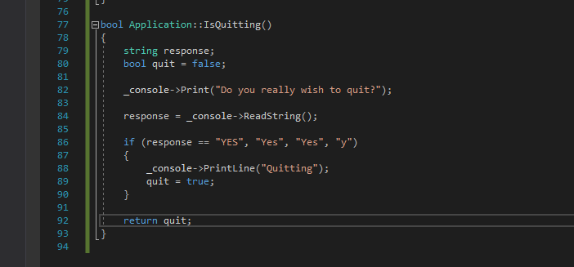
The fix is simple, the other variation need to be added so that the program can response to each one.
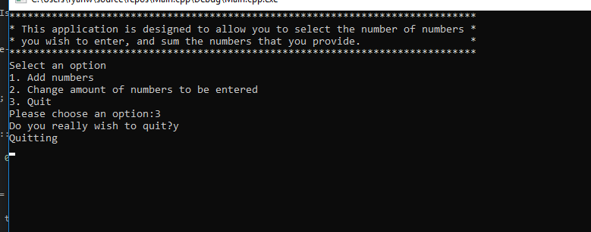

Text wrapping around total.
#1 | Correcting text wrapping
Description |  | When the value for the total is displayed, if it is more than one digit then the text wrapping will break and go on to a new line or over the edge parameters.
 |  | Test Steps:
1 | Open the program
2 | Enter number on option 1
3 | Display the total

Response |  | The wrapping should display correctly around the screen.
Status |  |  | Date |  |  | Description
Fail |  |  | 22/03/18 |  |  | The text wrapping around the code over hangs to the right side of the screen.

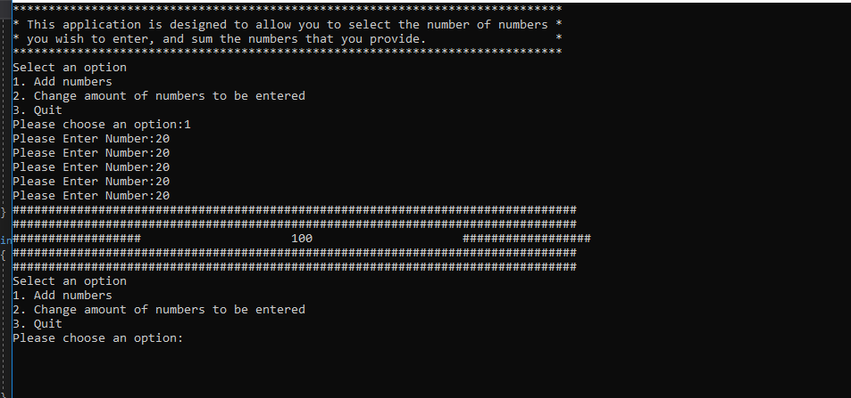
After numerous attempts on this problem the solution unable to be found, it is potentially down too the spacing of the hashtags and the result number.

