5CO02 - Evidence-Based Practice

Evidence-Based Practice - What is it? (AC 1.1)

The principle of evidence-based practice is to eliminate decision-making based on hunches, personal experience, or gut feelings. This can be done by using quality evidence and data, alongside sound critical thinking, to fuel the highest quality decision-making for an organisation. By using both qualitative and quantitative data we can make well informed decisions that power effective decision making. This data can take the form of feedback, employee surveys and one-to-one’s, which in turn provide us with the best available evidence, from multiple sources, to assist in the process of effective decision-making and change. Furthermore, this means we are able to ‘identify, find and evaluate additional evidence’ (Barends, Rousseau and Briner, 2014, p. 60) which is relevant to the decision-making process.

There are four sources of data we can use to our advantage:

Scientific, what is already researched and published.
Organisational, a combination of HR and customer data.
Experiential, the knowledge of our people.
Stakeholder, the affected or interested groups.

To achieve this, we can apply the concept of ‘6 A’s’ (Barends, Rousseau and Briner, 2014)

Asking, getting to the root source of the issue and transforming it into an answerable question.
Acquiring, collecting the data.
Appraising, using a critical mindset to assess the relevance and reliability of the information.
Aggregating, collating the data and forming a case.
Applying, using this data/evidence to support the decision-making process.
Assessing, appraise the outcome of the decision.

This process is vital to an effective HR strategy in that decisions are not just based on a ‘gut feeling or wishful thinking’ (Armstrong and Taylor, 2020, p. 110). This could lead to ill-informed decisions, negative outcomes and a lack of understanding of the issue at its core.
As people professionals, we also must be extremely careful not to ‘cherry-pick’ evidence that supports only one perspective of an issue. Naturally, we are prone to biases which can lead us to overvalue the opinion of one person or organisation who is seen as the expert on the issue (Authority bias), go with the most popular opinion in the room (Conformity bias) or confirm existing beliefs without taking into account new information (Confirmation bias) (CIPD, 2024c).

Therefore, by collecting and analysing the quality information, we can use it, alongside critical thinking, to make sound decisions which will address the matter and, in most cases, increase the chances of a more favourable outcome.

Analysis Methods (AC 1.2)

There are a number of tools and methods we can use to analyse our data once it has been collected. One such tool is a PESTLE analysis, sometimes also known as a STEEPLE analysis. This diagnostic tool examines the external factors of Political, Economic, Social, Technological, Legal and Environmental (within the STEEPLE model the extra E takes the form of Ethical factors). By considering these external factors, we can ‘observe and comprehend long-term trends’ which can aid us in facilitating change. (CIPD, 2024b).
This method of analysis is useful as we can look at the bigger picture, however, it does not consider the strengths/weaknesses of the organisation and only assesses the factors externally that affect change and the decision-making process.

Therefore, alongside PESTLE, a SWOT analysis can be really useful in building a much more comprehensive picture. SWOT, Strengths, Weaknesses, Opportunities and Threats, assesses both internal and external factors but combines these into 4 key areas so it is not as in-depth as PESTLE.
However, by using them in tandem we gain the ability to make much more sound and reasonable decisions. These are just 2 tools available but can be especially useful to people practitioners as they take into account the legal and ethical factors among others.

One method of investigation could take the form of an employee job analysis questionnaire to collect information. This would allow us to gather a spread of information across an organisation to help identify key areas of concern. Then by using this information and appraising it with the above models we are able to see if there are any factors that we could address which could lead us to positive change.

Thinking Critically (AC 1.3)

Critical thinking is a way of analysing and evaluating information that questions assumptions and examines evidence but also considers biases and alternative perspectives. By doing so we are able to make more sound and reasonable judgements before enacting change. By being both ‘reasonable and reflective’ (Fisher, 2011, p. 5), this may require us to be self-reflective of our own beliefs, values and biases so that we are objective in our decision making.

Thinking in this way is essential to people practice as it means we are able to put our biases aside and think about a problem more rationally, reasonably and logically. Challis (2021) states that sometimes people with influence hold the power and can sometimes ‘influence our reasoning’ without us even being aware. This in turn could lead to us taking information at face value and not looking at the problem objectively or checking the validity of the sources presented to us. One thing to consider is if we are fair and rational in comparing like for like. This means that our arguments, challenges and opinions are well reasoned and have perspective, rather than being based on personal opinions.

Within people practice we must always think in this way in every situation, especially the decision making process so we can differentiate between fact and opinion. This removes any bias from the process and ensures sound judgement. This may seem difficult to do from within a VUCA environment as these factors, Volatility, Uncertainty, Complexity and Ambiguity, may be ever changing (Kraaijenbrink, 2018). However, by always approaching with a critical mind, we can be assured that we are always being rational and feeding into bias or assumptions.

Decision Making for Effective Outcomes (AC 1.4)

When it comes to decision making, it is not a linear process and there are many processes that can be used to achieve effective outcomes. This can prove challenging as we are in a society that moves quickly, and conditions could be uncertain, or limited information could be provided to us from the outset (CMI, 2020). As people professionals, using our skills of critical thinking and an appreciation for what information we require and how best to use it will lead us to a goal of effective decision making. We also then need to choose the tool that best fits our needs.

Once such tool is ‘De Bono’s six thinking hats’ (deBono, 2021), which can be used in both group discussion and individual reflection. Each hat focuses on a different way of thinking about the matter at hand. Below is a summary of each hat.

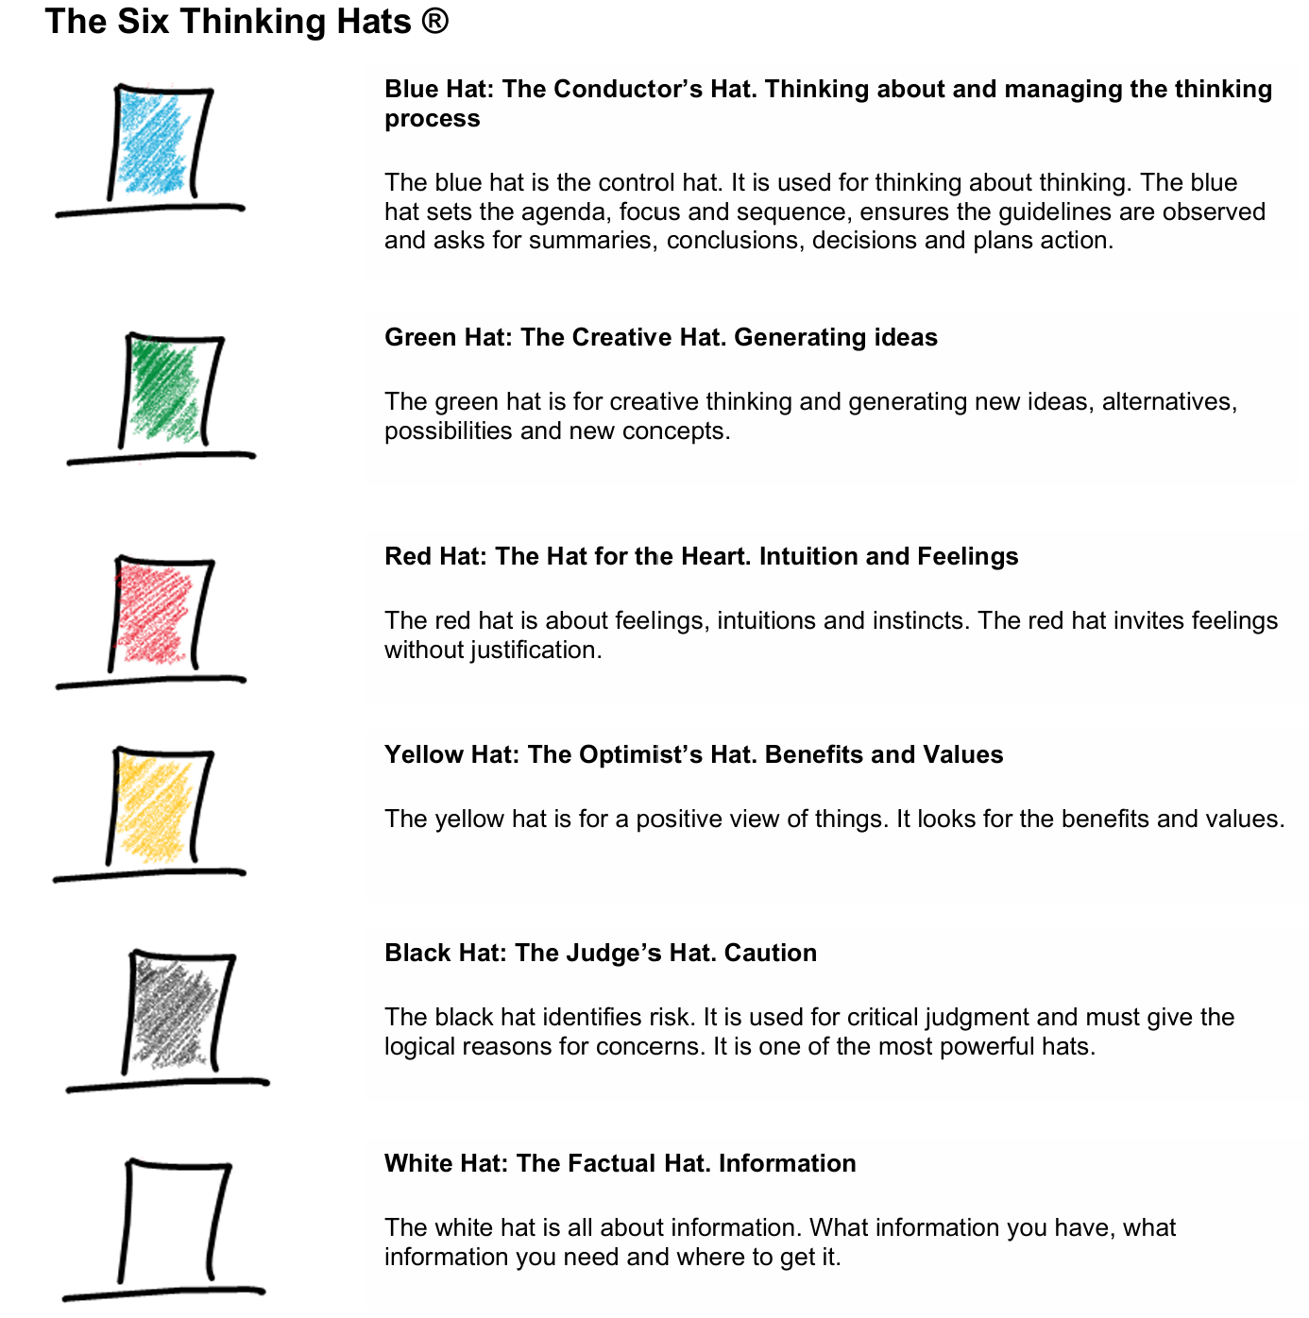

Figure 1: The Six Thinking Hats (deBono, 2021)

Developed by Edward De Bono in 1985, this process encourages both the individual and/or group to look at the matter from different perspectives. By doing so we can be objective whilst also looking at the issue through different lenses, or in this case, hats. At any point during the process, we are able to switch hats to approach from a different perspective which may then provide a different solution. By gathering these perspectives and different solutions we are then able to make more informed recommendations. We could surprise ourselves by seeing the problem through a different hat and therefore reach a decision that would not have been obvious to us previously. Alongside this, we may even reach a decision that combines the outcomes of several hats’ perspectives.

Another process we could use is that of Action Learning. This process involves small groups or ‘sets’ of colleagues meeting to assess the matter at hand and get to the core issue through reflection, making sense of one’s actions and how this could affect future events.
McGill and Brockbank (2004) explain how the group is then able to learn both with and from each other whilst taking forward an important issue with the support of the set.

The role of a facilitator is key as they keep the conversation driving towards the matter at hand rather than the personal feelings/judgments. Once the matter is discussed by the team member who has brought it forward the group is then invited to ask key questions, without judgement, that will help delve deeper into the issue and allow the team member to compose actions which they need to complete in order to reach their goal. This process can be very useful as it enables us to look at what our goals truly are and strip away anything that may not be necessary or indeed hinder us in achieving our desired outcome.

There are many other tools that we could use for our process but essentially, we need to follow the key points of:

- Identifying the issue
- Evaluating what is already known
- Obtaining good quality information
- Interpreting and forming a conclusion

By following these, we can assure ourselves we have approached the situation in an informed way and not jumped to a conclusion.

Ethics & Sound Morals in Decision Making (AC 1.5)

As people practitioners, we should always be thinking about the ethical implications of our decisions. Along with thinking critically, we always need to have a strong awareness for what is both ethically and morally responsible. The CIPD factsheet (2024d), discusses eight different lenses through which considerations should be made when making workplace decisions

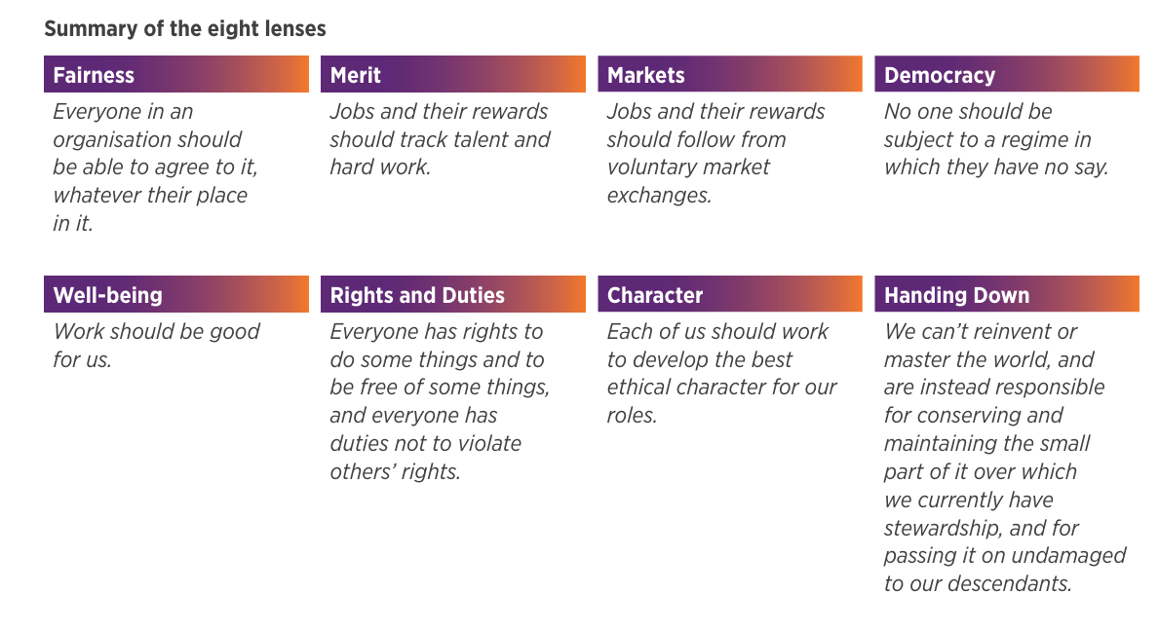
Figure 2: Eight ethical lenses (CIPD, 2024d)

As we can see, decision making is indeed a multi-faceted process, but these are just some of the perspectives that are used in ethical decision making.

There are many theories around this and one such is referred to as deontology. Rawling (2023) describes it as ‘an account of moral duty set out as a system of rules’. It is therefore the focus on our behaviours rather than the end product and that the ends do not justify the means. We should be acting and making decisions in a way that does no harm to another. This is a very important concept when making decisions as we are making sure that our actions through the whole process are coming from a place of good intention. If we have the rules or framework in place, it can make sure that decisions are made in this way and that when we reach our desired outcome, we have done so in a way that brings our (hopefully correct) behaviour to the forefront.

From a people management perspective, this can be useful in that during the decision-making process we take into account how our actions may affect everyone involved in the process. Yes, there will be consequential actions, but by being aware of it from the outset we take it into account to minimise the disruption to everyone involved.

Another theory is utilitarianism, which focuses less on the actions/behaviours but instead on a goal that benefits the happiness and wellbeing of the people involved. De Lazari-Radek and Singer (2017) delve into its ancestral origins stating that the key concept is that we should make the world the best place we can. They go on to say this concept is seen back as far 490bc in Chinese philosophy and can also be compared with teachings of the Buddha. So, what does it mean for us as people practitioners?

This approach means that when making a decision, the goal is to maximise the benefit to the greatest number of people at once. When we are making informed decisions, this theory pushes us to think about whether it achieves the best overall outcome for the majority of people involved. However, this theory is not without its flaws, as if the decision is beneficial to the majority of people involved then there will, in turn, be a minority that it will not benefit. Risk management is key here as a people practitioner as we may struggle to make decisions that benefit all, especially in larger organisations.

Measuring Performance (AC 3.1)

Critical to an organisation’s success is measuring its performance. There are several ways in which we can do this, and they can be broken down into categories including: financial, non-financial, public and private.

When looking at our KPI (Key Performance Indicators), we may not have a head for numbers or financial inclinations, however, having a basic understanding of them can help to improve our decision-making processes and add help in providing additional value to the organisation (Stobierski, 2020). KPI figures usually remain within the organisation as they are a metric used to measure internal performance. Managers and people practitioners can use this data to measure non-financial performance by investigating if employees are meeting the targets set out for them either individually or as a team. This can be useful as it gives a goal for the organisation, and its teams, to work towards. It can also be useful to highlight areas that may be underperforming which can provide the basis for any intervention work.

However, it could also be demotivating as the targets could be unachievable or put time-based pressure on employees if the deadline is fast approaching. This could in turn have a negative impact on mental health within the organisation and see a spike in absence. Having a culture where reflection on why targets were not met and not a blame culture would be essential in this instance.

One of the many financial ways in which we can measure success is by looking at our figures relating to gross and net profit. These figures relate directly to the cash flow of the organisation in terms of revenue, expenditure and other incomes while subtracting all costs for goods and any other operating expenses (Stobierski, 2020). Usually available publicly in annual or quarterly reports, while this is a good measure of business success on paper it does not show us how our people are performing only their effect on the figures. However, by measuring areas which are more profitable, or not, we can assess their processes and management to see if it is working effectively and use this to initiate change if it is needed.

Adding Organisational Value (AC 3.2)

As people practitioners (and HR as a whole), the value that we add to an organisation isn’t always financial. However, the tangible benefits we add are not something to be discounted, we add value by investing in people. This investment can take different forms, for example it may be in the training and development of our people. By having a culture of learning, it empowers our teams to take an active interest in their development, both professionally and personally. This support of continuous improvement activity can engage our people to expand their knowledge and help keep them motivated, drive growth and contribute to team and organizational success (Forbes, 2022)

This will help to support a lower turnover rate which does equate to a financial saving. By lowering turnover, in some cases, this means spending less on recruitment and in some cases, spending high fees on agency workers to fill the gaps. In the longer turn, it also encourages our people to continue their pursuit of knowledge and training which influences succession planning. When it comes to hiring to replace an experienced role, by having a skilled workforce waiting in the wings we are not losing valuable time or assets in the period of change (CIPD, 2023). Thus, the return on investment (ROI, the identification of gains and losses in relation to cost), for training and development is huge.

So how do we measure this? There are a number of ways that we can measure our success (and our areas of opportunity). One such way is to analyse the cost-benefit of training schemes. Some training can present financial challenges when looking solely at numbers on a page. However, when weighing this with the ROI of having an up-skilled workforce who are ‘more motivated, efficient and pride themselves on self-initiative and growth’ the rewards are great (Forbes, 2022). Having a workforce that feels invested in can ensure that productivity and output can sometimes outweigh the cost of the training in the initial stages.

Another way in which we can measure our impact is by conducting an employee satisfaction survey. By asking a range of questions we can gather a broad picture of the organisation in terms of its feelings on key subjects such as: well-being, training and development, work-life balance and job satisfaction to name a few. By gathering this information, we then have the data to begin the process of identifying whether our objectives are being met. It also forms the basis for our organisational data which is key for us to begin our evidence-based practice.

Briefing part 2

Analysis of data – AC2.1 & AC2.2
Q1
Department | Outstanding | Meets KPI | Not Quite There Yet | Underperforming
Administration Department | 20% | 20% | 30% | 30%
Logistics Department | 20% | 40% | 30% | 10%
Research and Development | 30% | 30% | 10% | 30%
Sales Department | 0% | 100% | 0% | 0%
Grand Total | 17% | 49% | 19% | 15%
In the process of formatting the data, some adjustments have been made to achieve an accurate representation of each department’s performance for both quarters. This has meant the omission of any absent members of staff, for either quarter, so we can get a clear representation of each team’s performance situationally. Also please note that Sally Starling (Administration) was omitted as they were absent in Q1 and there was no data recorded in Q2.

Q2
Department | Outstanding | Meets KPI | Not Quite There Yet | Underperforming
Administration Department | 10% | 40% | 40% | 10%
Logistics Department | 28% | 50% | 22% | 0%
Research and Development | 56% | 33% | 11% | 0%
Sales Department | 0% | 100% | 0% | 0%
Grand Total | 22% | 58% | 18% | 2%

This gives us an understanding, by department, of how they are performing. It also gives us an accurate look at the range of performance across the organisation. For instance, we can see that over half of the organisation is performing at a level of ‘Meets KPI’ or above for both quarters. While the numbers for ‘Not quite there yet’ and ‘Underperforming’ vary by department it is worth noting that these only make up 34% (Q1) and 20% (Q2) of the entire organisation. We will look deeper into each department analysis shortly.

Using the data, we are also able to extrapolate the company average performance level and measure this against each department. This can be seen in the following graphs.

Immediately, we can see that the sales department are consistently above the company average. This we were also able to see from the raw data as every employee from sales came under the ‘Meets KPI’ for both quarters. However, there is no range in their performance and their level of consistency will be looked at in my recommendations later.

Also worth noting from the analysis of this data is the combination of both ‘Not Quite’ and ‘Underperforming’ data. For this, Q1 and Q2 were combined to provide a percentage of each department’s performance on where they are falling short of target.

This means, although Administration had figures that proved members of the team were performing well, in some cases ‘Outstanding’ for both quarters, 55% of the department are underperforming across both quarters. This is also evident in Logistics for Q1 but by the end of Q2 they have significantly reduced this figure as a division, a trend that is also evident within Research and Development.

When looking at both quarters combined, it is evident that Administration has a wider range of performance across the four indicators as opposed to the other departments having much higher figures of positive performance.

Bonus payments were applicable to those staff who achieved an outstanding. 4% of salary for each quarter was applied and, in the case of 6 employees, this meant an 8% bonus payment. Financially the breakdown of bonus payments is as follows:
Department | Name | Salary | Bonus Payment
Administration Department | Robin Bird | £31,500.00 | £1,260.00
Administration Department | Saffron Finch | £24,000.00 | £1,920.00
Logistics Department | Ruth Sixsmith | £23,750.00 | £950.00
Logistics Department | Wendy Boot | £23,750.00 | £950.00
Logistics Department | Sally Rigbye | £23,750.00 | £950.00
Logistics Department | Jean Livesey | £26,000.00 | £1,040.00
Logistics Department | Julie Chisnall | £19,500.00 | £1,560.00
Logistics Department | Rick Lovall | £19,500.00 | £780.00
Logistics Department | Gill Jamieson | £19,500.00 | £1,560.00
Research and Development | Ethan Brar | £32,500.00 | £2,600.0
Research and Development | Harrison Briggs | £32,500.00 | £1,300.00
Research and Development | Steve Owens | £29,500.00 | £1,180.00
Research and Development | Tasha Graham | £29,500.00 | £2,360.00
Research and Development | Jennifer Frost | £29,500.00 | £2,360.00
Total Bonus Payments |  |  | £20,770.00

note that the staff highlighted in gold achieved ‘Outstanding’ in both quarters and were awarded an 8% bonus payment (4% for each quarter)

Recommendations – AC2.3
As previously mentioned, there are some fantastic numbers across the organisation with over half performing at ‘Meets KPI’ or above. However, the breakdown of some divisions has shone a light on areas of opportunity. One area especially is the Administration department as their split for both quarters was almost half. When taking into consideration the feedback from the employee survey, when asked if the question ‘My line manager provides clear and direct guidance’ the result was split with 113 answering in the positive and 122 in the negative. Similarly, when surveying 50 managers, the result for the question ‘I have no issue in challenging underperforming employees’ 41 in the negative.

From a Learning & Development perspective I believe there is room to look at the leadership styles within Administration to see if clear direction is being given and/or challenge is issued to underperforming employees. Using objective setting could be a useful tool for this, for instance the SMART model (Specific, Measurable, Achievable, Relevant & Time-bound) could prove useful. However, for more complex and analytical processes it might be better to focus on the development outcomes (CIPD, 2024a). This recommendation is a low cost, but effective, method as the internal L&D department could lead on the training and facilitation of this.

Another option would be to have in-house coaching and mentoring for Administration, as the Logistics department had similar percentages for Q1 but had significantly reduced this by Q2. By sharing what Logistics have done to enact change, they could inspire other departments, especially Administration, to adapt their processes which could lead to a positive impact on the figures going forward.

Looking at behaviours and teamwork is also a recommendation as the cohesiveness of the team may improve the performance output. Once such method, ‘The Five Behaviours’, takes Patrick Lencioni’s analysis of team dysfunctions and turns it into a positive to allow teams to work more cohesively while moving toward the ‘ultimate goal of achieving results’ (Wiley, 2024) This programme is less cost effective as it comes with a fee to provide the in-depth report and analysis. However, the in-depth analysis would shine a light on the key areas for improvement, address any problems at their root cause and provide a foundation for better working going forward.

The Sales department are at a consistent level of ‘Meets KPI’ for every employee and for both quarters. Observation is needed here as to why they are not overperforming. Is leadership motivating the team to achieve above and beyond or is it simply that the targets are so high that they are unachievable in any given quarter. Addressing these factors could make the department more energised and focused on pushing above and beyond their normal capacity, which would in turn drive sales and increase profits.

The premise that performance management is everyone’s responsibility (CIPD, 2024a) leads us to fostering a culture of growth, opportunity and progression. By supporting our staff to take accountability whilst also empowering our managers to lead effectively, we can invest in a future of high KPI results.

Overall, whether choosing the priced option or the in-house training, the indirect ROI is that of better motivated teams, higher performance output and a culture of growth. This inevitably leads to better performance statistics and potentially a higher percentage of bonus payments across the organisation.

