
BA (Hons) Computer Games Design

User Experience Design:
User Experience (UX) Design Analysis ACCA6034

Mia Harries
Student Number: 2304406

December 22nd, 2025

Contents

Summary & Selected Product 2
Initial Product Review 3
UX Design Principles 5
UX Product Analysis 7
Recommendations for Improvement 11
Conclusion 12
Bibliography 13

Summary & Selected Product

During this assignment, the task will be to critically analyse the digital product with the use of user experience design principles and provide meaningful feedback on improvement that can be made and justify the reasoning behind the use of appropriate user experience methodologies.
The digital product chosen is the Amazon Kindle [1], a reading website that’s used as a library to hold all of the users’ purchased books, making reading available at any time from the web. There will be a brief discussion of the Amazon Kindle [1] display on the Kindle E-Reader [2]. The reasoning behind choosing this as the product to analyse, is because this product is widely used especially amongst students, making this analysis valuable from an active user’s perspective as well as a formal reflection.

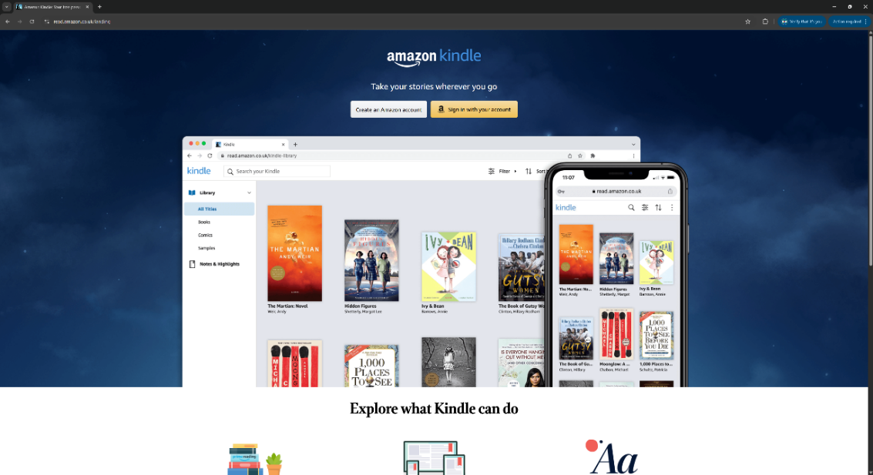[1] Kindle Login Page
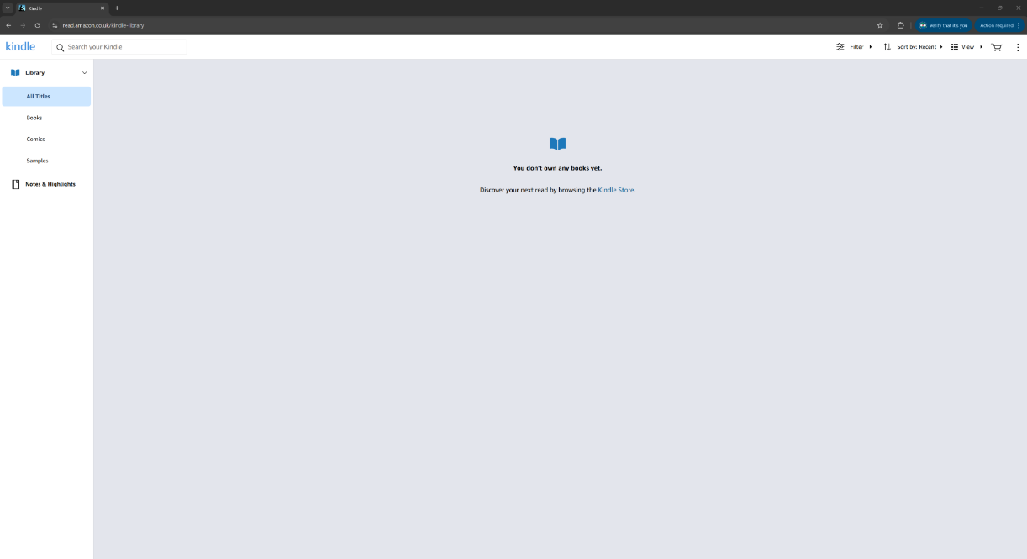[1] Kindle library. New user’s view

Initial Product Review

Upon opening the website, the user is greeted with a sign-in page, as access requires either creating an account or using an existing Amazon account. Once logged in, the user can clearly see their library of owned and borrowed books. On the left-hand side are categories such as books, comics, samples, and notes, providing easy organisation for users who read different types of literature. The top right corner contains filters and sorting options, along with different viewing modes. A store icon sits beside the three-dot “options” symbol [3], which is easily recognised. The search bar appears at the top of the screen, and the colour palette consists of white, black text, and subtle blue accents, creating a calm and readable design [4].
Navigation is simple, with few buttons and all books displayed on the main page, accessible by scrolling. However, users may struggle to find settings, as none are available directly on the website. Instead, users must access the Amazon Kindle Store [5] to edit settings, which may cause frustration. Filters are easy to locate but limited, as they do not allow organisation by genre. Despite this, the simple design benefits all users, particularly those unfamiliar with navigating web pages [6].
The main reasons a user may open this website are to read on a larger screen, view notes in one place, or buy a new book. Due to its uncomplicated design and ease of navigation, the user experience creates a positive emotional response. The website functions as intended and is easy to understand, with only eight buttons on the main page. It is easy to return to after a long period of time, and the clear, direct layout makes everything easy to find. Icons effectively communicate function without the need for text [7].
To summarise, for a new user the website is functional, reliable, usable, convenient, and even pleasurable. Its purpose is to allow users to read purchased books across devices, and although it has few functions, it performs each effectively by keeping the design as simple as possible.

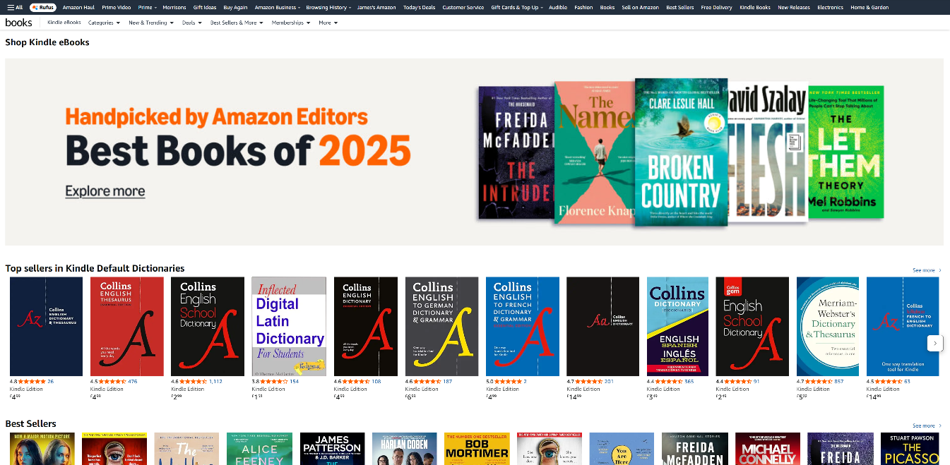[5] Kindle online book store
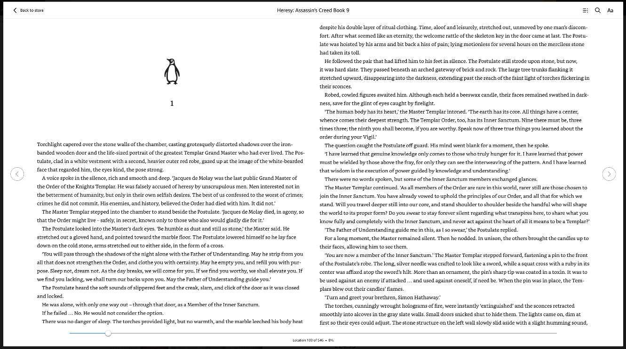[6] View of the UI when users open a book.

UX Design Principles

To correctly evaluate user needs it’ll be important to assess the user experience design principles that create positive user experiences. The five main UX design principles will be analysed and another beneficial way to figure it out is by using the UX Pyramid, it’s a conceptual framework that outlines the diverse levels of user needs.
These core principles are essential in creating a positive user experience by ensuring all aspect of user needs can be analysed and considered for the best response.
The first consideration is the psychology and comfort of users, focusing on how they think and feel and what motivates them to use a website. Psychology is vital in UX design as it supports user-centred decisions and considers emotional responses. Designers must assess whether users feel rewarded, confused, or distracted, and how overcomplication or excessive colour may affect their experience. Ultimately, successful UX design ensures users feel positive and comfortable when interacting with the product and the focus being on their psychology rather than the creator’s idea of what the user psychology is [8].
Another important aspect is usability. The product must be clear and direct, with all necessary features easy to find and intuitively placed. Navigation should feel natural, especially for inexperienced users, with minimal errors or confusion [9].
Design should prioritise usability over appearance. A website’s visual appeal is ineffective if it does not function well. The design should communicate its purpose clearly, feel trustworthy and legitimate, by limiting pop-ups, and remain easy to read and understand for first-time users. It’s said that colour and shape theory should only be used if they enhance navigation and usability of the website and not be used without reason [10].
Consistency is vital to meeting user needs and shaping positive experiences. A consistent design builds familiarity, reliability, and user trust, while inconsistency can frustrate users and discourage future use, resulting in loss of users for the product [11].
Accessibility is another key UX principle and cannot be overlooked. Designers must accommodate a wide range of users, not just the target audience, regardless of experience or ability. Features such as alt text, subtitles, and multi-platform availability ensure content remains accessible and inclusive for all users [12].
Copywriting also plays an essential role in creating a positive user experience. Text should be accurate, clear, and direct, guiding users confidently without assuming prior knowledge. Effective copyright reduces confusion and anxiety while informing users appropriately by making texts and usable buttons stand out against the website. [13].
The UX pyramid further helps explain user needs by dividing them into objective and subjective qualities. The lower tiers focus on functionality, reliability, and usability, while the upper tiers address user experiences such as convenience, pleasure, and meaning, which can vary between individuals [14].
Finally, user needs can extend beyond personal use into social interaction. Many users value customisable preferences, profiles, and the ability to collaborate or recommend content to others, depending on the nature of the product [15].
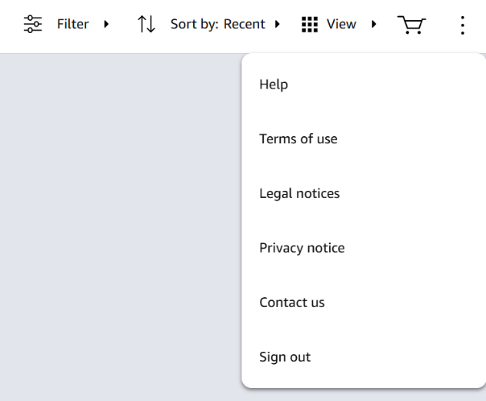[1] Kindle dropdown menu
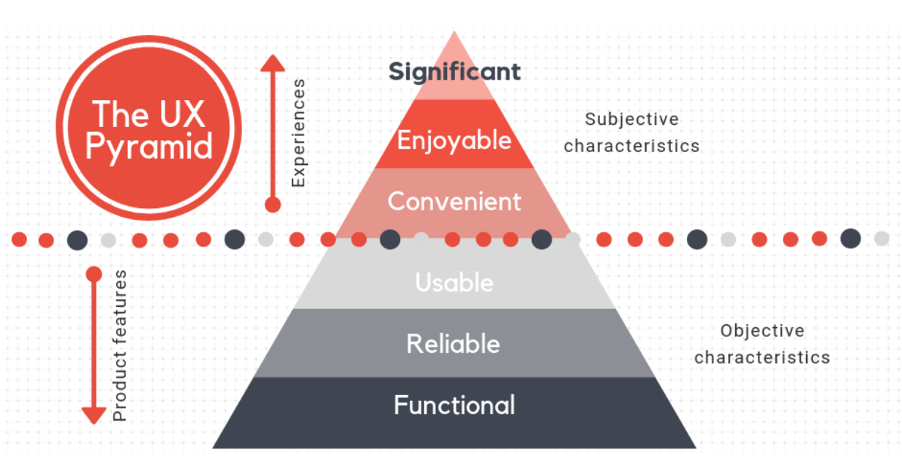
[22] UX Pyramid

UX Product Analysis

When it comes to the Amazon Kindle website [1], there are many positives to its UX design, as it follows several key design principles, though there are still areas for improvement. From using the website, it’s clear the navigation is direct and intuitive. The design is extremely limited, creating a user-friendly experience that allows users to move from point A to point B with minimal clicks. If a user is looking for a particular book, the search bar is clearly positioned at the top of the homepage and is easily accessible.
However, this simplicity can also be a drawback. To keep the interface minimal, settings cannot be accessed directly from the page. Instead, users must navigate through options and help, which redirects them to the main Amazon website. This may confuse some users, as settings would typically be expected to be accessible within the Kindle interface itself.
Overall, the visual and functional design is minimalist and effective. The main page displays the user’s library clearly, allowing books to be opened with a single click. The visual appearance supports this simplicity, using a limited colour palette of shades of grey and a subtle blue. This keeps the interface uncluttered and draws attention to the colourful book covers. As the website’s primary purpose is to open and read books, it functions well without unnecessary visual complexity.
The consistency and reliability shown in the Amazon Kindle website [1] is clear from the moment the user logs in. The overall aesthetic and behaviour of each feature is consistent, giving a sense of wholeness and confidence in its function. This consistency works alongside reliability, as features behave as expected and build user trust. However, some inconsistency appears with the options button, which opens a dropdown linking to external pages. This differs from the rest of the homepage and may concern new users who are cautious about being redirected to new URLs.
User interaction is simple and clearly designed with inexperienced users in mind. There are very few buttons on the homepage, each clearly labelled or supported by alt text. When opening a book, interaction remains intuitive: users can swipe pages, use a scroll wheel to jump ahead, adjust text settings, and search for key phrases. The design strongly reflects user-centred psychology, focusing on user needs such as adjustable text size, font, and colour. Overall, the experience delivers its purpose efficiently without feeling taxing or overcomplicated for such a simple action as turning a page.
As previously mentioned, accessibility is important to ensure that all users can easily access and navigate the website. This website achieves that, though it is not immediately obvious when first opened. Once a book is opened, options in the top left corner allow users to adjust the layout, including colour-blind friendly page colours, dyslexic font styles, and larger text sizes to support users with disabilities. In terms of usability, the website is very direct in its layout. Due to the minimal style referenced previously, it clearly directs users to what they need. Buttons are clearly labelled, meaning there is no guessing, it simply does what it states.
However, not all user needs are easy to find. If a user is looking for general settings or a dark mode for the home screen, these options are unavailable. The only settings redirect users away from the website, and dark mode exists only within books themselves [16].
Overall, the content presentation and quality are high and appear professional, as expected from a company like Amazon [2]. The minimalist design supports a streamlined user experience, and the copywriting is clear and instructional. However, this simplification can also be a weak point. From a user’s perspective, the absence of a dedicated settings tab, which is normally found on a physical Kindle, feels like a missed opportunity caused by oversimplifying the interface. Theres no reason why the website cannot have this also.
The kindle website is available on many different devices including on PC, Phone and on the Kindle device itself. All platforms allow for users to adjust text sizes, making it accessible to a variety of users not just those that own the kindle product. This is greatly beneficial and is appreciated by many users for its versatility.
After testing the website on a variety of platforms it’s clear to say that the performance of the website itself is good, it is fast and responds to users input like typing a book name or clicking for options very quickly. On the other hand, the kindle library website on the kindle itself is slow especially for older versions, though that could be the device rather than the website itself.
Convenience and pleasure are both objective and dependant on how the user uses the app and how frequently. It’s convenient in the way its accessible across multiple platforms though this doesn’t guarantee an enjoyable experience. If the users’ goal is to read a book, and if they enjoy that book, then yes, the amazon kindle website has successfully made a pleasurable app despite navigating the app itself not being pleasurable, and more of an appreciated function.
The same logic can be applied to meaningfulness and will depend on what users consider a meaningful website. The website simply functions as somewhere users can come to open books they’d like to read. The users may connect to it due to its functionality, and any religious users can download religious texts which make it align with their values and beliefs. Kindle does well in catering to user preferences, and showing them texts like what they read, adding to their emotional engagement.

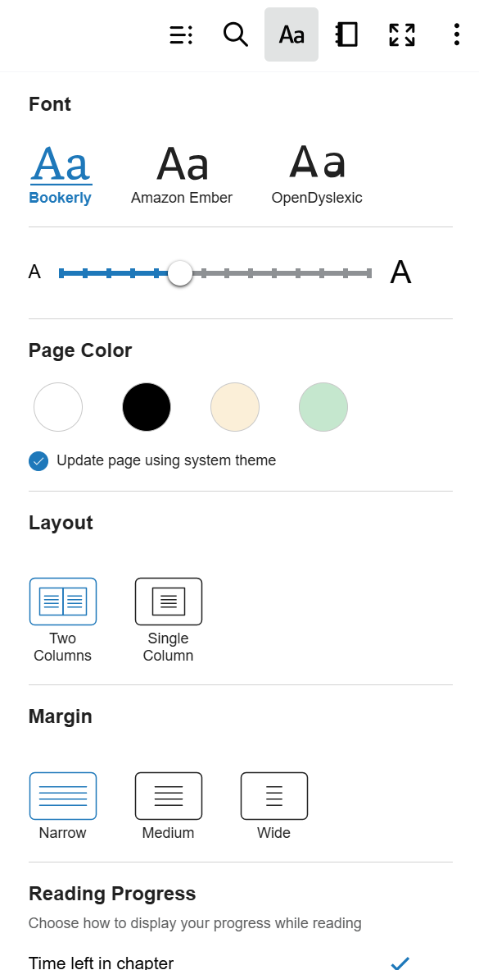[12] Formatting options available in a kindle book.

Recommendations for Improvement

Considering this website comes from an extremely large business, it is safe to say that its user experience design is well informed and succeeds in making navigation useful and enjoyable for most users [17].
One major issue noted while using the website is the lack of editing and settings options on the main page. Users must exit to Amazon to access their settings. Adding a settings area to the main menu would improve accessibility and reduce confusion, particularly for less tech-savvy users. This simple addition could also reinforce the website’s reliable image by removing the need to leave the site to make basic adjustments [18].
A primary feature that the Amazon Kindle website [1] could add to improve UX design and interaction is a customisable library. Currently, organisation is limited to text type such as books, comics, and samples, which feels restrictive for users with large collections. Allowing users to personalise their library would make the experience more engaging and meaningful. Features such as adjustable colour palettes, genre organisation, folders, display sizes, and hide options could enhance usability while maintaining visual appeal. Testing these features with users through usability testing would be essential to ensure positive outcomes [19].
Another feature that could improve user convenience and enjoyment is the ability to add friends. The website currently lacks social interaction, which feels like a missed opportunity for a platform centred on reading and recommendations. Allowing users to connect, recommend books, and discuss current reads within the site would improve convenience by keeping everything in one place. While optional, this feature would be particularly valuable for regular readers and book clubs [19].

Conclusion

To conclude the kindle website both online and on the physical kindle device all hit the fundamentals of successful user experience design. It includes features of functionality, usability, reliability and pleasurable, not to mention its consistency and ease of navigation. Though it succeeds in many places, making it easy to use for all users, it believed to be lacking in smaller aspects such as customisability and general organisation. Though these features are not included in the bare minimum, they would increase the kindle website’s meaningfulness and shareability to a wide range of users. It is successful in its job of being a library of books, its primary improvements would come from a cosmetic perspective, due to its minimalism making the website clear and direct from the start. Focusing on the primary user experience design principles will create a design even more user friendly than it already is. [21]

Bibliography

[1] Amazon, “Kindle Cloud Reader Library”. Amazon. (2010) [Online]. Available: https://read.amazon.co.uk/kindle-library (Accessed: 05 January 2026).
[2] Amazon, “Kindle eReaders – Amazon”. Amazon. (2007). [Online]. Available: https://www.amazon.co.uk/Kindle-Ereaders/b?ie=UTF8&node=5157836031 (Accessed: 05 January 2026).
[3] J. Saito, “The Mighty Ellipsis: How 3 Little Dots Can Say So Much”. Medium. (2016). [Article]. Available: https://medium.com/@jsaito/the-mighty-ellipsis-6c2c00ddc864 (Accessed: 08 January 2026).
[4] M.Richter, “Motivation and Emotion”. Springer. (2024). [Article]. Available: https://link.springer.com/journal/11031 (Accessed: 05 January 2026).
[5] Amazon, “Kindle Store – Amazon”. Amazon. (2007). [Online]. Available: https://www.amazon.co.uk/kindle-dbs/storefront?storeType=browse&node=341689031&ie=UTF8 (Accessed: 05 January 2026).
[6] Z. Bakar, S. Zain and N. Noor, “A Study of Minimalist Principles for Designing Entrepreneurs’ Website,” ACM Digital Library. (2017). [Book]. Available: https://dl.acm.org/doi/epdf/10.1145/3077584.3077609 (Accessed: 05 January 2026).
[7] H. Petrie, “Interacting with Computers”. ScienceDirect. (2013). [Journal]. Available: https://www.sciencedirect.com/journal/interacting-with-computers (Accessed: 05 January 2026).
[8] P. Turner, “A Psychology of User Experience: Involvement, Affect and Aesthetics.” Springer Nature. (2017). [Book]. Available: https://link.springer.com/book/10.1007/978-3-319-70653-5 (Accessed: 05 January 2026).
[9] G. Salvendy, W. Karwowski, “Handbook of Human Factors and Ergonomics”, 5th ed. Hoboken, NJ, USA: John Wiley & Sons, (2021). [Book]. Available: https://onlinelibrary.wiley.com/doi/book/10.1002/9781119636113 (Accessed: 05 January 2026).
[10] J. Fleming, R. Koman, “Web Navigation: Designing the User Experience”. Sebastopol, CA, USA: O’Reilly Media, (1998). [Book]. Available: http://jepelet.free.fr/studies/MBA/design/s4/lectures/Web%20Navigation%20Designing%20the%20User%20Experience.pdf (Accessed: 05 January 2026).
[11] M. Zuschlag, “Achieving and Balancing Consistency in User Interface Design,” UXmatters. (2010). [Article]. Available: https://www.uxmatters.com/mt/archives/2010/07/achieving-and-balancing-consistency-in-user-interface-design.php (Accessed: 06 January 2026).
[12] D.Brumby, “International Journal of Human-Computer Studies”. ScienceDirect. (2025). [Journal]. Available: https://www.sciencedirect.com/journal/international-journal-of-human-computer-studies (Accessed: 06 January 2026)
[13] C. Armstrong, “What Is UX Copywriting?”, Copyhackers, (2019). [Online]. Available: https://copyhackers.com/2019/11/ux-copywriting/ (Accessed: 06 January 2026).
[14] W.Sakai, “UX Pyramid: How To Evaluate the Design”, Medium, (2023). [Online]. Available: https://medium.com/@design.wkn/ux-pyramid-how-to-evaluate-the-design-aa2304df7fb6 (Accessed: 06 January 2026)
[15] M. Zuschlag, “Navigating Loneliness Through a Shared Love of Literature,” Taylor & Francis Online, (2024). [Article]. Available: https://www.tandfonline.com/doi/full/10.1080/01612840.2024.2374896(Accessed: 06 January 2026).
[16] Amazon, “Kindle Library”. Kindle for Web. (2010). [Online]. Available: https://read.amazon.co.uk/kindle-library (Accessed: 06 January 2026).
[17] C. Ellis, “Kindle for PC review and where to download,” TechRadar, (2017). [Online]. Available: https://www.techradar.com/reviews/kindle-for-pc (Accessed: 06 January 2026).
[18] P. Murano, K. Oenga, “The Impact on Effectiveness and User Satisfaction of Menu Positioning on Web Pages,” International Journal of Advanced Computer Science and Applications, (2012). [Journal]. Available: https://pietromurano.org/Papers/IJACSA-Murano-Oenga-Journal-Final.pdf (Accessed: 06 January 2026).
[19] T. Ahram, “Procedia Manufacturing”, ScienceDirect. (2015). [Online]. Available: https://www.sciencedirect.com/journal/procedia-manufacturing/vol/3/suppl/C (Accessed: 06 January 2026).
[20] A. Kong, E. Fitch, “Using Book Club to Engage Culturally and Linguistically Diverse Learners in Reading, Writing, and Talking about Books,” JSTOR. (2003). [Book]. Available: https://www.jstor.org/stable/20205209 (Accessed: 06 January 2026).
[21] N. Hamidli, “Introduction to UI/UX Design: Key Concepts and Principles”, Academia, (2023). [Online]. Available: https://www.academia.edu/98036432/Introduction_to_UI_UX_Design_Key_Concepts_and_Principles (Accessed: 06 January 2026).
[22] T. Burda, “The UX design pyramid with the user needs,” Syndicode Blog, (2019). [Online]. Available: https://syndicode.com/blog/the-ux-design-pyramid-with-the-user-needs/ (Accessed: 06 January 2026)

