
Nines global buffet
Organisational Consultancy


8 May 2019

Student name: sirui zhao
STUDENT NUMBER: 1801886
MODULE NAME: ORGANISATIONAL CONSULTANCY
Contents
Executive summary 2
1.0 Introduction 3
1.1 Aims 3
1.2 Objectives 3
1.3 Research Methodology 3
2.0 The analysis of Nines Global Buffet 4
2.1 SWOT analysis 4
2.2 PESTEL analysis 5
3.0 The reason why there is low customer satisfaction 7
3.1 Customer satisfaction 7
3.1.1 Customer satisfaction survey 7
3.1.2 Dishes Issues 7
3.1.3 Customer services issues 8
3.1.4 Environment issues 8
4.0 Conclusions 9
5.0 Recommendations 9
6.0 References 11
7.0 Appendix 12

Executive summary
The aim of report is to figure out the reason why there is reduction in the customer quantity of Nines Global Buffet. The objectives are to find out the customer satisfaction, the quantity of dishes and the customer services and environment of Buffet. This report includes primary research and secondary research. Primary research is to send the electric questionnaires to the customer who have the experience in the Nines Global Buffet. All the secondary research is from the academic websites, official websites, academic journals and books. The SWOT and PESTEL model are used to analysis the internal and external facto which make the influence on the development of Nines Global Buffet. In terms of macro environment, there are a lot of opportunities for Nines Global Buffet to attract more and more potential customers. The buffet industry has a good future. It is a good sign for the Nines Global Buffet. In terms of internal factor, compared with other type of restaurant, buffet can provide a wide range of different flavour. It can satisfy different customers. It is a good place to have a party. The big party usually means the huge amount of customer, which also can bring a lot of profits for the buffet. More and more young people like to involve in the party. Therefore, there are many potential customers for the Nines Global Buffet. Besides, this project is researched through making customer satisfaction survey. The relevant information which is about the reason why the customer number reduced is gathered by the customer satisfaction survey. And then, find out the main reason. The main reason is from three aspects, which include dishes, customer services and environment. According to the reason, there are some recommendations for the Nines Global Buffet to help improve the customer satisfaction and then achieve the increase of customer number.

1.0 Introduction

1.1 Aims
This report discussion a Buffets which is located in the Swansea. It is Nines Global Buffets. This Buffets include various different flavour. It is one of the most popular restaurants in Swansea. However, the quantity of customer has decreased. Therefore, the aim of project is to find the reason why the customer numbers have decreased.

1.2 Objectives
In order to find the reason why the quantity of customers decrease, the main objectives are to find out the customer satisfaction, the quantity of dishes and the customer services and environment of Buffet.

1.3 Research Methodology
Research methods include primary research and secondary research. The primary research is electronic questionnaire. The electronic questionnaires will be sent to the Instagram, Facebook to gather the evaluation of Nines Global Buffet. The electronic questionnaire is in Appendix. The secondary researches include the relevant theories which are found in the academic books and academic websites and the relevant data which are found in websites.

2.0 The analysis of Nines Global Buffet

2.1 SWOT analysis
SWOT is an analytical tool, which can help to analysis the internal and external factors which make the influence for the firm (Pickton and Wright, 1998). SWOT analysis include strength, weakness, opportunity, and technology (Yu and Huimin, 2005).

Strength: Firstly, there are a wide rung of different flavour. In Nines Global Buffet, there are more than 100 dishes every day, such as fiery Spanish paella, fragrant Thai curry, Chinese flavour, Japanese flavour (NINES global buffet, 2019). The variety of different styles can attract more and more different potential customers, and it can satisfy customers’ different flavour needs and wants. Secondly, there is no the processing of ordering in Buffet. It can help to save the time of customers. When they reach the Buffet, they do not need to spend time to wait serve, they can pick what they want to eat up straightforward. Especially, Nines Global Buffet will be a great choice, if customers are quite starving. Thirdly, there are no price controls when choosing dishes. Customers only need to pay an entry fee, and then they can eat whatever they like without the control of prices.

Weakness: At first, there are health risks when customers pick the dishes up. The majority of dishes have no lids on the them on the dish platform, there is the possibility that something dirty fall into the dishes. More and more customers pay more attention to the healthy problems, so the dishes which are without lids is a big issue for the Nines Global Buffet. In addition, some customers have the bad behaviour when they pick dishes. Some customers will leave the communal utensils without order, which will change the taste of the dishes. What’s more, it’s easy to waste in a Buffet. Many consumers think that they can eat a lot, take a lot of food. And then they cannot eat up and put back, which will lead to a lot of food waste. This will not only increase the cost of the Nines Global Buffet, but also is not a good behaviour for environmental protection.

Opportunity: The change of people’s consumption demand is beneficial to the development of buffet areas. The change of people's consumption demand is beneficial to the development of buffet market. Change as life rhythm and of working pressure increase, traditional domestic kitchen is broken gradually. More and more people like to eat in restaurants. Many office workers who are burn a lot of energy at work. A lot of fast food and family vegetarian food can no longer meet their needs. So buffet is becoming more and more popular among these young people. The buffet industry has great potential for development (Ramanathan, 2016). In addition, differentiation of individual dietary needs creates the development opportunity of buffet industry. With the improvement of people’s living standard, unhealthy eating habits, lifestyle, environmental pollution, work pressure and other factors lead to that many people are in the state of sub-health or disease. Diet taboo and nutritional needs are different for different people. It is difficult to satisfy the needs of every customer to order in the ordinary restaurant. At this time, buffet play an important role in the Food and beverage industry (Charness and Cheung, 2013).

Threats: There are many substitutes. A lot of specialty restaurants in Swansea. There are more than 55 India restaurant, more than 40 Chinese flavour restaurant, 32 Italian restaurant, 8 Thai flavour (Tripadvisor.co.uk, 2019). Therefore, all of these restaurants make a large competition for Nines Global Buffets, such as Ocean Oriental Cuisine, Wild Swan, GiGi Gao’s.

2.2 PESTEL analysis
‘A PESTEL analysis is a framework or tool used by marketers to analyse and monitor the macro-environmental (external marketing environment) factors that have an impact on an organisation.’ (Academy, 2019). PESTEL includes political, economic, social, technological, environment, and legal (Johnson and Whittington and Scholes, 2012).

Political factor refers to the government how to intervene the economy, which include government policies, political stability or instability in overseas markets, foreign trade policies, tax policies, labour laws, environmental laws, trade restrictions (Academy, 2019). Under the government's plan, employers will be prohibited from using tips and service fees to ‘recharge’ employees’ wages to meet minimum wage standards. The minimum wage in the UK is currently 5.52, rising to 5.73 on October 1, 2008 (News.bbc.co.uk, 2009). The change of the salary of employees will influence the total revenue of the Nines Global Buffets.

Economic factor is able to affect the operation way of company and affect the financial performance. Relevant factors include the inflation, interest rate, exchange rate (Academy, 2019). In recent ten years, the change of tax made the influence for the operation of firm. In 2017, the tax of corporate profits reached 2.83%, which increased 0.4% than 3 years ago. The increase of tax will influence the financial performance of the firm, like Nines Global Buffets. The increase of tax means the increase of costs. In addition, there is the increase of exchange rate. In recent five years, the exchange rate of GBP increased continuously.
Table 1: Exchange rate (National currency units/US dollar)
Years | 2014 | 2015 | 2016 | 2017 | 2018
Exchange rate | 0.608 | 0.655 | 0.741 | 0.777 | 0.750
Source from: (The OECD, 2019)

The exchange rate increase lead to the decrease of costs. If the restaurant wants to buy the food from other countries, the restaurant can buy more foods in the same price. The costs of Nines Global Buffet reduced, which is good for the firm to develop.

Social factors refer to the historical development, cultural tradition, values, education level, customs and other factors of the members in the society where the organization is located. It includes the change of population quantity, health consciousness, career attitudes (Academy, 2019). With the development of society, more and more people pay more attention to have a good health life. Consumers’ preference for food starts to transform from simple taste experience to the pursuit of healthy nutrition. More and more people want every meal to be variety and nutritious. Buffet can satisfy the customers’ nutritious needs. Therefore, more and more people are willing to eat in Buffet due to the various choices. It means there are a considerable number of potential customers. It is good for the development of Nines Global Buffet.

Technological factor is inventions that cause revolutionary changes, which include the emergence, development trend and application prospect of new technologies to distribute goods and services, new processes of communicating with target markets and new materials related to the production of enterprises (Academy, 2019). Nines Global Buffet provide the service which is the customer can make restaurant reservations online in advance (NINES global buffet, 2019). This new service way can help the customer to save their time. The customers do not need to wait when they what to take a meal. It is quite convenient for customers to have a dinner.

Environmental factor is the elements of an organization’s activities, products, or services that interact with the environment (Academy, 2019). In terms of Nines Global Buffet, this restaurant is located in the south of United Kingdom and this city is nearby the sea. It is convenient for this restaurant to gather the seafood. But it is hard to transport the other food materials. The transport fee will be calculated in their financial performance. The costs will increase. In Wales, the population of Cardiff is 447,287. The population of Swansea is 239,000 (Sawe, 2019). Swansea is the second big city in Wales. The population of people is an advantage to operate a restaurant. In terms of Nines Global Buffet, there are a lot of potential customers in Wales.

Legal factors include health and safety, equality of opportunity, advertising standards, consumer rights and laws, product labels and product safety. The organisation must operate under the law, they cannot obey the lao. The firm must ensure all the activities of company is legal activities (Academy, 2019). The government regular that if the restaurant wants to run, the restaurant must have Food Hygiene Certificate, Food Premises Approval, Restaurant insurance, PRS for Music license, Alcohol licence, Building Permit, Building Permit. All the quality of food will be supervised by FAS (Food Standards Agency, 2019).

3.0 The reason why there is low customer satisfaction

3.1 Customer satisfaction
Customer satisfaction refers to the satisfaction customers get from doing business with the company. In other words, the key is how satisfied customers’ experience in the company (My Accounting Course, 2019). The customer satisfaction is a metric which is used to research whether the customers are satisfy the products and services or not. This metric is calculated through deploying a customer satisfaction survey. Customer satisfaction include how they feel about supporting interactions, purchases, or the overall customer experience, and to choose between ‘highly dissatisfied’ and ‘highly satisfied.’ (Bernazzani, 2019). Therefore, the customer satisfaction survey can help to know what the bad aspect in Nines Global Buffet is, which can help to analysis the reason why there is decrease in the quantity of customer number. The customer satisfaction survey is researched through electronic questionnaire.

3.1.1 Customer satisfaction survey
This customer satisfaction survey include whether they like Nines Global Buffet or not, when will the customer eat in Buffet lunch or dinner, how often do the customer eat in buffet, what the disappointed in this Buffet is, the expectation of the Buffet when the customer choose, which part of the Nines Global buffet is good, the satisfaction of customer service, dishes and environment. There are 51 people to take part in the survey. It is a bad result in customer satisfaction. There are more than 50% participants who do not like the products and services of Nines Global Buffet.

3.1.2 Dishes Issues
The customer survey results in dishes is in appendix 2. The figure shows that there are only 15% customer think they have a good experience in Nines Global Buffet. The most customer think the experience in this buffet is worth three and four stars, which is 33% three stars and 21% four stars. There are some customers who think there is a bad experience in Nines Global Buffet. More than 25% customers are not satisfied in this Buffet. According to the survey, the most customer who like to eat Chinese flavor in this buffet, fruit is followed. Some customers think the dishes is too spicy. They think that there are different flavours in this buffet, this buffet should show the unique taste of different styles of food. But all the dishes which is spicy are same, it is just very spicy. It does not taste anything else. In addition, some customers point that the dishes usually are chill. The chill food taste bad, which lead to the customers are quite disappointed for the dishes in this buffet. The actual food was not as tasty as the restaurant advertised, the dishes cannot achieve the expectation of customers. This leads to a situation where customers who have visited the buffet, they do not want to come back. There is few loyalty customers, it is a bad situation for the Nines Global Buffet.

3.1.3 Customer services issues
The customer satisfaction of customer service in Nines Global Buffet is in appendix 3. The figure describes that there is a bad customer service satisfaction in Nines Global Buffet. Only 11 percent said the customer service here gives them a satisfying experience. There are 22% customers who think that the customer service is worth four stars. And also 24% customers give three stars to the customer satisfaction of Nines Global Buffet. There are more than 20% customer who think that the customer service is just worth one star in Nines Global Buffet. The result is really not positive in Nines Global Buffet. Few customers said that the waiters always smile forward them. More customers pointed out that the waiters were not patient when serving customers. The waiter’s attitude also fluctuates. Some waiters who are from non-English speaking countries cannot give customers the help they want due to the English is not good. In addition, some customers say waiters give them extra service when they don’t need it. For example, one customer said a waiter took away his cutlery while he was still eating. At that time, he’s just going to pick up some other food or go to the bathroom. When he came back to enjoy it, he found that everything was gone. This also makes him very angry. According to the customer complaints, Nines Global buffet is not strict in employee recruitment and training. It leads to a lot of customer who have a bad experience in the buffet.

3.1.4 Environment issues
The customer satisfaction of environment in Nines Global buffet is in appendix 4. The figure display that there are the similar scores in different level. 18% customers think that the environment of Nines Global Buffet is only worth one and two stars. 24% customer think the environment of Buffet is three and four stars. And 16% give five stars to the environment of Nines Global buffet. In terms of environment of Nines Global Buffet, many customers think the environment is not very upscale but still can meet their needs. Few customers think that the dining room is in the basement, it influences their mood. In addition, they found the light in the dining room too dim. Others said the buffet had a toilet which is in upstairs. They have to go upstairs if they wanted to go to bathroom. It is very inconvenient. And the place that have a meal is very big, toilet is too small, the customer who wanted to go bathroom need to wait for very long time. Moreover, there are only two waiting chairs, so many customers have given up the buffet because they have no place to wait. Therefore, Nines Global Buffet must make some adjustment about the environment. Otherwise, the buffet will loose more potential customers.

4.0 Conclusions
In conclusion, the aim of project is to find out the reason why there is reduction of the customer quantity of Nines Global Buffet. The researching method is to research the customer satisfaction of Nines Global Buffet. The result of research shows that there is a not positive customer satisfaction in Nines Global Buffet. There are some issues in dishes, customer services and environment in Nines Global Buffet. These issues lead to the bad customer satisfaction of Nines Global Buffet. And then, the quantity of customer reduced in Nines Global Buffet. There are more than half customers who have experienced in Nines Global Buffet think the dishes do not make them satisfied. Similar flavour in different dished make the customer disappointed. What’s more, the customer service also must be improved in this buffet. A considerable number of customer complaint that the waiters and waitress are not professional. Waiters should be more patient and provide the service according to the customer’s needs and wants. It is necessary for the waiters and waitress to take part in the professional customer services training. And the buffet should hold the meeting about the staff performance in the buffet once a week or once a month. In terms of the environment of Nines Global Buffet, the customers describe the light is too dark. The dark atmosphere is not convenient for customers to have an enjoyable date or party. In addition, the bathroom is in upstairs, which is inconvenient for customer. The bathroom too small make a lot of customer spend time to wait, which also is a reason why the customers are unsatisfied with the environment of Nines Global Buffet. What’s more, the SWOT and PESTEL model also be used to analysis the internal and external factor which bring the influence for the operation of Nines Global Buffet. Buffet industry itself has great potential for development in the catering industry. More and more people who pay more attention to have a healthy lifestyle. They pursued the eat a balanced diet. Buffet can provide the various dishes in a meal. Moreover, more and more people, especially young people, like to eat in buffet. Therefore, the Nines Global Buffet have a lot of opportunities to attract more potential customers.

5.0 Recommendations
Firstly, Nines Global Buffet can hire chefs who are from different countries to cook the flavour of each country. This will make the food taste more recognizable and even better. In addition, dishes can be placed on the dish platform in a small number and add the warm dishes continuously to ensure that the dishes are warm and will not get cold.

Secondly, Nines Global Buffet should improve the standard of recruitment. In addition, professional training should be carried out before the waiters start to work. It is necessary for the staff to take regular professional training. The buffet also needs to hold weekly meeting to make a summary which is about the staff performance. Appropriate rewards and punishments can improve the motivation of employees.

Thirdly, the dining room can be lighter to create a happy atmosphere to have a dinner or lunch. In addition, Nines Global Buffet can build a bathroom in the dinning room. It is more convenient for customers to go bathroom.

6.0 References
Academy, P. (2019). Marketing Theories - PESTEL Analysis. [online] Professionalacademy.com. Available at: https://www.professionalacademy.com/blogs-and-advice/marketing-theories---pestel-analysis [Accessed 1 May 2019].

Bernazzani, S. (2019). What Is Customer Satisfaction?. [online] Blog.hubspot.com. Available at: https://blog.hubspot.com/service/what-is-customer-satisfaction [Accessed 6 May 2019].

Charness, G., & Cheung, T. (2013). A restaurant field experiment in charitable contributions. Economics Letters,.

Food Standards Agency. (2019). Register a food business. [online] Available at: https://www.food.gov.uk/business-guidance/register-a-food-business [Accessed 1 May 2019].

Johnson, G., Whittington, R. & Scholes, K., 2012. Fundamentals of strategy 2nd ed., Harlow: Financial Times Prentice Hall.

My Accounting Course. (2019). What is Customer Satisfaction? - Definition | Meaning | Example. [online] Available at: https://www.myaccountingcourse.com/accounting-dictionary/customer-satisfaction [Accessed 3 May 2019].

News.bbc.co.uk. (2009). BBC NEWS | Business | Restaurant tipping law to change. [online] Available at: http://news.bbc.co.uk/1/hi/business/7533863.stm [Accessed 1 May 2019].

NINES global buffet. (2019). About - NINES global buffet. [online] Available at: https://www.ninesrestaurant.co.uk/about/ [Accessed 1 May 2019].

NINES global buffet. (2019). Book - NINES global buffet. [online] Available at: https://www.ninesrestaurant.co.uk/book/ [Accessed 1 May 2019].

Pickton, D. and Wright, S. (1998). What's swot in strategic analysis?. [online] Wiley Online Library. Available at: https://onlinelibrary.wiley.com/doi/abs/10.1002/(SICI)1099-1697(199803/04)7:2%3C101::AID-JSC332%3E3.0.CO;2-6 [Accessed 3 May 2019].

Ramanathan, R., Di, Y., & Ramanathan, U. (2016). Moderating roles of customer characteristics on the link between service factors and satisfaction in a buffet restaurant. Benchmarking: An International Journal, 23(2), 469-486.

Sawe, B. (2019). The Largest Cities in Wales. [online] WorldAtlas. Available at: https://www.worldatlas.com/articles/the-largest-cities-in-wales.html [Accessed 1 May 2019].

The OECD. (2019). Conversion rates - Exchange rates - OECD Data. [online] Available at: https://data.oecd.org/conversion/exchange-rates.htm [Accessed 5 May 2019].

Tripadvisor.co.uk. (2019). THE 10 BEST Restaurants & Places to Eat in Swansea 2019 - TripAdvisor. [online] Available at: https://www.tripadvisor.co.uk/Restaurants-g186466-Swansea_Swansea_County_South_Wales_Wales.html [Accessed 1 May 2019].

Yu, L., & Huimin, G. (2005). Hotel reform in China: a SWOT analysis. Cornell Hotel and Restaurant Administration Quarterly,.

7.0 Appendix
https://www.surveymonkey.com/create/preview/?sm=re94x21BiiJDccygB5vLiLY6l_2F4N9_2FfmxGHkupulsOE_3D&tab_clicked=1
Appendix 1: The electronic questionnaire.

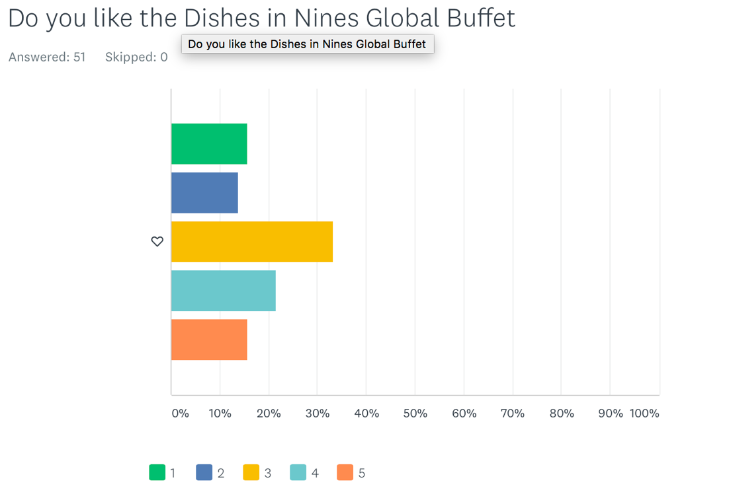
Appendix 2: the customer satisfaction of dishes in Nines Global Buffet
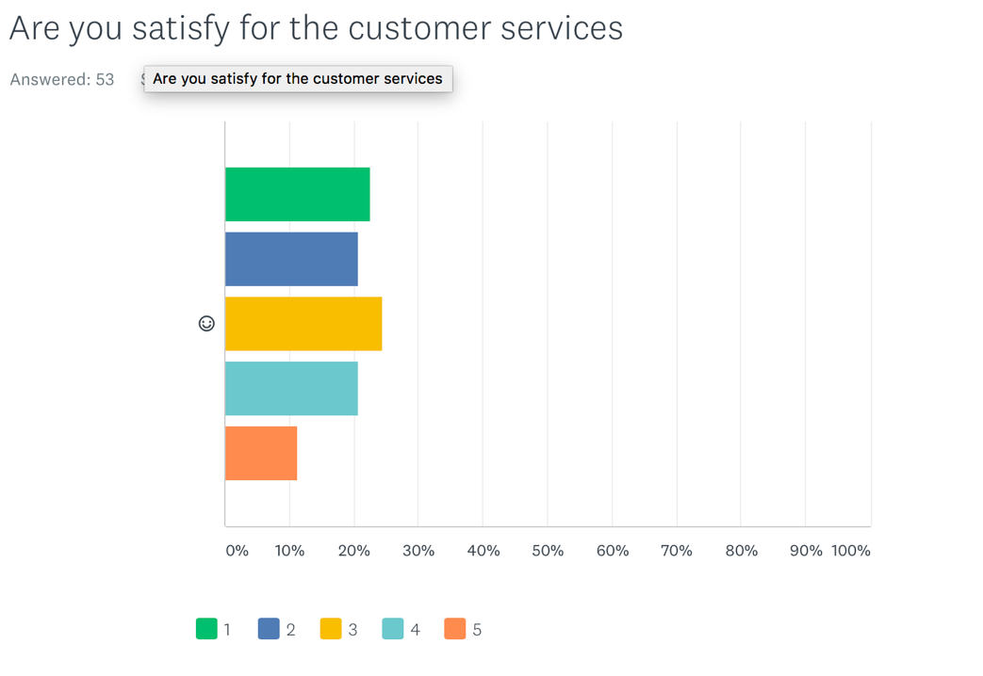
Appendix 3: the customer satisfaction of customer services in Nines Global Buffet
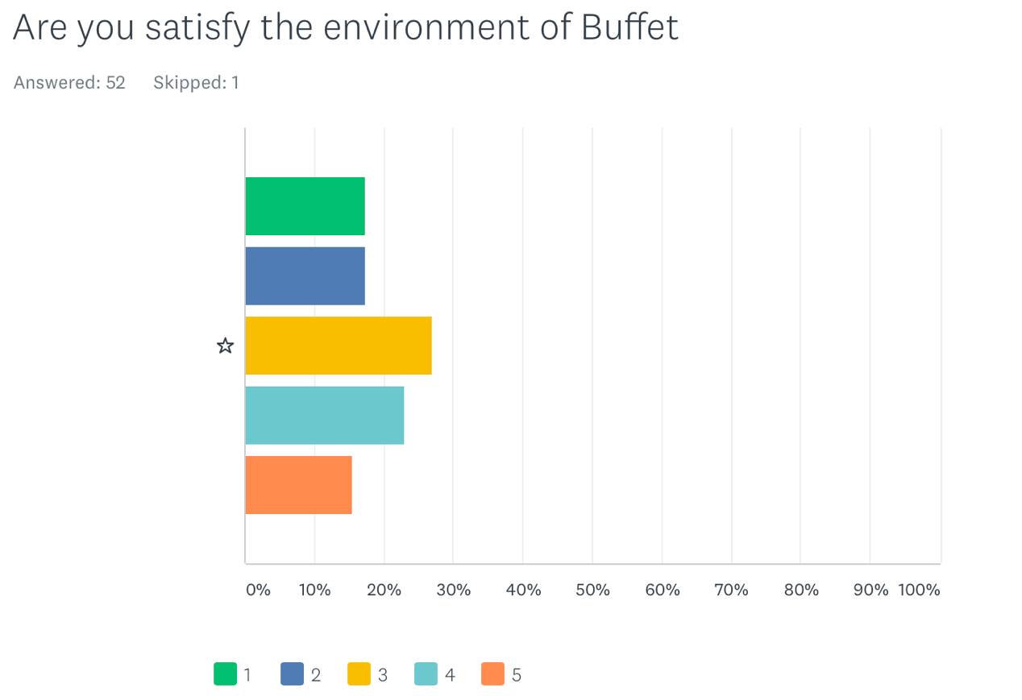
Appendix 4: The customer satisfaction of environment in Nines Global Buffet

