Live events

Chloe-May Southway
University of Wales Trinity Saint David

Appendix
Introduction | 2
Event concept | 2
Aims and objectives | 3
Market research | 4
Timing location | 5
Financial planning | 5
Evidence project | 6
Evidence of meetings | 6
The event marketing | 6
Risk management | 7
Contingency plan | 8
Event evaluation | 8
Apendices | 9
Refe

Introduction
The event management world is continuing to grow and evolve since the economic recession in 2008 the Great Recession was a period of marked general decline observed in national economies globally during the late 2000s and early 2010s. With more of the public having money to spend on the dream holiday and more of the public wanting that once in a lifetime events such as the dream concert or dream sporting event, the corporate event they’ve wished to attend. It is important whilst creating the dream event for the public that planning process’ must be conducted in order for the event to become successful. “The goals and planning process can be understood as success factors that event proponents and organisers need to pay attention to when planning and producing such events”(Getz,2012) This portfolio will discuss a number of different elements in order to create an event from scratch for example the five W’s, concept screening and also SMART objectives of the event.

The Event
“Without planning it is possible that the finished product will disappoint not only the intended audience, but also the organising bodies themselves.”( Getz,2012 )Event concept includes the tone, structure and goal of the event. “The event concept develops the initial planning stage, purpose, aims and desire event outcomes” (Booth,2001) Depending on the size of the event the idea will be creative but could be simple or complex in the planning. The steps of creating the concept will be the same for every type of event. Event concept can be created by brainstorming or mind map the initial idea and deciding what will the event be for example whilst coming up with the initial idea. The team decided to do a not for profit event which is on order to raise awareness and money for a small charity called Tomorrows Generation. The charities aim is to ‘provide young people with the necessary skills to help them learn effectively’ (tomorrows generation). After brainstorming the team decided to take a different approach to the pub quiz. The event needs an unique selling point in order for the pub quiz to stand out from competition the pub quiz would be a light and fun take on pub quiz as the charity is dyslexia the answers of the quiz would be the funniest or the most unique answer wins and if any team would write the actual correct answer would have a to do a forfeit such as sign off or twerk off e.c.t. Each round would end with a different type of music being played along with the attendees being able to feel free to get up and dance at anytime.
Before continuing with the event concept the idea must be run through the five W’s which are defined by Goldblatt (1997) as Why?,who?,when?,where? And what?
we ran our event concept through the golbatts five ws for example
Why?- in order to raise awareness for the charity which is Tomorrows Generation,
Who?- Stakeholders such as – the venue, the customers, the charity.
When?- 18th of March.
Where?- The Hyst.
What?- Pub quiz where the funniest answer wins.
By running our event concept through the (goldbatt 1977) five Ws it allows the team to identify why is the event running, who will be involved,when is the event happening, where will it be and what is the events concept.

Aims and objectives
The aims and objectives of an event should relate to the overall intent or purpose of the event for example this event aims are to a fun event in order to raise awareness for dyslexia alongside the Tomorrows Generation charity. The objectives are statements which describes what the events trying to achieve. Goals are part of everyday event planning it provides individuals with a sense of direction and motivation with the job ahead. Aims and objectives are aligned with the five SMART criteria which are Specific, Measurable, Achievable, Realistic and Time bound. SMART goals allow teams to track the progress and keep them motivated on the task ahead. Advantage towards creating smart goals are that it is easier for the team to visualise the end goal and quicker to identify the missed targets of the planning the event. Goals must be as specific as possible in order achieve the end goal Locke & Latham, found that in 90% of studies conducted, specific and challenging goals lead to higher performance than when people were set either easy goals or do your best goals. Measurable – once the goal has got a specific as possible it is important to be able to measure the success of the goal. The measurable part of the goal should make sense, so it is clear when the team have or loose to reaching the target. The measurable goal doesn’t need to include a stat or number of days it could be that it is clear when you have reached or are close to reaching the end goal. Achievable – each goal should be achievable and attainable it is important to make the goal challenging but it should be achievable with the time you have to achieve the end goal. relevant/realistic -it is important that any smart goal is relevant and realistic to specific goals because knowing you can achieve a goal that is relevant and realistic can motivate the team to accomplish the end goal. Lastly is timely; each goal must be time related It’s not productive to set a deadline too far in the future for a simple task or its unrealistic for a short deadline for something complex and time-consuming.
In order to achieve our goal to raise awareness and raise money for the dyslexia charity Tomorrows Generation we created a SMART goal:
S- Raising awareness for dyslexia tomorrows generation charity
M- The target will be measured by getting 85 attendees
A-It will be achievable by marketing the event on all social media
R- Getting 60 attendees is realistic in the time the team has.
T- The time bound is within 4weeks

Market research
Market research is critical whilst launching an event it helps the team gain knowledge of about their competitors and also allows them to gain trust with the customers. Market research can be conducted primary and secondary. Primary research is the first hand information on the market and its customers, primary research can be conducted by focus groups, online surveys and face to face communication. Secondary research is based on data such as trend reports, market statistics and industry content. Whilst conducting the events market research the team decided to create primary and secondary research in order for the event to access.

The market research began with potential competition. Whilst researching potential competition, the continuing pattern that recurred that pub quizzes was happening on Tuesday’s and mainly in a pub. The event team decided in order to reach the capacity of the Hyst which is 85 attendees and our target audience which are students that Wednesday would be the perfect day for a successful event. Many pub quizzes are stereotypically known as a ‘brainy’ event with trivia and general knowledge quizzes the recurring quiz.
The charity the team decided to choose is Tomorrows Generation which is the dyslexia charity of Wales. In order for the Win or Booze pub quiz to not be the stereotypically brainy general knowledge and trivia and in order to stand out from the researched market, the team decide to create a new concept of a pub quiz where the quiz is more fun where the funniest answer wins and the correct answer will get a for fit.

The demographic the team decided to go with is as been stated above is Student. Dyslexia isn’t discussed a lot within universities and according to (Dyslexia,2020) ‘1 in every 10 people has dyslexia’ so why is people with dyslexia frown apon as being too slow or stupid? The reason the team decided students as the demographic is because Wednesday is student night but also in order to raise awareness for dyslexia and allowing those with dyslexia to have a fun quiz night without the stress of getting the questions right. According to (Dyslexia - the facts., 2020) ‘the figure is more likely to be around 16% of the population, or 11.5 million people.’

Timing, location and event programme
Whilst choosing the location for the event it was important that the venue matches the concept of the event. The team decided on two options of venues the both of the venue suited our concept of the event. The venues that was chosen was The Bierkeller and The Hyst both in high street of Swansea. The reason the team chose these venues for the event are that the team wished for a laid-back venue. The Bierkeller was perfect for the laidback type of event concept the team was looking for with the barn style tables allowing their customers to dance on the benches. Unfortunately the Bierkeller responded but as the team was on a £0 the team decided that maybe other venues may match the concept more.

The Hyst is a local bar on Swansea high street located near the Train station. The venue was a laidback type of venue and allowed for the seating plan change in order for groups. The Hyst was chosen as the event concept as the layout was perfect for the event but also the laid back atmosphere and kind, friendly staff.

Financial planning
It is important to apply a budget to any sort of event in order to keep control of costs but also to support the vision and objectives of an event whilst understanding what can be afforded in each planning element. The team began with £0 budget, in order for income of the event it would have to consist of the income from ticketing but the team also decided on creating a raffle. The cashflow is important have enough capital to deliver the event. A member of the team created a budget sheet (appendix1.0)

Evidence of project planning techniques
Project planning techniques can be created in many different ways for example Gantt charts and Work breakdown Structure. The main purpose of the Work breakdown Structure is to reduce complicated activities to many small tasks. The work breakdown structures process continues until an appropriate level of detail has been reached to meet the needs of the event. In order for the Win or booze event to take place the team decided on creating a work breakdown structure (appendix 1.2) One member of the team created the WBS in order to increase the probability that every major but also minor task will be identified. A Gantt chart is a timeline is used to illustrate to the event manager how the event will run. The chart was created by Henry Gannt in 1901, they have become the common technique to representing the phrases and activities from the WBS. Gantt chart has been created for the win or booze in order for the team to visually summarise the event schedule it is also an effective way to communicate and point out the problem areas or clashing of schedules (appendix 1.3).

Evidence of the division of work and responsibilities
Weekly meetings was taken place in order for each member of the team to be on track with each task.(Appendix 1.4). The weekly meetings helped all the team to express their opinions on the event and also get up to speed if any meetings that was missed.

The event marketing
An event marketing plan is used to know where, what and when the marketing and communication of the event will take place. In order to creating a marketing plan it is important to remember and also run through the marketing mix the 7ps which are product, place, price, promotion, packaging, people and positing. ‘The elements of marketing mix assist and support the sellers to identify the needs and want of their potential buyers’(Tracy,2020). The most important P out of the 7ps is Product meaning what is the event offering to the customers. According to (Everleigh,2020) ‘The next time you are creating an advertisement for one of your product lines, you should take a helicopter view of your product and look deep into the product core’. As the event will appeal more to the younger demographic the method of marketing and where the event will be marketed. The team decided on Social Media as the events main marketing and communications as the event within 4weeks the team decided to choose one social media platform in order to gain more trust with the attendees. The social media platform the team decided to market and communicate on was Facebook over ‘79% of 18-24 year olds are users of Facebook, with 51% using the site serval times a day’ (demo et al , 2020). In order to keep the audience attention one member of the team will upload new posts weekly.(appendix 1.5)The weekly updates included posters, daily countdowns and description of the event.

Risk Management

Risk assessment is defined by (Bowdin ,2006 ) as ‘“…the likelihood that harm from a hazard is realised and the extent from it’ According to (Hse,2020) there are five key steps to risk assessment which contain Identify hazards created by activity / location, Decide who might be harmed and how, Evaluate the risk and decide whether existing measures are adequate or whether more should be done, Record your findings and Reviewing the assessment periodically. It is illegal to not have a risk assessment to any event. The win or booze team created a Risk assessment in order to reduce injury, accident and lose during the event.( appendix 1.6).
Contingency planning
Contingency plans are a backup plans if an unforeseen scenario distrupts the event for example someone smashing a glass, the purpose of creating a contingency planning is to allow the event to return to the original running sheet as quick as possible after the unforeseen event. The contingency plan identifies key staff assigned specifically and is responsible for the recovery.
Whilst creating the event the team decided that all tickets should be sold before the event and not on the door sales in order to control the numbers but also no risk if having too many or no attendees.

Event evaluation
“The need to learn about the environment surrounding the organisation and the intended outcomes of the event, to be aware of the unintended outcomes of the event, and to consider ways that management can improve it for the future.” (Getz, 2010) the reasons in order to evaluate the event are to determine the success of the event in relation to its objectives also to report to stakeholders and enable feedback and improvement. There are three forms of evaluation before the event, during the event which contains monitoring and controlling the event and after the event which are the event impacts and reports. The benefits to evaluation is Aids credibility, establishes outcomes, Acknowledges benefits and Lessons are learnt.
Event evaluations can be made by secondary and primary. Primary methods include data collection, feedback meetings and questionnaire. The Win or booze team have decided to collect primary evaluation by creating online questionnaires and also having feedback meetings.

Appendices
Appendix 1.0
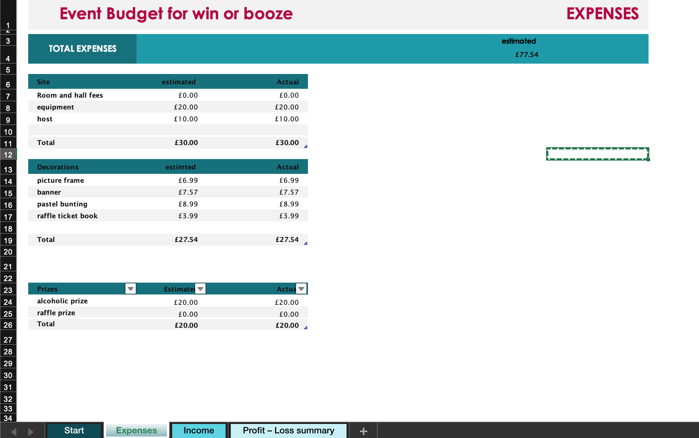

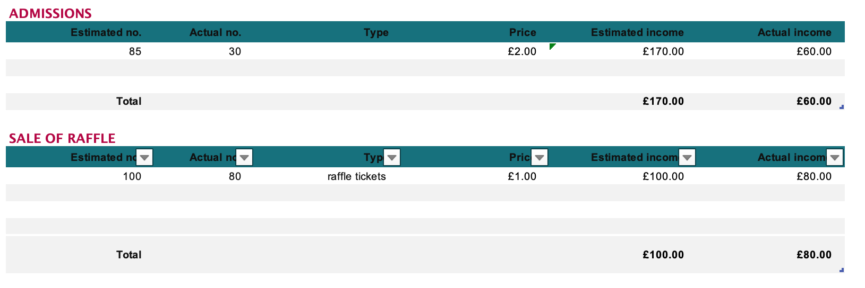

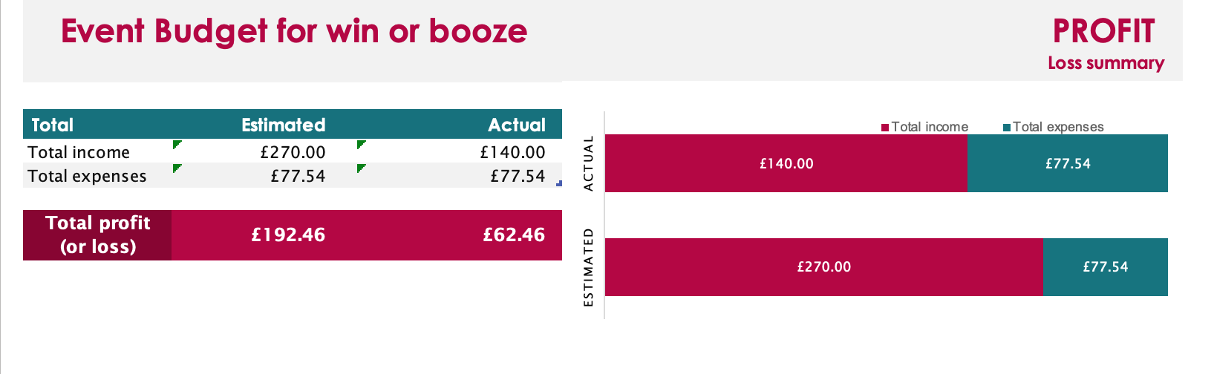
Appendix 1.1
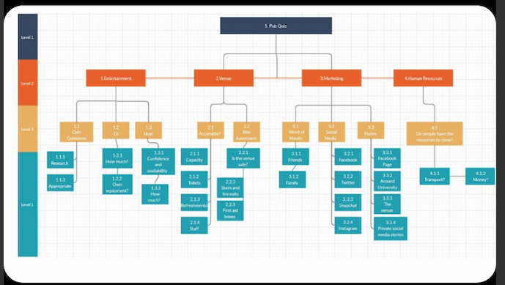
Appendix 1.2.

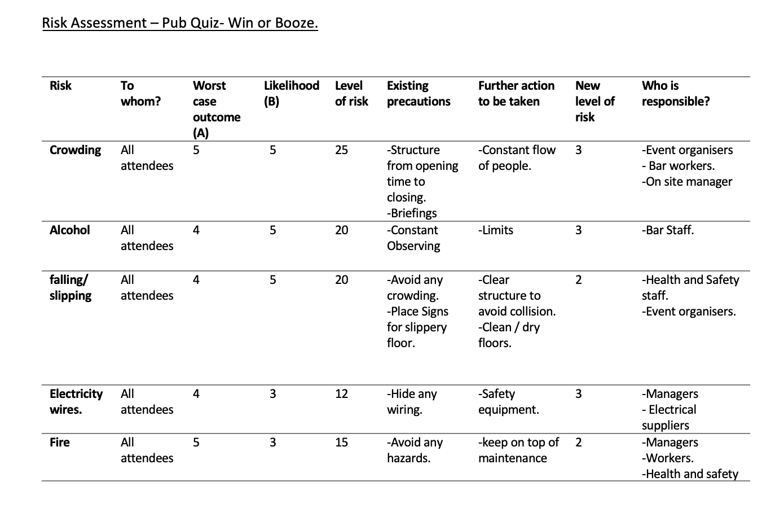

Appendix 1.3

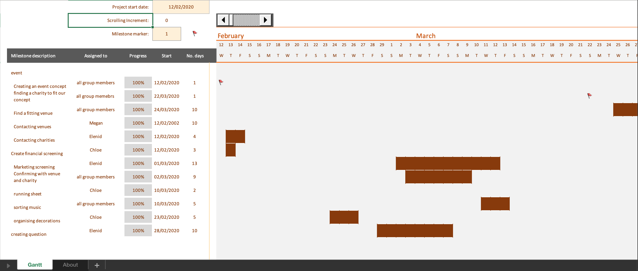

Appendix 1.4.

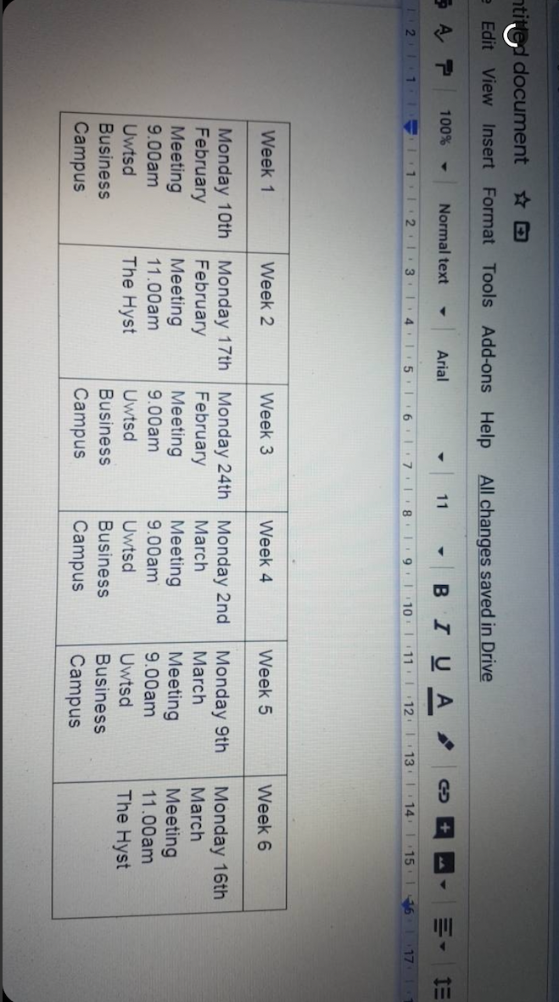

Appendix 1.5
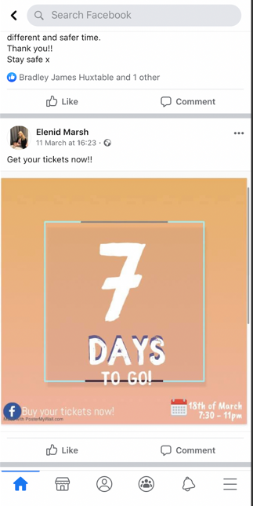
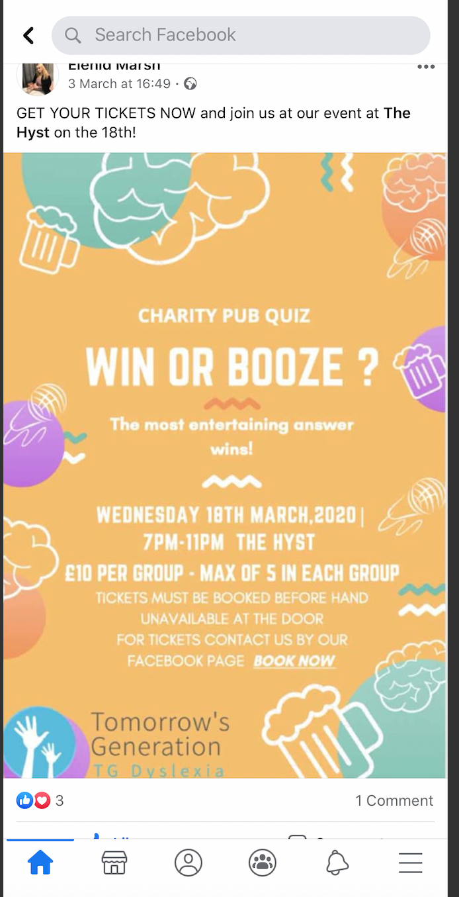

Appendix 1.6.

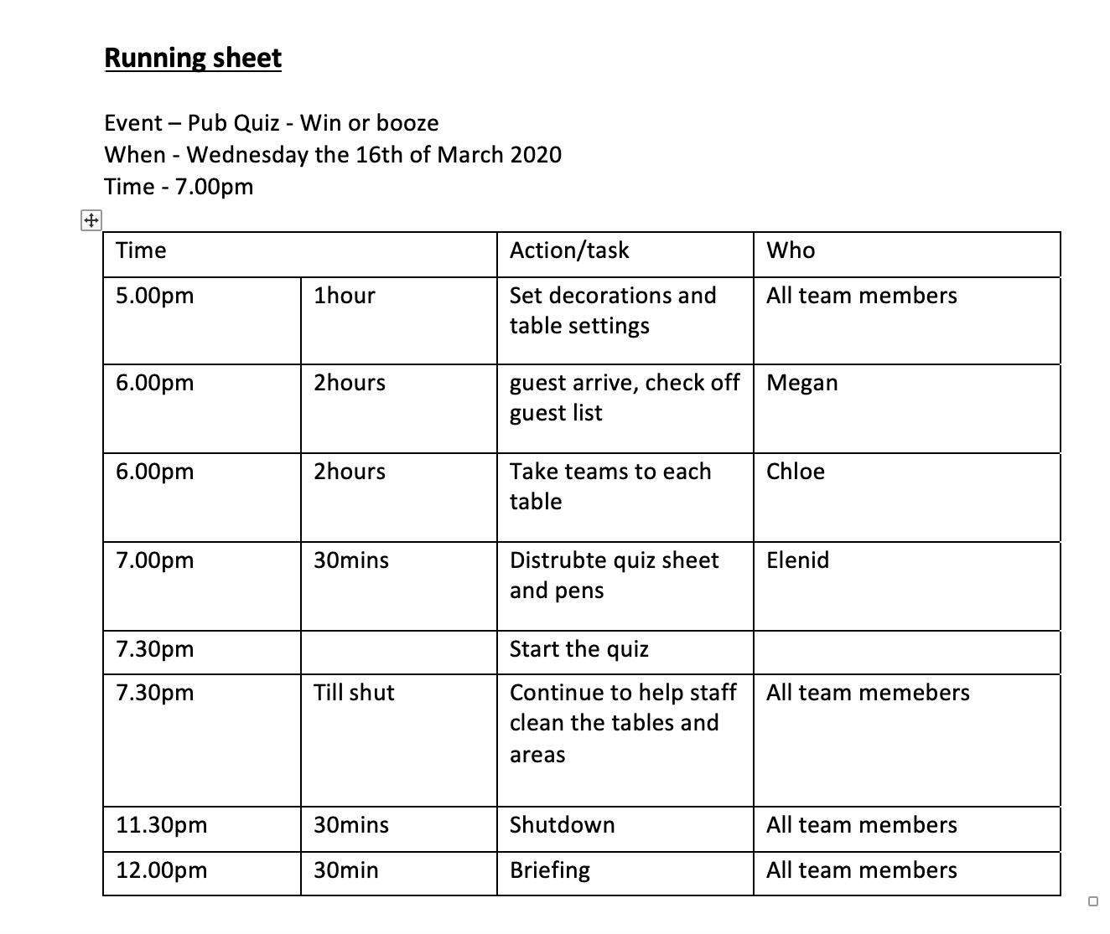

Reference list

<https://www.entrepreneur.com/article/70824> [Accessed 25 March 2020].
Booth, A., 2010. Developing the event concept. Events management, pp.19-31.
Cache.org.uk. 2020. Dyslexia - The Facts.. [online] Available at: <https://www.cache.org.uk/news-media/dyslexia-the-facts> [Accessed 25 March 2020].
Demo, R., Enterprise, F., Agencies, F., Business, F., Management, F., Care, F., Advocacy, F., Intelligence, F., Features, V., Difference, T., Sprout, A., Sprout, W., Blog, S., Thinking, B., Center, R., Updates, P., Tools, F., Studies, C., Publication, R., Social, S., Measured, S., Trial, S., Social, S., Measured, S., Trial, S., Trial, S. and Chen, J., 2020. Social Media Demographics To Inform Your Brand’S Strategy In 2020. [online] Sprout Social. Available at: <https://sproutsocial.com/insights/new-social-media-demographics/#FB-demos> [Accessed 25 March 2020].
Eveleigh, J., 2020. Why The Product Is The Most Important Part Of The Marketing Mix. [online] BXT Visual Marketing. Available at: <http://bxtvisuals.com/product-important-part-marketing-mix/> [Accessed 25 March 2020].
Getz, D., Svensson, B., Peterssen, R. and Gunnervall, A., 2012. Hallmark events: Definition and planning process. International Journal of Event Management Research, 7(1/2), pp.47-67.
https://www.hse.gov.uk/Risk/controlling-risks.htm[accessed 25 march 2020]
nhs.uk. 2020. Dyslexia. [online] Available at: <https://www.nhs.uk/conditions/dyslexia/> [Accessed 24 March 2020].
Tracy, B., 2020. The 7 Ps Of Marketing. [online] Entrepreneur. Available at:

https://tomorrowsgeneration.co.uk[accessed 25th of march 2020]

