Assignment Submission Form / Ffurflen Cyflwyno Aseiniad

WIWBL Copy
Student Number: _________ 1709341________________________

Student’s Name: __________ Ivor Chestnutt_______________________

Tutor Name: _____________ Julie Crossman ________________________

Assignment Title: __________Leading Service Improvement_______

Module Code: ______________DSAW7058__________________________

Submission Date: _____________11/09/19____________________________

Your work will not be marked unless it is accompanied by this statement.
I confirm that this is my original work and that I have adhered to the University’s policy on plagiarism.
Student’s Name: __Ivor Chestnutt_______________Signature_

WIWBL Staff only
Received by:_____________________Date submitted:____________________

Student Receipt
Student Number: ____________1709341__________________________________

Student’s Name: ________Ivor Chestnutt________________________________

Tutor Name: ___________ Julie Crossman ________________________________

Assignment Title: ________ Leading Service Improvement____________________

Module Code: ___________ DSAW7058__________________________________

Submission Date: _________11/09/19__________________________________

WIWBL Staff only
Received by:_____________________Date submitted:____________________

Too many patients – too little time
Managing the increasing demand for Oral Surgery

Project Proposal

Student Name: Ivor Chestnutt

Student Number: 1709341

Assignment Title: Leading service improvement

Module Number: DSAW7058

Project Proposal

Background
Oral surgery is the branch of dentistry that deals with the diagnosis and treatment of oral conditions requiring surgical intervention. It ranges from simple tooth extraction to the surgical management of head and neck malignancies (Mc Manners, 2007).

The problem
The number of patients being referred to the University Dental Hospital in Cardiff has increased substantially in the past three years from 4923 patients in 2013-14 to 5805 in 2016-17, an increase of 15.2%. This increase in referrals from primary to secondary care is not unique to Cardiff and has been reported elsewhere in the United Kingdom (Modgill and Shah, 2017). A number of reasons for the change have been postulated, including an increasingly risk averse generation of young dentists who are reluctant to undertake extractions, work that their predecessors would have carried out as routine. This changed attitude is attributed to worries over the stance being taken by the General Dental Council, whom it is perceived have become much more aggressive in their dealings with dentists when they experience an adverse event or patient complaint (Kelleher, 2017). A further highly relevant factor is one of finance. Under the current NHS dental contract, it may not be economically viable for high-street dentists to perform even the simplest oral surgery. As a result they will refer to secondary care.

The increased referrals mean that pressures on the oral surgery department are ever increasing and an analysis has shown that capacity to see newly referred patients is deficient by 64 slots per month. As of 2nd November 2017, the waiting list for new patients in Oral Surgery stood at 2,872 patients. As a result, it is a constant battle to meet the Referral to Treatment Targets (RTT) set by Welsh Government, the commissioners of the service.

Project aim
The proposed project aims to:

- Improve the efficiency with which patients flow through the Oral Surgery Department
- Act as a vehicle via which principles of leadership and management learned on the Medical Leadership Programme can be demonstrated.

Overall there are two elements to the project:

- Establish a “Single Access Clinic”
- Redesign how patients are managed in the Examination and Emergency Department.

This will allow for a range of leadership and organisational change tools to be demonstrated within the limits of the module guidance while at the same time result in an improvement in oral surgery services.

Methodology
In implementing the steps necessary to introduce the “Single Access Clinic” I will be guided by Kotter’s 8 steps for leading organisational change (Kotter, 2014). The principles outlined in the session on Improving Quality Together (IQT) (NHS Wales, 2018) will be used to implement the changes and underpin data collection.

Outcome data will comprise the number of Single Access Clinics established and the number of patients attending the Examination and Emergency clinics requiring a dental extraction who have the procedure completed on the day without the need to return for treatment on a subsequent occasion.

Timescale and project plan
Figure 1 Project Gantt Chart

Ethical considerations
The work proposed can be classified as a service improvement and evaluation. As such it does not require formal research ethics approval (Health Research Authority, 2018). Permission to carry out this work and for it to be included in this assignment has been obtained from Prof MAO Lewis, the Director of the Dental Clinical Board, Cardiff and Vale University Health Board.

Anticipated Outcomes
The following outcomes are anticipated:

Service related:
- Improved patient flow through the Oral Surgery Department.

Personal improvement related:
- The opportunity to apply in practice service change tools explored in theory during the Medical Leadership Programme (MLP6)
- The chance to demonstrate and reflect on how an increased appreciation of personal approaches to leading (derived from learning in the MLP6 course) have influenced my approach to this task.

References

Health Research Authority. Do I need NHS REC approval? Available at: http://www.hra-decisiontools.org.uk/ethics/ [Accessed 17th June 2018].

Kelleher, M. 2017. State-sponsored dental terrorism. British Dental Journal 223(10), pp. 759-764. DOI: 10.1038/sj.bdj.2017.983.

Kotter, J. 2014. 8-steps to accelerate change in your organisation. Kotter: Cambridge Mass. Available at: https://www.kotterinc.com/8-steps-process-for-leading-change/ [Accessed 17th June 2018].

Mc Manners, J. 2007. Oral and Maxillofacial Surgery. In: Chestnutt, I.G. and Gibson, J. Eds Clinical Dentistry 3rd Ed, Edinburgh: Churchill Livingstone, pp381-438.

Modgill, O and Salah, A. 2017 Compliance with the guide for commissioning oral
surgery: an audit and discussion. British Dental Journal 223(7), pp. 509-514. DOI: 10.1038/sj.bdj.2017.838.

NHS Wales 2018. 1000 Lives: Improving Quality together. Available at: http://iqt.pembrokeshire.ac.uk [Accessed 20th June 2018].

Too many patients – too little time
Managing the increasing demand for Oral Surgery

Student Name: Ivor Chestnutt

Student Number: 1709341

Assignment Title: Leading service improvement

Module Number: DSAW7058

Word Count: 4125, plus 4 Figures and 1 Appendix.

CONTENTS
TABLES AND FIGURES 3
GLOSSARY 3
BACKGROUND 4
The problem 4
PROJECT AIMS 4
Benefits to patients and to the service 5
What is a “Single Access Clinic” and how will it help? 5
Anticipated Outcomes 5
Service related: 5
Personal improvement related: 5
METHODOLOGY 6
Outcome data 9
Data collection and analysis 9
Ethical considerations 9
RESULTS 9
Projected gains from SAC clinic 10
To the service 10
To patients 10
Patient safety issues 11
Failed to attend (FTA) appointments 11
COMMENTARY ON SAC 11
LEADING THE CHANGES 12
Leadership styles 12
Leadership model 13
Management Model 13
CONCLUSION 14
ACTION PLAN 15
ACKNOWLEDGEMENTS 15
REFERENCES 16
Appendix 1 Patient appointment letter 18

TABLES AND FIGURES

Table/ Figure | Title | Page
Table 1 | Case complexity in Oral Surgery | 4
Table 2 | The PDSA Cycle as applied to the implementation of a Single Access Clinic (SAC) | 6
Table 3 | Leadership styles | 12
Figure 1 | Improving patient flow in oral surgery | 7
Figure 2 | Kotter’s Change Management Model as applied to the establishment of a “Single Access Oral Surgery Clinic” | 8
Figure 3 | Number of Single Access Clinics held March-June 2018 | 9
Figure 4 | Outcome of attendance at SACs | 10

GLOSSARY

E and E | Examination and Emergency – Clinic which deals with patients who have a dental emergency
FTA | Failed to attend – describes when a patient fails to attend an appointment
MLP6 | Medical Leadership Programme – 6 The cohort of the Medical Leadership Programme which I attended for which this assignment is written
N | Number
PDSA | Plan Do Study Act - a system of ordering thoughts and actions in the implementation and review of a project with a view to improving quality
PMS | Patient Management System – an electronic record system used to order and book patient appointments
Pt | Patient – members of the public who have or were scheduled to attend the University Dental Hospital (UDH)
RTT | Referral to Treatment Time – the time which may elapse between referral and treatment
SAC | Single Access Clinic – a primary objective of the project in which patients have their surgery at the initial and only visit to the department
SAS | Specialist and Associate Specialist staff – career grade staff at sub-consultant level
Tx | Treatment – in the context of this project, care within the UDH
UDH | University Dental Hospital, Cardiff – the only Dental Hospital in Wales and part of Cardiff and Vale University Health Board

BACKGROUND
Oral surgery is the branch of dentistry that deals with the diagnosis and treatment of oral conditions requiring surgical intervention. It ranges from simple tooth extraction to the surgical management of head and neck cancer (Mc Manners, 2007). Case-complexity can be divided into three levels as shown in Table 1 (Department of Health, 2015).

Complexity level | Definition
Level 1 | These are the simplest cases which should be seen in a hospital setting for teaching purposes only.
Level 2 | These are the cases that once vetted by a Consultant can be treated by specialist grade staff and staff in specialty training.
Level 3 | These cases require care by a consultant and or multi-disciplinary team approach with other dental/medical specialties.
Table 1 Case complexity in Oral Surgery. (From: Department of Health 2015)

The problem
The number of patients being referred to the University Dental Hospital (UDH) in Cardiff has increased substantially in the past four years from 4923 patients in 2013-14 to 5805 in 2016-17, an increase of 15.2%. This increase in referrals from primary to secondary care is not unique to Cardiff and has been reported elsewhere in the United Kingdom (Modgill and Shah, 2017). A number of reasons for the change have been postulated, including an increasingly risk averse generation of young dentists who are reluctant to undertake extractions, work that their predecessors would have carried out as routine. This changed attitude is attributed to worries over the stance being taken by the General Dental Council, whom it is perceived have become much more aggressive in their dealings with dentists when they experience an adverse event or patient complaint (Kelleher, 2017). A further highly relevant factor is one of finance. Under the current NHS dental contract, it may not be economically viable for high-street dentists to perform even the simplest oral surgery. As a result, they will refer to secondary care (D’Cruz, 2018).

The rise in referrals mean that pressures on the oral surgery department are ever increasing and an analysis has shown that capacity to see newly referred patients is deficient by 64 slots per month. As of 2nd November 2017, the waiting list for new patients in Oral Surgery stood at 2,872 patients. As a result, it is a constant challenge to meet the Referral to Treatment Targets (RTT) set by Welsh Government, who commission the service.

PROJECT AIMS
The proposed project aimed to:

- Improve the efficiency with which patients flow through the Oral Surgery Department
- Act as a vehicle via which principles of leadership and management learned on the Medical Leadership Programme can be demonstrated.

The objective of the project is to:

- Establish a “Single Access Clinic” (SAC) and in doing so, use principals of leadership and innovative strategy development, acquired as part of the Medical Leadership Programme.

This allowed for a range of leadership and organisational change tools to be demonstrated within the limits of the module guidance, while at the same time, result in an improvement in oral surgery services. It also will allow me to demonstrate awareness of different leadership styles, a management model and how these can be utilised to bring about change.

It should be noted that this report focuses only on the establishment of SACs – other change factors identified in the driver diagram (Figure 1) are being pursued but are not described further in this report.

Benefits to patients and to the service

What is a “Single Access Clinic” and how will it help?
An audit of referrals to the Oral Surgery Department found that the level of complexity (Table 1) of patients referred to the Department is Level 1 (36%), Level 2 (33%) and Level 3 (30%). This means that a large proportion of cases referred are fairly simple to treat. Traditionally patients referred by their general dental practitioner would attend a new patient Consultant Clinic, have their treatment agreed and then return on a second occasion to have the treatment e.g. surgical removal of a tooth root, or non-complex wisdom tooth extraction. They may or may not then attend on a third occasion for review, dependant on the complexity of the surgery. So up to three visits to complete the referral episode.

The change to the service introduced here, i.e. the introduction of a “Single Access Clinic” (SAC) has eliminated the need for attendance at the new patient Consultant Clinic and the patient has their surgery, at the time of the initial visit. In addition, wherever possible, if follow-up is needed following surgery, this will be by telephone, thereby reducing the number of visits from two or three to just one.

SACs are staffed by staff and specialty grade dentists and are designed to manage Level 1 and Level 2 cases.

Anticipated Outcomes
The following outcomes were anticipated:

Service related:
- Improved patient flow through the Oral Surgery Department

Personal improvement related:
- The opportunity to apply in practice service change tools explored in theory during the Medical Leadership Programme (MLP6)
- The chance to demonstrate and reflect on how an increased appreciation of personal approaches to leading (derived from learning in the MLP6 course) have influenced my approach to this task.

METHODOLOGY
To initiate the programme, I used a Driver Diagram to examine the primary and secondary factors influencing flow through the oral surgery department (Figure 1).

I used the driver diagram to consider the myriad factors impacting on the issue of “too many patients and too little time” and used this as a basis for discussion with colleagues. The change idea that I am using for my MLP 6 programme is the development of a Single Access Clinic (SAC).

I decided to utilise the “PDSA” cycle (1000 Lives Improvement, 2014; NHS Wales 2018) as a framework to guide piloting the changes as set out in Table 2.

Plan | - Meet with oral surgery staff, agreed need SAC  - Develop SAC  - Clinic set-up  - Adjustment to patient information and materials (Appendix 1)  - Identify suitable operators  - Change timetable for Specialty and Association Specialist Grade Staff
Do | - Clinic implemented
Study | - Data analysed to identify clinic outcomes  - Success factors identified  - Limiting factors identified
Act | - Decide on future of SAC
Table 2. The PDSA Cycle as applied to the implementation of a Single Access Clinic.

In implementing the steps necessary to introduce the SAC and to redesign the flow, I was guided by Kotter’s 8 steps for leading organisational change as described in Figure 2, (Kotter, 2014).

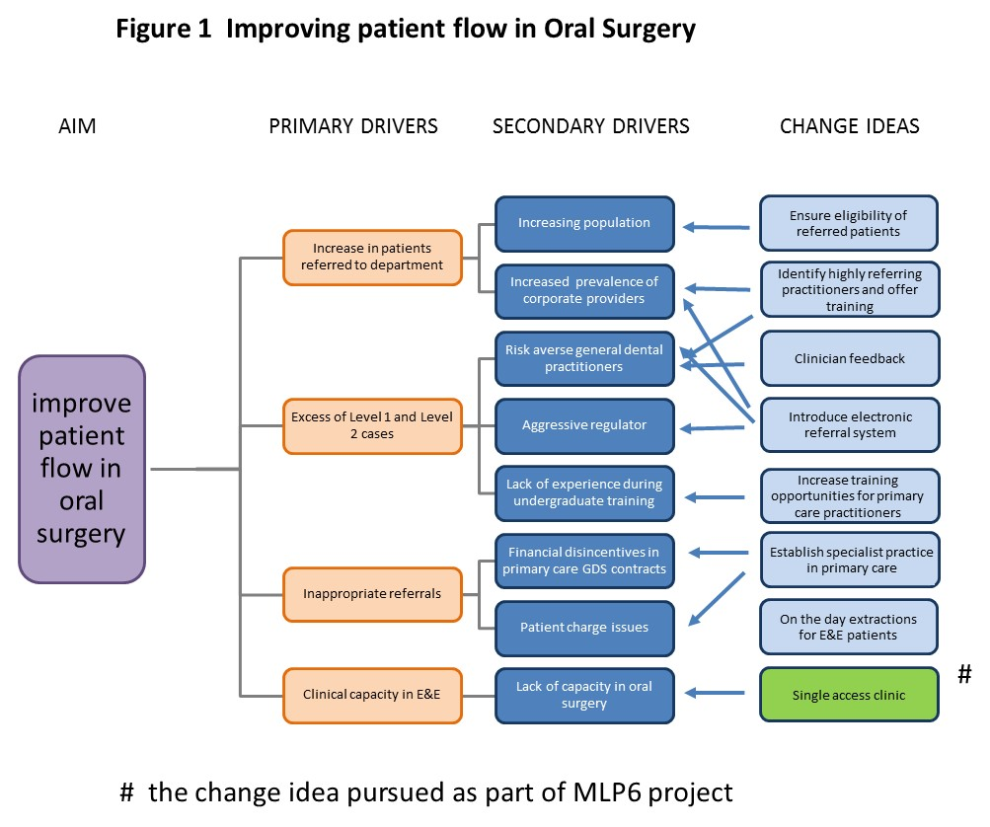
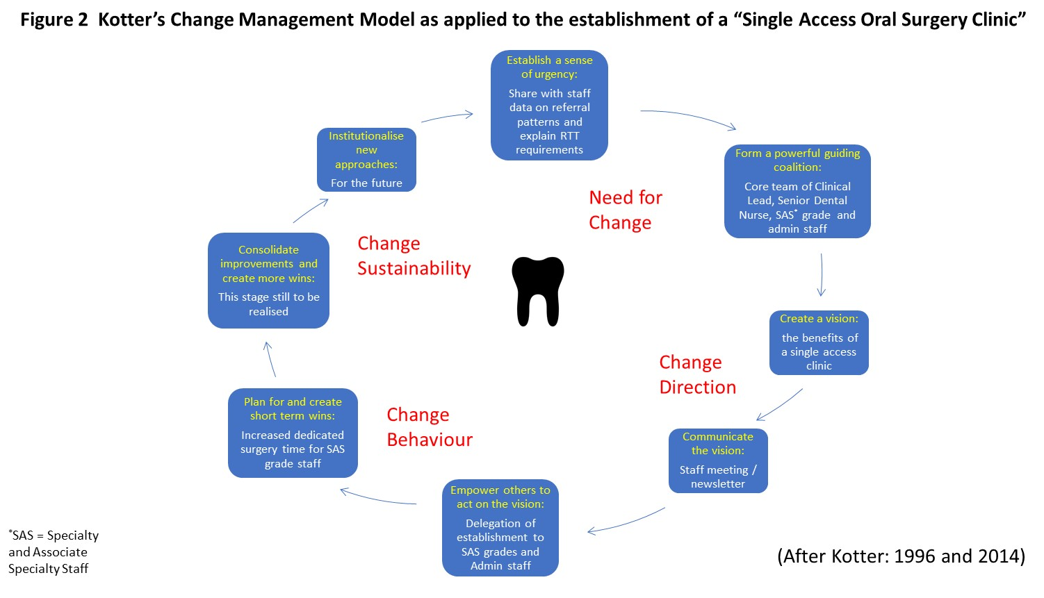

Outcome data
Outcome data comprised the number of Single Access Clinics established.

Data collection and analysis
A simple approach to data collection and analysis was adopted. Attendance at the SAC and visit outcomes were recorded from the Patient Management System (PMS) and by a manual evaluation of patient case-records.

Ethical considerations
The work proposed can be classified as a service improvement and evaluation. As such it does not require formal research ethics approval (Health Research Authority, 2018). Permission to carry out this work and for it to be included in this assignment has been obtained from Prof M.A.O. Lewis, the Director of the Dental Clinical Board, Cardiff and Vale University Health Board.

RESULTS
Between late March and the end of June, 32 SACs were held (Figure 3). In total 116 patients were appointed to these clinics.

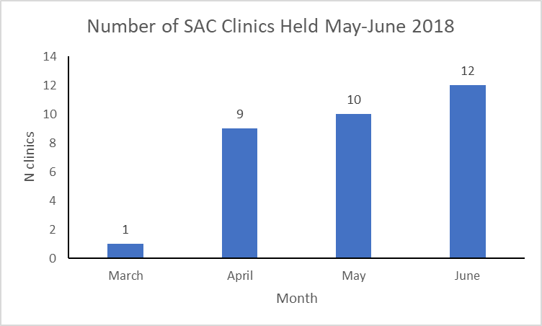

Figure 3 Number of Single Access Clinics held March – June 2018

The outcome of attendance is shown in Figure 4. Just over two-thirds of patients appointed to the SACs resulted in the desired outcome i.e. they attended the clinic and had their tooth/teeth extracted. One in five patients failed to attend. A small number of patients (5.2%) either declined treatment or decided on an alternative form of treatment (such has having procedures to have the tooth restored, rather than extracted) as requested by the referring practitioner. The number of patients for whom treatment could not be completed because of complexity issues, such as an inability to achieve anaesthesia or an overly complicated medical history was also small (3.4%). Just 2.6% were not treated because of anxiety issues and these patients were reappointed to receive treatment under sedation, general anaesthesia or in the day-stay unit. Just one patient was inappropriately vetted to attend the SAC.

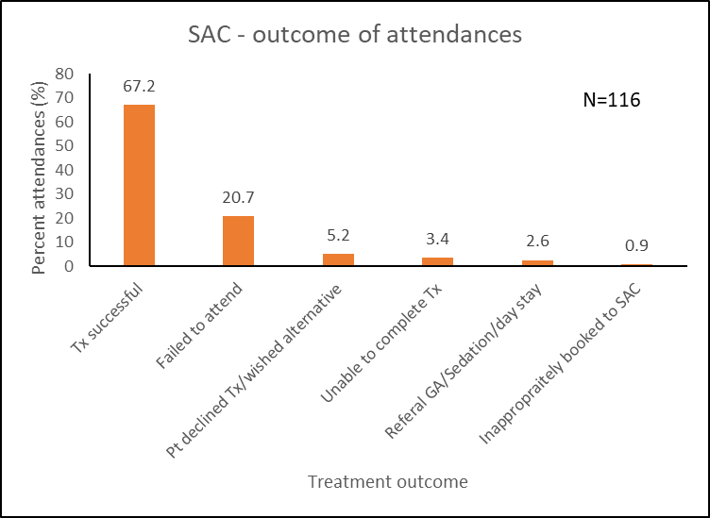
Figure 4 Outcome of attendance at the SACs

Projected gains from SAC clinic

To the service
To determine the benefits of this initiative to the service it is necessary to think about saved appointment times.
- 78 (67%) resulted in successful treatment and discharge in a single visit.

If it is assumed these patients would otherwise have required two attendances
- This represents a saving of at least 78 appointments at new patient appointment clinics.
This equates to a saving of at least one appointment at Consultant Clinic per 1.5 patients appointed to the SAC (78 per 116 appointed).

To patients
It is beyond the scope of this project to undertake a formal economic analysis of the benefits of the SAC in the wider context of society. However, it is obvious that there are benefits to patients in having to attend only once as opposed to two or three times. These benefits comprise the economic advantages of only having to attend once with associated savings in terms of travel to the hospital, time away from work, et cetera.

Patient safety issues
The post-operative analysis of the patient case notes did not reveal any untoward post-operative complications.

Failed to attend (FTA) appointments
The number of failed to attend (FTA) appointments is high at 20%. This contrasts with an average FTA of about 10% in the UDH as a whole. There are a number of possible explanations for this. As this time the pressure to meet referral to treatment time (RTT) targets set by Welsh Government is high. The patients booked to attend this clinic will have been waiting for their appointment for about 34 or 35 weeks. It is possible that in the interim the patient may have sought treatment elsewhere; these cases are at the simpler end of complexity and so the patient may have had treatment in primary care at a provider other than the referring practitioner. It is also possible that once the acute episode which led the patient to seek care initially has resolved, the patient then chooses not to attend the dental hospital for extraction. The patients involved here are not infrequently irregular attenders, those with poor oral hygiene and health and from a socially disadvantaged background.

A consideration in the future development of SACs is the time lost due to FTAs. We decided to allow a one-hour appointment slot for SACs, sufficient time to take the history, achieve anaesthesia and extract the tooth. Clearly if a patient FTAs, that is a lot of downtime and contrasts with the typical 20-minute appointment necessary to take the history in a traditional new patient clinic, with subsequent appointment for follow-up. So, if we consider lost time – an FTA in a SAC is “three times as expensive” as the traditional appointing system.

It is possible that patients were intimidated by the prospect of attending for surgery in advance of coming to the hospital first and meeting the treating team. We worked to prepare patients for the likely outcome of their visit, by suitably preparing patient invitation letters (Appendix 1).

COMMENTARY ON SAC
These preliminary findings from the SAC are encouraging. Being able to see and treat 67% of appointed patients in one visit is clearly preferable than the patients having to attend over two appointments. The results from the initial three months of clinic operation suggest that this method of operation will be a useful component of the several change ideas identified in the situation analysis of the mismatch between supply and demand in the provision of Level 1 and Level 2 oral surgery services in Cardiff (Figure 1).

The major issue at this stage is the higher than anticipated failure to attend rate at 20%. The length of clinical downtime (60 -90 minutes) arising from an FTA in the longer appointment time associated with the SAC is a negative factor compared with the time lost (20 minutes) if a patient fails to attend a new patient consultant clinic (the status quo). More work is required to determine if the overall net benefits of the SACs outweigh the downtime associated with FTAs.

LEADING THE CHANGES
Undertaking the Medical Leadership Programme and the opportunity to undertake the set-up of the SACs alongside an academic project has enabled me to learn about and reflect on three key parameters; leadership styles, leadership models and change management tools. In reviewing the factors relevant to delivering high quality care in the wake of the Mid-Staffordshire NHS Foundation Trust Public Enquiry (The Francis Inquiry) (Francis, 2013), the King’s Fund identified effective leadership and a culture that puts patients’ needs first as key determinants (King’s Fund, 2013).

Leadership styles
One of the interesting elements of the programme was reading about the formal definition of leadership styles (Table 3).

- Transformational
- Transactional
- Servant
- Autocratic
- Laissez-faire
- Democratic
- Bureaucratic
- Charismatic
- Situational
Table 3 Leadership styles (The Executive Connection, 2015)

Having been involved in higher education and healthcare since 1981, I have encountered all sorts of leadership styles. It has been interesting to read through this list and fit past bosses and line managers against those formally listed in management textbooks and websites. I reckon I have seen all of them in action. I have been led by and worked with people who displayed a number of these styles (sometimes simultaneously, and not in the positive manner envisioned by situational leadership!). I have also encounter the odd manager, whose style lay outside the classifications in Table 3, or any other classification.

The serious issue though, is what type of Leadership style(s) do I employ? My reading has given me a chance to think about the upsides and downsides to each of these styles and a recognition that different styles fit different situations (Matheson and Hayden, 2012). I also recognise that if left to my own devices, some of these styles would fit more comfortably with me than others and something that I think that would bear more through consideration and reflection on my part is the connection between leadership style and personality type. Price and Scowcroft discuss the concept of emotional self-awareness and the ability to “see ourselves as other see us” and that is an important factor to bear in mind when leading change (Price and Scowcroft, 2011).

Leadership model
I have through undertaking this module, learned about different types of leadership models and in the reading I have done around leadership models, I understand them to largely be frameworks around which leadership skills and styles can be directed. Many arise from business, some from the military but I guess the most relevant model I have come across is that described by the NHS Leadership Academy, which embodies nine dimensions of leadership behaviour (Leadership Academy, 2013). It has been useful to reflect on this model and to appreciate that I personally would regard my skills to be higher in some domains than in others – a helpful contributor to the concept of self-awareness discussed above.

Management Model
The formal use of and thinking about Kotter’s Change Management Model (2014) has been very helpful in guiding the implementation of the SACs. I have not really followed a formal management change model before and am not sure that I had even heard of Kotter before undertaking this course. His new enhanced model is on the internet in the form of an e-book. The eight steps in the original programme are now the eight accelerators coupled with four change principles. My initial reaction to visiting the Kotterinc.com site was one of “American corporate hype”. However, having got past my innate responses to corporate America, I could see that there was a lot of sense in the eight steps (Figure 2). Thinking about each of these –

Creating a sense of urgency – this was not too difficult as the pressures on the department were obvious to all.

Building a coalition – this was important and was a key element in the issue of me not directly working in the department. I am not an oral surgeon and I do not work in the department where the work is being done. I am the Clinical Director. This adds a layer of complication to the process. If I were within the department I could have been more directive to the oral surgeons and nursing staff making the changes. As it is, I am managing the project from the management layer above the Department. This therefore required me to manage the project from a more removed position then when I held a lower position in the management tree. I think the key at this stage in the process was not to adopt an autocratic style, a trap which I think a younger me might have fallen into.

Forming a strategic vision – this wasn’t too difficult in relation to the establishment of the SAC – the idea and the outcome was reasonably easy to get across and for the team to understand. However, where I am still struggling somewhat is in getting the Oral Surgery Department as a whole to see my overall vision for the future and how all of the other elements of the change plan I have in mind (but not described in this project write up) will fit into a more streamlined service. I guess what I need to do, is to rely more on a transformational approach, but that is a challenge when there are six consultant staff to engage with and not all of whom see this work as a priority, or rather would prefer to be pushing other agendas with the management team.

Enlisting a volunteer army – what I learned or at least had reinforced here was the benefits of working with the middle grade staff rather than too top down an approach via the clinical lead – I guess here I was operating more in a on democratic leadership style – demonstrating a listening and participative style but this required skill in order that “toes are not trodden on”.

Enable action by removing barriers – one of the unforeseen barriers to the implementation of the SAC was in the initial stages, a perceived shortage of nursing staff to cover the clinics. I had not sufficiently thought about this as an issue but have now resolved the issue by negotiating a redistribution of resources from elsewhere. To be honest, I did not use any formal technique to achieve that. I have been asked if I used a technique such as Kurt Lewin’s Force Field Analysis (Lewin, 1951; Mindtools 2018) but that isn’t something that I was aware of. I guess this element of the process happened via discussion with the nurse manager and persuading her of the benefits and need to make nursing staff available – I’m sure there is a management leadership term for what happened in this stage – but I guess I put it down to a combination of good working relationship with key individuals able to enact change and an element of directive style. I have as yet to establish whether this truly was a barrier or was in fact merely a ruse put forward by some members of the team who were less enthusiastic about the idea of SACs.

Generate short term wins – this project is my short-term win in terms of the larger changes that I want to apply to manage the ever increasing and inappropriate referral of level 1 and 2 cases to the Oral Surgery Department. In terms of wins for the staff delivering the clinical care, the use of specialists and associate specialists to staff the clinics were viewed as a means of freeing up Consultant capacity and also of giving enhanced autonomy to the SAS staff. It is generally accepted that autonomy is an important element of delegation and managing staff.

Sustain and accelerate change – this is the challenge for me now, to keep the SAC clinics going. I plan to do this by feeding back the data analysis undertaken as part of this project. I hope that will reinforce to the staff the benefits and potential savings associated with this way of working. My “day job” as a consultant in public health means of all the dimensions in the Healthcare Leadership model, I would regard my skill in “Evaluating Information” as exemplary.

Institute change – I believe that I have managed to do this fairly successfully as far as the SACs are concerned and that these are working well. The challenge at this point in time is to feed back in detail to the staff and to get the SACs established as a permanent way of managing the simpler cases referred to Oral Surgery.

On reflection, one important element of this service development is missing, namely we have not involved patients so I do not know the degree to which patients would prefer to come and have their surgery in a single visit or would prefer two visits. In establishing the SACs, we have assumed the former. At this time, we can only speculate if that is a factor in the higher than average FTA rates observed. In the future, it would be useful to conduct some informal interviews or questionnaire surveys with patients to gauge their preferences.

CONCLUSION
Clearly as just described, involvement of patients and potential patients is one thing. With more time I would have liked to have collected more data than the simple count of clinics and case note analysis reported here, although I do believe that the data we have enables me to work with the clinical staff directly involved in the delivery of the clinics to ensure the changes will be embedded in how we deliver our services.

ACTION PLAN
My plan of action from here is:

- To share the data collected here with the staff delivering the clinics
- To try and understand the reasons for the FTAs on the SACs
- To explore the opportunities for increasing the number of SACs we hold each month
- To embed SACs in the larger project to manage the increasing number of referrals to the Oral Surgery Department, UDH.

ACKNOWLEDGEMENTS
This project was a collaborative effort with staff from the Department of Oral Surgery; the Dental Records Department and the management of the University Dental Hospital Directorate, University Dental Hospital and School; and, Cardiff and Vale University Health Board. I am grateful to all staff who worked with me to set up the SACs.

REFERENCES
100 Lives Improvement, 2014. The quality improvement guide: the improving quality together edition. Cardiff: 1000 Lives Improvement.

D’Cruz, L. 2018. Tier 2 NHS services in primary dental care – where are the risks? British Dental Journal, 224, 927–929. DOI: 10.1038/sj.bdj.2018.440.

Department of Health, 2015. Guide for commissioning oral surgery and oral medicine. London: The Department of Health.

Francis, R. 2013. Report of the Mid Staffordshire NHS Foundation Trust Public Inquiry. Available at https://www.gov.uk/government/publications/report-of-the-mid-staffordshire-nhs-foundation-trust-public-inquiry [Accessed 09/09/2018].

Health Research Authority. Do I need NHS REC approval? Available at: http://www.hra-decisiontools.org.uk/ethics/ [Accessed 17th June 2018].

Kelleher, M. 2017. State-sponsored dental terrorism. British Dental Journal 223(10), pp. 759-764. DOI: 10.1038/sj.bdj.2017.983.

King’s Fund. 2013. Patient-centred leadership. Rediscovering our purpose. Available at: https://www.kingsfund.org.uk/sites/default/files/field/field_publication_file/patient-centred-leadership-rediscovering-our-purpose-may13.pdf [Accessed 09/09/2018].

Kotter, J. 2014. 8-steps to accelerate change in your organisation. Kotter: Cambridge Mass. Available at: https://www.kotterinc.com/8-steps-process-for-leading-change/ [Accessed 17th June 2018].

Lewin, K. 1951. Field theory in social science. London: Harper Row.

Matheson, J and Hayden, J. 2010. Leadership styles and skills. In: Markar, H and O’Sullivan. Medical Management – a practical guide. London: Hodder Arnold.

Mc Manners, J. 2007. Oral and Maxillofacial Surgery. In: Chestnutt, I.G. and Gibson, J. Eds Clinical Dentistry 3rd Ed, Edinburgh: Churchill Livingstone, pp381-438.

Mindtools. 2018. Force field analysis – analysing the pressures for and against change. Available at: https://www.mindtools.com/pages/article/newTED_06.htm [Accessed 09/09/2018].

Modgill, O and Salah, A. 2017. Compliance with the guide for commissioning oral surgery: an audit and discussion. British Dental Journal 223(7), pp. 509-514. DOI:10.1038/sj.bdj.2017.838.

Leadership Academy. 2013. Healthcare Leadership Model – the nine dimensions of leadership behaviour. Available at: https://www.leadershipacademy.nhs.uk/wp-content/uploads/2014/10/NHSLeadership-LeadershipModel-colour.pdf [Accessed 008/09/2018].

NHS Wales 2018. 1000 Lives: Improving Quality together. Available at: http://iqt.pembrokeshire.ac.uk [Accessed 20/06/2018].

Price, A. and Scowcroft, A. 2011. Essential Skills for Influencing in Healthcare. London: Radcliffe.

The Executive Connection. 2015. 9 common leadership styles: Which type of leader are you? Available at: https://tec.com.au/resource/9-common-leadership-styles-which-type-of-leader-are-you/ [Accessed 09/09/2018].

Appendix 1 Patient appointment letter

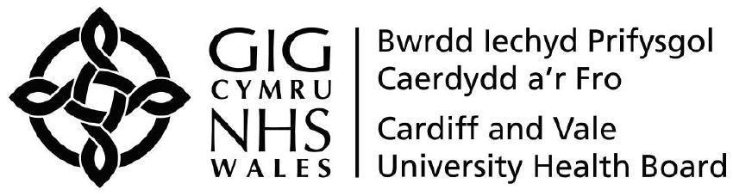 | Ysbyty Deintyddol Athrofaol  University Dental Hospital
Eich cyf/Your ref:  Ein cyf/Our ref:  Welsh Health Telephone Network 1872  Direct Line/Llinell uniongyrchol | Heath Park,  Cardiff,  CF14 4XY  Phone (029) 2074 7747 | Parc Y Mynydd Bychan,  Caerdydd,  CF14 4XY  Ffôn (029) 2074 7747

DEPARTMENT OF ORAL & MAXILLOFACIAL SURGERY
HEAD & NECK SURGERY
Mr A J Cronin
Secretary – 029 2074 6349
Direct Line for Reception – 029 2074 6379
Our ref: | AJC/LL
Date:

Dear

An appointment has been made for you to attend the Oral & Maxillofacial Surgery Outpatient’s Department to have one or more teeth extracted.

In order to avoid an unnecessary additional clinic appointment, it is our proposal that you are both seen and treated on the day that you next attend. This means that assuming all is well, some or all of the teeth that had been requested to be removed will be removed under a local anesthetic on the day that you attend.

We will be grateful if, when you attend, you bring with you an up to date list of your current medications, together with a completed Medical History sheet, a copy of which is enclosed. Depending on the difficulty of your extraction you may require a suture (stitch) to be placed in the gum and if that is the case, you will be given further instructions as to how to care for your mouth following your surgery.

Please ensure that you have either your breakfast and/or lunch on the day of your appointment and also be prepared that on the day in question you may be at the clinic for a few hours in total

Kind regards

Yours sincerely

Andrew J Cronin BDS,FFDRCSI,FDSRCS,MBBCh,FRCS
Consultant Oral & Maxillofacial Surgeon
Encl: Medical History Sheet

