

LOCATION: Swansea | LLEOLIAD: abertawe
LEVEL 4 | LEFEL 4
EXAMINATION PERIOD | CYFNOD ARHOLIADAU
MAY 2025 | MAI 2025

MODULE CODE: ACDA4009
Signals and System

Marking Scheme

QUESTION 1
- For function given below.
- $x(t)=\left\{ \begin{aligned}1, if t 1 \\ 0,Otherwise \end{aligned}\right.$
- Identify the Signals x(t) and provide the name of the function.
SOLUTION
Signal : Continuous Time Signal [1 Mark]
Function: Rectangular Function [1 Mark]
- Illustrate its graphical representation.
SOLUTION
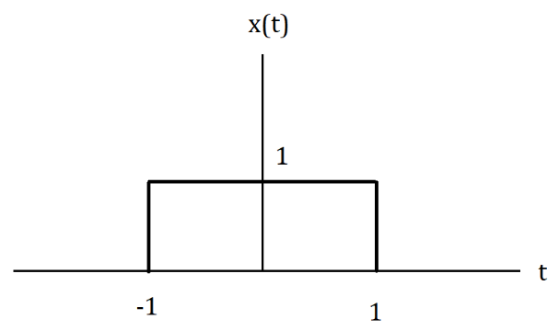
[Labelling axis: 1 Mark, Plotting the graph: 2 Marks]
- Apply the transformation y(t) = x(2t + 3) to the above function x(t).
SOLUTION
The transformation involves two operations:
- Time Scaling [1 Mark]
- Time Shifting [1 Mark]
- Description of Time scaling : x(2t) compresses the function by a factor of 2. [1 Mark]
- Description of Time Shifting: x(2t + 3) shifts the function to the left by 3 units. [1 Mark]

- Show the effect of transformation by generating the graphs for effects.
SOLUTION
Time Shifting x(t + 3) can be drawn as
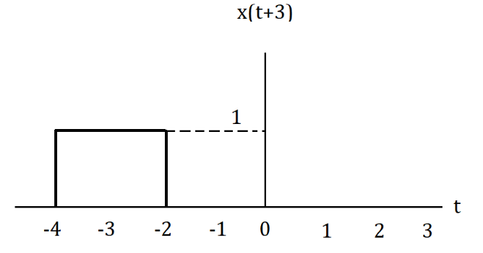

[Labelling axis: 1 Mark, Plotting the graph: 2 Marks]

Time scaling x(2t+3) can be drawn as
SOLUTION
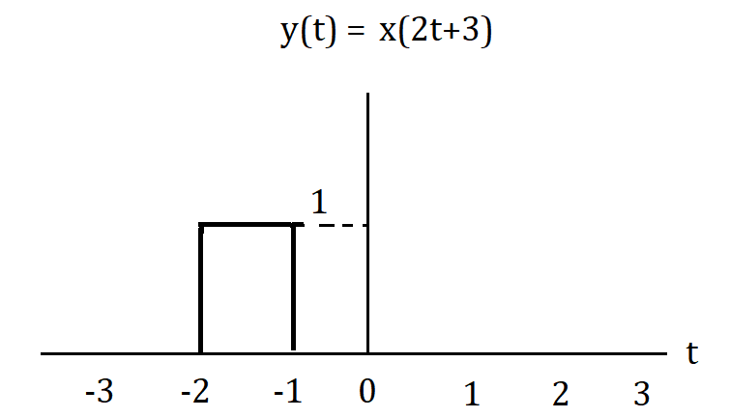
[Labelling axis: 1 Mark, Plotting the graph: 2 Marks]
State and Briefly the effect of Time shifting Property.
SOLUTION

The two effects of Time Shifting are
- Delay y(t)=x(t−t ₀)
- Advance y(t)=x(t+ t₀) [1 Mark]

Delay
y(t)=x(t−t ₀) :
The entire signal is shifted to the right by t₀​ units. Each point of the signal appears t₀ units later. [2 Marks]

Advance
y(t)=x(t+ t₀):
The entire signal is shifted to the left by t₀ units. Each point of the signal appears t₀ units earlier. [2 Marks]
QUESTION 2

- Answer the following related to signals
- Identify the Signal and the function of
r$\left[n\right]=\left\{\begin{aligned}n, if 0≤n≤3 \\ 0, n=0\end{aligned}\right.$
SOLUTION
This signal is known as a ramp signal within the specified range and 0 otherwise. Specifically, it is a discrete-time ramp signal defined for n from 0 to 3. [3 Marks]
- Sketch the above given function.
SOLUTION
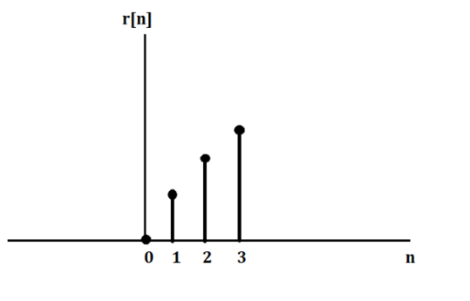
[Labelling axis: 1 Mark, Plotting the graph: 2 Marks]

- Find the Even signal $r_{e}[n]$ , and the Odd Signal $r_{o}\left[n\right]$ from the above given condition $r\left[n\right].$
SOLUTION
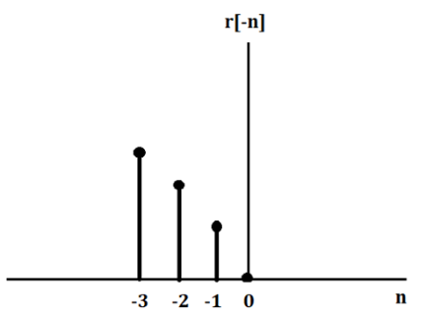
[Labelling axis: 1 Mark, Plotting the graph: 2 Marks]

The Even Function can be written as
$x_{e}[n]=\frac{1}{2}(x\left[n\right]+x\left[-n\right])$ [1 Mark]
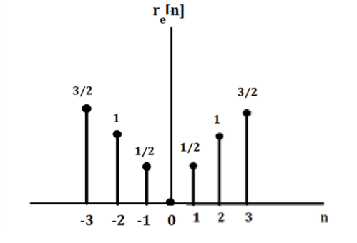
[Labelling axis: 1 Mark, Plotting the graph: 2 Marks]

The Odd Function can be written as
$x_{o}(t)=\frac{1}{2}(x\left[n\right]-x\left[-n\right])$ [1 Mark]
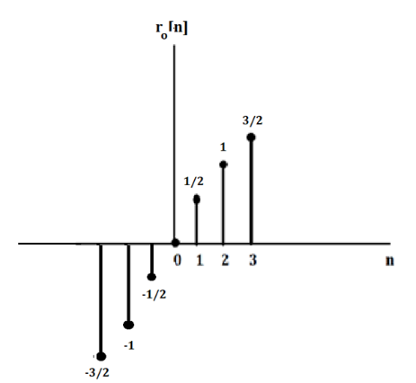
[Labelling axis: 1 Mark, Plotting the graph: 2 Marks]

- If $w[n]=r_{o}\left[n\right]$ then, find the value of $w[-n]$
SOLUTION
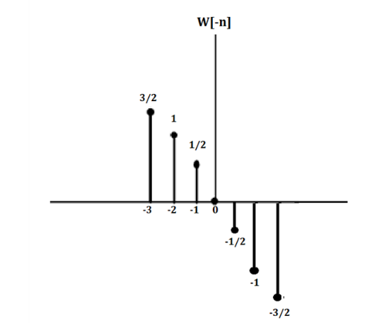
[Labelling axis: 1 Mark, Plotting the graph: 2 Marks]

QUESTION 3
- Suppose that the system of Figure: 1(a) has the impulse response h(t) given in Figure : 1(b). The system input is the unit step function $x(t)= u(t).$Answer the following to generate $y(t).$
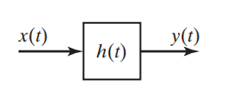
Figure: 1(a)
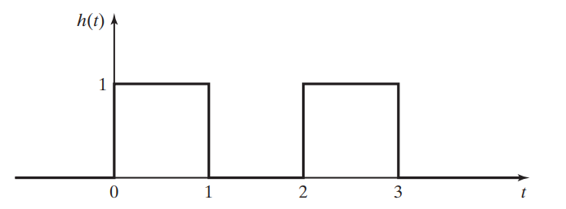
Figure : 1(b)
- Mathematical Representation of $h\left(t\right)$
SOLUTION
The $h(t)$could be mathematically written as
$$h(t)=\left\{ \begin{aligned}1 0≤t<1 \\ 0 1≤t<2 \\ 1 2≤t<3 \\ 0 Otherwise \end{aligned}\right.$$
[2 Marks]

- Formula for Convolution Integral.
SOLUTION
$$y\left(t\right)=x\left(t\right)*h\left(t\right)=\int_{-∞}^{∞}{x\left(τ\right)h\left(t-τ\right)dτ}$$
[2 Marks]
- Simply the unit step.

SOLUTION
For $x\left(t\right)=u(t)$
$$y\left(t\right)=\int_{0}^{t}{h\left(t-τ\right)dτ}$$
[1 Mark]
- Evaluate for different Intervals
SOLUTION
When $0≤t<1 :$
$$For 0 ≤ τ ≤ t , 0 ≤ t-τ < 1 , so h (t-τ) = 1$$
$$y\left(t\right)=\int_{0}^{t}{1 dτ=t}$$
[2 Marks]
When $1≤t<2$ :
$$For 0 ≤ τ ≤ t-1, t-τ ≥ 1 and h(t-τ)=0$$
$$For t-1≤τ≤t,0≤ t-τ<1, so h(t-τ)= 1$$
$$y\left(t\right)=\int_{t-1}^{t}{1 dτ=1}$$
[2 Marks]
When $2≤t<3 :$
$$For 0≤τ≤t-2,t-τ 2, so h\left(t-τ\right)= 0$$
$$For t-2≤τ≤t-1,1≤ t-τ<2, so h(t-τ)= 0$$
$$For t-1≤τ≤t,0≤ t-τ<1, so h(t-τ)= 1$$
$$y\left(t\right)=\int_{0}^{1}{1 dτ+\int_{t-1}^{t}{1 dτ=1+\left(t-2\right)=t-1}}$$
[2 Marks]
When t < 3 :
$$For 0≤τ≤t-3,t-τ 3, so h\left(t-τ\right)= 0$$
$$For t-3≤τ≤t-2,2≤ t-τ<3, so h(t-τ)= 1$$
$$For t-2≤τ≤t-1,1≤ t-τ<2, so h(t-τ)= 0$$
$For t-1≤τ≤t,0≤ t-τ<1, so h(t-τ)= 1$
$$y\left(t\right)=\int_{0}^{1}{1 dτ+\int_{2}^{3}{1 dτ=1+1=2}}$$
[2 Marks]
- Find the final mathematical expression for $y\left(t\right)$

SOLUTION
$$y(t)=\left\{ \begin{aligned} t 0≤t<1 \\ 1 1≤t<2 \\ t-1 2≤t<3 \\ 2 t 3 \end{aligned}\right.$$

[3 Marks]

- Sketch the Output of $y\left(t\right)$
SOLUTION
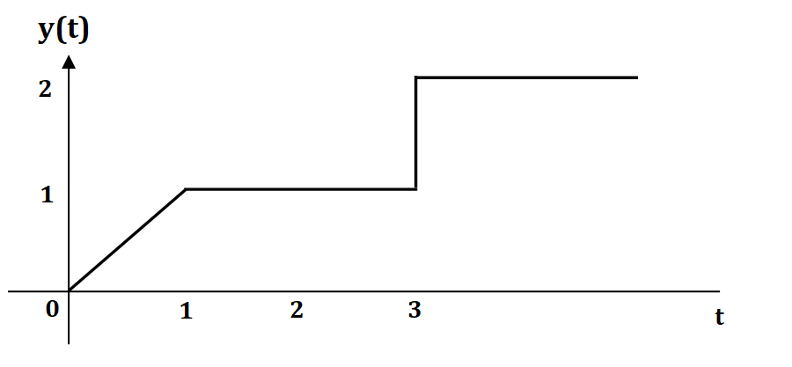
[Labelling axis: 1 Mark, Plotting the graph: 2 Marks, Plotting Amplitude:1 Mark]

QUESTION 4
- Provide answers to the below questions related to Counter type ADC.
  - Draw the block diagram of the counter type ADC. [4 Marks]
  - List the components used in counter type ADC. [3 Marks]
  - Explain in detail about how working principle of comparator utilised in the Counter type ADC. [7 Marks]
  - Explain why DAC is needed in the counter type ADC? [6 Marks]
SOLUTIONS
- Block Diagram
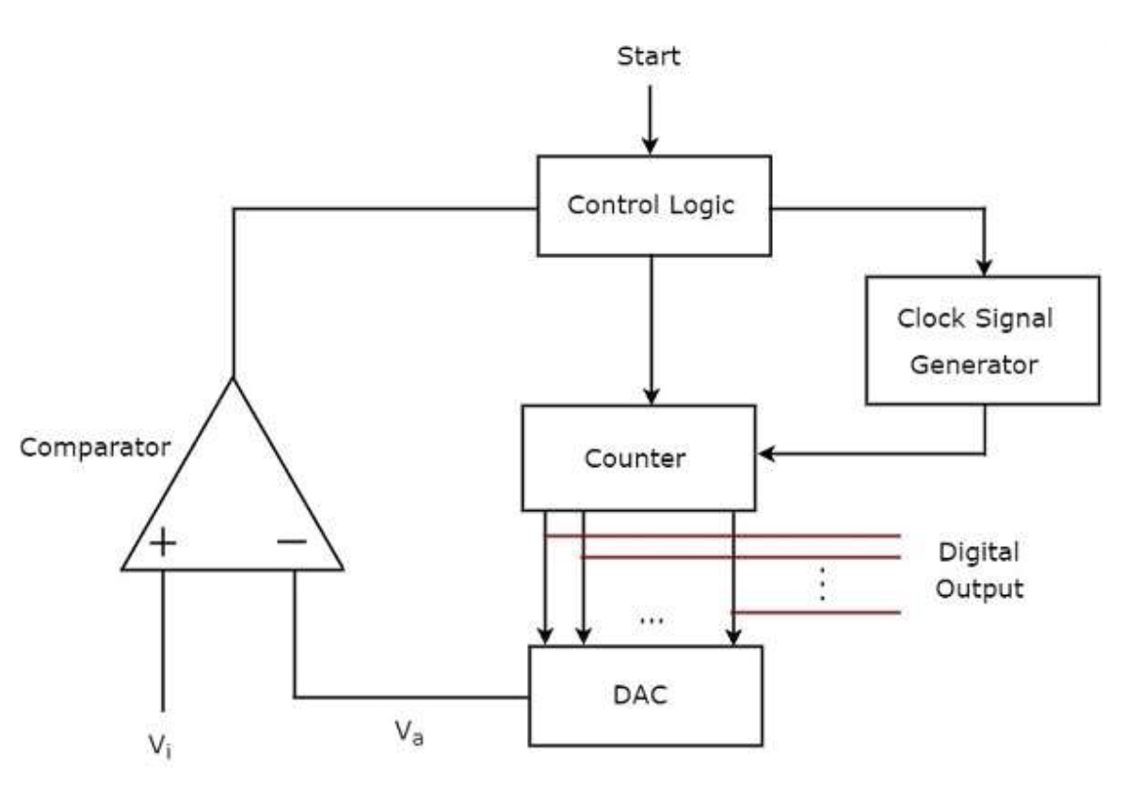
[Block Structure: 1 Labelling: 2 Marks, Block flow: 1 Mark]

- Components
- Comparator
- Control Logic
- Clock Signal Generator
- Counter
      - DAC
      - Digital Outputs [3 Marks]

- Working principle of comparator

- 𝑉𝑖 >Va
  - The output of comparator will be ‘1’ as long as 𝑉𝑖 >Va. This operations will be continuing if the control logic receives ‘1’ from the output of comparator.
[2 Marks]
- Vi $≤$ Va.
  - The output of comparator will be ‘0’ when Vi $≤$ Va. If the control logic receives ‘0’ from the output of comparator, the control logic disables the clock signal generator so that it doesn’t send any clock pulse to the counter.
[2 Marks]
- Digital Output
  - At this instant, the output of the counter will be displayed as the digital output. It is almost equivalent to the corresponding external analogue input value Vi. [2 Marks]
Clock Signal
If the start operation has logic 1, the control logic enables the clock generator.
[1 Mark]
- Need of DAC in ADC
- The DAC is used in ADC to convert the received binary (digital) input, which is the output of counter, into an analogue output.
[2 Marks]
- For an n-bit DAC, there are 2^n voltage levels. The voltage at each level is determined by the combination of bits that are set to '1' in the binary representation of the current count.
[2 Marks]
- The output of the DAC is given as one of the signal to the Comparator which compares this analogue value, Va with the external analogue input value Vi.
[2 Marks]
QUESTION 5
- Consider a UART communication scenario where the string "PRINT" is transmitted.
- Provide the binary representation of each ASCII character in the string.
[5 Marks]
- Demonstrate how the UART data frame would be constructed for each
character by providing relevant diagram. [15 Marks]
SOLUTIONS
- Provide the binary representation of each ASCII character in the string.

P : Hex Value = 50 and the binary value is 00110010 [1 Mark]
R : Hex Value = 52 and the binary value is 00110100 [1 Mark]
I : Hex Value = 49 and the binary value is 00110001 [1 Mark]
N : Hex Value = 4E and the binary value is 01001110 [1 Mark]
T : Hex Value = 54 and the binary value is 00110110 [1 Mark]
- Demonstrate how the UART data frame would be constructed for each
character by providing relevant diagram.
UART Data Frame for the character ‘P’
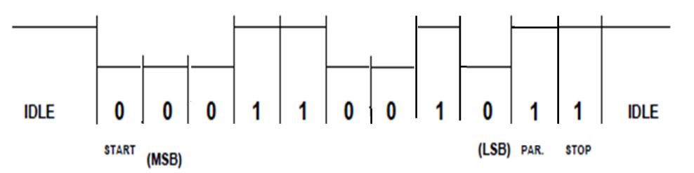
[Labelling: 1 Mark, representing pulses: 2 Marks]
UART Data Frame for the character ‘R’

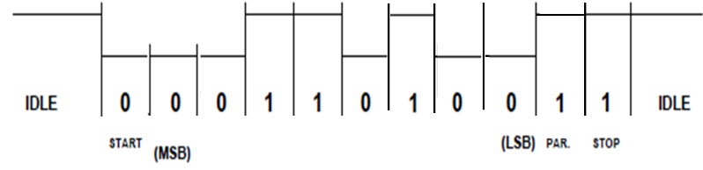
[Labelling: 1 Mark, representing pulses: 2 Marks]
UART Data Frame for the character ‘I’
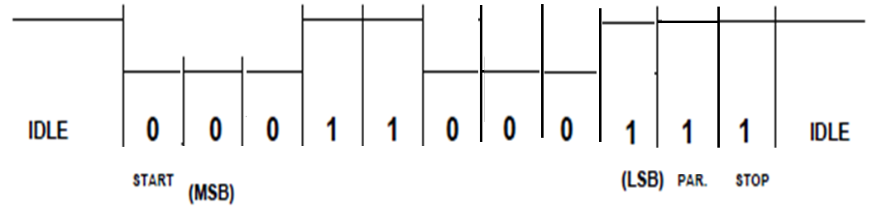
Labelling: 1 Mark, representing pulses: 2 Marks]
UART Data Frame for the character ‘N’
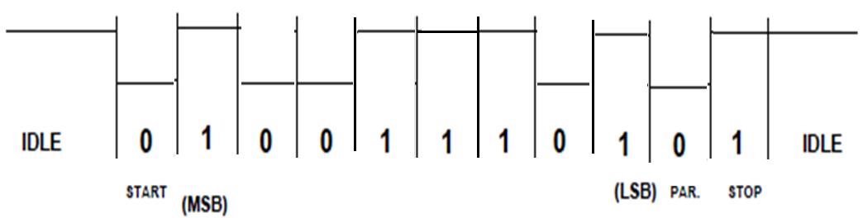
[Labelling: 1 Mark, representing pulses: 2 Marks]
UART Data Frame for the character ‘T’
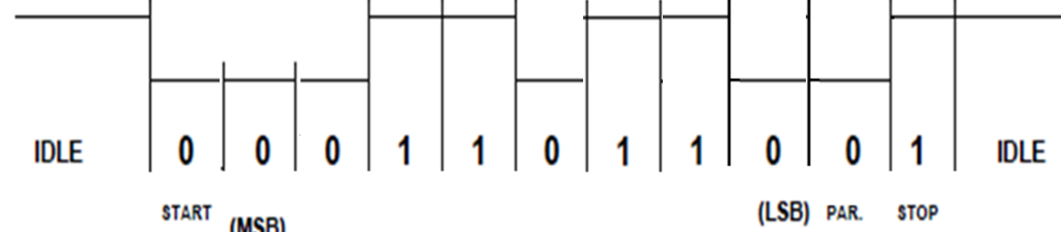
[Labelling: 1 Mark, representing pulses: 2 Marks]

Diwedd/End

