SIMULATION OF DIGITAL MODULATION TECHNIQUES
  - UWTSD Ordnance, Munitions, and Explosives
  - ACDA5008 Digital Signal Processing and Communications
  - Lecturer: Dr. Steve Mosey

  - Word Count: 2082

  - Conor Bradshaw
1907871
Date: 20/03/2021

Table of Contents
1. Introduction 2
1.1. Modulation 2
1.2. Amplitude-Shift Keying (ASK) 2
1.3. Phase-Shift Keying (PSK) 3
1.4. Quadrature Phase-Shift Keying (QPSK) 4
2. Experimental Method 4
3. Results 7
4. Analysis 10
5. Conclusions 10
References 11

Table of Figures
Figure 1: Basic amplitude-shift keying modulation of a source signal 3
Figure 2: A signal modulated using PSK 3
Figure 3: Four QPSK phase shifts 90° apart 4
Figure 4: Basic design of models constructed in Simulink 4
Figure 5: ASK modulator/demodulator created in Simulink 5
Figure 6: PSK modulator/demodulator created in Simulink 5
Figure 7: QPSK modulator/demodulator created in Simulink 6
Figure 8: Graph of bit error rate against signal-to-noise ratio in the ASK system 9
Figure 9: Graph of bit error rate against signal-to-noise ratio in the PSK system 9
Figure 10: Graph of bit error rate against signal-to-noise ratio in the QPSK system 9
Table 1: BER data from ASK system 7
Table 2: BER data from PSK system 7
Table 3: BER data from QPSK system 8

1. Introduction
The aim of this assignment is to compare the performances of amplitude shift keying (ASK), phase shift keying (PSK), and quadrature phase shift keying (QPSK) in the presence of additive white Gaussian noise. Models of these modulators were created and tested in Simulink to compare how well each method could demodulate a signal from a Bernoulli Random Binary generator. The demodulated data was compared to the source data to determine the Bit Error Rate (BER). Noise was gradually increased until system failure occurred, which was determined to be a BER of greater than 0.5.

1.1. Modulation
Modulation is a method of data transmission, in which information is impressed upon a carrier wave through altering one or more characteristics of that wave. Amplitude, frequency, and phase are the most commonly altered characteristics. [1]
Where signals are transmitted wirelessly, the radio wave on its own would not contain any signal information, and as such it must be altered to be of use. Characteristics of the carrier wave are changed to represent symbols (discrete carrier wave states). These symbols may be read by a transceiver and understood to convey information, i.e. the segment of the wave in 90° phase would convey a binary 0, while the segment in 270° phase would convey a binary 1. Examples of altering wave characteristics are amplitude modulation and phase modulation, which are explained in sections 1.2 and 1.3, respectively.
Besides being required, modulation also has benefits. Modulating a transmission allows for, for example, far greater broadcasting ranges, smaller antennae and higher power antennae, since modulating a carrier wave translates it to a higher frequency domain. Higher frequency waves can be more easily transmitted through the Earth’s atmosphere and subsequently across longer distances, which makes modulation vital for communication in the present day, where the need for quick and reliable dialogue across many thousands of miles is greater than ever.

1.2. Amplitude-Shift Keying (ASK)
In ASK, only the amplitude of the carrier wave is modified when the signal is modulated. The simplest version is on–off keying (OOK), where either bursts of a carrier wave are transmitted or nothing is transmitted, depending on whether the input message signal is 1 or 0. Other versions of ASK use non-zero amplitudes to represent 1 and 0. [2]
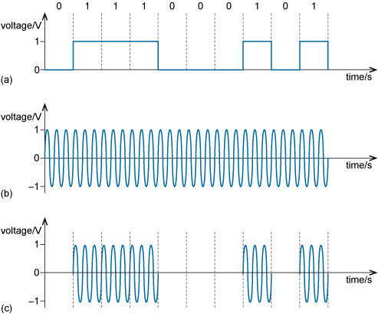
Figure 1(a) shows a digital source signal with two voltage levels. One level (1V) represents 1 and the other (0V) represents 0. The unmodulated carrier wave is illustrated in Figure 1(b). Figure 1(c) is the waveform having been modulated using OOK. [2]
Figure 1: Basic amplitude-shift keying modulation of a source signal [2]

1.3. Phase-Shift Keying (PSK)
PSK in its most simple form is Binary Phase-Shift Keying (BPSK). This is where 0 and 1 are represented by different segments of a sinusoid that differ in phase with each other. Distinguishing between the different phases is easiest for the receiver when the phases are as different as possible. Therefore, in BPSK the phases are separated by 180° or π radians, which makes them completely out of phase. [3]
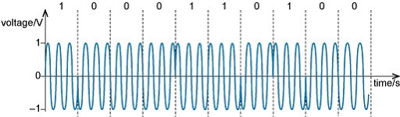
Figure 2 shows a signal that has been modulated using BPSK, where one phase is used to represent a 1, and the other phase, which is 180° out of phase with the first, is used to represent a 0. PSK is less susceptible to the effects of certain types of noise than ASK, since the amplitude of the wave remains constant. Therefore, if the signal is received, the data can be obtained. With ASK, parts of the signal could be more easily lost in background noise as there is not always that constant amplitude.
Figure 2: A signal modulated using PSK [3]

1.4. Quadrature Phase-Shift Keying (QPSK)
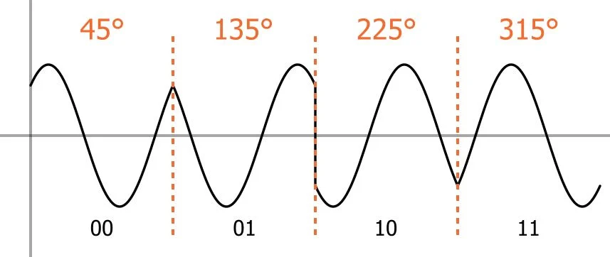
ASK and BPSK make the carrier assume one of two states depending on whether a binary 1 or 0 is being transmitted. As such, ASK and PSK are only capable of transmitting one bit per symbol. QPSK is different because it can transmit two bits per symbol. Because QPSK varies in phase, there are four possible phase shifts, so four possible symbols. A symbol will represent 00, 01, 10, or 11, as opposed to just 0 or 1. This means that QPSK has higher bandwidth efficiency; a baseband signal in a BPSK system has a set frequency, and during each symbol period one bit can be transmitted, but use QPSK and within that same period, two bits can be transmitted. In an ideal system, QPSK would have a higher bandwidth efficiency by a factor of two. [4]
Figure 3: Four QPSK phase shifts 90° apart [4]

2. Experimental Method
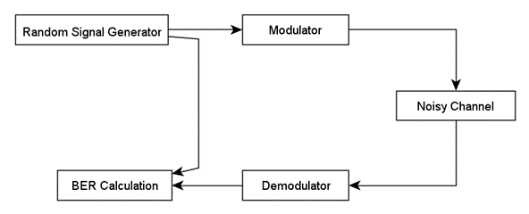
Models of the three different modulation techniques were created in Simulink following the basic design of Figure 4.
Figure 4: Basic design of models constructed in Simulink [5]
A Bernoulli Random Binary generator was used as the input source, and the signal was passed through a Gaussian white noise generator to add noise to the channel. The input signal and demodulated signal were compared to determine the BER of the system at a given level of noise.
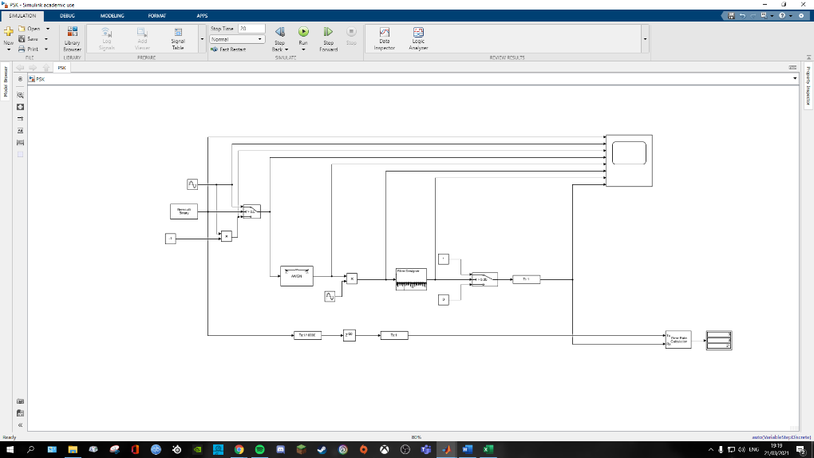
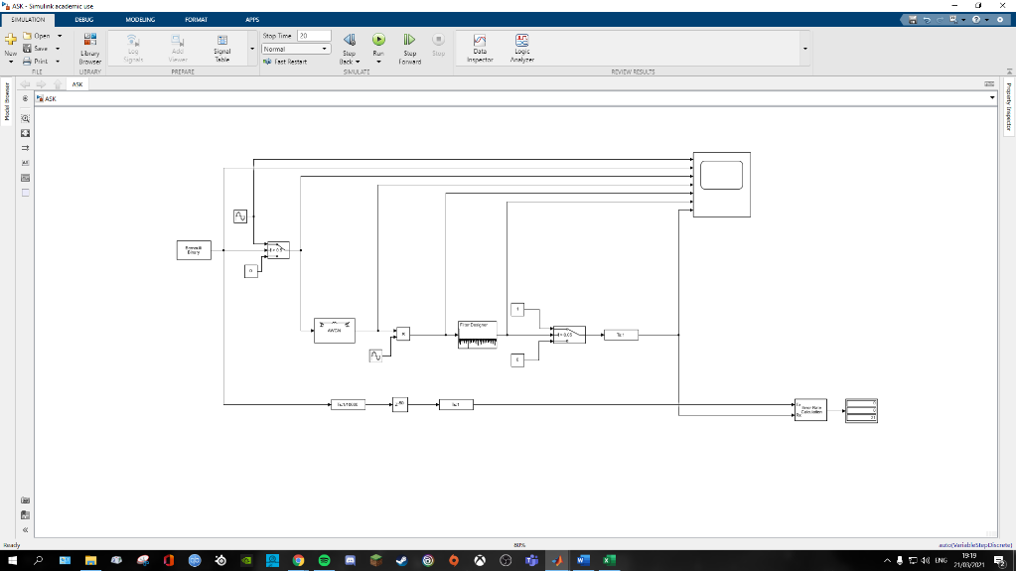
The models created are shown below:
Figure 6: PSK modulator/demodulator created in Simulink
Figure 5: ASK modulator/demodulator created in Simulink

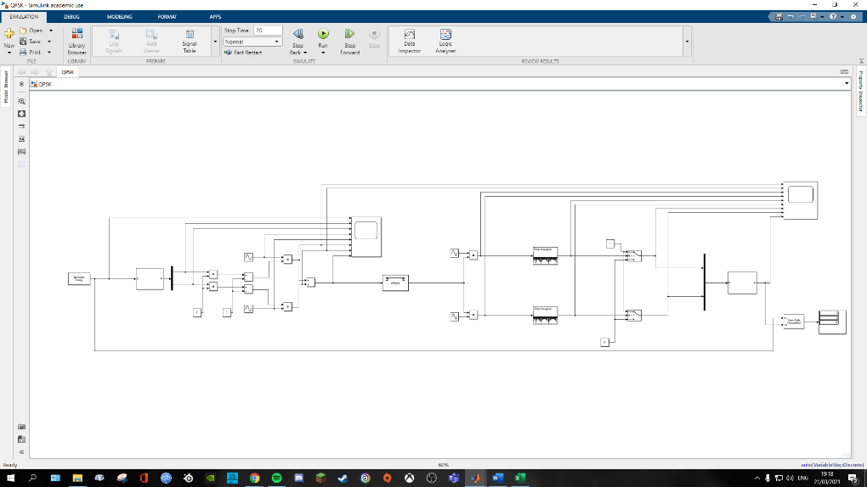
Several simulations were performed, beginning with no noise. To achieve this, the SNR in the AWGN was set to 1. Then, the levels of additive white Gaussian noise were increased incrementally, in steps of 5dB from -5dB to -60dB. These values were chosen as they were determined to make the system reach failure – defined as a BER of > 0.5, since if half the signal is lost it is highly unlikely the signal can be recovered – in a timely manner that still afforded granularity in the data.
Figure 7: QPSK modulator/demodulator created in Simulink
The independent variable in this investigation is the SNR of the AWGN generator. Changes in this variable impact the BER of the system – which is the dependent variable. The BERs of the different systems using different modulation techniques will be compared graphically to determine which modulation technique performs best in the presence of noise.

3. Results
Table 1: BER data from ASK system
SNR (dB) | BER |  |  | Avg. BER
 | 1 | 2 | 3
1 | 0 | 0 | 0 | 0.000000
-5 | 0 | 0 | 0.04762 | 0.015873
-10 | 0.09524 | 0.04762 | 0.09524 | 0.079367
-15 | 0.33333 | 0.28570 | 0.19050 | 0.269844
-20 | 0.33333 | 0.38100 | 0.33333 | 0.349222
-25 | 0.38100 | 0.28570 | 0.38100 | 0.349233
-30 | 0.38100 | 0.33333 | 0.47620 | 0.396844
-35 | 0.38100 | 0.47620 | 0.42860 | 0.428600
-40 | 0.42860 | 0.42860 | 0.47620 | 0.444467
-45 | 0.42860 | 0.57140 | 0.42860 | 0.476200
-50 | 0.57140 | 0.38100 | 0.47620 | 0.476200
-55 | 0.47620 | 0.52380 | 0.57140 | 0.523800
-60 | 0.57140 | 0.52380 | 0.57140 | 0.555533

Table 2: BER data from PSK system
SNR (dB) | BER |  |  | Avg. BER
 | 1 | 2 | 3
1 | 0 | 0 | 0 | 0.000000
-5 | 0 | 0 | 0 | 0.000000
-10 | 0.09524 | 0.09524 | 0.09524 | 0.095240
-15 | 0.04762 | 0.14290 | 0.19050 | 0.127007
-20 | 0.19050 | 0.19050 | 0.23810 | 0.206367
-25 | 0.33333 | 0.23810 | 0.28570 | 0.285711
-30 | 0.28570 | 0.33333 | 0.28570 | 0.301578
-35 | 0.33333 | 0.28570 | 0.38100 | 0.333344
-40 | 0.47620 | 0.42860 | 0.38100 | 0.428600
-45 | 0.57140 | 0.47620 | 0.42860 | 0.492067
-50 | 0.42860 | 0.52380 | 0.57140 | 0.507933
-55 | 0.57140 | 0.47260 | 0.52380 | 0.522600
-60 | 0.52380 | 0.47620 | 0.61900 | 0.539667

Table 3: BER data from QPSK system
SNR (dB) | BER |  |  | Avg. BER
 | 1 | 2 | 3
1 | 0 | 0 | 0 | 0.000000
-5 | 0 | 0 | 0 | 0.000000
-10 | 0.05882 | 0.11760 | 0.05882 | 0.078413
-15 | 0.05882 | 0.17650 | 0.17650 | 0.137273
-20 | 0.11760 | 0.17650 | 0.23530 | 0.176467
-25 | 0.17650 | 0.29410 | 0.29410 | 0.254900
-30 | 0.29410 | 0.23530 | 0.29410 | 0.274500
-35 | 0.29410 | 0.41180 | 0.35290 | 0.352933
-40 | 0.35290 | 0.29410 | 0.41180 | 0.352933
-45 | 0.47060 | 0.29410 | 0.41180 | 0.392167
-50 | 0.35290 | 0.47060 | 0.41180 | 0.411767
-55 | 0.47060 | 0.58820 | 0.35290 | 0.470567
-60 | 0.52940 | 0.47060 | 0.52940 | 0.509800

Figure 9: Graph of bit error rate against signal-to-noise ratio in the PSK system
Figure 10: Graph of bit error rate against signal-to-noise ratio in the QPSK system
Figure 8: Graph of bit error rate against signal-to-noise ratio in the ASK system

4. Analysis
All graphs show a strong relationship between the noise level of the system, as shown by the signal-to-noise ratio, and the likelihood of failure; the more noise present in the system, the higher the likelihood is of system failure. System failure is more likely to occur the more noise there is present, since the addition of noise makes it more challenging for the receiver to distinguish between what is signal and what is noise, and so probability dictates that more segments of the original signal will be lost the more noise there is present.
The strong relationship mentioned is evidenced by the clear negative gradients present in Figures 8, 9, and 10, which show that as the level of noise in the channel increases (more negative dB), the bit error rate also increases. The steepest gradient is in Figure 9 (-0.0099), and the shallowest is in Figure 10 (-0.0087). What this means is that the error rate increases more with the addition of noise while using PSK modulation, and the error rate increases less with the addition of noise while using QPSK modulation.
The spread of data across the three graphs is consistent, following a linear trend. However, in Figure 8, anomalous data points that lie further from the trend line can be seen at -15 dB and -20 dB. A possible explanation for these spurious values could be that by chance, higher bit error rates occurred at the lower noise levels in all three measurements taken. While this is possible, it is more likely that the ASK system is a poorer modulation technique, and as such struggles more with even small amounts of noise.
Further evidence of the poorer performance of ASK and PSK modulation is evidenced in the noise level at which each technique failed. The red line at $y=0.5$ represents the threshold of system failure, and as such the point of system failure was determined to be where the trend line of the data series and this threshold intersect. For the ASK system, system failure occurred at a noise level of -48.0549 dB (Figure 8). For the PSK system, system failure occurred at a noise level of –50.3636 dB (Figure 9). For the QPSK system, system failure occurred at a noise level of -57.1954 dB (Figure 10).

5. Conclusions
From this investigation it can be concluded that QPSK modulation performs best in the presence of noise, when compared with ASK and PSK modulation. This is evidenced by the fact that the QPSK system reached system failure significantly later than the ASK and PSK systems. It can be ascertained then, that QPSK is the superior choice of modulation technique, not just for its better handling of noise, but also for its improved bandwidth efficiency. Therefore, not only would QPSK perform as required more of the time, but it would also allow for more data to be transmitted per signal segment, meaning less energy would have to be expended to get the signal across.
ASK, being so basic, is used in more rudimentary ways nowadays, especially with AM radio having been obsoleted. It is commonly found in portable two-way radios and modems for computers, but its lack of widespread use can be explained by the results of this investigation. Its limited performance in noisy situations makes it impractical to use with any frequency or for important jobs in the real world, given the real world’s nature to be less than ideal in terms of operating conditions. While its simplicity is great for ease of implementation, it is also limiting in terms of bandwidth efficiency, making it more practical to use a modulation technique such as QPSK.

References

[1] | Britannica, the Editors of Encyclopaedia, “Modulation,” 9 September 2010. [Online]. Available: https://www.britannica.com/technology/modulation-communications. [Accessed 23 March 2021].
[2] | The Open University, “Amplitude-Shift Keying,” 11 March 2019. [Online]. Available: https://www.open.edu/openlearn/science-maths-technology/exploring-communications-technology/content-section-1.4. [Accessed 22 March 2021].
[3] | The Open University, “Phase-Shift Keying,” 11 March 2019. [Online]. Available: https://www.open.edu/openlearn/science-maths-technology/exploring-communications-technology/content-section-1.6. [Accessed 22 March 2021].
[4] | R. Keim, “Understanding Quadrature Phase Shift Keying (QPSK) Modulation,” 17 August 2016. [Online]. Available: https://www.allaboutcircuits.com/technical-articles/quadrature-phase-shift-keying-qpsk-modulation/. [Accessed 22 March 2021].
[5] | S. Mosey, DSP & Communications Assignment Specification, Swansea: UWTSD, 2020.

