

BEng Motorsport/Automotive Engineering

Engineering Design and Materials

Material Selection Report & GD&T Drawings

ACHA4001

Nevin Jyothis 2205181

University of
Wales Trinity Saint David
School Of Engineering

Contents:
Introduction 3
Component design specification 4
Material selection 5
Manufacturing process selection 7
Conclusion 8
References 9

Introduction:
This report investigates the selection of a specific material and manufacturing process for the
engine block of a twin-turbo 4.0 L TFSI V8 engine from a 2020 Audi RS6.
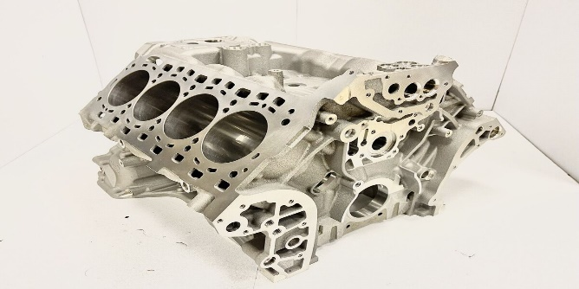
Figure 2 Audi rs6 2020 engine block (Auto Express, n.d.)
Figure 1 Audi rs6 2020 (eBay, n.d.)

The engine block, being a critical component of the engine, requires a material that
can withstand high temperatures and pressures, while also being lightweight and
cost-effective. The manufacturing process must ensure precision and quality, while
minimizing the waste and cost.
The aim of this report is to analyse the reasons behind the chosen material and
manufacturing process whilst also considering factors such as thermal properties, strength,
weight, cost, and compatibility with the engine design. The objective is to
understand the decision-making process that led to the enhanced performance and
efficiency of the Audi RS6 engine, while ensuring durability and reliability.

Component design specification
A component design specification for my engine block would look like:

Performance requirement | Design Requirement | Design specification
Cost | Must be within budget | £3000
Manufacturing process | must be precise and quality | Use high quality materials
Environmental impact | Minimise environmental impact | Design with sustainability minimising environmental impact such as using cad to minimise material usage
corrosion | Use materials that are resistant to corrosion | Use aluminium and certain types of steel and cast iron
Material selection | Needs to withstand high temperatures and pressure | Use materials like cast iron, aluminium and compacted graphite iron
durability | Withstand every day and rigorous use | Strong materials such as aluminium

The selection of material and manufacturing process for an engine block involves considering a range of acceptable figures/values for various factors:

Strength: The material should have high tensile strength to withstand the pressures and temperatures in an engine. For aluminium, the tensile strength typically ranges from 40 to 90 ksi.
Thermal Conductivity: Aluminium has a thermal conductivity of around 150-200 W/mK, which is beneficial for heat dissipation.
Density: ‘Aluminium has a density of about 2.7 g/cm³, making it lighter than cast iron’ (Zhang and Li, 2023).
Material Cost: The cost of aluminium can vary, but it’s generally more expensive than cast iron.
Environmental Impact: The environmental impact of the material and manufacturing process is increasingly important. This includes the energy required for manufacturing and the recyclability of the material.
Corrosion Resistance: Aluminium has good corrosion resistance, which can extend the life of the engine block.

Material selection

Using the component design specification table, you can see that aluminium and cast iron are common materials listed, so using that we can look at figure /value ranges to help us compare each material to help us pick a material to use for the engine block:

Cast iron:
Cost: Cast iron is generally more affordable, reducing the cost of the block by about 40% or more compared to aluminium.
Strength: Cast iron is more rigid than aluminium, which can lead to better ring seal and more power because it won’t deflect and distort as much under high cylinder pressures.
Weight: Cast iron is heavier, which can be a disadvantage in applications where weight reduction is important.
Heat Retention: Cast iron retains heat well, which can be beneficial in certain applications.

Aluminium:
Cost: Aluminium engine blocks are more expensive due to the cost of the alloys used.
Strength: Aluminium is not as durable as cast iron and is somewhat prone to warping.
Weight: Aluminium is much lighter than cast iron, which can lead to improved fuel efficiency and performance.
Cooling: Aluminium dissipates heat much more quickly than cast iron, which can help to prevent overheating.

We can also compare these materials more thoroughly by using a property table

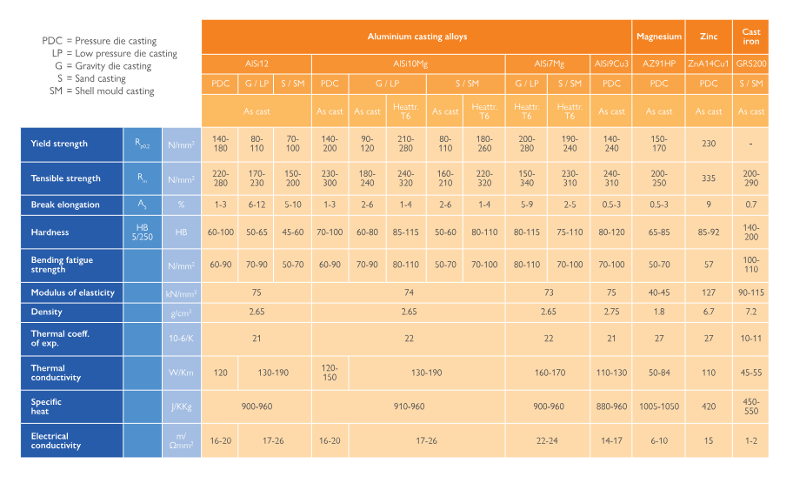
Figure 3, material property table of cast iron & aluminum (2024)

Using the table, you can come to the conclusion that:
Density: Aluminium is lighter than cast iron due to its lower density.
Tensile Strength: Aluminium has a good tensile strength, but it’s lower than that of cast iron.
Ductility: Aluminium is more ductile and malleable than cast iron.
Melting Point: Aluminium melts at a lower temperature compared to cast iron.

Manufacturing process selection

The manufacturing process for an aluminium engine block involves several key steps, each with its own considerations for environmental impact, cost, durability, and corrosion:
Casting: The first step is casting, where molten aluminium alloy is poured into a Mold. ‘Sand casting is commonly used due to its cost-effectiveness and ability to create complex shapes’ (UAE’s leading autos blog dubizzle Cars, 2022). However, it can have environmental impacts due to the energy required to melt the aluminium and the waste generated from used sand Molds.
Heat Treatment: After casting, the engine block undergoes heat treatment to enhance its strength and durability. This process requires significant energy, contributing to a slight environmental impact.
Design: ‘The engine block design is created using CAD (Computer-Aided Design) software. This design includes all the necessary features of the engine block, such as cylinders, coolant passages, and mounting points’ (shaikhah, 2023). Designing the product in CAD also lowers the environmental impact as you can plan and test how the block would perform without wasting energy on cutting materials.

Machining: ‘The engine block is then machined to its final shape and dimensions. While machining ensures precision, it also generates waste material’. (Engine Builder Magazine, 2017)
Finishing: The final step is finishing, which may include cleaning, inspection, and application of any necessary coatings. The coatings can enhance the corrosion resistance of the aluminium engine block.
In terms of cost, ‘aluminium engine blocks are generally more expensive to produce than cast iron blocks due to the higher cost of aluminium alloys and the more complex casting process required’ (Bike Restart, 2021). However, the benefits of aluminium, such as its lightweight nature and excellent heat dissipation properties, often justify the higher cost.
Durability is a key in consideration of the design of an aluminium engine block. ‘While aluminium is not as durable as cast iron and is somewhat prone to warping, modern manufacturing techniques and alloys have significantly improved the durability of aluminium engine blocks’. (Performance Racing Industry, n.d.2021)
Corrosion resistance is another important factor. Aluminium actually has excellent corrosion resistance due to a formation of a stable oxide film on its surface. This film is resistant to water and oxygen, making aluminium alloys useful in a variety of environments.

Conclusion

In conclusion, this report has conducted a detailed analysis on the selection of an appropriate material and manufacturing process for an aluminium engine block for an Audi rs6; we’ve chosen Aluminium, due to its high strength-to-weight ratio, excellent heat dissipation, and corrosion resistance sue to this it has been identified as an ideal material for to use for the engine block. The manufacturing process, which includes casting and machining, has been optimized to ensure the production of high-quality and durable engine blocks. The manufacturing process, including casting and machining, has been optimized to ensure the production of durable and high-quality engine blocks.
For Audi, the use of aluminium not only enhances the vehicle’s performance but also contributes to better fuel efficiency due to the reduced weight. This aligns with Audi’s commitment to delivering high performance vehicles that are also sustainable.

This report also underlines the significance of continuous research and development in the field of materials and manufacturing processes. This will not only lead to the production of more efficient and reliable engine blocks but also contribute to the overall advancement of the automotive industry.

References

Engine Builder Magazine. (2017). Machining Aluminium Engine Blocks - Engine Builder Magazine. [online] Available at: https://www.enginebuildermag.com/2017/07/machining-aluminum-engine-blocks/.[Accessed 17 Apr. 2024]
‌Performance Racing Industry. (n.d.). Make The Case: Iron vs. Aluminum Engine Blocks. [online] Available at: https://www.performanceracing.com/magazine/columns/03-01-2021/make-case-iron-vs-aluminum-engine-blocks. [Accessed 17 Apr. 2024]
‌Bike Restart. (2021). What Are Engine Blocks Made Of? (Engine Block Materials). [online] Available at: https://bikerestart.com/engine-block-materials/.[Accessed 19 Apr. 2024]
‌
UAE’s leading autos blog | dubizzle Cars. (2022). Guide to Engine Block Making: Process, Materials & More | dubizzle. [online] Available at: https://www.dubizzle.com/blog/cars/engine-blocks/.[Accessed 19 Apr. 2024]
‌Zhang, A. and Li, Y. (2023). Thermal Conductivity of Aluminum Alloys—A Review. Materials, 16(8), p.2972. :https://doi.org/10.3390/ma16082972. [Accessed 19 Apr. 2024]
‌shaikhah (2023). Mastering The Art Of Engine Design: A Step-By-Step Guide. [online] ScienceSphere.blog. Available at: https://sciencesphere.blog/engine-design-step-by-step-guide/ [Accessed 21 Apr. 2024].
‌eBay. (n.d.). New OEM Audi S8 RSQ8 RS6 RS7 Porsche Cayenne Panamera Engine Block 0P2103023M. [online] Available at: https://www.ebay.co.uk/itm/124647413571 [Accessed 21 Apr. 2024].
‌Auto Express. (n.d.). New Audi RS 6 Avant 2020 review. [online] Available at: https://www.autoexpress.co.uk/audi/rs6/avant [Accessed 21 Apr. 2024].
‌

