What made the Cistercian Wool Economy Uniquely successful?
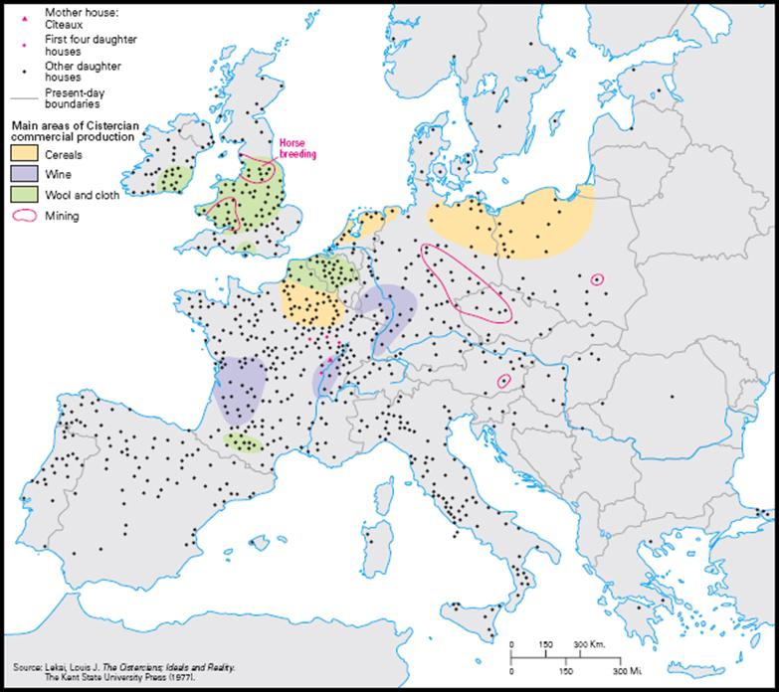
Wool was the most important economic product in England in the twelfth century (Burton, 1995; 236). The Cistercians were not the first to farm sheep on a large scale, yet they have become regarded as the most successful. The exemption from taxes benefited all the monastic orders, and the Cistercians developed free passage through tolls that enabled them to transport the wool clip from disparate areas to a central location for cleaning, grading and selling (Donkin, 1958a; 110). Cistercians were not allowed to earn money from temporal sources, necessitating a “trade of surplus” system to maintain the monastic populations. In England and Wales, the land was perfect for pastoral farming, such as sheep. This is not the case across Europe; the Cistercians developed trade with whatever they had in surplus (Fig. 1). While we talk about the English wool trade being dominated by the White Monks, trading in wool was an English trade rather than a Cistercian one.
Figure 1: Map showing main areas of Cistercian commercial production (https://www.medieval.eu/new-cistercian-studies-a-handlist-of-good-books/; Accessed on 05/01/2022)
The documents produced by the monastic houses give the most information about the pastoral economy; however, when looking at the extant records, it is important to note that larger houses and estates produced more records; therefore, the overall picture is distorted (Burton,1995; 233). In addition, there is an absence of evidence in the form of account rolls and early charters, which complicates the understanding of monastic administration (Burton, 1999; 245). One of the most essential resources for examining the wool trade of the Middle Ages is Francesco Balducci Pegolotti, La Pratica Della Mercatura (The Merchants Handbook). Pegolotti discusses many aspects of the medieval economy, and his handbook contains a comprehensive list of English wool producers with the types of wool (good, medium, poor) they processed and how much they received per sack (Pegolotti, 1936). Although this work focuses on the wool trade, it is vital to remember that sheep were kept for other purposes, such as milk and cheese.
The first wave of monasticism in England saw the construction of many Benedictine houses, and much of the best arable land had already been donated to these houses by the second wave in the twelfth century (Bond, 2004; 34). One of the main aspects of the Cistercians was their aspiration of self-sufficiency, as such any new foundation required a large area of land; other orders, such as the Augustinians, did not require as much land as they were able to generate income from other sources such as churches (Bond, 2004; 34). The Cistercian desire for “deserted” locations helped their foundations and expansions in Yorkshire as the north had been devastated by King William in the late eleventh century. Land was the most important economic resource to religious orders, and the main period of land expansion was from the period of foundation pre-conquest the late twelfth century (Burton, 1995; 235). While the Cistercians were known for their “grange” system, most monasteries owned land away from the abbey site. The black monks owned manors, and there is not much difference between secular and monastic management of the manor (Burton, 1999; 244-245). In order to successfully run a monastic house, there must be enough arable land near the monastery to feed the monks, or at least most of them if another resource could be exploited to bridge any gap. Some monasteries, such as the Augustinian Bolton and Lilleshall, moved the site to gain better arable land near the monastery (Burton, 1995; 235). After the initial foundation, many religious houses received donations and benefactions of land. In some cases, there is a record of what the land was for, such as cattle or sheepfolds (Burton 1995; 229). Donated pastoral land could be access to common grazing where the monastery would have to cooperate with its neighbours (Burton, 1995; 236; Bond 2004; 40). Depending on what land was available to them, different religious houses may focus on different areas of production. For example, Bolton Priory produced most of its own corn, whereas Malton Priory focused on sheep and bought in large amounts of corn (Burton, 1995; 235). This can also be seen in Pegolotti’s Handbook as Bolton produced six sacks of wool per year and only in one grade, whereas Malton produced 45 sacks per year in three different grades (Appendix. 1). Flowing water was incredibly important to large monasteries for many reasons, including hygiene and transportation. The location of Thornton Abbey close to a watercourse, enabled them to trade in the major wool ports with ease (Oswald, 2011; 106). When looking for a “unique” aspect of the Cistercian wool economy, there is little to be found in their acquirement and use of land.
The Cistercians are often made out to be the pioneers of the wool trade and masters of sheep and wool; however, their role in the wool trade should not be overestimated. The large Benedictine houses were very accomplished sheep farmers, with Ely having flocks of over 13,000 sheep in 1086 (Burton, 1995; 236). Wool was one of the most significant strands of the economy at the Augustinian Thornton Abbey (Oswald, 2011; 106). In 1291 the income of Thornton was £235 but had risen to over £1,500 by 1313, of which almost half came from the wool trade (Oswald, 2011; 2). In 1313, the abbey had almost 8,000 sheep and produced more than 86 sacks of wool. The flock size is similar to the top Cistercian wool producers of Wales (Tintern and Margam); however, it is only half the 14,000 owned by the Yorkshire houses of Fountains, Rievaulx and Meaux (Oswald, 2011; 11). By the thirteenth century, the Cistercians had gained a reputation for producing good wool. However, we should be cautious in viewing the “Cistercian flock” as a homogeneous entity. There are substantial variations between the wool produced in different areas, and Donkin’s assertion that sheep from the Fens would do well on the plains around Chichester is not necessarily true (Donkin 1958b; 4). Sheep on rough pasture, like the Fens and Yorkshire Moors, produce a high-quality fleece (Walling, 2014; 17). The Yorkshire estates seem to produce a heavier fleece than those in the south (Stevenson, 1988; 373). Initially, the General Chapter of the Cistercians ruled that monasteries were only allowed to sell wool one year in advance without permission from the General Chapter; however, by 1278, this rule was amended to allow for longer contracts (Whitwell, 1904; 11). Not only did the Cistercians benefit from toll and tithe exemption, but in 1221 Pope Honorius III “inhibited the extraction of tithe of wool, milk or lambs by the rectors of parishes in which the Cistercian’ sheep were pastured”; this act was repeated and was sometimes for the benefit of specific houses (Whitwell, 1904; 16). In Pegolotti’s Handbook, there are more Cistercian houses producing wool than any other monastic order, and the prices show that the monks were getting a better price than other producers (Donkin, 1958b; 2). While most of the Cistercian houses listed by Pegolotti supplied wool in at least two of the three grades, the same is not true of other religious orders which generally supplied unsorted wool (Donkin, 1958b; 7).
Once the clip had been brought to the abbey, it could be washed and graded. By grading the entire years clip together, the abbeys could get the most amount of money for the raw material. An agreement between Pipewell Abbey and merchants of Cahors in 1291 shows how much influence the merchants had over the wool producers in running and organising the flocks (Donkin, 1958b; 4). This does question how much the monks developed English wool and how much was at the direction of the cloth merchants. Indeed, the monasteries offered cloth makers a stable and controlled wool supply. The merchants were able to affect the care of the sheep, and if disease did break out, the monasteries were in a better position to isolate infected flocks than the average farmer, though this did not stop them from being severely affected by outbreaks of scab and ‘murrain’ (Donkin, 1958b; 6).
Monasteries were the most capable of washing, sorting and packing to a high standard. They had access to flowing water for cleaning, buildings to collect and sort the wool into grades and a large, unpaid workforce of lay brothers. Many monastic houses had buildings specifically for the collecting and sorting wool called lanaria (Donkin, 1958a; 447). There is also evidence that buyers would occasionally send someone to sort and pack the wool. The 1291 contract with Pipewell Abbey states that the merchants nominated preparer would be housed and fed at the cost of the abbey (Donkin, 1958b; 7), another factor that the monasteries could easily absorb as they were already engaged in hospitality. The contract from Pipewell shows how highly regarded the preparer was as it states that neither the abbey nor merchant can disagree with him (Donkin, 1958b; 7). If this person was working at the abbey, he would have undoubtedly communicated with the lay brothers who worked with sheep and wool and imparted a vast amount of information. A similar contract with Darnhall also stipulated that the wool be “...’ dressed’ in Hereford by an employee of the merchants” (Donkin; 1958b; 7).
The exemption from toll and grading of wool is a unique factor in the Cistercian wool economy. While other monastic houses also had some toll and tithe exemptions, the evidence suggests that the Cistercians benefited the most and could transport goods almost all the way across the country without paying (Donkin; 1957; 116). The grading system was a definite advantage to houses that produced “good” grade wool, and the Cistercian houses appear to have had a very close relationship with European merchants. This connection would have enabled them to understand what the merchants wanted from the fleece and how they wanted it packed, all of which made the White Monks preferable suppliers. While all the large monastic houses had the capabilities to collect, wash and sort the wool at a central location and provide board and lodgings for outsiders, it appears that the Cistercians are the ones who took advantage of this to the fullest extent.
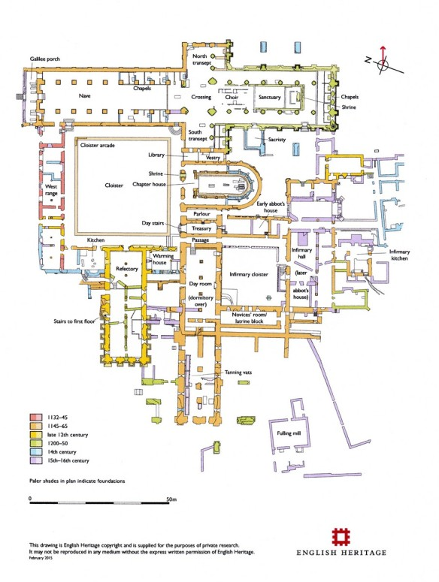
Cistercians were not allowed to obtain income from a temporal source such as mills and ovens (Burton, 1995; 236); because of this, developing a “trade of surplus” was necessary for their survival. No matter how determined, it is not possible for a community the size of Fountains to sustain itself without support from outside society. When looking at the Cistercians, it is easy to fall into the trap of viewing change as a form of decline from the original ideal of the order and of Saint Bernard. However, it is important to remember that despite the eventual size of the order, the different geographical locations and changes in broader society, the Cistercians were always regarded as men who had the ear of God (Bouchard, 1991; x). In the fourteenth century, the wool trade contracted, and it was no longer economically viable for the Cistercians to send the raw material to the continent and buy the finished cloth. In the fifteenth century, the wool behemoth of Rievaulx installed a fulling mill in the inner court to produce their own cloth (Fig. 2).
Figure 2: Plan of Rievaulx Abbey (English Heritage; 2015)
When it comes to discussing the economics of monasteries, the focus tends to be on self-sufficiency as this is an integral part of monastic life. However, a monastery that was entirely self-sufficient to the point of not needing anything from the outside world ceases to function as an authentic monastery as it neglects the other pillars: charity and hospitality. It is possible to determine how much arable land would be required for the number of monks at a particular monastery, but there are always times when more is needed. Benefactors, kings and travellers stayed in the guesthouses and required food and fuel, and during times of famine, the local population would go to the church for help. By reaching for the ideal of self-sufficiency, monasteries were able to look after their own and, at the same time, service people on the road and help during times of distress. For example, during the famine of 1189, the monks of Margam were sent to Bristol to buy corn (Burton, 1995; 236); a monastery completely cut off from society would not have the connections to be of assistance in this situation. As monastic houses became wealthier, they gained greater responsibilities that had a financial burden, requiring them to maintain their income. In the winter of 1304, Edward I stayed at Thornton Abbey on his way to Lincoln (Oswald, 2011; 11).
The Cistercians were latecomers to the monastic life. Because of this, their options for land in England was fairly limited. The best land had already been endowed to other monasteries, and while it can be argued that this was in their favour; after all the Cistercians sought a “desert” existence, they still needed a large amount of arable land for a degree of self-sufficiency. The houses with foundations before the Norman conquest were the most successful (Burton 1995; 234). There are many aspects of the Cistercian wool economy that can be seen in other religious and secular flocks. However, the influence of the merchants on the management of flocks and the grading of wool seems to be the unique factor. The significant advantage the Cistercians had was a pre-eminence in preparing wool for sale (Donkin, 1958b; 8). This advantage was undoubtedly developed over time through a very close working relationship with the merchants buying the wool. Kirkstall Abbey entered into a contract in 1292 to supply merchants from the Society of Betti of Lucca with all the wool of the house for ten years; however, it was three years into the contract before the abbey was grading the wool (Donkin, 1958b; 7-8). These conclusions are based on information that is easily accessible. While there may be evidence in some manuscripts from other religious houses, they have not been translated or published. The Cistercians are also highly organised, leaving more extant records than other monasteries. The repeated statues given by the general chapter show the kinds of wool related issues faced by the Cistercians and how they attempted to deal with it.

Appendix 1
A selection of wool production data from Francesco Balducci Pegolotti, La Pratica Della Mercatura
House | Religious Order | Marks Per Sack of Wool |  |  |  | Sacks per year | Page in Handbook
House | Religious Order | Good | Medium | Poor | Other | Sacks per year | Page in Handbook
Fountains | Cistercian | 21 | 12 | 9 | - | 76 | 260
Thornton | Augustinian | 16 ¹/₂ | 10 ¹/₂ | - | - | 8 | 267
Merton | Augustinian | - | - | - | - | 20 | 269
Rievaulx | Cistercian | 17 ¹/₂ | 10 ¹/₂ | 9 | - | 60 | 260
Beaulieu | Cistercian | 24 | - | 15 | - | 25 | 262
Tintern | Cistercian | 28 | 15 | 14 | - | 16 | 261
Kirkham | Augustinian | - | - | - | 14* | 30 | 267
Langley | Benedictine | - | - | - | 7** | 8 | 266
Shouldham | Augustinian | 12 ¹/₂ | - | - | - | 16 | 265
Malton | Gilbertian | 17 | 11 | 6 | - | 45 | 265
Bolton | Augustinian | - | - | - | 12** | 6 | 267
Pipewell | Cistercian | 22 | 12 | - | - | 14 | 262

* Rolled wool
** Collected wool

Reference List
Primary
Francesco Balducci Pegolotti, La Pratica Della Mercatura, Evans, A (ed), (The Medieval Academy of America, 1936)
Secondary
Bond, J. Monastic Landscapes (Tempus Publishing, 2004)
Bouchard, C. B. Holy Entrepreneurs: Cistercians, Knights, and Economic Exchange in Twelfth-Century Burgundy (Cornell University Press, 1991)
Burton, J. Monastic and Religious Orders in Briton, 1000-1300 (University of Cambridge Press, 1995)
Donkin, R. A. ‘The Dispersal of Cistercian Wool in England and Wales During the Twelfth and Thirteenth Centuries’ Citeaux In Der Netherlander (1957) 109-131
Donkin, R. A. ‘Bercaria and Lanaria’, Yorkshire Archaeological Journal Vol. 39 (1958a) 447-450
Donkin, R. A. ‘Cistercian Sheep-Farming and Wool-Sales in the Thirteenth Century Agricultural History Review, Volume 6 (1958b) 2-8
Oswald, A., Goodall, J., Payne, A. and Sutcliffe, T-J. ‘Thorton Abbey, North Lincolnshire: Historical, Archaeological and Architectural Investigations’ Research Department Report Series 100-2010, (English Heritage, 2011)
Stephenson, M. J. ‘Wool Yields in the Medieval Economy’ The Economic History Review 41:3 (Wiley, 1988)
Walling, P. Counting Sheep: A Celebration of the Pastoral Heritage of Britain (Profile Books, 2014)
Whitwell, R. J. ‘English Monasteries and the Wool Trade in the 13th Centuary’, Vierteljahrschrift für Sozial- und Wirtschaftsgeschichte, 2:1 (1904) 1-33

