LEVEL 6 ASSESSMENT SPECIFICATION

Student name: | Madalina Ionela Preda
Student ID number: | 2213175
Programme: | BA International Hotel Management
Module: | Managing Food & Beverage Operations
Module code: | BMIH6002
Assignment Title: | Student Learning Log
Lecturer: | Lisa Bassler
I acknowledge the use of Grammarly (https://www.grammarly.com/) on 02 March 2025 to check my work using the prompt(s):
Please check the following text for readability, grammar and syntax.
I acknowledge the use of ChatGPT (https://chatgpt.com/) on 02 March 2025 to write my notes into submission format using the prompt(s): 1. Please write up these bullet points as an essay paragraph at university level.
I confirm that I have not presented any AI generated text as my own work. I confirm I have copies of my drafts, notes, and other resources I used before, and after the use of AI tools which I may be asked to provide in evidence.

REFLECTIVE LEARNING LOG: SHADOWING A SUPERVISORY ROLE IN THE FOOD AND BEVERAGE DEPARTMENT

Table of Contents
Introduction 3
Section 1: Reflection on Experience and Personal Development (Gibbs’ Model – Description, Feelings, and Evaluation) 3
Experience of Shadowing a Supervisory Position 3
Work-Based Skills and Technical Knowledge 4
Impact of Personal and Vocational Development 5
Section 2: Critical Analysis of Work-Based Skills and Technical Knowledge (Gibbs’ Model – Analysis) 5
Importance of Work-Based Skills and Technical Knowledge 5
Application of Learning Examples 6
Section 3: Reflection on Organisational Issues (Gibbs’ Model – Conclusion and Action Plan) 7
Identifying an Organisational Issue 7
Conclusion and Action Plan (Gibbs’ Model – Action Plan) 8
Key Insights and Reflections 8
Future Professional Development 8
References 10

Introduction
The Hilton Inn Racecourse Doncaster is a well-established hotel that provides high-quality food and beverage (F&B) services to guests, particularly catering to racecourse visitors. The hotel's F&B department plays a crucial role in ensuring exceptional guest experiences through efficient service, high-quality menu offerings, and well-trained staff.
The primary learning objectives for this placement included:
- Understanding the role and responsibilities of a supervisor within the F&B department.
- Developing key work-based skills, such as communication, teamwork, and task management.
- Gaining technical knowledge required to maintain high guest service standards.
- Learning how organizational challenges affect service delivery and exploring potential solutions.
- Enhancing personal and professional growth within the hospitality industry.
This reflective learning log follows Gibbs’ Reflective Cycle, which provides a structured framework for self-analysis and continuous improvement.

Section 1: Reflection on Experience and Personal Development (Gibbs’ Model – Description, Feelings, and Evaluation)

Experience of Shadowing a Supervisory Position
During my placement, I had the opportunity to shadow a supervisor in the F&B department, observing and participating in various supervisory tasks (Chan et al., 2024). This included overseeing staff, managing guest interactions, coordinating service during peak hours, and ensuring compliance with hotel policies. The role required balancing efficiency, guest satisfaction, and team motivation, which provided me with first-hand insights into the complexities of hospitality management.
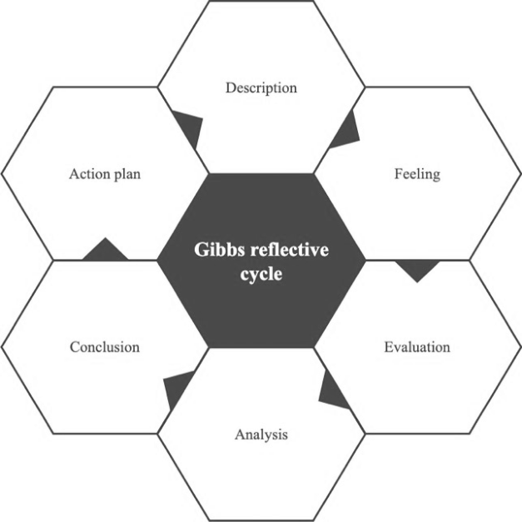
Figure 1: Gibbs’ Model – Description, Feelings, and Evaluation
(Source: researchgate.net, 2025)

Work-Based Skills and Technical Knowledge
This experience significantly contributed to my understanding of the essential skills and knowledge required in F&B supervision:
- Communication Skills: Effective communication was vital in coordinating staff, addressing guest concerns, and ensuring seamless service (Thorton and Stairs-Davenport, 2025). I observed how supervisors used clear verbal instructions and non-verbal cues to manage the team efficiently.
- Teamwork and Leadership: Working alongside the supervisor highlighted the importance of teamwork and delegation (Mirren, 2021). A successful supervisor must foster collaboration and ensure every team member understands their role.
- Task Management: The supervisor’s ability to prioritize tasks, handle multiple guest requests, and maintain service flow was crucial. Learning to adapt to fast-paced environments improved my time management skills.
- Guest Service: The experience reinforced the significance of high service standards. Personalized interactions, attention to detail, and prompt responses to guest needs enhanced customer satisfaction.

Impact of Personal and Vocational Development
Following Gibbs’ model, I evaluated how my background influenced my learning:

Academic Journey (Level 4 to 6): Theoretical knowledge from my studies was practically applied in a real-world setting (Manfreda et al., 2023). I specifically applied customer service recovery theories when handling guest complaints.

Previous Industry Experience: Shadowing a supervisor expanded my understanding of strategic decision-making and leadership responsibility, reinforcing my ability to use delegation techniques effectively.

Placement Learning: Observing supervisors make quick decisions reinforced the importance of problem-solving and adaptability (Negrin et al., 2022). I also gained insight into operational cost management, a crucial aspect of F&B supervision.

Section 2: Critical Analysis of Work-Based Skills and Technical Knowledge (Gibbs’ Model – Analysis)

Importance of Work-Based Skills and Technical Knowledge
Vocational competencies and professional content knowledge are relevant in delivering quality services to customers and retaining their patronage. The particular competencies that have been gained in the process are as follows:
- Conflict Resolution: This is why it is possible to say that learning how to accept and handle guest complaints is of paramount importance in the F&B service. I ascertained the way that supervisors manage to manage conflict, give advice and sustain the confidence of the guests.
- Operation Experience: Being aware of basic restaurant operations, including reservation management, inventory, and the kitchen, made me aware of the efficiency of the restaurant business (Hung, 2024). I participated in optimizing table turnover rates to enhance service efficiency.

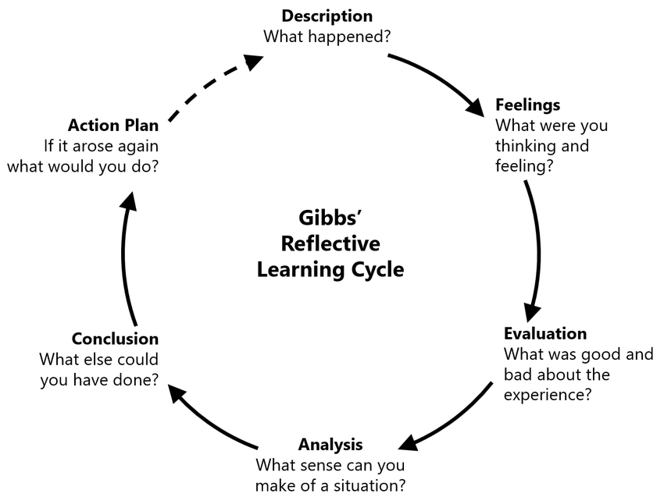
Figure 2: Gibbs’ Model – Analysis
(Source: researchgate.net, 2025)
- Training and Development: Supervisors play a crucial role in training staff to uphold service standards (Goldman et al., 2024). I assisted in training sessions where menu engineering techniques were discussed to improve profitability.
- Application of Learning Examples
- Example 1: Managing Peak Service Hours – The supervisor, for instance, maneuvered to assign the staff to sections appropriately during rush hour so that customers must wait for a shorter time (Pelowich et al., 2024). This showed the need to delegate and make decisions promptly to achieve the overall objectives of the team.
- Example 2: Dealing with a dissatisfied Guest – One of the guests was not satisfied with the meal he was served, and he was quickly attended to by the supervisor, who apologized and found a suitable way of solving the problem. Facebook gave me information about emotional intelligence and guest recovery techniques. The LEARN model (Listen, Empathize, Apologize, React, Notify) was effectively applied in this scenario.
- Example 3: Staff Coordination – There was a time when one of the staff members was overwhelmed with work. The supervisor joined to help with the errands as well as advising the employees on how to do it faster. This also brought out issues of power sharing between the leader and the members of the team.

Section 3: Reflection on Organisational Issues (Gibbs’ Model – Conclusion and Action Plan)

Identifying an Organisational Issue
Another important factor that I faced once placed in my area of specialty was a shortage of staff during busy hours. This is because, according to the record, there was a high turn-up of guests while the number of workers was low, making it difficult to attend to all the guests quickly, hence, longer waits and guest dissatisfaction.
Impact of the Issue
- Guest Service: Delayed service negatively affected guest experience and feedback (Pieper et al., 2021).
- Employee Stress: Staff members were overwhelmed, leading to decreased morale and productivity (Dutta et al., 2023).
- Operational Challenges: The lack of sufficient staff created bottlenecks in food preparation and order delivery.
Proposed Solutions

- Flexible Workforce: Implementing a flexible workforce by cross-training employees to handle multiple roles could help during peak hours (Ezezika and Johnston, 2023). This aligns with the multi-skilling approach discussed in hospitality management theories.
- Improved Staffing Strategies –Maintain an on-call staff database for emergency coverage.
- Enhanced Scheduling Systems –
Using data analytics to predict busy periods and schedule staff accordingly would optimize resource allocation.
- Temporary Staffing Pool –
Establishing a pool of on-call employees who can be contacted during high-demand periods could provide immediate relief.
- Implementing a Service Blueprint: Mapping out guest service journeys to pinpoint where staff shortages most impact service and adjust staffing accordingly.
- Employee Incentives –
Offering incentives such as bonuses for working peak hours could improve staff motivation and retention (Mello and Wattret, 2021). Additional incentives like employee recognition programs, performance-based rewards, extra paid time off, and career development opportunities can further enhance job satisfaction. Providing small perks such as free meals, transportation allowances, or wellness programs can also make employees feel valued and encourage long-term commitment.
These solutions, based on Gibbs’ Reflective Cycle, would not only mitigate the immediate issue but also enhance overall operational efficiency in the long run.

Conclusion and Action Plan (Gibbs’ Model – Action Plan)

Key Insights and Reflections
This shadowing experience has been instrumental in developing my professional skills and technical knowledge. The key takeaways include:
- The importance of effective communication in managing teams and guest interactions.
- The value of leadership and teamwork in maintaining service efficiency.
- The significance of work-based skills such as conflict resolution, task management, and operational knowledge in ensuring guest satisfaction.
- A deeper understanding of organizational challenges and the need for strategic problem-solving.

Future Professional Development
This experience has reinforced my aspiration to pursue a leadership role in hospitality. Moving forward, I plan to:
- Enhance my leadership skills through further training and mentorship.
- Develop a deeper understanding of guest service strategies by studying industry best practices.
- Improve problem-solving abilities by learning from real-world challenges and applying theoretical concepts.
- Stay updated on industry trends to adapt to evolving guest expectations and operational requirements.
- Attend industry conferences on emerging hospitality technology and guest service innovations.
By implementing these strategies and continuously reflecting using Gibbs’ Reflective Cycle, I aim to contribute meaningfully to the hospitality industry and excel in future supervisory roles.

References
Journals:
Chan, E.K., Li, S., Way, S.A. and Donahue, R. (2024) ‘The intuitive and counterintuitive effects of supportive and abusive supervision on hotel employees’, Cornell Hospitality Quarterly, 65(3), pp. 304-320.
Thorton, D. and Stairs-Davenport, A. (2025) ‘From “special but shadowed” to beloved but expendable: A study of pandemic-era news media and the public’s perception of the teacher’s role’, Discourse: Studies in the Cultural Politics of Education, pp. 1-15.
Mirren, D.H. (2021) ‘Findings—Co-creation and stewardship of the garden’, Creating the container for reflective practice in virtual small group supervision, p. 188.
Manfreda, A., Presbury, R., Richardson, S., Melissen, F. and King, J. (2023) ‘Walking the talk: A high engagement research implementation framework in the qualitative study of tourism and hospitality experiences’, Tourism Management Perspectives, 48, p. 101142.
Hung, A.H.C. (2024) ‘The role of boundary-spanners in the control of a Chinese garment factory in Myanmar’, Work, Employment and Society, 38(5), pp. 1333-1356.
Goldman, M., Vaidyam, A., Parupalli, S., Rosencranz, H., Ramkumar, D. and Ramkumar, J. (2024) ‘Food systems and planetary health nexus elective: A novel approach to a medical education imperative for the 21st century’, Challenges, 15(1), p. 6.
Pelowich, K.A., Akibu, T., Pellowski, J., Hatcher, A., Rebombo, D., Christofides, N. and Hampanda, K. (2024) ‘Male perspectives on intimate partner violence: A qualitative analysis from South Africa’, PLoS One, 19(4), p. e0298198.
Pieper, M., Roelle, J., vom Hofe, R., Salle, A. and Berthold, K. (2021) ‘Feedback in reflective journals fosters reflection skills of student teachers’, Psychology Learning & Teaching, 20(1), pp. 107-127.
Ezezika, O. and Johnston, N. (2023) ‘Development and implementation of a reflective writing assignment for undergraduate students in a large public health biology course’, Pedagogy in Health Promotion, 9(2), pp. 101-115.
Mello, L.V. and Wattret, G. (2021) ‘Developing transferable skills through embedding reflection in the science curriculum’, Biophysical Reviews, 13(6), pp. 897-903.
Dutta, S., He, M. and Tsang, D.C. (2023) ‘Reflection and peer assessment to promote self-directed learning in higher education’, Journal of Educational Research and Reviews, 11(3), pp. 35-46.
Negrin, K.A., Slaughter, S.E., Dahlke, S. and Olson, J. (2022) ‘Successful recruitment to qualitative research: A critical reflection’, International Journal of Qualitative Methods, 21, p. 16094069221119576.

Websites:
researchgate.net (2025) Home Gibbs’ model – Description, feelings, and evaluation [Online]. Available at: https://www.researchgate.net/figure/Gibbs-reflective-cycle-image-created-by-the-author_fig1_376751333 [Accessed 22 February 2025].
researchgate.net (2025) Home Gibbs’ model – Analysis [Online]. Available at: https://www.researchgate.net/figure/Gibbs-Reflective-Learning-Cycle-22_fig1_354704371 [Accessed 22 February 2025].

