

Name: Harrison Davies

Student Number: 2114726

Course: HND Quantity Surveying (Higher Apprenticeship)

Module: Modern and Traditional Construction. Managing the Design and Construction Process / Civil Engineering Technology

Assignment Title: Case Study

Lecturer: Rhodri Thomas

Contents
Aims and Objectives 2
Site Study: 2
SA1 Innovation Matrix 3
Foundation Requirements 3
Foundation of Choice 4
Equipment used for piling: 4
Required Excavation Works 5
Superstructure 6
Conclusion 7
Bibliography 8

Aims and Objectives
The aim of this piece of work is to provide a real-life case study the new SA1 Innovation Matrix with an in depth analysis on the foundation requirements given consideration to the location of the build. Further to this, an estimate of the excavation works required will be carried out. This will be based on information given and other sources via online research. I will also analyse and discuss the choices of materials for the super-structure paying close attention to the design, structural strength, stability, fire safety, aesthetics and environmental impact and sustainability. Images, diagrams and drawings will be provided within the body of the case study to support the information entailed.

Site Study:
Site Location: Plot C1, Alexandra Rd, Swansea, SA1 8PH
Size of Building: The ground floor level is going to cover approximately 3,200 m² of floorspace.
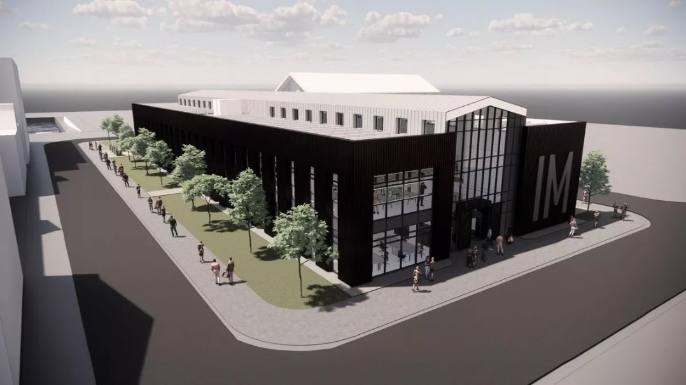

(Youle, 2022)
The structure is a two storey build, the proposed type of construction is steel frame. The location of the plot is adjacent to the UWTSD SA1 Campus IQ Building. Please see the below virtual image of the ‘Innovation Matrix’ and SA1 Site plan.

SA1 Innovation Matrix
The SA1 Innovation Matrix is a new groundbreaking project nestled in the UWTSD SA1 Campus, the exciting development worth £9.3 million takes front for the next phase of the growing university campus and plans to home small-scale hard-working enterprises that are rising in stature. The key concept is for businesses who are outgrowing their spaces to move to a state-of-the-art facility to further enhance and as a result offer value to the university campus (Youle, 2022). The build is set to be 3200m2 and just 2 storeys made up of a steel frame optimising the space available. Externally finished in brickwork and grey and brown metal cladding giving a modernised aesthetic.

Foundation Requirements
The foundation type of choice comes down to many factors when approaching a new project such as location, size of the build, underlying geology financial feasibility and ground conditions. Each of these all have a massive influence on the choice of foundation to support the superstructure. This is why it is important for case studies to take place for construction professionals to assess the risks.
When doing a ground investigation, it is crucial to consider not only the area immediately surrounding the site, but also its geological history. This must be done before starting a project since the client might not be aware of possible harm that has already been done to the environment, which could have an impact on the project's cost or even put individuals at risk. As shown in the below image, this is the location of the site. It has an area of 3,200 square metres and is located relatively close to the River Tawe and also the dock water. The architecture of the building can suffer as a result. We will need the field research to help us with the foundation design. The cladding and outside materials must be able to survive the elements while also blending in with the surroundings, thus their selection will be vital.
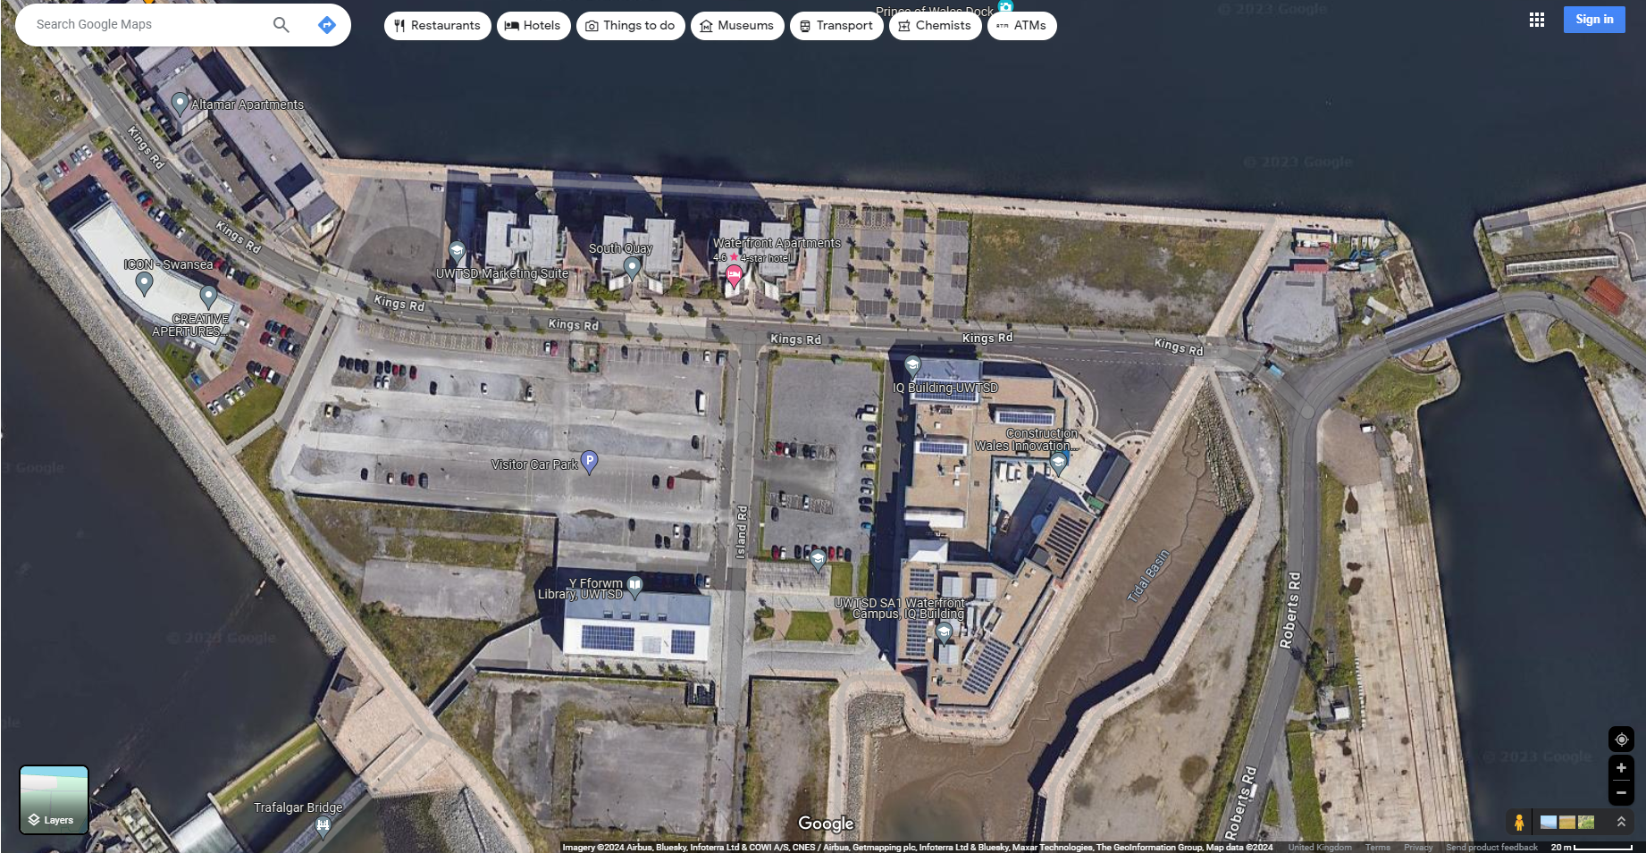
(Maps, 2023)

The proposed site is located in the SA1 Swansea Waterfront or as some call it, The Marina. Adjacent is the Prince of Wales Dock. This dock is famously known for the shipping in and out big quantities of copper, iron, tinplate and zinc. During World War 1 It became of the largest docks in Britain.
The area that surrounds the dock also has a long and illustrious history. Around the 19th century Swansea was an industrial beast and copper smelting was an industry that grew colossally in the town and the lower valleys. Wales was also very popular for the mining of coal therefore Many mines were dug over the years in the local area and due to this, the ground below could potentially be contaminated. Borehole tests have not taken place in this specific location however this is something that should be taken into account on the study.
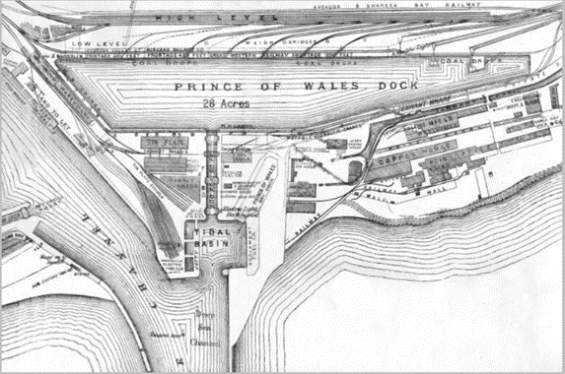
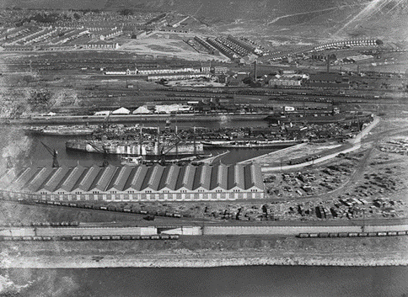
(Retired Section Swansea Docks, n.d.)

Foundation of Choice
Due to the location of the site being close to water the probability of the soil being weaker is a lot more compared to a more urban site. Therefore a Pile foundation, in my opinion, is the best kind of foundation to utilise for this project. The adoption of the proper sort of foundation is essential to the project since, in the absence of it, the building may experience significant settlement problems, including differential settlement.
Piling is used typically out of reinforced concrete, they are a type of deep foundation used to transfer the loads from a structure into deeper, more stable soil or rock layers below the ground surface. They are employed when the upper layers of soil are unable to support the loads of a structure or when the construction site has challenging soil conditions. This important due to sheer size of the building and where soil is not suitable to prevent settlement such as loose gravels/sands and ‘made ground’, the strongest foundation must be utilised. Piles are classified as end bearing piles, most of friction is at toe of pile, the pile transmits load directly to firm strata and receives lateral restraint. Friction when harder strata are too far buried, piles are a good option since the majority of their bearing capacity is created by shear stress along the pile's sides. Because of the friction between the soil and the pile's surface, the load is transmitted to the surrounding soil, lowering the bulb pressure. (Designing Buildings, 2022)

Equipment used for piling:
  - Percussion drivers: hammers driven by compressed air or diesel
  - Hydraulic drivers: hydraulic rams push piles into ground
  - Vibratory drivers: piles vibrated into ground
  - Rotary Augers: used to provide holes for ‘replacement piling’

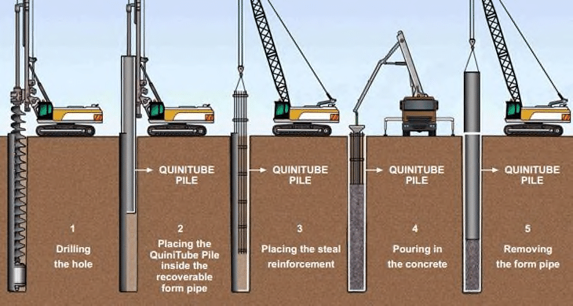

(Research Gate, 2020)
Pile foundations provide many advantages in the construction industry, especially when handling difficult soil conditions or large structural loads. For example, they are versatile as piles are adaptable to different types of soil. Various pile types, including driven heaps, bored piles, and screw piles, can be employed in accordance with the particular needs of the site, providing flexibility in both design and use. They are an efficient way to get across weak or unstable soil layers and reach more stable bedrock or more competent soil in situations with varying soil composition. Furthermore, the use of pile foundations offers great stability as piles reach deeper, more stable ground by penetrating weak or compressible soil layers. This ensures the stability and lifespan of the structure by reducing the danger of differential settling and settlement. When compared to certain other deep foundation choices, pile foundations, particularly driven piles can frequently be erected rather quickly, cutting down on construction time. This may result in reduced costs and faster project completion time. Given these advantages, pile foundations are frequently chosen for construction projects, especially with the Innovation Matrix as difficult soil conditions, large structural loads and the requirement for greater foundation system stability and dependability exist. (Prasad, n.d.)

Required Excavation Works
The excavation works required for pile foundations typically involves several stages to prepare the site for the installation of the piles. (Capital Piling, n.d.) Firstly, the separation of the site. Clearance and levelling of the sites grounds will take place to create an area ready for excavation providing access for machinery and equipment. Next the pile locations will be set out and marked. Marking the precise locations using a theodolite where piles will be installed based on engineering plans and layout designs. The initial excavation will follow by excavating the topsoil or any loose, non-load-bearing layers to expose where the piles will be founded. Another type of works that may be required are boreholes. For certain pile types like drilled or bored piles, further excavation is done to create holes of specified diameters and depths for pile installation. This can involve drilling equipment to bore into the ground or using augers to remove soil and debris. (The Constructor, 2024). In some cases, where piles are designed to be socketed into rock or strong soil layers, additional excavation or cleaning of the bottom of the pile shaft may be necessary to ensure proper bonding between the pile and the substrate. The next step is to remove the spoils. As excavation progresses, soil, debris, or excavated material (spoils) need to be removed from the site to maintain a clean and safe working environment and to facilitate pile installation. Depending on the depth and soil conditions, excavation support systems like shoring, sheet piles, or other retaining structures might be employed to prevent cave-ins or instability of the excavation site. Verification and Inspection. During excavation, it's essential to verify the soil conditions against the design specifications and conduct inspections to ensure the excavation meets the required dimensions and standards. Finally, once the pile installation is complete, backfilling of excavated areas with suitable material is carried out to reinstate the ground level, and the site is restored to its original condition or prepared for further construction activities. (Constructor, 2024).

Superstructure
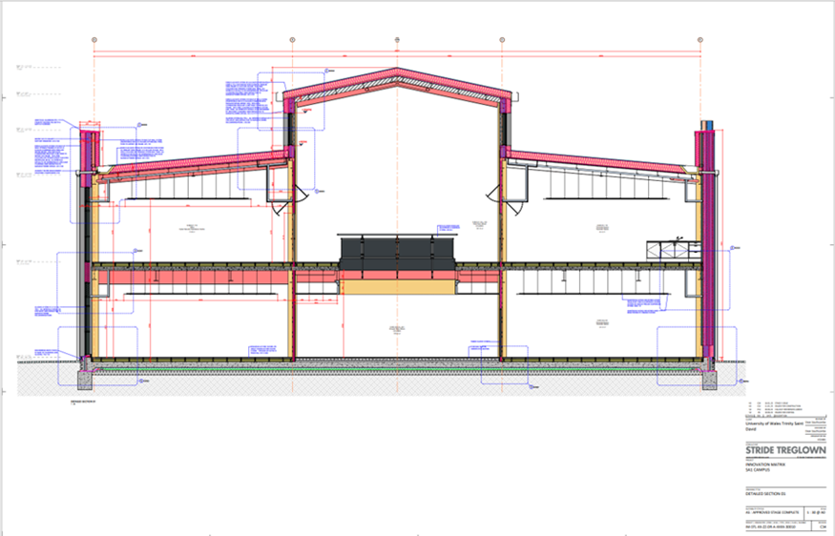
As previously mentioned, the Superstructure of the Innovation Matrix is going to be made up of a steel frame along with metal sheet cladding and brickwork. Deciding what the right materials to use for a project of this size involves thorough analysis of the various factors to ensure the building will be structurally sound while also considering the safety, cost effectiveness, location of the building and functionality. Firstly, it is important to consider the load bearing capacity of the structure. Assessments must be made on the loads that the structure can bear as well as dead loads. It is vital that within this, close attention is paid to the building regulations, namely Approved Document A – “Structure” This document explains how to comply with building laws and ensure the building's structural safety and stability. It ensures that the structure does not collapse, fall, or sink. An example would be that the foundations may not be able to go as deep due to an underground car park therefore reducing the structural stability of the building. The use of steel frames is very popular among the construction industry due to its strength and stability. It is easily fabricated, has good fire resistance and is a sustainable material. (HPD Construction, 2019)

The above section drawing shows the steel frame of the SA1 Innovation Matrix. As you can see the steel frame maximises the space available due to its design flexibility. This makes the building more functional given the fact that there are no internal walls, aiding the University’s plans to house more smaller businesses in the building. This is a big advantage of using steel frame as it has greater design flexibility compared to other types of materials. Larger spans and open floor plans enable architects to create aesthetically pleasing structures. The building also features a curtain wall made up of glass which allows for great light exposure. Another advantage of using steel frame construction is the fact it is more eco friendly than other materials. Steel is commonly recycled, making it environmentally friendly as it can be recycled multiple times without losing its properties (Designing Buildings The Construction Wiki, 2022).
Furthermore, when it comes to building materials, steel has an innate resistance to fire, unlike timber. It is a safer option for buildings, particularly those with strict fire safety regulations such as “Approved Document B – Fire”, as it does not aid in the spread of fire. Due to the substantial amount of electrical equipment that will be housed inside the building, the innovation matrix centre is intended to house numerous businesses that are leading the local digital technology economy. For this reason, it is crucial that the building uses highly fire-resistant materials like a steel frame and metal sheet cladding. An important factor to consider when choosing a building material in today’s construction is sustainability. Steel is a very sustainable material as due to modern technology computer modelling reduces the amount of scrap used during fabrication. Any scrap that is produced can easily be recycled to use on other projects. Due to the building’s coastal location, the choice of material must have great strength and stability. Structural steel components are lighter and stronger than weight bearing wood products and concrete. Attached below are elevations of the Innovation Matrix.
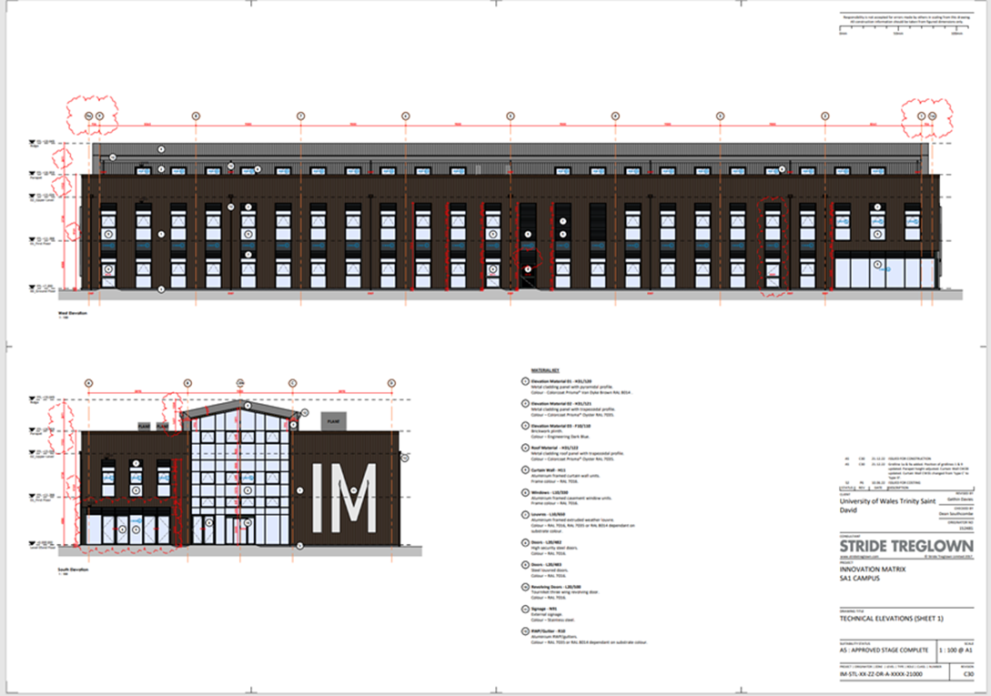

In an online article which discusses the properties of steel, Geoffry White mentioned “A typical weight-bearing steel fabrication is 30% to 50% lighter than a wooden equivalent. This makes steel frame construction far stronger and more durable than traditional wood framed alternatives.” (White, 2017). This means that the steel will be able to withstand the high winds and strong weather that the coastal located building will have to deal with. Cost effectiveness is important to clients and contractors in any construction project. Steel may initially cost more than certain other materials, but in most cases, the long-term savings surpass the initial expense. Over the course of the building's life, shorter construction times, less maintenance needs, and the capacity to recycle steel all add to the building's overall cost-effectiveness. (Designing Buildings, 2022).

Conclusion
As an overview, the main targets clients set out when conducting a scheme of this manner are to be safe, sustainable, cost-effective, eco-friendly and aesthetically pleasing. The use of steel, brick and metal sheet cladding collectively are the right choice for the building and take considerations for all factors.

Bibliography
Capital Piling, n.d. [Online]
Available at: https://www.capitalpiling.co.uk/articles/preparing-a-surface-for-piling-foundations-a-guide-for-piling-contractors
[Accessed 21 12 2023].
Constructor, T., 2024. The C. [Online]
Available at: https://theconstructor.org/geotechnical/pile-installation-methods/1812/
[Accessed 01 01 2024].
Designing Buildings The Construction Wiki, 2022. Designing Buildings The Construction Wiki. [Online]
Available at: https://www.designingbuildings.co.uk/wiki/8_reasons_why_structural_steel_frames_are_advantageous_for_any_building_project
[Accessed 07 01 2024].
Designing Buildings, 2022. Designing Buildings. [Online]
Available at: https://www.designingbuildings.co.uk/wiki/Pile_foundations
[Accessed 20 12 2023].
HPD Construction, 2019. HPD Consult. [Online]
Available at: https://www.hpdconsult.com/steel-frame-construction-advantages-and-disadvantages/#:~:text=Steel%20frame%20construction%20is%20a%20popular%20choice%20in,to%20fire%2C%20pests%2C%20and%20the%20effects%20of%20weather.
[Accessed 04 01 2024].
Maps, G., 2023. Google Maps. [Online]
Available at: https://www.google.com/maps/@51.6177055,-3.9269426,300m/data=!3m1!1e3?entry=ttu
[Accessed 20 12 2023].
Prasad, n.d. Structural Guide. [Online]
Available at: https://www.structuralguide.com/advantages-and-disadvantages-of-pile-foundations/
[Accessed 21 12 2023].
Research Gate, 2020. Research Gate. [Online]
Available at: https://www.researchgate.net/figure/Manufacturing-technology-of-the-pile-foundation-at-the-construction-site_fig1_347199193
Retired Section Swansea Docks, n.d. Retired Section Swansea Docks. [Online]
Available at: http://swanseadocks.co.uk/oldsite/Maps.htm
[Accessed 20 12 2023].
The Constructor, 2024. The Constructor. [Online]
Available at: https://theconstructor.org/geotechnical/setup-borehole-layout-site-investigation-foundations/18857/
[Accessed 03 1 2024].
White, G., 2017. GLW Engineering. [Online]
Available at: https://blog.glwengineering.co.uk/the-advantages-disadvantages-of-steel-frame-construction
[Accessed 07 01 2024].
Youle, R., 2022. Nation Cymru. [Online]
Available at: https://nation.cymru/news/plans-unveiled-for-9-3-million-state-of-the-art-innovation-centre-in-swansea/
[Accessed 20 12 2023].

