BSc Health and Social Care
Module: Changemakers: Building your Personal Brand for Sustainable Employment
BMHP5015

Student Number: 2407750
Student Name: Mohammed Mobeen Ali
Tutor Details: Olufemi Oluranti
Assignment (Report)
Submission Date: Monday 19th July 2026
Table of Contents
Introduction 1
Job advertisement 1
Employability Skills for the Job Role. 1
Assessment of my abilities 2
Action Plan and Action Timeline 1
Discussion of the way to build my personal brand. 1
Highlights of my professional identity 2
Development plan for a successful employment network 3
Conclusion 4
References 5

Introduction
This report is for analysing and developing an action plan of my skills based on a job description at Band 7 Highly Specialist Prosthetist of the NHS. A Highly Specialist Prosthetist would specialise in designing and fitting prostheses to patients who have lost a limb. This job role develops individual treatment plans and works with multi-disciplinary teams to contribute towards rehabilitation and improve the lives of patients. This position also includes clinical leadership, mentoring, research and safe and effective provision of prostheses. The role is significant as it allows people with disabilities to be more independent, mobile and healthy. I chose this path because I love health care, technology, and patient-centred care. I want to be able to make a difference to those who require prosthetic rehabilitation. This report will analyse the skills necessary for the job, discuss my own skills and provide an action plan for my career.

Job advertisement
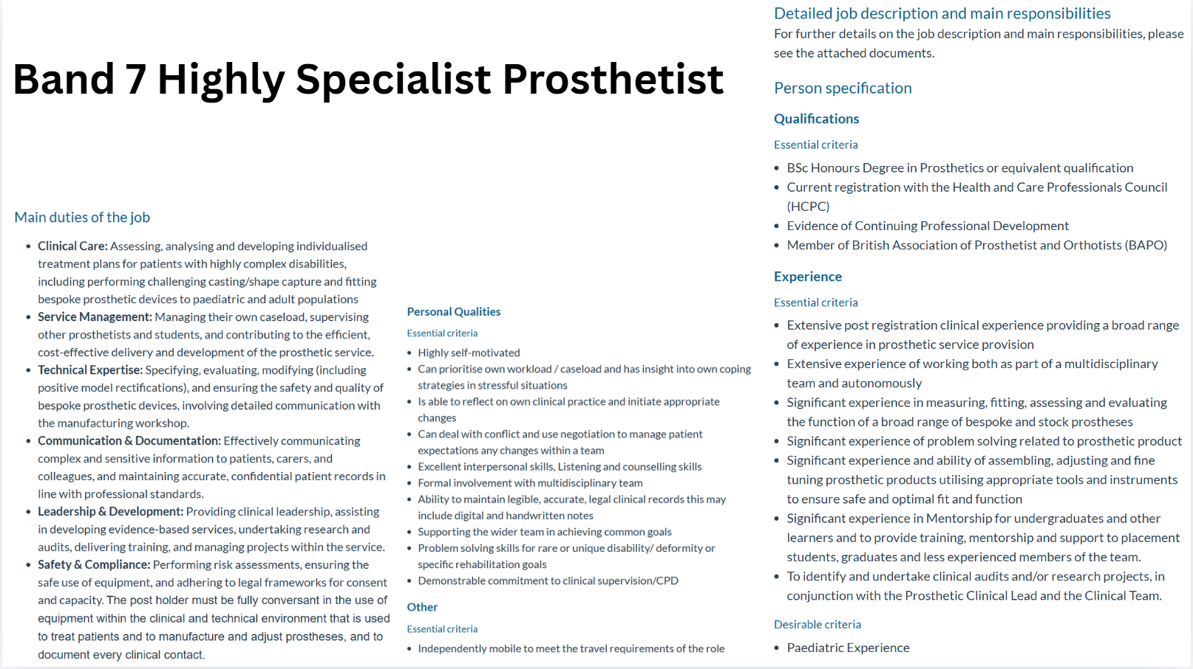
Figure 1: Job vacancy for a Highly Specialist Prosthetist at NHS Foundation Trust
Source: Band 7, 2026

Employability Skills for the Job Role.
The band 7 – highly specialist prosthetist job description outlines some important employability skills that are essential to quality patient care and rehabilitation. Communication is one of the most crucial skills (Sharkiya, 2023). Being able to clearly communicate complex clinical information to patients, carers and colleagues. Communication facilitates trust building, aids in informed decision making and enhances outcomes for patients. Just like that, teamworking is another important employability skill. The role requires good teamwork skills and interactions with other teams, including doctors, physiotherapists, occupational therapists and rehabilitation specialists (Rosen, 2020).
Skill in problem-solving is also required for the job role. Often, patients with special disabilities, deformities or rehabilitation objectives require the services of a prosthetist (Physiopedia, 2024). They must evaluate the patients' needs, pinpoint problems and devise appropriate prosthetic solutions to enhance their mobility and function. Technical skills are an essential part of this position. The person specification focuses on skills in prosthetic measurement, fitting and evaluation. Safe and effective treatment means using digital scanning technologies as well as manufacturing processes. It requires knowledge of the latest advancements in prosthetics (Flott, Maguire and Phillips, 2021).
Organisational and leadership skills are also a must. A Band 7 practitioner should oversee and mentor junior practitioners, have their own caseload and be involved in service development. Workloads are effectively prioritised and organisational skills are good, ensuring a high standard of patient care. Lastly, professional responsibility and ongoing education are crucial. Completing Continuing Professional Development, research involvement, and reflective practice is evidence of commitment to maintaining and enhancing professional standards. The employability skills that enable an HWP to look after patients safely, effectively and patient-centred (Rosewilliam et al., 2020).

Assessment of my abilities
When thinking about being a highly specialist prosthetist, I need to consider my current skills, experience and areas for improvement in Band 7. The skills that I have acquired from my education, group projects and work experiences are transferable. They have improved the way that I communicate and work in a team, problem-solving skills and organisational skills (Indeed Career Guide, 2025). In addition, my current BSc Health and Social Care studies have provided me with knowledge of person-centred care, communication and professional practice, which are valuable foundations for a future career in prosthetic rehabilitation.
Strengths: I'm very effective in communicating. Academic presentations and cooperative work have helped me to communicate and work effectively in groups. I can also work cooperatively and collaboratively with others in group activities. I have learnt that listening and respecting others' views is important, just like working in a team (Rosen, 2020). One of my assets is my ability to be flexible and learn. To ensure that the role of a Highly Specialist Prosthetist is performed in a way that is up to date and meets the needs of the patient. I also realised that ongoing professional development and keeping up to date with advances in prosthetic technology are essential. I love learning, expanding and developing my own skill set throughout my career as a professional. My USP is my sense of commitment and hard work. I have a keen interest in the improvement of the lives of the differently-abled. These qualities would help me to make a difference in the care and rehabilitation of patients (Mohamad, Tan and Asano, 2026).
Weaknesses: I have other pieces to work on. An employment requires a BSc (Hons) degree, an HCPC registration and extensive clinical experience, as well as specialist knowledge and understanding of prostheses. These specialist qualifications I don't yet have. Other than that, I want to be able to apply all of that knowledge as a patient evaluator, a prosthetic fitter, a digital scanner, a clinical decision maker and a multi-disciplinary rehabber.
Areas of Improvement and Supporters: There are several people or groups of people who will help me to grow. Academic advisement and expert advice can be offered by university lecturers. Practical guidance, supervision and professional support can be offered via clinical mentors and experienced prosthetists. Placement supervisors are able to assist me in developing my clinical skills and gaining real-world experience. Professional organisations, such as the British Association of Prosthetists and Orthotists (BAPO), may provide access to training opportunities. I can develop my skills and experience through these people and organisations, and become a ‘Highly Specialist Prosthetist' in the future.

Action Plan and Action Timeline
SMART Goal | Specific Actions | Measurable Outcome | Relevant to Role | Timeframe
Developing foundational knowledge of prosthetics and rehabilitation | Research prosthetic career pathways, attend workshops, undertake self-directed study in anatomy, biomechanics, and patient-centred care, and gain volunteer experience in healthcare settings (Skills England, 2023). | Complete at least 3 workshops, attend volunteer placements, and maintain records of learning activities. | These will provide the theoretical foundation required for a career in prosthetics. | Year 1
Improving employability and transferable skills | Participate in group projects, presentations, and volunteering to develop communication, teamwork, problem-solving, and leadership skills (Sree, 2025). | For that, I will receive positive feedback from teachers and complete skills self-assessments. | These are essential skills identified in the Band 7 Prosthetist person specification (Band 7, 2026). | Year 1-2
Obtaining professional qualifications | Enroll in and complete a recognised Prosthetics degree Programme from the University of Wales Trinity Saint David. | Achieve degree completion by meeting academic requirements and gaining a good GPA. | It will require a qualification for HCPC registration and prosthetic practice (HCPC, 2026). | Years 2-4
Gaining practical clinical experience | Complete clinical placements and practical training opportunities in prosthetic and rehabilitation settings. | Complete all placement requirements and gain competency sign-offs. | Develop patient assessment, prosthetic fitting, and multidisciplinary working skills. | Years 2-4
Building a professional portfolio | Record achievements, training certificates, reflective practice, and CPD activities. | Create and maintain an up-to-date professional portfolio on LinkedIn (Johnson, 2021). | Demonstrate professional development and readiness for employment. | Years 2-5
Developing advanced technical and clinical skills | Gain experience in prosthetic fitting, digital scanning technologies, patient assessment, and rehabilitation planning | Complete specialist training courses and receive competency evaluations | Supports progression towards specialist prosthetic practice | Years 3-5
Achieving professional registration and employment | Apply for HCPC registration and seek employment within a prosthetic service. | That is why I will obtain HCPC registration and secure a prosthetist position. | It is an essential step towards becoming a Highly Specialist Prosthetist (NHS, 2015). | Years 4-5
Expanding professional network and mentorship opportunities | Join professional organisations, attend conferences, and seek mentorship from experienced prosthetists. | Attend at least 2 professional events annually and establish mentoring relationships. | It will support career development and professional growth. | Throughout Years 1-5
Progressing towards a Band 7 Highly Specialist Prosthetist role | Continue CPD, undertake research and audits, gain leadership experience, and develop specialist expertise. | Look for the evidence of advanced clinical skills, leadership responsibilities, and specialist practice (Ali et al., 2025). | This practice will prepare me for future progression to the Band 7 level. | Beyond 5 Years

Discussion of the way to build my personal brand.
Having a good personal brand is very important because it is vital to establish a good reputation in the health and social care field. The impression given with my personal brand as a future Highly Specialist Prosthetist should portray a professional, caring, technical and empowering outlook. It will enable me to be more distinguishable from other employees and show employers how committed to patient-centred care and continuous skill development (Skills England, 2023).
I will use LinkedIn to develop my professional profile to present myself to the world with my education, skills, accomplishments and career goals. By keeping my LinkedIn profile up-to-date, I can network with healthcare professionals. It will help me stay informed about industry updates and participate in discussions with other professionals (Nuvo Healthcare Recruitment, 2024). I will attend professional networking events, conferences and workshops in the field of prosthetics and rehabilitation. I will also post articles, blog posts, case studies, and thoughts on healthcare topics. By always portraying myself as a motivated, knowledgeable, and ethical future healthcare worker, I can maintain my personal brand that demonstrates my readiness to pursue a career in the healthcare field and my knowledge and commitment to ethical behaviour.

Highlights of my professional identity
It's crucial to establish a professional image during the application process for healthcare jobs. Employers require solid proof of a candidate's skills, experience, qualifications and adherence to professional standards. So, I will employ differing strategies to demonstrate my appropriateness for a career in prosthetics. I will have to prepare myself a well-organised CV and cover letter to present my skills and achievements. My CV will clearly reflect appropriate school experiences, transferable skills, volunteer experiences, professional development and any healthcare experiences. My cover letter will be tailored to each application to showcase the alignment of my skills and experiences with the requirements of the position (Lery, 2025).
It's also significant to have a professional online image. I will add new qualifications, placements and accomplishments to my LinkedIn profile periodically. This will give the potential employer a better understanding of my skills and dedication to the profession (Johnson, 2021).

Development plan for a successful employment network
I will seek advice and guidance from experienced prosthetists, placement supervisors and lecturers to help me establish my professional network. Their suggestions and comments can help to enhance my clinical practices and understanding of professional expectations (Wilesmith et al., 2025). I will also be contacting professional organisations such as the British Association of Prosthetists and Orthotists. This network may offer training and professional events, opportunities and resources related to prosthetists (BAPO Admin, 2024).
I will attend conferences and career fairs related to the healthcare industry and go to various professional workshops to meet individuals in the prosthetics and rehabilitation services industry. I will have the chance to learn some tricks from the professionals (Health Conferences Australia, 2025). It will also give me insights into the changes taking place in the industry. I will focus on the networks that will build up productive work relationships via networking to achieve my career goals.

Conclusion
This report has focused on both the role of Band 7 Highly Specialist Prosthetist and the employability skills needed to be successful in the role. The organisation is looking for communication, teamwork, problem-solving, leadership, and technical Skills. These skills are required for safe, effective and patient-centred care of the prosthesis. It also led to an evaluation of my own skills and qualities, and recognised many strengths: communication, teamwork, adaptability and willingness to learn. Concurrently, it recognised that further development was required for professional registration and a wide range of experience in prosthetic practice. A structured action plan and 5-year plan were developed to close these gaps in learning, practical and professional development that would take a person towards this career objective.
The report also discussed how to spin a professional brand, develop a professional online persona and establish a solid professional network. Overall, I am very motivated to work in prosthetics because it's an opportunity for me to help with the independence, mobility and quality of life for people with limb loss. My goal is to become a successful Highly Specialist Prosthetist in the future.

References
Ali, S., Sethi, A., Soltani, A. and Nazar, Z. (2025). Impact of continuing professional development (CPD) on patient outcomes: a systematic scoping review. BMC Medical Education, 25(1). doi: https://doi.org/10.1186/s12909-025-07883-4.
Birmingham Community Healthcare NHS Foundation Trust, Highly Specialist Prosthetist job advertisement. Available at: https://www.healthjobsuk.com/job/UK/Birmingham_Black_Country/Birmingham/Birmingham_Community_Healthcare_NHS_Foundation_Trust/Highly_Specialist_Prosthetist/Highly_Specialist_Prosthetist-v8023440?_ts=1 [Accessed 31 May 2026].
BAPO Admin (2024). Learner voice at BAPO. [online] Bapo.com. Available at: https://www.bapo.com/learner-voice-at-bapo/ [Accessed 31 May 2026].
Flott, K., Maguire, J. and Phillips, N. (2021). Digital safety: the next Frontier for Patient Safety. Future Healthcare Journal, 8(3), pp.e598–e601. doi: https://doi.org/10.7861/fhj.2021-0152.
HCPC (2026). Eligibility to apply for registration |. [online] www.hcpc-uk.org. Available at: https://www.hcpc-uk.org/registration/getting-on-the-register/international-applications/eligibility/.
Health Conferences Australia (2025). How Attending Healthcare Conferences Can Boost Your Career - Health Conferences Australia. [online] Health Conferences Australia. Available at: https://www.d4hmelbourne.com/how-attending-healthcare-conferences-can-boost-your-career/ [Accessed 31 May 2026].
Indeed Career Guide (2025). Transferable Skills: 10 Skills That Work Across Industries. [online] Indeed Career Guide. Available at: http://indeed.com/career-advice/resumes-cover-letters/transferable-skills [Accessed 31 May 2026].
Johnson, K.M. (2021). Using LinkedIn to Teach Students How to Build Their Professional Network and Enhance their Personal Brand. Global Research in Higher Education, 4(2), p.p83. doi: https://doi.org/10.22158/grhe.v4n2p83.
Lery (2025). How to Write a Cover Letter for a Job Application (With Samples). [online] Mycvcreator.com. Available at: https://www.mycvcreator.com/blog/how-to-write-a-cover-letter-for-a-job-application-with-samples-?
gad_source=1&gad_campaignid=23012490912&gbraid=0AAAABA6AOb9UWH_CMV9KiR14OBkiT1ICX&gclid=CjwKCAjwuO_QBhAWEiwAIkVhU3e_wW4LFWQJrHiXlPhhDyQBiYU6VkmyPRlxRkgvcJRmd5zmnsRjPxoCySAQAvD_BwE [Accessed 31 May 2026].
Mohamad, N.B.Z., Tan, G.Y.Q. and Asano, M. (2026). Experiences of Caring for Adults with Acquired Physical Disabilities: A Qualitative Study. Journal of Long Term Care, 1(1), pp.31–46. doi: https://doi.org/10.31389/jltc.373.
NHS (2015). Prosthetist/orthotist. [online] Health Careers. Available at: https://www.healthcareers.nhs.uk/explore-roles/allied-health-professionals/roles-allied-health-professions/prosthetistorthotist.
Nuvo Healthcare Recruitment (2024). Networking is a crucial aspect of career development in any field, but in healthcare, it becomes even more vital due to the collaborative nature of the industry. Building a strong professional network can lead to career growth, mentorship opportunities, partnerships, and staying current with industr. [online] Linkedin.com. Available at: https://www.linkedin.com/pulse/strategies-successful-networking-healthcare-nuvo-recruitment-dgmre/ [Accessed 31 May 2026].
Physiopedia (2024). Role of prosthetists and orthotists in a rehabilitation team. [online] Physiopedia. Available at: https://www.physio-pedia.com/Role_of_Prosthetists_and_Orthotists_in_a_Rehabilitation_Team.
Rosen, M.A. (2020). Teamwork in healthcare: Key Discoveries Enabling safer, high-quality care. American Psychologist, [online] 73(4), pp.433–450. doi: https://doi.org/10.1037/amp0000298.
Rosewilliam, S., Indramohan, V., Breakwell, R. and Skelton, J. (2020). Learning to be patient-centred healthcare professionals: how does it happen at university and on clinical placements? A multiple focus group study. MedEdPublish, 9(1). doi: https://doi.org/10.15694/mep.2020.000053.1.
Sharkiya, S.H. (2023). Quality communication can improve patient-centred health outcomes among older patients: A rapid review. BMC Health Services Research, [online] 23(1), pp.1–14. doi: https://doi.org/10.1186/s12913-023-09869-8.
Skills England (2023). Prosthetist and orthotist. [online] Skills England. Available at: https://skillsengland.education.gov.uk/apprenticeships/st0601-v1-2 [Accessed 31 May 2026].
Sree, S.D. (2025). Transferable Skills: Why they are essential for employability and career growth. [online] NSN. Available at: https://nationalskillsnetwork.in/transferable-skills-for-employability-career-growth/.
Wilesmith, S., Mandrusiak, A., Lang, R., Martin, R., Lu, A. and Forbes, R. (2025). Educational Interventions to Develop and Enhance Clinical Documentation Skills in Health Professional Students: A Systematic Review. The Clinical Teacher, [online] 22(5). doi: https://doi.org/10.1111/tct.70157.

