Problem Solving and Decision Making

Contents
Introduction 2
Definition and impact of complex problem in the workplace 2
Using a decision-making technique to evaluate a range of solutions to identify the most appropriate option 4
Developing a plan for implementing the solution 5
Communicating the plan to stakeholders 6
Conclusion 7
References 7

Introduction
In modern times, organizations have to undergo through a continuous transformation process to retain their competitiveness in the global competitive business environment. Quick and right decision making is considered to be the key aspect for any organization to solve their daily problems effectively (Granlund et al., 2004). This paper will explore the complex situation that NHS face in this COVID 19 pandemic situation and their decision-making techniques to tackle the situation to sustain their organizational growth in this disastrous situation.

Definition and impact of a complex problem in the workplace
COVID 19 global pandemic situation has forced the whole world to undergo a critical condition especially in the field of public health. More than 36,765 people died in COVID 19 in England which has led the whole public health scenario in a very complex situation (NHS, 2020). This type of complex problems rarely solved by individuals but independently working teams can solve the complex problems in the organizations by playing dynamic improvements and interconnection features (Fiore et al., 2010; Brehmer, 1992; Funke, 1995). NHS faces several negative impacts on the workplace due to these complex situations such as doctor-nurse shortage, medicine shortage, accommodation facilities crisis, hospital equipment crisis etc. This condition made the health service delivery difficult for NHS under this pandemic situation. As NHS is the most trusted and one of the biggest health care provider organization of England, these issues need to be tackled immediately otherwise people will lose their faith from it. By balancing the financial and human resource constraints NHS needed to develop a concrete plan within a very short period. Top management of NHS needed to identify the core problems first before it's too late.
Analysing the identified problem information toward decision-making process
The decision-making process usually helps managers and other industry leaders solve challenges by evaluating possible options and agreeing on the best path to take. Using a step-by-step strategy is an effective way of making rational, educated decisions that reflect positively on the short and long-term goals of a company (Jonassen et al., 2006; Arthur et al.,2005; Middleton, 2002 Bilski et al., 2007). TO tackle this global pandemic situation, NHS authority mainly follows their 5 stage model of data analysis to understand the depth of the problem from the root (Driskel et al., 2010; Dillard, 2020). These are-
- Define the problem: the first thing of any decision-making process starts with problem identification where top-level official mainly identifies the existing problems and the probable cause behind those problems by conducting a survey or other techniques to general people and hospital administration.
- Set clear measurement priorities: the second thing is to set the priority of the problems. Which problem needed to be addressed first, where more emphasis is needed, which can be the most crucial factor in achieving success are set out by NHS authority.
- Collect data: in this stage, NHS collect data from the patients and hospital administration to identify their major loopholes of service delivery using the measure priority by the top management.
- Analyse data: Collected data is analysed properly for getting inside of their existing drawbacks
- Interpret result: based on the analysed data, NHS set priorities of their problems and search for solutions of these problems to improve their current service delivery
Proposing a range of alternative solutions to the problem
Leaders and managers propose a range of alternative solution to meet the problems and to achieve the organizational objectives. It can be approached by following three kinds of techniques to find out the best alternative solution. these are-
Identify the problem | - Shortage of manpower  - Medicine and equipment crisis  - Accommodation crisis for COVID and general patients  - Difficulties faced by a quick response team  - Shortage of ambulance  - Difficulties faced by hospital management to maintain hygiene environment during this pandemic  - Financial issues
Increase alternative solutions | - Emergency recruitment of staffs  - Make agreements with more companies for emergency medical supplies  - Increase manpower in the emergency response team  - Contractually arrange more ambulances to provide better coverage during this pandemic.  - Contractually recruit doctors for NHS  - Look for public and private donations to meetup financial constraints
Evaluate and select an alternative | - Assess alternatives against a target standard  - Unbiased evaluation of all alternatives  - Evaluate alternatives to targets set  - Assess the results, both confirmed and probable  - Explicitly state the alternative chosen

Using a decision-making technique to evaluate a range of solutions to identify the most appropriate option
Complex problem solving "takes place with the aid of cognitive exercises and actions, to reduce the barrier between a given starting state and a planned target state. Start status expected target status, and obstacles illustrate uncertainty, change dynamically over time, and maybe partially untransparent "(Funke, 2012). Decisions may often fail in real-life business situations because the best options are not obvious at the start, or key considerations are not regarded as part of the procedure. To prevent this from happening, you need to put together a plan for problem-solving and decision-making to explain your perception (Fortney et al.,2013; Strobel et al.,2011 Neubert et al., 2015). Quick and accurate decision making can be considered as one of the most effective tools to reduce the mortality rate and ensure quality health care during this pandemic situation. But making the right choice is not an easy task. NHS give immense importance to public health issues and follow the force field analysis technique and brainstorming technique while evaluating a range of solutions to identify the most accurate option-
- Forcefield Analysis- organizations mainly used this technique to increase their productivity and expand business coverage. It identifies the loopholes in the existing plan and suggests the best possible way to reduce those problems. NHS can use this technique to identify their existing service providing mechanism and make it updated to tackle this global pandemic attack.
- Brainstorming- to deal with a new type of situation, NHS arranges discussions among different level of their employees for evaluating numerous solutions for tackling this pandemic situation. Different creative solutions are often generated from this type of discussions which may help to provide a better experience to the patients while availing service from NHS.

Developing a plan for implementing the solution
An implementation plan is the recorded steps that must be taken to accomplish your implementation activities (Simen et al., 2009; Lyles et al., 2008). There are some crucial steps that NHS follow to develop an implementation plan. These are-
- Listing outcomes required: NHS made the list of the goals that it wants to achieve through this implementation exercise to decide the steps needed and the objectives of the tasks. These are typically in the form of suggestions from an exercise of analysis or enhancement of business processes.
- Assign a champion for every result: Creating a list of results is not enough; you need to appoint a champion to head everyone, a champion who will be inspired to accomplish the result and hold the entire project team accountable for it. Look for different team members who are involved in achieving this outcome or who are positive and dedicated to successful implementation
- Establish roles, budget and accountabilities: Once NHS has a list of steps which will confirm your implementation tasks are accomplished. It also decides the implementation team's roles and responsibilities.
- Timetable and conduct a study within six months: It is a learning experience that should be checked every time NHS introduce change. That’s why it is important to analyse what worked during the evaluation process, and what did not recognize areas for improvement. Looking at the challenges NHS come across along the way and how they could have been prevented or minimized to carry this insight into the next set of implementation functions.

Communicating the plan to stakeholders
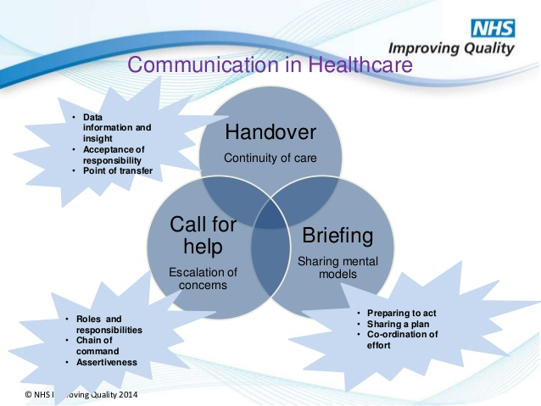
A coordination strategy for the stakeholders usually develops out of the management plan's knowledge and results. It should list key stakeholders, including form, frequency and information, who need to receive communications (Tsetsos, et al.,2011; Ravlin, 2007). NHS first clear out the roles and responsibilities, chain of command and assertiveness to the key stakeholders (care providers, medicine and equipment suppliers, hospital administration etc). Then the top management of NHS makes a detailed outline of how this new plan can be implemented in a coordinate manner. Finally, data information of the current situation is presented to the employee and his cordial assistance is seek to upgrade this scenario according to the intended plan.
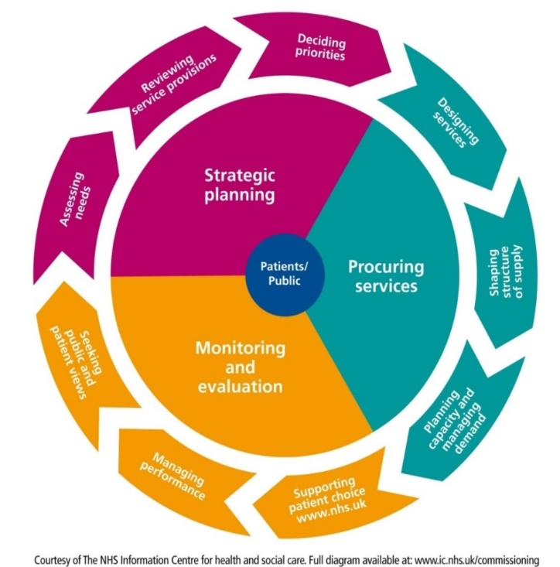
Assessing appropriate monitoring and review techniques to ensure successful implementation of the solution. Monitoring and review are an integral component of any preparation for adaptation, and should not be overlooked. It is possible to control trigger indicators and performance measures, and the results used to assess when interventions should be enforced and to track the adaptation plan's progress (Matsiliza, 2012; Kanabar et al., 2012). NHS monitors and evaluates its working techniques in three stages. At first, it reviews patients’ comments and recommendations to understand the need of the people. Then manage its performance based on internal and external performance feedback. And finally, it supports their patient’s choice through their organizational website.

Conclusion
Problem-solving is important for both employees and organisations as it helps us to exercise control over our setting. It provides one with a technique to assess these problems, find out why they are broken and determine a plan of action to repair them. NHS mainly follows the above-mentioned techniques to solve different problems arise in COVID 19 pandemic situation. These strategies are very crucial for them to ensure better health care coverage during this pandemic situation.

References
- Arthur, W., Edwards, B., Bell, S., Villado, A., and Bennet, W. 2005. Team task analysis: identifying tasks and jobs that are team-based. Hum. Factors 47, 654–669. DOI: 10.1518/001872005774860087
- Bilski, P., Blomgren, J., d'Errico, F.R.A.N.C.E.S.C.O., Esposito, A., Fehrenbacher, G., Fernàndez, F., Fuchs, A., Golnik, N., Lacoste, V., Leuschner, A. and Sandri, S., 2007. The problems associated with the monitoring of complex workplace radiation fields at European high-energy accelerators and thermonuclear fusion facilities. Radiation protection dosimetry, 126(1-4), pp.491-496.
- Brehmer, B. 2002. Dynamic decision-making: human control of complex systems. Acta Psychol. 81, 211–241. DOI: 10.1016/0001-6918(92)90019-A
- Dillard, J. 2020. The Data Analysis Process: 5 Steps To Better Decision Making, Bigskyassociates.com. Available at: https://www.bigskyassociates.com/blog/bid/372186/The-Data-Analysis-Process-5-Steps-To-Better-Decision-Making (Accessed: 29 August 2020).
- Driskell, J., Salas, E., and Hughes, S. 2010. Collective orientation and team performance: development of an individual differences measure. Hum. Factors 52, 316–328. doi: 10.1177/0018720809359522
- Fiore, S. M., Rosen, M. A., Smith-Jentsch, K. A., Salas, E., Letsky, M., and Warner, N. 2010. Toward an understanding of macrocognition in teams: predicting processes in complex collaborative contexts. Hum. Factors 52, 203–224. doi: 10.1177/0018720810369807
- Fortney, K.S. and Yamagata‐Lynch, L.C., 2013. How instructional designers solve workplace problems. Performance Improvement Quarterly, 25(4), pp.91-109.
- Funke, J. 2005. “Experimental research on complex problem solving,” in Complex Problem Solving: The European Perspective eds P. A. Frensch and J. Funke (Hillsdale, NJ: Lawrence Erlbaum Associates), 243–268.
- Funke, J. 2012. “Complex Problem Solving,” in Encyclopedia of the Sciences of Learning ed N. M. Seel (Heidelberg: Springer), 682–685.
- Georgakopoulos, A., Wilkin, L. and Kent, B., 2011. Workplace bullying: A complex problem in contemporary organizations. International journal of business and social science, 2(3).
- Granlund, R., and Johansson, B. 2004. “Monitoring distributed collaboration in the C³Fire Microworld,” in Scaled Worlds: Development, Validation and Applications, eds G. Schiflett, L. R. Elliot, E. Salas, and M. D. Coovert (Aldershot: Ashgate), 37–48
- Jonassen, D., Strobel, J. and Lee, C.B., 2006. Everyday problem solving in engineering: Lessons for engineering educators. Journal of engineering education, 95(2), pp.139-151.
- Kanabar, M.G., Voloh, I. and McGinn, D., 2012, January. Reviewing smart grid standards for protection, control, and monitoring applications. In 2012 IEEE PES Innovative Smart Grid Technologies (ISGT) (pp. 1-8). IEEE.
- Lyles, M.A. and Thomas, H., 2008. Strategic problem formulation: biases and assumptions embedded in alternative decision‐making models. Journal of Management Studies, 25(2), pp.131-145.
- Matsiliza, N., 2012. Participatory Monitoring and Evaluation: Reviewing an Inclusive Approach in South Africa's Government-Wide Monitoring and Evaluation. Africa’s Public Service Delivery & Performance Review, 1(2), pp.67-83.
- Middleton, H., 2002. Complex problem-solving in a workplace setting. International Journal of Educational Research, 37(1), pp.67-84.
- Neubert, J.C., Mainert, J., Kretzschmar, A. and Greiff, S., 2015. The assessment of 21st-century skills in industrial and organizational psychology: Complex and collaborative problem-solving. Industrial and Organizational Psychology, 8(2), pp.238-268.
- Ravlin, E.C. and Meglino, B.M., 2007. Effect of values on perception and decision making: A study of alternative work values measures. Journal of Applied psychology, 72(4), p.666.
- Simen, P., Contreras, D., Buck, C., Hu, P., Holmes, P. and Cohen, J.D., 2009. Reward rate optimization in two-alternative decision making: empirical tests of theoretical predictions. Journal of Experimental Psychology: Human Perception and Performance, 35(6), p.1865.
- Statistics » COVID-19 Daily Deaths. 2020. Retrieved 29 August 2020, from https://www.england.nhs.uk/statistics/statistical-work-areas/covid-19-daily-deaths/
- Strobel, J. and Pan, R., 2011. Compound problem solving: Insights from the workplace for engineering education. Journal of Professional Issues in Engineering Education & Practice, 137(4), pp.215-222.
- Tsetsos, K., Usher, M. and McClelland, J.L., 2011. Testing multi-alternative decision models with non-stationary evidence. Frontiers in neuroscience, 5, p.63.

