ASSIGNMENT: 1-Reflective Writing

MODULE: Managing Guest Service Operations
Module Code-BMIH6003

STUDENT NAME: Ruksana Begum

STUDENT NUMBER: 2118820

TUTOR: Jessica Newport

DUE DATE: 3rd June 2024

Introduction-For my work placement, I have been attending the Whitehouse Hotel in Peterlee. In this learning log-I will be sharing my insights from working within the guest services department/reflecting and reviewing my experiences-In particular within the hotel organisation of event management.

My goal in this placement is to gain valuable insights from the placement supervisor and improve my guest service skills. I am determined to prepare myself with as much skills as possible required to aspire myself into becoming a successful hotel manager-by effectively managing important guest service/responsibilities and gain practical knowledge/experience(Toth, 2018)within this profession during my time at the Whitehouse hotel.

(ASET Online.Org, 2019, p5)Emphasises that “the objective of any work based or placement learning experience, regardless of length, is to consolidate and complement the academic learning, knowledge and skills with experience.”

Reflection on Experience/Personal Development-It’s important to consider the insight of work experience as it promotes self-awareness/helps identify learning opportunities/improves problem solving skills/enhances future performances/fosters resilience-and better professional practices through active reflection. Engaging effectively in your work placement can optimise your experiences-fostering personal growth/development within the hotel industry(Casado, M, 2012 p10-18).

Vocational Development-Throughout my time at placement I was given the chance to improve my academic/professional skills-allowing me to develop a thorough understanding of guest service management. This reflection has given me an overview of my whole placement experience-on a vocational level it has given me a strong insight on how to develop effective customer services skills and establishing a solid foundation in event management system(Sulaiman & Musnadi, 2018).

In every step of placement experience-I was determined to be active/involved on all the activities required in various tasks aimed at to ensure the success of an event. This included jobs such as-table set up with runner and centre pieces/ to flower arrangement/ event food set up and even the aftermath cleaning of events. (Refer to Appendix1a of events food set up/flower arrangement/ table set up with runners and centre pieces). Some tasks required an extra element of technical knowledge to complete task from the basics of calling for a taxi for the guests/to sending verification emails/to knowing how to use the card machine to take payments at the bar. This reflective practise helped me to-gain good skills with dealing with problem solving abilities as it gave me the experience to gain firsthand exposure of various fields-thereby aiding in the cultivation of strong customer service skills and served as a valuable educational experience(Hagg, E,2012).

Critical Analysis-I have made a continuous effort to apply diverse theoretical concepts in order to bridge the gap between my academic understanding and real world experience(Gaakeer. J, 2019) After the2nd week of placement-I was allowed to engage with clients through-a professional manner via various technical networks such as video calls/emails. I have learnt a lot of technological elements that goes in setting up events-as some other tasks required more complex knowledge on knowing how to set up the sound system for a wedding/party events.
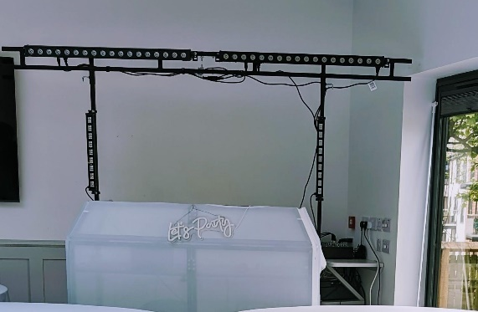
Reflection on Organisational Issues-Reflecting on the overall experience one particular issue I identified/encountered in terms of event management-is I specifically requested that due to my faith/religious reasons I would not be serving any alcohol but I was happy to take bar payments if needed-which the hotel management had respected my decision for this-however when it comes to training there was not enough given on how to take different types of transactions as management are more focused on other hotel services, this initially had a negative impact on serving the customers at first until I weas shown by another member of staff(QAA, 2018 p.99). explains-despite technological advancements may eliminate the necessity for specific job functions like processing contactless payments-organisations will still need to continue to rely on employees as-direct interactions/engagement with customers remains crucial. Organisations must assess the alignment of their values with those of their employees-if businesses are failing to implement policies/practices that support employees providing them with adequate training to integrate effectively into their roles failure to do so may result in high rates of employee turnover rates.(REFER TO APPENDIX2-FOR MORE ON THE REFLECTION OF ORGANISATION ISSUES)

According to(Bardy. J, 2011)it’s crucial to incorporate suitable management techniques/theoretical approaches to ensure that the hotels guests/event services have access to current resources/information necessary to facilitate their daily operations. This personal reflection from my placement had aligned with the 6 stages of Gibbs learning cycle on reflection(Martin. H, 2021).
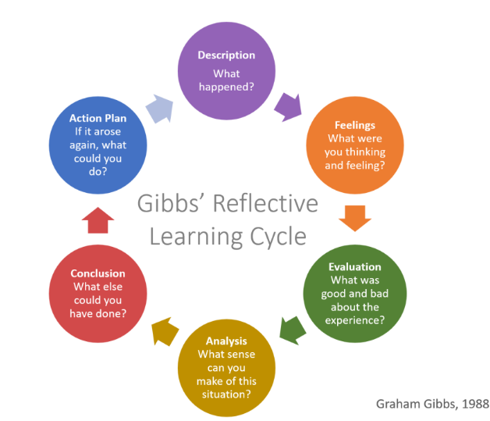
(Martin. H, 2021)
Looking back on specific projects set for me in particular of the event management set up task for a wedding-where I was directly placed hand on hand with a supervisor to help the preparations for this wedding event. This exposed me to a complication that had risen-I had to address the issue to the management team and find a way to resolve the issue to improve the customer’s demands/satisfaction.

Description-The operational issue that I was challenged with is that the customer initially wanted to place black chairs with no covers on as a way to save on the event cost-however on the previous day before the actual event the hotel manager had asked me to email the customer a picture of the set up to ensure she was happy with the outcome. The customer decided to change her mind last minute and include chair covers at an extra cost.

Feelings- At first, I felt a mixed emotion of frustration and worry regarding the possible impact on client satisfaction. My motivation stemmed from a strong urge to understand the core factors to the reason why the customer had changed her mind. It was important to process the situation in such short amount of time involved and actively carry on making the changes as requested to make the wedding event a success.

Evaluation-The bad effect/experience of this is we spent time working to place chairs spaced out evenly to how the customer initially wanted it-that amount of time had just felt like a waste had this information been communicated at an earlier stage. The positive effect/experience is that the hotel was determined to meet the customers need and hold its reputation for customer satisfaction. The quick shift to switch the chairs over was done just in time before guest arrivals. REFER TO APPENDIX1 FOR BEFORE AND AFTER PICTURES OF CHAIR SET UP.

Analysis-After analysing the situation/and processing the resources materials that would be needed to deliver this demand. It became clear that the time schedule had been severely delayed as the preparation of the changeover of each seat cover/ribbon required ironing each-as they were very creased despite effective teamwork put in by all of the staff in the hotel it caused a considerable degree of stress to the situation to be on time and to stay on track.

Action Plan-what could I of done better?It may have been useful to create a feasible/vision plan for the customers-communicating a deadline for at least a weeks’ notice if amendments are needed rather than doing last minute changes. For my future action plan initially prior to going into the events industry field was not something within my interest-however after placement experience I have found it to be very useful and enjoyed the creative side of setting up events especially the colour schemes/flower arrangements-previously this was not something within my skill set but I have enjoyed learning this new skill, and after positive feedback being received from the hotel team I am now thinking of incorporating this into my future career path-as working in a hotel industry can also mean hosting large events.

Conclusion-This scenario had made me realise the importance to maintain/open up channels of effective communications between the customers. To be hosting an event of any kind is a massive process involved from the planning/implementation and evaluation stage-everything needs to be on schedule to pursuit operational efficiency. For my future role as a hotel manager and what I aim to do differently is to implement a contingency plan this is important when organising an event in a hotel, it’s crucial for a successful execution of an event. There are key measures that can be taken to ensure various scenarios-such as last minute changes/medical emergencies/natural disasters etc having a back-up plan to minimise disruptions and ensure everything runs according to plan is crucial. This placement experience at the Whitehouse hotel has proven to be beneficial as comparing this to past work placement/experiences I did not get the opportunity to take part in event management. The acquisition of valuable knowledge, being in the solid groundwork/establishment of an events environment-being part of the communication network/teamwork/task management and guest services, all of this was essential for achieving my placement objectives-it’s a valuable tool/skill set to be taking forward for my future career path within the hotel industry.
REFERENCES

ASET Online.Org (2019) ASET Good Practice Guide to Successful Work Based Learning for Apprenticeships in Higher Education [Online] Available at: ASET-Good-Practice-Guide-to-Successful-Work-Based-Learning-for-Apprenticeships-in-Higher-Education.pdf (asetonline.org) Accessed: 1st May 2024.

Bardi. J, (2011) Hotel Front Office Management (5th ED) Wiley, US.

Casado, M. (2012) Housekeeping Management, London 2nd ed Wiley,

Gaakeer. J, (2019) Practical Knowledge: Facts, Norms & Phronesis, Judging From Experience pp95-116. doi:10.3366/Edinburgh/9781474442480.003.0007.

Hagg, E (2012) Internship Guide Eleven International Publications

Martin. H, (2021) GIBBS' REFLECTIVE LEARNING CYCLE [Online] Available at: Gibbs' Reflective Learning Cycle – HELEN MARTIN BLOG (helendenheld.com) Accessed: 1st May 2024.

QAA (2018) QAA Quality Code: Work based Learning [[Online] Available at: https://www.qaa.ac.uk/qualitycode/advice-andguidance/work-based-learning
Accessed 19th May 2024

Sulaiman & Musnadi (2018) ‘Customer Relationship Management, Customer Satisfaction & it’s Impact on Customer Loyalty’, Proceedings of the 7th International Conference on Multidisciplinary Research [Preprint] doi:10. 5220/0008892606920698.

Toth. C (2018) ‘chapter 4 directed self-placement at “Democracy open door” Writing placement and social justice in community colleges’, Writing Assessment, Social Justice, and the advancement of opportunity,pp.137-170. doi:10.37514/per-b.2018.0155.2.04.

APPENDIX 1
BEFORE AND AFTER PICTURES OF CHAIR SET UP
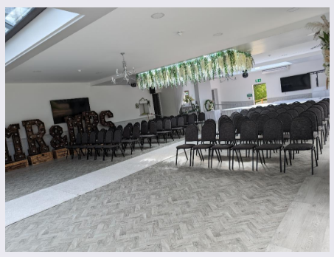
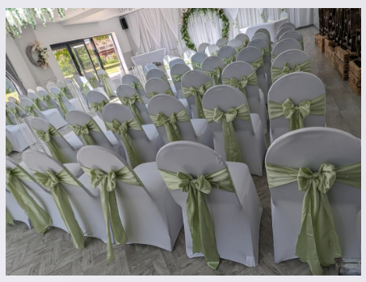

Appendix 1a:

- Events food set up/flower arrangement/ table set up with runners and centre pieces:
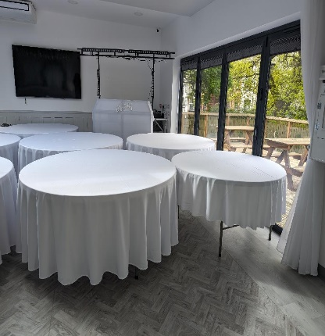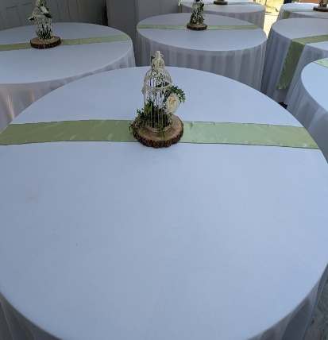

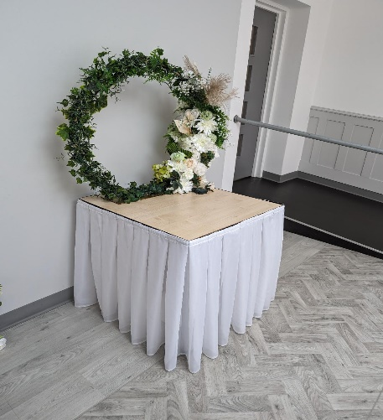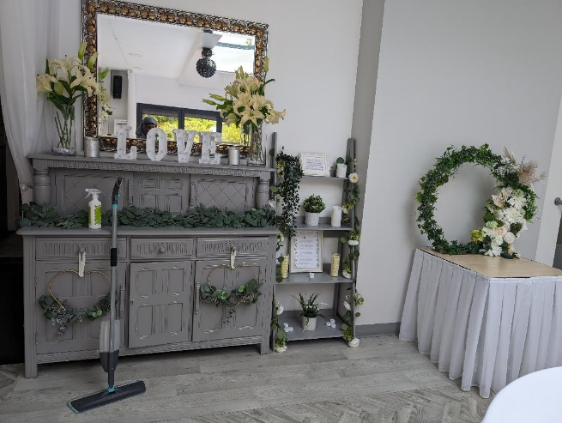

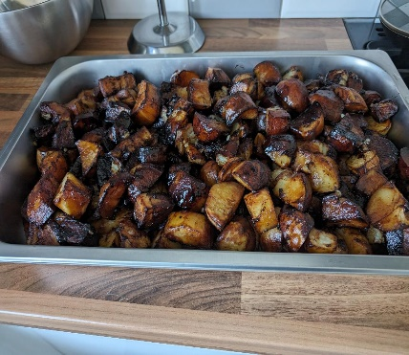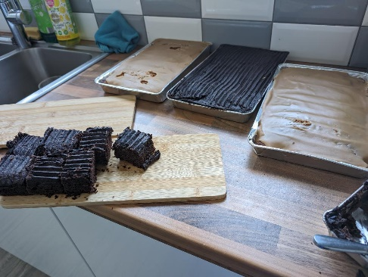

APPENDIX 2:

REFLECTION OF ORGANISATION ISSUES:
-There are back to back events every week within this hotel it’s important to be respectful-of different cultures/ ways of communication different gestures and signals can mean different things and it’s important to make amendments as needed to accommodate for the guests culture-which is something-I wasn’t prepared for and again is an area where the hotel could better train/communicate the staff on how to respond to different cultural needs. This also aligns with personal/vocational development goals and contributes to professional growth within the events management industry (QAA, 2018 p.97).

