C2 Written Report

Analysing SDG 3 and SDG 10
Targeting Black Maternal Mortality

Student Name: Sabya bibi Ali
Student ID: 2313056
Module: Health, Wellbeing and Sustainable Development
Module Code: BMHP6030

Table of Contents
1. Introduction: 3
2. Section 1: SDG 3 (Good Health and wellbeing) 3
2.1. Overview 3
2.2. Critical Evaluation of Global Initiative 4
2.2.1. Strengths and Weaknesses 5
2.2.2. UK Initiatives 5
2.3. Theoretical Perspective 6
2.4. Recommendations 6
3. Section 2: SDG 10(Reducing Inequalities) 7
3.1. Overview 7
3.2. Global Initiative 8
3.3. UK Initiative Targeting SDG 10 8
3.4. Theoretical Perspective 9
3.5. Recommendations 10
Conclusion 11
Reference list 12

Introduction:
The Sustainable Development Goals (SDGs) are 17 interconnected goals adopted by United National in 2015 to promote social equity, economic development and environmental sustainability by 2030 (United Nations, 2023). SDG 3 (Good Health and Well-being), aims to ensure healthy lives and promote wellbeing for all and SDG 10 (Reduced Inequalities), seeks to reduce disparities by promoting social inclusion, equal opportunities and equitable access to resources and services (United Nations, 2025). These goals are inherently interconnected as achieving equitable health outcomes depends on addressing social, economic and structural factors that create health inequalities.
Despite international commitments, racial disparities remain persistent challenge within maternal healthcare (UK Parliament, 2024). Black women continue to experience poorer maternal health outcomes and inequitable access to high-quality, culturally responsive care. These disparities are shaped by structural racism, discrimination and wider social determinants of health, demonstrating that maternal health extends beyond clinical care to encompass human rights, health inequity and sustainable development (Sapsed-Foster, 2025; RCOG, 2019).
This report critically examines how SDG 3 and SDG 10 influence efforts to address racial inequity in Black maternal health at global, national and local levels. It evaluates the effectiveness of current UK health, wellbeing and sustainability policies and initiatives, identifies implementation challenges and evidence gaps, and proposes evidence-based recommendations to improve equitable maternal mental healthcare.

Section 1: SDG 3 (Good Health and wellbeing)

Overview
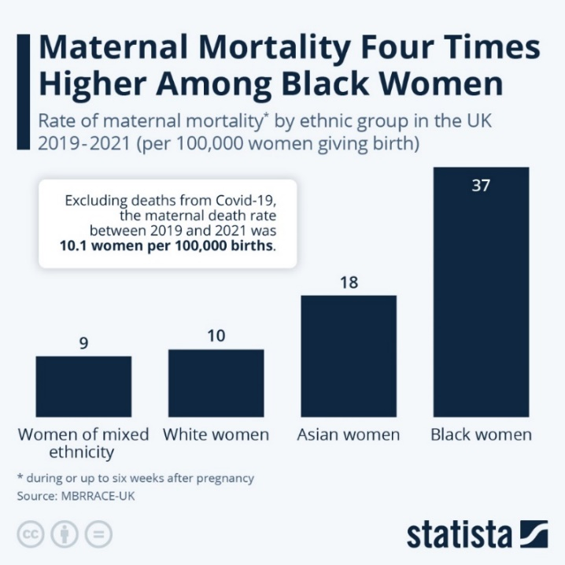
The Sustainable Development Goals (SDGs) target 3 (Good Health and Well-being) aims to ensure healthy lives and promote well-being for people of all ages by reducing preventable mortality, strengthening health systems, achieving UHC (Universal health coverage) and access to quality maternal healthcare. A key target, SDG3.1 seeks to reduce global maternal mortality ratio to fewer 70 deaths per 1000,000 live births by 2030 (UNICEF, 2025). According to World Health Organization (2025), maternal mortality remains a significant global health issue. In 2013, an estimated 260,000 women died during pregnancy, childbirth or shortly after birth, with 92% of these deaths happening in low and lower middle-income countries (Nabyonga-Orem, 2022; Reach Alliance, 2026). MBRRACE-UK reported (Fig. 1) that black women were almost five times more likely to die during pregnancy or after childbirth than White women (MBRRACE-UK, 2019: Fourreau, 2024). Universal Health Coverage (UHC), adopted as part of SDG 3, aims to ensure that everyone can access essential health services without financial hardships and is recognised by WHO as a key strategy for achieving health equity (Williams and Jesper Sundewall, 2025). Although it aims to provide equitable access to healthcare without financial hardship, it does not fully address the wider social determinants that influence maternal health outcomes. Factors such as poverty, low educational attainment, unemployment and insecure housing continue to limit women’s ability to access timely and appropriate maternity services (Akinbi, 2024). Furthermore, UHC inadequately addresses structural racism, implicit bias and discrimination within healthcare systems, which contribute to poorer experiences and outcomes for Black women (Todd et al., 2000).

Fig. 1 (Fourreau, 2024)

Critical Evaluation of Global Initiative
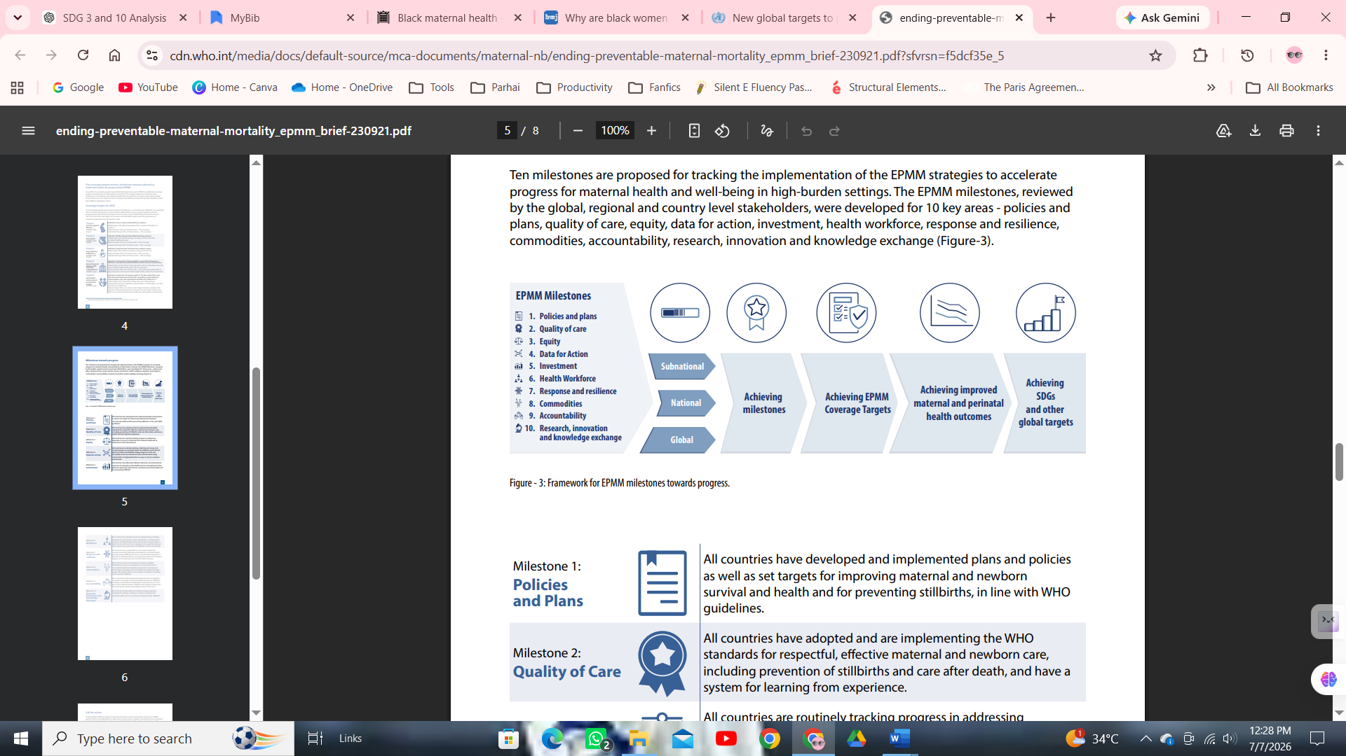
The World Health Organization Ending Preventable Maternal Mortality (EPMM) framework provides a comprehensive global strategy for achieving SDG 3 by reducing preventable maternal deaths while improving maternal health and wellbeing. Unlike earlier initiatives that focused primarily on mortality reduction EPMM adopts a rights-based and equity-focused approach, emphasising respectful, person-centred and high-quality maternity care throughout pregnancy and childbirth. Central to the strategy is the recognition that maternal health inequalities cannot be eliminated through healthcare alone (Fig.2) (WHO, 2020).

Fig. 2 EPMM Framework (WHO, 2020)

Strengths and Weaknesses
WHO (2020), highlights the need to strengthen health systems, improve governance, expand maternity workforce, ensure timely emergency obstetric care and address wider social determinants such as poverty, education, gender inequality and discrimination (WHO, 2020). EPMM represents one of the most comprehensive global maternal health strategies with strong human rights approach but its effectiveness has been constrained by uneven implementation, limited accountability ad insufficient national investment. For Black ethnic groups it is an important strategic framework that promotes improvement in referral pathways, financing and governance but meaningful reduction in maternal deaths require national initiatives. With the initiatives like this, maternal deaths declined from approximately 309,000 in 2016 to 287,000 in 2020, representing a 34% reduction since 2000. However, the global maternal mortality ratio remained 223 deaths per 100,000 live births in 2020, considerably above the SDG 3.1 target of fewer than 70 deaths per 100,000 live births by 2030 (Focus,2023). This demonstrates that despite progress, current efforts remain insufficient to meet global targets, closing the gaps could save 275,000 women annually (Sayed Mohammad Rasel et al., 2024).

UK Initiatives
The UK has introduced several initiatives to reduce maternal health inequalities, reflecting the objectives of SDG3 and SDG 10. The NHS Long-Term Plan (2019) aims that most women from black ethnic groups would receive enhanced continuity of midwife care. By 2024, NHS targets 75% women of ethnic minorities should receive continuity of care from their midwife. This should help reduce preterm birth, hospital admission and maternal inequalities. The Maternal Care Bundle, a best practice standard across 5 areas of clinical care represents a significant advancement in standardising evidence-based maternity care by targeting the leading causes of maternal deaths. it works in collaboration with MDTs, personalised care and explicit focus on reducing inequalities (NHS England, 2026). However, effectiveness is likely to depend on adequate workforce, sustained funding and consistent implementation. The bundle primarily addresses clinical practice so it is not enough to target disparities like racism socioeconomic gap and social determinants of health. At the local level, initiatives such as London Maternity Clinical Network support the implementation of Better Births through shared learning, continuity of care and service improvement. However, its impact on black maternal mortality depends on consistent implementation across NHS trust, skilled workforce to target racial discrimination and social determinants of health (NHS England, 2026; NHS London, 2017).

Theoretical Perspective
Integrated interventions are needed to reduce the maternal mortality rates in Black women in UK to achieve SDG 3.1 targets. The Biopsychosocial Model recognises that maternal outcomes result from interaction of medical conditions, psychological wellbeing and wider social influences. Research shows that inadequate prenatal and postnatal care is deeply associated with poor maternal outcomes, infant mortality and wider health inequalities, while social support, experiences of racism, psychological wellbeing and family circumstances are strong predictors of maternity care utilisation. Therefore, improving maternal outcomes for Black women depends not only on high-quality clinical care but also on reducing social and racial disparities that limit access to equitable maternity services (Qiu, Chirico and Duberstein, 2021). The House of Commons Women and Equalities Committee (2023) concluded that Black maternal health are impacted by interconnected factors including preexisting health conditions, socioeconomic deprivation, bias, microaggression and racism. Therefore, a holistic approach is needed to address clinical, mental, wider social determinants and culturally competent care (Brader, 2023).

Recommendations
- The recommendations are informed by evidence from the Nuffield Trust Explainer, Is England Making progress to Improve Maternity Care (2025). And UK government’s practical guide on making maternal health services women friendly (2001), based on findings from CQC National Maternity Review, Th Health Services Safety Investigation body (HSSIB) AND National Maternity and Neonatal Investigation (NMNI) (NHS, 2026; nuffieldtrust.org.uk; GOV.UK, 2001). The focus is on improvement, accountability and person-centred care to improve maternal outcomes.
- There is an acute need to implement targeted maternity interventions rather than relying on general safety initiatives to reduce ethnic inequalities.
- Strengthen continuity of care and ensure that woman from ethnic minorities is listened to, involved in decision-making to improve safety concerns.
- There is need to develop realistic national targets, clear timelines and regular monitoring to improve accountability across NHS.
- Streamline implementations of maternity recommendations as the reports says more than 748 recommendations have been proposed over the last decade. There is need to prioritise evidence -based actions rather than producing additional guidance.
- Sustained workforce investment, retention strategies and supportive leadership can only help in achieving SDG 3 and SDG 10 targets by 2030.

3. Section 2: SDG 10(Reducing Inequalities)

3.1. Overview
SDG 10(Reduced Inequalities) aims to reduce inequalities within and between countries by promoting social inclusion, equal opportunities and eliminating discrimination based on race, ethnicity, gender, disability and socioeconomic status. The principle of “leaving no one behind” recognises that sustainable development cannot be achieved while disadvantaged populations continue to experience unequal access to healthcare and poorer health outcomes (United Nations, 2025a). Health equity cannot be achieved without reducing social and economic inequalities (Akinbi, 2024). According to the United Nations, discrimination continues to affect one in five people globally, disproportionately impacting women and marginalised communities (United Nations, 2025b). For Black women, structural, racism, socioeconomic disadvantage and unequal access to high quality maternity care contribute to poorer maternal outcomes despite advances in health care (RCOG, 2019).

3.2. Global Initiative
At global level, the WHO developed the Operational Framework for Monitoring Social Determinants of Health Equity to help countries identify the causes of health inequalities, monitor them using data and develop policies across different sectors to improve health equity. This framework strengthens SDG 10 by encouraging countries to monitor health inequalities like racial discrimination, gender bias and socioeconomic differences and develop policies across multiple sectors. The limitations of this framework are that it only provides guidance and success depends solely on political and national policies. Insufficient data on ethnic minorities can hamper monitoring and targeting persistent challenges. Although there is recognition of social determinants it gave no specific actions as how to eliminate racism or discrimination in healthcare. (World Health Organization, 2024).

3.3. UK Initiative Targeting SDG 10
NHS England introduced Core20PLUS5 strategy to reduce healthcare disparities of the most deprived population including Black ethnic minorities (Fig. 3 NHS England, 2021). Targeting high mortality neonatal rates in black ethnic groups there 8% reduction in maternal deaths, newborn deaths are reduced by 5.8%, and stillbirths by 18.8% in England since 2010. Approximately £40 million has been invested on maternity services in England, supporting this achievement (GOV.UK, 2019).
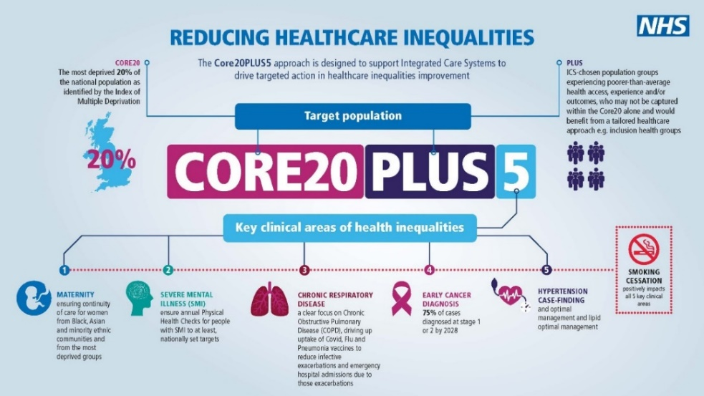

Fig.3 (NHS England, 2021)

Subsequent initiatives, including the Maternity Inequalities Oversight Forum and Equity and Equality Guidance for Local Maternity Systems, strengthened the NHS focus on identifying ethnic disparities, co-producing local action plans and improving equitable access to maternity services (Kulakiewicz et al., 2021). This initiative represents an important shift from focusing solely on clinical care to addressing systemic racism a discrimination within maternity services, aligning closely with SDG 10. By recognising that inequalities arise from organisational culture as well as health care delivery it supports more equitable care. However, as relatively recent programme the success depends on sustained leadership, workforce engagement, adequate resources and robust monitoring of outcomes.

3.4. Theoretical Perspective
Persistent racial disparities in Black maternal mortality demonstrate that health outcomes are influenced by biological, psychological and social factors rather than clinical alone (Linton, 2025). Linton (2025) argues that Black Women are facing poor maternal outcomes are a result of structural racism, implicit bias, delayed recognition of complications and socioeconomic inequalities (Figure. 4 Bond et al., 2022). There is an acute need for person-centred culturally competent care to address social determinants. According to Ranee Thakar, president of the UK’s Royal College of Obstetricians and Gynaecologists, Black maternal motility cannot be attributed to a single cause. Instead, it results from combined effects of medical factors, wider social inequalities and different forms of racism within society and healthcare services.

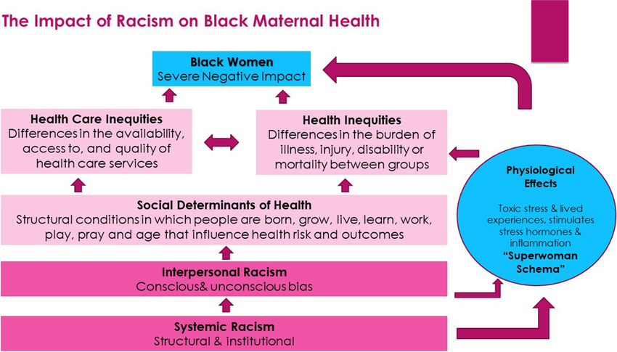

Fig. 4 (Bond et al., 2022)
The Dahlgren and Whitehead (Rainbow) Model (Dahlgren and Whitehead, 2021), provides a useful framework for understanding why Black women continue to experience poorer maternal health. The model recognises that health is influenced by multiple layers of determinants, including individual factors, social support, living and working conditions, healthcare services and wider socioeconomic environments (Fig. 5 Review, 2024).
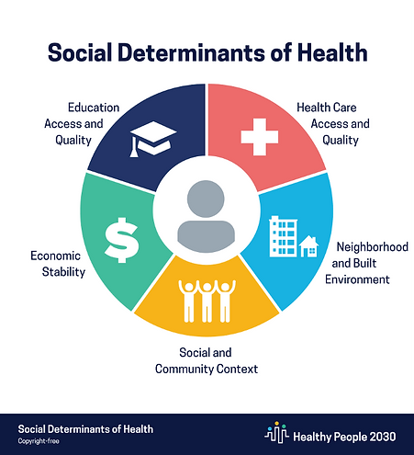

Fig. 5 (Review, 2024)
A recent systematic review found that maternal morbidity, mortality are strongly associated with structural factors such as racial discrimination, access to services and socioeconomic deprivation. For Black Women these intersecting determinants increase the risk of delayed diagnosis and adverse maternal outcomes. It demonstrates that SDG 3 depends on SDG 10 by targeting inequality through action on structural racism, poverty and equitable access (Walker et al., 2023). The Marmot Review (2010), concluded that health inequalities are driven by wider social inequalities, meaning that improving health requires action on social determinants of health. MBRRAC-UK reported that women living in the most deprived areas are 2.5 times more likely to die during childbirth than those in least deprived areas. Black women are mostly facing this socioeconomic deprivation further increasing the risk of poor maternal outcomes (UK Parliament, 2022; Marmot, 2010).

3.5. Recommendations
To target SDG 10 goals there is need for the following steps to be taken to meet the targets by 2030.
- Cross sector collaboration is needed to bridge the gap regarding deprivation, housing, education and access to services.
- Promote dignity, privacy and respectful communication and informed choice to improve experience and engagement with the maternity services.
- There is need to enhance community-based support to target language barrier, cultural appropriateness to target ethnic groups. Involvement of local community in service design is crucial to target needs.

Conclusion
Unless persistent Black ethnic disparities in maternal health are specifically addressed, achieving SDG 3 will remain unattainable, highlighting acute interdependence of SDG 3 and SDG 10. Despite significant progress Black women continued to experience disproportionate maternal mortality because inequalities remain deeply rooted in structural racism and wider social determinants. Achieving sustainable improvements require stronger accountability, women centred care workforce investment and consistent implementation of recommendations. Collectively these actions will support progress towards reducing preventable maternal death and more equitable outcomes for women from Black ethnic groups.

Reference list
Akinbi, J. (2024) Addressing Disparities in Maternal Mortality: An Analysis of Pain Management Protocols and Their Impact on Global Maternal Health Equity. Available at: https://sdgs.un.org/sites/default/files/2024-05/Akinbi_Addressing%20Disparities%20in%20Maternal%20Mortality.pdf.
BMJ (2025) Maternal health inequalities: focusing on Black pregnant women, https://www.britishjournalofmidwifery.com/content/professional/maternal-health-inequalities-focusing-on-black-pregnant-women?__cf_chl_f_tk=cVlsn8pEow5EtrvYho9FZdtjZboocUxl7ImHDIkENhY-1783338388-1.0.1.1-x2TuHt_BjDYd86RBhGqescTI8.ZE4AqKm_BKxybsF18.
Bond, R.M. et al. (2022) “Cardiovascular Health of Black Women Before, During, and After Pregnancy: A Call to Action and Implications for Prevention,” Current Cardiovascular Risk Reports [Preprint]. Available at: https://doi.org/10.1007/s12170-022-00703-0.
Brader, C. (2023) Maternal mortality rates in the Black community, House of Lords Library. Available at: https://lordslibrary.parliament.uk/maternal-mortality-rates-in-the-black-community/ (Accessed: July 7, 2026).
Dahlgren, G. and Whitehead, M. (2021) “The Dahlgren-Whitehead Model of Health Determinants: 30 Years on and Still Chasing Rainbows,” Public Health, 199(1), pp. 20–24. Available at: https://doi.org/10.1016/j.puhe.2021.08.009.
Focus (2023) Maternal mortality in the world in the light of the Sustainable Development Goals, Focus 2030. Available at: https://focus2030.org/en/maternal-mortality-in-the-world-in-the-light-of-the-sustainable-development-goals/ (Accessed: July 7, 2026).
Fourreau, V. (2024) Black women four times as likely to die in pregnancy, Statista Daily Data. Statista. Available at: https://www.statista.com/chart/31860/maternal-mortality-per-ethnic-group/?srsltid=afmbooq3zomwkszyhidubaletx-ffnqu0gg2q2om8vupwwqbjr_-trgm (Accessed: July 6, 2026).
GOV.UK (2001) How to Make Maternal Health Services More Women-friendly A Practical Guide. Available at: https://assets.publishing.service.gov.uk/media/57a08d67ed915d622c00198f/Hperipractical_guide.pdf (Accessed: July 7, 2026).
Kulakiewicz, A. et al. (2021) DEBATE PACK Black Maternal Healthcare and Mortality. Available at: https://researchbriefings.files.parliament.uk/documents/CDP-2021-0055/CDP-2021-0055.pdf (Accessed: July 7, 2026).
Linton, S. (2025) “Why are black women still more likely to die in childbirth?,” BMJ, p. r226. Available at: https://doi.org/10.1136/bmj.r226.
Marmot, M. (2010) Fair society, healthy lives : The Marmot Review : Strategic review of health inequalities in England post-2010., GOV.UK. Available at: https://www.gov.uk/research-for-development-outputs/fair-society-healthy-lives-the-marmot-review-strategic-review-of-health-inequalities-in-england-post-2010 (Accessed: July 7, 2026).
MBRRACE-UK (2019) Saving Lives, Improving Mothers’ Care | MBRRACE-UK | NPEU, Ox.ac.uk. Available at: https://www.npeu.ox.ac.uk/mbrrace-uk/presentations/saving-lives-improving-mothers-care (Accessed: July 6, 2026).
Nabyonga-Orem, J. (2022) Towards Universal Health Coverage, the need for innovative approaches to reach women and children in low-income countries., Https://africa-health.com/wp-content/uploads/2022/12/TOWARDS-UNIVERSAL-HEALTH-COVERAGE-.pdf.
NHS (2026) Is England making progress to improve maternity care?, Nuffield Trust. Available at: https://www.nuffieldtrust.org.uk/resource/is-england-making-progress-to-improve-maternity-care-an-explainer (Accessed: July 7, 2026).
NHS England (2021) Core20PLUS5 an Approach to Reducing Health Inequalities, Www.england.nhs.uk. NHS England. Available at: https://www.england.nhs.uk/about/equality/equality-hub/national-healthcare-inequalities-improvement-programme/core20plus5/ (Accessed: July 7, 2026).
NHS England (2023) Three year delivery plan for maternity and neonatal services, NHS England. Available at: https://www.england.nhs.uk/publication/three-year-delivery-plan-for-maternity-and-neonatal-services/.
NHS England (2025) NHS England » Actions to improve care for women, babies and families: Next steps, England.nhs.uk. Available at: https://www.england.nhs.uk/long-read/actions-improve-care-women-babies-families-next-steps/.
NHS England (2026) NHS England » The Maternal Care Bundle, England.nhs.uk. Available at: https://www.england.nhs.uk/long-read/the-maternal-care-bundle/ (Accessed: July 7, 2026).
NHS London (2017) NHS England — London » London Maternity Clinical Network Publications, England.nhs.uk. Available at: https://www.england.nhs.uk/london/london-clinical-networks/our-networks/maternity/publications/ (Accessed: July 7, 2026).
Qiu, P., Chirico, F. and Duberstein, Z. (2021) “The Biopsychosocial Model and Perinatal Health Care: Determinants of Perinatal Care in a Community Sample,” Frontiers in Psychiatry | www.frontiersin.org, 1(12), p. 746803. Available at: https://doi.org/10.3389/fpsyt.2021.746803.
RCOG (2019) How inequalities impact maternal and perinatal care | RCOG, RCOG. How inequalities impact maternal and perinatal care | RCOG. Available at: https://www.rcog.org.uk/news/how-inequalities-impact-maternal-and-perinatal-care/ (Accessed: July 6, 2026).
Reach Alliance (2026) Improving Black Maternal Health: A Holistic Approach in the U.S. and Ghana - The Reach Alliance, The Reach Alliance. Available at: https://reachalliance.org/reports/improving-black-maternal-health-across-the-african-diaspora-holistically/.
Review, P.-C.G.H. (2024) Examining Black Maternal Mortality: Racialization and the Social Determinants of Health, PGHR. Available at: https://www.pghr.org/post/examining-black-maternal-mortality-racialization-and-the-social-determinants-of-health (Accessed: July 7, 2026).
Sapsed-Foster, I. (2025) Systemic Silence: Addressing Racial Inequity in Black Maternal Mental Health, Research Communities by Springer Nature. Springer Nature. Available at: https://communities.springernature.com/posts/systemic-silence-addressing-racial-inequity-in-black-maternal-mental-health?utm_medium=referral&utm_source=sn&utm_content=rm&utm_term=null&utm_campaign=conr_none1_att1_gl_pcom_06dz4_sntr-sdg-2 (Accessed: July 6, 2026).
Sayed Mohammad Rasel et al. (2024) “Assessment of the association between health problems and cooking fuel type, and barriers towards clean cooking among rural household people in Bangladesh,” BMC Public Health, 24(1). Available at: https://doi.org/10.1186/s12889-024-17971-7.
Todd, K.H. et al. (2000) “Ethnicity and analgesic practice,” Annals of Emergency Medicine, 35(1), pp. 11–16. Available at: https://doi.org/10.1016/s0196-0644(00)70099-0.
UK Parliament (2022) Black maternal health - Women and Equalities Committee, Parliament.uk. Available at: https://publications.parliament.uk/pa/cm5803/cmselect/cmwomeq/94/report.html (Accessed: July 7, 2026).
UK Parliament (2024) Black Maternal Health, Parliament.uk. Available at: https://publications.parliament.uk/pa/cm5901/cmselect/cmhealth/895/report.html.
UNICEF (2025) SDG Goal 3: Good Health and Well-being, Unicef. Available at: https://data.unicef.org/sdgs/goal-3-good-health-wellbeing/ (Accessed: July 7, 2026).
United Nations (2023) Goal 3: Ensure healthy lives and promote well-being for all at all ages, United Nations Sustainable Development Goals. Available at: https://www.un.org/sustainabledevelopment/health/.
United Nations (2025a) Goal 10: Reduce Inequality within and among Countries, United Nations Sustainable Development. United Nations. Available at: https://www.un.org/sustainabledevelopment/inequality/ (Accessed: July 7, 2026).
United Nations (2025b) SDG Indicators, Un.org. Available at: https://unstats.un.org/sdgs/report/2025/ (Accessed: July 6, 2026).
Walker, S.L. et al. (2023) “Examining the Relationship between Social Determinants of Health and Adverse Pregnancy Outcomes in Black Women,” American Journal of Perinatology [Preprint]. Available at: https://doi.org/10.1055/s-0043-1771256.
WHO (2020) Ending Preventable Maternal Mortality (EPMM) A RENEWED FOCUS FOR IMPROVING MATERNAL AND NEWBORN HEALTH AND WELLBEING. Available at: https://cdn.who.int/media/docs/default-source/mca-documents/maternal-nb/ending-preventable-maternal-mortality_epmm_brief-230921.pdf?sfvrsn=f5dcf35e_5 (Accessed: July 7, 2026).
Williams, A. and Jesper Sundewall (2025) “Understanding policy commitments for universal health coverage: A framework for analysis,” Health Research Policy and Systems, 23(1). Available at: https://doi.org/10.1186/s12961-025-01370-4.
World Health Organization (2024) Operational framework for monitoring social determinants of health equity, Www.who.int. Available at: https://www.who.int/publications/i/item/9789240088320 (Accessed: July 7, 2026).
World Health Organization (2025) Maternal mortality, World Health Organization. Available at: https://www.who.int/news-room/fact-sheets/detail/maternal-mortality.

