

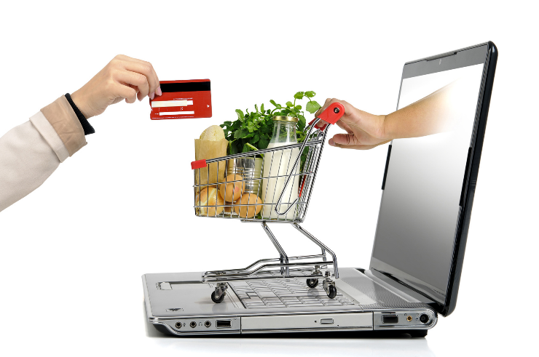
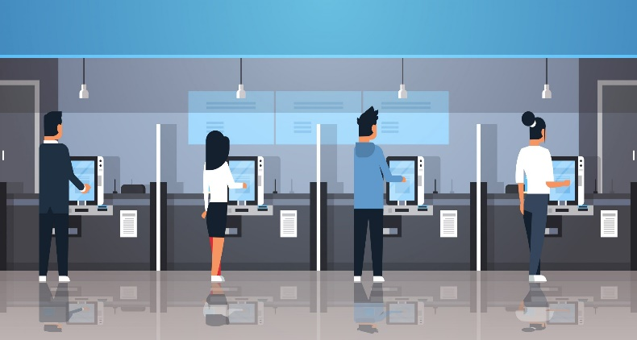
19/04/2021
Shannon Jones (1803188)

The Impact of Technology in UK supermarkets
BMSP6004
Figure i (Anon., n.d.)
Figure 1 (Anon., 2021)
Signed Statement
In submitting this dissertation, I confirm that:
- This work has not previously been accepted in substance for any degree and is not being concurrently submitted in candidature for any degree.

- This dissertation is being submitted in partial fulfilment of the requirements for the degree of BA Business and Management.

- This dissertation is the result of my own independent work/investigation, except where otherwise stated.

- . Other sources are acknowledged by footnotes giving explicit references. A Bibliography is appended.

- . I hereby give consent for my dissertation, if accepted, to be deposited in the School Dissertation Library.

Name: Shannon Jones
Date of Submission: 19/04/2021
Signature: S. M. Jones

Acknowledgements
First, I would like to express my gratitude to all of the lecturers at the University of Wales Trinity Saint David in Carmarthen, who have been invaluable during my three years of study. I want to express my appreciation to Glenn Behenna, my dissertation supervisor, for his help and support during the process, from helping to select a suitable dissertation topic to showing me the direction to go with my thesis.
Participants in my survey are also people to whom I want to express my gratitude for filling out the questionnaire and returning it in such a short amount of time. With their input, I was able to gain a better understanding of how technology has impacted the supermarket industry.
I would also like to thank my fellow peers and family who have given me support throughout this dissertation and general study at University.

Abstract
The grocery industry is constantly changing due to the rise in new technologies. To stay relevant in today's society, Supermarkets are having to adapt their businesses. This can be hard for certain businesses as introducing new technologies into a business can come with many risks, such as cost. This research's primary aim was to find out how the rise in technology has impacted the way businesses operate and how they have adapted to new technologies, with a clear explanation of digitisation and the impact of its development. This study aims to research the impact technology has had on UK supermarkets. Primary information will be collected via surveys distributed to the public, including employees and customers. Other information will be collected using various sources such as the Internet. Different approaches can be taken to collect information depending on the wanted or needed outcome. The research carried out for this paper requires responses from a broad range of people of different ages and backgrounds. Research, a quantitative approach will be used as it will allow for a larger audience. It would also provide faster responses as surveys can be completed by more than one person—the results and finding identified that technology mainly had a positive impact on the grocery industry. Several respondents said they felt that home delivery services and click and collect allowed them to access shopping services when they could not shop in-store. However, some of the respondents expressed their opinion that technology had not helped and that shopping the traditional way was better.

Table of Contents
Signed Statement 1
Acknowledgements 2
Abstract 3
Chapter 1. Introduction 8
1.1 Introduction to Digitalisation 8
1.2 Background of retail technology 8
1.3 Problems 9
Chapter 2. Literature Review 11
2.1 Introduction 11
2.2 Digitalisation 11
2.3 Business digitalisation 11
2.4 Grocery Industry 12
2.5 UK Supermarkets 13
2.6 Sustainability 14
2.7 Coronavirus Pandemic Impact 15
Chapter 3. Methodology 16
3.1 Research Overview 16
3.2 Aims and Objectives. 16
3.3 Research Method 17
3.4 Planning 18
3.5 Research Design 19
Chapter 4. Findings 19
4.1 Statistical data 20
4.1.2 Figure 1 Percentage of how many respondents did their shopping online. 20
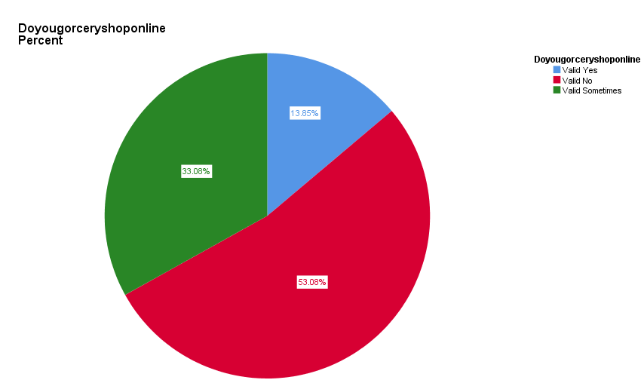 20
4.1.3 Figure 2: Age of Respondents compared to if they shop online. 21
4.1.4 Figure 3: frequency of which online grocery provider was used. 22
4.1.5 Figure 4: How often people shopped compared with online provider used. 23
4.1.6 Figure 5: What service respondents used compared with their age. 24
4.7 Public opinions 25
4.7.1 Has technology impacted the way people buy groceries? 25
4.7.2 Do you think that being able to shop online has helped Supermarkets during the pandemic? If so, how? 28
4.7.3 Why do you prefer to shop in-store? 31
4.7.4 What made you decide not to use those services in-store? 32
4.7.5 Does technology within the supermarket industry help the way that you and/or your colleges work? 33
Chapter 5. Discussions 34
5.1 Comparison to literature review 34
Chapter 6. Conclusion 38
6.1 Objectives 38
6.2 Analysis 39
6.3 Findings 40
6.4 Critical reflection 41
6.4.1 Planning 41
6.4.2 Research 41
6.4.3 Analysis 42
6.4.4 Limitations 42
References 43
Appendix 54
Figure i Survey (Basic Information) 54
Figure ii Survey (Online Shopping Section) 55
Figure iii Survey (Shopping instore section) 56
Figure iv Survey (work Experience Section) 57
Figure V (Additional Question about facial recognition) 58

Chapter 1. Introduction

1.1 Introduction to Digitalisation
The word "digitalisation" refers to the digital transformation of culture and the economy as a whole. It defines the transition from an industrial age marked by analogue technology to an age dominated by digital technologies and digital business innovation, characterised by knowledge and creativity (innolytics.ag, n.d.). As artificial intelligence, advanced robotics, and cyber-physical systems take the digital revolution to new heights, technological change is reshaping the economy's growth (Qureshi, 2020). Business technology is on the rise, and the business world is learning and adapting to innovative technologies. Trade and commerce have increased as a result of the role of technology in business. As a consequence of technological advancement, business concepts and models have been transformed (bookfresh.com, 2020).

1.2 Background of retail technology
Retail has a long history that dates back hundreds of years to become what it is today. With the emergence of online shopping, brick and mortar stores can no longer compete solely on price and quality. Retailers must now have a compelling purpose for customers to visit their establishment. The idea of a nearby convenience store may not be as appealing as it was a decade ago. The physical space and overall experience must differentiate brick and mortar stores from online stores. Additional services and amenities, leisure provision, and price are some of the factors that affect customers' decisions. According to IGD research, the top ten global online grocery markets are projected to produce total revenue of nearly £145,479 by 2023. Four of these supermarkets are based in Europe, The United Kingdom, France, Germany, and Spain (Askew, 2018). The significance of the retail environment is projected to grow in the future (Deloitte, 2017).
Grocery stores to the high street face increasing competition both physically and digitally, so the retail industry must continually adapt and evolve to a digitising environment (McCarthy, 2019). The transition to online shopping has been one of the most dramatic retail industry developments in recent decades. Every year, the online market evolves, with a higher percentage of sales being generated (McCarthy, 2019). As technology has progressed, so have the applications that are now readily available. The gig economy has allowed more effective delivery services, artificial intelligence developments have resulted in the self-checkout machine, and IoT breakthroughs have laid the groundwork for cashier-less stores (Smart Sense, 2020). The growing value and use of the Internet and other technological advancements significantly affect marketing strategies and enhance the size and reach of consumer self-production (Oghazi, et al., 2012). The idea of having customers take on a partial employee role during a transaction has broad appeal and is highly advantageous for service providers (Curran & Meuter, 2005). Self-checkout is increasingly being used as an alternative to recruiting and educating workers, and therefore as a possible source of cost savings (kara & Orel, 2013).

1.3 Problems
According to consumer research conducted by Phononic last year, 50% of consumers felt that grocery stores had not yet figured out how to use technology as other retailers have (Bandoim, 2019).
One of the biggest problems of introducing technology into supermarkets is the risk of security. Shoppers are becoming more relaxed with providing their personal and credit card information. In contrast, other shopper's concerns are holding them back from online shopping (Hudson, 2018). Other problems include theft. Theft is a growing concern in the modern era of shopping as the more self-service is provided, the more risk there is for theft as there is less supervision. Customers can easily switch price tags or fail to scan every item. A study conducted by the international study revealed an average 4% loss based on the total merchandise value (Heil, 2018). A study conducted by Voucher Codes Pro, a sales coupon website, quizzed 2,532 shoppers about their supermarket habits and found that close to a quarter had committed theft at a self-checkout machine at least once (Moshakis, 2018)
One of the other technology issues is the cost. Self-service systems, for example, are many times more costly than conventional cashier lanes. The average cost of a setup is £90,747.93. There are also the costs of integrating the systems with existing technologies – software and other systems for tracking inventory and sales – as well as the continuing costs of breakdowns and maintenance (Harris, 2017). The two largest UK operators, Tesco and Sainsburys, have said they expect to make around the same profit this year as last despite a vast transfer of food consumption from restaurants to home and a property tax holiday. One of the main reasons is the high cost of expanding online delivery operations (Eley & McMarrow, 2020).
The global grocery e-commerce market is expected to rise at a compound annual growth rate of 13.5% over the next decade, from €43 billion in 2017 to €135 billion in 2025. According to analysts, e-commerce companies are attempting to develop a presence in the United States and Europe. Still, they face significant challenges because the current grocery market is crowded (Tomra, 2018)

Chapter 2. Literature Review

2.1 Introduction
The purpose of this paper is to present research on how technology and digitalisation have impacted businesses, with a particular focus on supermarkets. This will be accomplished by gathering information from public surveys and secondary sources such as websites, articles, and previous research

2.2 Digitalisation
(Gartner, n.d.) describes digitalisation as
"The use of digital technologies to change a business model and provide new revenue and value-producing opportunities; it is the process of moving to a digital business".
Digitalisation is becoming increasingly important in emerging business ecosystems. Adapting to technology has proven beneficial by making work systems more manageable and less complicated, allowing people to focus on their work and be less preoccupied with external factors (The Enterprise World, n.d.).

2.3 Business digitalisation
Several factors drive a degree of digitalisation within a business that includes the following: Technology, technology has many potential benefits on operations within a business and difficulty level of digitalisation. The demand comes down to the customers. Some customers like it the old-fashioned way and others like adapting to new things. The consumer's behaviour also plays a big part in the digitalisation of a business (Consolidated Technologies Inc, 2018).
While there are many advantages of integrating technology in a business, there are also disadvantages, such as investing in digitalisation, which takes a lot of time and money. (Bossard, 2020) The speed at which technology is developing can also negatively impact businesses, especially high street retailers who may struggle to catch up. Although digitalisation has a beneficial impact on the environment to a certain degree, it also has a negative impact as certain technologies can cause CO2 emissions, negatively affecting the environment (Pettinger, 2020).

2.4 Grocery Industry
The growth of technology in the grocery industry is reaching a fever pitch because of growing consumer demand for everything from online grocery shopping to more targeted ads. Phononic, a cooling solution provider, found that 89 % want to shop in a supermarket that understands how to make grocery shopping more efficient. At the same time, the Food Marketing Institute and Nielsen recently estimated that in as little as five to seven years, 70% of grocery shoppers would shop online (Crowe, 2020). Consumers have traditionally made purchase decisions at the store shelf, giving institutional brick-and-mortar retailers great power to learn about and influence behaviours and preferences. With the rise of e-commerce, mobile shopping, and most recently, smart technologies, new competitors threaten this long-standing supremacy (Reinartz, et al., 2019). The new dynamics of the modern world and the speed at which the new technological, social, and information revolution impact consumers' way of having has become a reality for companies (European Business Magazine, 2020). In 2020 Nestle reported its best quarterly growth for nearly five years. This was mainly caused by customers stockpiling due to the coronavirus lockdowns. Nestle Chief Executive Mark Schneider noted E-commerce as a "Key Area" (Morrison, 2020).
There are several different types of technology that are changing the way we shop. More and more supermarkets are now offering online ordering, allowing customers to shop in the comfort of their own home. Offering online ordering and delivery shopping has become more accessible for many people, such as the disabled, the elderly, and those who want to avoid contact due to the current pandemic caused by the coronavirus (The Grant County Beat, 2020). Other revolutionary technologies are self-scanning and self-checkout. Using a company's mobile app to scan and pay for products means that there will be no queuing to pay (epc, n.d.)

2.5 UK Supermarkets
Many retailers in the United Kingdom have begun selling groceries, beverages, meal kits, and other goods and services online. Morrisons, Ocado, Iceland, Amazon Fresh, and several other businesses are among the companies that British customers are buying from. Tesco, on the other hand, is one of 2020s most popular store brand. In the last 12 months, nearly half of online shoppers in the UK said they had ordered groceries from Tesco. (Statista, 2021)
The United Kingdom has gone further in embracing internet retail than any of its Western peers at the moment; 20% of UK shoppers buy totally or partially online. For UK retailers to stay relevant and profitable, they must adopt new technologies and advance analytics to meet changing consumer needs. (Blachandani, et al., 2020). A survey conducted by Deloitte Digital Found that digital technology influenced 33% of in-store retail sales in the UK, equivalent to almost £100 billion. (Deloitte Digital, 2014) The transformation of the UK's traditional grocery and store scene by online providers is looking to grow. Amazon already provides free grocery delivery to millions of consumers in a major expansion of its fresh food operation. Traditional supermarket stores are struggling to catch up, with Tesco making a follow-up announcement promising free delivery to holders of its Clubcard Plus Reward Program in an attempt to compete with digital rivals. Meanwhile, Marks & Spencer has recently become Ocado's primary retail affiliate – perceived to be the next step in the expansion to catch up with rivals (Gupta, 2020)
Although technology has improved UK supermarkets' operation, it has also come with some disadvantages, for example, a trial with involved facial recognition in the UK supermarket coop. The software 'Facewatch' would notify staff if a customer has had previous experience of theft or anti-social behaviour. This caused privacy concerns. In an open letter to the retailer, privacy international questioned the legality of the technology used in stores. Facial recognition has proved to be a controversial subject, with questions over how well it recognises darker shades of skin and ethical concerns about invasion of privacy (Wakefield, 2020).

2.6 Sustainability
Over the years, sustainability has become a cause for concern within the supermarket industry worldwide. This is partly due to customer demand for a sustainable and environmentally friendly shopping experience. Technology has played a big part in the improvement of sustainability. For example, an app called Ubamarket offers a creative and simple solution that puts customers in charge of their shopping experience. (Ubamarket, n.d.) Ubamarket's technology provides a solution for both retailers and consumers to maintain safety protocols while also prioritising sustainability. The app has a 'plastic warnings' feature that allows consumers to check every product's packaging for details on whether it is recyclable. At checkout, customers will see an overall sustainability score that allows them to see where they can make changes (Broome, 2020)
A study from The Guardian suggested that supermarkets in the United Kingdom are responsible for nearly one million tons of plastic waste. However, digital innovation provides supermarkets with vast amounts of data that can generate accurate customer demand predictions and dramatically reduce the amount of food waste generated (Drinkwater, 2019).

2.7 Coronavirus Pandemic Impact
When the pandemic first started in Europe, google searches for "Food delivery and "local food" reached an all-time high. Supermarket giants such as Ocado and Amazon Fresh became overwhelmed due to the high demand for home delivery services (Shveda, n.d.). Since the beginning of the Coronavirus crisis, grocery retailers have had to adapt to consumer demand, both in-store and online. Supermarkets have had to scale up operations while also putting precautions in place to protect staff and customers (Darmody, 2020). Many businesses have had to adapt their business model or implement new technologies to help customers feel more at ease and encourage shoppers back into the store (Baldwin, 2020). Many technological solutions are emerging or gaining prominence that promise an improved, smooth, and Covid-19 safe in-store shopping experience, ranging from digital signage and QR codes to scan, pay, and go technology. Depending on their success, many of these innovations could become a part of the "new normal" retail experience in the long run (Sentance, 2020). The most significant change to the grocery industry has been the rise in online ordering. Many stores were already providing click and collect as well as delivery services. Due to the pandemic, many businesses have had to introduce these services to keep up with consumer demand (Morgan, 2020).
According to a recent study, since Q1 of 2020, there has been a larger growth in online shopping behaviours among Generation Z and baby boomers as well as consumers living in rural and suburban environments (Gorman, 2020).
The pandemic has seen sales in stores rise rapidly. Over 12 weeks, Iceland's sales were up by 28.6%. This was due to the rise in customer demand as lockdown started. To achieve this, Iceland had to increase its online capacity and extend available delivery slots (Perkins, 2020)

Chapter 3. Methodology

3.1 Research Overview
This study aims to research the impact technology has had on UK supermarkets. Primary information will be collected via surveys distributed to the public, including employees and customers. Other information will be collected using various sources such as the Internet.

3.2 Aims and Objectives.
This research's primary aim was to find out how the rise in technology has impacted the way businesses operate and how they have adapted to new technologies, with a clear explanation of digitalisation and the impact of its development.
1. Explanation of digitalisation within a business
2. Evaluate the impact it has had within the Supermarket industry.
3. Provide information from previous research carried out.
4. Explain both positive and negative impacts.
5. Obtain secondary data for analysis.
6. Compare both primary and secondary data.
7. Present findings
8. Provide recommendations.

3.3 Research Method
To complete the research that is required for this study, a suitable method must be selected. Several different types of approaches can be taken to collect information depending on the wanted or needed outcome. The research carried out for this paper requires responses from a broad range of people of different ages and backgrounds. There are two main types of research methods which are quantitative and qualitative data. Quantitative research collects numerical data to find patterns and averages, make predictions, and generalise results to a broader population (Bhandari, 2020). Quantitative research can be broken down into three main categories depending on the outcome that needs to be achieved.
1. Descriptive
2. Correlational
3. experimental
Descriptive research is defined as a method for describing a population's characteristics or a phenomenon under investigation. This approach emphasises the "what" of the study rather than the "why" of the subject. Descriptive research focuses on explaining a demographic segment's nature rather than investigating why a particular phenomenon occurs (Question Pro, n.d.).
Correlational studies aim to determine if there are differences in a population's characteristics depending on whether or not its subjects have been exposed to an event of interest in the naturalistic setting (Lau & Kuziemsky, 2017).
Experimental research is research that uses two sets of variables and is conducted systematically. The first set serves as a constant against which the second set's differences are measured (Question Pro, n.d.).
In the early 1930s, Paul Felix Lazarsfeld introduced research through the use of surveys by conducting a study about employment in Marienthal, a small industrial town near Vienna. By careful assessment, Lazarsfeld transformed qualitative data into quantitative analysis, a breakthrough in research survey methods (SoGoSurvey, 2019).
Qualitative data focuses on obtaining data through open-ended and conversational communication (Question Pro, n.d.). Qualitative research usually is recognisable via the use of methods that include in-depth interview and group-moderation techniques; researchers who offer expertise and knowledge to cover the procedures they use and the interpretations they derive; a particular objective to answer 'why?' and 'how?' questions (Bailey, 2013)
Although a qualitative approach would provide more opinions from people, it would also limit the amount of research that can be analysed. For the purpose of this research, a quantitative approach will be used as it will allow for a larger audience. It would also provide faster responses as surveys can be completed by more than one person, whereas with qualitative methods such as interviews, only one person could respond at one time.

3.4 Planning
Upon completing the literature review and gaining a clearer image of what questions need to be answered, a quantitative approach in the shape of a survey is created and distributed through various online social media platforms to gather information from the relevant sources within the specified timeframe. By sharing the survey through the different social media platforms, it allowed access to a broader audience of diverse backgrounds as well as the option for the survey to be shared by others allowing for even more exposure. As the majority of data from the surveys will be statistical, it is vital to include questions that require different opinions and experiences. This will allow for a more in-depth analysis of data.

3.5 Research Design
Basic questions such as sex and age were asked, allowing for categorising data for analysis. When asked if they do grocery shopping online, three options are available "yes", "no", and "sometimes. Depending on the chosen answer, the respondent is taken to different sections, meaning that the questions will be relevant to the respondent. One section includes questions that involve shopping experiences such as services that are used and thought-provoking questions such as How technology has impacted the way they buy groceries online and how technology may have helped supermarkets during the pandemic. Respondents that said that they did not shop online were directed to a different section that involved questions about in-store experiences surrounding technology as well as questions about why they decided not to shop online.
Both sections asked if they worked or have ever worked in the supermarket industry. Questions in that section included what role they played and how technology has helped within their employment experience and any changes they may have noticed.

Chapter 4. Findings
The results of the questionnaire review are discussed in this section. The data will be presented in pie charts, each with a summary. Multiple software applications were used to provide the most precise analysis possible, including Google forms for producing and sharing questionnaires and SPSS for analysing the answers. SPSS was primarily used for crosstabulations and frequency analysis of the responses. Upon receiving the responses, it was clear that there were some duplicate answers that would make it more challenging to analyse. This will be included within the analysis. To avoid these problems in the future, restricting the answers that can be given would help prevent answers that were not relevant to the research purposes. Giving the choice of "other" in the questions meant that unique answers were given. This provided both advantages and disadvantages. Having more unique answers has allowed for more analysis. However, it has also meant that some of the responses were not particularly relevant to the question asked; this has made analysis a lot harder.

4.1 Statistical data

4.1.2 Figure 1 Percentage of how many respondents did their shopping online.
Figure 1 Percentage of respondents who do or do not do their shopping online
This pie chart shows the percentages of if the respondents shopped online. Out of the 130 people who responded to the survey, 53.08% of respondents said that they did not shop online, whereas 33.08% of people said that they shopped online but only sometimes. Furthermore, only 13.85% of people said yes to having shopped online.

4.1.3 Figure 2: Age of Respondents compared to if they shop online.
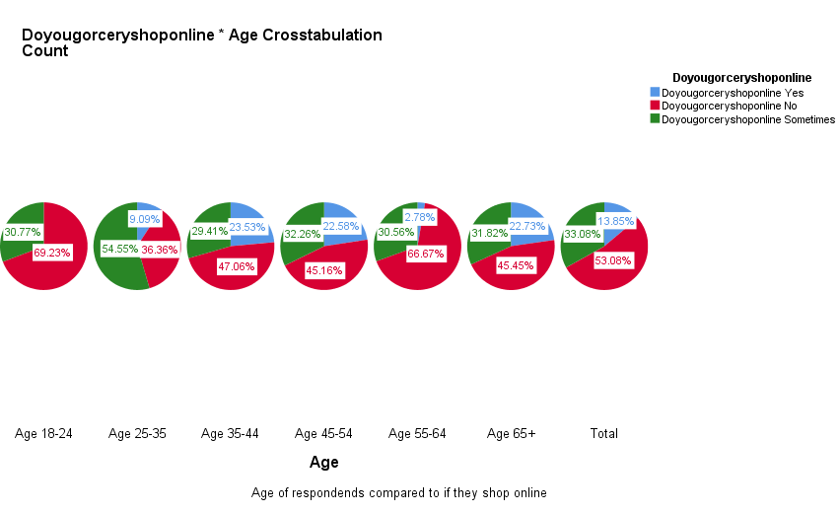
Figure 2 SPSS Chart- crosstabulation of age compared with if respondents shopped online
These pie charts display the respondents' ages and their answers to whether or not they shop online.
69.23% of those aged 18 to 24 said they did not shop online, while 30.77 % said they sometimes did.
54.55 % of those aged 25 to 35 (8.46 %) said they sometimes shop online, 36.36 % said yes, and only 9.08% said they never shop online. Nearly half of the respondents (47.06 %) said they did not shop online, 29.43 % said they did shop online sometimes, and 23.58 per cent said they did shop online.
The most popular response from respondents in the 45-54 age range (23.89 per cent) was "no," with a percentage of 45.16, followed by "sometimes," with a percentage of 32.26 per cent, and "yes," with a percentage of 22.58 per cent.
From the respondents aged between 55 and 64 (27.68%), most of them said that they did not shop online (66.67%), 30.58% said they sometimes shopped online, and only 2.78 said yes to shopping online.
Out of the respondents aged over 65, over half of them, 53.08%, said they did not shop online, 33.08% said they sometimes did, and 13.85% said they did shop online.

4.1.4 Figure 3: frequency of which online grocery provider was used.
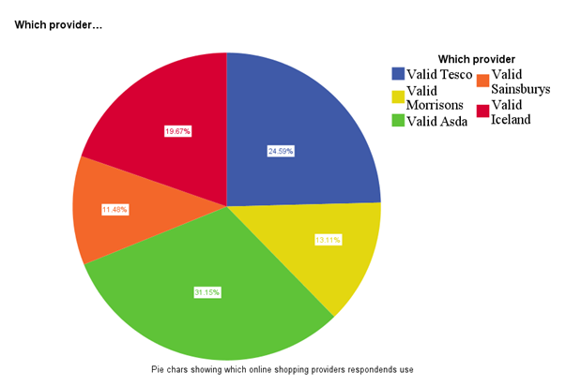
Figure 3 SPSS Chart- Frequency of online shopping provider used.
This graph shows the Percentage of responses to a particular online provider used. The most used online provider was Asda at 31.15%, the second most used was Tesco at 24.59, the third being Iceland with 19.67%, the fourth Morrisons at 13.11% and finally the least used provider Sainsburys at 11.48%.

4.1.5 Figure 4: How often people shopped compared with online provider used.
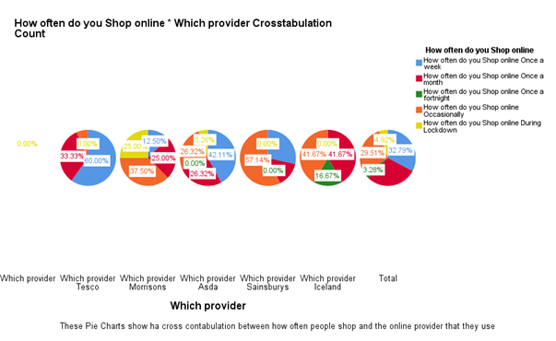
Figure 4 SPSS Chart- crosstabulation of how often people shopped compared with which provider
These pie charts show a comparison between how often the respondents shopped online and which provider they used.
The most used online provider was Tesco, where 60% of respondents said they shopped there weekly 33.33% said that they shopped online with them once a month, and only one respondent saying they shopped online with them occasionally.
Morrison's was used occasionally at 37%, once a month at 25%, once a week at 12.5%, and 25% of respondents said that they only started using Morrison's online services during lockdown due to the current pandemic.
Asda was the second most used weekly at 42.11%, and both "monthly and "occasionally" came back with 26.32%, with only 5.26% using them since lockdown. Sainsbury's was used occasionally at 57.14% and weekly at 28.57%.
The least used shopping provider was Iceland, with both occasionally and monthly coming back with 41.67% and 16.67% shopping online with them fortnightly.

4.1.6 Figure 5: What service respondents used compared with their age.
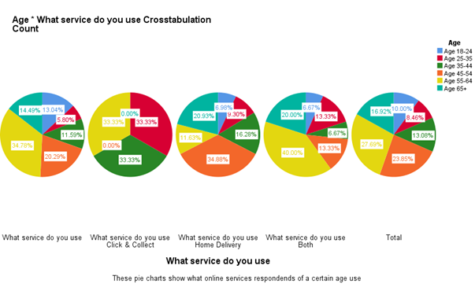
Figure 5 SPSS Chart- crosstabulation of age compared with what service is used
These pie charts show a comparison of age compared with which online service they use.
The click and collect services were used equally between 25-35, 35-45 and 55-64, all coming back with 33.33%.
The home delivery services were diversely used between all ages—the most popular among being in the age range of 45 and 54 at 34.88%. Respondents aged 65 and over were the following highest Percentage to use home delivery, with 20.93%. From the respondents aged between 55 and 64, only 11.63% said they used home delivery services. From the Respondents aged between 35-44, 16.28% said that they used home delivery services. The age range that used home delivery the least were respondents aged between 18 and 24 with a percentage of 6.98.
Respondents aged between 55 and 64 said that they used both the most at 40%. The second highest age range to use both services were those aged 65 and over with a percentage of 20. Respondents aged between 25-35 and 45-54 both came back with a percentage of 13.33. The lowest Percentage for using both home delivery and click and collect were in the age ranges of 18-24 and 35-44 with a percentage of 6.67.

4.7 Public opinions

4.7.1 Has technology impacted the way people buy groceries?
Several survey questions asked respondents to express their thoughts on specific topics. When asked how technology has changed the way they shop for groceries, respondents had various responses. The majority of respondents said that online shopping has made their lives much easier, whereas others found that it either has not helped or was worse than shopping in-store. Many of the responses were also linked to the ongoing coronavirus pandemic. According to the responses, there is a strong trend of increased use of online shopping due to the current pandemic, which has disrupted the retail industry as a whole. Many respondents stated that they had used online shopping platforms significantly more after lockdown restrictions were implemented, making it more challenging to access shopping in-store. One respondent said
"it is easy to do using my mobile phone! It makes my life so much more organised as I am working, and it saves a lot of time. Particularly during covid, it has been a huge help."
Another respondent said
"It has been fantastic, especially when not being able to get to the shops through isolation."
These responses show that the use of technology in UK supermarkets has enabled customers in purchasing the groceries and other necessities they need. Without these technologies, many supermarkets would have had to rely on customers buying in-store, which would not have been feasible due to certain restrictions in place.
Other respondents reported that they only shopped online due to the current pandemic but that they preferred shopping in-store because they were unhappy with the food delivered. One respondent said
"I tend to avoid it where possible. At the start of the first lockdown, I had a couple of deliveries but not happy with the quality of the goods, so I will not do it again unless I am desperate."
Another respondent said
"I would only buy cupboard stuff. The fresh items have not been very good."
These responses imply that getting the ease of home delivery and click and collect comes at the disadvantage of not being able to choose from the items yourself.
Not all of the responses were related to the pandemic. Some respondents mentioned that they used online shopping for general convenience.
"I use an app and add to the basket as the week goes on - much more convenient."
"It has made it more convenient to access groceries and clothing at the same time."
Other respondents stated that shopping online helps them remain on budget and avoid being distracted by items they do not need. Several respondents came back with the following responses,
"It has made it easier to stick to a budget as you do not get distracted by things like the end of aisle offers or household items that I do not need."
"Makes it easier to keep to a budget. Easier access to shops."
"Just buy exactly what is needed and saves money."
These responses suggest that shopping online allows people to search for what they need rather than get distracted by other products in the shopping aisles.
Accessibility is another way that technology has changed the way people shop. Due to disability or illness, many people are unable to shop in-store. This was expressed by two of the respondents in their responses.
"Due to mobility and pain issues, going to the supermarket is too difficult."
"It is made it more accessible as I have a priority slot due to illness."
By being able to shop online from the comfort of their own home and the convenience of groceries being delivered straight to their door. It allows them to have the same access to groceries as fit and able people do.

4.7.2 Do you think that being able to shop online has helped Supermarkets during the pandemic? If so, how?
Since the pandemic first started in March 2020, it has had a significant impact on the economy, including the retail industry. The pandemic implications have disrupted the economy due to people not being able to access stores because of lockdown restrictions. However, due to online services provided to consumers, people have been able to overcome these circumstances.
As part of this paper's research, respondents were asked whether they thought online shopping services had helped supermarkets during the pandemic. Nearly all respondents said they thought online shopping had benefited supermarkets, with only a few saying that they felt it had not helped.
Many people have had to shield themselves during the pandemic meaning that they have had to rely on home deliveries for their groceries and other essentials. One respondent highlighted this in their response,

"Yes. Allows them to reach people who are shielding who otherwise could get out to do a shop. Also, it avoids having long queues in store which puts customers off and has increased staff cost due to volume of customers. Increasing profits."
The respondent also said that it allowed fewer people in-store due to delivery services, making it safer and more accessible for people who could get to the stores. Another respondent also mentioned less footfall in supermarkets.
"It has reduced the footfall in supermarkets which have helped reduce the spread of the virus without impacting on the turnover that needs to be maintained so that the supermarket can keep operating."
With more than one person coming back with the same kind of response suggests that home delivery services have positively impacted both customers who shop in-store and the safety of customers shielding at home.
Another respondent believes that the more vulnerable customers who have only just started online shopping due to the pandemic may continue to use the services even when the pandemic has ended. This suggests that there may be an increase in the use of online shopping services in the future, leaving physical stores at risk.
"It has enabled them to support the more vulnerable in our society and reach more customers. I think a lot more people who did not online shop prior to the pandemic and have been throughout will now continue to do so."
Two of the respondents mentioned the increase in employment due to the pandemic.
"Online shopping had been beneficial for many. The huge demand in online shopping through covid has given supermarket the chance to employ more people."
"Yes, fewer people in stores to help the pandemic and has helped in opening more job opportunities as in delivery drivers along with store staff."
The pandemic caused panic among shoppers who rushed both in-store and online to buy as much as possible, increasing the demand for delivery drivers and in-store staff.
Two respondents expressed their opinion that they felt online services had not helped supermarkets during the pandemic. One respondent said
"no, really, there are just as many people that go out to the store to shop. I don't think it helped them much as they cannot keep up with demand."
Another respondent said
"They are not losing so many customers. However, I wonder if the charge of £6.50 is too expensive for a lot of customers who are pensioners. in the1st lockdown, it was free, and £6.50 is quite expensive for people, e.g., OAP and single parents etc."
This risk of shortage of groceries and essentials meant that people rushed to buy as much as possible. This caused an increase in the use of online shopping. One of the respondents expressed their concern about the price of the delivery charge. In the first lockdown, delivery services were free, but now it costs approximately £6.50. the impact on the economy may have caused the price increase.

4.7.3 Why do you prefer to shop in-store?
The respondents who answered no to online shopping were taken to a different section of the survey. It asked them questions about their in-store experience with technology and why they decided not to use online shopping. This was done by provided multiple-choice questions and questions that required their opinion. The respondents were asked why they preferred to shop in-store. This was done through a multiple-choice question with the option to provide their own response if needed. Out of the 69 respondents who answered this particular question, 28 of them ticked the option of "simpler" there could be many reasons for this, such as the lack of knowledge when it comes to using technology. Nearly all the respondents said that they would rather see the product in person. Others said that they also liked the social aspect of shopping in-store. Others provided a more personal answer, such as missing offers due to them not being advertised online, and another wrote that there is no access to online shopping where they live.
The respondents were also asked what type of in-store technology they may have used. Out of the 69 respondents who answered, nearly all of them used some instore technology, including scan as you shop and self-checkout.

4.7.4 What made you decide not to use those services in-store?
The respondents who said they did not use any in-store technology were asked why they preferred not to. This question required a personal response rather than a multiple-choice this allowed for a more in-depth analysis. A few of the respondents mentioned that they prefer to talk to the person at the checkout as it provides a more personal experience.
"Like to have a person checkout and have a bit of personal service."
"Forget to scan items, and I like to talk to the person at the till."
Others expressed that it was much easier for them to go to a person at the till rather than doing it by themselves
"Easier for myself and quicker."
"Quick and easy."
"Scan as you shop seems a bit faffy."
One responded wrote that they do not use self-service technology while instore as using staffed tills keep people employed
"Keeps people in work."

4.7.5 Does technology within the supermarket industry help the way that you and/or your colleges work?
One of the questions that all respondents were asked is whether they worked in the supermarket industry. If they answered yes, they were then taken to a section that asked them if they thought technology had helped within their industry role. The answered that came back were mixed. Some said that technology had not helped them in their roles, while others said technology had helped them. Most of the responses came back with a simple yes or no; however, a few came back with an explanation of how technology had helped them. One respondent said
"Yes, we have an app which we can access from our phones to check prices and stock."
"Yes. We use a handheld device to do price changes within the store."
A respondent who is a delivery driver said
"Makes it easier when out on the road."
Delivery drivers use several different technologies to aid their roles, such as satnavs for directions and tablets, to see what needs to be delivered and where. For example, Tesco has collaborated with Microlise, a telematics platform, to introduce a new journey management system to increase efficiency and reduce cost, improving transport and turnaround efficiency (Supply Chain Analysis, 2015).

Chapter 5. Discussions
The research, data collection, and analysis needed for this research paper have now been completed. The discussion will focus on whether the obtained data from the survey carried out agrees with or contradicts the secondary data. A critical reflection of how this paper was produced will also be addressed, including its strengths and limitations and what would be achieved better if the process were to be repeated.

5.1 Comparison to literature review
One of the main objectives of this research was to find out how the rise of technology has affected the grocery industry. The respondents' results mainly returned with a favourable opinion of technology within the grocery industry, with many using technology for home delivery and click and collect services. Many respondents also said that they used in-store technology such as self-checkout and scan as you shop services.
It is reported that the United Kingdom has gone further in embracing internet retail than any of its western peers. 20% of UK shoppers buy totally or partially online (Blachandani, et al., 2020). This somewhat contradicts the analysis carried out for this paper as 53% of respondents said that they did not shop online, with only 13.85% saying they did and 33% saying that they sometimes did. This could be for several reasons, some of which were answered in the survey many respondents said that they found it much easier to shop the traditional way instore this may be because they are unable to use technology but as this was not mentioned in the answers given it is only a theory.
As stated in the literature, the transition to online shopping has been one of the most dramatic retail industry developments in recent decades (McCarthy, 2019). As mentioned earlier in this paper, Tesco is one of the most popular store brands of 2020, with nearly half of online shoppers in the UK saying they had ordered groceries from Tesco (Statista, 2021); however, the result from the survey carried for this paper showed that Asda was the most used supermarket among the 130 respondents, with 31% of respondents reporting to shop there. This may be due to the current pandemic as Tesco struggled to keep up with customers' demand. This meant that all the online delivery slots were filled, forcing people to use alternative supermarkets to where they would usually shop. Out of the 19 respondents who said they shopped at Asda, 15 of them reported shopping online more since the pandemic started.
One of the biggest problems of technology within supermarkets is the risk of security. Many consumers are readily providing their personal and credit card information; however, others are more cautious (Hudson, 2018). During the primary research process, respondents were asked why they did not use supermarket technology. Several respondents expressed their concern about privacy. Out of the 69 respondents who were asked why they prefer not to use the technology available, six said they had online privacy concerns, with one respondent saying that they do not trust technology. While rereading the literature review, one of the topics that stuck out the most was the concern over facial recognition software that was trialled in a well-known supermarket but was later pulled due to concerns to the accuracy with people of darker ethnicity as well as concerns over the privacy of others (Wakefield, 2020). It felt right that opinions from the public would be suitable for this paper, so an additional survey was created with the question, "How would you feel if supermarkets were to introduce facial recognition in supermarkets?". The answers that were provided were of mixed opinions but mainly agreeable. Many of the respondents agreed and said it would be good to implement facial recognition within supermarkets. In contrast, others who were concerned about invasion of privacy disagreed with the thought of using facial recognition, saying "invasion of privacy, would not like the idea of being always monitored when in a shop."
Another respondent said that although they thought it was a good idea, they were concerned about the General Data Protection Regulation. "I think that is a good idea, to stop anti-social behaviour. However, I can see some people may have issues with GDPR."
Other respondents stated that they would be happy if this type of technology were introduced, saying, "I would feel okay about that. I would even feel positive about it because I have seen many thefts in the supermarket. I usually go to buy food so that it would be a positive improvement for areas high in crime and a good deterrent for crime."
One respondent mentioned that they thought it was a good idea to introduce facial recognition as they had worked in retail in the past, and theft was a common problem
"I think it would be great to implement this to avoid theft, as previously working in retail, this was a common issue."
The majority of these opinions are for introducing facial recognition in supermarkets to help prevent theft and reduce anti-social behaviour. However, a couple of the responses to show a sense of concern over privacy.
Another respondent expressed their concern about the possible misuse of the software, saying,
I would prefer they did not. The problem of privacy and concerns about the misuse of using facial technology to track people (whether by governments, hackers, stalkers or companies) far outlays any benefits in reducing theft or anti-social behaviour.
The respondents who raised concerns over privacy were not alone as While researching what Facewatch is all about, a quote from the director of civil rights group Big Brother Watch stood out, saying
"This surveillance is well-known to suffer from severe inaccuracy and biases, leading to innocent people being wrongly flagged." (Silkie Carlo, n.d.)
Although there have been privacy concerns, facial recognition within the retail industry has proved to be helpful to some extent. Facewatch, a leading UK security service, has successfully been deterring crime. Facewatch is operated in numerous stores despite criticisms from privacy campaigners. The system sends an alert to store staff when someone on the watchlist walks through the door and is seen on CCTV (Poulter, 2021).
When the pandemic first started in Europe, google searches for "Food delivery and "local food" reached an all-time high. Supermarket giants such as Ocado and Amazon Fresh became overwhelmed due to the high demand for home delivery services (Shveda, n.d.). This links well with the analysis carried out. Out of the 61 respondents who answered, 82% said that they had shopped online more since the pandemic started, with only 18% saying It had not made a difference to their usual shopping habits.

Chapter 6. Conclusion
The aim and objectives of this study were to discover the various impacts of technology on the grocery industry and to provide knowledge in the areas explored.
This dissertation has identified essential aspects of how technology has impacted both consumers and supermarket employees. This has been done in every chapter of this dissertation. First, chapter one described the research subject, which investigated the various effects of technological advancement. The second chapter was a concise review of the existing literature on the topic's related areas. In Chapter 3, the most appropriate method and methodology for collecting primary data were established. It was discovered that this analysis required a quantitative approach to gather as much data as possible. The fourth chapter was quite extensive, analysing the data and presenting the results in a logical order.

6.1 Objectives
At the start of this research, the objectives set out for this paper was to research different effects technology has had on supermarkets in the UK. The literature reviewed during this research has shown that technology has had both positive and negative impacts on supermarkets, consistent with the quantitative research data analysed. Initially, the primary target audience for this research was going to be the supermarket chains in the UK. However, with the time constraints and the current pandemic, it was impossible to get in touch with these supermarkets. Instead, it was decided that a survey would be published to the public, meaning that both consumers and employees within the industry could share their opinions.
Many of the objectives of this paper have been achieved, such as:-
- Review the current literature available relating to technology within the grocery industry
Various sources were used to collect the primary data required for this paper which was conducted in chapter 2
- Collect primary data from the public for comparison with the secondary data
This was achieved in chapter three by identifying the method needed to research the topic
- Analyse the impact that technology had had on the grocery industry using the primary data collected
This was achieved in chapter 4 of this paper by analysing the primary data using SPSS, allowing for visual data.
- comparing both the primary and secondary data to find any links or contradictions
This objective was achieved in chapter 5, where both the literature review and the data collected were compared.

6.2 Analysis
Based on the quantitative analysis carried out, it can be concluded that technology has had mainly a positive impact on the industry but also has room for improvement. Results indicate that both customers and employees both find that technology has improved supermarkets, especially during the coronavirus pandemic. However, some respondents also expressed opinions that showed weaknesses within the technologies used. Now more than ever, online shopping is on the rise. Nearly half of the respondents said that they either shopped or partially shopped online for their groceries.
The literature review stated many positive impacts that technology has had on supermarkets so much that the United Kingdom is one of the most advanced in embracing internet retail than any of its western peers. It is thought that 20% of UK shoppers buy totally or partially online (Blachandani, et al., 2020). The literature review also mentioned that Tesco was one of 2020s most popular store brand, with nearly half of online shoppers saying they had ordered groceries from Tesco (Statista, 2021). The research carried out for this paper showed that Asda was the most used online grocery store among respondents.
Respondents were also asked how they would feel if facial recognition was to be introduced into supermarkets. Many of the respondents said they would be happy if this came into place, while others believed it was an invasion of privacy and would make them uncomfortable. This question was asked after reading an article about a trial that took place in a supermarket that had implemented software called facewatch that notifies employees of repeat offenders of theft or anti-social behaviour. This technology was later pulled from the supermarket as it was believed that there were inaccuracies when it came to people of darker ethnicity (Wakefield, 2020).

6.3 Findings
The main finding from the data does contradict the literature contained in chapter 2 to some extent. Although the data collected from both literature and quantitative research both show the positive and negative impacts technology has had, it also shows some inconsistencies. This may be due to several factors which have been outlined in the above chapters.
The research carried out for this paper showed a close result between respondents shopping online and in-store. The research showed that 46.93% of respondents either bought all their groceries online or partially used online shopping. Whereas 53% of respondents said that they did not shop online, preferring to shop in-store.

6.4 Critical reflection

6.4.1 Planning
During the early stages of planning, there was a rough idea of what the topic was to be about, which was how digitalisation had affected businesses in today's society and how they have managed to adapt to changes. As the literature review started to take shape, the topic was narrowed down to how Supermarkets in the UK have adapted to technology changes and how it has affected customers. Once the topic was decided, it was possible to think about what research was needed to achieve the intended goal. Both quantitative and qualitative methods were thought about, but it was decided that a quantitative approach would be more suited to the type of research needed.

6.4.2 Research
To collect secondary data, numerous online articles, websites and previous research papers were researched. This allowed to build up a literature review. A survey was created to collect primary data, including basic questions such as age and gender, as this allowed data to be categorised. Everybody that took part in the survey was asked if they shopped online. They were then navigated to different parts of the survey depending on the answer they gave. Although this allowed for a more detailed analysis, it also made it more complex as different respondents were asked different questions. If the respondent answered "yes" or "sometimes", they were taken to a section of the questionnaire that was centred around online shopping, whereas the people who answered "no" were taken to a section that centred around their experience or lack of experience with in-store technology such as scan as you shop and self-service checkouts. Respondents were also asked whether they did work or had worked in the supermarket industry in the past. If the respondent indicated that they had worked or previously worked in the industry, they were taken to questions based on technology and its role within their employment.

6.4.3 Analysis
Many of the multiple-choice questions also included the option for other which allowed for a more personal response, but this made the analysis more complex as some of the answers were either duplicates or were off-topic, possibly due to the lack of understanding from the respondent this may be because of how the question was worded or due to the respondent's knowledge on the particular subject. If the analysis were to be completed again, questions would be worded differently, and the multiple-choice questions would be given more thought to avoid these problems.
When using SPSS, it was not possible to export the data as some of the questions were not in the correct format. This meant that two different types of analysis needed to be done, the first being the statistical data and the other being personal responses from the survey. The data was analysed using crosstabulation and was then transformed into pie charts. This allowed for Visual analysis.

6.4.4 Limitations
This dissertation's main focus was initially meant to be on researching the supermarket chains directly. However, due to time constraints and the current pandemic, it was not possible to do this. Instead, it was decided that customer and employees were to be the target audience for this research. During the analysis, it was clear that nearly all the respondents from the survey were female. Although this did not make much difference to the results, it may have been interesting to gain more opinions from male respondents. The process of analysing the data was also quite limited due to the format of the questions asked. If repeated, the format and wording of questions would be different to allow for a more thorough and straightforward analysis.

References
Anon., 2021. Self-Checkout: Error 404 – This Efficiency Does Not Exist. [Online]
Available at: https://902558.smushcdn.com/2161880/wp-content/uploads/2021/02/21764-750x375.jpg?lossy=1&strip=1&webp=1
[Accessed 15 April 2021].
Anon., n.d. ODE TO GROCERY DELIVERY AND ONLINE GROCERY SHOPPING. [Online]
Available at: https://savvyscot.com/ode-grocery-delivery-online-grocery-shopping/
[Accessed 15 April 2021].
Askew, K., 2018. 2020 and beyond: Six trends shaping the supermarkets of the future. [Online]
Available at: https://www.foodnavigator.com/Article/2018/12/21/2019-and-beyond-Six-trends-shaping-the-supermarket-of-the-future?utm_source=copyright&utm_medium=OnSite&utm_campaign=copyright
[Accessed 31 March 2021].
Bailey, F. L., 2013. From the 1990s to the present. In: The origin and success of qualitative. s.l.:The Market Research Society, p. 169.
Baldwin, C., 2020. Covid-19: How retailers are using technology to respond to changing shopping habits. [Online]
Available at: https://www.computerweekly.com/feature/Covid-19-How-retailers-are-using-technology-to-respond-to-changing-shopping-habits
[Accessed 23 March 2021].
Bandoim, L., 2019. Can Grocery Stores Embrace Change And Technology?. [Online]
Available at: https://www.forbes.com/sites/lanabandoim/2019/05/28/can-grocery-stores-embrace-change-and-technology/?sh=197263c273a0
[Accessed 28 March 2020].
Bhandari, P., 2020. An introduction to quantitative research. [Online]
Available at: https://www.scribbr.com/methodology/quantitative-research/#:~:text=Quantitative%20research%20is%20the%20process,generalize%20results%20to%20wider%20populations.
[Accessed 17 March 2021].
Blachandani, A., Hancock, B., Phillips, S. & Wachinger, T., 2020. Rebooting retail: How technology will shape the future of retail. [Online]
Available at: https://www.mckinsey.com/industries/retail/our-insights/rebooting-retail-how-technology-will-shape-the-future-of-retail
[Accessed 15 March 2021].
bookfresh.com, 2020. THE ROLE OF TECHNOLOGY IN BUSINESS. [Online]
Available at: https://www.oksbdc.org/the-role-of-technology-in-business/#:~:text=Technology%20as%20a%20Business%20Necessity&text=It%20provided%20a%20faster%2C%20more,simpler%20or%20more%20complicated%20tools.
[Accessed 26 March 2021].
Bossard, 2020. The Pros and Cons of Digitalization. [Online]
Available at: https://provenproductivity.com/the-pros-and-cons-of-digitalization/
[Accessed 11 March 2021].
Broome, W., 2020. How mobile technology can encourage sustainability. [Online]
Available at: https://environmentjournal.online/articles/how-mobile-technology-can-encourage-sustainability/
[Accessed 16 March 2021].
Consolidated Technologies Inc, 2018. Impact of Digital Transformation on Your Business. [Online]
Available at: https://consoltech.com/blog/impact-of-digitization-businesses/#:~:text=The%20impact%20of%20digital%20transformation,Improved%20customer%20satisfaction
[Accessed 11 March 2021].
Crowe, E., 2020. How technology is shaping the future of food retail. [Online]
Available at: https://www.smartbrief.com/original/2018/04/how-technology-shaping-future-food-retail
[Accessed 11 Feburary 2021].
Curran, J. M. & Meuter, M. L., 2005. Self‐service technology adoption: comparing three technologies. [Online]
Available at: https://www.emerald.com/insight/content/doi/10.1108/08876040510591411/full/html
[Accessed 14 April 2020].
Darmody, J., 2020. 5 ways Covid-19 will bring tech changes to the grocery sector. [Online]
Available at: https://www.siliconrepublic.com/enterprise/covid-19-grocery-sector-tech
[Accessed 23 March 2021].
Deloitte Digital, 2014. Digital Influence in UK Retail. [Online]
Available at: https://www2.deloitte.com/content/dam/Deloitte/uk/Documents/consumer-business/deloitte-uk-digital-influence-in-uk-retail-2014.pdf
[Accessed 15 March 2021].
Deloitte, 2017. Disruptions in Retail through Digital Transformation: Reimagining the Store of the Future. [Online]
Available at: https://www2.deloitte.com/content/dam/Deloitte/in/Documents/CIP/in-cip-disruptions-in-retail-noexp.pdf
[Accessed 31 March 2021].
Drinkwater, B., 2019. How the Worlds Biggest Supermarkets Are Harnessing Digital to Transform the Way We Shop. [Online]
Available at: https://www.circusstreet.com/blog/now-its-personal-how-the-worlds-biggest-supermarkets-are-harnessing-digital-to-transform-how-we-shop
[Accessed 5 March 2021].
Eley, J. & McMarrow, R., 2020. Why supermarkets are struggling to profit from the online grocery boom. [Online]
Available at: https://www.ft.com/content/b985249c-1ca1-41a8-96b5-0adcc889d57d
[Accessed 28 March 2021].
epc, n.d. Technology in the Supermarket: The New Way to Shop for Groceries. [Online]
Available at: https://www.epcits.com/blog/technology-in-the-supermarket/
[Accessed 15 March 2021].
European Business Magazine, 2020. Understanding the impact of Digital Transformation. [Online]
Available at: https://europeanbusinessmagazine.com/business/understanding-impact-digital-transformation/
[Accessed 16 Feburary 2021].
Facewatch, 2021. Facewatch. [Online]
Available at: https://www.facewatch.co.uk/
[Accessed 16 April 2021].
Gartner, n.d. Digitalisation. [Online]
Available at: https://www.gartner.com/en/information-technology/glossary/digitalization
[Accessed 11 March 2021].
Gorman, D., 2020. How COVID-19 has shaped online grocery trends. [Online]
Available at: https://blog.globalwebindex.com/chart-of-the-week/online-grocery-trends-amid-covid-19/
[Accessed 23 March 2021].
Gupta, R., 2020. How traditional supermarkets can keep up with digital natives and changing consumer demand. [Online]
Available at: https://www.itproportal.com/features/how-traditional-supermarkets-can-keep-up-with-digital-natives-and-changing-consumer-demand/
[Accessed 15 March 2021].
Harris, S., 2017. The economics of self-service checkouts. [Online]
Available at: https://theconversation.com/the-economics-of-self-service-checkouts-78593
[Accessed 30 March 2021].
Heil, K., 2018. Self Checkout: The Pros and Cons of Giving the Customer Control. [Online]
Available at: https://www.palmerretailsolutions.com/blog/self-checkout
[Accessed 30 March 2020].
Hudson, M., 2018. E-Commerce and Selling Online: Pros and Cons. [Online]
Available at: https://www.thebalancesmb.com/selling-online-retailing-storefront-alternatives-2890252
[Accessed 30 March 2021].
innolytics.ag, n.d. What is Digitalization?. [Online]
Available at: https://innolytics-innovation.com/what-is-digitalization/
[Accessed 28 March 2021].
kara, A. & Orel, F. D., 2013. Supermarket self-checkout service quality, customer satisfaction, and loyalty: Empirical evidence from an emerging market. [Online]
Available at: https://www.researchgate.net/publication/259139296_Supermarket_self-checkout_service_quality_customer_satisfaction_and_loyalty_Empirical_evidence_from_an_emerging_market
[Accessed 14 April 2021].
Lau, F. & Kuziemsky, C., 2017. Chapter 12 Methods for Correlational Studies. In: F. Lau, ed. Handbook of eHealth Evaluation: An Evidence-based Approach. Canada: University of Victoria, p. 213.
McCarthy, G., 2019. THE HISTORY OF RETAIL TECHNOLOGY. [Online]
Available at: https://www.barcoding.co.uk/history-retail-technology/#0
[Accessed 28 March 2021].
Morgan, B., 2020. 3 Lasting Changes To Grocery Shopping After Covid-19. [Online]
Available at: https://www.forbes.com/sites/blakemorgan/2020/12/14/3-lasting-changes-to-grocery-shopping-after-covid-19/?sh=3629b0ca54e7
[Accessed 23 March 2021].
Morrison, O., 2020. Time for the grocery sector to finally deliver?. [Online]
Available at: https://www.foodnavigator.com/Article/2020/04/27/Time-for-the-online-grocery-sector-to-finally-deliver
[Accessed 2 March 2021].
Moshakis, A., 2018. Nation of shoplifters: the rise of supermarket self-checkout scams. [Online]
Available at: https://www.theguardian.com/global/2018/may/20/nation-of-shoplifters-supermarket-self-checkout
[Accessed 14 April 2021].
Oghazi, P., Mostaghel, R., Hultman, M. & Parida, V., 2012. Antecedents of Technology-Based Self-Service Acceptance: A Proposed Model. [Online]
Available at: https://www.researchgate.net/publication/254376544_Antecedents_of_Technology-Based_Self-Service_Acceptance_A_Proposed_Model
[Accessed 14 April 2021].
Perkins, C., 2020. What impact is coronavirus having on the UK grocery market?. [Online]
Available at: https://www.thegrocer.co.uk/consumer-trends/what-impact-is-coronavirus-having-on-the-uk-grocery-market/605195.article
[Accessed 23 March 2021].
Pettinger, T., 2020. The digital economy – Pros and Cons. [Online]
Available at: https://www.economicshelp.org/blog/164275/economics/the-digital-economy-pros-and-cons/
[Accessed 11 March 2021].
Poulter, S., 2021. Daily Mail reports on Facewatch's success in deterring crime. [Online]
Available at: https://www.facewatch.co.uk/2021/01/10/daily-mail-reports-on-facewatchs-success-in-deterring-crime/
[Accessed 17 April 2021].
Question Pro, n.d. Descriptive Research: Definition, Characteristics, Methods, Examples and Advantages. [Online]
Available at: https://www.questionpro.com/blog/descriptive-research/
[Accessed 24 March 2021].
Question Pro, n.d. Experimental research – Definition, types of designs and advantages. [Online]
Available at: https://www.questionpro.com/blog/experimental-research/
[Accessed 24 March 2021].
Question Pro, n.d. Qualitative Research: Definition, Types, Methods and Examples. [Online]
Available at: https://www.questionpro.com/blog/qualitative-research-methods/
[Accessed 17 March 2021].
Qureshi, Z., 2020. Technology and the future of growth: Challenges of change. [Online]
Available at: https://www.brookings.edu/blog/up-front/2020/02/25/technology-and-the-future-of-growth-challenges-of-change/
[Accessed 26 March 2021].
Reinartz, W., Wiegand, N. & Imschloss, M., 2019. The impact of digital transformation on the retailing value chain. [Online]
Available at: https://www.sciencedirect.com/science/article/pii/S0167811618300739
[Accessed 8 Feburary 2021].
Sentance, R., 2020. Eight examples of in-store technology innovations for the Covid-19 era. [Online]
Available at: https://econsultancy.com/examples-in-store-retail-technology-innovations-covid-19-era/
[Accessed 23 March 2021].
Shveda, K., n.d. How coronavirus is changing grocery shopping. [Online]
Available at: https://www.bbc.com/future/bespoke/follow-the-food/how-covid-19-is-changing-food-shopping.html
[Accessed 23 March 2021].
Silkie Carlo, n.d. s.l.:s.n.
Smart Sense, 2020. Emerging Issues in Grocery: The Future of Retail. [Online]
Available at: https://blog.smartsense.co/emerging-issues-in-grocery-future-of-retail
[Accessed 28 March 2021].
SoGoSurvey, 2019. Paul Felix Lazarsfeld: The Father of Research Surveys. [Online]
Available at: https://www.sogosurvey.com/blog/paul-felix-lazarsfeld-the-father-of-research-surveys/
[Accessed 22 March 2021].
Statista, 2021. Online grocery shopping in the United Kingdom (UK) - Statistics and Facts. [Online]
Available at: https://www.statista.com/topics/3144/online-grocery-shopping-in-the-united-kingdom/
[Accessed 15 March 2021].
Supply Chain Analysis, 2015. Tesco transforms delivery systems. [Online]
Available at: https://supplychainanalysis.igd.com/news/news-article/t/tesco-transforms-delivery-systems/i/14317
[Accessed 17 April 2021].
The Enterprise World, n.d. IMPACT OF DIGITALISATION ON THE BUSINESS WORLD. [Online]
Available at: https://www.theenterpriseworld.com/impact-of-digitalization-on-the-business-world/
[Accessed 11 March 2021].
The Grant County Beat, 2020. Ways Technology is Changing the Grocery Store Experience. [Online]
Available at: https://www.grantcountybeat.com/columns/informational/tech-tips/59164-ways-technology-is-changing-the-grocery-store-experience
[Accessed 15 March 2021].
Tomra, 2018. The technologies and trends shaping the supermarket of the future. [Online]
Available at: https://www.newfoodmagazine.com/news/76582/the-technologies-and-trends-shaping-the-supermarket-of-the-future/
[Accessed 28 March 2021].
Ubamarket, n.d. Apps for the entire shopping and hospitality journeys. [Online]
Available at: https://ubamarket.com/
[Accessed 16 March 2021].
Wakefield, J., 2020. Co-op facial recognition trial raises privacy concerns. [Online]
Available at: https://www.bbc.co.uk/news/technology-55259179
[Accessed 16 March 2021].

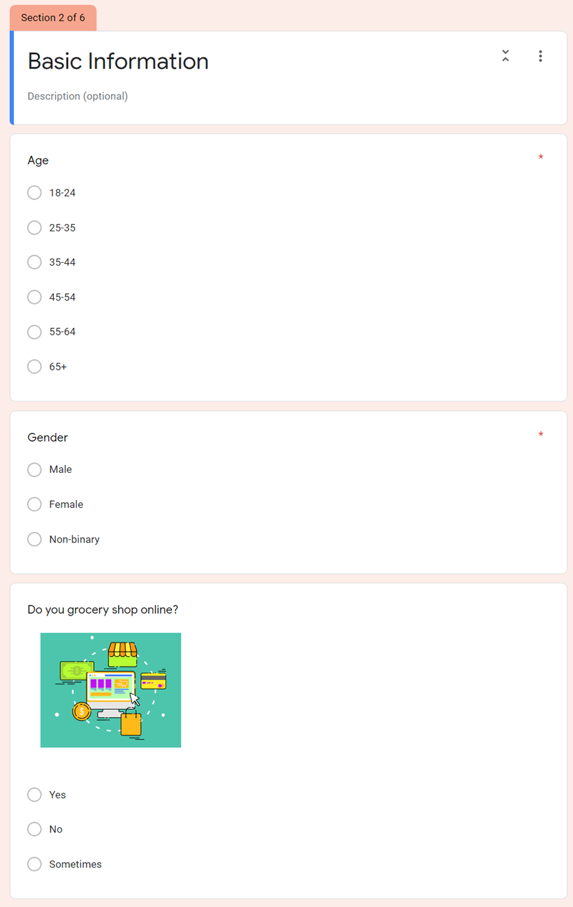
Appendix

Figure i Survey (Basic Information)

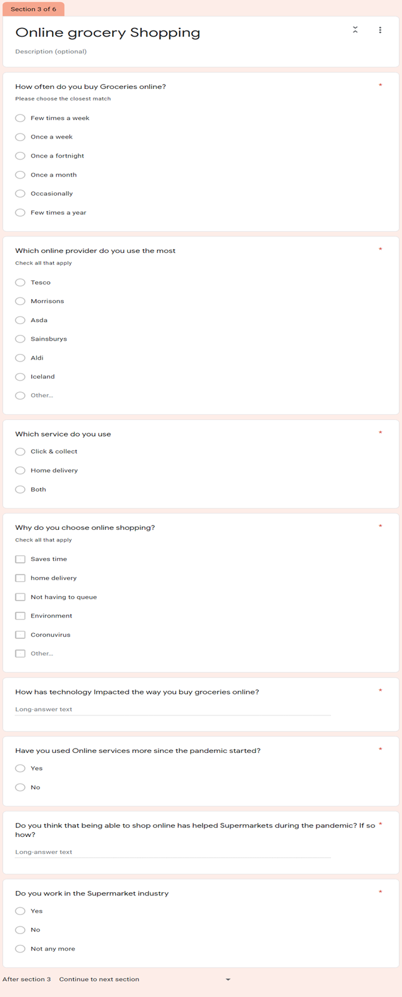

Figure ii Survey (Online Shopping Section)

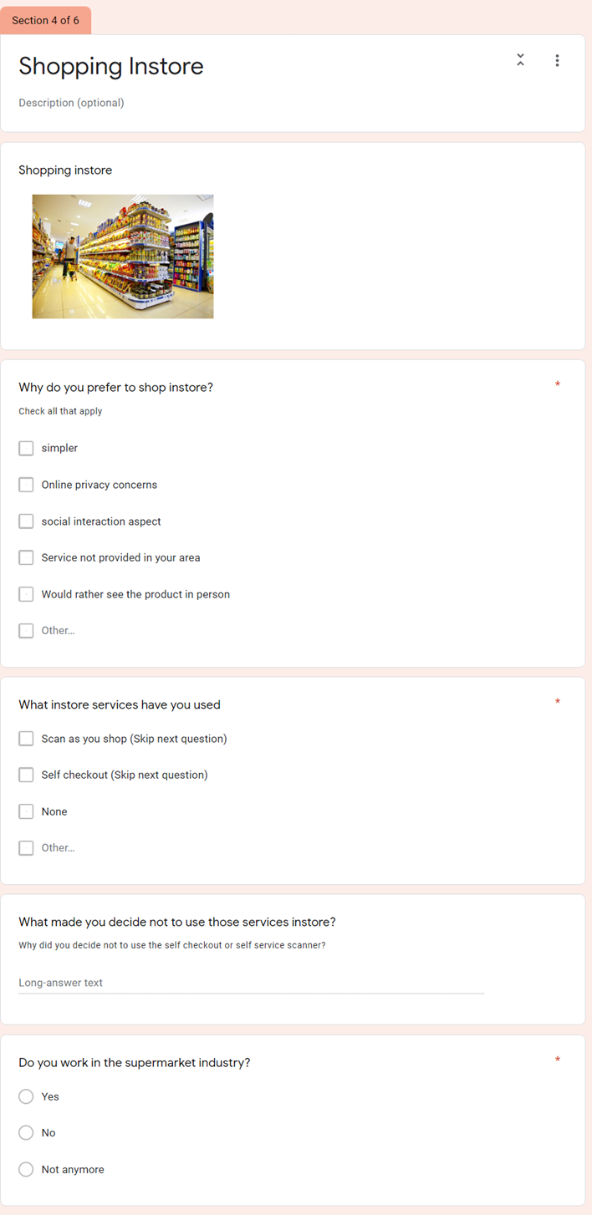

Figure iii Survey (Shopping instore section)

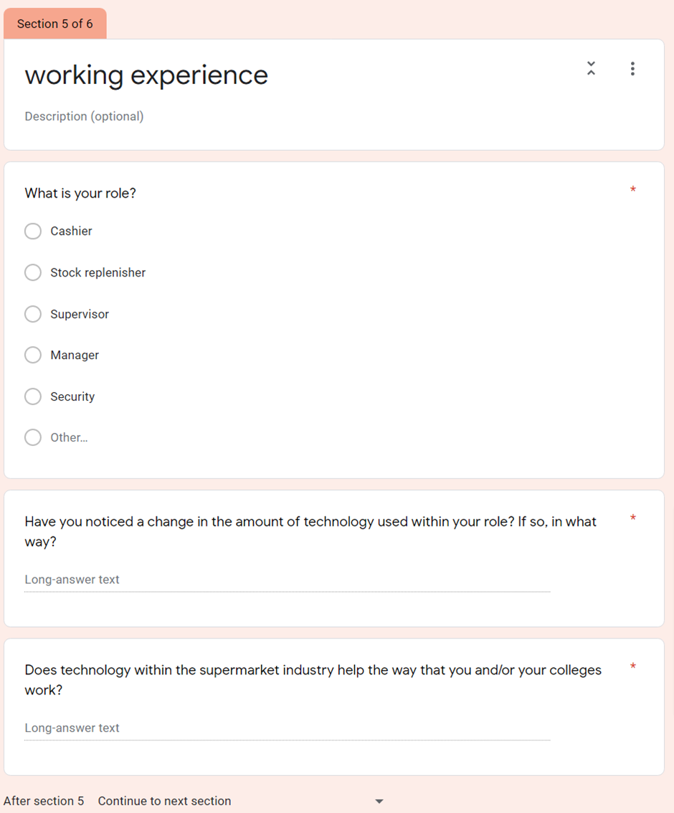

Figure iv Survey (work Experience Section)
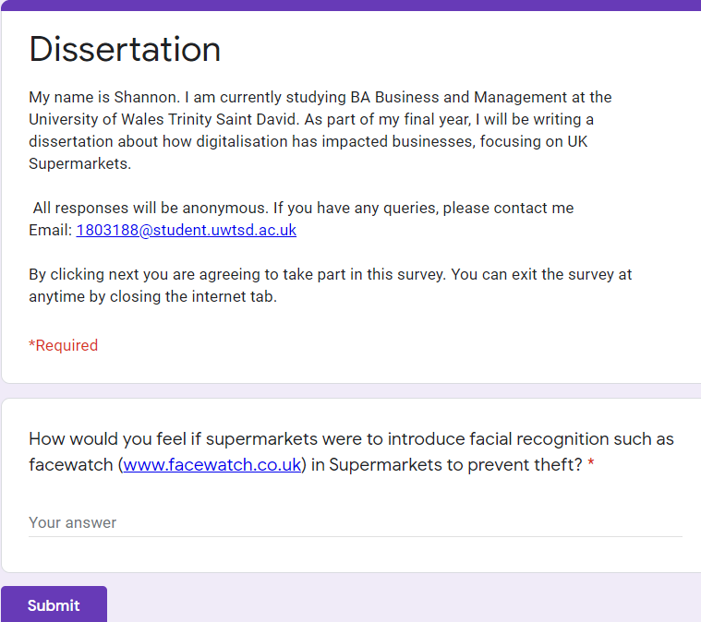

Figure V (Additional Question about facial recognition)

