BEng Electrical and Electronic Engineering
Power Factor Correction & Variable Frequency Drives
Power Electronics & Drives
Joshua Hunt

Contents
Abstract 3
Introduction 3
Power Factor 3
Power factor Correction 4
Motor Drives 4
Three Phase Inverters 5
Method 7
PFC Capacitor 7
Phase angle 8
Current amplitude 8
Pulse Width Modulation 10
Results 10
PFC Capacitor 11
Shunt Capacitor Values and results 11
Fault Finding 11
Fault A Inserted 11
Shunt Capacitor values and results with fault inserted 12
Pulse width modulation investigation 12
PWM Oscilloscope measurements 12
Figure 10 – Positive peak of sine wave 12
Figure 11 – Negative half-cycle of sine wave 13
Figure 12 – CH.1 Y-amplifier set to 10V/div 14
Over-Current Protection investigation 14
Figure 13 – Short circuit across the load impact 14
Figure 14 – Short circuit removed 15
Single-Phase Synchronous Motor 15
Fault B Inserted 15
Discussion 16
Conclusion 17
References 17

Abstract
Power factor is an important theory in electrical equipment, with wasted energy and hefty bills being a result of low power factor. Even electricity suppliers may penalise consumers with low power factor. This study contains research into power factor, power factor correction, motor drives and three-phase inverters. The study also uses LJ Create software to conduct experiments on an a circuit to evaluate the effects of adding capacitors in relation to the power factor and also to investigate PWM variable drives in order to back up and compare with other studies previously done and discovered during the research. As expected, this study further proves that by adding capacitors to the electrical circuit it compensates the reactive power of the inductive load which improves the power factor and saves energy.The results are then interpreted and compared to other studies which have been conducted.

Introduction
Power factor is something that has an impact on everyone’s lives without most realising. Electricity suppliers will penalise for low power factors so it’s important to understand what it is and how power factor correction can be implemented to provide positive outcomes. This report will also be indulging into the world of motor control. Motor drives process about two-thirds of the world’s electrical power into mechanical power and are close to processing all of this power via power electronics.
Not only is there information on electrical principles in relation to power factor correction, motor drives, three phase inverters and PWM. This lab report consist of the methods and results of two pieces of practical work which was to identify the best power factor correction capacitor to add to the circuit and to investigating PWM (pulse width modulation) variable frequency drives.

Power Factor
When discussing power factor there are three basic terms that will come up time and time again that will need to be understood and they are; True power, Reactive power and Apparent power.
True power – (also known as Actual Power, Active Power or Real Power). It is the power that actually powers the equipment and performs useful work and is measured in kW.
Reactive Power–this is the power that is supplied to the load and returned to the source. It is the energy that is first stored and then released in the form of magnetic field, it’s also known as use-less power and watt less power and is measured in kVAR.
Apparent Power –this is the total power in the electrical equipment, the combination of True Power and Reactive Power. Apparent Power is measure in units of Volt-amp (VA). (electricaltechnology, 2019)
Power factor is the ratio between true power to the apparent power that is consumed by an item of A.C electrical equipment or a complete electrical installation. It is the measure of how efficient the system is in regards to power usage. Ideally the power factor should be 1.0, this is the greatest value it can have. If it’s less than 1.0 it means that extra power is required to carry out the actual task. If the power factor is 0.70 for example, it means that only 70% of the supplied volt amps is being used which is a considerable loss and results in a higher bill for the consumer. The slightest improvement to the power factor can reduce the losses dramatically since the losses are proportional to the square of the current. The power that is not being used is the reactive power, this needs to be reduced and the process of this is call power factor correction, which is explained further down.
Poor power factor is usually the result of the phase shift between the voltage and current, it can also be the result of high harmonic or a distorted current waveform which can be caused by invertors, rectifiers and variable speed drives. (Ware, 2006)
There are two ways power factor can be stated:
$$Power factor=\frac{True Power}{Apparent Power}=\frac{VI}{VA}= \cos{θ}$$
Or $True Power=Apparent Power * \cos{θ}$

Power factor Correction
Power factor correction is the term used to improve the power factor as close to 1.0 (unity) as possible by reducing the reactive power. This is done by adding capacitors to the electrical circuit which compensates the reactive power of the inductive load. The capacitors in most power factor correction equipment pull the current that leads the voltage, causing a leading power factor. Usually the corrected power factor will be between 0.92 and 0.95, with power distributors offering incentives for power factors above 0.9, while alsopenalizing customers with poor power factor below 0.9.
Advantages of improving power factor
- Good for the environment, Less power consumption means less greenhouse gas emissions
- Reduce electricity bills
- Reduction of voltage drop in long cable
- Longer equipment life – less electricity burden on components

Motor Drives
Motor drives are electronic devices that control the speed, torque, direction and horsepower of a motor. They are used in a wide range of applications such as power tools, fans, electrical vehicles and so on. Therefore motors also come in many different types, depending on the requirements of the application.
For years, the brushed DC motor was chosen for applications that required a high performance; drives of up to several hundred kilowatts have used this motor. (J.David Irwin, 2005)
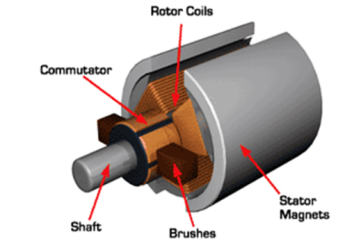
Figure 1 – Brushed DC Motor
Low performance, adjustable speed applications at low and medium power levels on the other hand, used induction motors, an example of this motor can be seen in figure 2.
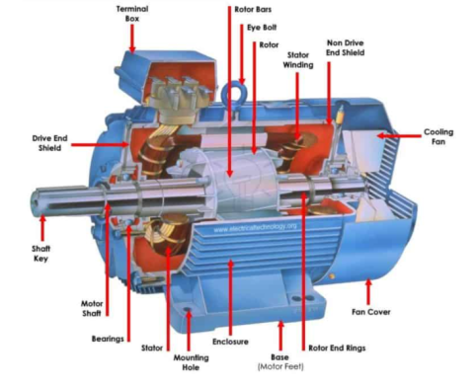
Figure 2 – Induction Motor
The slip ring induction motor was the natural choice for applications requiring very high power levels.
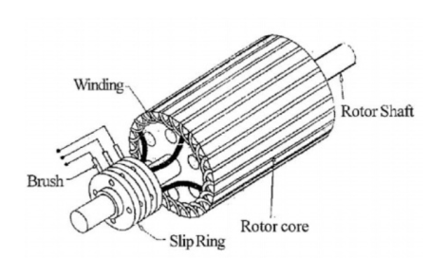
Figure 3 – Slip Ring Induction Motor
So, it’s clear now that motors are extremely important in modern life. Their ability to convert electricity into mechanical energy makes it perfect for industrial systems, vacuum cleaners, dishwashers; water pumping stations, the list is endless. However, for many years, the motor would only run at one speed.Matching the motors speed to the required process is essential to avoid wasted energy. To avoid this, a variable frequency drive was invented which consist of inverters that are used to control electric motors to regulate their speed, boosting productivity and saving energy. (fujielectric, 2022)

Three Phase Inverters
A three phase inverteris used to convert DC voltage to a three phase AC supply. It is an essential factor in regulating the speed of the motor and is a key part in a device that’s known as the variable frequency drive (VFD).
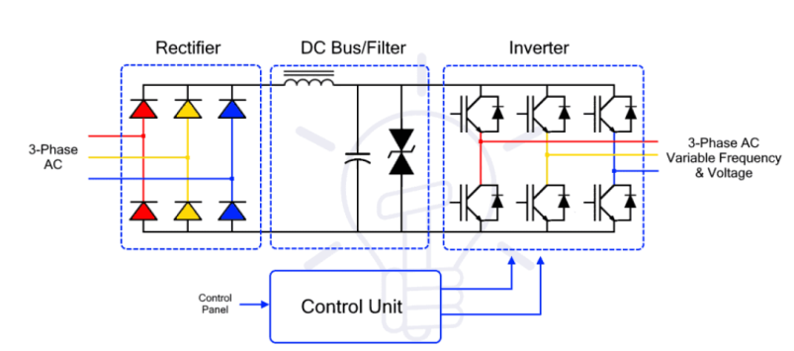
Figure 3 – VFD Schematic
The inverter section consists of six switches that by switching on and off at a rapid speed, can determine the output AC frequency that controls the speed of the motor. Its three arms are usually delayed by an angle of 120°. The inverter switches each have a ratio of 50% and switching ovvurs every T/6 of the time T 60°angleinterval60°angleinterval. There are two types of of conduction mores, 180° and 120°. (tutorialspoint, 2020)
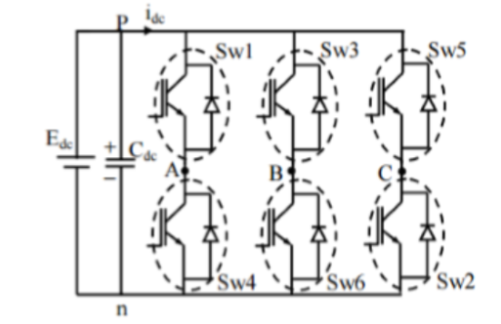
Figure 4 – Three Phase Inverter
The table below is a guide to the typical motor, convertor and application which can be found in the power electronics handbook by Muhammad H. Rashid. (J.David Irwin, 2005)
Motor | Type of Converter | Type of Control | Applications
Brushed dc motor | Thyristor ac–dc converter | Phase control, with inner current loop | Process rolling mills, winders, locomotives,  large cranes, extruders, elevators
Brushed dc motor | GTO/IGBT/MOSFET chopper | PWM control with inner current loop | Drives for transportation, machine tools,  office equipment
Induction motor (cage) | Back–back thyristor | Phase control | Pumps, compressors
Induction motor (cage) | IGBT/GTO inverter/cycloconverter | PWM V–f control | General-purpose industrial drive such as for  cranes, pumps, fans, elevators, material  transport and handling, extruders, subway  trains
Induction motor (cage) | IGBT/GTO | Vector control | High-performance ac drives in  transportation, motion control, and  automation
Induction motor (slip-ring) | Thyristor ac–dc converter | Phase control with dc-link current loop | Large pumps, fans, cementkilns
Synchronous motor (excited | Thyristor ac–dc | Dc-link current loop | Large pumps, fans, blowers,  compressors, rolling mills
Synchronous motor (PM) | IGBT/MOSFET inverter | PWM current control | High-performance ac servo drives  for office equipment, machine  tools, and motion control

Method
As previously stated the practical work of this project was split into two. Identifying the best power factor correction capacitor and investigating PWM (pulse width modulation) variable frequency drives. All measurements were acquired using LJ Create software.
Let’s first look at the methods used to identify the best power factor correction capacitor on a three-phase synchronous AC motor.

PFC Capacitor
In order to identify the best power factor correction capacitor the circuit was connecting, as shown in figure 1.
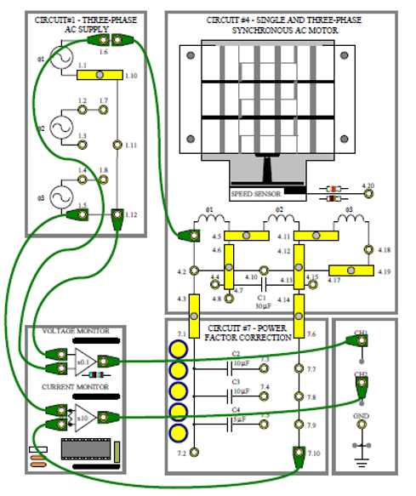
Figure 5
This was an inductive system and as we know in order to reduce the reactance, capacitors need to be added which in turn increases power factor. So, once the oscilloscope was set up, shorting links could then be connected between specific sockets on the board to add the intended capacitor. However, before adding Capacitors it was important to gather information on the circuit with no capacitors added, as a base point and to identify the original power factor. The information gathered was the phase angle between the supply voltages and current, also the current amplitude was measured.

Phase angle
The phase angle (φ) was determined by using the following formula:
φ = (Δt / T degree) * 360
Where Δt = time delay (lagging), T = period of waveform
To acquire the time delay the difference between the peaks of the voltage and current signals were measured, as you can see in figure 2, two cursers on the voltage (white) and current (yellow) peaks were added to work out the difference.
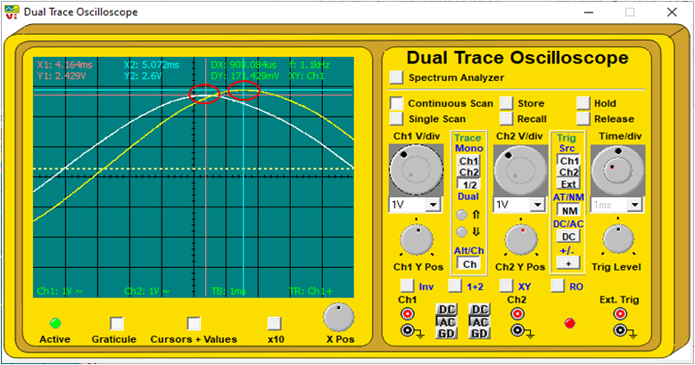
Figure 6 peak to peak difference
The period of the waveform was determined by the setup of the oscilloscope at the beginning of the process, so for this experiment the time base control was adjusted so that a half cycle covers 9 divisions. The division of time delay and period of waveform was then multiplied by 360 in order to get the phase shift (angle) in degrees. To work it out in radians the time delay would have been multiplied with two time pi.

Current amplitude
The peak to peak current amplitude was then calculate using the following formula:
$$Current Amplitude (mA) = \left(\frac{2 x peak x 1000}{10}\right)$$
2 x peak produces the peak to peak, however due to the way the system was used in regards to the X0.1 gain for the voltage monitor and X10 gain for the current monitor the product was divided by 10. The factor of 1000 is merely there to get the answer in mA.

With this information the phase angle and current amplitude for the system was calculated when each of the correction capacitors were added which were the 10μF,15μF and 20μF. This information was then gathered and recorded in the table below.
Correction Capacitor | None | C2 - 10μF | C2+C3 - 20μF | C2+C4 - 15μF
Phase angle (lead/lag) | lead/lag ° | lead/lag ° | lead/lag ° | lead/lag °
Current amplitude | ma p-p | ma p-p | ma p-p | ma p-p

It was then easy to see the value of shunt capacitance which gives the nearest to complete correction of the phase angle. The phase angle and current are both at a minimum with the best value of power factor correction capacitor in the circuit. Whether the current is lagging or leading the voltage could then be determined, the power factor was also calculated with the phase angle, using the following formula:
Power Factor = Cosθ (phase angle)
The product of this translates to the percentage of the supplied volt amps (VxI) that is being dissipated as power in the load. Ideally the power factor should be 1.0 which is the greatest value it can have, if there is no reactive component of current and supply current is in phase with the supply voltage.With this being said and the power factor being calculated for the circuit with no correction capacitor and with the best correction capacitor in place, the next step was to identify the supply voltage, it was also important to remember that when measuring with an oscilloscope, you get a peak-to-peak reading of voltage. An example of this can be seen in figure 3, where the cursers are situated at the peaks to show the peak to peak voltage at the top of the screen next to DY. This could also have been easily manually calculated as each division is equal to 1V.
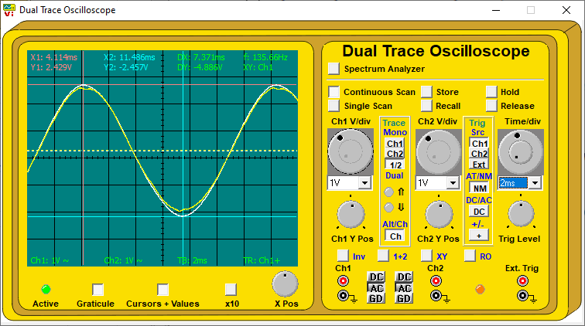
Figure 7 Voltage P-P
Once this was determined, the power supplied in watts with no correction capacitor in the circuit and also with the best correction capacitor in circuit was calculated to compare how much power was being wasted.

Pulse Width Modulation
The second part of this task was to investigate PWM (pulse width modulation) variable frequency drives. For this I connected the circuit as show in figure 8

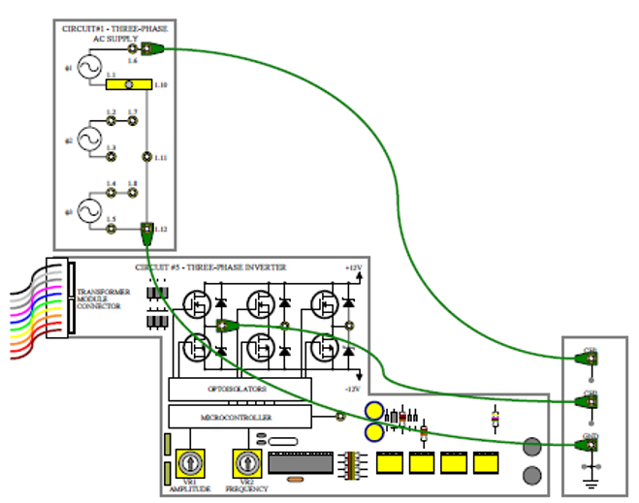
Figure 8
Once the circuit was connected up, the oscilloscope was configured as specified in the brief to display the individual pulses from the microcontroller as amplified by the complementary MOSFET amplifiers on CH.2. With this information now being visually displayed, investigation of the output pulses of varying width when clocked, that were generated from the microprocessor could then take place.
The pulses at the positive peak of the sine wave was measured to observe their behaviour and a count of the microcontroller positive pulses in one half-cycle. It could also be determine if there was any ripple as a result of the rectifier part of the variable frequency drive which rectifies A.C voltage to make D.C.

Results
This section will contain the various results obtained from the measurements of the tasks that were carried out.

PFC Capacitor

Shunt Capacitor Values and results
Correction Capacitor | None | C2 - 10uF | C2+C3-20uF | C2+C4-15uF
Phase Angle (lead/lag) (°) | 36.32 Lag | 7.08 Lead | 32.76 Lead | 24.84 Lead
Current Amplitude (mA p-p) | 520 | 474.2 | 525.8 | 485.8
Power Factor | 0.80 | 0.99 | 0.84 | 0.90
Power Supplied (Va) | 3175.9 | 2896.2 | 3211.3 | 2967.0
True Power (W) | 2558.9 | 2874.1 | 2700.5 | 2692.5
Supply Voltage (V p-p) | 48.86
Table 1
Table 1 shows the phase angle, current amplitude, power factor, power supplied (apparent) and true power in relation to the correction capacitor value that was added to the circuit. The capacitor that gives the nearest to complete correction of the phase angle is C2- 10uF, which also coincides with the best power factor of 0.99.

Fault Finding

Fault A Inserted
The management computer inserted a fault to the following circuit :
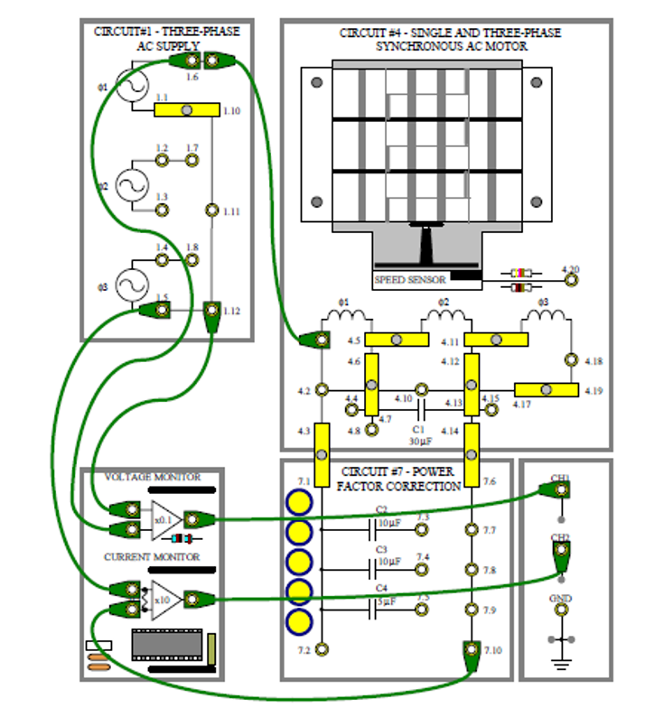
Figure 9

Shunt Capacitor values and results with fault inserted
Correction Capacitor | None | C2 - 10uF | C2+C3-20uF | C2+C4-15uF | C3 - 10uF | C3+C4 - 15uF
Phase angle (lead/lag) ° | 41 Lag | 37.52 Lead | 75 Lead | 56.72 Lead | 0.88 Lead | 26.16 Lead
Current amplitude mA p-p | 525.8 | 542.8 | 622.8 | 577.2 | 474.2 | 508.6
Power Factor | 0.75 | 0.79 | 0.26 | 0.55 | 0.99 | 0.90
Power Supplied (Va) | 3211.3 | 3315.2 | 3803.8 | 3525.2 | 2896.2 | 3106.3
True Power (W) | 2423.6 | 2629.4 | 984.5 | 1934.4 | 2895.8 | 2788.1
Supply Voltage | 48.86
Table 2
Table 2 shows the phase angle, current amplitude, power factor, power supplied (apparent) and true power in relation to the correction capacitor value that was added to the circuit, this time there was a fault inserted to the circuit. The results of table 2 was then compared with table 1 (no fault inserted) in order to identify the problem. It’s clear from this that there was an issue with C2 as the power factor has dropped massively this time round when C2 is involved.

Pulse width modulation investigation

PWM Oscilloscope measurements

Figure 10 – Positive peak of sine wave
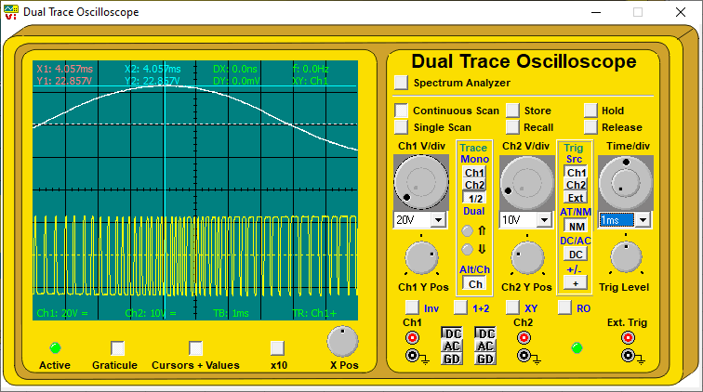
Figure 10 - Positive peak of sine wave
The number and behaviour of the pulses in relation to the positive peak can be seen in figure 6.

Figure 11 – Negative half-cycle of sine wave
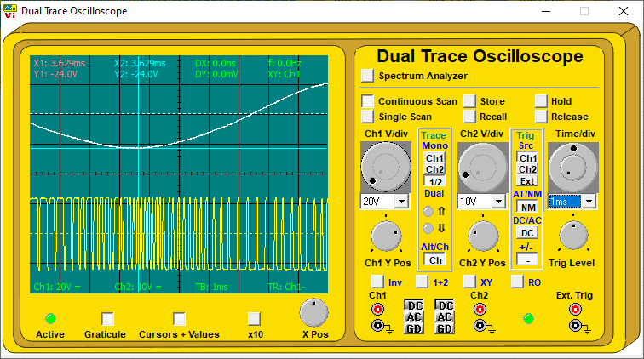
Figure 11 - Negative half-cycle of sine wave
The oscilloscope was changed to negative triggering to show the negative half-cycle of the sine wave as seen in figure 11.

Figure 12 – CH.1 Y-amplifier set to 10V/div
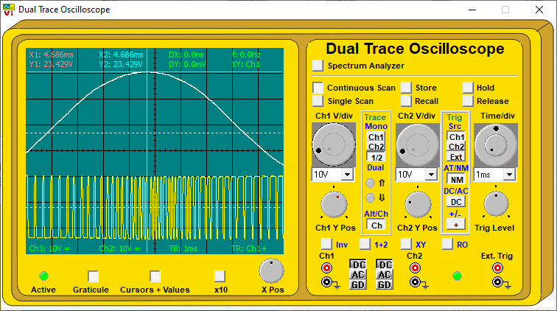
Figure 12 - CH.1 Y-amplifier set to 10V/div
Figure 12 is the result of the CH.1 Y-amplifier being set to 10V/div instead of 20V/div.

Over-Current Protection investigation

Load Current before short circuit was 26.3 mA.

Figure 13 – Short circuit across the load impact
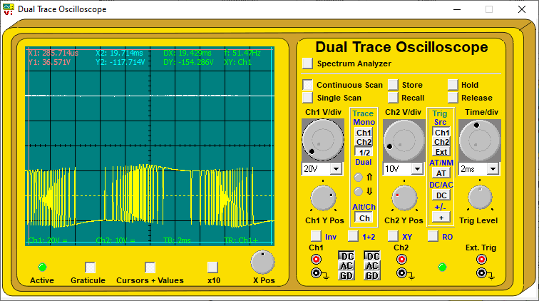
Supply Voltage | 0V
Load Current | 68.2mA
Figure 13 - Microcontroller pulses

Before a short circuit was placed across the load with a connecting lead between sockets 2.2 & 2.3, the Load current was measured at 26.3mA. When the short circuit was introduced the supply voltage dropped to 0V and the load current rose to 68.2mA before reducing.

Figure 14 – Short circuit removed
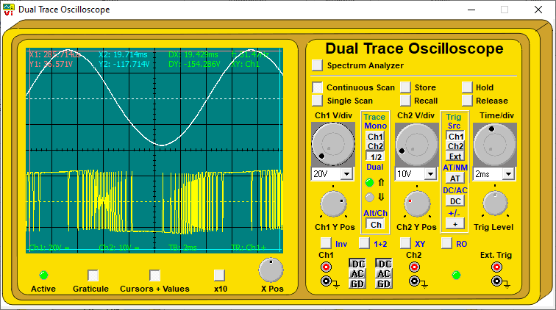
Supply Voltage | 0.30V
Load Current | 26.1
Figure 14 - Microcontroller pulses short removed

When the short circuit was removed the Voltage and current returned to normal immediately.

Single-Phase Synchronous Motor

Fault B Inserted
The management computer inserted a fault to the following circuit :
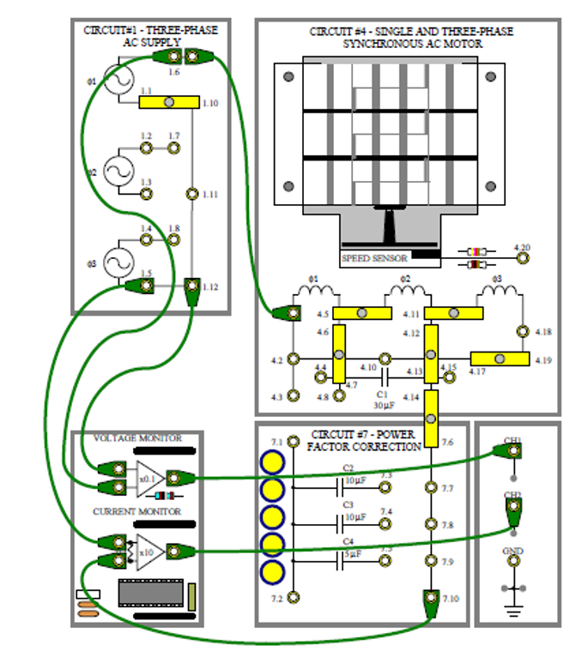
Figure 15
When the fault was inserted in the circuit it caused the motor to shut off, upon further investigation it became evident that there was a short circuit within the capacitor bank, the readings suggested this as there was no current when measuring the links.

Discussion
The results from Table 1 are consistent with previous studies in regards to the reactance of the circuit being neutralized with the addition of capacitors, which in turn increased power factor. Every measurement taken with capacitors added provide a better power factor (closer to unity) than when there is no capacitor in place. The power supplied and the actual useful power (True Power) is also shown in Table 1, which proves the point that circuits with a power factor closer to 1.0 result in less energy wasted. This observation has previously been illustrated in a study by EdvardCsanyi, an Electrical engineer, programmer and founder of EEP. (Csanyi, 2016) On the other hand, Table 2 contradicts this information. However, the point still stands and this only shines a light that there is something wrong with the circuit or capacitor as the power factor became worse with the addition of capacitors.
There was also data collected on PWM which was the method used by the microcontroller to generate three-phase sine wave supplies. The behaviour of the pulses in relation to the sine wave contradicts what we know about PWM in regards to the frequency and the peak of the sine wave should coincide with the width of the pulse. The positive peak of the sine wave, the microcontroller pulses become broader, this is fact and is seen in many studies in that past (theorycircuit, 2005). Figures 10, 11 and 12 do not support this, causing the uncertainty on the experiment. There appears to be a phase shift as the sine wave and PWM signals or possibly due to an inverted channel.
Finally, the three-phase supply generator has two-stage over-current protection built in, to prevent damage to the circuit in the event of a short circuit. The output voltages reduce to a low vault and the current rises. Data collected on this which are provided in this report support this. If the short circuit remains and the current continues to rise until it eventually becomes too much, a thermal protection circuit operates which alter the pulses from the microcontroller to further reduce the voltage and bring the output current back to a safe value.

Conclusion
To conclude, this report has outlined the importance of the concept of power factor and power factor correction, motor drives and three phase inverters. Providing a brief description of each, experiments were also carried out to support the points raised such as the positive effects capacitors have to power factor when added to the circuit. The methods and results of said experiments can also be found in this report as well as a discussion which interprets the results and compares with previously conducted studies on the subject.

References
Csanyi, E. (2016). How capacitors improve the power factor and how to calculate them? EEP.
electricaltechnology. (2019, June 15). electricaltechnology. Retrieved April 5, 2022, from electricaltechnology: https://www.electricaltechnology.org/2013/07/active-reactive-apparent-and-complex.html
fujielectric. (2022, April 2). fujielectric. Retrieved 04 2, April, from fujielectric: https://www.fujielectric.com/products/column/inverter/inverter_01.html
J.David Irwin, M. H. (2005). POWER ELECTRONICS. Florida: Academic Press.
Ladder Logic World. (2020, 10 11). Retrieved 12 09, 2021, from Ladder Logic World: https://ladderlogicworld.com/plc-manufacturers/
theorycircuit. (2005, June 25). theorycircuit. Retrieved April 7, 2022, from theorycircuit: https://theorycircuit.com/pwm-inverter-circuit/
tutorialspoint. (2020, December 12). tutorialspoint. Retrieved April 5, 2022, from tutorialspoint: https://www.tutorialspoint.com/power_electronics/power_electronics_types_of_inverters.htm#:~:text=Three%20Phase%20Inverter,erval.
Ware, J. (2006). Power Factor Correction (pfc). IEE Wiring Matters.

