

Improving the COP equipment to better comply with GMP standards
By
Connor Daniel

Supervisor: Stalin Jacob Wilson Packia Dhas

Project submitted as part of the requirements for the award of
BEng (Hons) Electrical and Electronics Engineering

April 2025

Declaration
I, Connor Daniel declare that I am the sole author of this Project; that all references cited have been consulted; that I have conducted all work of which this is a record, and that the finished work lies within the prescribed word limits.

This work has not previously been accepted as part of any other degree submission.

Date: 29th April 2025

Form of consent

I Connor Daniel hereby consent that my Project, submitted in candidature for the BEng Electrical and Electronic Engineering degree, if successful, may be made available for inter-library loan or photocopying (subject to the law of copyright), and that the title and abstract may be made available to outside organisations.

Date: 29th April 2025

Acknowledgements

I would like to first thank my family especially my parents Andrea and Robert and my brother Callum who have supported and assisted throughout this project and my degree. I would also like to thank my partner Katie who has been extremely patient and supportive through the process of completing this project. I would also like to give thanks to my project supervisors Gary Jones who guided me through the first half of my project and Stalin Jacob Wilson Packia Dhas who guided me through the last half. I would also like to give thanks to Stephen Mosey who has helped me throughout my degree. Finally, I would like to give thanks to my liaison officer Yang Lu who has helped throughout my degree.

Abstract
This report outlines the improvement of a Clean-Out-Of-Place (COP) system, aimed at improving the efficiency of the system and compliance with Good Manufacturing Practice (GMP) regulations.

The project began with an assessment of the key areas of improvement on the existing system before conducting research into various aspects that affect the project design and components that can be used to complete the build of the project.

The information gained from the research was taken and put into practice to begin the process of building the hardware and software aspects. Any challenges faced throughout this process are highlighted before providing the solution to how any challenge was overcome.

A testing process was then completed to analyse whether the improvements made to the system met the overall aim and objectives set for the project. An evaluation of the results is then conducted providing any recommendations for further work.

The report concludes with a reflection discussing how the project has led to personal growth, developed project management skills and the technical skills gained.

Table of Contents
Declaration 2
Form of consent 2
Acknowledgements 3
Abstract 4
List of Figures 8
List of Tables 10
Chapter 1 – Introduction 12
1.1 – Project overview 12
1.2 – Aim and Objectives 12
1.3 – Following Chapters 13
Chapter 2 – Research and review of literature 15
2.1 - Introduction 15
2.2 -Cleaning systems in the pharmaceutical industry 15
2.2.1 - Clean-Out-Of-Place (COP) 15
2.2.2 - Clean-In-Place (CIP) 16
2.2.3 - Sterilise-In-Place (SIP) 17
2.3 - Validation and Regulations 17
2.3.1 – FDA guidelines 18
2.3.2 - Contamination 19
2.3.3 – Sampling techniques 19
2.4 - Environmental factors 20
2.4.1 – Wastewater treatment plants 20
2.4.2 – Licensed waste companies 20
2.4.3 – Green Chemistry practices 21
2.5 - Conclusion 21
Chapter 3 – Development methodology 22
3.1 - Waterfall methodology 22
3.1.1 - Requirements 22
3.1.2 - Design 22
3.1.3 - Implementation 23
3.1.4 - Verification and testing 23
3.1.5 - Deployment and maintenance 23
Chapter 4 – Design & Implementation 24
4.1 - Analysis of current system 24
4.1.1 - Hardware issues 24
4.1.2 - Software issues 24
4.1.3 - Procedure issues 25
4.1.4 - Advantages of current system 26
4.2 - Component selection 26
4.2.1 - Wash lance 27
4.2.2- Enclosure box 28
4.2.3 – Pump 29
4.2.4 - Solenoid valve 30
4.2.5- Solenoid plug 31
4.2.6 – Contactor 32
4.2.7 - Power supply 33
4.2.8 – MCB 34
4.2.9 - Terminal blocks 35
4.2.10 - Panel isolator 36
4.3 – Design 36
4.3.1- Requirements 37
4.3.2 - Simulation prototype 38
4.3.3 - Physical prototype 45
4.4 - Results 67
4.4.1 – Detergent volume results 67
4.4.2 – Questionnaire results 68
4.4.3 – New HMI screen 72
Chapter 5 – Evaluation 73
5.1 - Aim 73
5.2 - Objectives 74
5.2.1 - Assessment of current COP system 74
5.2.2- Redesigning hardware and software 75
5.2.3- Producing a new procedure for operator 75
5.2.4- Installation, validation and testing 76
5.2.5- Implementation of the new system 76
5.3 – Results 77
5.4 – Project requirements 78
Chapter 6 - Conclusion and recommendations 80
Chapter 7 – Reflection 82
References 83
Appendices 87
Appendix 1- Preventative maintenance work order 87
Appendix 2 – Software simulation program 88
Appendix 3 – Physical prototype software program 100
Appendix 4 – Operator questionnaire 107

List of Figures
Figure 1 - Current HMI screen 25
Figure 2 - Simulation prototype HMI 39
Figure 3 - Simulation prototype Factory IO 39
Figure 4 - Simulation prototype network 1 40
Figure 5 - Simulation prototype network 2 40
Figure 6 - Simulation prototype network 3 41
Figure 7 - Simulation prototype network 4 41
Figure 8 - Simulation prototype network 5 42
Figure 9 - Simulation prototype network 6 43
Figure 10 - Simulation prototype network 7 43
Figure 11 - Simulation prototype network 9 44
Figure 12 - Hardware block diagram 45
Figure 13 - 2-to-1 hose connector and manifold 46
Figure 14 - Air fittings 46
Figure 15 - Electrical panel drawing 49
Figure 16 - Backplate hole layout 49
Figure 17- Components fitted to backplate 50
Figure 18 - Internal wiring 50
Figure 19 - First stage of panel build complete 51
Figure 20 - First hardware design 52
Figure 21 - Circuit testing 53
Figure 22 - Software program block diagram 54
Figure 23 - Software flowchart 55
Figure 24 - Physical prototype network 1 56
Figure 25 - Physical prototype network 2 56
Figure 26 - Physical prototype Factory IO testing 57
Figure 27 - Physical prototype network 3 58
Figure 28 - PLC and HMI testing 59
Figure 29 - Original manifold leaking 60
Figure 30 - New fittings 60
Figure 31 – LM317T voltage regulator [38] 61
Figure 32 - Voltage regulator 62
Figure 33 - Tank 1 Level function block 63
Figure 34 - Tank 1 level function block network 1 63
Figure 35 - Physical prototype network 3 64
Figure 36 - Physical prototype network 4 64
Figure 37 - Tank 1 empty alarm 65
Figure 38 - Tank 1 HMI low level 66
Figure 39 - Tank 1 HMI empty level 66
Figure 40 - Questionnaire graph 1 68
Figure 41 - Questionnaire graph 2 69
Figure 42 - Questionnaire graph 3 70
Figure 43 - Questionnaire graph 4 71
Figure 44 - New HMI screen 72
Figure 45 - New standard operating procedure 76
Figure 46 - Planned maintenance work order 87
Figure 47 - Software simulation HMI 88
Figure 48 - Software simulation Factory IO 88
Figure 49 - Software simulation Network 1 89
Figure 50 - Software simulation network 2 89
Figure 51 - Software simulation network 3 90
Figure 52 - Software simulation network 4 90
Figure 53 - Software simulation network 5 91
Figure 54 - Software simulation network 6 91
Figure 55 - Software simulation network 7 92
Figure 56 - Software simulation network 8 92
Figure 57 - Software simulation network 9 93
Figure 58 - Software simulation network 10 93
Figure 59 - Software simulation network 11 94
Figure 60 - Software simulation network 12 94
Figure 61 - Software simulation network 13 95
Figure 62 - Software simulation network 14 95
Figure 63 - Software simulation network 15 96
Figure 64 - Software simulation network 16 96
Figure 65 - Software simulation network 17 97
Figure 66 - Software simulation network 18 97
Figure 67 - Software simulation network 19 98
Figure 68 - Software simulation network 20 98
Figure 69 - Software simulation network 21 99
Figure 70 - Physical prototype network 1 100
Figure 71- Physical prototype network 2 100
Figure 72 - Physical prototype network 3 101
Figure 73 - Physical prototype network 4 101
Figure 74 - Physical prototype network 5 102
Figure 75 - Physical prototype network 6 102
Figure 76 - Physical prototype function block 1 102
Figure 77 - Physical prototype function block 2 103
Figure 78 - Physical prototype final HMI 103
Figure 79 - Physical prototype HMI low level alarm 104
Figure 80 - Physical prototype empty alarm 105
Figure 81 - Physical prototype alarm pop up 106
Figure 82 - Questionnaire page 1 107
Figure 83 - Questionnaire page 2 108

List of Tables
Table 1 - COP components [4] [5] [6] 16
Table 2 - CIP components [4] [5] [6] 17
Table 3 - Suction lance comparison table [15] [16] [17] 27
Table 4 - Enclosure box comparison table [18] [19] [20] 28
Table 5 - Pump comparison table [21] [22] [23] 29
Table 6 - Solenoid valve comparison table [24] [25] 30
Table 7 - Solenoid plug [26] 31
Table 8 - Contactor comparison table [27] [28] [29] 32
Table 9 - Power supply comparison table [30] [31] [32] 33
Table 10 - MCB table [33] 34
Table 11 - Terminal blocks table [34] [35] [36] 35
Table 12 - Panel isolator table [37] 36
Table 13 - Project requirements 37
Table 14 - Electrical drawing wiring key 47
Table 15 - Electrical drawing component key 48
Table 16 - Recipe 1 delivery rate results 67
Table 17 - Recipe 2 delivery rate results 67
Table 18 - Evaluation of project requirements 78

Chapter 1 – Introduction

1.1 – Project overview
This project looks at improving the current clean-out-of-place (COP) wash system at PCI pharma services. PCI pharma services is a Contract Development and Manufacturing Organisation (CDMO) which manufactures highly potent oncology drugs for its clients [1]. Due to PCI being part of the pharmaceutical industry which is a highly regulated sector there is a need to adhere to regulations such as Good Manufacturing Practice (GMP) and Food and Drug Administration (FDA) [2] [3].

1.2 – Aim and Objectives
The main aim of the project is to improve the compliance with GMP regulations and efficiency of the clean-out-of-place system which is located inside a contained manufacturing facility (CMF) seeking to target the following areas:

- Ease of use for the operator to run different purging recipes.
- Reduce cross contamination between detergents.
- Make it easier for the operator to comply with GMP standards.
- Reduce the engineers’ workload.

These areas are being improved by enhancing and redesigning both the hardware and software currently in place. These improvements must be made taking into consideration the strict validation procedures and guidelines set by GMP. To achieve the main aim of this project the following objectives have been set:

- Assessment of current COP system
The current system in place needs to be assessed to identify where improvements can be made to the hardware and software therefore improving the procedure in terms of complying with GMP standards.

- Redesigning hardware and software
After the areas are identified that need to be improved on, the design process begins. This objective includes both a simulation-based prototype using Factory IO and a physical working prototype to show proof of concept. Research is conducted into current wash systems used in the pharmaceutical industry, the different components that can be used to complete this project and the regulations that impact how the design is built to ensure it complies with GMP regulations.

- Producing a new procedure for operator
A new procedure is produced for the operators due to the improvements made. The improvements made aim to ease use for the operator when complying with GMP standards and operating the parts washer purging recipes. This aims to reduce downtime and the need for an engineer.

- Installation, validation and testing
Once the improvements have been decided through the prototypes and a new procedure has been created, the improvements can be installed to the current system. The equipment and procedure are put through validation and testing. This ensures that the changes implemented still allow the equipment and procedure to pass the GMP regulations and do not have an impact on the effectiveness of the wash.

- Implementation of new system
This objective involves finalising the implementation and integration of the new equipment and standard operating procedure into production, which indicates the completion of the project.

1.3 – Following Chapters
The following chapters outline how the project has been dissected into different segments to achieve the main aim, whilst highlighting any challenges encountered and the action taken to resolve the challenge.

Chapter 2 – Research & Review of literature analyses the current cleaning systems available throughout the pharmaceutical industry. Research is conducted to look at the validation procedure and GMP standards to ensure a good base knowledge before designing the new system. The environmental effect of producing and cleaning harmful drugs is also investigated looking into how pharmaceutical companies mitigate and minimise these effects.

Chapter 3 – Research and/or development methodology highlights the development methodology used in this project. The reasons for the chosen development methodology are explained and how it relates to each section of the building process for the new system.

Chapter 4 – Design and implementation begins with an assessment of the current system stating what the advantages and disadvantages are. This analysis of the system indicates the areas of the machine and process that can be improved. This chapter also researches into different options available for components and design builds to reach the main aim of the project. Chapter 4 uses the information gathered earlier on in this chapter and chapter 2 to outline the proposed changes to improve the hardware, software and cleaning procedure. These improvements will be utilised to form both a software simulation and a fully operational prototype which shows proof of concept.

Chapter 5 – Evaluation is a discussion of how the project finished in comparison with the aim and objectives set out at the start of the project. This section analyses the test results, questions the operators for their final opinion and go analyses each individual objective to see if the aim of the project was met.

Chapter 6 – Conclusions and recommendations reflects on the project from a perspective of how the product effected the business. This chapter also highlights any recommendations for further work and further analysis that may be required to prove if the project has had a positive impact on the business.

Chapter 7 – Reflection is a personal reflection highlighting the personal knowledge gained from both a practical and theoretical standpoint. This chapter outlines how challenges were dealt with from a personal point of view and how personal growth was gained.

Chapter 2 – Research and review of literature

2.1 - Introduction
The cleaning process in the pharmaceutical industry is essential to ensure the safety and quality of the product being produced. Throughout this research and literature review different cleaning systems are explained providing the benefits of each method of cleaning. Research is also conducted into the validation procedure and the regulations that govern cleaning in the pharmaceutical industry. These procedures and regulations provide information on how the laws in place help reduce cross contamination between batches and uphold the quality of the drugs. The environmental impact of washing highly potent product and using harsh chemicals to do so is researched. The counter measures that can be put in place are also investigated, to give an outline of the best way to ensure the project has no further impact on the environment. The key points from each section are evaluated at the end of this research explaining how it has had an impact on the project moving forward.

2.2 -Cleaning systems in the pharmaceutical industry
There are different cleaning systems that are used in the pharmaceutical industry these include Clean-Out-Of-Place (COP), Clean-In-place (CIP) and Sterilise-In-Place (SIP). Each method has its advantages and disadvantages which are discussed throughout this section.

2.2.1 - Clean-Out-Of-Place (COP)
COP cleaning involves dismantling and transporting the dirty equipment from its designated area and placing it inside of a wash bay [4]. For this reason, the COP system is used to clean smaller components used in the manufacturing process, for example different valves, hoses and seals. A COP system also has a conductivity sensor to test if the clean has been effective by reading against purified water at the last stage of the wash. A COP system consists of many different components to ensure the equipment being cleaned is done so to a standard that complies with the stringent regulations in place. The basic components of a COP system and their purpose have been listed below in Table 1 [5] [6].

Table 1 - COP components [4] [5] [6]
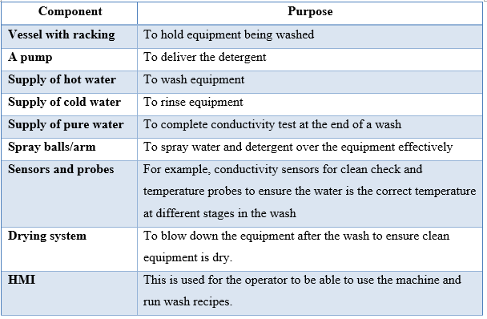

2.2.2 - Clean-In-Place (CIP)
A CIP system allows for the equipment used throughout the manufacturing process to be cleaned in situ, this means there is no need to disassemble the equipment [5]. This type of cleaning equipment is used on the larger manufacturing equipment that cannot be moved such as capsule filers and granulating equipment. Due to the CIP system not requiring equipment to be disassembled it is a faster and safer process than the COP system as it does not expose people to the highly potent drugs being produced. This is shown in Table 2 [4] [6].

Table 2 - CIP components [4] [5] [6]
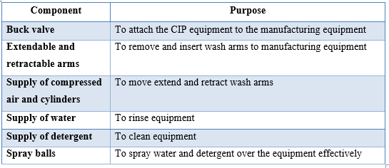

2.2.3 - Sterilise-In-Place (SIP)
Sterilise-In-Place uses the addition of steam to the typical CIP system, this is to raise the temperature of the manufacturing equipment. The aim is to raise the temperature to around 121℃ with the focus being to sterilize the equipment before the next batch whereas a CIP system would be more targeting the prevention of cross continuation using detergents between the batches [7].

2.3 - Validation and Regulations
Cleaning validation is essential with in the pharmaceutical industry to ensure the quality and integrity of the product being produced. Validation of a cleaning process ensures the equipment is free from contamination from the previous batch. Pharmaceutical manufacturers are governed by stringent laws to ensure the drugs produced are fit for human consumption. These laws are enforced by the Food and Drug Administration (FDA) and the European Medicines Agency (EMA) ensure Good Manufacturing Practice (GMP) is complied with throughout the United States and Europe respectively [2] [3].

2.3.1 – FDA guidelines
Source [8] provides information on the expectation from the FDA to meet GMP guidelines stating these 7 requirements:

“1. FDA expects firms to have written standard operating procedures (SOP) detailing the cleaning process used for various pieces of equipment [8].

2. If firms have a specific cleaning process for cleaning between different batches of the same product and use a different process for cleaning between product changes, FDA expects the written procedures to address these different scenarios [8].

3. If firms have one process for removing water-soluble residues and another process for non-water-soluble residues, the written procedure should address both scenarios and make it clear when a given procedure is followed [8].

4. It is required by the FDA, in the general validation procedure, that the personnel responsible for performing and approving the study should comply with the acceptance criteria and the revalidation data [8].

5. FDA expects firms to prepare specific written validation protocols in advance for the studies to be performed on each manufacturing system or piece of equipment which should address such issues as sampling procedures, and analytical methods to be used including the sensitivity of those methods [8].

6. It is expected that firms conduct the validation studies in accordance with the protocols and document the result of studies [8].

7. Final validation report is to be approved by the regulatory board which states whether or not the cleaning process is valid” [8].

2.3.2 - Contamination
The cleaning validation procedure is used to target 3 types of contamination that affect the quality of the future product being manufactured these are:

- Contamination with Active Pharmaceutical Ingredients (API)
This type of contamination occurs when residue from the previous batch has remained on the manufacturing equipment. This causes issues for the company manufacturing the drug as if active ingredients are detected which should not be present with in the batch, then the batch of drugs cannot be sent out for consumption. This costs the company loss of time, money and issues with the client the drug is being produced for [8] [9].

- Contamination with unintended materials or compounds
This type of contamination occurs when materials or compounds from cleaning or maintaining the machine become present within the drug being manufactured. This can be from forms of lubrication, detergents that have not being washed away correctly or tools for cleaning and manufacturing [8] [9].

- Contamination with microbiological organisms
This type of contamination occurs through cleaning, maintenance and storage conditions encouraging microorganisms to grow on manufacturing equipment [8] [9].

2.3.3 – Sampling techniques
After the clean of the equipment has taken place, the equipment is required to be checked to ensure the wash has been effective. There are two main types of sampling techniques used in the industry these are direct swab sampling and rinse sampling [8] [9].

2.3.3.1 – Direct swab sampling
Direct swab sampling is typically used for equipment using CIP washing systems. This type of sampling involves swabbing the equipment with a solvent and then testing it to see if there is any remaining unwanted API remaining on the surface of the equipment. The advantage to this form of sampling is that it allows you to target the areas of the equipment that would be the most likely for API to remain. Source [8] states “Swabs used should be compatible with the active ingredients and should not interfere with the assay. They should not cause any degradation of the compound. The solvent used for swabbing should provide good solubility for the compound and should not encourage degradation” [8]. This is important to take into consideration to ensure the swab sample test results are not affected [8] [9].

2.3.3.2 – Rinse sampling
Rinse sampling is used on COP equipment, it involves the use of a conductivity sensor and purified water. At the end of the wash cycle, a purified water rinse takes place where purified water flows over the equipment then a conductivity sensor before going to the drain. The conductivity sensor has a set limit typically measured in MicroSiemens per centimetre (μS/cm). If the sensor reads back higher than the set limit, an alarm will be shown on the HMI of the washing equipment, this will indicate the wash has failed and the equipment inside will have to go through another wash cycle and retested [8] [9].

2.4 - Environmental factors
The cleaning process within the pharmaceutical industry has the potential to cause the environment harm, this is due to the harmful chemicals used in cleaning and the dangerous API that is also washed away when cleaning. For this reason, measures are put in place with the aim of mitigating or minimizing harm to the environment [10].

2.4.1 – Wastewater treatment plants
One of the mitigating techniques put in place would be the use of wastewater treatment plants on site. The wastewater produced from using harsh chemicals to clean potent API cannot get directly disposed of into the general population wastewater. This is due to the fact they could be harmful to the public and wildlife if not properly treated before disposal. Therefore, all water waste produced from the pharmaceutical company is treated to remove any harmful chemicals or product before disposed of [11].

2.4.2 – Licensed waste companies
Pharmaceutical companies are also required to work with waste companies that are licensed to dispose of pharmaceutical waste. This type of disposal is needed for waste used during the manufacturing processes this can be PPE such as masks and gloves or cleaning materials such as paper towels. This type of waste must be put in special containers or bins and labelled up identifying that it is pharmaceutical waste, which will then be collected and disposed of correctly by the licensed company [11].

2.4.3 – Green Chemistry practices
Greener chemistry practices are implemented to reduce the environmental impact from manufacturing pharmaceuticals. It reduces the harm to the environment by using safer solvents and detergents when possible, designing for degradation so the waste produced does not persist in the environment and designing safer chemicals where the effectiveness of the product is not affected whilst reducing the toxicity. The practice of greener chemistry also looks in to making the manufacturing process as energy efficient as possible to reduce the effect on the environment [12].

2.5 - Conclusion
In conclusion to run a successful pharmaceutical manufacturing business a combination of all three COP, CIP and SIP systems are essential to provide washing equipment for each style of manufacturing equipment. This allows for a high-quality product to be manufactured. This alongside an effective wash and sampling procedure to ensure GMP standards are met to allow production to continue. The reduction of environmental harm when disposing of the waste produced is a very important factor as it protects both human life and wildlife. Therefore, the importance to follow the guidelines set and to continuously improve on the current systems in place is crucial. Following these guidelines ensure the company complies with the environmental authorities.

Chapter 3 – Development methodology

3.1 - Waterfall methodology
To complete the project in a structured manner, research was conducted into various development methodologies. As the aim of the project is clearly defined and the pharmaceutical industry is highly regulated which requires tracking documentation. The waterfall method was the best suited for this project. This due to the 5 common stages of the waterfall methodology which are discussed below explaining why each stage is important and how it aligns with the project [13] [14].

The waterfall methodology has 5 common stages these are:
- Requirements
- Design
- Implementation
- Verification and testing
- Deployment and maintenance

3.1.1 - Requirements
The waterfall methodology gathers all the project requirements first, getting a detailed understanding of what the customer desires from the project. In the case of this project, the customer would be the engineering management team and the operators. An analysis of the current system is conducted to highlight areas that can be improved, to ensure the aim of the project is met. The requirements are collated and documented before establishing timelines and success metrics for the project [13] [14].

3.1.2 - Design
In this stage of the waterfall methodology, the engineer develops solutions to achieve the requirements set. Once solutions are identified, a physical design is created using both hardware and software applications. For this project, this stage involved comparing and sourcing the best components, building a software simulation and building a proof-of-concept prototype which combined the hardware components and the software program. This allowed for a system that could be tested before moving on to implementation [13] [14].

3.1.3 - Implementation
At this stage of the waterfall methodology, the research and design aspect of the project is complete. This phase involves the implementation of the research and design to begin building the project to the requirements set out at the start. For this project, this stage involves using the information gained from the simulation prototype and proof of concept prototype and begin fitting the new system on to the current COP equipment. This stage involves some testing throughout implementation on both the software and hardware to ensure that the project can move forward to the verification and testing stage [13] [14].

3.1.4 - Verification and testing
The verification and testing stage of the waterfall methodology takes place to check and rectify any final errors with the project. It also ensures that the project is user friendly for those running the equipment and so documents can be created for the equipment. This stage is crucial for this project as it involves the validation and operation departments. It consists of running tests to ensure the operator has a clear idea on how to operate the machine and the delivery rate of the purging recipes still pass the delivery verification planned maintenance. Once the validation team pass the new system, the next stage can take place [13] [14].

3.1.5 - Deployment and maintenance
The final stage of the waterfall methodology is deployment and maintenance, this is the stage where the project is released and can be used as the new standard. For this project this will be when the new system is in place and is the new standard operating procedure. Any defects that are found will be dealt with and the maintenance work order will be updated if needed [13] [14].

Chapter 4 – Design & Implementation

4.1 - Analysis of current system
The current system in place has several areas for improvement to ensure the success of the project. As previously stated, the current system in place is causing downtime issues, cross contamination issues and does not make it easy for the operator to record GMP information. Due to these challenges, improvements are being made to the current hardware, software and operator procedures.

4.1.1 - Hardware issues
The current system only has one suction lance shared for each different detergent this is one of the main reasons an engineer is required every time a new detergent is needed for a wash. This is due to the need for the detergent lance to be moved between each detergent. The proposed solution is to fit individual lances for each detergent this removes the need for an engineer for each wash, resulting in less downtime for both the parts washer and other manufacturing equipment. The individual lances also reduce the cross-contamination issue as the lance is not shared between detergents. The current lance in place also is not fitted with a level switch meaning it is not possible to show any detergent levels to the operator. The current system uses a low-pressure alarm to detect when the current jack is empty. The new lances selected have two-way level switching allowing for both a low-level and empty alarm.

Another issue with the current hardware in place is the pump currently in place is a peristaltic pump and requires upgrading for the extra lines to be put in place. This is due to there not being enough space within the containment for the machine to fit individual pumps for each line.

Due to these two previous factors, additional solenoids have been integrated into the hardware before the pump, this is so each detergent line can have its own solenoid which opens when its respective recipe is selected on the HMI allowing the desired detergent to pump through.

4.1.2 - Software issues
The issue with the current software is that it provides the operator with no information for GMP records or does not show the operator the state of the parts washer in terms of detergent levels. This then leads to the engineer having to provide the GMP information such as batch number and expiry date. The operator also can only start the pump to run currently with no option to select certain detergents, this is changed with the addition of the solenoids and separate detergent lines.

The proposed changes to improve the software are implemented so that each detergent line will have its own recipe which can be selected on the HMI by the operator. The recipe opens the respected solenoid and starts the pump to deliver the detergent. The HMI also has a tank for each detergent symbolising their respective detergent jack, this decreases in level when the detergent is used or increase to the top when a new detergent jack is put on. This provides the operator with the level of each detergent, which allows them to analyse whether a fresh jack is needed prior to starting a wash. The HMI also has sections under each detergent with the ability to enter GMP information such as batch number and expiry date, this can be changed each time a new jack is put on. This means GMP information can be recorded without the need for an engineer each time. The current HMI that is in place is shown below in Figure 1.

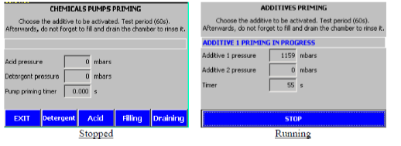
Figure 1 - Current HMI screen

4.1.3 - Procedure issues
Due to the changes made to the hardware and software, the current procedure is not suitable. Therefore, a new procedure must be created with the aim to for it to be validated after the new system is implemented. The new procedure includes key changes that have been made for example selecting the correct detergent, recording new GMP information on HMI when a jack is changed and allow the operator to analyse whether there is enough detergent in the jack to start the wash.

4.1.4 - Advantages of current system
The advantage of the current system is that everything is in place to make the upgrades to the machine. The equipment already has an HMI in place to update with the new software and the panel has also been built with expansion meaning there is room on the PLC for new inputs and outputs, as well as space in the panel for extra components. There is also already a space for the new detergent lines to be put in place as there is already a path for the current one.

4.2 - Component selection
This section investigates the various components needed to build the proof-of-concept prototype and to make the proposed improvements to the current system. Different components are analysed before being selected and providing the reason why the component was best suited to this project.

4.2.1 - Wash lance
Table 3 - Suction lance comparison table [15] [16] [17]
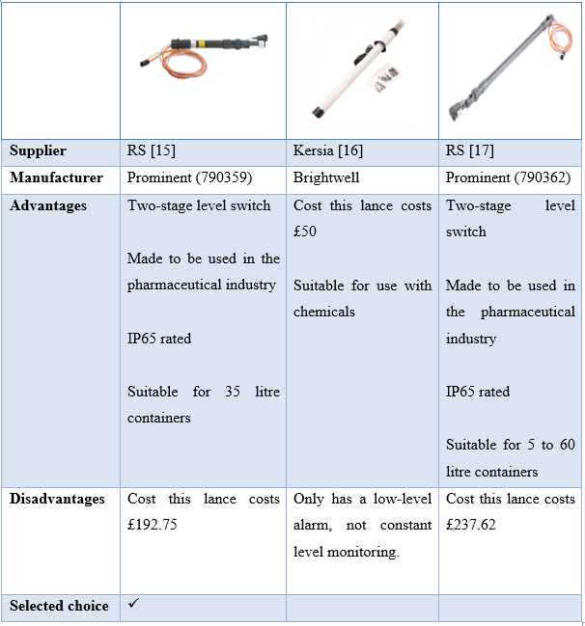

This lance was selected as it is suitable for the size of container used in the workplace, whilst being the cheaper option when compared to the other option provided by prominent. The suction lance selected also has two-level switching which is not provided by the lance on offer from Brightwell.

4.2.2- Enclosure box
Table 4 - Enclosure box comparison table [18] [19] [20]
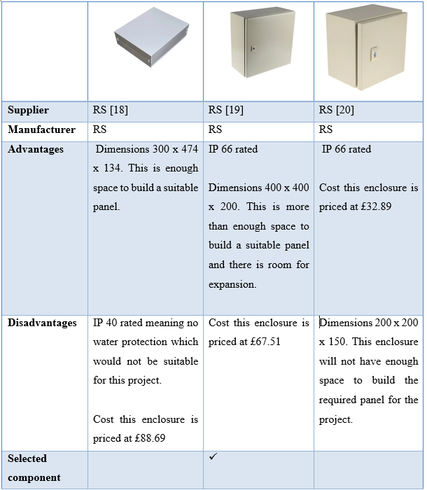

Enclosure [19] has been selected as it has a good IP rating, this is important for this project as the panel is built for pumping chemicals and water, so it needs adequate protection. The enclosure has also been selected as although it is more expensive than enclosure [20], it has more suitable dimensions for the needs of the project.

4.2.3 – Pump
Table 5 - Pump comparison table [21] [22] [23]
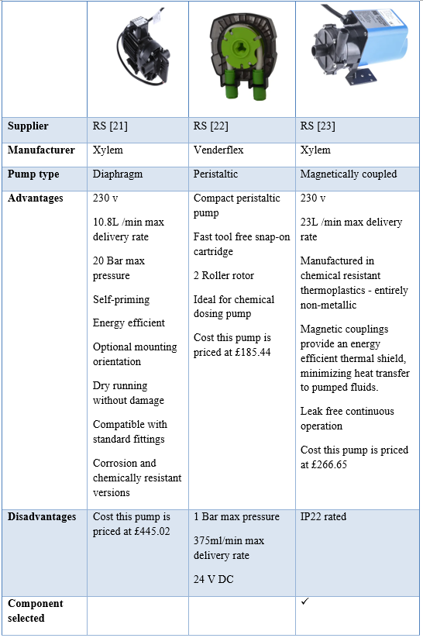

Pump [23] was chosen as it was manufactured to be used for chemical pumping purposes, it also offers a max delivery rate of 23 L/min meaning that the pump does not have to work near its maximum to pump the desired amount of detergent that is needed. Comparing it to pump [22] which only delivers a max of 375ml/min. When comparing pumps [21] and [23] the extra cost of pump [21] was not worth this project therefore, pump [23] was chosen.

4.2.4 - Solenoid valve
Table 6 - Solenoid valve comparison table [24] [25]
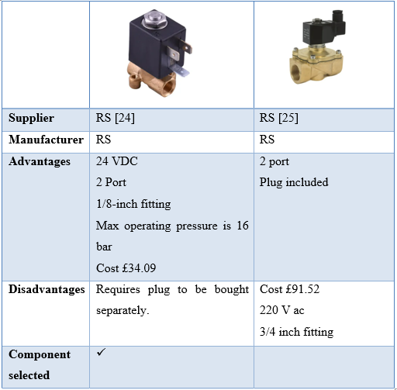

The reason solenoid valve [24] was chosen is because the 24VDC and 1/8-inch fitting better suit the requirements for this project when compared to solenoid valve [25]. This is due to the use of a PLC to operate the solenoid and the size of pipe which can be fitted to the suction lance previously selected.

4.2.5- Solenoid plug
Table 7 - Solenoid plug [26]
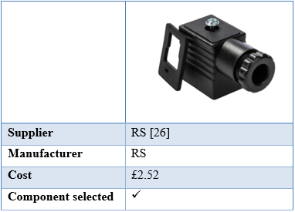

This connector was selected as it fits the solenoid valve that has been chosen.

4.2.6 – Contactor
Table 8 - Contactor comparison table [27] [28] [29]
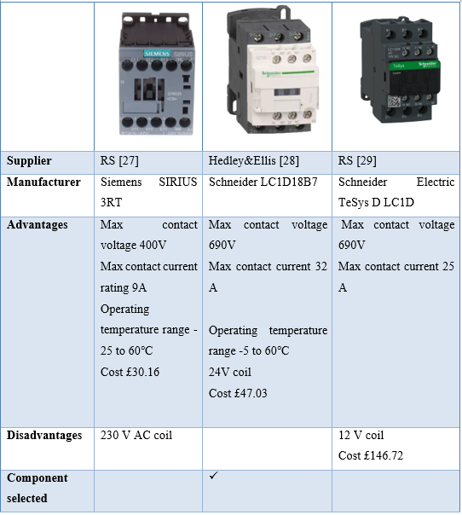

The Schneider LC1D1D18B7 has been chosen for the contactor to start and stop the pump as it better suits the requirements for this project. This is due to the fact it has a max contact voltage of 690V meaning it has more than enough contact voltage for the 230V pump being used for the project. This contactor was also the best suited for this project as the 24V coil allows for the contactor to bring on the pump from the HMI. This is important as it simulates an operator using the HMI in the workplace.

4.2.7 - Power supply
Table 9 - Power supply comparison table [30] [31] [32]
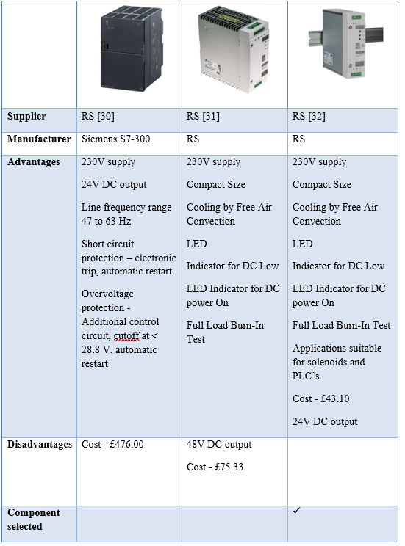

Power supply [32] has been selected as it is the best suited for the design of this project. This is due to its 24V DC output, and its applications being suited to solenoids and PLC’s which are the components the power supply is used to provide power to in this project. When comparing the two 24 V DC output power supplies, the Siemens S7-300 costs £476 and is beyond the specifications needed for this project.

4.2.8 – MCB
Table 10 - MCB table [33]
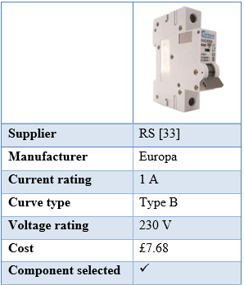

This MCB has be chosen and two have been purchased. One protects the contactor and pump, the other protects the power supply and 24V DC circuits such as the solenoids and PLC. This MCB has been chosen as it has the correct current and voltage rating to protect both these circuits.

4.2.9 - Terminal blocks
Table 11 - Terminal blocks table [34] [35] [36]
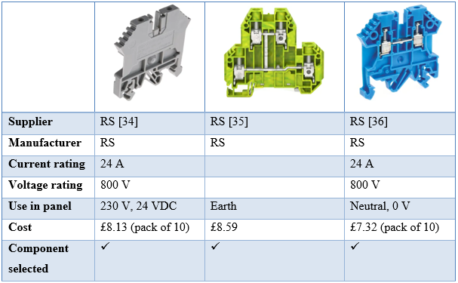

These terminals have been selected to use in the panel to wire up the different circuits needed in the panel.

4.2.10 - Panel isolator
Table 12 - Panel isolator table [37]
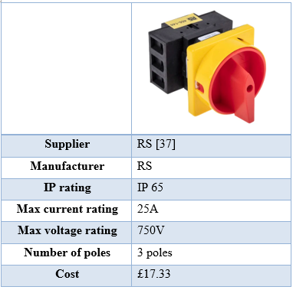

This isolator was chosen as it had 3 poles which allows for connection to a 3-pin socket and plug to get the 230V supply needed. It was also chosen due to its IP 65 rating which suited this project as it involves pumping liquids.

4.3 – Design
The design of this project was developed with the aim and objectives set out in the introduction of this report whilst taking into consideration the limitations of the current system that is in place. The key factors the design aimed to improve was the
- PLC program and operator HMI
- The number of suction lances and changing the pipework to suit
The improvement of these factors then allowed for a more efficient procedure to be put in place. The design of the new system also took into consideration the amount of space available in the machine and the delivery rate requirements set out by the validation documents and preventative maintenance work order (See Appendix 1- Preventative maintenance work order). Therefore, both a simulation and proof of concept protype have been created prior to implementation to the current system. This would allow for testing of the proposed improvements and to detect any potential issues before full implementation. Several decisions were made throughout the design process, and this section outlines how and why each of the decisions were made to meet the requirements needed to achieve the aim of the project.

4.3.1- Requirements
The aim of the project is to improve the COP equipment to provide a more efficient process making it easier for the operator to comply with GMP regulations. Therefore, reducing downtime and engineer’s workload whilst reducing the risk of cross contamination. The first stage of creating the design was communicating with the engineering management team and operators of the COP system to develop a set of requirements for the system to make it feasible for the cost and downtime of the project. The list of requirements is stated below:

Table 13 - Project requirements
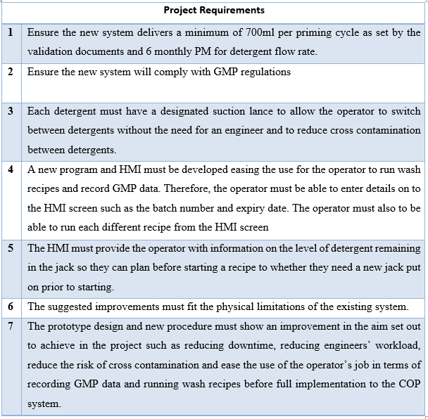

4.3.2 - Simulation prototype

4.3.2.1 – Simulation system overview
A simulation prototype was created using factory IO and Siemens TIA portal, this was developed to show the operators and engineering management team a first look at how the new system would work and the idea for the new HMI screen.

The simulation prototype was created using the tanks on factory IO to resemble detergents jacks in the workplace. The fill valve was used to simulate an engineer replacing an empty detergent tank. The discharge valve was used to simulate when and engineer starts a recipe to purge the detergent lines.

This simulation was created to show how the new system would work, allowing the operator to swap between purging recipes without the need for an engineer. The HMI would also show how the new system meets some of the requirements that were set, such as showing where the batch number and expiry date for each detergent can be inputted. The HMI also shows the level of the tanks changing as the detergent is used, giving the operator an indication of the remaining detergent levels for each jack.

Before creating an HMI screen and the tags to accompany it, the simulation prototype was created using pushbuttons to ensure the program was going to work. There were some issues when creating the simulation prototype, as the tank was not emptying every time the detergent recipe was selected and would sometimes take numerous clicks of recipe start button to begin discharging from the tank. This was due to some of the coding and the use of the tanks for what the prototype was trying to simulate.

The simulation was developed to show the concept and was more complex for coding than the physical prototype was expected to be. Overall, the simulation prototype was a success which provided both the operators and engineering management team a concept of how the new system was going to work. However, the program would need debugging to run more smoothly when it came to applying it to the physical prototype.
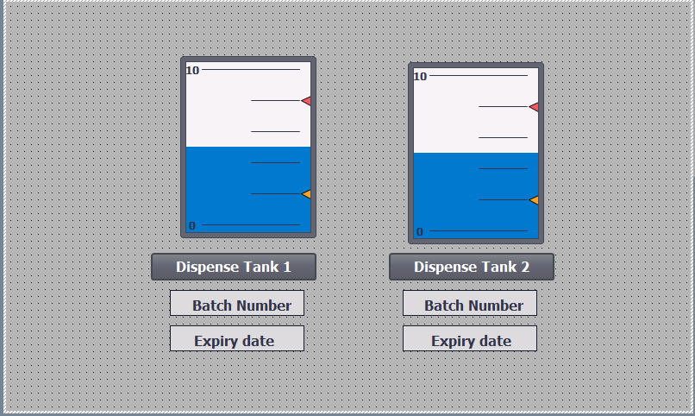
Figure 2 - Simulation prototype HMI

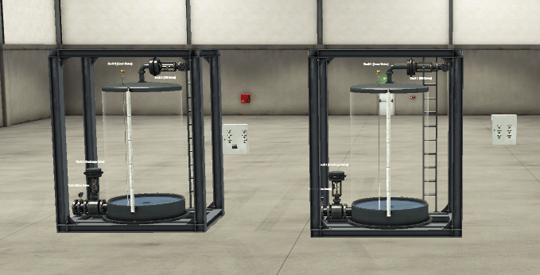
Figure 3 - Simulation prototype Factory IO

4.3.2.2 – Simulation prototype PLC program
For full code please see Appendix 2 – Software simulation program.

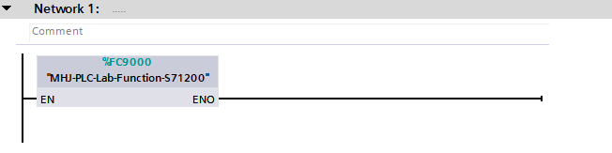
Figure 4 - Simulation prototype network 1
Figure 4 shows the function block that allowed Siemens TIA portal to connect to Factory IO.

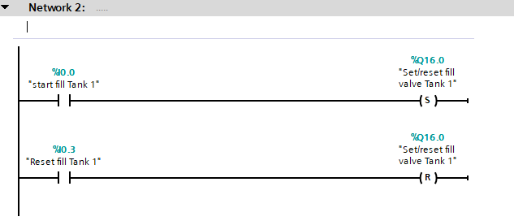
Figure 5 - Simulation prototype network 2
Figure 5 shows the input for starting and resetting the set and reset for the fill valve for tank 1, this allows for the fill valve to be energised and deenergised to fill the tank and then close when the tank is full.
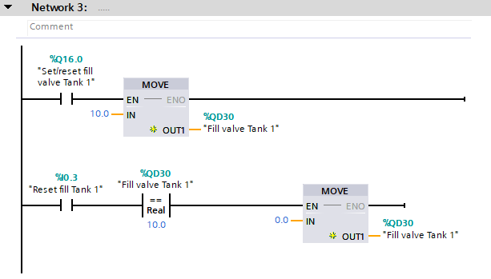
Figure 6 - Simulation prototype network 3
Figure 6 shows the output “Set/reset fill valve Tank 1” moving the fill valve for tank 1 high to start filling the tank with water. Figure 6 also shows how the valve is closed using the output “Reset fill Tank 1” and reading if the fill valve is high. This then goes to a move function block setting “Fill valve Tank 1” back to 0.

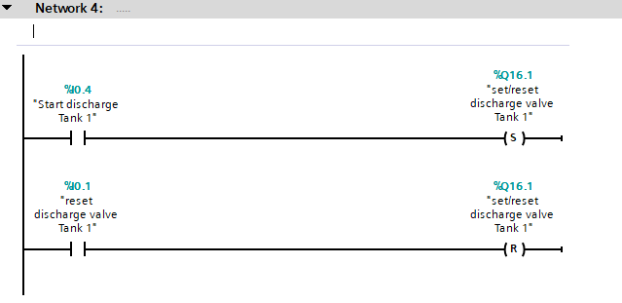
Figure 7 - Simulation prototype network 4
Figure 7 shows the process of using inputs “Start discharge Tank 1” and “reset discharge valve Tank 1 to set and reset the bit for output “set/reset discharge valve Tank 1”. This code allows for the discharge valve to open and close when needed, to simulate detergent leaving the jack when a recipe is run.

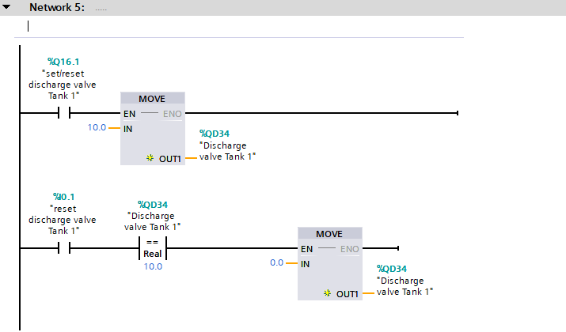
Figure 8 - Simulation prototype network 5

Figure 8 shows how the program opens and closes the discharge valve on tank 1. When the output “set/reset discharge valve Tank 1” is set the value of the discharge valve is set to 10 therefore, opening the valve. If the input “reset discharge valve Tank 1” is energised and the value of the discharge valve is high, then the value of the discharge valve will be set back to 0 closing the valve.
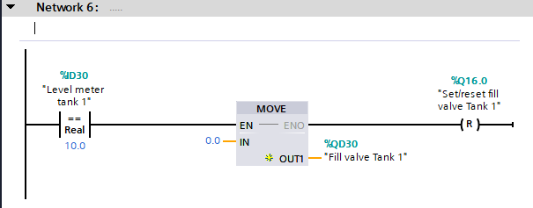
Figure 9 - Simulation prototype network 6

Figure 9 shows how the fill valve is shut when the tank is full using the level meter. When the level meter reaches a value of 10 meaning the tank is full, a value of 0 is moved to the fill valve closing the valve. The “set/reset fill valve Tank 1” bit is then reset to prevent the valve reopening.

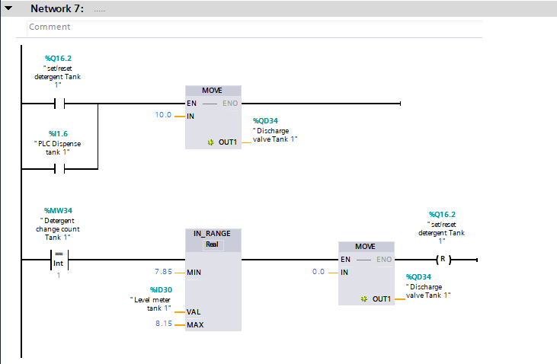
Figure 10 - Simulation prototype network 7
Figure 10 shows how the tank was emptied when a detergent recipe was selected on the HMI. The input “PLC dispense tank 1” is connected to the respective button shown on the HMI shown in Figure 2. When then the button is pressed on the HMI the discharge valve is sent high opening the valve. When the button is pressed on the HMI it also adds 1 to the memory bit “Detergent change count Tank 1”. This memory bit is then used to lower the level in the tank by approximately 20 percent of the tank using an IN_RANGE function block with respect to the level meter for the tank. Once the level of the tank lands in the correct range the MOVE function block is used to set the value of the discharge valve back to 0 to close the valve. The “set/reset detergent Tank 1” bit is then reset to prevent the valve reopening.

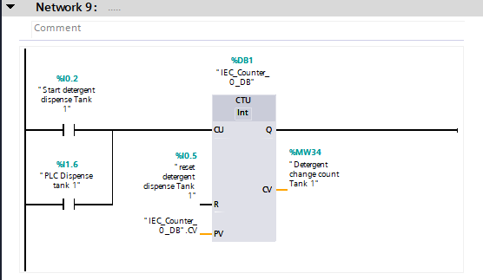

Figure 11 - Simulation prototype network 9
Figure 11 shows how the “PLC Dispense tank 1” is used to add a count to the memory bit “Detergent change count Tank 1”. This is an important part of the program as the count for the memory bit was used to stop the water at the correct level in the tank as shown in Figure 8.

The steps shown in Figure 4 through Figure 11 were replicated for tank 2 for the simulation prototype. This allowed for the program to show that the operator of the HMI could switch between detergent recipes whilst showing the level in the tank lowering both in factory IO and on the HMI.

4.3.3 - Physical prototype

4.3.3.1 – Hardware build
A physical prototype was created to show proof of concept and for testing purposes to ensure a smooth transition when integrating the new system on to the COP machine. This prototype consists of the components needed to complete the project with the software program to match. A block diagram was created to aid with the hardware build this is shown in Figure 12.

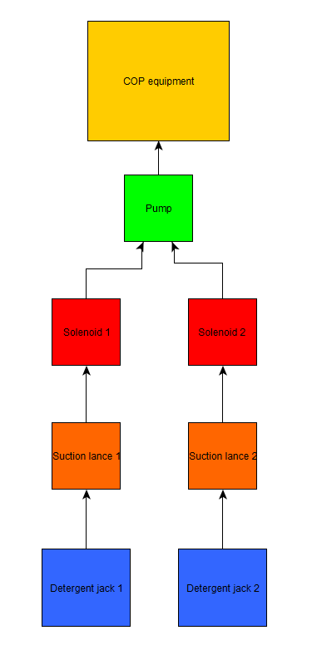
Figure 12 - Hardware block diagram

The first step of development was to obtain all the components needed for building. This was completed by going through the requirements and the aim of the project to decide the best solution to suit. One of the decisions that needed to be made was whether each detergent line was going to have its own peristaltic pump or if a single pump and a manifold with solenoid valves was going to be used. The decision was made to use a single pump and manifold due to the physical limitations of the COP system. Due to this there would not be enough space to fit multiple individual pumps and detergent lines. However, throughout the process of testing, the design was changed due to leaks from the manifold and other fittings that were used. The design was changed from using a manifold and 6mm hose connector (2-to-1) shown in Figure 13. To the air fittings shown in Figure 14. The change to air fittings would remove the leaks present in the prototype.

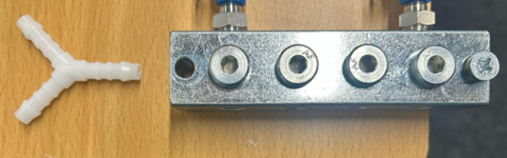
Figure 13 - 2-to-1 hose connector and manifold
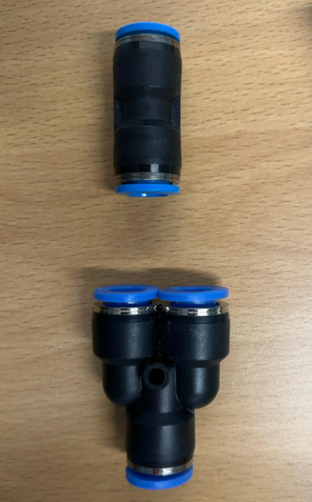
Figure 14 - Air fittings
After the design was decided on, the ordering of components started. However, once some of the components began to arrive, it was clear that only the main components had been ordered such as the pump, solenoids, contactor, power supply, suction lances and enclosure. This happened throughout the project as the build progressed, components that weren’t used to complete one of the requirements however were essential to complete the build of the prototype were identified such as trunking, din rail, pipe connectors and jumper bars for the terminal blocks. This resulted in multiple orders for parts and time that was not initially accounted for.

Another issue that was encountered during the build was the expected delivery date for some of the parts that were ordered, an example of this would be the two 1A MCB’s originally ordered were not going to be delivered at a suitable time. Therefore, two new MCB’s had to be ordered which created another delay.

After enough of the components the first step of the build could take place which was to begin building the panel. A drawing was created for an idea of how the panel layout would look and the wiring involved, this was created to act as a guide and to later reference when completing the wiring. This drawing is shown below in Figure 15:

Table 14 - Electrical drawing wiring key
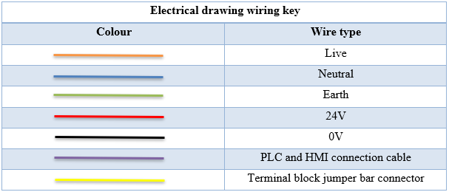

Table 15 - Electrical drawing component key
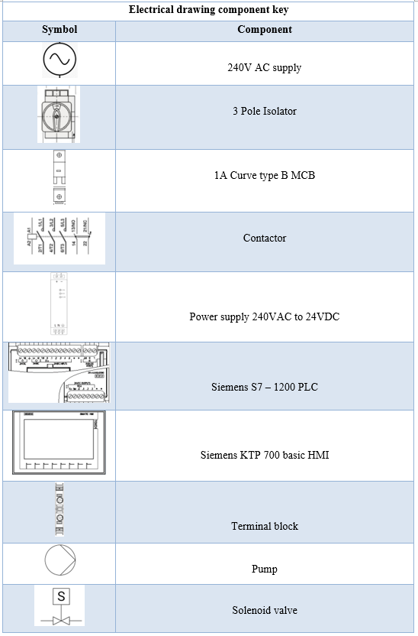

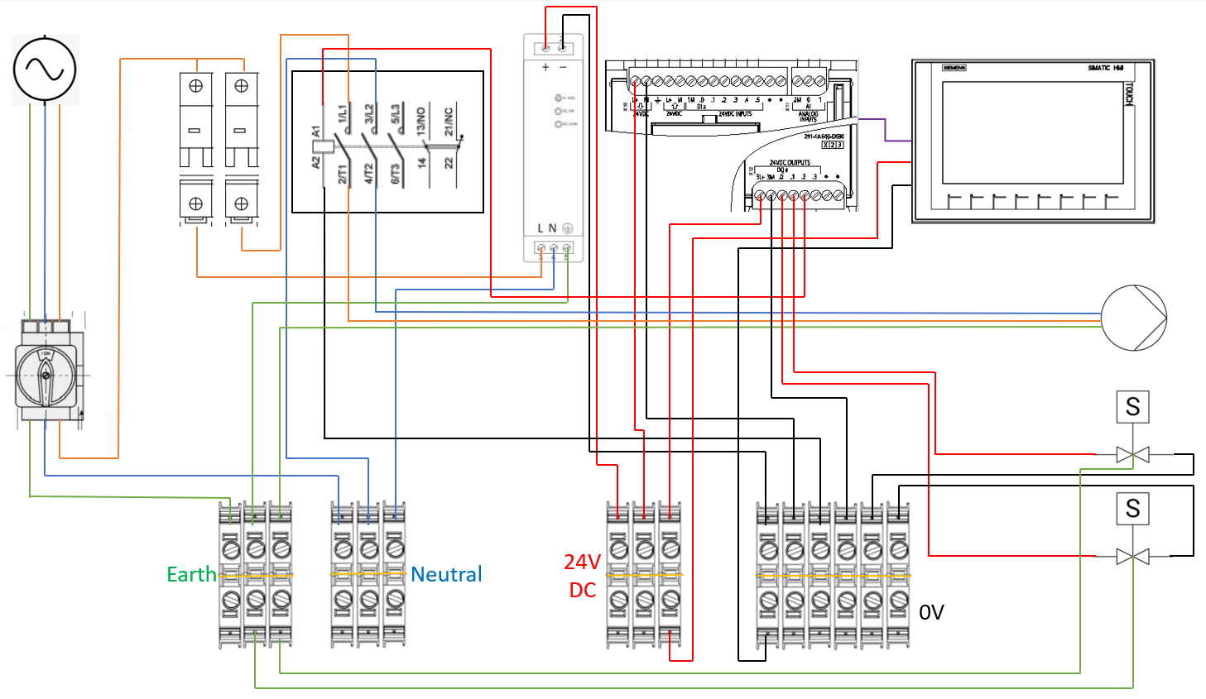
Figure 15 - Electrical panel drawing
This drawing was then taken and applied when marking out the backboard, it ensured that every component was going to fit before starting to drill the holes for the trunking and din rail. After satisfied that the all the components would fit and the markings for the holes were correct, the holes were drilled, and the components were fitted to the backboard. Due to the cost of a PLC and HMI combined with the fact, the final system uses the current PLC and HMI in place on the Clean-Out-Of-Place (COP) equipment. The decision was made to use a PLC and HMI provided by the university. The PLC and HMI were wired externally from the panel later.

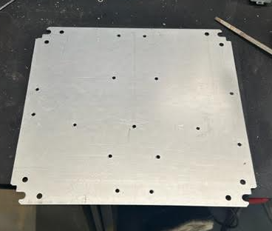
Figure 16 - Backplate hole layout
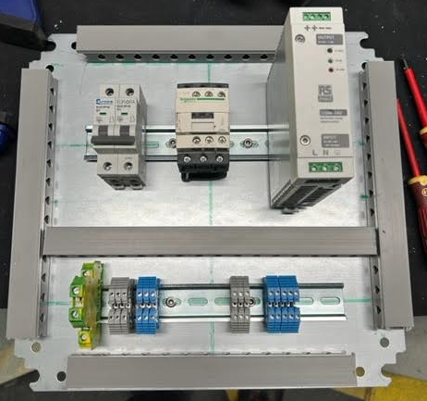
Figure 17- Components fitted to backplate

The next stage of the build was to complete as much of the internal wiring as possible before reattaching the backboard. This was done before reattaching the backboard as it is easier to wire the panel up with the backboard separated from the enclosure.

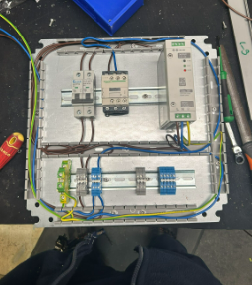
Figure 18 - Internal wiring
After completing all the internal wiring was completed an isolator was fixed to the side of the panel. This would allow for power to be turned on and off from the side of the panel. Once the isolator was fixed to the side of the panel the trunking lids were fitted and the backboard was fitted meaning the remaining wires could be connected to the isolator.

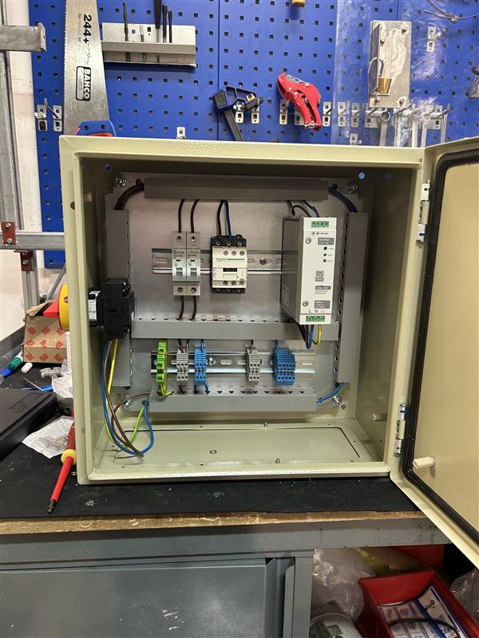
Figure 19 - First stage of panel build complete

The internal wiring was now complete so this meant the components external to the panel could be built and wired into the panel. This began by connecting the pump, solenoids, pipework and suction lances. This was done before any electrical wiring to ensure the layout of the external components was suitable.

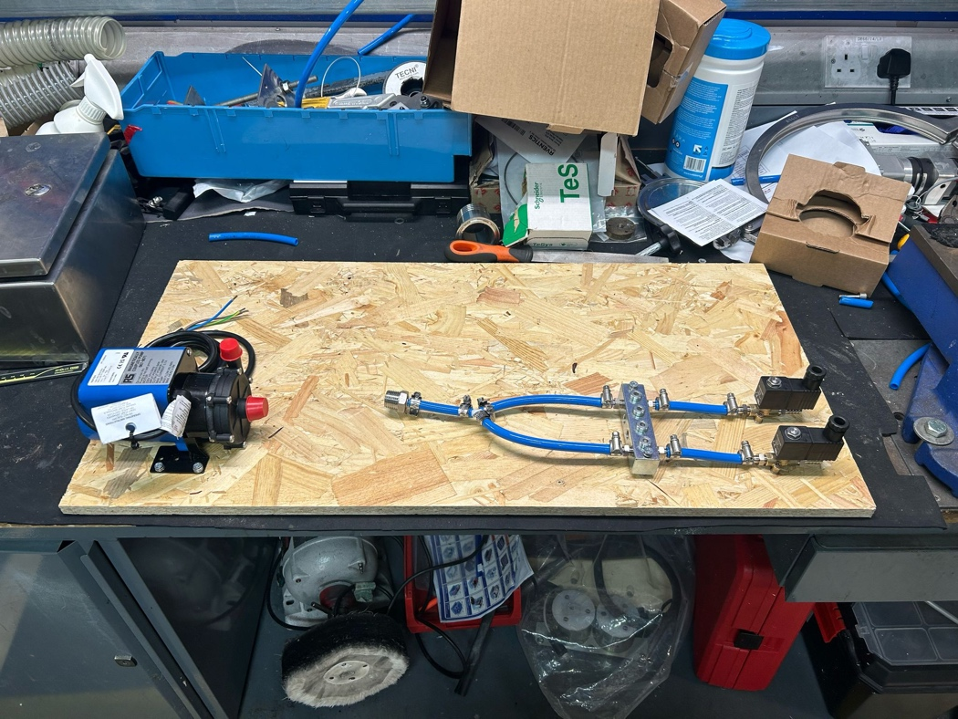
Figure 20 - First hardware design
After the external components were connected the wiring of the components started. The pump, solenoids and PLC were all wired and connected to the panel. The build of the panel was complete and testing of the panel before power was connected could begin, this was done with the use of a multimeter and testing for continuity through each circuit. Once the testing was completed to satisfaction, the next stage of the build was to begin writing the code for the PLC.
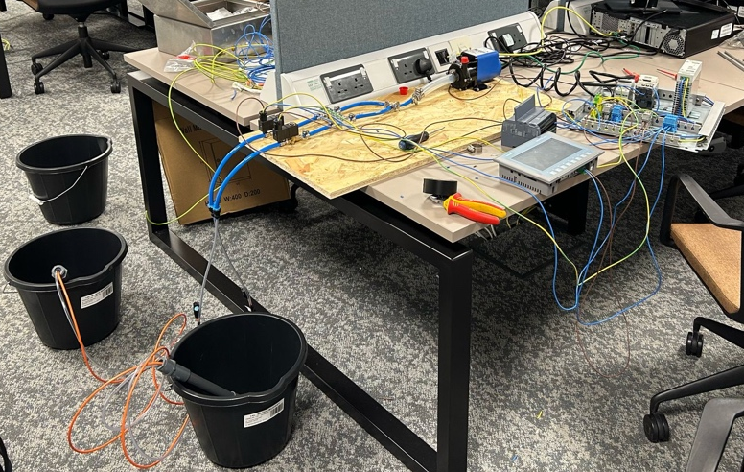
Figure 21 - Circuit testing

4.3.3.2 – Software program

For full code please see Appendix 3 – Physical prototype software program.

Siemens TIA portal was used to write the PLC program for the physical prototype. The lessons learnt from writing the simulation software proved to be very useful when writing the code for the physical prototype. The block diagram shown in Figure 22 shows how the software is connected.

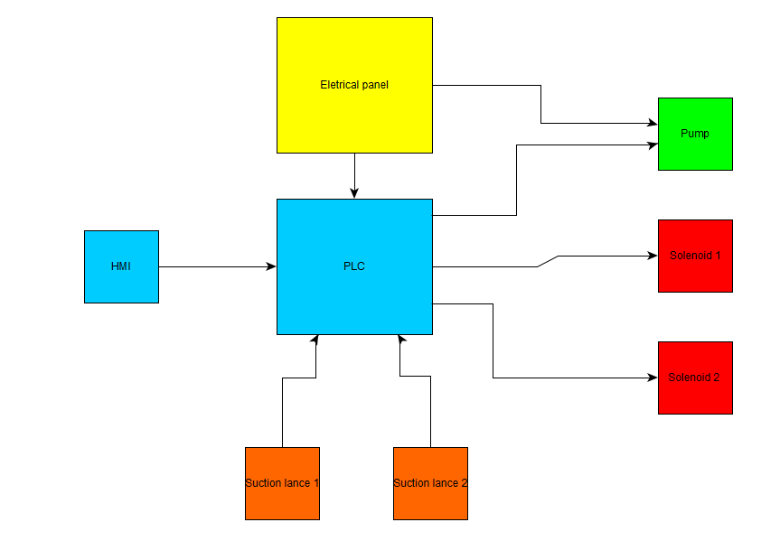
Figure 22 - Software program block diagram

A flow chat was also created to show how the program functions which is shown below in Figure 23.

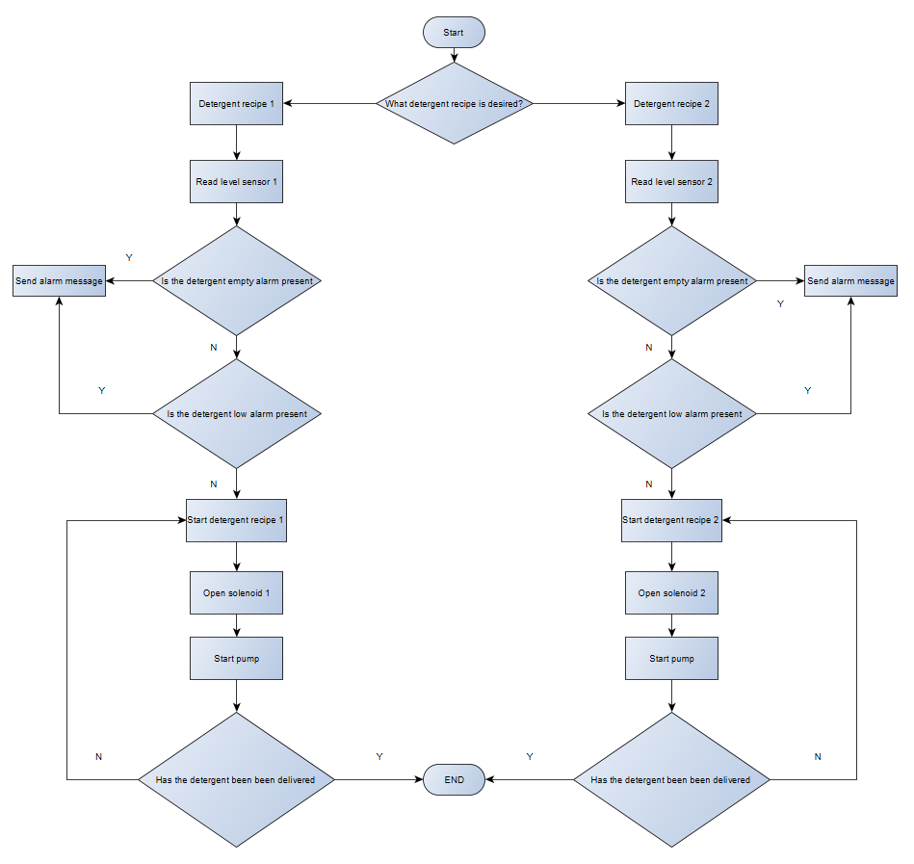
Figure 23 - Software flowchart

The first step of the code was to add the factory IO function to allow for testing before it was integrated with the physical prototype as shown in Figure 24. This function block was removed before downloading the code to the PLC as it was causing an error.

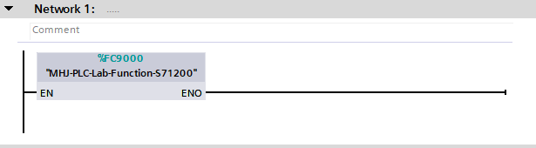
Figure 24 - Physical prototype network 1

After the function was added, the coding for the main program began. The first step was to start writing the code for ‘recipe 1’, this started with creating some PLC tags. Once the relevant tags were created, the first stages of the code to activate the solenoid and start the pump for recipe 1 was written which is shown in Figure 25.

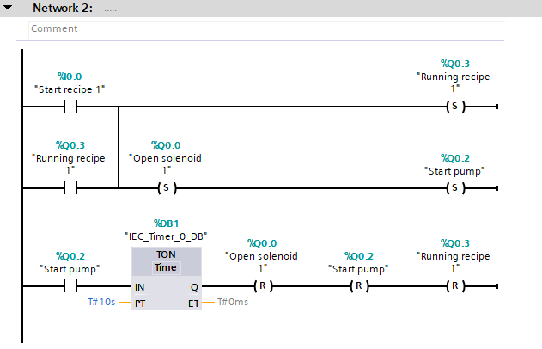
Figure 25 - Physical prototype network 2
Figure 25 shows the code for how the input “Start recipe 1” sets the “Running recipe 1” output. This output is then used as a normally open contact to provide a latch to the output, so it remains set until the output is reset. This latch has rectified the issue spoken about in the simulation prototype. The normally open contact opens the solenoids before starting the pump. The “Start pump” output is then used as a normally open contact which when closed will start a TON for a period of time before resetting the solenoid, pump and recipe to allow the process to begin again when needed.

A basic HMI screen was then created to test out the code. Factory IO was also used to test out the code using components such as a light to test for solenoid activation and a roller conveyor acting as the pump running. This was an essential part of writing the code for the physical prototype as it allowed for testing before connecting to the system. After using this method of testing through trial and error, the issue from the simulation software was resolved. The program was working every time the button on the HMI was pressed rather than having to press it multiple times. The testing set up is shown in Figure 26.

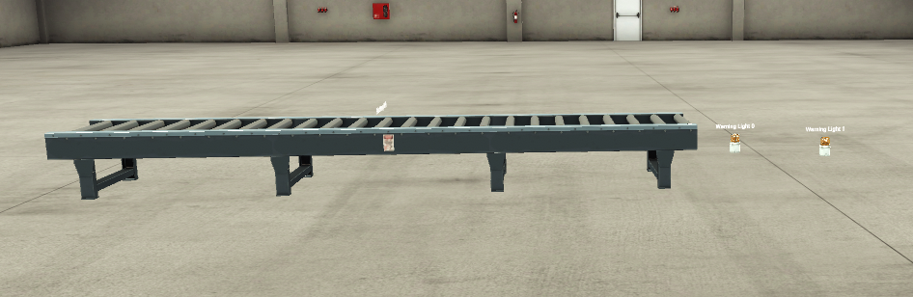
Figure 26 - Physical prototype Factory IO testing

When the program was working how it should have been for recipe 1, the process was repeated for recipe two creating the relevant tags, using recipe 1’s code as a guide for recipe 2, adding to the HMI and testing on factory IO. Both codes worked perfectly and were able to switch between the two recipes seamlessly. This code is shown below in Figure 27.

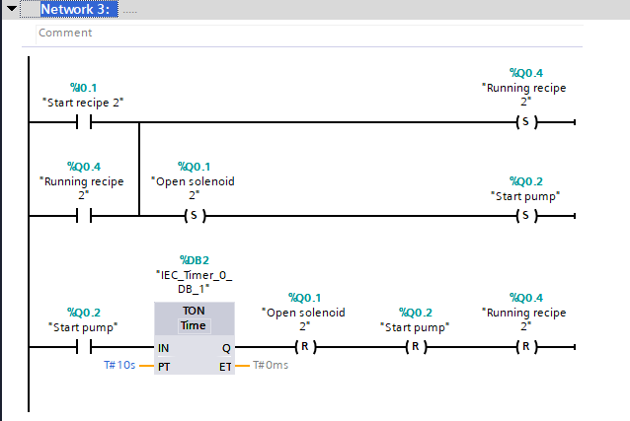
Figure 27 - Physical prototype network 3

4.3.3.3 – Testing on physical prototype
The first step of the testing phase involved uploading the program to the PLC and HMI. This was done away from the panel and rest of the hardware to ensure the program could be uploaded correctly before wiring the PLC and HMI to the rest of the components. This is shown below in Figure 28.

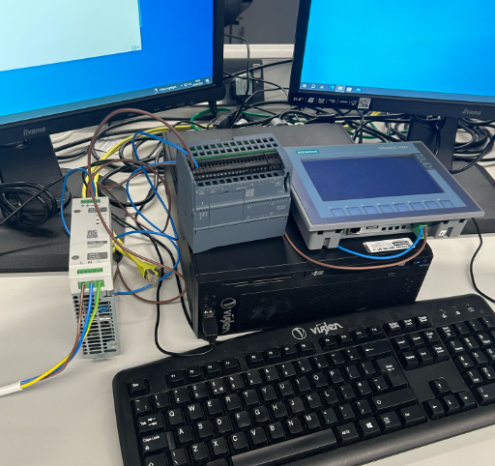
Figure 28 - PLC and HMI testing

The set up shown in Figure 28 shows how the program was uploaded prior to connecting to the rest of the hardware. A 3-pin plug was wired with a live, neutral and earth cable. This could then be plugged in to a regular socket providing the input of the power supply with 240V. The 24V from the output of the power supply could then be used to power the PLC and HMI. During this part of testing a fault was found when trying to upload the program. The error was a “Temporary CPU error: Maximum program cycle time exceeded”. This issue was rectified by removing the Factory IO function block. After the program was successfully uploaded to the PLC and HMI, the recipe buttons on the HMI were used to test whether the correct outputs were lighting up on the PLC.

Once the program was tested successfully from the system, the PLC and HMI could be wired to the remaining system. The system was then tested to pump water through however when testing the system, the water was not pumping through due to airlocks in the system. Therefore, the system was purged, and it was evident from the purge the fittings and manifold originally used were leaking.

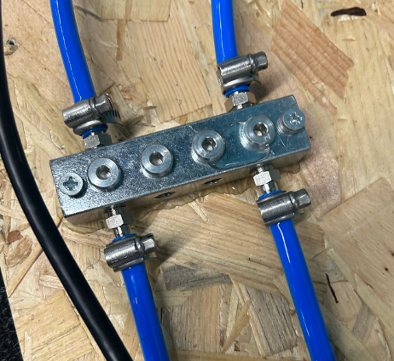
Figure 29 - Original manifold leaking

To rectify the issue of the system leaking air fittings were used to ensure the system was airtight. This is shown below in Figure 30

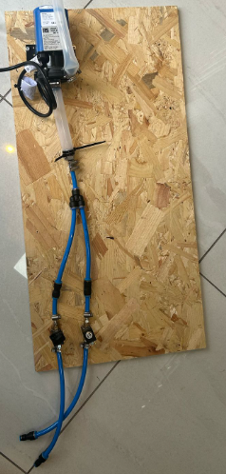
Figure 30 - New fittings
The system was tested, and the program was adjusted by changing the length of time the pump was running to meet the criteria set by the validation documentation and preventative maintenance work order of a purging cycle of at least 700ml of detergent (See Appendix 1- Preventative maintenance work order). This test was completed by using a measuring jug at the end of the priming cycle measuring the amount of volume delivered. After the prototype was working to a satisfactory standard it was shown to both the operators and engineering management team to see if any further improvements could be made.

4.3.3.4 – Programming level switch on suction lances
After the prototype was delivering the correct volume, the program for level switches on each suction lance could be created. The first step for this process was to create a voltage regulator for each suction lance to bring down the 24V circuit to 10V. This was essential as it would allow the lances to connect to the analogue input of the PLC. The voltage regulator used was a LM317T which can be seen below in Figure 31 [38].

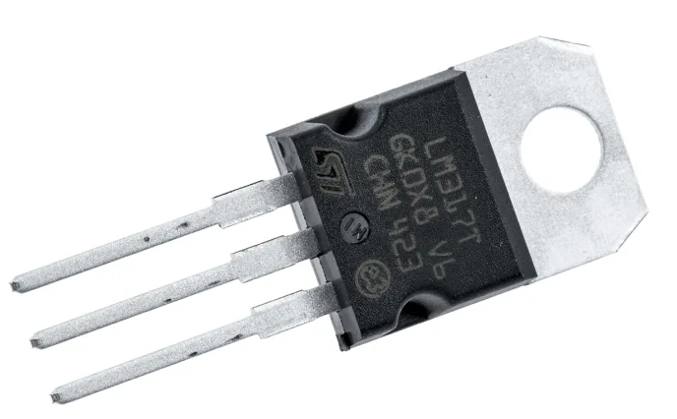
Figure 31 – LM317T voltage regulator [38]

To find the correct resistor values to complete the voltage regulator circuit the calculation below was completed. The values for Vref and R1 have been taken from the LM317T datasheet [38].

$$Vout=Vref \left(1+\frac{R2}{R1} \right)$$

$$10V=1.25V \left(1+\frac{R2}{240Ω} \right)$$

$$\frac{10V}{1.25V}=1+\frac{R2}{240Ω}$$

$$8V=1+\frac{R2}{240Ω}$$

$$7V=\frac{R2}{240Ω}$$

$$7 ×240Ω=R2$$

$$R2=1680Ω$$

The values from R1 and R2 were then taken to create the voltage regulator circuit which is shown below in Figure 32.
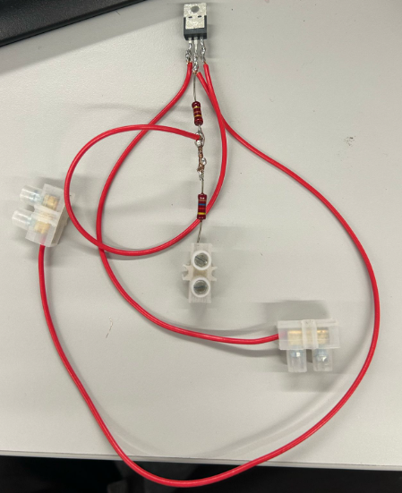
Figure 32 - Voltage regulator
The code for the suction lances was then added to the existing PLC program. A new function block was first created with the necessary tags shown in Figure 33.

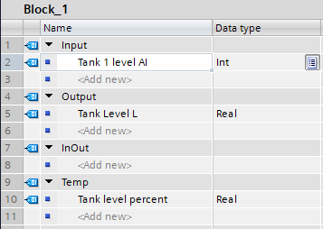
Figure 33 - Tank 1 Level function block

These tags were then used to create network 1 of the function block shown below in Figure 34.

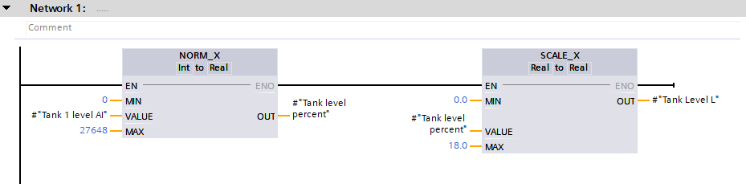
Figure 34 - Tank 1 level function block network 1
Figure 34 shows how a ‘NORM_X’ block is used to change the value of input ‘Tank 1 level AI’ as an integer data type into a real data type for tag ‘Tank level percent’. This percentage is then inputted to a ‘SCALE_X’ function with a minimum value of 0 and maximum value of 18 to symbolize the size of the bucket used for the prototype. This then gives the output as a real data for tag ‘Tank level L’.

The function block can then be put in the main program as shown in Figure 35.
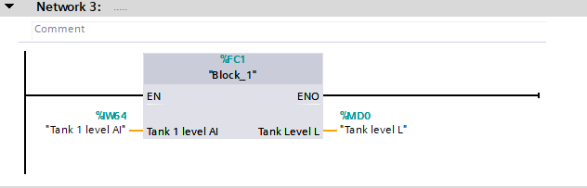
Figure 35 - Physical prototype network 3

Alarms were then created using comparator functions against the tag ‘Tank 1 level L’ to show the operator when tank 1 was low and empty as shown in Figure 36. This alarm then shows on the HMI to inform the operator as shown in Figure 37.

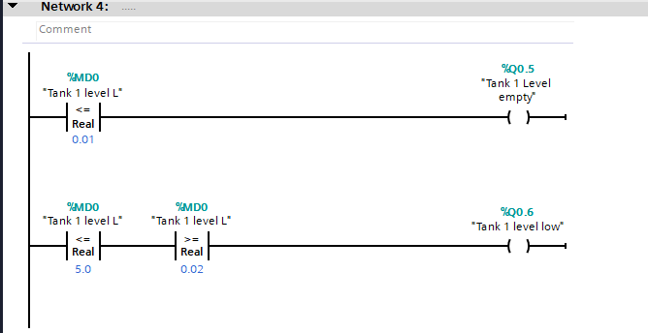
Figure 36 - Physical prototype network 4
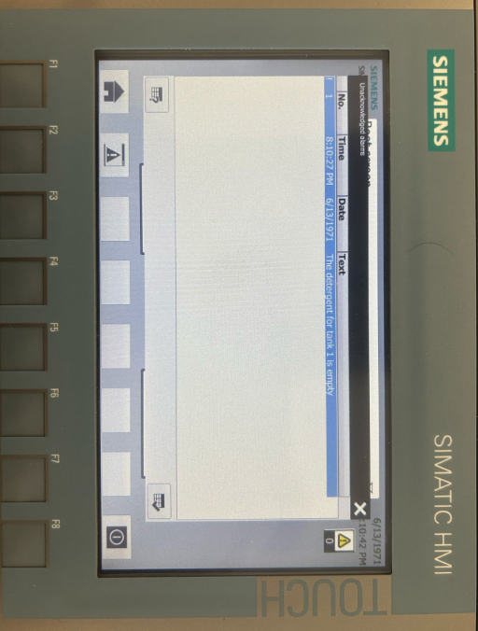
Figure 37 - Tank 1 empty alarm
The HMI screen also provides an indication of low and empty levels as shown in Figure 38 and Figure 39.
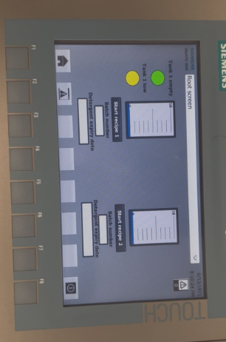
Figure 38 - Tank 1 HMI low level
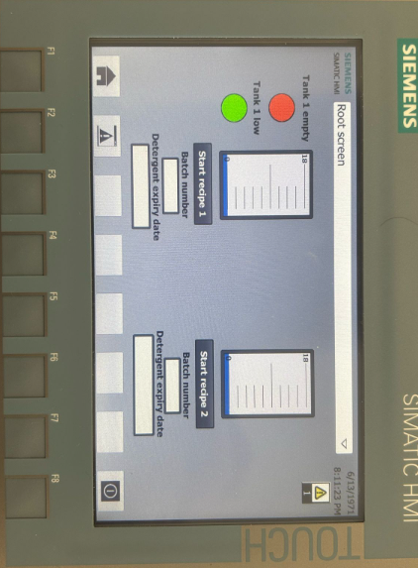
Figure 39 - Tank 1 HMI empty level
The process shown in Figure 33 through Figure 36 was repeated for Tank 2 of the program for full code please see Appendix 3 – Physical prototype software program.

4.4 - Results

4.4.1 – Detergent volume results

4.4.1.1 – Recipe 1 results
Table 16 - Recipe 1 delivery rate results
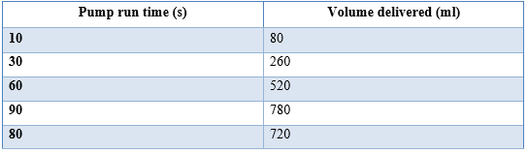

4.4.1.2 – Recipe 2 results
Table 17 - Recipe 2 delivery rate results
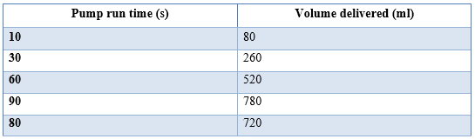

4.4.2 – Questionnaire results
A video of the physical prototype was shown to nine operators of the Clean-Out-Of-Place equipment in PCI Pharma services. They were then asked a series of questions to see if they believed the proposed changes improved the system in various aspects. For questionnaire, please see Appendix 4 – Operator questionnaire.

4.4.2.1 - From the video shown, the proposed changes to the Clean-Out-Of-Place equipment makes it easier to run detergent priming cycles

As shown by Figure 40, out of the nine operators questioned 78% strongly agree and 22% agree that the proposed changes make it easier to run detergent priming cycles.

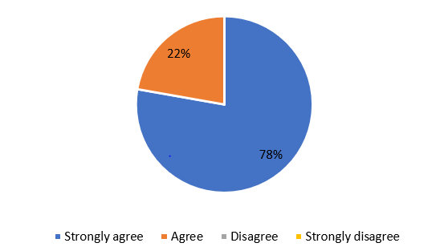
Figure 40 - Questionnaire graph 1

4.4.2.2 - From the video shown, the proposed changes to the Clean-Out-Of-Place equipment reduces the need for an engineer

As shown by Figure 41, out of the nine operators questioned 89% strongly agree and 11% agree that the proposed changes reduce the need for an engineer.

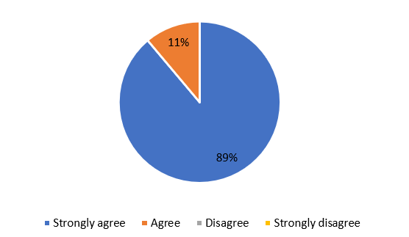
Figure 41 - Questionnaire graph 2

4.4.2.3 - From the video shown, the proposed changes to the Clean-Out-Of-Place equipment allows for better compliance and easier documentation of GMP regulations

As shown by Figure 42, out of the nine operators questioned 78% strongly agree and 22% agree that the proposed changes allow for better compliance and easier documentation of GMP regulations.

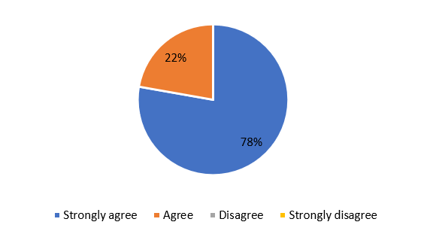
Figure 42 - Questionnaire graph 3

4.4.2.4 – From the video shown, the proposed changes to the Clean-Out-Of-Place equipment will reduce downtime on the COP equipment

As shown by Figure 43, out of the nine operators questioned 78% strongly agree and 22% agree that the proposed changes will reduce downtime on the COP equipment.

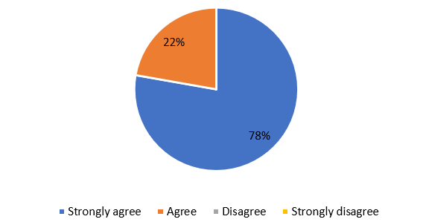
Figure 43 - Questionnaire graph 4

4.4.3 – New HMI screen
Figure 44 shows the new HMI screen.

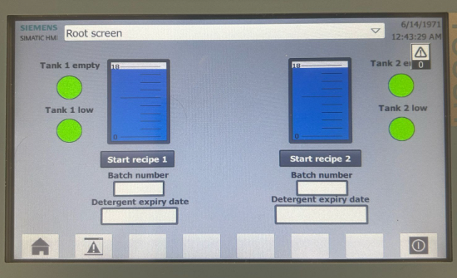
Figure 44 - New HMI screen

Chapter 5 – Evaluation
In evaluating the results of this project several factors will be discussed such as data results from the measurable factors set from this project. This allows for analysis to decide if the main aim of the project and objectives were met. The evaluation also highlight any changes to the process of completing the project that could have been done differently.

5.1 - Aim
In terms of the measurable factors to evaluate whether the aim was met from a cleaning point standpoint there was the delivery rate of the detergent and the swabbing samples. However, only one of these two factors was able to be measured before the hand-in of this report due to the time taken to build both the prototypes and complete background research. The swabbing samples are used to measure the effectiveness of the clean and ensure it passes the validation criteria. This can only take place after the new system has been implemented on to the cleaning system in the workplace, as the materials inside of the machine need to be swabbed to confirm this factor. The second factor, being the delivery rate of the detergent, could be measured as this could be tested on the physical prototype. A desired value of over 700ml with a tolerance for the purging recipe was already set by the preventive maintenance work order. This was achieved however, throughout the testing of this factor there were challenges faced.

The first challenge was to adjust the amount of time the pump was running for in the PLC program to ensure the correct delivery rate was achieved. The delivery rate aimed at this prototype to be 720ml per purging cycle, this was to ensure that over 700ml would be delivered but there was enough space to fit the tolerance. This was achieved through the method of trial and error, first running the pump for 10 seconds then adjusting as necessary till the desired rate was achieved.

The second challenge faced when testing for the correct delivery rate was the initial design of the prototype was not airtight. This was causing airlock within the system. The PLC program was working correctly with the pump starting and solenoid opening however, no water was being pulled through the system. The first idea to rectify this issue was purge the line with water before starting the recipe. However, through purging the line it was clear that some changes would need to be made to the design as there were leaks. Therefore, the pipe work and fittings were changed to more suitable options to mitigate this challenge. After these changes were implemented into the design, this was no longer an issue and testing could continue as the system was now pulling the water through at the rate desired.

The second measurable factor allowing to see if the aim was met was improving the system so the operator could record GMP data and run recipes more efficiently. This factor was a success of the project due to the addition of the lances and the new HMI design. The new HMI design allowed the operator to run different detergent recipes through the screen and record GMP data required. To gather the information on whether the operator thought the new system had improved on the factors previously mentioned a questionnaire was provided to them and they were shown a video of the prototype working. From the results of the questionnaire, it is shown that 100 the operators believe that the improvements being made to the system shown on the prototype make the job more efficient and easier to record GMP information.

The cross-contamination issue of using only one suction lance was fully mitigated with the addition of a lance for each of detergent. The addition of these lances and the upgrades to the operators HMI previously mentioned greatly reduced the engineer’s workload for this specific task. On average engineers at PCI complete 6 detergents changes a day however, only one of these detergent changes requires a fresh detergent jack to be put in place. Therefore, with the new system in place it is estimated that the engineers’ workload will be reduced by 83.3%. This was a huge success as now engineers have more time to focus on breakdowns and preventative maintenance which was one of the main targets for this project.

5.2 - Objectives

5.2.1 - Assessment of current COP system
Overall, this objective was met very well, with the help of the engineering management and the operations teams. A clear vision was made from the start of the improvements that could be made to the current system and the desired results of the project. This clarity from the start allowed for a plan to be put in place that would aid throughout the project.

Redesigning hardware and software
This objective also went very well. The research into the different wash systems, GMP regulations and the environmental impact provided the vital information needed to consider before redesigning the system. The information gathered coupled with the research on different components were critical in finding the best components for the project that were also suitable to be used for pharmaceutical applications. The software simulation using Siemens TIA portal and factory IO was also another success of this project as it showed the concept of the project at an early stage. The use of the tanks in factory IO to represent the jacks emptying with the simulation HMI was a good visual representation to the engineering management team, operations team and university supervisor in the interim viva. It gave all parties a clear look into the design that had been chosen. The physical prototype which was a combination of the hardware and software to show proof of concept was also a success managing to get both sides to work as a complete unit to the specification that was desired. However, as previously stated this was not without its challenges.

5.2.3- Producing a new procedure for operator
This objective was completed with a new procedure being created to accommodate the new changes made to the system. This procedure was not able to become the new standard operating procedure at the time of this report as the validation and testing stage had not started. However, the improvements that were made to the system did allow for the new procedure to improve ease of use for the operator, reduce downtime and reduce the need for an engineer. The procedure is shown below in Figure 45.
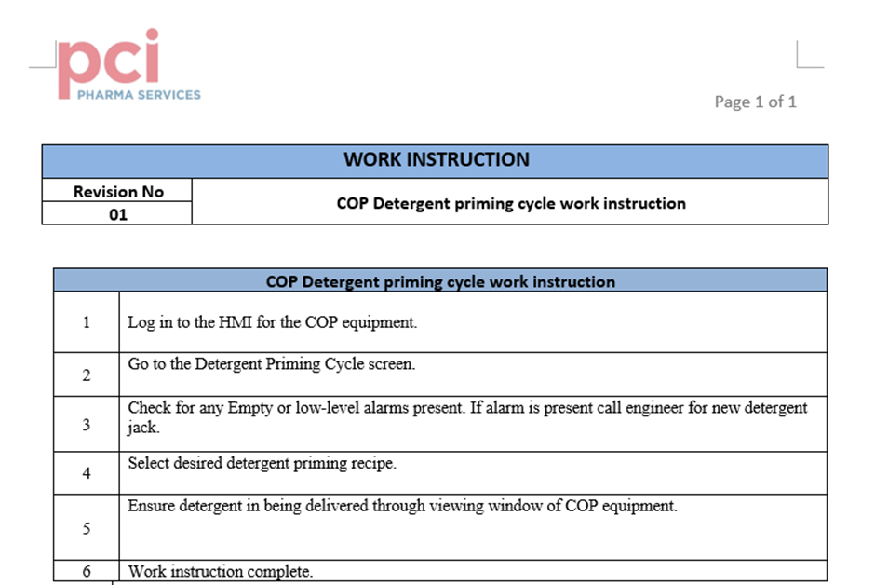
Figure 45 - New standard operating procedure

Installation, validation and testing
This objective was not completed due to the time taken to complete background research and build the two prototypes. The installation, validation and testing aspect will be the longest objective to complete and will be completed after this report is handed in. The reason for this objective being the most time consuming is due to the rigorous testing needed for the new system to pass the validation regulations.

Implementation of the new system
The new system failed to get implemented within the time frame set for this report hand in. The reason for the new system failing to get implemented was due to the project not completing the prior objective meaning the system was not installed, tested and validated. However, this will be completed later.

5.3 – Results
Evaluating the results from the delivery rate tests, the delivery rate was as expected at 80 seconds. The expected delivery rate was expected to be between 60 and 90 seconds, this is due to the current system taking 60 seconds to deliver over 700ml of detergent.

The results from the operators questionnaire are also as expected with the feedback being positive. The areas that were targeted by the prototype that was shown to the operators was aimed at improving the ease of use to run purging cycles, easier documentation of GMP records and a reduction in the need for an engineer. All these areas improved through completing this project and the video shown was evidence of this hence, the expected positive feedback.

5.4 – Project requirements
Table 18 - Evaluation of project requirements
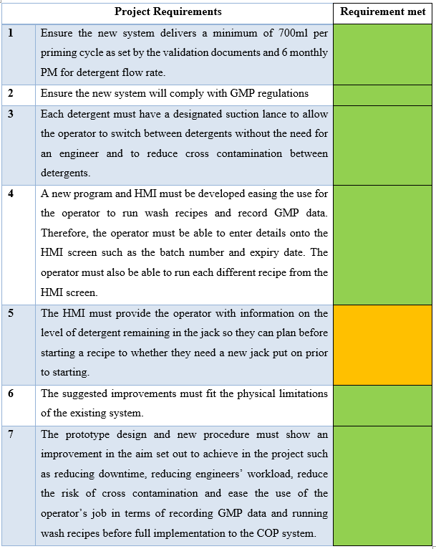

To evaluate the project requirements, they have been mostly met successfully. Project requirement 5 was only partially met due to the time constraints of this report. The HMI provides the operator with a low-level and empty alarm, however, does not provide a constant level reading of the tank. This would have to be completed after full implementation on to the COP equipment due to calculations of wash recipes and purging recipes volume delivery would need to be added and implemented on to the tank level on the HMI.

Chapter 6 - Conclusion and recommendations
To conclude this report, the project was a success. The aim and objectives set out at the beginning of the project were met with some work still outstanding to be completed due to the time constraints of this project. The project has provided PCI pharma services with a good understanding of how the proposed changes to the Clean-Out-Of-Place system will have a positive impact on reducing downtime, complying with Good Manufacturing Practice standards and employee job satisfaction.

Analysing how the project was managed, a clear vision for the final product from the offset conferring with all the relevant departments necessary. This allowed for a clear and concise plan to be developed from the start which had a positive impact throughout. Due to the clear and concise plan created a simulation prototype was produced at the early stages of the project which provided PCI and the university a good concept of the final prototype. The simulation prototype was also a good aid when creating the final prototype due to the program similarities. However, there were challenges faced through managing this project. One of these challenges was ordering components, there were some components that were not delivered and had long lead times. Therefore, an alternative option had to be ordered. Another issue related to ordering components was that the need for certain components was only recognised throughout building the physical prototype. This led to delays throughout the project, if the project was to be completed again, the building of the prototype would begin at an earlier date.

There were also setbacks in the project with the first design of the prototype causing leak issues. However, these issues were resolved and dealt with promptly. Overall, any challenges faced were overcome and the final prototype was a success.

In regards, to any recommendations for the system user access rights should be added to the software. This would require operators, engineers and contractors to log in to the machine prior to being able to operate and navigate the system. This would also incorporate various levels of user access to allow for restricted access to certain screens when fully implemented on to the Clean-Out-Of-Place equipment. This is essential for GMP regulations as people who operate need to be trained therefore user access is a requirement for any equipment.

There are still outstanding tasks that must be completed after this report is submitted. One of these tasks is the full implementation of the new system to the COP equipment in PCI pharma services. This could not be completed during the time of this report due to the extensive validation and testing process.

Chapter 7 – Reflection
Overall, this project and the process of studying to complete a BEng in Electrical and Electronic Engineering has taught me many lessons. These lessons are transferable to both the workplace and everyday life. I have learnt that through determination and perseverance the goals that I set myself can be achieved.

The project has also taught me how to correctly prioritise tasks by requiring me to find the correct balance between completing university work, my job in PCI Pharma services and my personal life. This was difficult in periods where family events were occurring and other projects in work became priority to the department. However, I learnt that I needed to remain consistent and find the time to complete the work needed for this project, this was an essential lesson for myself

I have also seen improvements to my skill set in the workplace from an engineering standpoint and a project management standpoint. This has not gone unrecognised by others in the workplace now viewing me as someone who can lead projects in the engineering department. This comes from me overcoming the various challenges faced throughout the project, planning and communicating with other departments and sourcing materials to complete the project. These are important skills that I have learnt throughout the process of completing this project.

References

[1] | PCI Pharma services, “PCI Pharma services,” [Online]. Available: https://pci.com. [Accessed 17 April 2025].
[2] | GOV.UK, “Medicines: good manufacturing practice and good distribution practice,” 18 December 2014. [Online]. Available: https://www.gov.uk/guidance/good-manufacturing-practice-and-good-distribution-practice. [Accessed 17 April 2025].
[3] | U.S. Food & Drug Administration, “Development & Approval Process | Drugs,” 8 August 2022. [Online]. Available: https://www.fda.gov/drugs/development-approval-process-drugs. [Accessed 17 April 2025].
[4] | P. Khalate, B. Chaudhari and V. Redasani, “Cleaning Validation in Pharmaceutical Industry,” October 2022. [Online]. Available: https://www.proquest.com/docview/2758392927/fulltextPDF?accountid=130472&pq-origsite=primo_ra&sourcetype=Scholarly%20Journals. [Accessed 5 December 2024].
[5] | G. Miller, “Equipment cleaning: CIP vs. COP,” May 2022. [Online]. Available: https://www.proquest.com/docview/2669103827/abstract/3B7C8FAB53FB4516PQ/1?accountid=130472&sourcetype=Trade%20Journals. [Accessed 5 December 2024].
[6] | G. Witherington, “Back to basics on CIP, COP practices,” October 2015. [Online]. Available: https://www.proquest.com/docview/1725380776/fulltext/2ADA93F3682B459EPQ/1?accountid=130472&sourcetype=Trade%20Journals. [Accessed 5 December 2024].
[7] | K. Roy, C. Undey, T. Mistretta, G. Naugle and M. Sodhi, “Multivariate statistical monitoring as applied to clean-in-place (CIP) and steam-in-place (SIP) operations in biopharmaceutical manufacturing,” in Biotechnology progress, Blackwell Publishing Ltd, 2014, pp. 505-515.
[8] | A. Raj, “CLEANING VALIDATION IN PHARMACEUTICAL INDUSTRIES,” Journal of Atoms and Molecules; Journal of atoms and molecules, vol. 4, no. 4, p. 779, 2014.
[9] | L. P. Sakthivel and T. Suriyaprakash, “Cleaning Validation and its importance in,” Pharma Times, vol. 42, no. 7, pp. 21-25, 2010.
[10] | R. Dietmar, “The Composition of Cleaning Agents for the Pharmaceutical Industries.,” DRUGS AND THE PHARMACEUTICAL SCIENCES, vol. 173, pp. 69-71, 2008.
[11] | VLS enviromental solutions, “Types of Pharmaceutical Waste and How to Dispose of Them,” [Online]. Available: https://www.vlses.com/stay-in-the-know/newsroom/types-of-pharmaceutical-waste/. [Accessed 23 January 2025].
[12] | P. Anastas and N. Eghbali, “Green Chemistry: Principles and Practice,” The Royal Society of Chemistry, no. 39, pp. 301-312, 2010.
[13] | Adobe communications, “Waterfall Methodology: A Complete Guide,” 18 March 2022. [Online]. Available: https://business.adobe.com/uk/blog/basics/waterfall. [Accessed 31 March 2025].
[14] | teamwork.com, “Project Management Methodologies,” [Online]. Available: https://www.teamwork.com/project-management-guide/project-management-methodologies/. [Accessed 31 March 2025].
[15] | RS, “ProMinent Chemical Tank Suction Assembly 790359, For Use With PVC Chemical Tank,” [Online]. Available: https://uk.rs-online.com/web/p/chemical-tank-accessories/0531359?gb=s. [Accessed 30 January 2025].
[16] | Kersia, “Suction lance,” [Online]. Available: https://www.kersia.uk/shop/washdown-hygiene-and-cleaning-equipment/neat-chemical-dispensing-equipment/wpd1-dosing-unit/suction-lance/. [Accessed 30 January 2025].
[17] | RS, “ProMinent Pump Accessory, Suction Lance for use with Beta & Gamma Meter Pumps,” [Online]. Available: https://uk.rs-online.com/web/p/pump-accessories/1218622?gb=s. [Accessed 30 January 2025].
[18] | RS, “RS PRO Aluminium Aluminium Aluminium Case, IP40, Aluminium Lid, 300 x 474 x 134mm,” [Online]. Available: https://uk.rs-online.com/web/p/general-purpose-enclosures/2883203. [Accessed 30 January 2025].
[19] | RS, “RS PRO Steel Wall Box, IP66, 400 mm x 400 mm x 200mm,” [Online]. Available: https://uk.rs-online.com/web/p/wall-boxes/7755801?searchId=df061008-3fd4-4cbb-9627-e56575a01b44&gb=s. [Accessed 30 January 2025].
[20] | RS, “RS PRO Steel Wall Box, IP66, 200 mm x 200 mm x 150mm,” [Online]. Available: https://uk.rs-online.com/web/p/wall-boxes/7755785. [Accessed 30 January 2025].
[21] | RS, “Xylem Flojet Diaphragm Electric Operated Positive Displacement Pump, 10.8L/min, 20 bar, 230 V,” [Online]. Available: https://uk.rs-online.com/web/p/positive-displacement-pumps/4463506?gb=s. [Accessed 30 January 2025].
[22] | RS, “Verderflex Peristaltic Electric Operated Positive Displacement Pump, 375ml/min, 1 bar, 24 V dc,” [Online]. Available: https://uk.rs-online.com/web/p/positive-displacement-pumps/1856129?gb=s. [Accessed 30 January 2025].
[23] | RS, “Xylem Flojet 230 V 1.4 bar Magnetic Coupling Centrifugal Water Pump, 23L/min,” [Online]. Available: https://uk.rs-online.com/web/p/water-pumps/6679071?searchId=4f7e5833-9e4b-4926-b9a2-902afb6544a7&gb=s. [Accessed 30 January 2025].
[24] | RS, “RS PRO Solenoid Valve, 2 port(s) , NC, 24 V, 1/8in.,” [Online]. Available: https://uk.rs-online.com/web/p/solenoid-valves/2554146?searchId=480a199e-7009-4aab-822a-8406f414360f&gb=s. [Accessed 6 February 2025].
[25] | RS, “RS PRO Solenoid Valve, 2 port(s) , NC, 220 V ac, 3/4in,” [Online]. Available: https://uk.rs-online.com/web/p/solenoid-valves/2351122?gb=s. [Accessed 6 February 2025].
[26] | RS, “RS PRO Solenoid Valve Connector,” [Online]. Available: https://uk.rs-online.com/web/p/din-43650-solenoid-connectors/1762066?searchId=683284ac-ad77-48a1-8e07-9075368e3ff3&gb=s. [Accessed 13 February 2025].
[27] | RS, “Siemens SIRIUS 3RT Size S00, 3RT2 Contactor, 230 V ac Coil, 3-Pole, 9 A, 4 kW, 3NO, 400 V ac,” [Online]. Available: https://uk.rs-online.com/web/p/contactors/7061125?searchId=c84bc6cd-750a-44e5-85e1-45af4c1be8f1&gb=s. [Accessed 13 February 2025].
[28] | hedley&ellis, “Schneider LC1D18B7 Contc 18A 24V 50/60Hz,” [Online]. Available: https://hedleysonline.co.uk/ProductDetails/?Code=LC1D18B7&srsltid=AfmBOorYISa0lpQJLd959PCbGVL9dtOgke3jDkeXk7rBzaILNpY7BFvz. [Accessed 13 February 2025].
[29] | RS, “Schneider Electric TeSys D LC1D Contactor, 12 V dc Coil, 3-Pole, 25 A, 3NO, 690 V ac/dc,” [Online]. Available: https://uk.rs-online.com/web/p/contactors/7447368. [Accessed 13 February 2025].
[30] | RS, “Siemens S7-300 Switched Mode Power Supply, 240V ac ac Input, 24V dc dc Output, 10A Output, 267W,” [Online]. Available: https://uk.rs-online.com/web/p/din-rail-power-supplies/2577448?gb=s. [Accessed 20 February 2025].
[31] | RS, “RS PRO Switched Mode DIN Rail Power Supply, 230V ac, 48V dc dc Output, 5A Output, 240W,” [Online]. Available: https://uk.rs-online.com/web/p/din-rail-power-supplies/1368322?gb=s. [Accessed 20 February 2025].
[32] | RS, “RS PRO Switched Mode DIN Rail Power Supply, 230V ac, 24V dc dc Output, 5A Output, 120W,” [Online]. Available: https://uk.rs-online.com/web/p/din-rail-power-supplies/1368319?gb=s. [Accessed 20 February 2025].
[33] | RS, “Europa EUC1P EUB MCB, 1P, 1A Curve B, 230V AC, 10 kA Breaking Capacity,” [Online]. Available: https://uk.rs-online.com/web/p/mcbs/8496459?searchId=9ae08c77-cde7-45ed-b22a-af80a001e9f9&gb=s. [Accessed 20 February 2025].
[34] | RS, “RS PRO Grey, 0.2 → 2.5mm², Single-Level,” [Online]. Available: https://uk.rs-online.com/web/p/din-rail-terminal-blocks/0501639?searchId=0c36c728-c62a-4f17-bb9f-8b35b66345df&gb=s. [Accessed 20 February 2025].
[35] | RS, “RS PRO Green, Yellow, Double-Level, Screw Termination,” [Online]. Available: https://uk.rs-online.com/web/p/din-rail-terminal-blocks/8724802?searchId=443a0dea-76ae-42ca-bfc9-965a37c6f204&gb=s. [Accessed 20 February 2025].
[36] | RS, “RS PRO Blue, 0.2 → 2.5mm², Screw Termination,” [Online]. Available: https://uk.rs-online.com/web/p/din-rail-terminal-blocks/0802783?searchId=261d6461-9ec4-48f1-9cc1-b08fb0e554cd&gb=s. [Accessed 20 February 2025].
[37] | RS, “RS PRO 3P Pole Panel Mount Isolator Switch - 25A Maximum Current, 11kW Power Rating, IP65,” [Online]. Available: https://uk.rs-online.com/web/p/isolator-switches/0466148?gb=a. [Accessed 27 April 2025].
[38] | RS, “STMicroelectronics LM317T, 1 Linear Voltage, Voltage Regulator 1.5A, 1.2 → 37 V 3-Pin, TO-220,” [Online]. Available: https://uk.rs-online.com/web/p/voltage-regulators/7140792?gb=s. [Accessed 28 April 2025].

Appendices

Appendix 1- Preventative maintenance work order

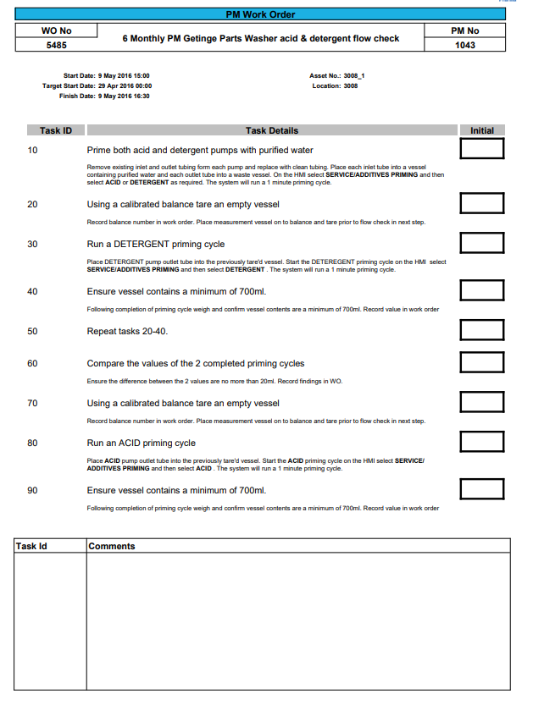
Figure 46 - Planned maintenance work order

Appendix 2 – Software simulation program
Figure 47 - Software simulation HMI

Figure 48 - Software simulation Factory IO

Figure 49 - Software simulation Network 1

Figure 50 - Software simulation network 2
Figure 51 - Software simulation network 3
Figure 52 - Software simulation network 4

Figure 53 - Software simulation network 5
Figure 54 - Software simulation network 6

Figure 55 - Software simulation network 7

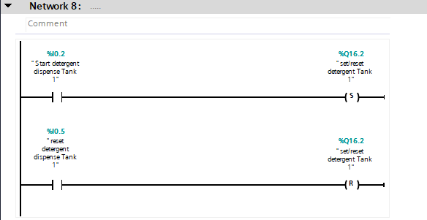
Figure 56 - Software simulation network 8
Figure 57 - Software simulation network 9

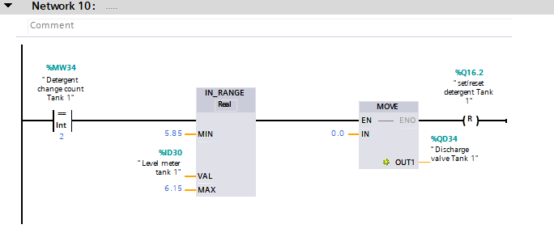
Figure 58 - Software simulation network 10
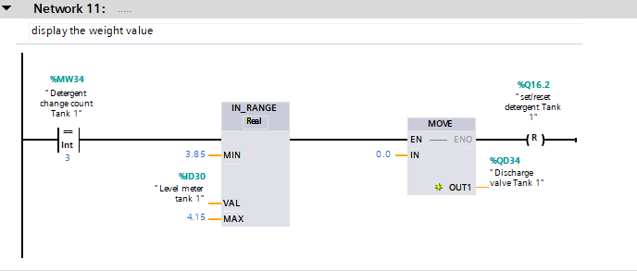
Figure 59 - Software simulation network 11

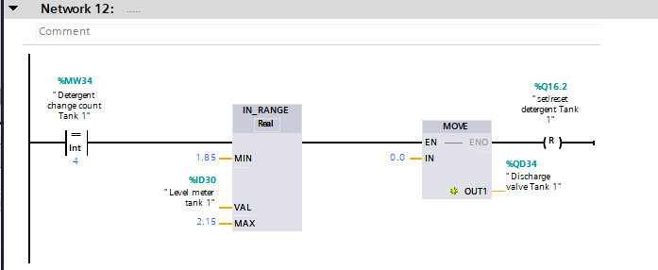
Figure 60 - Software simulation network 12

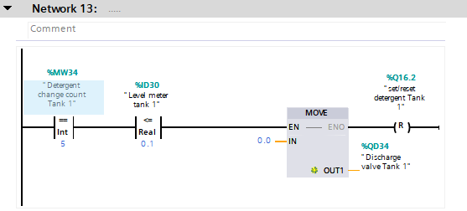
Figure 61 - Software simulation network 13

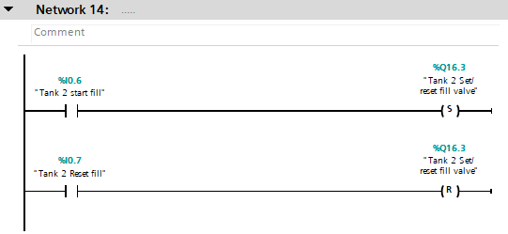
Figure 62 - Software simulation network 14
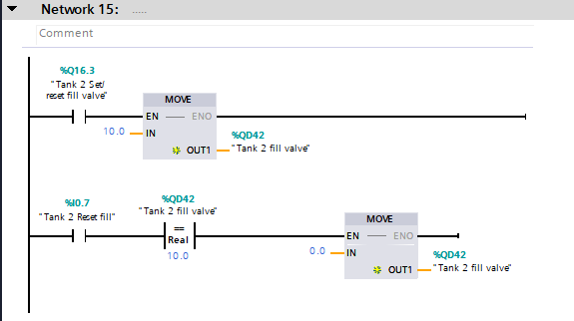
Figure 63 - Software simulation network 15
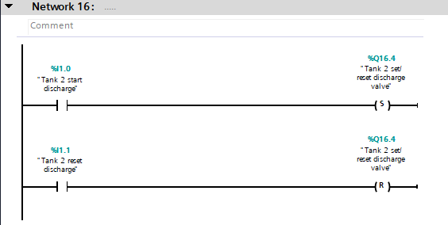
Figure 64 - Software simulation network 16
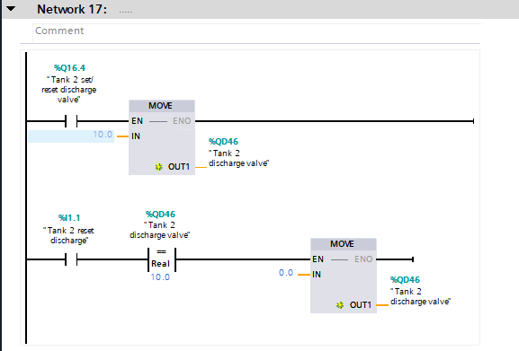
Figure 65 - Software simulation network 17

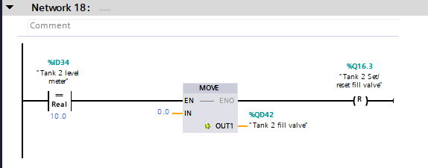
Figure 66 - Software simulation network 18
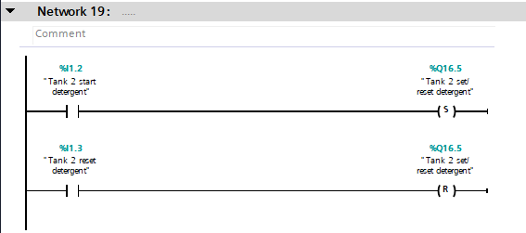
Figure 67 - Software simulation network 19

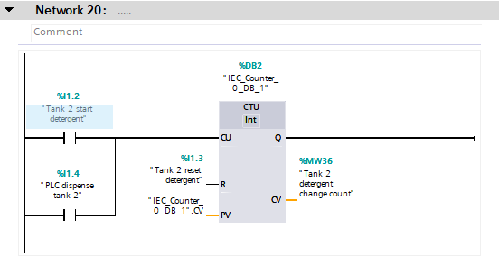
Figure 68 - Software simulation network 20
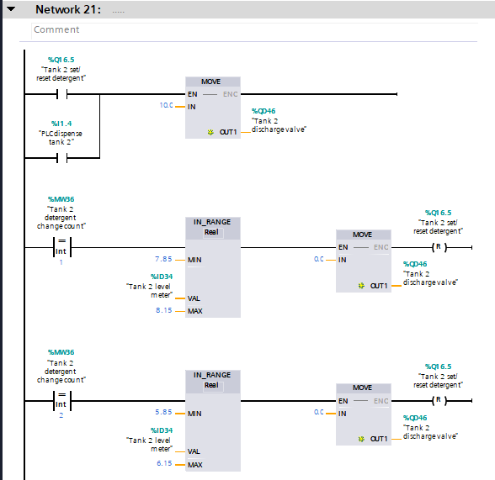
Figure 69 - Software simulation network 21

Appendix 3 – Physical prototype software program
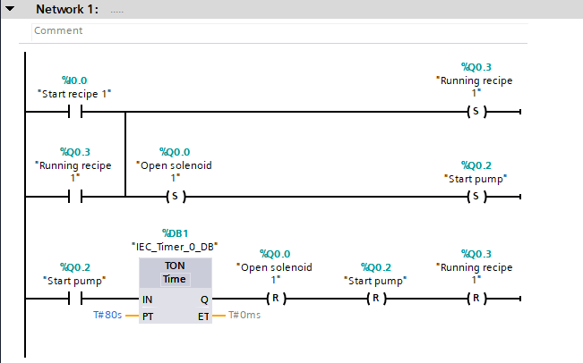
Figure 70 - Physical prototype network 1

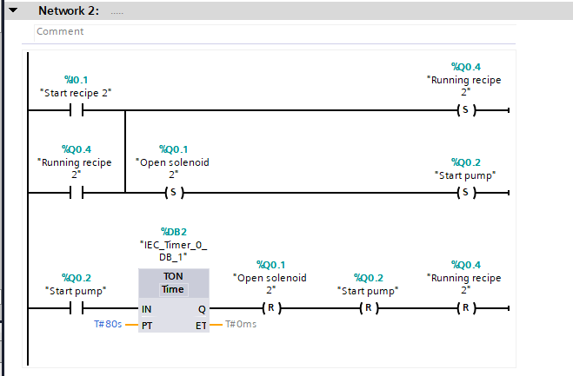
Figure 71- Physical prototype network 2

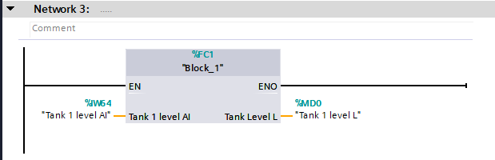
Figure 72 - Physical prototype network 3

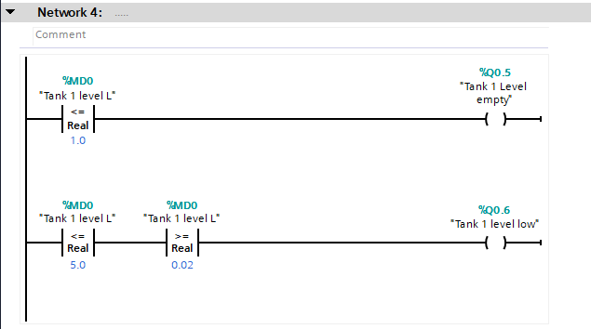
Figure 73 - Physical prototype network 4

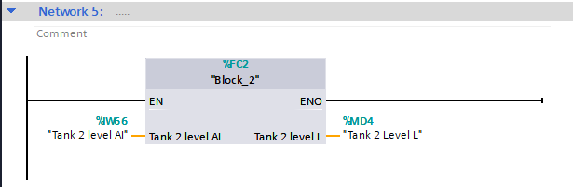
Figure 74 - Physical prototype network 5

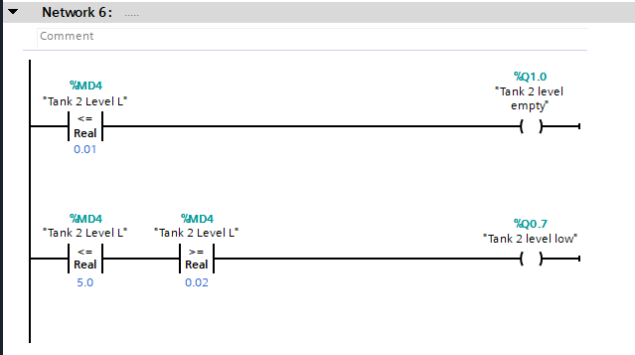
Figure 75 - Physical prototype network 6

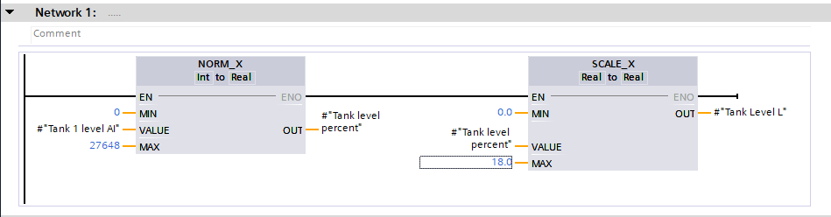
Figure 76 - Physical prototype function block 1

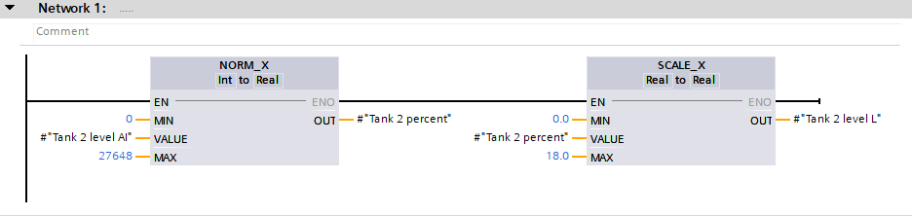
Figure 77 - Physical prototype function block 2
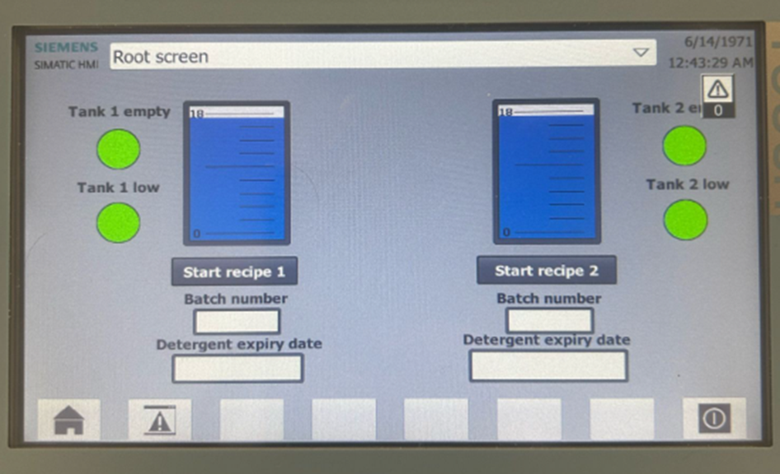
Figure 78 - Physical prototype final HMI

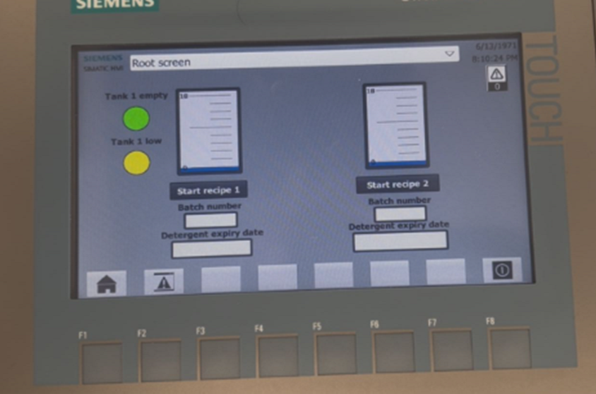
Figure 79 - Physical prototype HMI low level alarm

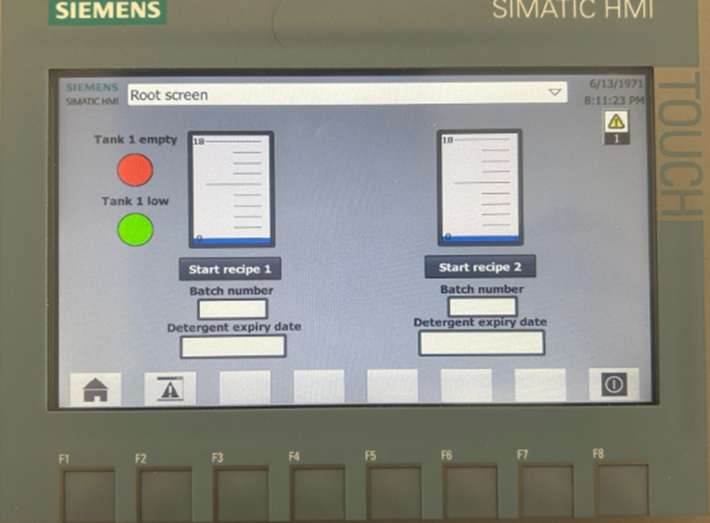
Figure 80 - Physical prototype empty alarm

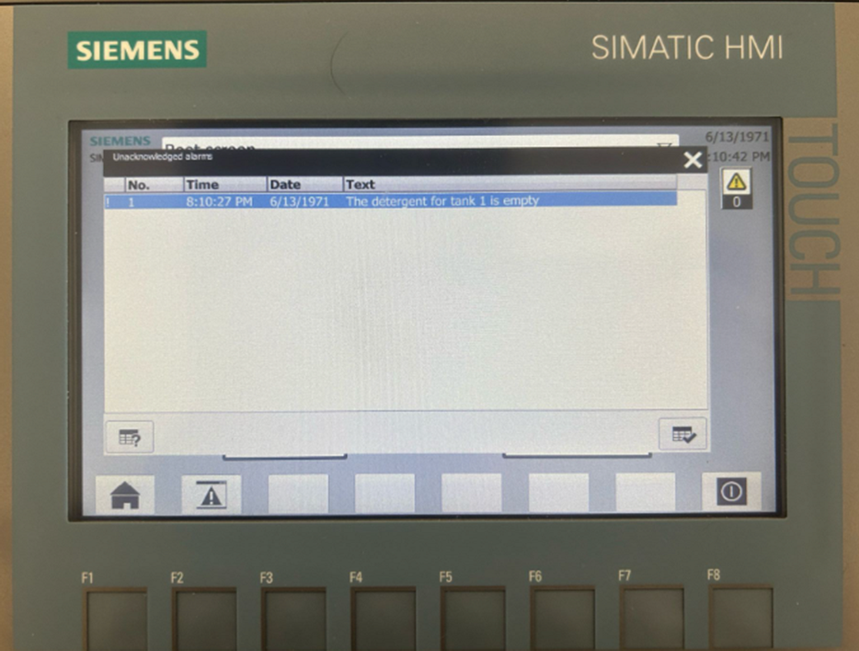
Figure 81 - Physical prototype alarm pop up

Appendix 4 – Operator questionnaire
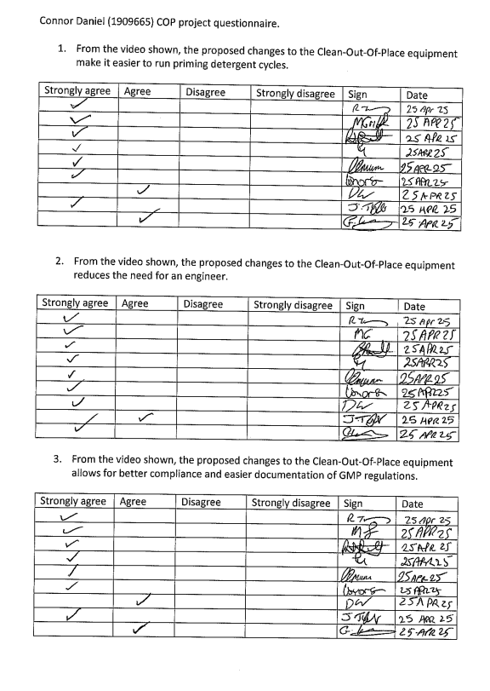
Figure 82 - Questionnaire page 1

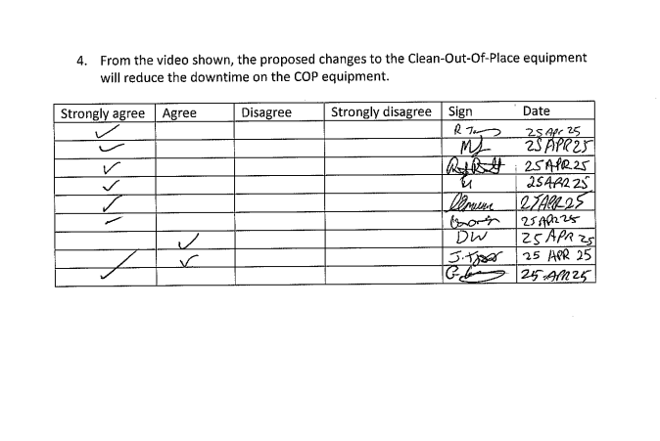
Figure 83 - Questionnaire page 2

