Ellis Jones – 1708692

Work Based Project Learning Contract – Interim Submission No.1

What new skills did you learn in the period?

Since starting this project, I have learnt a lot about techniques that are used in the industry such as BIM, BREEAM and Passivhaus. In my previous job I was working on new build developments for housing associations – straight forward builds with less complicated construction details.

As the job is to be built to Passivhaus standards, the construction details are a lot more complex than I have previously worked with and so I have had to learn and familiarise myself with these various details and requirements. Typically, these details are more complex due to the importance of airtightness and to avoid any potential thermal bridging.

I was also fortunate enough to attend a Passivhaus course where we were given some guidance on potential issues and key design requirements to look out for to help avoid any problems on site such as the requirement for louvre grills to the outside of windows to allow them to be fully openable and still achieve Secure by Design.

How have you been able to adapt / use the new skills learnt within the work environment?

I have now become more familiar with the requirements for BIM and as such, I have started to familiarise myself with software such as Revit for modelling, Navisworks for viewing integrated models easily & Viewpoint to submit drawings to the client for approval. By learning how to use Revit and navigate through a Revit model, I have been able to get a better understanding of the design of the building.

I am able to manage my time through various documents the company has in place, such as a Design Control Action Plan, a Design Release Schedule, an RFI Schedule and various other documents. By utilising these documents, I can ensure I am meeting deadlines, managing my workload efficiently and making sure no queries are being lost in my emails.

What was the highlight and why?

The highlight of the project so far has been the experience gained from working on a larger scale job than what I have been used to previously and as a result, being able to gain experience of BIM and Passivhaus.

What part of the task / activity were most challenging and least challenging?

One of the most challenging aspects so far has been understanding the steel frame construction and how it interlinks with the timber frame cassettes. As I have only worked on traditional build and timber frame construction previously, this area was one of which I had little experience. Interacting with knowledgeable consultants has been quite a challenge but I have made sure to make notes during any meetings and to then research anything I have been unsure of post-meeting. One example of something I was previously unsure of and so required research in my own time was the function of a MVHR unit. I have since studied the system to gain a general understanding of how it works and how it is important in a Passivhaus scheme.

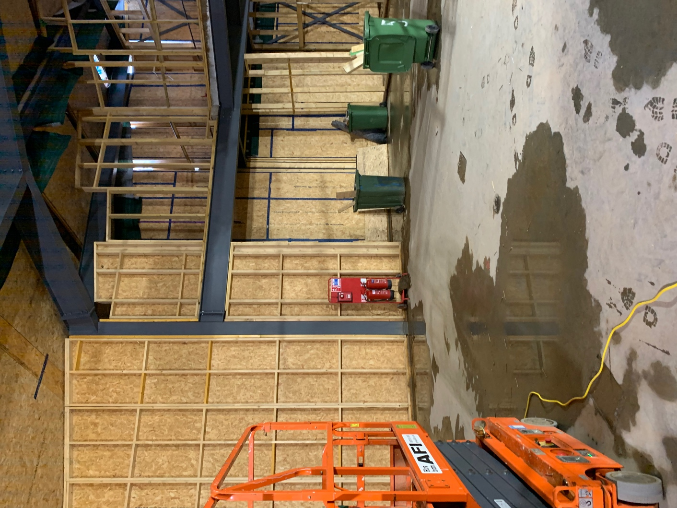

(Interlinking Steel & Timber Frames)
How are you progressing according to your objectives (learning contract)?

One of my learning objectives was “to learn things such as the correct specialist materials used, any unique design factors that apply to a Passivhaus building and also the correct workmanship required”. I believe I am progressing well in achieving these objectives. I have familiarised myself with the specialist materials used such as “Pro Clima Tescon Vana” tape applied to any penetrations of the building envelope, the “Jablite” underslab insulation used to meet the correct U values required and the “Smartply Pro Passiv” OSB panels which have integrated vapour control and air barrier properties.

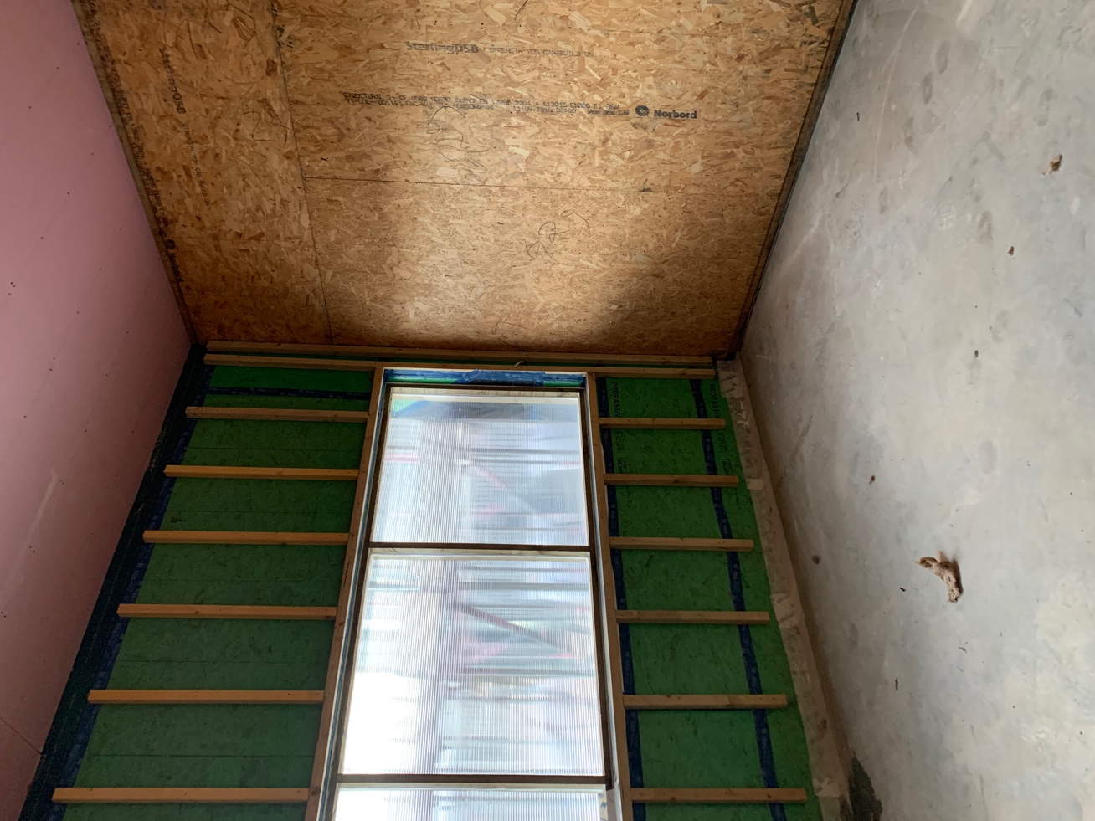

(Pro Passiv OSB Panels & Pro Clima Tescon Tape)

I have managed to gain a general understanding of the critical nature of detailing in Passivhaus buildings and the utmost importance of achieving a maximum of 0.6 from air testing. I will continue to enhance my knowledge by attending site frequently and studying the various details within the build.

