Kiera Bazelya
1806166
BA/MArts 3D Computer Animation
Creative Practice 2
M4X01558
Project Document
Coursework 2

In this assignment we were given the task to create an animatic in the same team as creative practice one, we came together as a group and we decided to have the four of us do similar roles to what we originally had assigned ourselves in creative practice one. At first, we were meeting regularly to come up with weekly plans and to discuss how long it would take each of us to complete the roles we were responsible for. Me and Tiegan were responsible for the environments and the colour scheme, I also had my own roles which was to create my ‘TumTum’ tree into a model for the animatics and to do the audio of the script. Karol and Dylan shared roles from the start helping each other with different tasks which was great as we all had our tasks to focus on.
The second week we all met up to figure out if everyone was happy with their roles and to work out a time scale in how long each task would take to get done. Everyone was happy and we worked it out to take 5 weeks to get everything done with time left to develop more ideas that unfortunately wouldn’t make it into the animatic.
Below on the left is a print screen of my ‘TumTum’ tree in ‘Zbrush’, this is how it looked at first after me figuring out what the right shape for the tree was, how far apart the branches should be. I used Zsphere’s to create my ‘TumTum’ tree including the branches, it was difficult at first but I really enjoyed finding new ways with creating the ‘TumTum’ tree but at the same time still keeping to the old style of drawing as my reference. I then added clay to the tree sculpture to make sure I could add more details and to create more of a thickness to it. The third print screen below the other two, is my final take on the ‘TumTum’ tree, I wanted to make sure it felt like a tree even though my take on it has loads of human features which I was unable to complete. The texture I chose to use is print screened below to, I went for a thicker bark texture to make sure you can see it against the sculpture as I had a lot of trial and error with the textures.

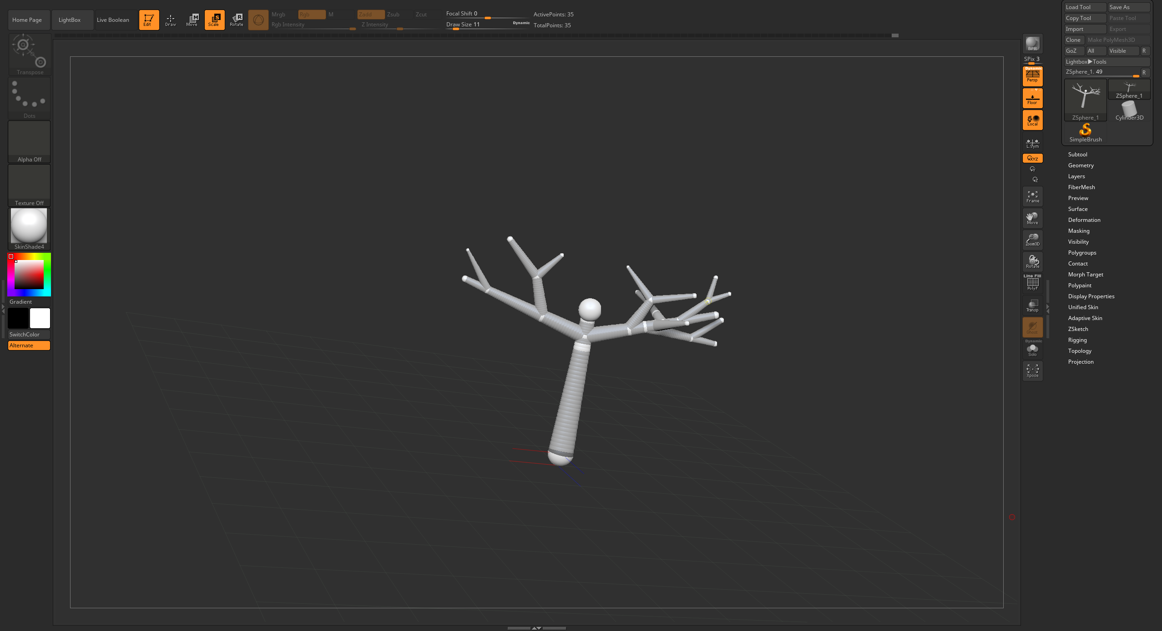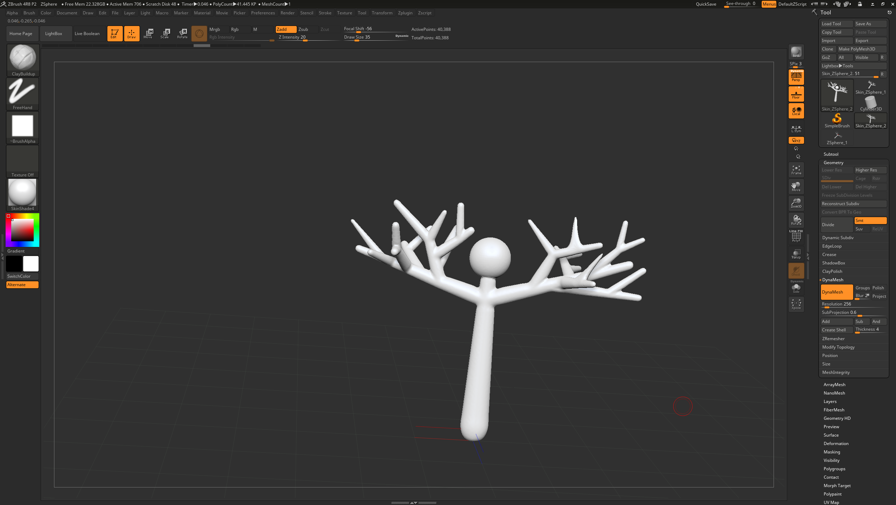
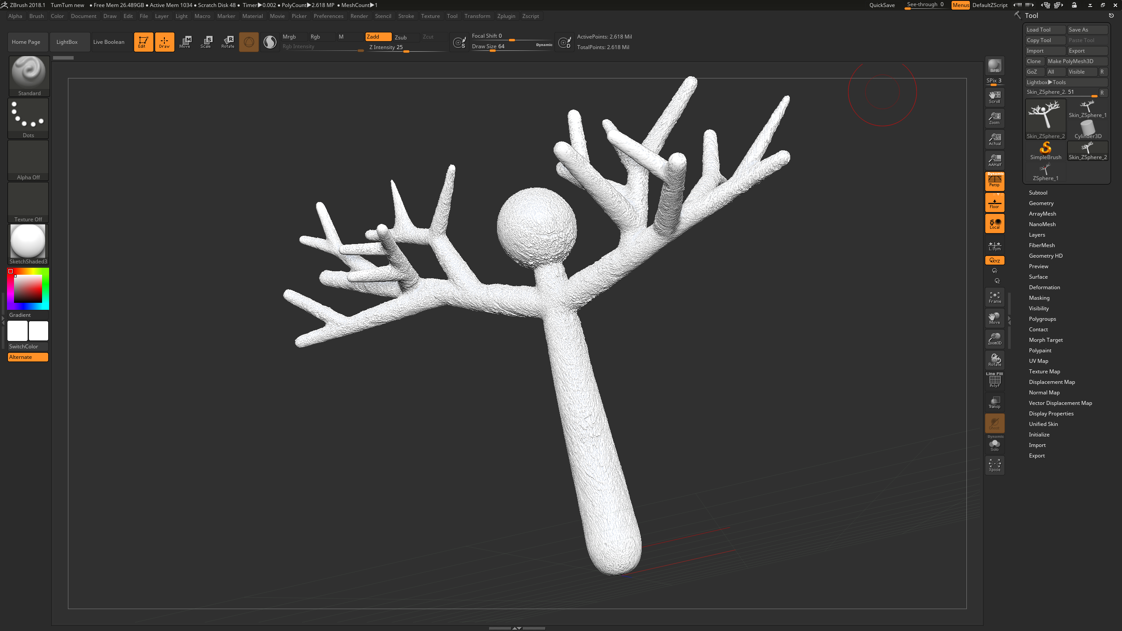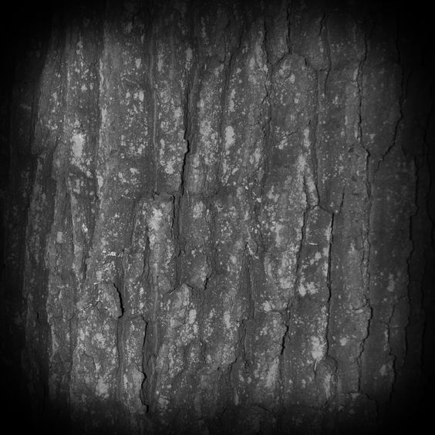

A few weeks went by and the group distanced itself a lot from each other, this was due to lack of communication within the group because of everyone not being available on certain days to meet. It became a big problem as we all didn’t know what had been done or if everyone was sticking to the assigned roles we originally discuss together. This was an ongoing thing until me and Tiegan decided to go off in a pair to create a number of scenes for the animatic by ourselves and then to add ours with the boys when we were both finished and ready to render in ‘Maya’.

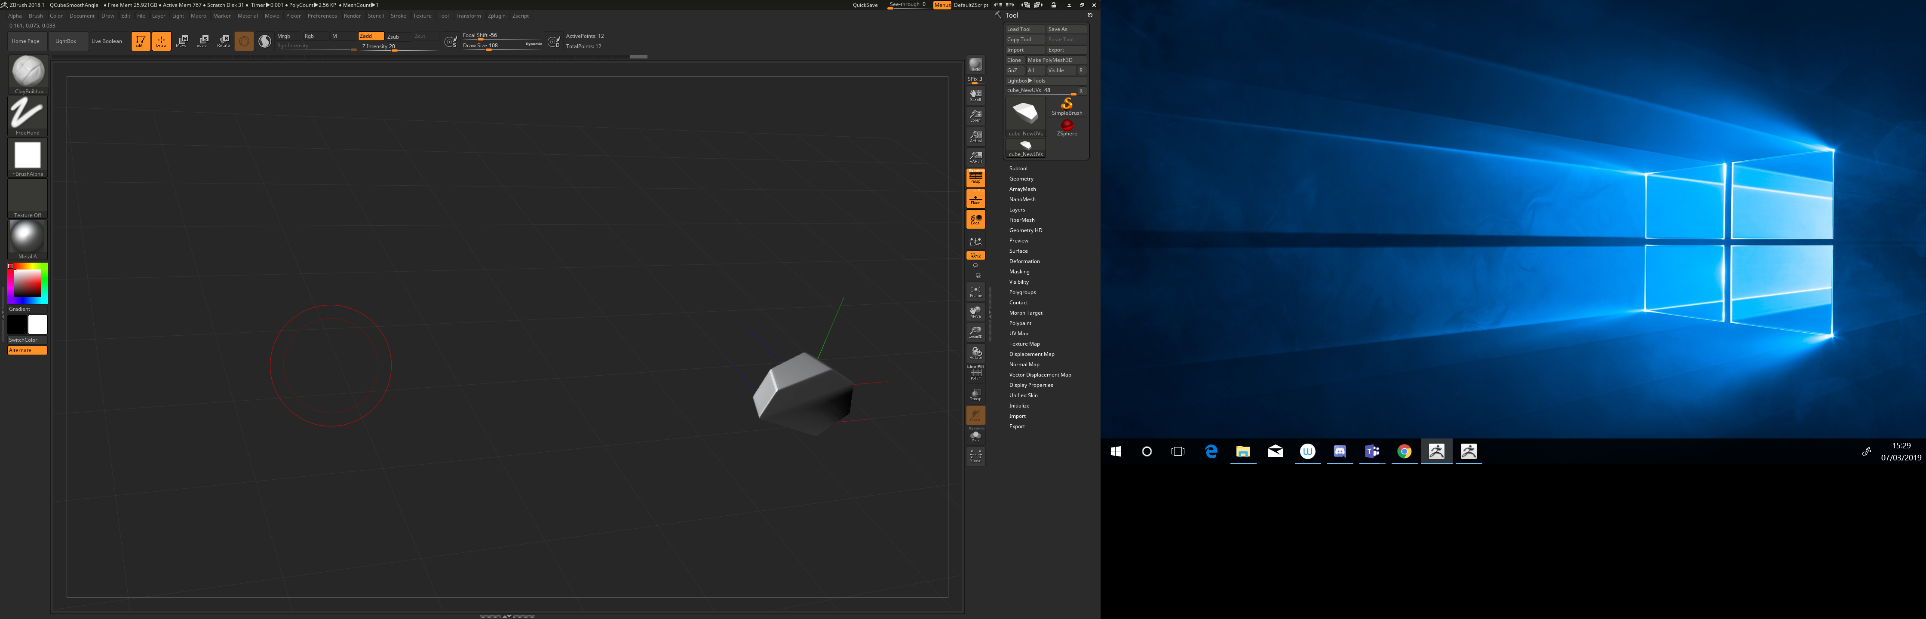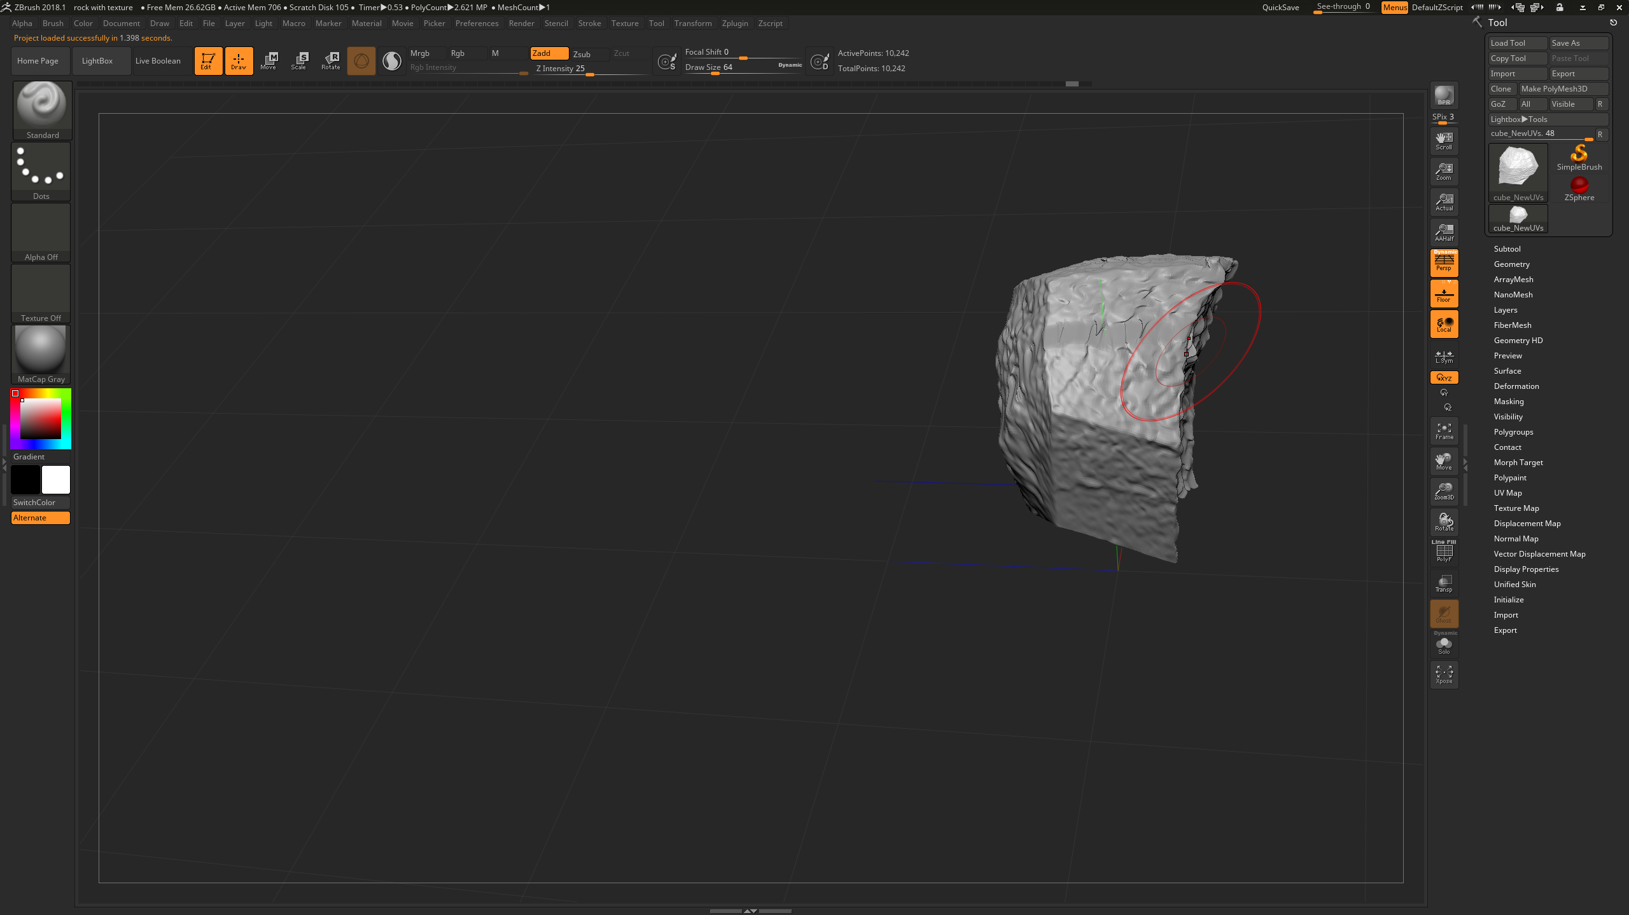
I also made some rocks for the Borogroves and the Wabe as me and Tiegan met up every week to discuss the environments because they are the main thing that sets the scene for the audience as it is the same in any type of media platform. We decided to go with how the original storyboards were mapped out on ‘trello’ but we wanted to make it more darker especially in the Borogroves because to us it sounded like an interesting or lost place where as the Wabe being seen more whimsical by the both of us. I wanted to the audience whether they are young or old to feel the emotion within the background not just the emotion from the characters.

I also was in charge of the speaking audio which was the character’s voices from the script, I asked everyone on my team if anyone would like to do the voices for the characters and no one felt comfortable to do it which wasn’t a problem. I the decided to contacted my uncle and asked him if he would like to do the voices for both characters which were for the ‘father’ and also for the ‘jubjub’ bird. He agreed as he loves doing voice and I knew he would be great for it. I allowed him to have all freedom in choosing what voices he felt best fitted the character, that way it gives him flexibility with finding a personality for the certain character. As you can see by the pictures below is the script but with the characters marked in either red or green to identify which lines are whose, green being the father and red being the jubjub bird, I did this to give my uncle a better understanding of who is who. I have also attached the voice recording my uncle created below to. Unfortunately, this didn’t make it into the final animatic. I also wrote each line out followed by the noises the characters would make while in that scene but I didn’t attach it as it was in my first assignment.
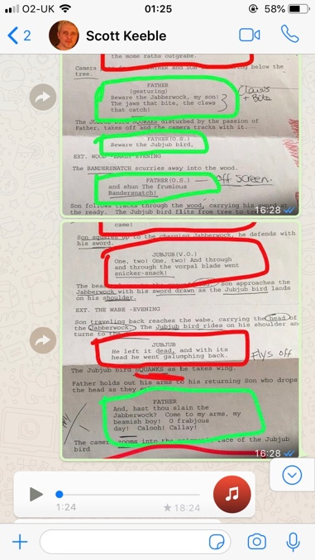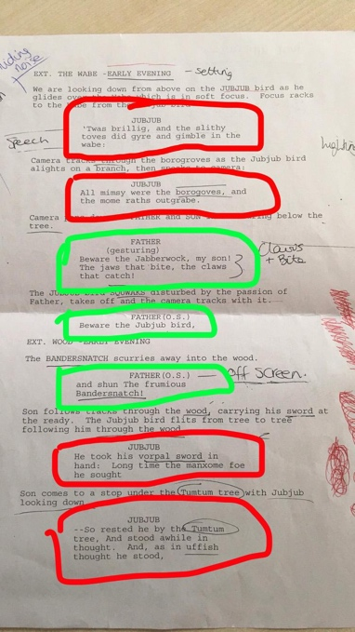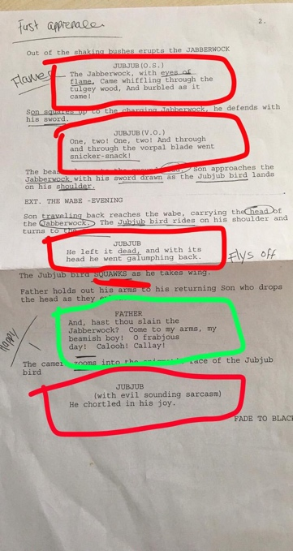


I am very proud of what me and my team have created in our animatic, I feel as a team I think we worked very well together especially after we sorted out our differences, I would happily do many more projects with my group. I am very disappointed in myself as I feel like I have let my team down to an extent because of certain circumstances I have faced during the same time I was trying to focus on my animatic and I fell far behind the others and got very lost in my own head and with what was happening around me, it was very traumatic. I know I am capable of way more than I have presented today and it isn’t at all my best. I am just very grateful for being able to develop my skills while using ‘Maya’ and also ‘Zbrush’ this task has really helped me to gain more knowledge in the areas I was mainly weak in and that Is mainly due to working within a team as they are all very talented in their own departments, I think it is very important to help and teach one another in ways you would want to be helped.

Reference:
- Rock texture - http://kamiladvancedskills.blogspot.com/2013/01/zbrush.html
- Zbrush - http://www.zbrushcentral.com/
- Maya - https://www.autodesk.com/products/maya/overview

