Fatumata Djarai Djalo
2008470
BMSW4001
shao-Lan Yuen

Academic and Employability Skills

Write an appropriately structured academic report where you reflect on your learning in this module, using a recognised model of reflection (one). Discuss 3-4 topics from those covered during the term (listed below) and reflect on how useful they have been to you, taking into consideration what you already knew and any learning you undertook outside of the classroom. You will need to explain the chosen model of reflection and apply it to each topic. You will also need to analyse published literature relating to the specific topics you discuss and use the feedback you received on all in-class activities.

Table of contents

Section 1: Introduction………………….................................................3

Section 2: Time Management………………...........................................4

Section 3: Referencing……………………..........................................….5

Section 4: reflection……………………...........................................…….6

Section 5: conclusion……………………...........................................…..7

Section 6: references……….……………..........................................…..8

Section 1: Introduction
I see myself in the future as a successful entrepreneur and I know that in order to achieve this, I need to start tracing my rides for that desired future and along this journey I will have to develop many skills. Here I will talk about some of those abilities I learned during this module, such as: Time management, Reference and Reflection. I will use Kolb's method to reflect on these themes

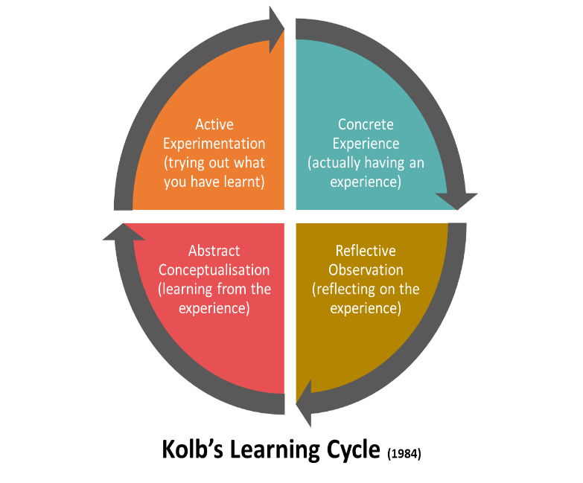

Section 2: Time Management
Concrete experience
I always had a very unbalanced time management, always wanting to do several tasks and not being able to complete several of them due to having an immense difficulty in concentrating. Before having this module, I had no idea of ​​so many tools that will help me organize my time and increase my productivity. I used to by a procrastinator leaving everything to do even the most important tasks at the last minute, the feeling I have is that in my head I always believe that I have more time than I really have and in the end everything accumulates, which has caused me anxiety
Reflective observation
Learning about these methods was not a simple process as they are very complex and it is very important to understand them well and to know how I can fit them in my daily life. Gradually I try to adapt to this new way of living, because I believe that it really is a lifestyle that is not easy to adapt and it is necessary to apply time management daily and be persistent in it so that more and more start to see concrete results. I'm reading Brian Tracy's book, Eat That Frog, and one of the things I realized is that everyone can have time management if they want to apply it to their lives. the way the book spoke to me made time management seem as easy and possible. This book is building a new way of thinking for me and one of the things I want to get used to and eat the ugliest frog first and then the others disciplined
Abstract conceptualisation
I ask my self what kind of professional I would be if I do not apply time management in to my life, or even my study journey would it be satisfactory if I don’t learn how to organize my time? I don’t think so, In time management we learn about several elements that can help in this process of personal organization. I realized how interesting it is to list my tasks and prioritize the important ones, leaving the ones that are not important to the end. In my view, what is most valuable in this complex process of time management is the satisfaction of having the tasks completed and being able to have time for other lighter and more pleasurable activities
Active experimentation
I have tried to introduce the things I learned in class into my personal life, I organized my tasks and in addition to prioritizing what I think is important, I determined the day, time and place where I will do them because I think it will help me to complete them, with the purpose of maximizing my productivity which has given me more motivation.
I redefined the time I spend on Instagram and YouTube because it was a lot of time wasted on things that are not important and so I can have more time for activities that I think are important, such as studying, finishing the book I am currently reading and going for walks, which is something that help me to re-engage . I used to spend about 3 hours or more on the Instagram daily lately I decided to use the app only once a day and for no more than 30 minutes which is not easy, because I am adapting little by little, so sometimes I spend a little beyond the target and should not exceed 30 minutes

Section 3: Referencing
Concrete experience
I did not understand much about the concept of referencing before because I always thought that the things that are available on the internet, for example, could be used freely without having to give explanation where I got them from. but after we referenced this in class now I understand the importance of knowing how to reference and always applying it . When I was doing research, I didn't really care who wrote what I read; in fact, I was not aware of what was unethical on my part. not only should it be noted, but also refer to the author whenever using his work
Reflective observation
I now have a broader idea about the concept of reference and I know that there are many implications in not referencing someone's work, by doing so, the act can be considered plagiarism . For a quality academic work it is essential that the content offered has credibility and sustainability , when showing your research source not only allows people to have access to it but also gives credibility to your arguments showing that you are not the only one who has such a point of view.

Abstract conceptualisation
Imagine everyone being able to use each other’s works without giving due recognition, it seems like a big mess being that nobody would know the origin of anything the , not even the real author of any work. Knowing and reflecting more deeply on the concept of reference I realize the lack of consideration that my work would reflect if I didn’t apply it. For me now it makes perfect sense to give people the copyright of any work that belongs to them.
Active experimentation
There are several methods you can use if you need to reference a text, the method recommended by most universities in the UK is Harvard, which consist in making citations within the paraphrased text using the author's name and publication date. also quotation using the actors' word directive and cite him as usual, after that it is necessary to make a list of references at the end of the work putting more information on the source of your research

Section 4: reflection
Concrete experience
What I most admire in people is the ability to present situations with a critical and analytical sense, showing the situation clearly and simply with a beginning, middle and end, which shows a great capacity for reflection.
I confess that I am not very good at reflection, and it is difficult for me to think in an abstract way, my emotional side is always due to weighing more in my reflections, which makes my analysis difficult to understand because I take everything personally.
Reflective observation
First of all, I tried to understand reflection models well in order to be able to apply them, and it is a quality that I intend to develop because I believe that it will help me in terms of argumentative quality. It is always important to have different perspectives on our reflection, making People see the situation in different ways, understand it better and relate in some way to what we are presenting. I love to change my mind because I believe that when it happens it is because I have learned something and in order for it to happen, I must always listen and reflect on what is being said to me and finally agree or disagree with the possibility of changing my mind
Abstract conceptualisation
living without ever reflecting on the situations that we go through, in my view, is a very empty way of living letting everything go without absorbing any experience from it. so that I can go beyond just experiencing the situations, I reflect on it in order to understand the events in a more primitive way and thus allow me to know what I can learn from every situation, which is something that everyone can learn if they allow themselves. reflecting on yourself helps to simplify things and allows us to know what we have learned from difficult situations and what to do so that they do not happen again (Porter, 2017).
Active experimentation
there are many ways that help us to know how to face situations and teach us different models of reflection that we can use . I particularly use the kohl’s experiential learning cycle because it makes more sense for me, I think it is simple and applicable. but there are other reflection models like the Gibb’s reflective cycle.

Section 6: conclusion
I believe that all these learning tools will contribute a lot to my future . knowing how to manage my time, knowing how to use my research always giving due value to those who provided it and knowing how to reflect with analytical sense on situations, I believe that I will become a great professional, besides everything I will have to be persistent applying these skills in my life because it is not easy and it will always be a continuous learning throughout my life, both personally and professionally.

Section 7: References:
- Eat that frog by Brain Tracy

Why You Should Make Time for Self-Reflection (Even If You Hate Doing It) by Jennifer Porter, 2017

