Task A
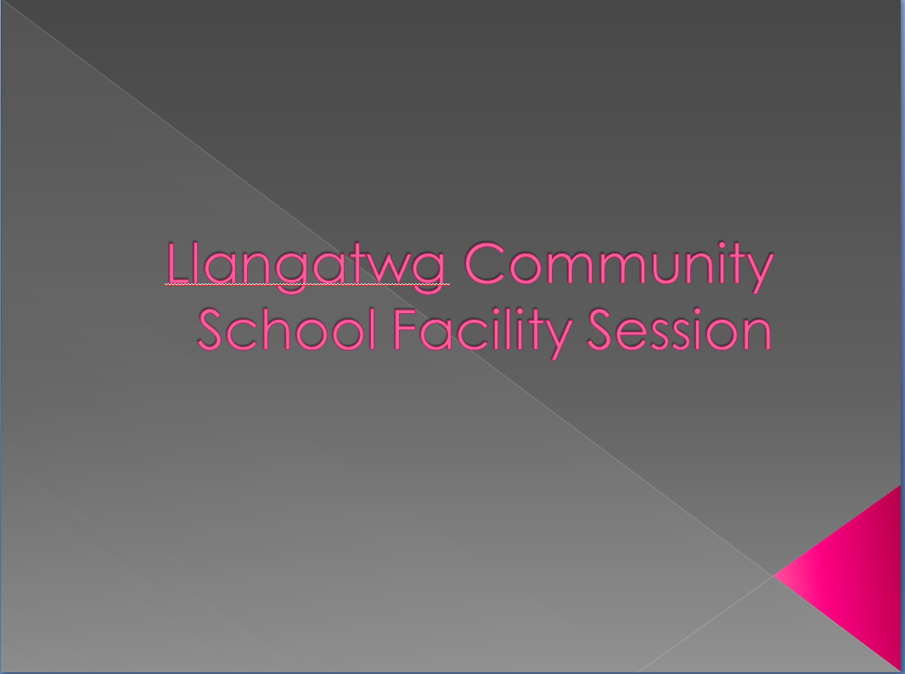
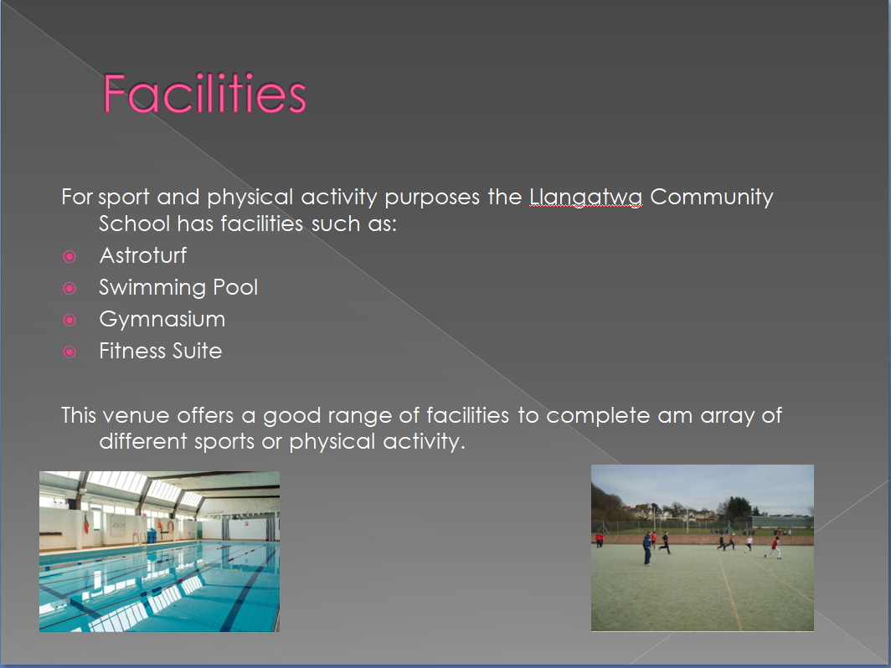
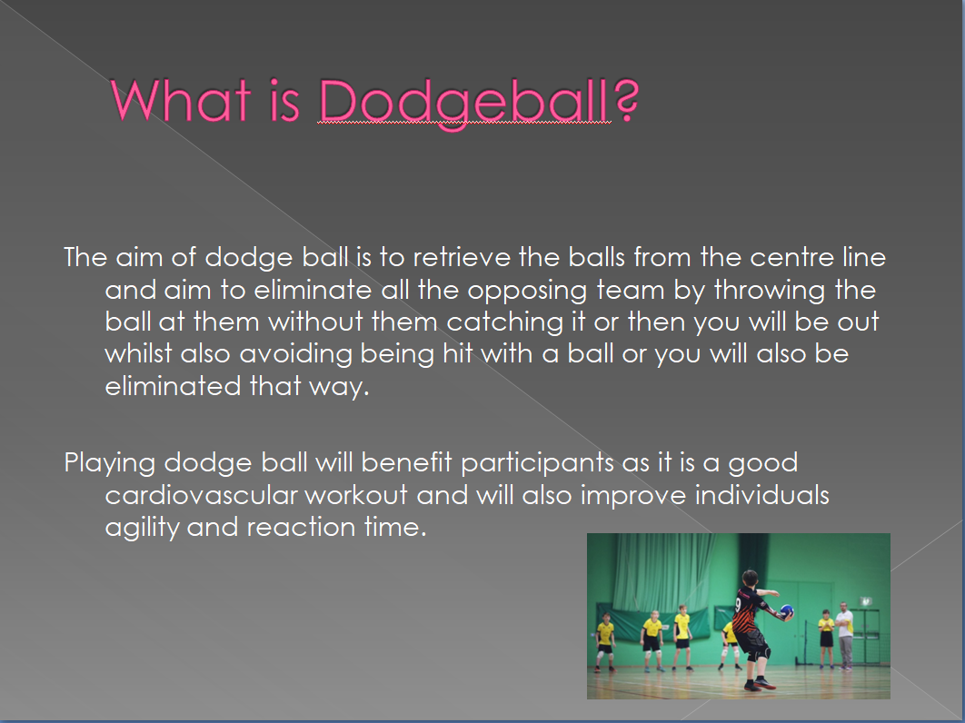

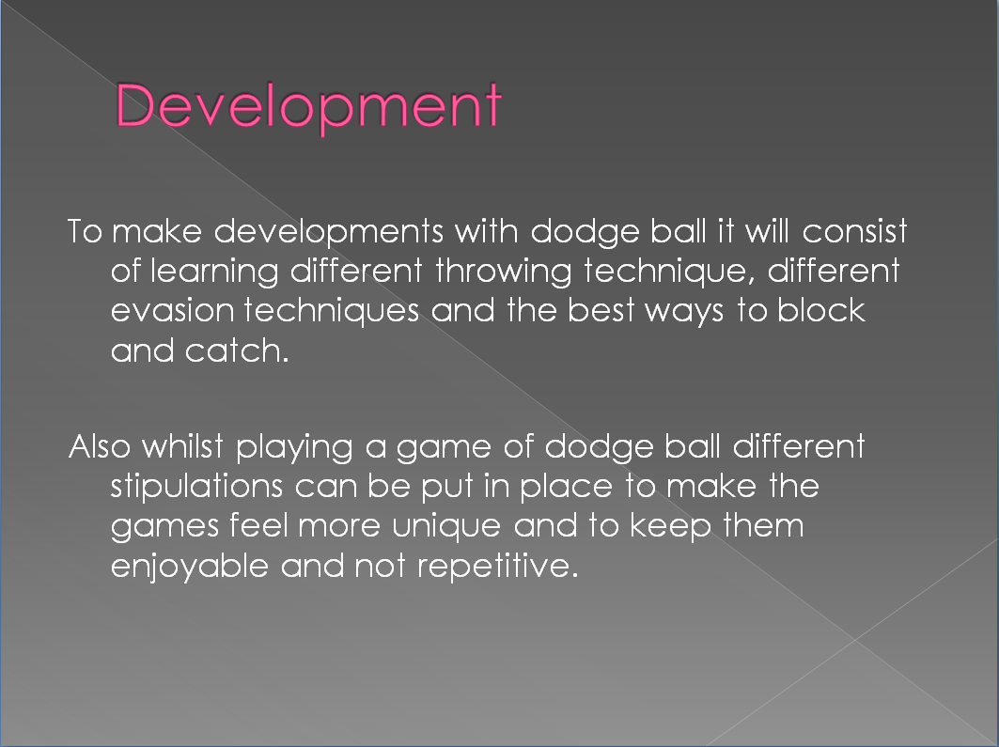
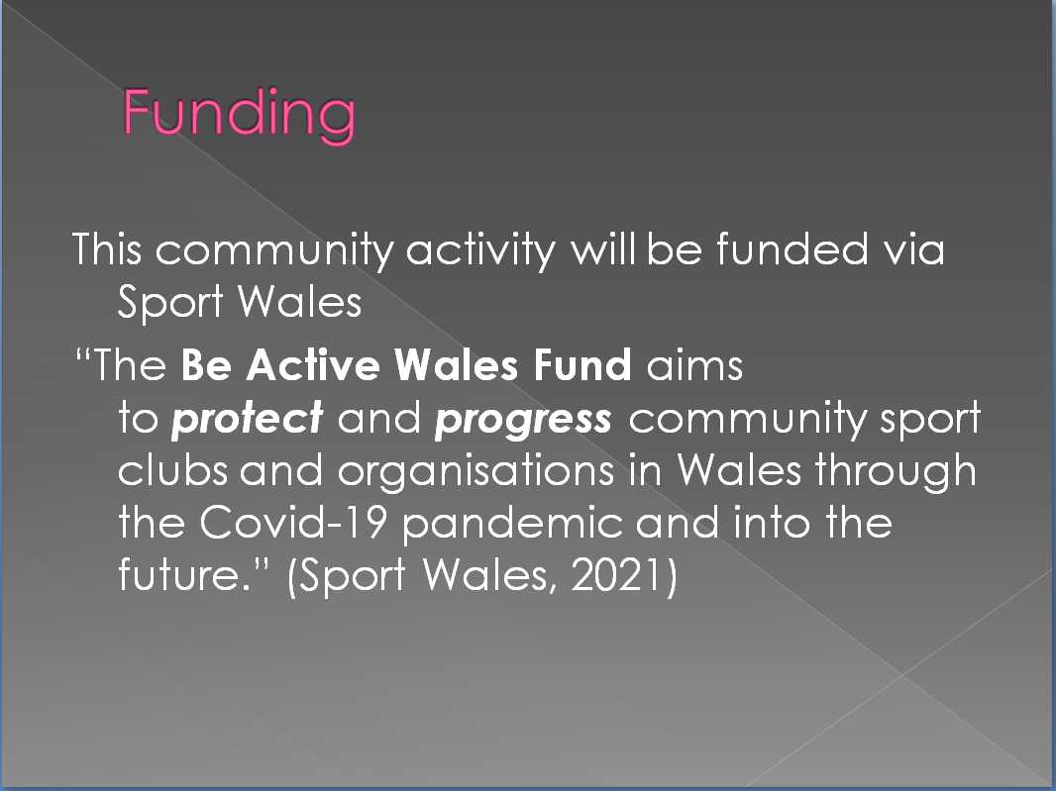

Task B
Introduction
This assignment will primarily be about researching what PASS (Physical Activity & Sport Service) are offering in the Neath Port Talbot area and the positive and negative impacts that running active living sessions have on the community. A S.W.O.T analysis will be carried out to analyse the information that has been research in order to complete a detailed analysis to be able to identify all the correct information.

Strengths
PASS (Physical Activity & Sport Service) are a company primarily based in the Neath Port Talbot area who have identified that sport and physical activity can have positive impacts on an individual's health whether that be physically or mentally so they are looking to increase the amount of physical activity in order to improve the local area, as stated by Neath Port Talbot Council (2021) " Increasing the activity levels of the Authority’s population will have significant health benefits for all concerned, resulting in a more Confident and Healthier Borough." PASS are very firm with the goals they set out to make the population a healthier and happier environment, as stated by Neath Port Talbot Council (2021) "The Physical Activity and Sport Service has a vision of promoting a better life through active living."
They run many different schemes in the local area that are very impressive locally such as: Young Ambassador Scheme which is actively teaching young individuals that they can have a voice in sport and physical activity and encouraging them to become leaders, as stated by Neath Port Talbot Council (2021)" The Young Ambassador scheme trains children and young people to be leaders and the voice for sport and physical activity." Street Games is also something run via PASS which is mainly directed towards poverty area's and is something offered to give opportunities to individuals to take part in sport and physical activity who may not be able to otherwise because Street Games is aimed to be affordable for this target group, as stated by Neath Port Talbot Council (2021) " Street Games activities designed and delivered by PASS aims to target areas of poverty and provide affordable, accessible activity provision for young people on their doorstep." PASS also look to operate in higher education as well via partnerships with Neath Port Talbot College Group, University of Wales Trinity St David and the University of South Wales and this offer more sessions for people to be able to attend of all a different variety of ages and ability.
PASS are looking to make the most of the local area by using natural area's in order to complete their sessions that are available to them and they also use the facilities of different schools and community centres.

Weaknesses
Looking over all the different sessions that Pass run its hard to find any weaknesses with this brand. PASS are constantly growing and they reach out to all age groups and abilities whilst offering a vast variety of new unique fresh sessions which are best for the communities enjoyment and promoting active living for a healthier community.

Opportunities
as previously mentioned PASS have contacts with Neath Port Talbot College Group, University of Wales Trinity St David and the University of South Wales and is ever growing and the workload for these sessions would struggle to be carried out by a limited amount of coaches so this leaves opportunities open to potential work if you can successfully acquire a job with this brand, this also leaves open volunteering opportunities to coach with a unique brand with will offer a plethora of experience and knowledge to help individuals to grow as coaches. Colleges and Universities that are in partnership also offer placement opportunities where you can again gain a plethora of experience and training from a great brand, as stated by Neath Port Talbot Council (2021) "We have also used research undertaken by undergraduates to shape the offer for physical activity and sport. Many of our employees have completed a placement with us or have been trained at colleges / university in the area."
They have a great example of more and more sport opportunities being offered towards girls with netball and a competitive league that is played weekly with teams travelling from Bridgend and Swansea to compete, as stated by Neath Port Talbot Council (2021) " Netball is a fantastic example with the development of 6 community based clubs and a Swansea Bay Netball league with over 500 girls playing competitively on Friday evenings with clubs from Swansea and Bridgend travelling to Neath Port Talbot to compete."
PASS also offered frequent opportunities by having sessions target to individuals who will struggle to attend regular sessions frequently such as the previously mentioned Street Games which primarily focuses on poverty area's and offering affordable opportunities which may have not previously been available.

Threats
The main threats with promoting active with sessions is the amount of different clubs and community sessions that get put on which might be more appealing to different individuals whether that be due to location, family connections or that there friend goes to a different session, so keeping PASS as unique, enjoyable and as affordable as possible is something which needs to be in place whilst also promoting active living.
Another major threat currently not only to PASS but to the world of sport is the current Covid-19 pandemic as this limits the locations which can be used and currently there isn't a great amount of knowledge when locations in Wales will be open especially with it ever changing. This may also incur additional funding costs as if staff are in contact with participants then there will have to be successful Covid-19 tests in order to make sure the sessions are safe.

References
Neath Port Talbot Council (2021) NPT Physical Activity and Sport Service [Online] Available at: https://www.npt.gov.uk/17515 (Accessed: 5th March 2021)

