Data Handling & Business Intelligence
LCBB5000: Data Analysis and Visualisation

Student Name
Sevila Gorahmedova
Student Number
2113595

Table of Contents
Introduction 3
Part 1: 4
1.1 Determining the trend of average room reservation priceS ranging from 2017 to 2021 4
1.2 Use of MS Excel functions and graphical demonstration 7
Part 2: 10
2.1 Number of male and female students 10
2.2 Qualification status for reduced or free lunch 10
2.3 Mean and median of students who qualifY and do not qualify for reduced/free Lunch 11
2.4 Mean and median differences of student's pre-test and post-test scores 12
2.5 Practical example of clustering technique by using A given dataset 13
2.6 Five most useful data mining and text mining methods with example 17
2.7 Advantages and disadvantageS of using SPSS and Excel using relevant practical examples 18
Conclusion 20
List of references 21

Introduction
This is a world of data specifically bid data as the decision is completely based on data so it requires to use of data analysis tools and techniques properly. The first part of this report discusses the use of MS Excel in the hotel reservation dataset and presents the dataset by using visualization tools and techniques. The second part of the report discusses the use of MS Excel and SPSS for manipulating students' data for launch qualification. Moreover, this part of the report also compares the use of MS Excel and SPSS.

Part 1:

1.1 Determining the trend of average room reservation priceS ranging from 2017 to 2021
It is important to determine the trend of variables based on raw data and then present the trend in graphs, charts, and figures for a better understanding of the trend (Apte, D.P., 2019). This section of the report presents the hotel reservation data after analysing them by using MS Excel. The given data set presents 36,276 rows and 19 columns so management of such a large data set is easier by using MS Excel so which allows the users different dimensions.
Before starting the data analysis some pre-processing is necessary like tabular presentation, cell formatting, outlier consideration, text manipulation, etc. These steps are necessary to make the data understandable to the analysis tools like MS Excel, SPSS, etc. The following table shows the summary of average hotel room reservation prices from 2017 to 2021-
Average of Average price
Arrival_year | Average room price | Price change
2017 | £ 90.04 | -
2018 | £ 106.36 | 15.34%
2019 | £ 70.96 | -49.88%
2020 | £ 81.40 | 12.82%
2021 | £ 105.33 | 22.72%
Table: Average room reservation room price from 2017 to 2021 (Author)
From the above table, it seems that the average price follows a mixed trend over the years as it varies from GBP 70.96 in 2019 to GBP 106.36 in 2018. In 2018 average price increased by 15.34% compared to 2017 and then in 2019 average price decreased by 49.88% compared to 2018. Such a price decrease was the result of the Covid-19 pandemic around the world as different restrictions like movement, travel, shopping, and entertainment were imposed to tackle the virus from spreading.
After the initiation of the vaccination campaign in late 2020 the industry started to revive to a normal level. It is reflected in the average price as in 2020 average price increased to 12.82% compared to 2019 and the average price increased by 22.72% in 2021 compared to 2020. It shows that at the beginning of recovery, the tour and travel industry started to grow, and then the hotel industry as well. The following figure presents the above table in a graphical manner that is easy to understand for the users-

Figure: Average room reservation room price from 2017 to 2021 (Author)
It shows that the average price varies a lot during the last five years from 2017 to 2021 as different internal and external factors influence the movement of tourists. This chart is made by using MS Excel where in the insert section different types of charts and graphs are available namely column, line, pie, bar, area, scatter, etc.
The following table shows the number of bookings and the number of adult guests from different industry types. It seems that the least number of bookings and number of guests are from the aviation market which is 127 adult guests. After that complementary, corporate, office, and online industries are respectively in the list. It is mentionable that a total of 23,214 bookings are recorded from online sources where the number of guests is 45,023. So, the management of hotels must make a smooth online booking system for the guests.
Number of guests in different market types
Market type | Count of Booking ID | A sum of Adults No
Aviation | 125 | 127
Complementary | 391 | 580
Corporate | 2017 | 2481
Offline | 10528 | 18715
Online | 23214 | 45023
Table: Booking of hotel rooms from different types of industries (Author)
The following figure demonstrates the booking statistics from different industry types where the minimum is from the aviation industry and the maximum is from the online segment of the market.

Figure: Booking of hotel rooms from different types of industries (Author)

1.2 Use of MS Excel functions and graphical demonstration
MS Excel is a very useful tool to analyse and present data that is easy to understand and present. This section of the report presents some MS Excel functions namely Vlookup, Pivot table, If formulas, etc. These tools and techniques are very useful to extract required data from a large dataset. The followings are the application of some MS Excel tools for the hotel reservation data-
Use of vertical lookup (Vlookup)
Vertical lookup or Vlookup is a widely used tool in MS Excel that helps to find data in the vertical columns from a large data set (Rigby, D., 2018). This technique is used to find out the meal type of each guest within the whole data set given in this module. The steps of Vlookup are selecting a cell in the MS Excel file and putting an equal (=) sign. After that Vlookup formula is selected and then the lookup value needs to select which is the code that is required to search. Then the full table array needs to select and then the column index number is selected where is expected data is located. Finally, a true or false value is selected which indicates the exact or approximate value of the dataset.
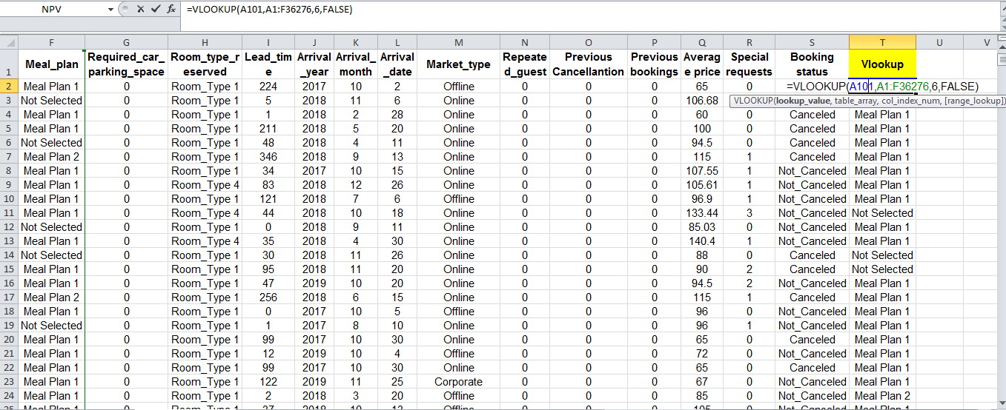
Figure: Use of Vlookup formula to find out meal type of guests (Author)
The above figure demonstrates the application of the Vlookup function in MS Excel where the meal type of each guest is found by applying the formula. It seems that the meal plan of each guest concerning their ID is shown in the rightmost column of the MS Excel file. Similar functions are Hlookup, Xlookup, etc. used in different situations and as required.
Use of Pivot table
This section of the report presents the application of Pivot table which is a widely used tool in MS Excel. A pivot table is used to summarise a large data set into different comparisons, patterns, trends, percentages, counts, summary statistics, etc (Rigby, D., 2018). These indicators help to understand the whole data set within a very short this. Moreover, the Pivot table is useful in numerical analysis of unstructured data which needs to present in a manner that is useful for the users of the dataset.
The following table shows the Pivot table output using MS Excel. A pivot table is available in the insert option of MS Excel where the existing or new worksheet can be used to draw the Pivot table. The following table shows the number of bookings, average price, and percentage of bookings for each type of room.
Types of room and booking percentage
Room_type_reserved | Number of booking | Average price | Percentage of booking
Room_Type 3 | 7 | £ 73.68 | 0.02%
Room_Type 7 | 158 | £ 155.20 | 0.44%
Room_Type 5 | 265 | £ 123.73 | 0.73%
Room_Type 2 | 692 | £ 87.85 | 1.91%
Room_Type 6 | 966 | £ 182.21 | 2.66%
Room_Type 4 | 6057 | £ 125.29 | 16.70%
Room_Type 1 | 28130 | £ 95.92 | 77.55%
Table: Use of Pivot table to find out the number of bookings and the average price of different types of rooms (Author)
It seems that the highest 77.55% of rooms are type 1 1 where the average price is GBP 95.92 and the minimum number is room type 3 which is 0.02% of total bookings with an average price of GBP 73.68. Apart from that 16.70% of room bookings are room type 4 where the average cost is GBP 125.29. So, there is a trend that the standard price rooms are booked enough compare to high and low end rooms concerning the pricing of rooms. The following figure is the graphical presentation of the Pivot table output where the largest pie is the room type 1. This chart is convenient for the users of information in decision making as a clear and simple view is available.

Figure: Use of Pivot table to find out the number of bookings and the average price of different types of room (Author)

Part 2:

2.1 Number of male and female students
The following figure shows the number of male and female students in the dataset. This number of found by applying the Pivot table technique in MS Excel. It seems that the total male is 1,077 and the total female is 1,056. So, the numbers of female students are less than number of male students.

Figure: Number of male and female students in the dataset (Author)

2.2 Qualification status for reduced or free lunch
The following table shows the number of students who qualified for free/reduced lunch and who does not qualify for the free/reduced lunch. It seems that a total of 1,215 students or 59.96% of the students do not qualify for free/reduced lunch and a total of 918 students or 43.04% of the students qualify for free/reduced lunch. So, it can be said that more than half of the students don’t qualify for reduced/free lunch which is a large number compared to total students.
Lunch | Count of Lunch | Percentage
Does not qualify | 1,215 | 56.96%
Qualifies for reduced/free lunch | 918 | 43.04%
Grand Total | 2,133 | 100.00%
Table: Number of students qualified or not for free lunch (Author)
The following figure presents the table shown in the above table. It seems that the large pie size is for students who don’t qualify for free/reduced lunch and the smaller pie is for the student who qualifies for free/reduced lunch.

Figure: Number of students qualified or not for free lunch (Author)

2.3 Mean and median of students who qualifY and do not qualify for reduced/free Lunch
The following table shows the mean and median of students who qualifies and who do not qualify for free/reduced lunch. The mean is calculated by using the MS Excel formula and for median calculation also the MS Excel formula is used. It seems that the mean for students who qualify is 45.25 and 62.29 for students who do not qualify. Furthermore, the mean for students who qualify is 44 and who do not qualifies is 62.
Qualifiers | Average | Median
Qualifies for reduced/free lunch | 45.25 | 44
Does not qualify | 62.29 | 62
Table: Mean and median for students who qualify or nor for free/reduced lunch (Author)
The following figure shows the above table outcomes by using visual tools so that users can easily understand the meaning-

Figure: Mean and median for students who qualify or not for free/reduced lunch (Author)

2.4 Mean and median differences of student's pre-test and post-test scores
The following table shows the differences in mean and median scores of students before and after the test and the final column shows the differences. It seems that after the test both the mean and median for students who qualify and students who do not qualify increases. So, there is no impact of lunch qualification on students' scores.

Qualifiers | Pre-test |  | Post-test |  | Differences
Qualifiers | Average | Median | Average | Median | Mean difference | Median difference
Qualifies for reduced/free lunch | 45.25 | 44 | 57.48 | 55 | 12.23 | 11
Does not qualify | 62.29 | 62 | 74.38 | 74 | 12.08 | 12
Table: Mean and median differences of student’s pre-test and post-test scores (Author)
The above table stipulates that with the increased benefits of lunch at a free or reduced cost, students’ scores do not improve that many raters in all aspects scores increase without any influence of free/reduced lunch facilities to the students. That is why differences are the same in both cases.

2.5 Practical example of clustering technique by using A given dataset
Clustering analysis is a widely used technique in statistical analysis to identify the data structure. This analysis tries to identify homogeneous groups of cases within a dataset. There are different clustering analyses in clustering analysis namely binary, nominal, ordinal, and scale (Albright, S.C. and Winston, W.L., 2019). The following are the steps of clustering analysis using SPSS. These are the screenshot of the work done by using the given data set in the module.
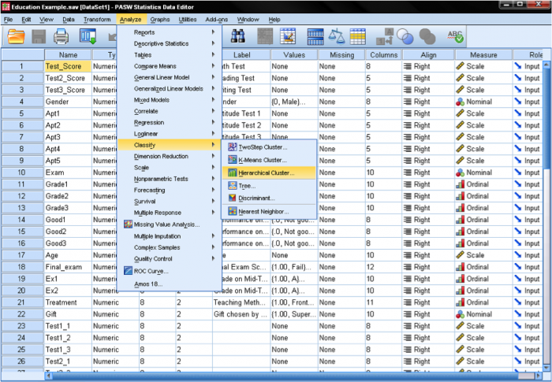
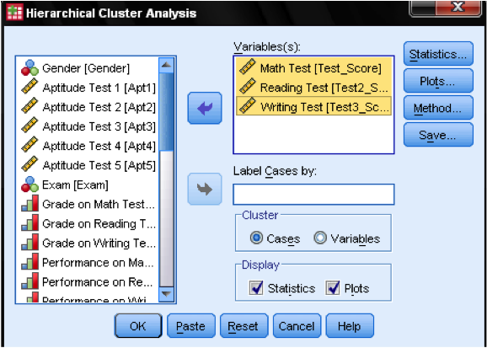
There are three basic steps in clustering analysis in SPSS namely calculating the distances between the data points (Monahan, G.E., 2020). After the first stage, a link between the clusters is prepared and then a solution is selected by selecting the right number of clusters.

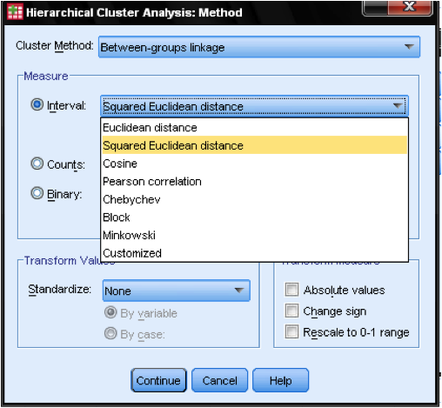
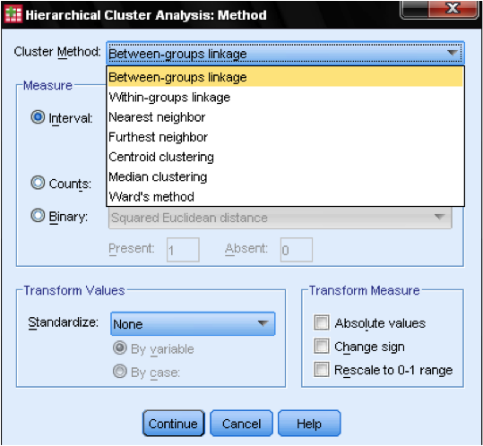

2.6 Five most useful data mining and text mining methods with example
The followings are some most useful data and text mining methods used in contemporary business-
a. Association: Data association methods are used to correlate and associate between data points which is useful in business decision making. There are two association tools namely single dimension association and multi dimension association (Bose, I. and Mahapatra, R.K., 2021). For instance, in a marketing campaign launch organisations seek the relationship between different tools and the sales revenue.
b. Classification analysis: Classification analysis is used to categorise data into different classes based on their use. Data and metadata are used to prepare different classes of data like fields, segments, etc (Duan, L. and Xiong, Y., 2017). For instance, data classification is used to categorise emails into spam, important, social, promotion, etc.
c. Data visualisation: The data visualisation tool is widely used to present data in an understandable format namely tables, graphs, charts, diagrams, etc. Business data can present in comparison charts, maps, heat maps, density plots, histograms, network diagrams, scatter plots, word clouds, etc (Albright, S.C. and Winston, W.L., 2019).
d. Information extraction: This technique is used to identify data from a large data set that focuses on entities, attributes, relationships, graphs, and charts within structured and semi-structured data (Cyert, R.M., et al., 2018). For instance, business entities use these techniques to generate useful insights from customers' browsing patterns and online shopping patterns.
e. Information retrieval: The information retrieval method is used to retrieve required data from a large dataset (Cleff, T., 2020). In modern data science, keyword search from raw data is an important aspect of data management which involves various tasks like research, library management, cyber security, etc.

2.7 Advantages and disadvantageS of using SPSS and Excel using relevant practical examples
Both MS Excel and SPSS are widely used in data analysis and business decision making. This section of the report discusses the advantages and disadvantages of MS Excel and SPSS-
Advantages and disadvantages of SPSS-
Advantages | Disadvantages
SPSS is a comprehensive statistical tool that can be used in complex data analysis situations like big data, correlated data, classified data, etc. | Users need specialized training for the optimal use of all features and interpretations.
The interpretation of the output is easy to understand so management can easily use the result in decision making. | It required funds to use the software in full pledge.
The data and tables can be easily prepared and displayed which is necessary for easy visualization (Apte, D.P., 2019). | Data visualization is not easy as MS Excel so it requires time to get used to it.
This tool can be expanded as required by the users.

Advantages and disadvantages of MS Excel-
Advantages | Disadvantages
In MS Excel data input is very easy and simple by using different tools like filtering, formatting, etc (Duan, L. and Xiong, Y., 2017). | MS Excel is not appropriate for a big dataset as the number of rows and file size is limited.
Data retrieval from a large dataset is easier in MS Excel as it allows the users to apply lookup tools to locate the required data. | In some instances it is difficult to learn MS Excel and some features like autofill are not available (Apte, D.P., 2019).
Excel functions are easy to apply in different cells of the spreadsheet and it is easy to use for all levels of users. | Some difficult features need time and care to perform the analysis for the complex dataset.
Visual tools are easy and simple for the users as they provide a clear view of the whole dataset.

Conclusion
After a comprehensive application of data analysis, data mining, data warehousing tools, and techniques it becomes clear that the use of data analysis tools and techniques is the most important for business decision making. Moreover, proper use of MS Excel and SPSS functions allows the users to present and analyse large data sets systematically and understandably. Data analysis is a crucial aspect of modern business decision-making processes. By applying data mining, data warehousing, and other analytical tools and techniques, businesses can uncover valuable insights and trends hidden within large sets of data. These insights can then be used to inform important decisions and improve overall business performance. Microsoft Excel and SPSS provide powerful functionality for organizing, manipulating, and visualizing data, making it easier for users to identify patterns and draw meaningful conclusions. In addition, effective data analysis relies on proper data management and data governance practices, such as data quality assurance, data security, and data ethics. These practices help ensure that data is accurate, reliable, and ethical, and can be used with confidence in making important business decisions.

List of references
Albright, S.C. and Winston, W.L., 2019. Business analytics: Data analysis & decision making. Cengage Learning.
Apte, D.P., 2019. Statistical tools for managers: Using MS Excel. Excel Books.
Bose, I. and Mahapatra, R.K., 2021. Business data mining—a machine learning perspective. Information & management, 39(3), pp.211-225.
Cleff, T., 2020. Exploratory data analysis in business and economics. Exploratory Data Analysis in Business and Economics. https://doi. org/10.1007/978-3-319-01517-0.
Cyert, R.M., Simon, H.A. and Trow, D.B., 2018. Observation of a business decision. The Journal of Business, 29(4), pp.237-248.
Duan, L. and Xiong, Y., 2017. Big data analytics and business analytics. Journal of Management Analytics, 2(1), pp.1-21.
Hair, J.F., Money, A.H., Samouel, P. and Page, M., 2017. Research methods for business. Education+ Training, 49(4), pp.336-337.
Kauffman, R.J., Srivastava, J. and Vayghan, J., 2020. Business and data analytics: New innovations in the management of e-commerce. Electronic Commerce Research and Applications, 11(2), p.85.
Monahan, G.E., 2020. Management decision making: Spreadsheet modeling, analysis, and application. Cambridge University Press.
Radovilsky, Z., Hegde, V., Acharya, A. and Uma, U., 2018. Skills requirements of business data analytics and data science jobs: A comparative analysis. Journal of Supply Chain and Operations Management, 16(1), pp.82-101.
Rigby, D., 2018. Management tools and techniques: A survey. California management review, 43(2), pp.139-160.

