Certificate of Higher Education in Employability Skills
Module: Digital Skills for Personal and Professional Growth
Module code: BMSW4008
Task 1 and 2
Student Name: RAMONA ELENA MIRON
Student ID Number:2421212

Table of Contents
1. Task 1: Market Research and Website Development Project 4
1.1 Circulate Questionnaire 4
1.2 Data Analysis of 4 questions for BlissBite 8
1.3 Analysis Report 11
1.4 Website 13
1.5 Marketing Materials 16
1.6 Segmentation 17
1.7 SEO strategies 18
1.8 References 19
2. Task 2: Excel Financial Projection & Digital Skills 20
2.1 Essay 20
2.2 Spreadsheet 22
2.3 References 22
3. Appendix 23
3.1 Questionnaire 23

Task 1: Market Research and Website Development Project

Circulate Questionnaire
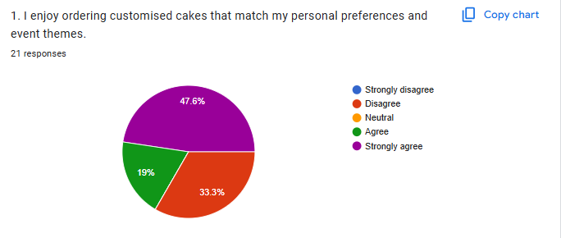
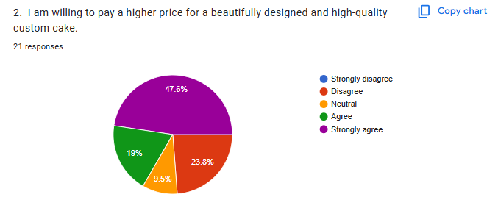
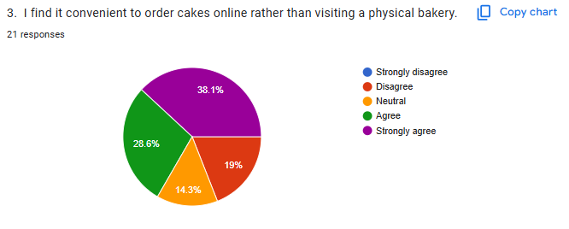

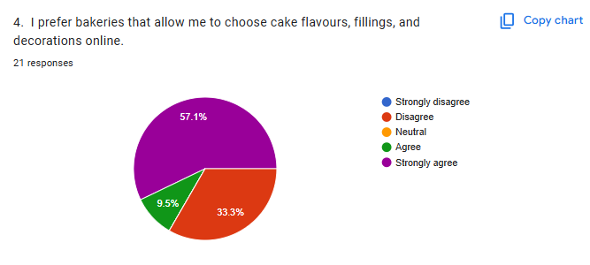
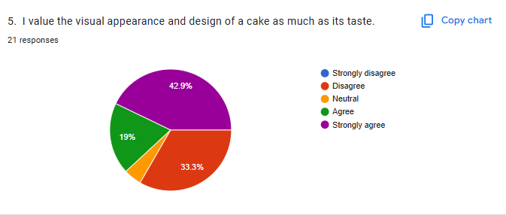
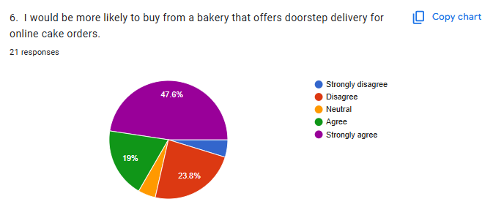
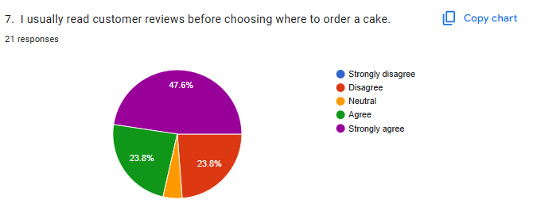
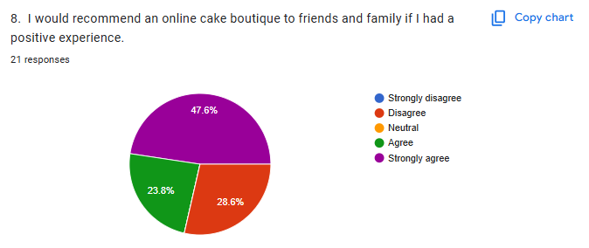
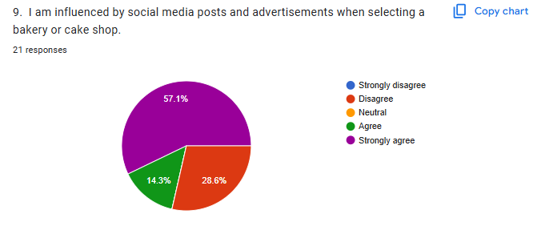
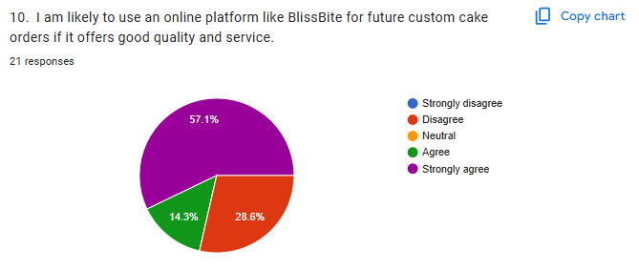

Data Analysis of 4 questions for BlissBite
- Willingness to Pay for High-Quality Custom Cakes (Question 2)
The findings demonstrate that 47.6% of the respondents strongly agree and 23.8% agree that they would be willing to pay a premium price for a beautiful design and high-quality custom cakes. Most people only disagreed with 19% and a small proportion, 9.5% were neutral. It can be assessed that the consumers are highly predisposed to the value of aestheticism and high-quality production rather than their price sensitivity, which means that the target customer of Bliss Bite would be the person who values the craftsmanship and design quality of bakery products.
Implications for Business:
BlissBite needs to position itself as a high-end online store that focuses on design art and personalisation. Because the majority of respondents are willing to pay higher, the company can introduce tiered pricing (Classic, Deluxe, and Signature) in consideration of the greater or lesser amount of detail in the design and quality of ingredients. The luxury experience and emotional value that is placed on custom cakes should be emphasised through marketing, which uses graphics to depict elaborate decorations and fancy presentation (Byrd, 2021).
- Preference for Online Cake Ordering Convenience (Question 3)
The figures demonstrate that 38.1% strongly agree and 28.6% agree that they feel finding online ordering easier than going to a bakery building. Disagreements are at 19% and the percentage of being neutral is 14.3%. This demonstrates that there is a majority of respondents who feel comfortable with online dealings in terms of cakes, meaning the increasing trend of ease and preference to convenience when it comes to time-saving cake purchases in the modern fast-paced world.
Implications for Business:
BlissBite ought to invest in an intuitive, eye-catching website with easy navigation options, live customisation options, and a safe form of payment. The focus on home delivery, convenient communication, and live order tracking will address the expectations of customers. The value of digital convenience is also relatively high, so marketing BlissBite by using SEO and social media advertisements with an emphasis on easy online ordering of cakes will ensure the company develops a more substantial online presence and attracts contemporary buyers who are interested in quick and quality services (Dadwal, 2020).

- Importance of Cake Design and Visual Appeal (Question 5)
Findings indicate that 42.9% of the respondents strongly support and 19% support that the design and look of cakes are equally relevant as their taste, whereas 33.3% do not support it. This implies that most customers pay a lot of attention to aesthetics, and cakes are viewed as a food item and an event centerpiece (Soltanifar et al., 2021). A significant number of them, however, still value taste as the priority, which implies that BlissBite will have to juggle the creativity in design with the quality of flavours.
Implications for Business:
BlissBite needs to emphasise its artistic cake design by displaying professional photographs and bright web images with the help of a gallery where one can see custom-made decorations for various events. Because there are also customers who regard taste as equally important, the business ought to make sure that recipes are pleasant, as well as being attractive. The marketing materials must also focus on the fact that BlissBite is bringing beauty with flavour, developing cakes that are as delicious as they appear to please both groups of people.
- Likelihood of Recommending an Online Cake Boutique (Question 8)
The results show that 47.6% of the participants strongly agree and 23.8% of them agree that they would recommend an online cake boutique to their friends or family members based on a positive experience, and 28.6% of them do not agree. This shows that customer satisfaction and service quality greatly determine loyalty and referrals. Good experiences may easily become a form of word-of-mouth marketing, which is very effective in developing a reputation and trust in the online bakery industry (Rabindranath and Singh, 2024).
Implications for Business:
Exceptional customer experiences are another priority that BlissBite must have, including delivery on time, quality packaging, and customer responsiveness. To capitalise on recommendations, the brand may consider a referral or loyalty programme where customers receive rewards for recommending the brand or introducing new customers (Sandhu, 2020). The regularity of the quality of the services and after-sales follow-up will assist in turning satisfied clients into brand supporters, increasing the online presence and reputation of BlissBite through real promotion by customers.

Analysis Report
The responses of the questionnaire were very illuminating about consumer attitudes and their preference in the purchasing of custom cakes online, as well as the preferences in taking orders online and consumer loyalty. As they reflect the most relevant trends in the digital business model and market positioning of BlissBite, four questions were chosen to analyse. The results indicate that 47.6% and 23.8% of the participants strongly agreed and agreed, respectively, that they are ready to pay more to get a high-quality, beautifully designed custom cake. This indicates that the customers perceive cakes not as a food commodity but as an emotional and aesthetic experience in the case of celebrations (Alba-Martínez et al., 2022). Tiered pricing strategy where BlissBite will focus on mid-range and high-end consumers was therefore the most appropriate pricing strategy. The same insight was used to create marketing content in Canva, which focuses on the artisanal, sophisticated ornament, and luxury by using high-resolution images and a cordial, festive mood.
Regarding the ease of placing orders online, 38.1% had a strong agreement, and 28.6% had a deal that digital ordering is more straightforward than going to physical bakeries. This confirms the e-commerce orientation of BlissBite as there is a high consumer acceptance of digital communication in the bakery business (Reedy and Parker, 2017). The site was thus built to incorporate basic navigation, customisation of the site, and a responsive order form to facilitate user experience. Other keywords that received priority in the SEO strategies to reach the digital audience identified in the research included online cake boutique, custom cakes UK, and home delivery cakes (Burgess et al., 2018). There was also the aesthetic value, which also became final; 42.9% strongly agreed and 19% agreed with the statement that design and visual appeal are as important as taste. This observation influenced the development of the product and presentation on the internet.
Lastly, customer loyalty was in the case of 47.6% strongly agree and 23.8% agree that they would recommend an online cake shop after having a positive experience. It means that the word-of-mouth potential is high, and BlissBite must provide a referral programme and a feedback option on the site. Promotional content and resources thus promote sharing and collective interaction, which strengthens the emotional attachment to the brand (Pinto and Pinto, 2020). In general, the lessons learned in this instance show that the idea of BlissBite fits the customers perfectly regarding the quality and convenience, as well as innovativeness and creativity. The results were directly applied to the functionality and brand appearance of the websites, as the BlissBite is capable of turning the market research into a well-planned business and online strategy.

Website
https://blissbiteboutique.weebly.com/
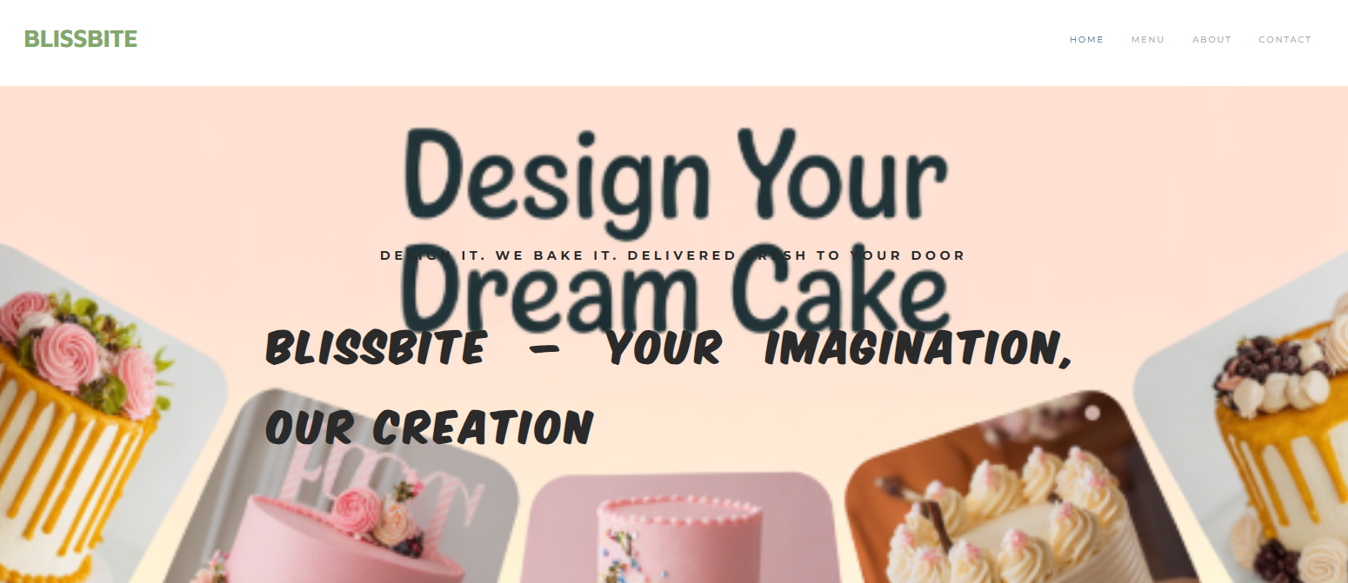
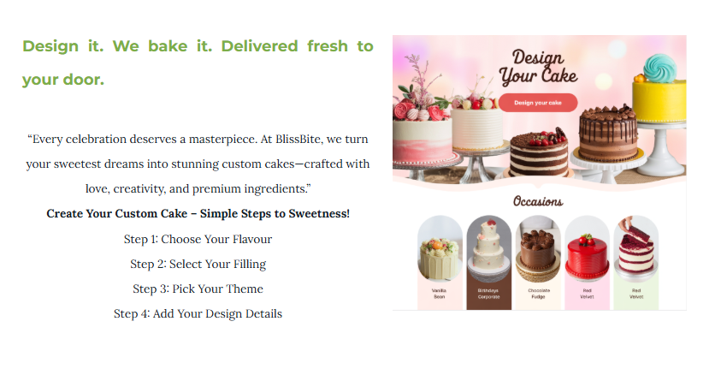
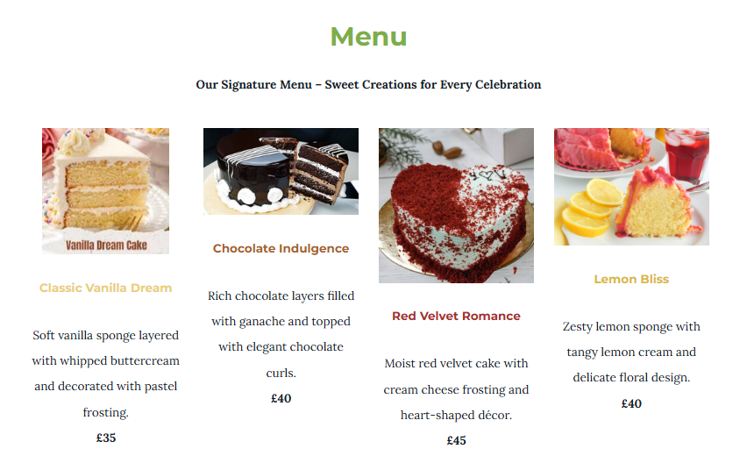
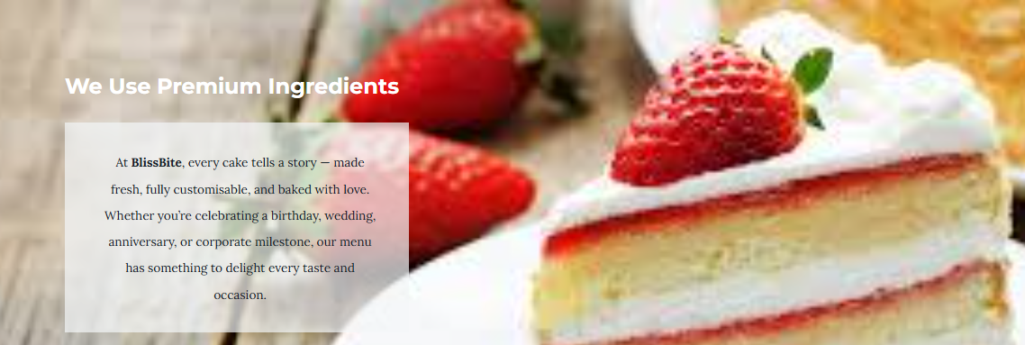
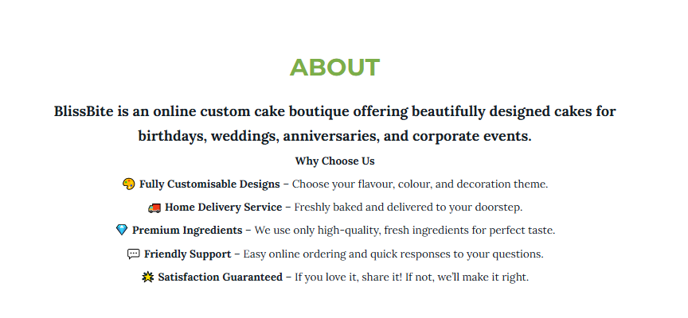
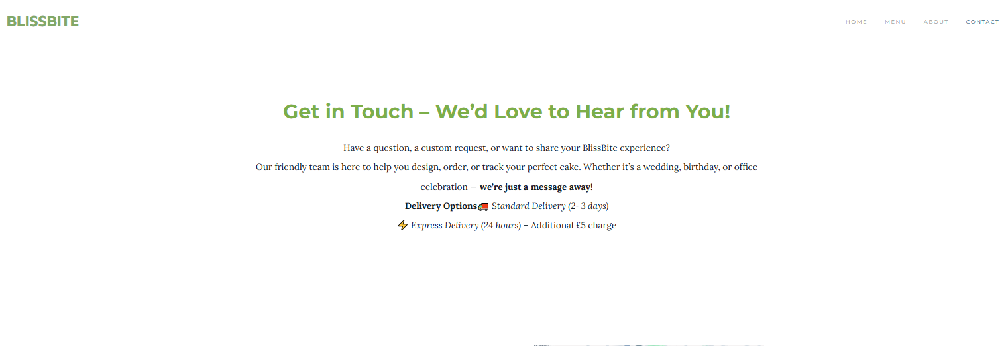

Marketing Materials


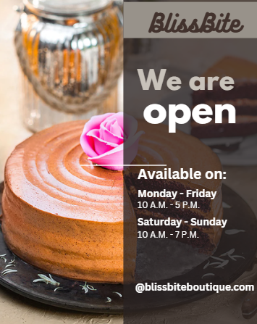

Segmentation
 | 
 | Targets adults aged 18–45, primarily middle- to upper-income individuals who purchase cakes for birthdays, weddings, or corporate events. This group values quality, aesthetics, and convenience.
 | Focused on urban areas across the UK, particularly cities like London, Manchester, and Birmingham, where online delivery services are in high demand.
 | Appeals to customers who enjoy personalised experiences, appreciate artistic cake designs, and associate desserts with emotional and social celebrations.
 | Aims at customers who frequently order online, are willing to pay for premium quality, and are likely to recommend BlissBite after positive experiences.

SEO strategies
As a way of making online presence more prominent and targeting the correct target audience, BlissBite utilises a narrow Search Engine Optimisation (SEO) strategy. According to the insights of the questionnaire on the presence of intense interest in ordering online, such words as custom cakes UK, online cake boutique, birthday and wedding cakes, and order cakes online are implemented throughout the website content. The optimisation of product images is done in terms of Meta descriptions and alt-texts that enhance the position in the search results (Olivetti and de Freitas Melo, 2024). Regular posting of blogs on cake trends, cake flavour, and ideas for a celebration is part of organic traffic. All these strategies enlarge the online presence, enhance the digital presence, and transform the site visitors into regular customers of BlissBite.

References
Alba-Martínez, J., Bononad-Olmo, A., Igual, M., Cunha, L.M., Martínez-Monzó, J. and García-Segovia, P. (2022). Role of Visual Assessment of High-Quality Cakes in Emotional Response of Consumers. Foods, 11(10), p.1412.
Burgess, J., Poell, T. and Marwick, A.E. (2018). The SAGE handbook of social media.
Byrd, L.S. ed. (2021). Cultivating Entrepreneurial Changemakers Through Digital Media Education. IGI Global.
Dadwal, S.S. ed. (2020). Handbook of research on innovations in technology and marketing for the connected consumer. IGI Global.
Olivetti, J.F.H. and de Freitas Melo, P. (2024), October. Through the Eyes of Instagram: Analyzing Image Content utilizing Meta's Automatic Alt-Text. In Brazilian Symposium on Multimedia and the Web (WebMedia) (pp. 275-282). SBC.
Pinto, F.M. and Pinto, C.C. (2020). Country Marketing Strategy: A Low-Cost Digital Marketing Proposal for Cabo Verde. In Digital Marketing Strategies and Models for Competitive Business (pp. 131-159). IGI Global.
Rabindranath, M. and Singh, A.K. (2024). Advertising Management. Springer Books.
Reedy, K. and Parker, J. (2017). Digital literacy unpacked. Facet.
Sandhu, K. ed. (2020). Digital Transformation and Innovative Services for Business and Learning. IGI Global.
Soltanifar, M., Hughes, M. and Göcke, L. (2021). Digital entrepreneurship: Impact on business and society (p. 327). Springer Nature.

Task 2: Excel Financial Projection & Digital Skills

Essay
Introduction
With the current digital age, data has emerged as one of the most important assets to both people and companies (Gawer, 2022). Efficiency in gathering, analysing, and interpreting information effectively is one of the key success factors in keeping up with competition and enhancing decision-making (Adewusi et al., 2024). One of the most helpful and available tools to achieve this task is Microsoft Excel. With more and more companies using technology in performance planning, tracking, and reporting, the ability to have an organising, calculating, and visualising function of data enables Excel to become an essential part of business. Excel offers a low-cost method of ensuring finances, tracking sales patterns, and projecting future performance in the case of small companies like BlissBite - Online Custom Cake Boutique (Al Maruf et al., 2022). It is flexible, which gives entrepreneurs the chance to make knowledgeable and data-driven choices that would directly contribute to the profitability and expansion.
Main Body
The primary significance of the use of Excel is its capacity to analyse high volumes of data with the help of the programme and the possibility to provide accurate and fast outcomes (Okoli et al., 2022). It allows companies to document, tabulate, and examine financial transactions without having to use costly programmes or intricate spreadsheets. It allows the user to automate repetitive computations using formulas such as SUM, AVERAGE, and IF which reduce human error, and use less time. The use of Excel that will be applied in the case of BlissBite to track the sales, expenses, and profits made every month will help visualise the performance of the business over time. As soon as data is entered in the period January-Dec, BlissBite would be able to identify the pattern of the revenue and the areas that need to be enhanced. Taking the projection table of finances as an example, one can see how the income is projected to rise to a level of £2300 in Dec, when the profits had already gone up to £1360. With this, strategic planning and establishment of the effectiveness of the marketing campaigns or price adjustment can be established.
The ability to perform data visualisation is also another important use of Excel in the digital era (Zakaria, 2021). There are charts, graphs, and conditional formatting features that enable complex numerical data to be converted to visual trends, which can be easily interpreted. BlissBite will be able to develop a bar chart of income and expenses over one year to evaluate the financial health rapidly. The visual representation has simplified the process of business owners tracking the seasonal changes in sales, performance goals, and reporting financial performance to stakeholders or partners.
In addition, Excel aids in forecasting and budgeting, which are essential in future planning (Al Maruf et al., 2022). The trendline and projection tools in Excel allow BlissBite to project the possible sales growth and resource requirements in the coming months upon analysing the past financial data. Predicting would help manage inventory, need to plan the quantity of ingredients required to prevent shortage or waste, and also set the best pricing mechanisms during the high seasons such as weddings or holidays (Kayikci et al., 2022). Excel also enables the business to utilise scenarios or simulate what would occur in the event of different circumstances such as the projection of profits in case ingredient prices rise or the introduction of new marketing programmes (Rees, 2023). Such futuristic vision enables BlissBite to be agile and operational in the competitive market.
Conclusion
In conclusion, Microsoft Excel remains one of the most important tools in the digital age to handle, process and display business information. It is also multi-purpose and has a wide range of operations such as budgeting and forecasting, performance monitoring, and decision-making. Excel provides financial control, optimising costs, and growth planning in BlissBite case, Online Custom Cake Boutique, and Excel. With effective monitoring of the monthly revenues and costs and profits, the company can make good decisions on the way to efficiency and profitability. The visualisation and prediction characteristics also allow BlissBite to forecast the changes in the market and respond in a strategic manner.
Finally, Excel allows small businesses to survive in a world of technology, transforming data into actionable intelligence and making sure that all decisions move the company towards sustainable success.

Spreadsheet

References
Adewusi, A.O., Okoli, U.I., Adaga, E., Olorunsogo, T., Asuzu, O.F. and Daraojimba, D.O. (2024). Business intelligence in the era of big data: a review of analytical tools and competitive advantage. Computer Science & IT Research Journal, 5(2), pp.415-431.
Al Maruf, A., Paul, R., Imam, M.H. and Babar, Z. (2022). A Systematic Review of The Role Of SQL And Excel In Data-Driven Business Decision-Making For Aspiring Analysts. American Journal of Scholarly Research and Innovation, 1(01), pp.249-269.
Gawer, A. (2022). Digital platforms and ecosystems: remarks on the dominant organizational forms of the digital age. Innovation, 24(1), pp.110-124.
Kayikci, Y., Demir, S., Mangla, S.K., Subramanian, N. and Koc, B. (2022). Data-driven optimal dynamic pricing strategy for reducing perishable food waste at retailers. Journal of cleaner production, 344, p.131068.
Okoli, I., Akinboboye, O., Frempong, D., and Omolayo, O. (2022). Optimizing academic operations with spreadsheet-based forecasting tools and automated course planning systems. International Journal of Multidisciplinary Research and Growth Evaluation, 3(4), pp.658-674.
Rees, M. (2023). The Essentials of Financial Modeling in Excel: A Concise Guide to Concepts and Methods. John Wiley & Sons.
Zakaria, M.S. (2021). Data visualization as a research support service in academic libraries: An investigation of world-class universities. The Journal of Academic Librarianship, 47(5), p.102397.

Appendix

Questionnaire
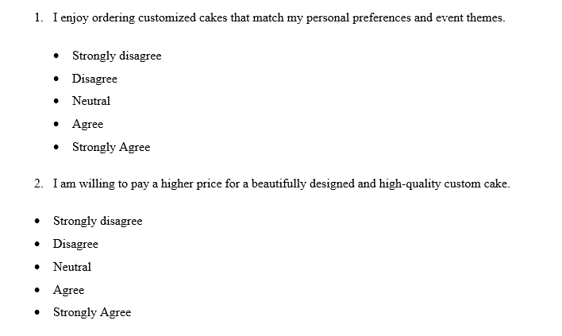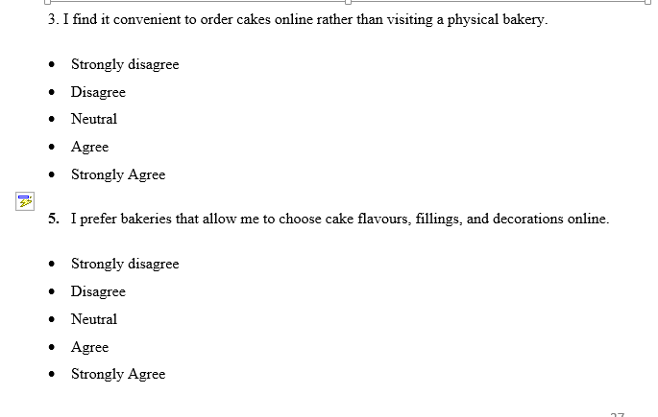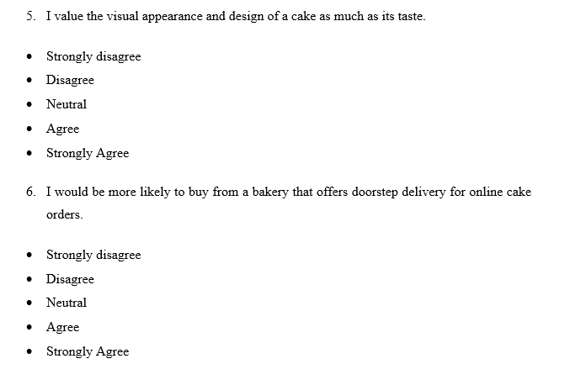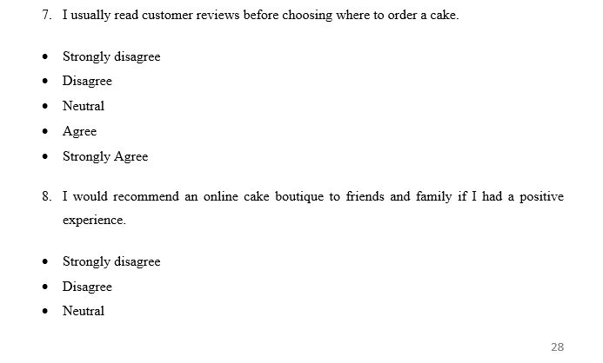
- Agree
- Strongly Agree


