

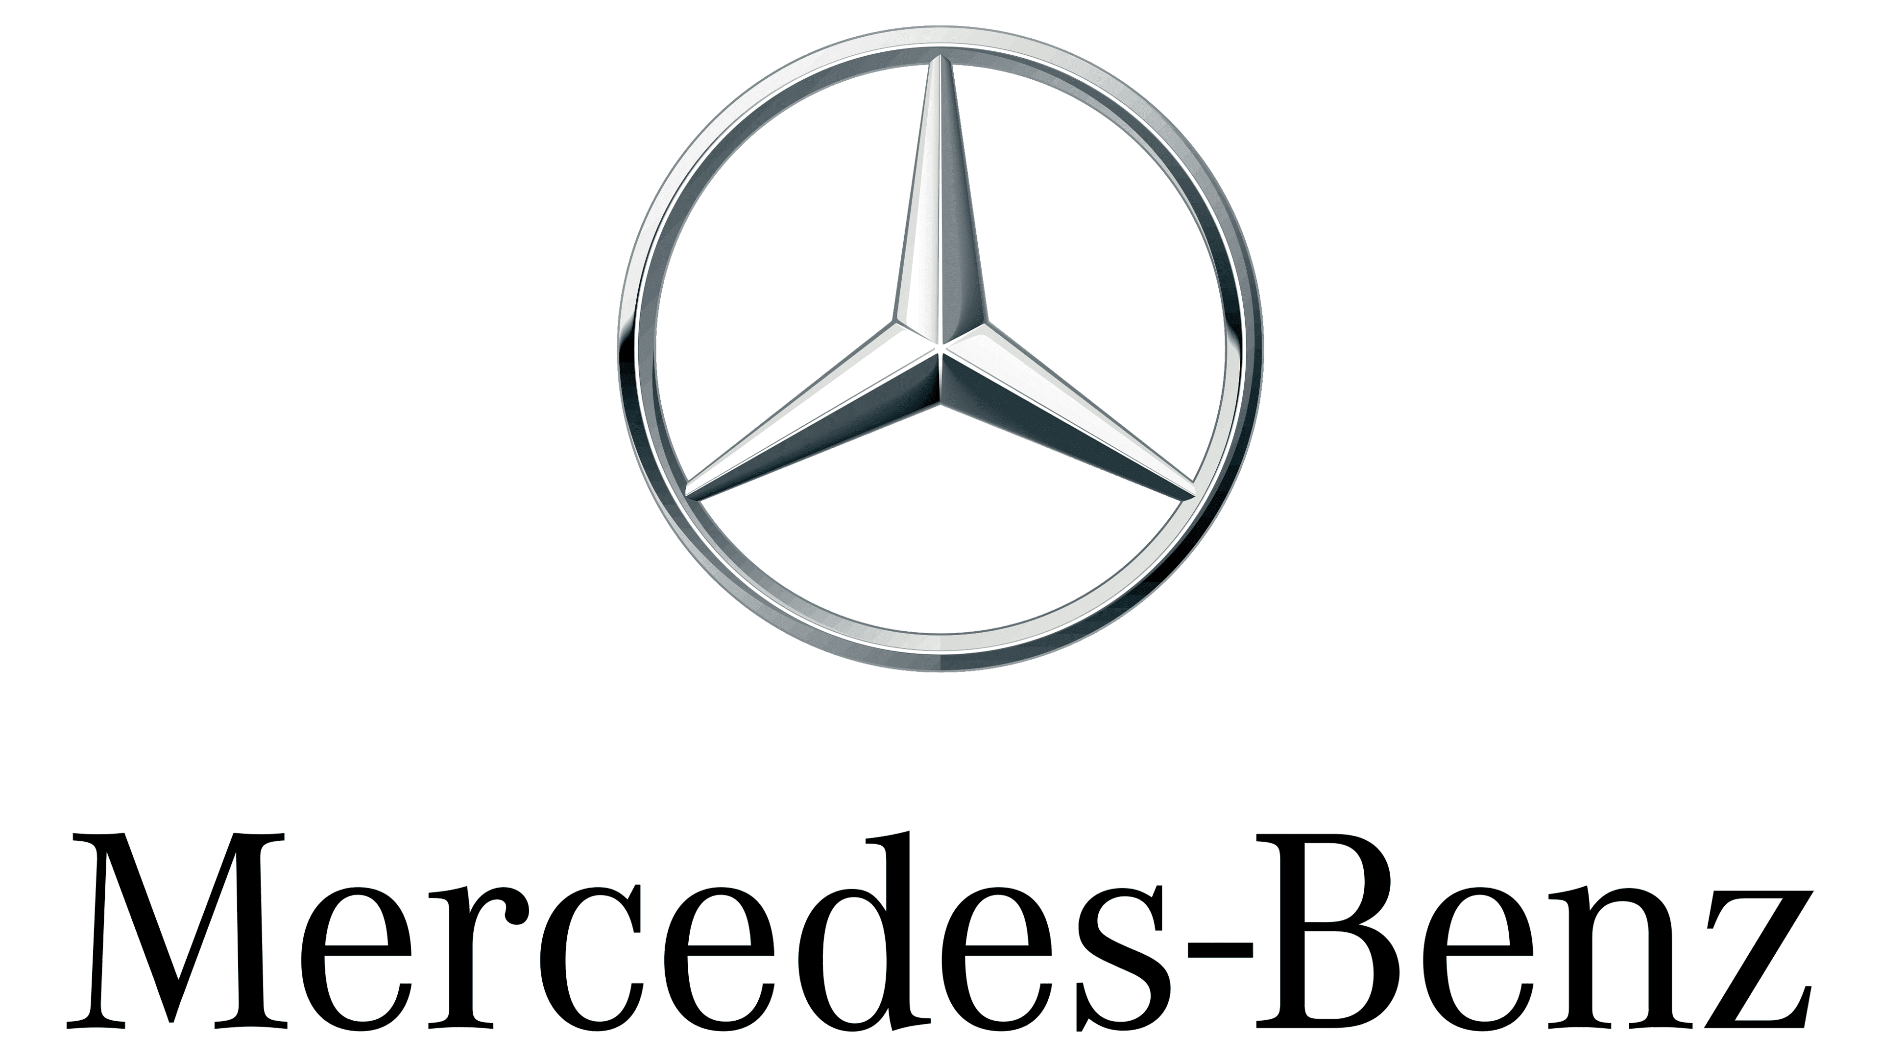
International Marketing Assignment

Name : Ramanpreet Kaur
Student ID : 2226502
Module Name : International Marketing
Module Code : LCMB7006
Lecturer : Tushara Balendran

CONTENTS
Introduction………………………………………………………………………..3
Company Background……………………………………………………………..4
Analysis of Mercedes Benz Macro Environment………………………………….5
PESTEL Factors……………………………………………………………………5
HOFSTEDE Module of cultural Dimension……………………………………….7
Country Comparison Germany and United Kingdom……………………………...8
Porter’s Five Forces……………………………………………………………….14
Benefits of Applying Porter’s Five Forces Situational Model…………………….18
SWOT Analysis Highlighting Mercedes Benz Strengths, Weaknesses, Opportunities and Threats in Germany and UK Markets…………………………19
Mercedes Benz Marketing Mix Elements and Market Segmentation Strategies…23
Mercedes Benz Market Entry Methods…………………………………………...27
Advantages and Disadvantages of Chosen Entry Methods………………………29
Directional Development Strategy……………………………………………......33
Ansoff Matrix…………………………………………………………………......35
Recommendation………………………………………………………………….36
Conclusion………………………………………………………………………...37
References………………………………………………………………………...39

Introduction
Mercedes-Benz is one of the world's leading premium car manufacturers and a symbol of automotive excellence. Mercedes-Benz is widely recognized for its dedication to innovation, high quality, and a long history spanning more than a century. The brand has come to represent luxury, performance, and state-of-the-art technology. (Statista, 2018)
Historical Legacy:
Karl Benz invented the first gasoline-powered car in 1886, while Gottlieb Daimler and Wilhelm Maybach created the Mercedes automobile in the same year. The brand was founded in 1926. The union of these two innovative businesses gave rise to the Mercedes-Benz brand, whose influence now permeates the automotive sector. (Mercedes- Benz, n.d)
Engineering Excellence:
Mercedes-Benz has always raised the bar for engineering skill and technological breakthroughs. Pushing the limits of what's possible in the automotive industry, the brand is known for its innovative safety measures as well as its design and performance improvements.
Luxury and Design:
Mercedes-Benz interiors are characterized by excellent craftsmanship and meticulous attention to detail. The brand's dedication to luxury is demonstrated using premium components, elegant design features, and cutting-edge technology. Mercedes-Benz vehicles are a fusion of engineering and artistry, not just means of mobility. (Mercedes- Benz, n.d)
Innovation and Sustainability:
Mercedes-Benz has led the way in automobile innovation, emphasizing environmentally friendly and sustainable technologies. The company's commitment to a cleaner future is reflected in its electric and hybrid vehicles, which don't sacrifice style or performance.

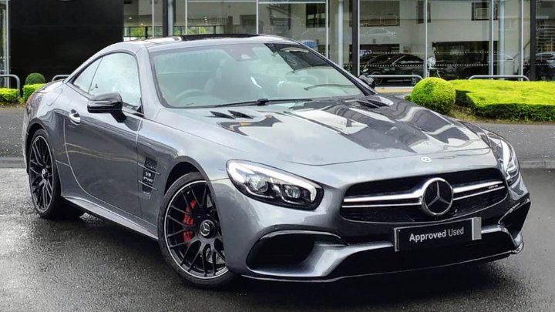
(Source: Mercedes-Benz, n.d)

Company Background: Mercedes-Benz
Foundation and Early Years:
The innovative work of two automotive visionaries, Karl Benz, and Gottlieb Daimler is the source of the world-famous luxury car manufacturer Mercedes-Benz. Karl Benz is credited with creating the first gasoline-powered vehicle in 1886, and Wilhelm Maybach and Daimler soon followed with the creation of the first Mercedes vehicle. The legendary Mercedes-Benz brand was created in 1926 because of the amalgamation of these two innovative businesses.
Founders:
Karl Benz (1844–1929): Engineer and inventor, known for developing the first usable vehicle.
Founder of Daimler-Motoren-Gesellschaft (DMG) and creator of the Mercedes brand, Gottlieb Daimler (1834–1900) was a pioneer in the automotive industry.
Historical Milestones:
The Motorwagen, regarded as the first gasoline-powered car, is patented by Karl Benz in 1886.
1901 saw the introduction of the Mercedes 35 HP, a car with a design that would later have an impact on automotive innovation.
1926: Mercedes-Benz is formed through the combination of Daimler-Motoren-Gesellschaft and Benz & Cie.
Global Expansion and Innovation:
Mercedes-Benz has pioneered a few ground-breaking technology and design ideas, placing it at the forefront of automotive innovation. The brand has maintained its position as a leader in the premium car market thanks to its dedication to safety, performance, and luxury.
Key Elements of Mercedes-Benz:
Luxury and Craftsmanship: Mercedes-Benz automobiles are renowned for their dedication to luxury and are equipped with fine materials, innovative design, and precise craftsmanship.
Innovation and Technology: Throughout its existence, Mercedes-Benz has been known for its constant innovation in connection, engine technology, and safety measures.
Performance: The Mercedes-AMG brand's high-performance cars are the epitome of elegance combined with power.
Environmental Responsibilities:
Mercedes-Benz has made a commitment to environmental responsibility and sustainability. The company's commitment to an environmentally friendly automotive future is demonstrated by its development of electric and hybrid vehicles.
Analysis of Mercedes-Benz Macro environment
Mercedes-Benz must consider a variety of aspects when analyzing the macroenvironment in the UK and Germany, including the legal system, the economy, society, technology, and the environment. (Statista, 2020)
Pestle factors for UK:
Political:
Government Policies: The political stability of the UK affects the auto sector. Benz activities may be impacted by laws pertaining to safety, emissions, and trade agreements with the EU.
Favorable:
- Stable political climate following Brexit.
- The Commonwealth of Nations membership opens trading prospects.

Unfavorable:
- Trade agreements and post-Brexit regulatory reforms uncertainties.
Economical:
Economic Stability: In the UK, the state of the economy and consumer confidence can have an impact on auto sales. Consumer expenditure on luxury vehicles may decline during economic downturns. (Eurostat, 2020)
Exchange Rates: Manufacturing costs and the dynamics of import/export can be impacted by fluctuations in currency exchange rates, particularly those associated with Brexit.
Favorable:
- Strong purchasing power of the consumer.
- Expanding market in the UK for premium cars.
Unfavorable:
- Uncertainties in the economy and possible effects on consumer expenditure.
Social:
Customer Preferences: Product development tactics may be impacted by social trends, such as a demand for digital amenities and eco-friendly automobiles.
Demographics: Benz's marketing and sales efforts may be impacted by population patterns like urbanization or ageing. (Statista, 2020)
Favorable:
- A varied customer base with a preference for high-end labels.
- Mercedes-Benz's values are in line with the emphasis on sustainability.
Unfavorable:
- Customer preferences are changing, particularly in reaction to difficult economic times.
Technological:
Developments in Electric Vehicles: Benz's product development and market positioning are impacted by the UK's drive towards electric vehicles and technology advancements.
Digitalization: To satisfy customer expectations, it is essential to integrate digital technologies into cars and sales procedures.
Favorable:
- Cutting-edge infrastructure for technology that fosters innovation.
- Customers with high-tech skills.
Unfavorable:
- Technology is changing quickly, necessitating constant investment and adaptability.
Legal:
Regulatory Compliance: It's critical to follow UK car laws, safety requirements, and emission guidelines.
Brexit Impact: Benz's supply chain and cost structures may be impacted by modifications to trade laws and prospective levies following Brexit.
Favorable:
- Adherence to the laws and regulations of the UK.
- There are laws protecting consumers.
Unfavorable:
- Prospective modifications to laws and difficulties with compliance after Brexit.
Environmental:
Emission Regulations: Benz is concentrating on environmentally friendly and sustainable car technologies due to stricter emission regulations.
Corporate Social Responsibility (CSR): Socially conscious production and activities are in demand by consumers.
Favorable:
- Increasing focus on sustainability of the environment.
- Adherence to environmental laws.

Unfavorable:
- More strict environmental laws could make compliance more difficult.

Pestle factors for Germany:
Political:
Government Stability: Germany's general business climate is influenced by political stability.
Government Support: Benz may profit from policies that assist the automotive sector, particularly in research and development.
Favorable:
- The political climate in the European Union is stable.
- Supportive of a stable business environment.
Unfavorable:
- Possible political shifts or difficulties pertaining to the EU that could affect the automotive sector.
Economical:
Economic Growth: The demand for luxury cars and consumer purchasing power are impacted by Germany's economic situation.
International Trade: Germany's trade policy and relationships with important markets have an impact on Benz as a significant exporter.
Favorable:
- German consumer wealth and the economy are strong.
- A solid market for high-end cars.
Unfavorable:
- Economic downturns have an impact on how much consumers spend on high-end goods.
Social:
Culture and Lifestyle: Mercedes's marketing and product tactics are influenced by the German consumers' strong preference for quality and performance.
Urbanization: Growing urbanization may influence people's preferences for electric or compact cars.
Favorable:
- Strong cultural feelings for premium cars and fine engineering.
- A focus on innovation and quality.
Unfavorable:
- Desires for luxury products are impacted by changes in societal attitudes.
HOFSTEDE Module of cultural Dimension
A framework for comprehending cultural variations among various countries is Hofstede's Cultural Dimensions Theory. (Daimler, 2018) Power Distance, Individualism vs Collectivism, Masculinity vs Femininity, Uncertainty Avoidance, Long Term Orientation vs Short Term Normative Orientation, and Indulgence vs Restraint are the six dimensions that are identified. Here is an examination of these dimensions within the Mercedes-Benz setting, taking Germany and the UK into account. (C. W., & Jones, G. R. 2020)
Country comparison between UK and Germany
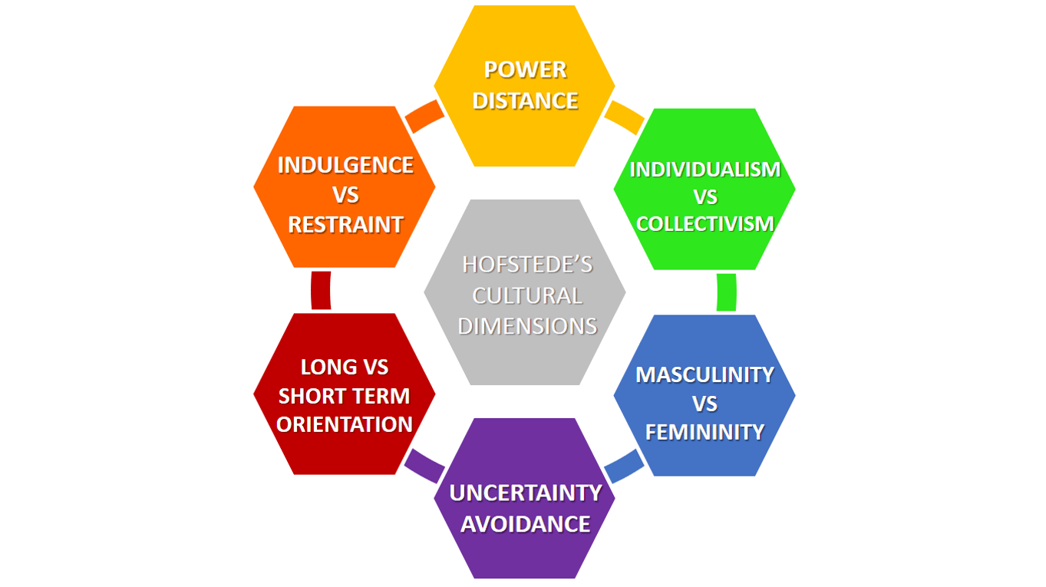
(Source: Business to you)

Power Distance:
UK:
- In general, the power distance is lower in the UK.
- Equal rights are expected, and decision-making processes should take a more collaborative approach. (Mercedes-Benz, n.d)
- What this means for Mercedes-Benz It might be well appreciated to have a decentralized and participatory management style.

Germany:
- Germany typically has a reduced power distance, indicating a more equitable allocation of electricity. (Eurostat.com, 2020)
- Open communication and decentralized decision-making are expected in the workplace.
- Mercedes-Benz should take note of this and prioritize open lines of communication and cooperative decision-making.
Individualism:
UK:
- Individualism is prevalent in the UK, where emphasis is placed on self-actualization and independence.
- In some situations, collectivist values are in balance.
- What this means for Mercedes-Benz tailored advertising that draws attention to unique qualities and advantages.
Germany:
- Germany's individuality score is comparatively high.
- The emphasis is on individual growth and self-reliance.
- What this means for Mercedes-Benz Rewards based on achievement and individual recognition could be powerful motivators.
Masculinity:
UK:
- The UK values success and performance and has a tendency towards masculinity.
- Work-life balance and quality of life are two examples of feminine values that are balanced.
- What this means for Mercedes-Benz Marketing messaging can highlight characteristics of lifestyle as well as performance.
Germany:
- Germany emphasizes accomplishment, assertiveness, and material success, with a tendency towards masculinity.
- Feminine ideals, like concern for the environment and quality of life, are balanced.
- Mercedes-Benz should take note of this: marketing and organizational culture should place equal emphasis on performance and quality of life factors.

Uncertainty Avoidance:
UK:
- The UK's uncertainty avoidance index is rather low.
- Both a willingness to take chances and a tolerance for ambiguity are present.
- What this means for Mercedes-Benz Adaptability to shifts in the market and an eagerness to try new things.
Germany:
- Germany's uncertainty avoidance index is comparatively low.
- Both the willingness to take chances and the tolerance for uncertainty are stronger.
- What this means for Mercedes-Benz willingness to take measured risks and adaptability to changes in the market.
Long Term Orientation:
UK:
- A short-term normative orientation is common in the UK.
- There is an emphasis on the here and now and a readiness to change swiftly.
- Mercedes-Benz should be nimble in adapting to consumer preferences and market changes.
Germany:
- Germany is known for its long-term outlook.
- Future-focused planning, tenacity, and frugal living are emphasized.
- Mercedes-Benz should prioritize long-term strategic planning, long-lasting products, and devoted customers.
Indulgence:
UK:
- The UK emphasizes enjoyment of life and leisure, with a tendency towards indulgence.
- Under some circumstances, there is a balance with restraint.
- What this means for Mercedes-Benz Advertisements might emphasize how fun and opulent the cars are.
Germany:
- Germany emphasizes self-discipline and rigid societal rules, leaning towards moderation.
- There is moderation when it comes to some forms of pleasure.
- What this means for Mercedes-Benz Promotional materials might highlight the useful qualities and attributes of the cars.

Advantages of Hofstede Model | Disadvantages of Hofstede Model
- Cross-Cultural Understanding: Mercedes-Benz uses Hofstede's methodology to better identify and manage cultural variations among its diverse worldwide workforce, clients, and stakeholders. (Mercedes-Benz, n.d)  - Strategic Decision-Making: Strategic decision-making, including marketing plans, product positioning, and managerial techniques adapted to cultural contexts, can be influenced by cultural factors.  - Human Resource Management: Recognizes and considers cultural preferences for motivation, communication, and leadership styles, which aids in managing and inspiring a varied workforce. (Mercedes-Benz, n.d)  - Global Brand Consistency: Helps create a uniform worldwide brand image by taking cultural preferences into account and preventing unintentional cultural conflicts in marketing initiatives.  - Negotiation and Business Relations: Improves negotiating abilities and cultivates favorable corporate relationships by comprehending cultural perspectives on individualism, hierarchy, and uncertainty.  - Training and Development: Directs the creation of staff cross-cultural training programs, enhancing their ability to function effectively in various cultural contexts. (Mercedes-Benz, n.d) | - Cultural Stereotyping: Because the concept generalizes cultural qualities for entire nations while ignoring individual variances within cultures, it may result in oversimplification and stereotyping.  - Dynamic Nature of Culture: Culture is ever-changing and dynamic. The model may not be able to keep up with the quick changes in culture, particularly in the globalized world of today.  - National vs. Organizational Culture: The model's primary focus on national cultures may not adequately capture the nuances of organizational cultures, particularly in global corporations such as Mercedes-Benz. (Mercedes-Benz, n.d)  - Individual Differences: Individual distinctions within a culture are important, and differences in beliefs, values, and behaviors amongst members of the same cultural group may not be considered by the model.  - Neglect of Other Cultural Models: If one only uses Hofstede's model, they can miss out on other cultural frameworks and aspects that could shed more light on cross-cultural dynamics.  - Limited Contextual Specificity: Because the model is not context-specific, its implementation might not consider certain historical, economic, or industry-specific elements that influence cultural behaviors in each setting. (Mercedes-Benz, n.d)

Technological:
Innovation Hub: Benz benefits from the cutting-edge automotive research and development ecosystem in Germany, which is a technology hub.
Industry 4.0: Supply chain management and manufacturing include Industry 4.0 techniques.
Favorable:
- The reputation of Germany as a leader in technology.
- Conformity to Mercedes-Benz's dedication to cutting-edge automotive technologies.
Unfavorable:
- Quick developments in technology necessitate ongoing investment.
Legal:
Regulatory Compliance: Following EU and German car laws, safety requirements, and emission guidelines.
Labor Laws: Adherence to German labor laws and regulations that impact the management of the workforce.
Favorable:
- Adherence to the existing legal and regulatory frameworks of the EU.
- Respect for international safety and quality requirements.
Unfavorable:
- Possible legal issues pertaining to safety concerns, regulatory changes, or product recalls.
Environmental:
Green Initiatives: Germany's emphasis on environmentally sustainable technologies is in line with Benz's dedication to environmental sustainability.
Recycling Requirements: End-of-life vehicle compliance with recycling and waste management requirements.
Favorable:
- Germany is a sustainability leader.
- Investments in hybrid and electric car technology.
Unfavorable:
- More stringent environmental laws could make compliance more difficult.
Similarities and Differences Stated relation to PESTLE factors for UK and Germany
Political:
Similarities: As members of the European Union (EU), Germany and the UK adhere to similar political norms and rules. Eurostat (European Commission, 2023)
Differences: A new set of political dynamics and possible modifications to trade agreements have been brought about by the UK's decision to leave the EU, or Brexit.
Economic:
Similarities: Due to their robust economies and importance as premium car markets, both nations offer Mercedes-Benz sizable customer bases.
Differences: Economic conditions and policies may differ, and Brexit's effects may have different effects on the UK's economy than it does on Germany's.
Social:
Similarities: Germany and the UK both have a fondness for luxury automobiles and superior engineering. Eurostat (European Commission, 2023)
Differences: Consumer tastes and behaviors may differ depending on the specific cultural and economic context.

Technological:
Similarities: Both nations have highly developed technological infrastructures that foster creativity, which is consistent with Mercedes-Benz's dedication to developing cutting-edge automotive technologies.
Differences: There may be differences in the UK and Germany regarding the rate of technological adoption and certain regulatory regimes.
Legal:
Similarities:
- Despite the UK's exit from the EU, Germany, and the UK both remain abide by several EU laws, particularly those pertaining to emissions and vehicle safety.
- Strong consumer protection regulations that oversee the automotive sector in both nations guarantee consumers' rights and safety. (UK Government Brexit Guidance, 2023)

Differences:
- The UK will have the freedom to impose its own regulations after Brexit. Mercedes-Benz's operations in the UK may be impacted by modifications to standards and regulations.
- Germany is still very much in line with EU laws, which has an impact on Mercedes-Benz's compliance with uniform requirements in the EU market.
Environmental:
Similarities:
- Due to stringent pollution regulations in the UK and Germany, automakers such as Mercedes-Benz are obligated to manufacture cars that either meet or surpass these norms.
- Both nations place a strong emphasis on environmental sustainability, which motivates the auto sector to make investments in eco-friendly technologies and lessen the environmental effect of cars. (UK Government Brexit Guidance, 2019)
Differences:
- Following Brexit, the UK might create new environmental regulations, which would affect Mercedes-Benz's approach to environmental issues in the nation.
- Germany supports EU-wide sustainability goals, which has an impact on Mercedes-Benz's strategy for environmental projects in the larger European framework.
Porter's Five Forces Analysis for Mercedes-Benz

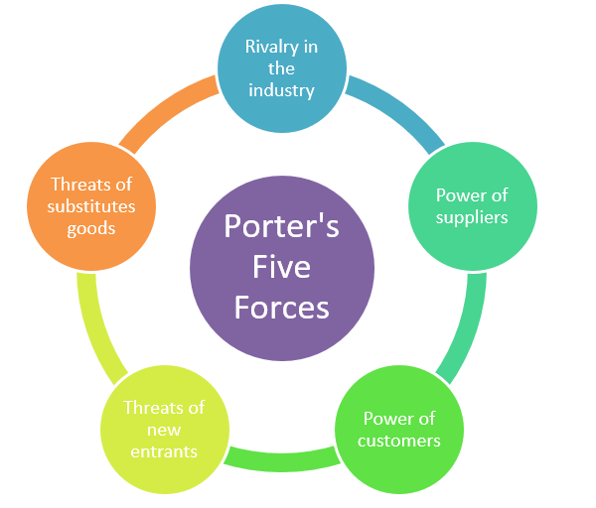
(Porter’s five forces)
Factors | Impact
Threat of New Entrants | Low
Threat of Substitutes | Moderate to High
Bargaining Power of Customers | Moderate
Bargaining Power of Suppliers | Moderate
Competitive Rivalry | High
(Source: Self-Developed)
Threat of New Entrants:
UK:
Low Threat: Due to significant financial requirements, well-known brands, and strict regulatory requirements, the automobile business in the UK has high entry hurdles.
Germany:
Low Threat: Due to high capital requirements, well-known brands, and strict regulations, the German automobile industry has substantial entry barriers. (Mercedes- Benz, n.d)
Bargaining Power of Buyers:
UK:
Moderate to High Power: Because there are other brands to choose from, buyers in the luxury automobile market in the UK have a lot of purchasing power. Unique qualities and brand loyalty do, however, somewhat offset this strength. (Mercedes- Benz, n.d)
Germany:
Moderate to High Power: Because there are other brands available, buyers in the German luxury automobile market have a lot of negotiating leverage. Distinctive qualities and brand loyalty lessen this power.
Bargaining Power of Suppliers:
UK:
Moderate Power: The UK's suppliers of important components might be moderately powerful. Power dynamics, however, can be impacted by Mercedes-Benz's size and its supplier ties.
Germany:
Moderate Power: Germany's suppliers of essential components can be moderately powerful. Power dynamics can be impacted by Mercedes-Benz's size and its supplier ties. (Eurostat, )
Threat of Substitute Products:
UK:
Moderate Threat: Although there are other ways to get around, premium vehicles like Mercedes-Benz's distinctive features and well-known brands lessen the immediate threat of replacements in the UK market.

Germany:
Moderate Threat: While there are other ways to get around, luxury vehicles like Mercedes-Benz with their distinctive features and well-known brands lessen the immediate threat of replacements in the German market.
Competitive Rivalry:
UK:
High Intensity: Several well-known manufacturers are fighting for market share in the UK's luxury automobile sector, where competition is fierce. Design, marketing, and innovation are essential.
Germany:
High Intensity: The German luxury automobile industry is very competitive, with many well-known companies fighting for consumers' attention. Design, marketing, and innovation are essential.
Similarities and Differences of Porters five forces for Benz in UK and Germany
Threat of New Entrants:
Similarities:
The threat of new competitors entering the premium car industry is minimal in both Germany and the UK. Significant entry barriers are produced by high capital needs, well-established brand loyalty, and complex manufacturing processes.
Differences:
- Following Brexit can be specific regulatory changes that affect the UK car market. New competitors' ease of entry may be impacted by trade agreements and new restrictions.
- Germany upholds regulatory conformity with EU standards as an EU member. Compared to the UK, the regulatory landscape may be more stable for newcomers.
Bargaining Power of Buyers:
Similarities:
German and British consumers of luxury cars have significant negotiating power. The abundance of high-end brands available to them affects Mercedes-Benz car demand and pricing.
Differences:
- Buyer behavior in the UK may be influenced by cultural quirks and economic conditions in a different way than in Germany, which could affect consumers' bargaining power.
- German customers may differ from British consumers in their preferences and expectations, which affects their ability to negotiate.
Bargaining Power of Suppliers:
Similarities:
Mercedes-Benz's primary component suppliers in both nations have a moderate amount of negotiating leverage. To some extent, Mercedes-Benz's size and established relationships aid in the management of this influence. (Mercedes- Benz, n.d)
Differences:
- Compared to Germany, the UK automotive supply chain may have distinct dynamics that impact suppliers' bargaining strength in a different way.
- Different supplier dynamics and relationships may be present in the German automotive supply chain, which could affect negotiating strength.
Threat of Substitute Products:
Similarities:
The threat of substitutes is moderate in both markets. Although there are no direct alternatives for luxury cars, there are difficulties due to shifting consumer preferences and alternate forms of transportation.
Differences:
- The UK and Germany may have different levels of accessibility and recognition for comparable goods, such as competing luxury brands or other forms of transportation.
- Germany's substitute market may have features that affect customer preferences and the threat posed by substitutes in general.

Competitive Rivalry:
Similarities:
There is fierce competition in the luxury automobile markets of Germany and the UK. A few well-known brands compete with one another for market share, which spurs ongoing innovation and bold marketing approaches.

Differences:
- In comparison to Germany, the luxury car market in the UK can have a diverse competitive landscape with distinct players and dynamics.
- Germany may have a different competitive rivalry scenario than the UK because it is home to multiple luxury automobile manufacturers.

Benefits of Applying Porter’s five forces for Mercedes Benz
Strategic Decision-Making: Mercedes-Benz uses Porter's Five Forces to guide its strategic choices. The organization can more efficiently allocate resources and develop strategic plans by analyzing the forces and identifying its areas of strength and weakness.
Competitive Positioning: The model helps evaluate Mercedes-Benz's competitive standing in the market for high-end vehicles. By comprehending the threat posed by new competitors, the ability of buyers to negotiate prices, and competitive rivalry, the company may improve its market positioning and tactics for differentiation.
Risk Mitigation: Potential dangers and hazards in the external environment are identified with the aid of the analysis. Mercedes-Benz can create risk-reduction plans to manage difficulties and uncertainties in the market by comprehending the level of rivalry among competitors and the possibility of replacements.
Market Entry and Expansion: When thinking about entering or expanding a market, the model is useful. Mercedes-Benz can decide whether to enter new markets or increase the range of products it offers by evaluating the threat posed by new competitors and comprehending the point at which the market is saturated.
Customer Relationship Management: Mercedes-Benz can better customize its customer interaction strategy by knowing how much buyers can bargain for. The business can increase client happiness and loyalty by attending to their wants and preferences.
Innovation and Product Development: Mercedes-Benz is incentivized to invest in innovation and product development by the recognition of the threat posed by substitutes. Maintaining a leading edge in technology and design can boost a brand's competitiveness and lessen the perception of a threat from imitations.
Supply Chain Management: Understanding suppliers negotiating power is helpful for efficient supply chain management. Strong ties with important suppliers help Mercedes-Benz maintain a reliable and effective supply chain.
Market Differentiation: Mercedes-Benz can concentrate on market distinctiveness by evaluating the competitive rivalry. This is an advantageous approach. The business can emphasize its USPs and keep a standout presence in the market by being aware of the advantages and disadvantages of rivals.
Regulatory Compliance: Mercedes-Benz can successfully adapt to changing regulatory environments and maintain compliance by comprehending the impact of rules, particularly considering Brexit in the UK.

Swot Analysis Highlighting Mercedes Benz in UK and Germany
Strengths | Weaknesses
Brand Reputation:  UK & Germany: Mercedes-Benz has a solid reputation for luxury, innovation, and quality throughout the world, which helps to foster brand loyalty in these two markets. (Daimler AG, 2021)  Innovation and Technology:  UK & Germany: The corporation is a leader in technology, specializing in cutting-edge features, autonomous driving, and electric vehicles. (Mercedes Benz, 2023)  Product Portfolio:  UK & Germany: Mercedes-Benz provides a wide variety of high-end automobiles to suit various consumer tastes and market niches.  (Statista - Mercedes-Benz important statistics) | Cost Structure:  UK & Germany: These markets high operational and manufacturing expenses could hurt their ability to offer competitive prices. (Reuters – Daimler, 2021)  Dependency on Key Markets:  UK & Germany: Mercedes-Benz is more vulnerable to changes in the local economy in these countries due to its over-reliance on these markets. (Financial times – Mercedes, 2023)
Opportunities | Threats
Electric Vehicle Market:  UK & Germany: Mercedes-Benz has a big opportunity as the market for electric vehicles grows. (Bloomberg - Mercedes)  Global Expansion:  UK & Germany: There are prospects for additional worldwide expansion into developing markets. (Forbes - Mercedes) | Intense Competition:  UK & Germany: Market share is threatened by fierce competition from other luxury car makers across the world. (MarketWatch)  Regulatory Changes:  UK & Germany: Production may be impacted, and compliance costs may rise because of changing emission standards and regulations. (Automotive news Europe)

Similarities and differences of SWOT Analysis for Benz in UK and Germany
Similarities:
Strengths:
Excellent Branding:
Germany and the UK: Mercedes-Benz is a well-known brand throughout the world that is linked to innovation, luxury, and performance, which encourages consumer loyalty and trust.
Leadership in Technology:
Germany and the UK: Mercedes-Benz is a leader in automotive technology, having pioneered advancements in areas like connectivity, autonomous driving, and electrified vehicles.
Variety of Products:
Germany and the UK: The company offers a wide range of products to suit different consumer needs, including electric vehicles that are environmentally friendly and high-performance sports automobiles. (Statista, 2020)
Differences:
Weaknesses:
Drawbacks: Financial Reliance:
UK: Mercedes-Benz may face difficulties because of Brexit-related economic uncertainty, which could affect the company's cost structure and economic reliance.
Germany: As a major hub for the automotive industry, Germany's economic stability might help Mercedes-Benz find a more secure market.
Market Share and Harmony with Culture:
UK: Mercedes-Benz may make more use of its cultural fit and historical presence in the country to appeal to British consumers' tastes for luxury and tradition.
Germany: The brand may enjoy even greater cultural resonance and brand loyalty in its home market of Germany.
Opportunities:
Revolution Electric:
Germany and the UK: Mercedes-Benz has the chance to increase the range of electric vehicles it offers and profit from the world's transition to more environmentally friendly transportation thanks to the growing demand for electric vehicles.
Global Expansion Strategies:
Germany and the UK: Mercedes-Benz can reach new customer segments and secure long-term growth possibilities by entering emerging markets as part of its worldwide expansion strategy.
Threats:
Strong International Competition:
UK & Germany: There is intense competition in the global luxury car industry. To preserve market share, fierce rival competition necessitates constant innovation and strategic differentiation.
Regulatory Structure:
UK & Germany: Regulations are always changing, particularly when it comes to safety requirements and emissions. It's critical to maintain compliance while adjusting to shifting regulatory environments.

Mercedes Benz Marketing Mix Elements and Market Segmentation Strategies
Marketing segmentation strategies:
Segmentation:
Demographic Segmentation:
- Mercedes-Benz caters to a market segment consisting of high-earning individuals, executives, and professionals. (Source: Mercedes Benz)
- Various age groups and lifestyle choices are catered to by different models.
Psychographic Segmentation:
- Customers that appreciate elegance, grandeur, and cutting-edge technology are drawn to the brand.
- In the segmentation strategy, emphasis on values, goals, and lifestyle is essential.
Geographic Segmentation:
- Mercedes-Benz customizes its products for several global markets.
- adapting marketing strategies and models to local consumer preferences and market conditions.
Behavioral Segmentation:
- Aims high-performance models at performance enthusiasts.
- Its selection of electric vehicles appeals to those who are concerned about the environment.
Targeting:
- Mercedes-Benz caters to a specific group of customers who want high-end, luxurious cars with cutting-edge technology. (Source: Mercedes Benz)
- The brand seeks to satisfy the demands and goals of a wealthy clientele.

Positioning:
Luxury and Performance: Mercedes-Benz presents itself as a representation of performance, luxury, and innovation. (Source: Marketing91)
Heritage and Innovation: Highlights a rich history along with state-of-the-art technology to provide a luxurious driving experience.
Lifestyle Choice: Mercedes-Benz appeals to people who are looking for a lifestyle option rather than just a car because it goes beyond transportation.
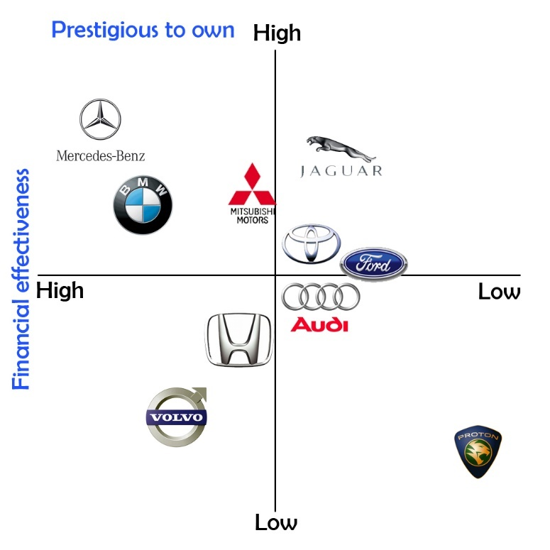
(Fig: Perceptual map for Benz)

UK and Germany should be discussed in relation to segmentation, targeting and positioning and similarities and differences stated:
Segmentation:
Similarities:
Demographic Segmentation:
- Mercedes-Benz caters to professionals, executives, and affluent individuals in both the UK and Germany. (Statista, 2019)
- The demographic profile highlights a customer base that values performance, luxury, and cutting-edge technology.
Psychographic Segmentation:
- Customers that appreciate luxury, style, and innovation are drawn to the brand in both markets.
- When creating marketing messages that speak to the values and goals of the target audience, psychographic variables are vital.

Differences:
Cultural complexity:
- As the home market, Germany may be able to take full advantage of cultural subtleties by leveraging the country's profound cultural love for fine automobile craftsmanship and precision engineering.
- The brand's global appeal and resonance with British consumers' inclinations for performance and elegance might be highlighted in the UK's marketing strategy.
Targeting:
Similarities:
Affluent customer Base:
- Mercedes-Benz predominantly caters to an affluent client base in both the UK and Germany.
- The targeted approach fits nicely with a certain market that is looking for luxury, high-performance cars. (Statista, 2019)
Differences:
Local Preferences:
- Targeting tactics may be modified to accommodate regional preferences. For instance, depending on the tastes of customers in Germany and the UK, particular models or characteristics can be highlighted differently.
- Tailored targeting strategies may take certain cultural or regional preferences into account.

Positioning:
Similarities:
- Luxurious and Innovative: Mercedes-Benz presents itself as a symbol of luxury, innovation, and performance in both markets.
- The brand's basic principles, which highlight a blend of tradition and modern technology, are the same in Germany and the UK.

Differences:
Cultural Emphasis:
- The positioning in Germany can place more of a focus on the brand's historical significance and its contribution to the country's automotive prowess.
- In the UK, the brand's contemporary features and appeal to a worldwide audience may receive more attention.
Marketing mix elements 7P’s
Product:
UK:
- To meet the varying tastes of customers, the product line in the UK comprises a variety of luxury cars, such as sedans, SUVs, and electric models.
- Due to their urban appeal, models such as the A-Class and C-Class can be highlighted.
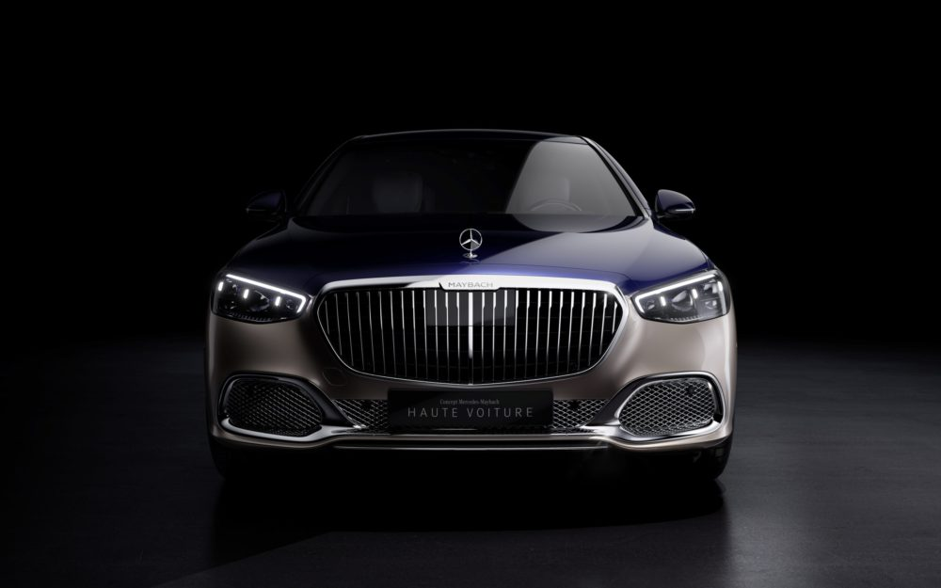
(Source: Mercedes-Benz, n.d)
Germany:
- The product range in Mercedes-Benz's home market is probably going to encompass the entire range of vehicles, highlighting the brand's history and engineering prowess.
- Models with exceptional performance and flagship cars might get special consideration.
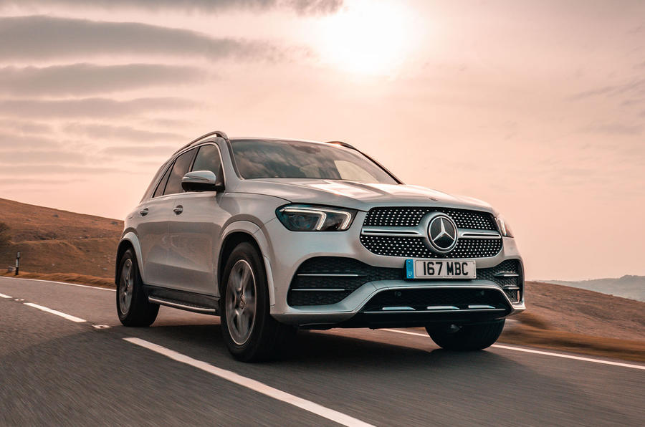
(Source: Mercedes-Benz, n.d)

Price:
UK:
- The brand's premium pricing approach reflects the country's affluence and refinement.
- In the premium class, competitive pricing is considered.
Germany:
- The brand's image of excellence and precision engineering may be in line with the pricing approach in this country.
- To remain competitive, the home market may have price structures.
Place:
UK:
- To ensure accessibility, dealerships and showrooms are positioned thoughtfully in important cities throughout the country.
- Online platforms are crucial for communicating with clients.

Germany:
- Considering the brand's beginnings, a sizable distribution network encompassing key cities and areas is probably in place there.
- Physical showrooms aim to offer a high-end experience.
Mercedes Benz Market Entry Methods
Exporting:
Method: Exporting automobiles straight from factories to foreign nations.
Application: Prior to having a physical presence, this strategy is frequently used to evaluate the market.
Joint Ventures & Strategic Partnerships:
Method: Creating strategic partnerships or collaborating with nearby businesses to launch a joint venture. (Daimler, 2018)
Application: Mercedes-Benz may share risks, negotiate regulatory settings, and make use of local experience by working with local firms.
Fully Owned Affiliates:
Method: Opening branches or subsidiaries with complete ownership in overseas markets.
Application: Offers the most control over operations and branding but necessitates a large financial outlay and familiarity with regional market dynamics.
Franchising and Licensing:
Method: Granting local partners licenses for the manufacture or marketing of automobiles.
Application: Provides localized production and distribution without requiring a large initial outlay of funds.
Strategic Purchasing:
Method: Purchasing already-existing auto facilities or enterprises in the intended markets.
Application: Gains a customer base, existing infrastructure, and local knowledge to expedite market entry. (Daimler, 2018)
Collaborations in Emerging Markets:
Method: Establishing tactical alliances with regional organizations in developing economies.
Application: In markets with development potential, it facilitates market entry by using existing networks and local knowledge.
Digital and Online Marketplaces:
Method: Using internet channels for marketing and sales.
Application: To reach a worldwide audience and expedite the purchasing process, Mercedes-Benz has placed a greater emphasis on digital platforms in recent years.
Creative Branding and Marketing:
Method: Developing creative brand positioning and marketing initiatives.
Application: Building a solid brand identity and reputation to draw clients from around the world. (Daimler, 2018)
Franchising and Licensing advantages and disadvantages:
Licensing:
Advantages | Disadvantages
Low Capital Investment:  Licensing is less expensive up front than starting fully owned subsidiaries or ventures.  Quick Market Entry:  Since the licensee oversees creating and running a business in the local market, it permits a quick entry into the market.  Accessing Local Knowledge:  The licensee frequently possesses an understanding of the regional market, customs, and commercial procedures, offering the licensor important perspectives.  Risk Reduction:  The licensee assumes all the risks related to production, marketing, and distribution in an outside market. | Limited Control:  The licensed product or service may be advertised and used in a foreign market, but the licensor has limited control over these aspects.  Risk of Quality Control:  It can be difficult to guarantee constant quality and adherence to brand standards because they depend on the licensee's competence.  Dependence on the Licensee:  The ability, dedication, and honesty of the licensee play a major role in the licensing arrangement's success.  Potential of Diluting Brand:  The licensor's trademark may become less recognizable if the licensee disregards quality requirements.

Franchising:
Advantages | Disadvantages
Rapid expansion:  Because franchisees invest in and run their own businesses utilizing the franchisor's tried-and-true business model, franchising enables quick business growth.  Local Entrepreneurship:  Franchisees are frequently local business owners with extensive knowledge of the area market, which helps the franchise succeed.  Shared Operational Costs:  By sharing in the costs of opening and running new sites, franchisees lessen the financial strain on the franchisor.  Brand Consistency:  By keeping control over brand standards, franchisors can guarantee a uniform client experience throughout their network of sites. | Loss of Control:  Franchisees receive some influence over the day-to-day operations from franchisors, which could result in irregularities.  Quality Control Challenges:  It might be difficult to maintain constant quality in products or services across various locations.  Dependency on Franchisee Performance:  The performance and managerial skills of each franchisee directly affect the franchisor's success.  Regulatory and Legal Challenges:  Franchising entails complicated legal contracts and adherence to rules that varies between nations.

Promotion:
UK:
- Mercedes-Benz's worldwide appeal may be emphasized in marketing campaigns there by emphasizing lifestyle and innovation.
- Social media and digital marketing are essential for connecting with UK consumers.
Germany:
- In Germany, marketing campaigns could emphasize the brand's historical relevance and its influence on the development of the automobile sector.
- There may be a significant presence of conventional advertising techniques and events.

People:
UK:
- Workers there are educated to grasp the varying tastes of the regional market and to appeal to the thinking of British consumers.
Germany:
- In keeping with the local cultural setting, the German workforce embodies the brand's dedication to engineering quality and precision.
Processes:
UK:
- With an emphasis on a great customer experience, streamlined procedures guarantee efficiency in sales, service, and client contacts.
Germany:
- Given the nation's standing as a leader in engineering, procedures there can highlight the brand's dedication to quality.
Physical Evidence:
UK:
- In keeping with the brand's image, showrooms and service centers in the UK are built to offer an opulent and contemporary atmosphere. (Gov.uk)
Germany:
- Artefacts at showrooms there may highlight the brand's heritage and highlight the development of Mercedes-Benz automobiles.
Similarities and Differences marketing mix elements 7P’s in UK and Germany
Similarities:
Product:
Global Product Offerings: Mercedes-Benz offers high-end automobiles with cutting-edge features in both markets, sticking to a consistent global product portfolio.
Emphasis on Innovation: In both markets, with Benz leading the way in incorporating state-of-the-art technologies into its cars.
Price:
Premium Pricing Strategy: To establish itself as a luxury brand, Benz uses a premium pricing strategy in Germany and the UK.
Adaptation to Economic Circumstances: The premium positioning is upheld even if prices may change in response to external factors.
Place:
Dealerships and Showrooms: In both nations, Mercedes is present in posh showrooms and dealerships situated in strategic areas.
Digital Presence: Customers in both markets may explore and configure cars online with the help of a strong online presence, which also helps with digital sales and customer relations.
Promotion:
Emotional Marketing: Campaigns highlighting the Benz brand's luxury, performance, and lifestyle are emotionally charged in both markets.
Digital marketing: It is the use of social media, influencers, and digital platforms for marketing campaigns in the UK and Germany.
Differences:
Price:
Tax Differences: The value-added tax (VAT) in Germany is higher than in the UK. It could be necessary to modify pricing methods to account for different tax rates.
Place:
Dealer Network: Depending on the needs and desires of the market, the dealer network's structure may change. For example, Germany might have larger showrooms than the UK, which might have more boutique-style dealerships.
Promotion:
Cultural Nuances: Promotional material and advertisements may need to take them into account. Although emotional marketing works in both markets, the cultural components that are highlighted may be different.

People:
Sales Approach: Sales teams in the UK may find that a more lifestyle-focused approach works better than those in Germany, which may take a more formal and technical approach that emphasizes engineering and performance.
Process:
Regulatory Compliance: Variations in rules, such as adherence to regional trade and consumer protection statutes, could affect the sales procedure.
Digitalization: Depending on customer preferences and the pace at which technology is adopted, there may be variations in how much of the sales process is digitalized.
Physical Evidence:
Design of Showrooms: Showroom layouts and designs can be modified to conform to regional tastes and aesthetics.
Test Drive Experience: Variations in the way test drives are carried out, maybe impacted by legal or cultural restrictions.

Directional Development Strategy for Benz
Product Blending:
Growth of Electric Vehicle (EV) Portfolio: To keep up with the world's transition to more environmentally friendly transportation, invest in research and development as well as the growth of electric and hybrid vehicles. Kotler (2018)
Innovative Technologies: Keep setting the standard for the integration of state-of-the-art technologies, like features for autonomous driving, into your car offers.
Market Growth:
Developing Markets Focus: Investigate business prospects in developing nations where demand for high-end automobiles is rising. Make items that are tailored to these markets' economic conditions and desires. Armstrong (2018).
Geographic Expansion: Consider going farther into areas with unrealized potential or growing demand for high-end cars.
Digital Transformation:
Improved Digital Customer Experience: Make investments in digital platforms and technologies to improve the online sales process and after-sale services for customers.
connected Vehicle Services: Keep enhancing and growing the linked capabilities that cars offer to increase convenience, safety, and entertainment.
Brand Expansion:
Diversification of Offerings: Look at ways to expand your brand's reach beyond cars by introducing luxury electric bicycles, accessories, or lifestyle goods.
Luxurious Experiences: To further strengthen the brand's luxury positioning, provide unique experiences, events, and services.
Collaborations & Partnerships:
Strategic Alliances: Forming strategic alliances with energy providers, technology businesses, and other industry players can help you take advantage of synergies and improve your competitiveness. Kotler & Armstrong (2018).
Collaboration on Sustainable Initiatives: Work together with groups pursuing sustainability projects to support the increased emphasis on environmentally responsible behaviors around the world.
Consumer-Driven Innovation:
Personalized Services: Make technology investments that enable customization, individualized care, and distinctive ownership experiences.
Subscription Models: To adapt to shifting consumer preferences, investigate different ownership models like subscription services.
Research and Development:
Innovation Centers: To stay on the cutting edge of automotive technology and design, establish or grow research and innovation centers.
Invest in AI and Machine Learning: Make the most of these technologies for improved driving experiences, safety features, and predictive maintenance.
Ecological Methods:
Green manufacturing: Use environmentally friendly and sustainable production techniques to lessen the influence of production operations on the environment.
Goal for Carbon Neutrality: Establish challenging objectives for carbon neutrality that are in line with worldwide environmental movements.

ANSOF MATRIX
By considering two dimensions, the Product-Market Expansion Grid, sometimes referred to as the Ansoff Matrix, is a strategic tool that helps organizations find expansion potential. Products and markets, Hansen, S. (2021). It provides a framework that can be used to decide whether to expand into new markets or add new items to an existing business. Considering Mercedes Benz while using Ansoff Matrix:
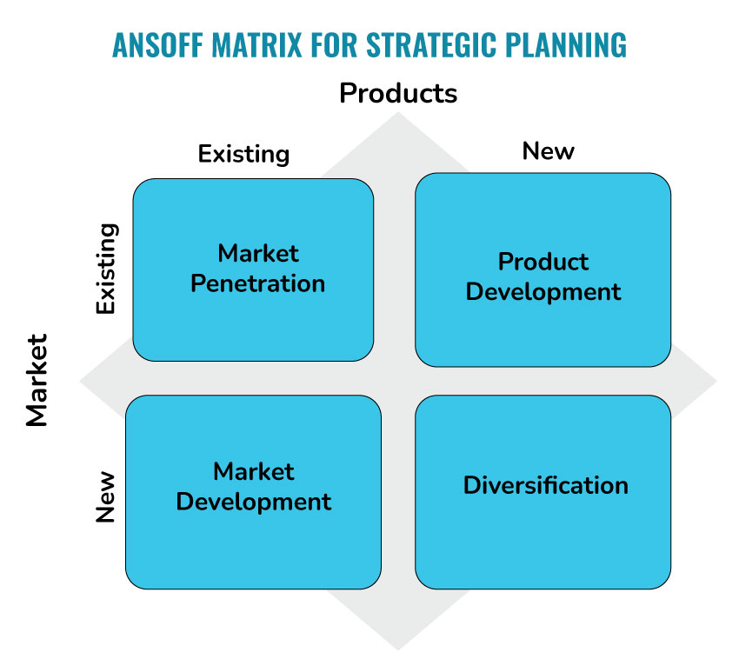
Market Penetration (Existing Products, Existing Markets):
Goal: Grow market share in markets where products are already available. (Kotler, P., & Armstrong, G. 2018)
Application for Benz: Starting advertising campaigns to highlight current models, releasing limited editions, or providing loyalty plans to draw in and keep customers.
Product Development (New Products, Existing Markets):
Goal: Expand into current markets by introducing new or modified products. (Wilson, H. 2016)
Application for Benz: Constantly adding new models, variants, and technical innovations to the lineup of vehicles, such autonomous driving capabilities, or new electric vehicle types.
Market Development (Existing Products, New Markets):
Goal: Expand into new markets by introducing current products. (Ansoff, I. H. 1957)
Application for Benz: Increasing its presence in developing nations where the market for high-end automobiles is expanding and customizing its advertising and product lines to meet the demands and tastes of local customers.
Diversification (New Products, New Markets):
Goal: Open new markets for new items. (Kotler, P., & Armstrong, G. 2018)
Application for Benz: Investigating non-conventional fields like luxury travel, mobility services, or novel car categories. This could involve experimenting with electric bicycles, eco-friendly transit options, or other cutting-edge mobility services.
Recommendations
Tows Matrix
The TOWS Matrix, also called the TOWS Analysis, is a technique for strategic planning that analyses the connections between an organization's external opportunities and threats and internal strengths and weaknesses to assist discover strategic options. This is a condensed version of the Mercedes-Benz TOWS Matrix:
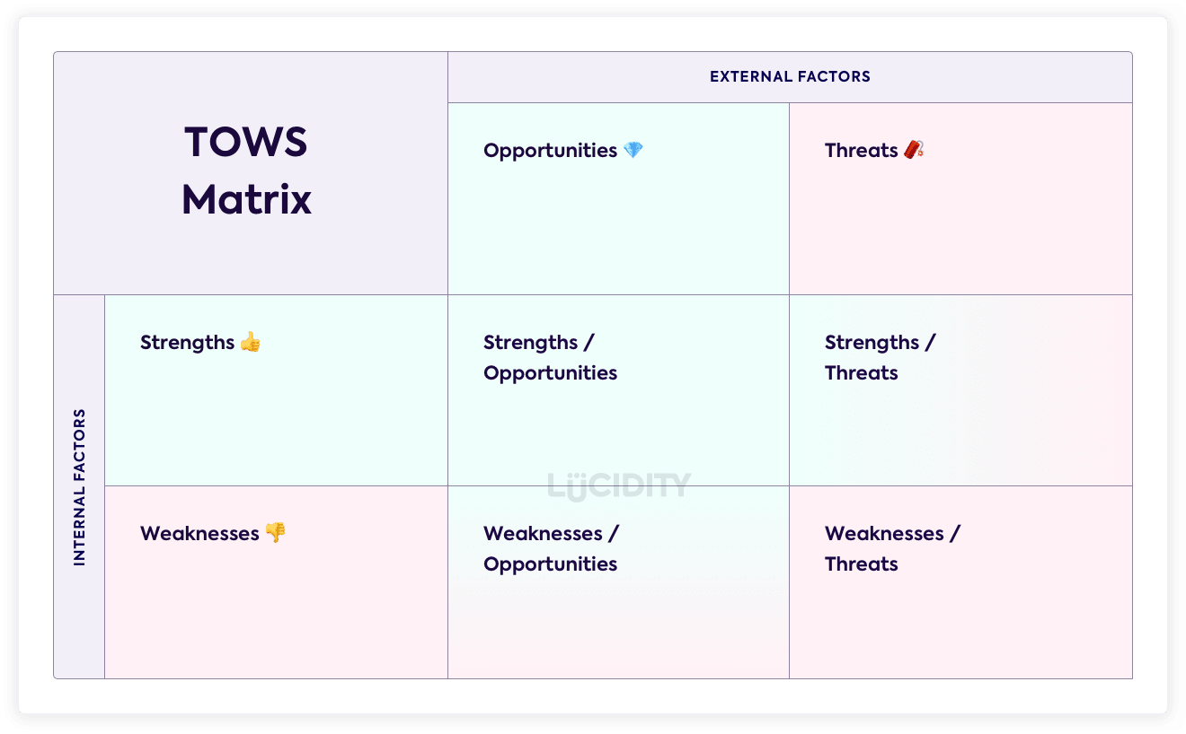
(Source: Lucid.com)

SO Strategies (Strengths-Opportunities):
- Make use of your excellent brand image to profit from the rising demand for electric cars.
- Increase worldwide presence even more in developing nations where demand for premium goods is rising.

ST Strategies (Strengths-Threats):
- Highlighting technological innovation in pollution reduction can help to lessen the effects of regulatory changes.
- To increase competitiveness, fortify alliances with tech firms.

WO Strategies (Weaknesses-Opportunities):
- Make significant investments in the creation and introduction of new electric models to help address the restricted selection of electric vehicles.
- Make use of the worldwide reach to expand into previously untapped markets and broaden your clientele.

WT Strategies (Weaknesses-Threats):
- To lessen the impact of economic downturns on luxury goods, diversify your product offers beyond high-end automobiles.
- Simplify the supply chain to increase productivity and lessen possible interruptions.

Conclusion
In conclusion, Mercedes-Benz represents the height of luxury and technological advancement in automobiles. The company, which is renowned for both its engineering prowess and iconic brand reputation, has skillfully combined heritage with cutting-edge technology. Due to its global reach and wide range of products, which includes luxury sedans, SUVs, and high-performance cars, Mercedes-Benz has become the preferred choice for a sophisticated customer base worldwide. But with the automobile industry changing so quickly, strategic concerns become crucial. There are many chances to expand the range of electric vehicles to satisfy the growing demand for environmentally friendly transportation. Establishing strategic partnerships might also put Mercedes-Benz at the forefront of innovation, particularly in the field of autonomous driving technologies.
To effectively navigate the competitive landscape, the brand must prioritize sustainability activities in addition to maintaining its commitment to luxury. Ambitious carbon neutrality targets and green production techniques will not only follow international trends but also bolster the brand's commitment to ethical corporate responsibility. Essentially, Mercedes-Benz's future success will depend on its capacity to adjust to changes in the business, seize new possibilities, and uphold the underlying principles that have established its reputation for excellence in automobiles.

References
Ansoff, I. H. (1957). Strategies for Diversification. Harvard Business Review, 35(5), 113–124.
Building a Global Brand - Daimler Annual Report 2018.
Daimler AG Company Overview (2021): https://www.daimler.com/company/about-us/
European Commission (2023): https://ec.europa.eu/
Eurostat (European Commission) (2023): https://ec.europa.eu/eurostat/home
European Union Emission Standards: https://ec.europa.eu/clima/policies/transport/vehicles_en
Federal Ministry for the Environment (Germany): https://www.bmu.de/en/
GOV.UK (2023): https://www.gov.uk/
History of Mercedes-Benz (1886): https://www.mercedes-benz.com/en/classic/history/
Kotler, P., & Armstrong, G. (2018). Principles of Marketing. Pearson.
Mercedes-Benz Global Strategy: A Case Study on the Launch of the Mercedes-Benz A-Class in the US - Andreas Bartels, David Aikman, and Andreas Richter, Daimler AG.
Mercedes-Benz Official Website (2023): https://www.mercedes-benz.com/
Mercedes-Benz: A History of Innovation (2023): https://www.history.com/news/a-history-of-mercedes-benz
Mercedes-Benz Corporate History (2022): https://www.mercedes-benz.com/en/classic/history/
Mercedes-Benz: The Birth of the Brand: https://www.mercedes-benz.com/en/classic/history/history-of-the-brand/
Statista (UK): https://www.statista.com/
Society of Motor Manufacturers and Traders (UK) (1998): https://www.smmt.co.uk/
UK Government Brexit Guidance (2023): https://www.gov.uk/transition
UK Government Economic Data (2022): https://www.gov.uk/government/statistics
UK Consumer Rights Act (2019): https://www.legislation.gov.uk/ukpga/2015/15/contents
UK Government Brexit Guidance (2018): https://www.gov.uk/transition
UK Government Environment and Sustainability: https://www.gov.uk/government/policies/environmental-quality
Wilson, H. (2016). Marketing Plans: How to prepare them, how to use them. John Wiley & Sons.
World Economic Forum (2020): https://www.weforum.org/

