

An Unbalanced Approach to Medical Negligence: How are Claimants at a Disadvantage

Name: Shaun Hopson
Student ID: 1701018
University of Wales Trinity Saint David
Due Date: 6th May 2022

Wordcount: 8278

Abstract
This report represents an analysis of medical negligence and how the system set out by the courts greatly favours the position as defendant. The Analysis shows that this statement is correct but there are significant reasons for this unbalanced approach. The major issues are that the courts attempt to make it incredibly difficult for claimants to reduce the flow of unsuccessful court appearances. This acts as a deterrent for disingenuous claims being made. The recommendations suggest that the system is unlikely to change as it has remained the same for last 35 years. But is this fair to the claimant?

Acknowledgements
I would like to thank Mike Durke for the support over the course of this module and the guidance that was provided.
I would also like to thank my friends and family that have provided me with the continued support in the last three years of my degree.

Declaration
This work has not previously been accepted in substance for any degree and is not being concurrently submitted in candidature for any degree.
Signed: S.Hopson Date: 03/05/2022
STATEMENT 1
This dissertation is being submitted in partial fulfilment of the requirements for the degree of BA.
Signed: S.Hopson Date: 03/05/2022
STATEMENT 2
This dissertation is the result of my own independent work/investigation, except where otherwise stated.
Other sources are acknowledged in the Reference Section.
Signed: S.Hopson Date: 03/05/2022
STATEMENT 3
I hereby give consent for my dissertation, if accepted, to be available for photocopying and for interlibrary loan, and for the title and summary to be made available to outside organisations.
Signed: S.Hopson Date: 03/05/2022
STATEMENT 4
I hereby give consent for my dissertation, if accepted, to be available on the university’s IT system to those who have consent to use the system.
Signed: S.Hopson Date: 03/05/2022

Contents
1. Introduction 5
2. Literature review 7
2.1 An Unbalanced Approach to Medical Negligence 7
2.2 What is owed to patients and how medical negligence can occur 8
2.3 Anti-claimant approach taken by the “Bolam” test for medical negligence and why improvement is difficult following “Bolitho” 9
2.4 Balance of probabilities in relation to the claimant’s award and Loss of Chance, is it fair? 11
2.5 Why the tests need to exist and the ‘barriers to claimants’ 12
2.6 Public attitudes to the time parameters for claims 14
3. Methodology 15
3.1 The Research Onion 15
3.1.1 Philosophy 15
3.2 The Research Approach 17
3.3 Strategy 18
3.4 Choices 18
3.5 Time Horizons 19
3.6 Techniques and Procedures 20
3.7 Questionnaire 21
3.8 Interview questions 23
4. Findings 26
4.1 Questionnaire 26
4.2 Focus group: medical professionals 29
4.3 Interview for legal professional 32
4.4 Interview for a victim of medical negligence 34
5. Conclusion 35
5.1 Main findings 35
5.2 Implications 36
5.3 Recommendations 37
5.4 Limitations 37
5.5 Future Research 38
5.6 Self-Reflection 38
5.7 Final thoughts on medical negligence and is it balanced? 39
Appendices 45
Ethics Form 45
Questionnaire results 48
Transcript for the Focus Group Discussion topics 53
Transcript for the Interview with a Legal professional 54
Transcript for the Interview with a Victim of Medical Negligence 54

Introduction
Medical negligence occurs when a claimant has suffered a loss because of medical malpractice. This can range from misdiagnosis to a doctor’s actions, or lack of action, which directly result in the claimant’s loss. The NHS in recent years has accumulated over £83bn in outstanding compensation pay as of 2020 (Crawford, 2020). The legal definition of medical negligence (sometimes referred to as clinical negligence) is when a patient takes their medical practitioner to court to seek compensation for the losses that they have sustained due to the actions of the defending party. The reason that this is important is to shed light on the UK’s unbalanced approach to medical negligence. The area of medical negligence exists in a grey area within law (Stauch, 2018). The legal system attempts to be fair in their approach to all matters brought before them. Despite this the courts appear to be reluctant in their pursuit of objectivity. It is a common misconception amongst that law has no place within the medical world. This steams from a quote from Frank Dobson the health sectary in 1999 that stated that “a lawyers place within the NHS is on a hospital bed” (Dobson, 1999). This could not be further from the truth as there must be a harmonious relationship between law and medical practise to ensure that those who feel as though they have been wronged by a medical professional can be treated as equals within the courtroom. However, it is evident from recent cases that the claimant is at a substantial disadvantage (Jackson, 2019). The issue of medical negligence being unbalanced may only be amplified in the near future as the Law society suggests that the courts are setting a fixed rate of £25,000 to reduce the cost of the NHS. This may have a huge impact on how much compensation a claimant can claim for the injuries they have received as a fixed recoverable cost (The Law Society, 2022).
Background and Rationale
For a claim of medical negligence to be successful it is paramount that the claimant stratifies the criteria set out by the courts. despite this it is not as simple as mainstream medical negligence advertisements make it seem. The claimant must content with external factors that make put them at a negative disposition. Compensation culture has become increasingly more popular after the turn of the millennium. This may be for several reasons. The first of which is that claimants are becoming more aware of their rights as a UK citizen. This is an advantage because it causes medical practitioners to be more meticulous in their approach to duty of care as per the Ministry of Justice in 2013 (MoJ, 2013). Although with many claimants’ feel as though they are aware of their rights some may attempt to cheat the system or may simply feel as though they have a case when there was nothing more medically that could have helped them (Williams, 2005). This growth of a compensation culture puts enormous pressure on the courts that could cause a tunnelled vision approach to medical negligence cases due to the short comings of the compensation act 2006 (Courts and Tribunals Judiciary, 2013). Moreover, what cannot be denied is that for the genuine claimant the process which they undertake to fight medical malpractice has become increasingly more difficult. This is due to many claims for negligence being closely regulated because of fraud. This topic is important because there is no definitive answer to what constitutes as fair as medical practitioner, claimant, and victim will lack in objectivity and seek to justify the questions asked to them (Jackson, 2016). This is relevant throughout all aspect of law as in many cases the fine details determine the outcome of the cases presented to the courts. The research that will be conducted is an opportunity to identify what areas of medical negligence needs to be updated and improved. The importance of this is to underline the common criticism of law that suggests that the courts methods are ridged and archaic. Moreover, the notion that medical negligence is “anti-claimant” is very accurate. This Anti-claimant approach is one of the main deterrents from claims being made (Carr, 2015). This differs to other areas of law for example criminal law where harsher sentencing is used to deter criminal acts. Furthermore, it is important to understand that it is hard to hold medical professionals accountable for acts of negligence as the NHS burdens much of the responsibility in terms of financial awards given to claimants. The tests for medical negligence have been heavily criticised as the take the responsibility away from the courts and puts it into the hands of medical professionals. This approach is anti-claimant as the courts are intended to be the embodiment of fairness and justice within the UK public sector, yet they have an inability to effectively judge cases of medical negligence (Samanta, 2003).
Objectives
• Why is it so difficult for claimants to make a claim for medical negligence?
• What are the barriers put in place to protect medical professionals?
• Are the tests for medical negligence “Anti-Claimant?
• Can the System be improved?
• Are Public and professional attitudes on medical negligence in line with academic opinion?
- What tests exist that make it harder for claimant to claim?

Literature review
Due to an overlap of information when dealing with the specific objectives each of the subheadings will contain information that will link back to the objectives of this research paper.

2.1 An Unbalanced Approach to Medical Negligence
And the disadvantages that claimants must overcome to have a successful claim.

2.2 What is owed to patients and how medical negligence can occur
Duty of care exists when a doctor or health care and skill when diagnosing, advising, or treating patients. This is demonstrated in Barnett v Chelsea and Kensington Hospital Management Committee [1969] and Wilshire v Essex Area Health Authority [1988]. This case is important because it highlights that the Duty of Care only arises when the doctor has knowledge of the patient’s condition. Furthermore, it highlights the “but for” test which is the basic test for causation within the tort of negligence (Earle, 2007) (Grubb, 1988). A General Practitioner (GP) may in some circumstances be required to seek out the individual. However, in most circumstances the patient must ask for assistance. The Darnley v Croydon Health Services NHS Trust [2018] case suggests that the receptionist for the hospital had a claim made against her due to the misinforming the claimant after he had suffered a head injury. This suggests that the duty of care owed to a patient extends beyond Medical Practitioners this is based on the chain of causation (Jackson, 2019) (Purshouse, 2018). Lord Lloyd George suggest that the misinformation that led to the claimant leaving the hospital did not break the chain of causation as it would be reasonable to suggest that the ordinary person would have done the same. Moreover, the duty of care that is owed to the patient in cases of sterilization seem to be unbalanced. This is because if the sterilization of a woman is done incorrectly or negligently then the woman can claim for damages. However, if the same degree of negligent practise is performed on a man, he is unable himself to claim for damages this must be carried out by his wife. This is significant because the courts appear to ostracise men by not allowing them to claim this can be seen in Goodwill v BPAS [1996] which prohibited a claim for a failed vasectomy since his current partner was not his partner at the time of the medical procedure. This is one of the main defences that defendants use to justify the failed medical procedures (Perera, 2016). Highlighting only women can claim for “wrongful pregnancies” (Tingle, 2002).
The second stipulation that must exist to satisfy if a duty of care was owed to the patient is there must be sufficient evidence to suggest that the duty of care was breached. Breach of the duty of care usually falls under the category of medical negligence as within clinical negligence the patient is already ill therefore the breach tends not to occur frequently. Unlike tortuous claims medical professionals are not held to the same standard of care as a “man on the Clapham omnibus” from The Tichborne Claimant (1871) but rather to a doctor that is “skilled in that particular art”, which is een in the Bolam v Friern Hospital Management Committee [1957] (McCaughran, 2011). This can be unfair on behalf of the claimant as medical knowledge is reserved for those who have perfected the “art” which does not leave room for the opinion of the jury like other facets of law (Adu-Gyamfi, 2021) (Lunney, 2017). The role of medical guidelines are important as professional bodies such as the Royal Collages or protocols issued by the National Institute for Health and Care Excellence will be incorporated into everyday practise for the purpose of avoiding medical negligence. These governing bodies provided detailed guidance on the conduct and advice projected by medical professionals in terms of diagnosing and treating patients for dieses such as cancer or other potentially terminal illnesses (NICE, 2021) (NICE, 2022).

2.3 Anti-claimant approach taken by the “Bolam” test for medical negligence and why improvement is difficult following “Bolitho”
The Bolam test is significant as calls for the opinion of an adequate body of medical professionals. It is often referred to by academics s the extend ‘but for test’ meaning that thee needs to be a significant trigger for the courts to establish where the negligence has occurred. By calling upon another medical professional the objective of the Bolam test is to justify or condemn the actions taken by the defendant (Stapleton, 2015). However, it is questioned that an adequate body of medical professionals is not specified within the hearing of the Bolam case. This was reinforced by the De Freitas v O’Brian [1995] this case attempts to answer what can be an adequate medical body (Jackson 2019). The judge suggests that the defendant must call upon a medical body that has a common approach to the practise of the negligent act accused of by the claimant. If the defendant calls upon a body that shares an unpopular opinion of the practise, then the defence will be void (Teff, 1998). This holds significance because it balances the playing field between medical practitioners and legal professionals as legal professionals cannot be expected to understand the medical profession to the level of expertise required to be a medical practitioner.
The Bolitho v City and Hackney Health Authority [1997] is essential as it bolsters test for medical negligence alongside the Bolam test. This allowed the test to become a two-stage test. This second stage takes the emphasise off the judge and puts it solely in the hands of medical practitioners. As Lord Browne-Wilkinson states that it would be unreasonable to suggest that a judge would have an equal opinion of medical practise compared to that of a competent medical practitioner. This additional test for medical negligence is a testament to the mine field that is medical negligence as there can be no definitive answer in many cases (Adu-Gyamfi, 2021) (Harrington, 2016). The Bolam and Bolitho tests are evidence that medical negligence leans on the side of subjectivity. In other law cases there is no room for subjective opinions, therefore it questions whether the claimant is being put at a disadvantage. One of the key criticisms for the Bolam and Bolitho tests is that its medical professionals set the legal standard to what can be medical negligence. Whereas in other facets of law the courts and legal professionals set their own standards (Keown, 1998). This sets medical negligence apart because it is effectively being governed by the defendants. The Bolitho test also been criticized for being an attempt to update the current format used by the courts, yet referred to as the gloss for the Bolam test which is inherently flawed but, still considered to be necessary as the courts call upon another medical professional to play the “advisor” role. (Mulheron, 2010) (Delacroix, 2021)

2.4 Balance of probabilities in relation to the claimant’s award and Loss of Chance, is it fair?
The claimant must be able to prove that the negligence of the medical practitioner has resulted in a loss for the claimant. This could be a “loss of chance” of recovery as can be seen in Hotson v East Berkshire AHA [1987] (Cripps, 1986). This case highlights that there was a chance that the individual would not have been left permanently disabled if the medical practitioner had acted reasonably. The same can be said for Gregg v Scott [2005] in which the misdiagnosis of Lymphoma dropped the claimant’s chance of survival from 42% to 25%. This relates to the final point that must be proven when dealing with medical negligence which is that the losses can be calculated with certainty (Hof, 2005). This alludes to the issue that if the doctor had not acted negligently then there would be no grounds for a claim. The claim can only exist if on the balance of probabilities that the plaintiff’s condition would have gotten better if the act of negligence did not occur. Lord Nicholls in Gregg v Scott [2005] suggested that the loss of chance is inherently unfair. As a “loss of 45% prospect of recovery” is just as valuable to a patient as a “55% loss of chance” (Cridland, 2005). He then suggests that it would unreasonable not to award the patient for that loss of chance on the ground that the medical negligence had still occurred and had still caused the patients loss of chance. Therefore, it cannot be right and just to argue that if a patient has dipped below the 50% benchmark for loss of chance, then they are treated as non-existent. Lord Hoffmann alludes to the dangers of loss of chance. If every case was treated the same as Gregg v Scott [2005] he suggested that there is always the risk that the claimant may claim more than what is originally owed to them. Therefore, the courts are left with the very difficult job of proving whether the act of negligence had occurred in most cases getting this proof is almost impossible (Spencer, 2005).
The courts finally will consider the damages owed to the claimant this works upon the principle of ‘balance of probabilities’. The balance of probabilities weights up the actions taken by defendant and the loss suffered by the claimant to calculate the liability of the defendant (Wilkinson, 2019). Since in the UK healthcare is provided free of charge in the form of the NHS this makes the process of the claimant getting rather medical treatment easier than in other countries such as America and Australia. However, the court will grant damages to the claimant on the grounds of loss of chance. In medical negligence this can manifest itself in the form of survival rate. This can be seen in the previously mentioned case Hotson v East Berkshire AHA (Tromans, 2010). The courts concluded that the disability had a 75% chance of developing even if the correct course of action was taken by the medical professional. Thus, on the balance of probabilities the claimant received no reward. However, there was still a chance that the disability could have been prevented. Therefore, it calls into question whether the methods taken by the courts are ethical in their pursuit to promote fairness.

2.5 Why the tests need to exist and the ‘barriers to claimants’
Another objective of this dissertation is to deal with the rise of compensation culture and why this concept makes it so difficult for claimants to build a case against medical practitioners. The compensation culture has become an ever-growing problem for the NHS as it diverts their resources from medical advancement to paying for compensation. The compensation act 2006 has been published to highlight specific guidelines that are to deter negligence actions (Oyebode, 2006). It also governs functions in relation to undesirable activities when a duty of care is owed to an individual. An issue which greatly affect the claimant’s ability to claim can be seen in Claims Management Companies that put pressure on individuals to claim for apparent negligence. This commercialisation of negligence has since been outlawed by the Claims Management Regulator in 2013, which has since been handed to Financial Conduct Authority in 2018, that made it illegal for Claims Management Companies to receive fees from claimant referrals (FCA, 2021). This has made it even harder for genuine claims to be successful as medical negligence claims are under such a fine microscope due to the previously mentioned Bolam and Bolitho tests. These two cases are the benchmark for the medical negligence that the courts refer to when determining whether negligence has occurred. The approach to finding a trusted medical professional to call upon for a defence is somewhat unbalanced as the courts are unaware of the intricacies of medical practise (Jackson, 2019). This is important as it gives the defendant the upper hand within court. The Bolam test is no exception to the fact that the biases do indeed exist. These biases are not intentional they exist only in the sense that a medical knowledge is required to unpack cases of medical negligence. This is evident in Whitehouse v Jordan [1980]. This case deals with a negligent action that occurred. Yet the defendant was not guilty of that action. This was since a medical professional claimed that in a similar circumstance, they may have done the same. This action was not considered by other medical professionals as common practise (Watt, 1995). Yet the Bolam test served as a safety net for the defendant. This highlights an unbalanced approach to medical negligence as the so-called safety net extended to the defendant is not applied to the claimant. Therefore, it is reasonable to suggest that the impartial nature of the court’s usual proceedings is often impaired. Overall, the danger of opening the proverbial floodgates and the added risk of the growth of a compensation culture within the UK has seen the courts take a step back when dealing with potential claims for medical negligence (Lloyd-Bostock, 2005).

2.6 Public attitudes to the time parameters for claims
What cannot be denied is that there is an unfairness on the length of time that is taken by the courts to decide whether medical negligence has occurred. On average a medical negligence claim can last up to 9-12 months in extreme case the process can take up to six years (Tennick, 2019). For patients with life altering conditions 6 years can be a significant time frame with many medical expenses possibly being required within this time. This must be the case as the claimant’s condition may change within this period. If the claims condition changes, then the judge can recalculate the award. This can work in the favour of the defendant but to be in court for an extended period may cause the claimant unnecessary stress that may not yield the results that they expect (Oyebode, 2012). The time frame for claimants to make a claim is very generous as a person can begin their claim no longer than three years after the negligence has occurred. This is perhaps one of the more claimant focused principles of medical negligence. This is further emphasised by the fact that the courts will consider that if the incident concerns a minor then the limit does not apply until three years after their 18th birthday. This is significant as it allows younger claimants to reach adulthood before having to attend court. Furthermore, claimants with limited mental capacity may have an extended time period as they may not be able to manage their own claim or to have the knowledge that an act of negligence was made against them. This is significant as the courts take into consideration that each claim is unique to the claimant’s situation (Powell, 2018).

Methodology

3.1 The Research Onion
The research onion first coined by Saunders in 2016 is the route that will be taken when conducting primary research to determine whether the claimant is at a disadvantage when entering a medical negligence claim. The research onion is important in attempting to understand the workings of medical negligence and how the notion of medical negligence inheritably favours the medical practitioner. The research onion is a layered method of data gathering that will allow to form answers to the questions that have been set out. This ranges from general research methods such as secondary research and the gathering of academic or philosophical sources to primary research such as case studies or questionnaires (Saunders, 2016). With the help and structure of the research onion the researcher will be able to get closer to answering the question of “are claimants at a disadvantage during medical negligence claims”.

3.1.1 Philosophy
The outmost layer of Saunders research onion is philosophy in the context of medical negligence this would refer to the common beliefs surrounding the topic and leading academic opinions. What cannot be denied is that the research conducted will be dictated by these common beliefs surrounding medical negligence. Therefore, it is paramount that the research conducted provides a definitive answer to the question of ‘an unbalanced approach to medical negligence’. The research philosophy is broken down into two key facets which are Epistemology and Ontology (Melnikovas, 2018).
Epistemology
Epistemology is a branch of research philosophy that relates to the understanding of what can be considered as acceptable knowledge in specific disciplines. For medical negligence it is important to understand that the leading opinion is that the Bolam tests are designed to be anti-claimant this is to reduce the influx individuals within the courts. This notion steams from the positivism approach to Epistemology. Positivism is important as it directly relates to pre-existing theories that are widely accepted by academics. Questions asked with positivism in minded are likely to generate quantitative results that appeal to the participant. Realism is the counterpart to positivism as it does not rely on a collective opinion on a topic. As it is not supported by common opinion but rather the individual’s approach to a specific question. It is important to understand that not all facts gathered from the use of realism are not entirely fact. Furthermore, realism will play a vital role as it is important to question the integrity of courts, which is the underlying focus of the intended research (Moon, 2017).
Ontology
Ontology refers to reality, reality can be defined as minds, properties, entities, numbers, values, and physical objects. Ontology can be defined by three separate philosophical views which are objectivism, constructivism, and pragmatism.
Objectivism deals with the values and knowledge that all individuals have. These values and knowledge are human nature and are inherently objective. This refers to the understanding that objectivity is a collective belief that is not considered to be individual for example “the sky is blue”. Everyone shares the collective knowledge that the ‘sky is blue’ therefore it is an objective belief based off observation.
Constructivism deals with the origins of the knowledge gathered. This is perhaps the most important facet for law in general. This is because any changes in the law may directly relate to an individual case. This individual case may change how future cases are perceived within the courts.
Pragmatism is important as it bridges the gap between constructivism and objectivism. It highlights that both the philosophical stances are equally valid in their approaches to research methods. This is important as it allows researchers to find solutions to the questions and problems that they are faced with (Bakhit, 2015).

3.2 The Research Approach
Saunders suggests that the research opinion can be approached inductively and deductively. These are common approaches used by researchers to carry out a specific type of research (Pelissier, 2008).
Deductive
The deductive approach to research is significant as it requires the researcher to have reasoning to theories that they are researching. With the use of deductive reasoning, it is possible that the researcher can prove or disprove the hypotheses that they are focused on. This is done via data collection studies (Wilson, J. (2010).
Inductive
This research approach differs to the deductive approach as its focus is to deal with the researchers own knowledge and understanding. This can lead to a more observative and descriptive type of analysis.
For this research paper, it is important that it encompasses both research approaches as this will yield more lucrative results. As they are exceptional ways to encourage emotional responses allowing the participant to talk freely within interviews or even focus groups (Thomas, 2006).

3.3 Strategy
The third stage of the research onion is how the researcher attempts to gather evidence. This is the most important part of the research onion as it ultimately decides in which direction does the researcher takes. This is dependent on the research surveys, action research and archival research. Academic researchers are likely to use multiple strategies to achieve their intended objectives. This academic research will be used for format the questions asked in the questionnaire, Focus group and interviews that will be conducted by the researcher (Stuckey, 2016). By following this strategy the researcher can produce valuable amounts of both qualitative and quantitative data that will be important in the study of Medical negligence.

3.4 Choices
Choices refers to how the researcher attempts to tackle the research that they are collecting. There are three forms of choices that Saunders believes to be important in the gathering of data. They are:
Mono-Method
Mono-method is the most simplistic form of gathering data, the researcher will choose a single data gathering technique to answer the question that they are researching. This mono method is usually seen in marketing that usually deals with gathering large quantities of data. This will deal with specifically quantitative or qualitative rather than considering both. For this study a mono method would not suffice as there are too many intricacies that make up the problematic nature of medical negligence (Vizcarguenaga-Aguirre, 2020).
Mixed Method
A mixed method is the use of both qualitative and quantitative data that will be used in tandem to answer a specific question. This will ensure that the data gathered is of equal standing. This will not be the focus of this research paper as it would be unreasonable to suggest that the average person would have the same standard of legal or medical knowledge as a professional in this field (Kroos, 2011).
Multi-Method
Multi-method would be the desired course of action as this form of research will take both qualitative and quantitative data and compare their validity in terms of which data will be most crucial in understanding the complex nature of medical negligence. It is likely that the overall analysis of the data gathered will lean in the direction of qualitative data. Despite this the data gathered from the quantitative research will hold some value as this data will be collected from members of the public (Roller, 2021).

3.5 Time Horizons
Saunders emphasis that the research gathered must have an intended “time Horizon”. This relates to the deadlines for research. The research onion suggests that there are two types of time horizons (Tengli, 2020).
Cross sectional
This is a desired period in which the research can be conducted and the knowledge and understanding that within this time frame that results are likely to be different to other periods of time. This is important as Saunders suggests that research based on a specific topic may yield greater results if that topic is significant at the time. However, this will leave a small window of opportunity for researchers and should conclude when enough data has been gathered (Saunders, 2016).
Longitudinal
This method is based on concentrated samples over a larger period. For the purpose of researching medical negligence, it is important that this is the course of action as many of the answers to the question are from individuals experiences within a specific field (Saunders, 2016).

3.6 Techniques and Procedures
This relates to techniques and procedures used by researchers to ensure that the research conducted has a valid outcome.
Techniques that will be used
For, the purposes of this research paper it would be important to focus on gathering both qualitative and quantitative data. Qualitative data will be important to ensure that the data that has been collected is academically correct. This data can be gathered from interviews with professionals that are in the field of both law and medical. There will be a significant emphasis on Focus groups as they will insight topics of conversation that will directly related to research being conducted. Focus groups are also an integral method of understanding the difference of opinion within the same field of work. Interviews will also play an important role that the research gathered is either a professional opinion or opinions drawn from personal experiences. Interviews allow the researcher to analyse emotional response to questions asked. Questionnaires will be used to gather quantitative data as it is impossible to know who has answered the question the response will be used to measure the public opinion of medical negligence (Volg, 2016).
Procedures
Procedures refers to the actions taken to ensure that all research conducted is ethical. This is significant as researcher must conduct their research under the laws set out in the data protection act 2018 (Gov.uk, 2018). The data protection act dictates that no personal information can be stored or shared within the public domain. Therefore, the relevant course of action would be to avoid the gathering of e-mail addresses and names. Furthermore, it would be relevant to suggest to participants of interviews and focus groups that their identity can remain anonymous if they desire. This will ensure that the integrity of the individual can be protected if they are under any court of protection or have an occupation that requires them to share a collective opinion (Allmark, 2009).

3.7 Questionnaire
Question | Multiple Choice Options | Rationale
Age? | - Under 18  - 19-29  - 30-49  - 50-65  - 66-80  - 81-90  - 90+ | The get an understand of the demographic answering this questionnaire.
Is medical negligence a term you are familiar with? | - Yes  - No  - Unsure | Get an incline of the public knowledge of medical negligence.
If so, where did you learn the term? | - Education  - Family member/Friend  - Television Commercial  - Newspaper/ News Report  - Other | To find out how the public hears about law terms.
Have you ever received legal advice on medical negligence? | - Yes  - No | To get a idea of how many members of the public have had legal advice on medical negligence.
Of answered “no” why is this the case? | - Don’t know where to get the advice  - Unaware of legal rights  - A lot of effort for an uncertain outcome  - Never needed to  - Other | To see what the main deterrents are for claimants.
If answered “yes” how difficult was the legal process (on a scale of 1-5 5 being very difficult) | - 1  - 2  - 3  - 4  - 5 | How difficult was the legal processes involved.
The Bolam/Bolitho test for medical negligence requires one third party medical professional’s opinion to cause a claim to fail. The Claimant is required to get multiple professional opinions that support their claim. On the other hand, if one practitioner agrees with the methods used by the defendant then the claim will be void. Do you think that this is a fair practise? | - Yes  - No  - Maybe | To see what the public opinion on the current tests for medical negligence.
The average medical negligence claim takes up to 6-12 Months to be decided by the courts? Do you think that this time frame is too long for claimants left with life limiting conditions? | - Yes  - No  - Maybe | The current public opinion on the length of medical negligence claims, and are the courts doing enough?
How often do you seek medical treatment or advice? | - Weekly  - Monthly  - Annually  - Every other year  - Almost never (Unless medical advice/treatment is urgently needed) | How often the public use medical professionals (with the understanding that age may have parallels how often medical advice is needed).
Are you satisfied with the medical care provided by the NHS (eg. GP, Doctors, Nurses) | - Yes  - No  - Unsure | General idea of public perception of the NHS.
Have you ever experienced negligence from a medical professional? | - Yes  - No  - Rather not say | How often do the public feel as if their duty of care has been breached.
Do you think that medical professionals should be prosecuted for making mistakes? | - Yes  - No  - Depends on the circumstances | Is human error tolerated?
Are you familiar with the growth of a compensation culture in the UK? | - Yes  - No  - Unsure | Is the existence of a compensation culture something that the public is aware of.
Compensation culture is seen across all aspects of the UK's legal system. Have you ever come into contact with establishments that offer legal advice for compensation? If so, where did this occur? | - Television Advertisement  - Phone call or Text message  - News Provider  - “Pop-up ad”  - Other | Sources of compensation culture that has been increasingly more popular.
Are you aware that the majority of the previous options are not approved by the Financial Conduct Authority (FCA) and are therefore illegal? | - Yes  - No | The financial conduct authority (FCA) enforces the principle that spurring the growth of a compensation culture is illegal, are the public aware of this.
What do you think the chances of a successful claim for medical negligence in the UK is? (on a liner scale of 1-5). | - 1  - 2  - 3  - 4  - 5 | After filling in this questionnaire what do the public think their chances of claiming for medical negligence is.

3.8 Interview questions
Due to the sensitivity and detailed responses expected from this interview the correct course of action is to limit the questions to three to four questions. This will maximise the chances of answering the question of whether there is an unbalanced approach to medical negligence.

Questions for medical professional focus group
It is important to gather qualitative knowledge for medical negligence as there are contrasting medical views on how to treat patients. Therefore, it is vital to ensure that is reflected in the evidence that will be gathered (Agar, 1995; Carey, 1994; Morgan, 1993).
Question | Rationale
Is medical negligence a point of interest in the medical profession? | This will insight a discussion between the participant to question where medical negligence is part of their consideration when dealing with patients.
Have you ever had a claim made against you? | This is to get a general understanding of how often claims are made against medical professions and how is dealt with by public bodies such as the NHS.
The Bolam and Bolitho case requires the courts to look for justification from other medical professionals, is this fair? | This will test the knowledge of medical negligence that medical professions have. It will also question whether they believe that the process taken by the courts are fair.
The Hotson case deals with the balance of probabilities. Is it fair to place an individual livelihood at risk due to a matter of statistics? | Is the balance of probabilities a fair process to taken by courts? Also due to the existence of a balance of probabilities it will question how long it takes for claimants to have their case closed.

Interview for a Legal Professional
It would be important to interview a legal professional as they would be able to provide a response that has in depth legal knowledge about how medical negligence is dealt with in the courts and why the protocols are anti-claimant (Boyce, 2006).
Question | Rationale
In your experiences with medical negligence are the claimants at a disadvantage due to the Bolam test? | Are the test for medical negligence designed to be anti-claimant and why is this the case.
Can the test for medical negligence be improved? | Is there a way in which the test for medical negligence (Bolam/Bolitho) can be improved.
On average a medical negligence case takes 6-12 Months, in some cases the legal process can take 10 years, to be conclude is this period too long for patients with life limiting conditions? | This is an opportunity to understand why the legal process can be so long and stressful for claimants.
The Hoston case is an example of balance of probabilities. Is it fair to judge a case on the mere fact that an induvial would have suffered the same outcome if medical aid was provided?  Should be claimant in Hotson been given the full reward because of no attempt of medical intervention? | This will provide in depth legal understanding of loss of chance and balance of probabilities which are the main factors in calculating how much compensation is owed to the claimant.
Has a growth in compensation culture caused the courts to be more cautious opening the proverbial “Floodgates”? | This is an important question because it will provide the link between compensation culture and the difficulties claimants experience when attempting to have a successful claim.

Interview for a Victim of medical negligence
Due to the sensitive nature of the questions that will be asked it is important to limit the questions asked in the interview. This will allow the participant to be more comfortable when conducting the interview.
Questions | Rationale
Why was your claim unique and how was it successful? | This will allow the participant to share important information about their case and how it has affected them. Furthermore, this question will allow the claimant to express their true feelings of their case in an environment where they can remain anonymous.
was the Bolam case vital during the court hearing? | This will get a general understand of how the public perceive the Bolam test and how the practical use of the test can be used to manipulate case to be successful or unsuccessful.
How long did the claim take? | This will allow for an opportunity to understand the mindset of the claimant when going through a claim for medical negligence.

Findings

4.1 Questionnaire
This questionnaire will only require at least fifty responses this is due to the mono method in which requires the researcher to use two methods of data gather either qualitative or quantitative. The most effective form of research for medical negligence is qualitative as this will yield the most informative responses. Despite this, quantitative data is also quite valuable as it will give a generalisation of the middle ground between claimants and defendants. The middle ground is usually filled by a court judge but their inability to comment on such topics restricts them from being interviewed.
The data gathered will include fifty-three respondents with varying numbers dependant on the participants previous choices or understand of the topic.
Question | Options | Result breakdown | Comments
Age? | - Under 18  - 19-29  - 30-49  - 50-65  - 66-80  - 81-90  - 91+ | - 3.8%  - 24.5%  - 41.5%  - 9.4%  - 11.3%  - 3.8%  - 3.8% | The majority of people who answered this questionnaire were between the ages of 30-49
Is medical negligence a term you are familiar with? | - Yes  - No  - Unsure | - 71.7%  - 18.9%  - 9.4% | The public are aware that medical negligence exists but there is a significant lack of knowledge on the subject.
If so, where did you learn the term? | - Education  - Family/Friend  - Television Commercial  - Newspaper/news reports  - Other | - 26.2%  - 21.4%  - 19%  - 21.4%  - 11.9% | These results were varied therefore this suggests that medical negligece is well documented in the public domain.
Have you ever received legal advice on medical negligence? | - Yes  - No | - 24.5%  - 75.5% | This answer was expected as experiencing medical negligence is very rare.
Of answered “no” why is this the case? | - Don’t know where to get the advice  - Unaware of your legal rights  - A lot of effort for an uncertain outcome  - Never needed to  - Other | - 2.5%  - 10%  - 17.5%  - 70%  - 0% | Apart from “never needed to”. “A lot of effort for an uncertain outcome” was the next most popular result. Which suggests that there is an understanding that medical negligence cases can go either way.
If answered “yes” how difficult was the legal process (on a scale of 1-5 5 being very difficult) | On a scale of 1-5  1  2  3  4  5 | - 0%  - 14.3%  - 14.3%  - 42.9%  - 28.6% | There is an understanding by the public that the legal process can be very difficult and stressful.
The Bolam/Bolitho test for medical negligence requires one third party medical professional’s opinion to cause a claim to fail. The Claimant is required to get multiple professional opinions that support their claim. On the other hand, if one practitioner agrees with the methods used by the defendant then the claim will be void. Do you think that this is a fair practise? | - Yes  - No  - Maybe | - 11.5%  - 67.3%  - 21.2% | The Bolam/Bolitho tests are not fair in the opinion of the public. Which is was the answer that the researcher was expecting.
The average medical negligence claim takes up to 6-12 Months to be decided by the courts? Do you think that this time frame is too long for claimants left with life limiting conditions? | - Yes  - No  - Maybe | - 73.6%  - 11.3%  - 15.1% | The public also believe that the time frame is much too long although there are many factors that effect this.
How often do you seek medical treatment or advice? | - Weekly  - Monthly  - Annually  - Every other year  - Almost never (unless medical advice is urgently needed) | - 7.5%  - 24.5%  - 22.6%  - 37.7%  - 7.5% | Every other year was the expected response as many people do not always seek medical treatment even when they need it.
Are you satisfied with the medical care provided by the NHS (eg. GP, Doctors, Nurses) | - Yes  - No  - Unsure | - 64.2%  - 15.1%  - 20.8% | The overwhelming responses to this question suggests that the public are happy with the UK’s medical care this is important as the public seem to express trust in the NHS.
Have you ever experienced negligence from a medical professional? | - Yes  - No  - Rather not say | - 41.5%  - 49.1%  - 9.4% | This was surprising as many people in the public believe that they are victims of medical negligence.
Do you think that medical professionals should be prosecuted for making mistakes? | - Yes  - No  - Depends on the circumstances | - 42.3%  - 3.8%  - 53.8% | This was unexpected as it appears that public take into consideration the gravity of the negligence.
Are you familiar with the growth of a compensation culture in the UK? | - Yes  - No  - Unsure | - 54.7%  - 26.4%  - 18.9% | Responses to this question are surprising as it displays that the growth of the compensation culture has not gone unnoticed by members of the public.
Compensation culture is seen across all aspects of the UK's legal system. Have you ever come into contact with establishments that offer legal advice for compensation? If so, where did this occur? | - Television advertisement  - Phone call or text message  - News provider  - “Pop-up ad”  - Other | - 28.8%  - 17.3%  - 7.7%  - 30.8%  - 15.4% | This is expected as the growth of a compensation culture is directly related to the different ways that people consume media.
Are you aware that the majority of the previous options are not approved by the Financial Conduct Authority (FCA) and are therefore illegal? | - Yes  - No | - 73.6%  - 26.4% | This is expected as many people are not aware of scam e-mails and phone calls that inflate the problem of compensation culture.
What do you think the chances of a successful claim for medical negligence in the UK is? (on a liner scale of 1-5). | On a scale of 1-5  1  2  3  4  5 | - 35.8%  - 24.5%  - 30.2%  - 7.5%  - 1.9% | Responses were varied which was expected as views on medical negligence are conflicting.

4.2 Focus group: medical professionals
Discussion topic one: is medical negligence a point of interest in the medical profession?
All responses said “no” this was since the individuals suggested that the protocols that they follow within nursing and ambulance service attempt to protect the workers against any claim that is made against them. All participants suggested that the Health and Care professions Council (HCPC) are the main safety net that they can fall back on when dealing with a claim. The HCPC have a series of guidelines that ensure that the professional has acted in accordance with their code of practise which is to ensure that all measures are taken to treat patients. They also referred to “the code” which is published by the Nursing and Midwifery Council (NMC) that outlines a standard of practise for active nurses and midwives when dealing with a patient. The responses came as a surprise as there is a vast quantity of safety nets put in place that help to reassure medical professionals that not claims can be made against them.
Discussion topic two: Have you ever had a claim made against you?
All response stated that “not to their knowledge”, this answer suggests that they would be unaware of the fact that a claim has been made against them unless the claim has a chance of being successful. They also suggested that if they were aware of claims made against them “it would affect their ability to do their job”. Another respondent suggested that it was “above his paygrade”. This statement alludes to the fact that the NHS board deals with claims before they are made aware of possibly making a court appearance. Given the response to discussion topic one this is unsurprising as the chances of a person making a claim are unlikely and the chances of having a successful claim are even more unlikely. One of the more interesting responses to the topic was that HCPC and NMC provided the practitioner an element of autonomy in certain situations. The respondent shared an experience in which they had administer the wrong medication to a patient. However, no claim could be made against the individual as they were open with the fact that the wrong medication was given, and the patient came to no harm. After looking at both the HCPC and NMC guidelines it is expressly stated that the practitioner should “be open when things go wrong” (HCPC, 2022; NMC, 2021).
Discussion topic three: The Bolam and Bolitho case requires the courts to look for justification from other medical professionals, is this fair?
The Reponses to this questioned were varied but all alluded to the gaining justification from the right source. The female member of the ambulance service suggested that the Bolam test is fair as the two stage test attempts to ensure that only the strongest of case will even make it to court. This response was expected as the Bolam case is notorious in the legal profession for being one of the main defences within medical negligence. This was incredibly important as it highlights that the organisations that make up the NHS are constantly retraining staff to ensure that an injustice is not committed against patients. The Nurse offered the most valuable response as she suggested that the Bolam case is designed to be “anti-claimant”. This is due to the lack of medical knowledge within the courts therefore it would be unfair to base the case off “morality” rather than “fact”. Later going on to suggest that “the simple fact of medical practise is that people get hurt and mistakes happen”. This response was surprising as although ethics are important within the medical industry human error is not completely avoidable.
Discussion topic four: The Hotson case deals with the balance of probabilities. Is it fair to place an individual livelihood at risk due to a matter of statistics?
This question yielded unlikely responses as there appeared to be push back on the question. The female member of the ambulance service suggested that although it is not ethical to treat a patient based on statistical facts in some cases it is relevant if the medical practitioner is not sure based on the injuries sustained. The male member of the ambulance service suggested that general statistics prove that the balance of probabilities in the case of Hotson was 25% therefore 25% would be the reasonable verdict. The researcher then asked the question of “if the patient’s loss of chance is below 50% should medical practitioners do nothing much like the circumstances shown in Hotson”. The participant did not answer the question as they suggested that medical practise is a “minefield for morality”. The nurse provided the response that “yes” measures should be taken to ensure that the patient. This is if a DATIX forum has been filled out by the NHS colleagues. This form is justification that patient is not experiencing anything out of the ordinary when it come to the nature of their injury or illness. This will allow the next doctor to make an informed diagnosis of the individuals condition.

4.3 Interview for legal professional
Question 1: In your experiences with medical negligence are the claimants at a disadvantage due to the Bolam test?
The legal professional stated that the Claimant is a massive disadvantage due to several factors. The first of which is that there is a lack of legal knowledge that within the legal and public domain. Therefore, identifying where the negligence has occurred is very difficult for both legal professionals and victim of medical negligence. This response confirms that the clash of the two professions greatly benefits the defendant as legal professionals are not expected to know details and the intricacies of medical practise. The second and most important factor is that medical professionals tend to “stick together” and codes of practise tend to protect them from claims against them.
Question 2: Can the test for medical negligence be improved?
The legal professional suggested that the system is unlikely to be changed as the court tend to stick with the established “status quo”. To change these methods that have been used for many years with lessen the value of case law and other legal practises that have been used to determine whether medical negligence has occurred.
Question 3: In extreme medical negligence cases it can take up to 5-6 years to be conclude is this period too long for patients with life limiting conditions?
The interviewee stated that this time frame is much too long and is very unfair to those with conditions that can be life limiting. However, suggested that this is the way things should be as a patient’s condition may improve or diminish over the course of a legal case. This may ensure that the claimant’s condition is confirmed before payment to them is made. This works to balance the interest of both parties as the claimant will receive the correct award for the damages caused.
Question 4: The Hoston case is an example of balance of probabilities. Is it fair to judge a case on the mere fact that an induvial would have suffered the same outcome if medical aid was provided?
Should be claimant in Hotson been given the full reward because of no attempt of medical intervention.
The respondent suggested that the balance of probabilities is a fair method of practise when used correctly this ensure that claimants at least get the minimum reward for the loss of chance that they have experienced. However, disagrees with the decision med in “Hotson” as there was no attempt of medical intervention. Since the claimant in Hotson had a 25% percent change of not becoming paralyzed if medical aid was provided 25% is still a chance that was not taken. Therefore, the participant suggested that the full award should have been given to the claimant due to lack of medical intervention. This suggests that the balance of probabilities is a double-edged sword that can usually work in the favour of the claimant but can also take away any chance of receiving an award.

Question 5: Has a growth in compensation culture caused the courts to be more cautious opening the proverbial “Floodgates”?
The response to this question was “yes, the courts are always conscious of the wording and ruling of cases. As the interpretation of words from previous rulings can be used in future cases. This may tip the balance of defendant and claimant and thus the courts would lose their objectivity.

4.4 Interview for a victim of medical negligence
Due to the sensitive nature of the questions asked to the participant it was in their best interests that the interview was shorter than normal with only key points being discussed. As the case in question came from the court of protection no personal information about the participant can be shared as doing so would be a breach of a court order. Despite this the participant was eager to share their experience for the purpose of this research paper.

4.4.1 Question 1: Why was your claim unique and how was it successful?
The participant suggested that their claim is unique because the NHS admitted being fully liable accepting to compensate him 100% for the loss he had sustained. This is particularly interesting as it is a rare occurrence that victims of medical negligence are not usually given 100% of compensation. This can be seen in many cases like Gregg v Scott where Lord Hoffman alluded to the fact that 45%-50% is the cut off point for the loss of chance to stand. Furthermore, defendant typically is not 100% liable due to there being many factors at play that can significantly drop the percentage of liability. The Participant suggested that one of the contributing factors was that the code of practise was not utilised by the team of nurses and midwifes that were present at the time of his birth. The NHS staff ignore the readings of the foetal heart rate monitor that resulted in the participant briefly passing away before he was born. After being resuscitated he was left with Cerebral Palsy and epilepsy due to the starvation of oxygen to the brain.

4.4.2 Question 2: was the Bolam case vital during the court hearing?
The Bolam test was highly significant as the participant suggested that it was the case that allowed him to receive the compensation that he deserved. Furthermore, he claimed that it “it could have easily gone the way of the defendant if one of the interviewed doctors agreed with the methods used by the defendant”. This is significant as although there was no reason for the claimant to lose the case the Bolam test provided a way out for the defendants if they had found medical professional that could justify the actions taken by the defendant. This suggests that the Bolam test is vital as the claim may hang in the balance of opinion which can be unfair as not all opinions are morally equal.

4.4.3 Question 3: How long did the claim take?
The claim took thirteen years to be successful, this is over the average time frame that is listed as five to six years. The participant stated that this time frame was too long as due to the nature of his condition the necessary “care packages” could not be put in place to ensure that he was properly cared for. the duration of time that it takes for medical negligence claims to be successful is significant as there were multiple factors that delay the process.

5. Conclusion

5.1 Main findings
One of the key findings that presented itself was that there is an understanding from both sides that there has been an anti-claimant approach taken. The findings from the research were inline line with academics such as Jackson (Jackson, 2019). The interviewees all agreed that the bloom of the compensation culture in the UK has vastly decreased the chances of successful claims. Looking at medical negligence objectively perhaps the unbalanced approach taken by the courts is justified.
Moreover, the research suggests that the merging of the too professions was always destined to fail as both systems have their flaws that are ultimately to the detriment of the claimant. This notion is reflected by the public as little faith was shown in the legal profession which can be seen in the research conducted.

5.2 Implications
In terms of improving the system to allow medical negligence specifically Bolam and Bolitho to be neutral the legal professional suggested that this would be difficult as there is an established “Status Quo”. This highlights the nature of the legal system in the UK. It appears that courts are not going to change the way that medical operates as to do so would be to discard many prior cases and principles according to the legal professional that was interviewed.
The research that was conducted to answer why making claims is so difficult was detailed by both parties. The main factor that is most relevant to the research conducted are that the Bolam test is still the best option in how to deal with medical negligence cases regardless of whether it is fair. Therefore, not matter which way the courts tip the balance there will still potentially be an unjust outcome. This is in line with academic comments made by Keown and Mulheron. (Keown, 1998; Mulheron, 2010)
The previously mentioned Bolam case is one example that blocks claimants. However, from the focus group of medical professionals they suggested that their policy as a medical professional allows autonomy when dealing with a patient. If the medical professional can justify why they took the action that they did, then no claim can be made against them providing that the justification is valid.
Perhaps the most disappointing facet of the research is that there does not appear to be a way in which the two professions can be cohesive when it comes to medical negligence cases. This is since Law and Medicine both have complexities that do not mesh in the courtroom.

5.3 Recommendations
The study that was made on the unbalanced approach to medical negligence yielded interesting results. The research still suggests that the public are not fully aware of the reasons why medical negligence is so unbalanced. There is a genal acceptance that the practise is unbalance and that is the way it will stay. Bolitho was intended to the more balanced approach to medical negligence, but it raised more questions within the courtroom than answers. For example, who is a “reasonable body” of medical opinion can be debated either way. Overall, the system is too rigid and therefore, it is not unreasonable to suggest that it needs to be simplified to prevent deterring future claimants. This point is reflected by the UK’s government website Gov.uk which suggests that laws have become too complex (Gov.uk, 2013)

5.4 Limitations
The key limitations that the researcher faced when conducting this study was that judges were unwilling to give an opinion on the topic. This is due to them attempting to maintain neutrality to as part of their job is to be objective. Furthermore, the limitations that can be seen in the research is that the neutral opinion comes from the public. Although the public play a large role in many areas of law they lack legal and medical knowledge therefore many of the answers given in the questionnaire would been done on face value. Without knowing the intricacies of both professions.
There were not enough questions asked to the interviewees as to do so would have caused the research paper to be too long and not within the parameters that were set out before the research started.
One of the more surprising limitations that the researcher found was that there has not been any progression made on medical negligence in the last 20 years since the Bolitho case. This incredibly effected the ability to find recent resources on medical negligence. This is because less academics are writing about the unbalanced approach taken by the courts.
The final limitation is the difficulty in finding solutions to the problem of medical negligence. There was very little in terms of improving the system. Improvements on the current tests for medical negligence have already been attempted but did not have the intended impact.

5.5 Future Research
The study has confirmed that medical negligence is unbalanced acknowledgements to this were made by all participants in the interviews and focus groups. In future research it may be prosperous to attempt to get a truly neutral opinion for example a retired judge that would be willing to give their opinion. Although this neutral opinion was not available at this time in future studies it could be a possibility.

5.6 Self-Reflection
The researched showed an interest and understanding of the approach taken by the courts when it comes to judging cases of medical negligence. Furthermore, the research into this topic is very limited on why has it become so difficult to make a claim for medical negligence.
The researcher through this study has been able to develop skills which gave value to the overall study. This was done whilst also learning new skills such as Saunders’ research onion that allowed the researcher to construct an effective method of information gathering.

5.7 Final thoughts on medical negligence and is it balanced?
The short answer to whether medical negligence is balanced is “no”. Despite its unbalanced nature it has remained the same for almost 40 years. This suggests that the courts are comfortable with how the system works. This study highlights that medical negligence is designed to be unbalanced although not fair for the claimant without this approach there would be serious problems within the medical sectors of the UK. The NHS pays out millions a year in compensation but if it wasn’t for the approach taken by the courts.

Bibliography
Adu-Gyanfi, D. (2021). The Bolam Test: An Unfair Decision in the Torts of Professional Negligence. Available at: https://www.cqlegal.net/the-bolam-test-an-unfair-decision-in-the-torts-of-professional-negligence/> [online] Accessed 04/01/2022
Agar, M. (1995). Focus Groups and Ethnography. Human Organisation. Vol 54. 78-86
Allmark, P. (2009). Ethical issues in the use of in-depth Interviews: literature review and discussion. The Association of Research Ethics Committees 2009. Pp 48-54
Bakhit, R (2015). Management Methodological Considerations in Studying Transformational Leadership and its Outcomes. Available at: https://journals.sagepub.com/doi/10.5772/60429 [online] Accessed 02/02/2022
Boyce, C. (2006). Conducting in-depth interviews: A guide for designing and Conducting in-depth interviews for evaluation input. Path finder international. 1-10
Carey, M. (1994). Focus Group Research. Routledge. Ppg. 1-118
Carr, C. (2015). Beginning Medical Law. Tayler and Francis. Pp. 100-176
Crawfrod, A. (2020). NHS faces huge clinical negligence legal fees bill. BBC. Available at: https://www.bbc.co.uk/news/health-51180944> [online] Accessed 05/03/2022
Cridland, S. (2005). Gregg v Scot: the lost chance of ‘a loss of chance’. The royal society of medicine press. Clinical Risk. Vol. 11 pg 138-141
Cripps, Y. (1986). Medical negligence and liability for loss of chance. The Cambridge law journal. Cambridge university press. Pp 6-8
Delacroix, S. (2021) Professional Responsibility: Conceptual Rescue and Plea for Reform. Oxford Journal of Legal Studies. Volume 42. Pp 1-26
Dobson, F. Quality of Care Threatened- Dobson. BBC. Available at: http://news.bbc.co.uk/1/hi/health/264042.stm> [online] Accessed 10/11/2021
Earle, M. (2007). Medical Law Essentials. Edinburgh University Press. Ppg 65-86
FCA. (2021). Claims management companies: our regulation. Available at: https://www.fca.org.uk/firms/claims-management-regulation> [online] Accessed 05/03/2022
Gov.uk. (2013). When Laws become too complex. Available at: https://www.gov.uk/government/publications/when-laws-become-too-complex/when-laws-become-too-complex. [online] Accessed 02/02/2022
Grubb, A. (1988). “Causation and Medical Negligence,” The Cambridge Law Journal. Cambridge University Press. Vol 47. Pp 350-352
Harrington, J. (2016). Towards a Rhetoric of Medical Law. Taylor and Francis. Pp 50-200
Harvey, W. (2011). Strategies for conducting elite interviews. Sage Publications. pp 431-441
Herring, J. (2020). Medical Law and Ethics. Oxford University Press. Pp. 1-654
House of Lords. (2005). Judgements- Gregg (FC) (Appellant) v. Scott (Respondent). Available at: https://publications.parliament.uk/pa/ld200405/ldjudgmt/jd050127/greg-1.htm> [online] Accessed 02/02/2022
Jackson, E. (2016) Medical Law. Oxford University Press. 4th Edition. Pp. 89-160
Jackson, E. (2019) Medical Law. Oxford University Press. 5th Edition. Pp. 121-200
Keown, J. (1998). Reining in the Bolam Test. The Cambridge Law Journal. Cambridge University Press. Vol 57. Pp 235-253
Kroos, K. (2012). Eclecticism as the Foundation of Meta-theoretical, Mixed Methods and Interdisciplinary Research in Social Sciences. Integrative Psychological and Behavioural Science. Springer Link. Pp. 20-31
Lloyd-Bostock, S. (2010). “Public perception of risk and ‘compensation culture’ in the UK. Cambridge University Press. pp. 90-113
Legislation.Gov.UK. (2018). Data Protection act. Available at: https://www.legislation.gov.uk/ukpga/2018/12/contents/enacted [online] Accessed 02/02/2022
Lunney, M. (2017). Tort Law: Text and Materials. OXFORD University Press. 6th edition. Pp. 381-500
McCaughran, J. (2011). Implied terms: The journey of the man on the Clapham Omnibus. Cambridge Law Journal. Cambridge University Press. Pp 607-622
Melnikovas, A. (2018). Towards an Explicit Research Methodology: Adapting Research Onion Model for Future Studies. Journal of Future Studies. Pp 30-40
Ministry of Justice, (2013). Turning the tide on compensation culture. GOV.UK. Available at: https://www.gov.uk/government/news/turning-the-tide-on-compensation-culture. [online] Accessed 11/11/2021
Morgan, D. (1993). Focus Groups as Qualitative Research: Planning and Research Design For Focus Groups. Sage Journals. Ppg. 1-18
Moon, K. (2017). A guide to ontology epistemology and philosophical perspectives for interdisciplinary researchers. Available at: https://i2insights.org/2017/05/02/philosophy-for-interdisciplinarity/ [online] accessed 02/02/2022
Mulheron, R. (2010). “TRUMPING BOLAM: A CRITICAL LEGAL ANALYSIS OF BOLITHO'S ‘GLOSS,’” The Cambridge Law Journal. Cambridge University Press. Vol 69. Pp. 609-638
National Institute for Health and Care Excellence (NICE). 2021. Prostate Cancer. Pp. 1-10
National Institute for Health and Care Excellence (NICE). (2022). Terms and Conditions. Available at: https://www.nice.org.uk/terms-and-conditions> [online] Accessed 01/02/2022
NMC. (2021). The Code: Professional Standards of Practise and Behaviour for Nurses, Midwives and Nursing Associates. Nursing and Midwifery Council. Pp 1-24
Oyebode, F. (2006). Clinical errors and medical negligence. Advances in Psychiatric Treatment. Cambridge University Press. Vol 12. Pp 221-227
Oyebode, F. (2012). Clinical Errors and Medical Negligence. Medical Principles and Practise. University of Birmingham. Pp 323-333
Pelissier, R. (2008). Business Research Made Easy. Juta & Co. pp. 3
Perera, A. (2016). Defending medical Negligence Claims: a Surgeon’s Guide (Part 1). Attorney General’s Department of Sri Lanka. Pp 21-25
Powell, R. (2018). Medical Negligence Solicitors. Available at: https://www.hughjames.com/service/medical-negligence> [Online] Accessed 01/02/2022
Purshouse, C (2018) The Impatient Patient and the Unreceptive Receptionist: Darnley v Croydon Health Services NHS Trust [2018] UKSC 50. Medical Law Review. Pp 1-8
Roller, M. (2021). Applied Qualitative Research Design: A total quality Framework Approach. The Guildford Press. Pp 288-289
Samanta, A. (2003). Legal Standard of Care: a shift from the traditional Bolam test. Clinical Medicine. Leicester University. Pp 443-446
Saunders, M. (2016). Research Methods for business students. Person Education Limited. Pp. 124
Spencer, J. (2005). Damages for Lost Chances: Lost for Good?. The Cambridge Law Journal. Cambridge university Press. Vol 64. Pp 282-285
Stapleton, J. (2015). An ‘Extended But-For’ Test for the Casual relation in the Law of Obligations. Oxford Journal of legal studies. Vol 35. Pp 697-726
Stauch, M. (2018). Text, Cases and Materials on Medical Law and Ethics. Routledge. 15-125
Stuckey, L. (2016). Three types of interviews: Qualitative research methods in social health. Department of Medicine and Public Health Sciences. Pp. 56-59
Teff, H. (1998). The Standard of Care in Medical Negligence- Moving on from Bolam?. Oxford Journal of Legal Studies. Volume 18, Issue 3. Ppg. 473-484
Tennick, C. (2019). How long does a medical negligence claim take? Available at: https://www.first4lawyers.com/medical-negligence/resources-and-guides/how-long-does-a-medical-negligence-claim-take/> [online] Accessed 02/02/2022
The Law Society, (2022). Fixed recoverable costs in lower value clinical negligence claims- Law society response. Available at: https://www.lawsociety.org.uk/campaigns/consultation-responses/frc-in-lower-value-clinical-negligence-claims [online] Accessed 02/02/2022
Thomas, D. (2006). A General Inductive Approach for Analysing Qualitative Evaluation Data. University of Auckland. Pp 237-244
Tingle, J. (2002). Nursing Law and Ethics. Blackwell Sciences. Pp 75-83
Tromans, C. (2010). Establishing causation when an injury has more than one cause. The Law Society Gazette. Available at: https://publications.parliament.uk/pa/ld200405/ldjudgmt/jd050127/greg-1.htm> [online] Accessed 01/02/2022
Vizcarguenaga-Aguirre, I. (2020). Mono, mixed or multiple strategy approach: a descriptive study of the latest published articles in the International Journal of Project Management. University of the Basque Country. Pp. 1-4
Vogl, S. (2016) Developing an analytical framework for multiple perspective, qualitative longitudinal interviews (MPQLI). International Journal of Social Research Methodology. Pp. 177-190
Watt, J. (1995). Whitehouse v. Jordan. AVMA Medical & Legal Journal. Pp 157-159
Williams, K. (2005). State of fear: Britain’s “compensation culture” Reviewed. Sheffield Hallam University. Pp 1-24
Wilkinson, D. (2019). Medical Ethics and Law. Elsevier Health Services
Wilson, J. (2010). Essentials of Business Research: A guide to doing your research project. SAGE Publications. Pp. 7

Key Case Law and Legislation List
Barnett v Chelsea & Kensington Hospital [1969] 1 QB 428
Bolam v Friern Hospital Management Committee [1957] 1 WLR 582
Bolitho v City & Hackney Health Authority [1997] 3 WLR 1151
Compensation Act 2006
Darnley v Croydon Health Services NHS Trust [2018] UKSC 50
Data Protection Act 2018
De Freitas v O’Brien and Connolly ([1995] EWCA Civ 28
Gregg v Scott [2005] 2 WLR 268
Goodwill v BPAS [1996] 1 WLR 1397
Hotson v East Berkshire Area Health Authority [1987] AC 750
Whitehouse v Jordan [1980] UKHL 12
Willsher v Essex Area Health Authority [1988] 1 AC 1074

Appendices

Ethics Form
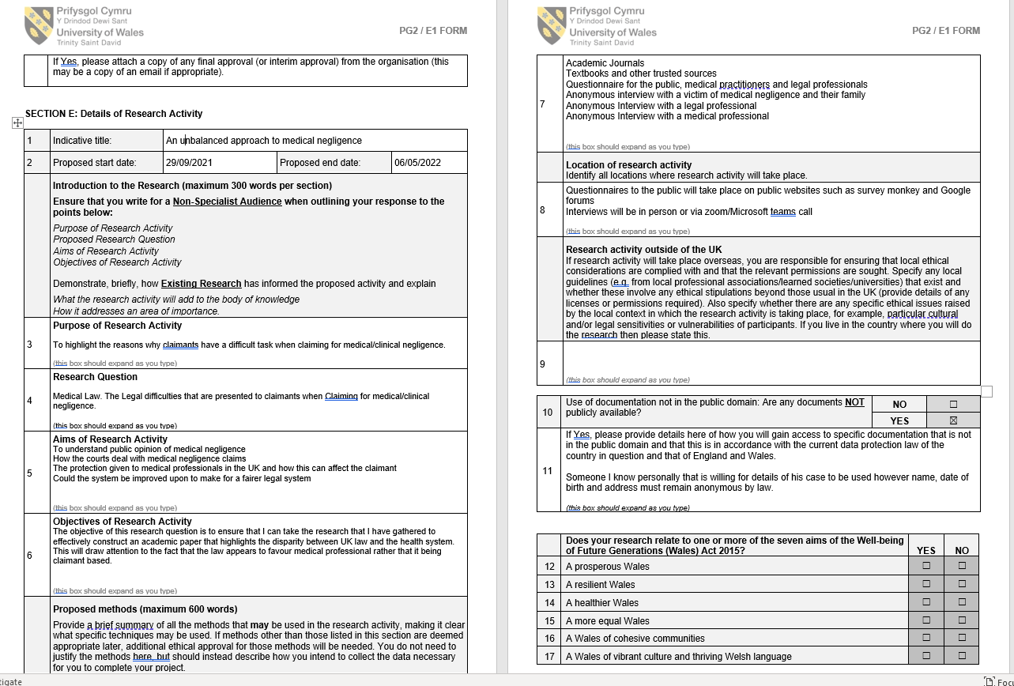
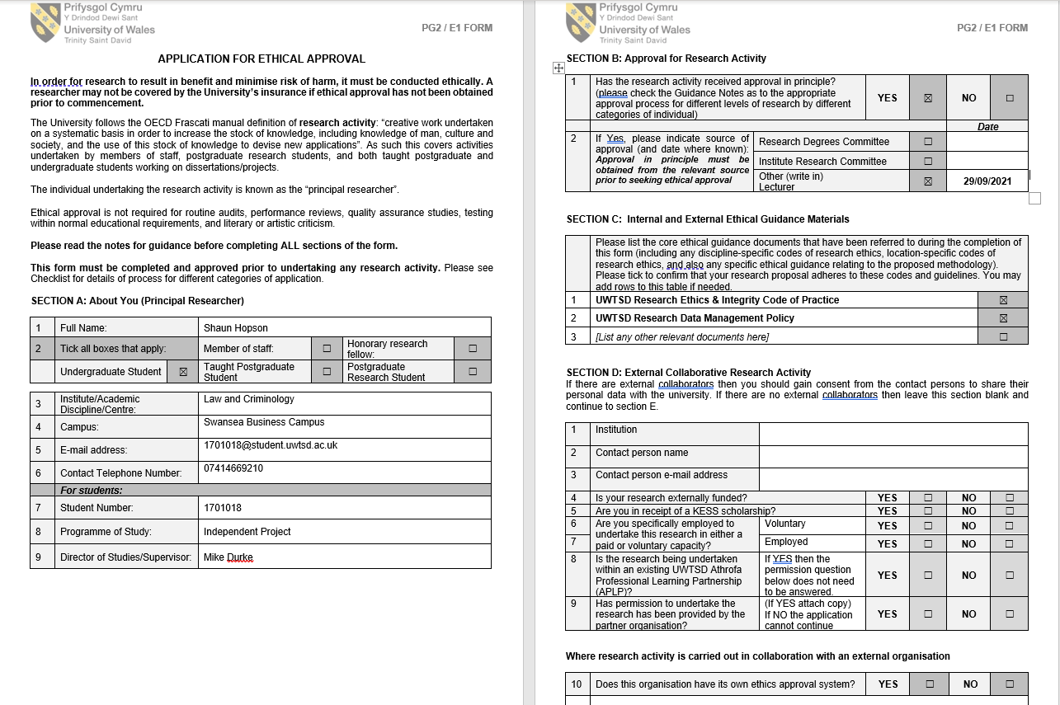
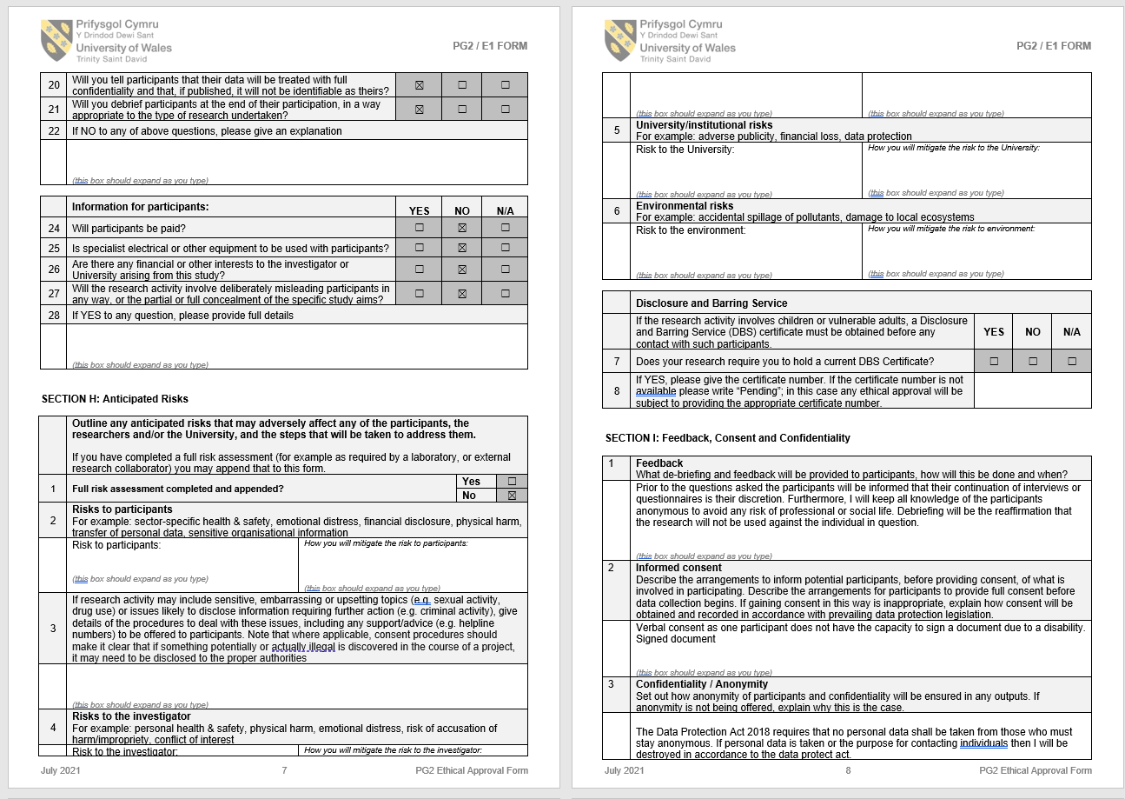
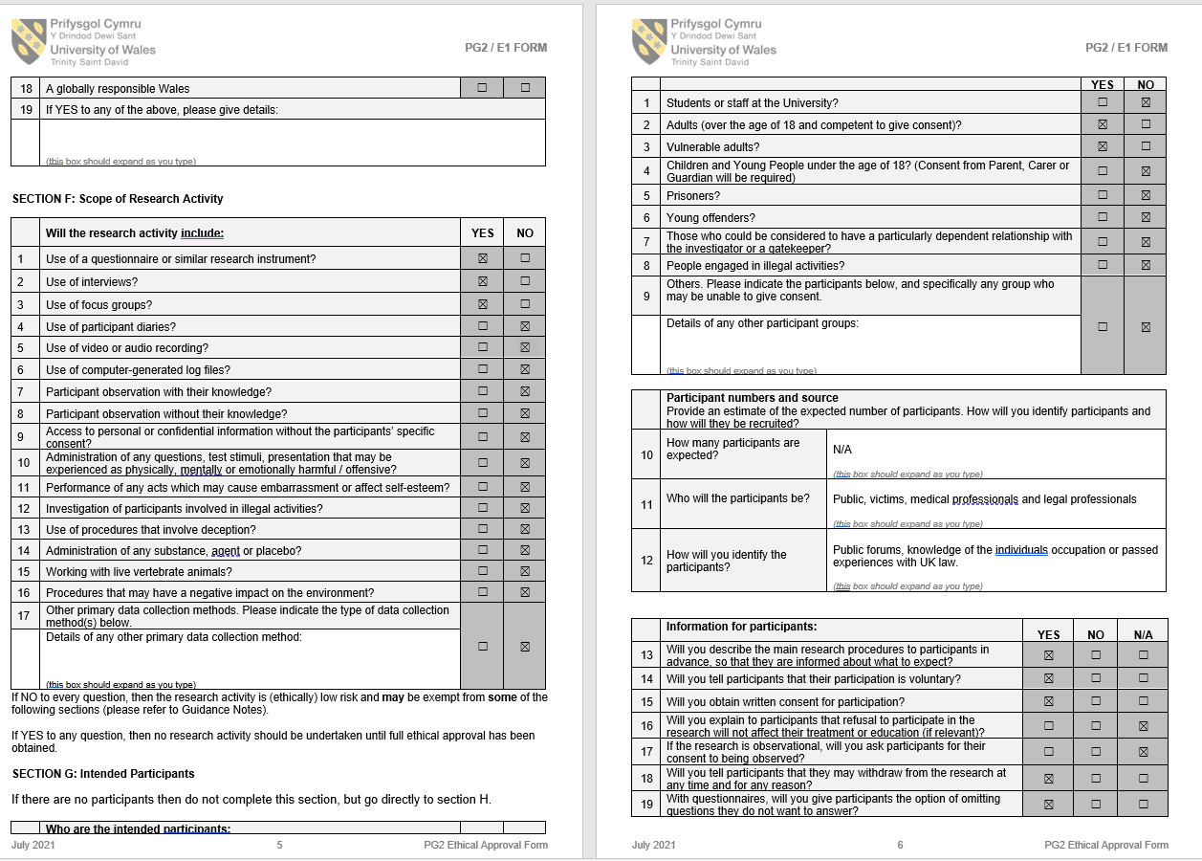
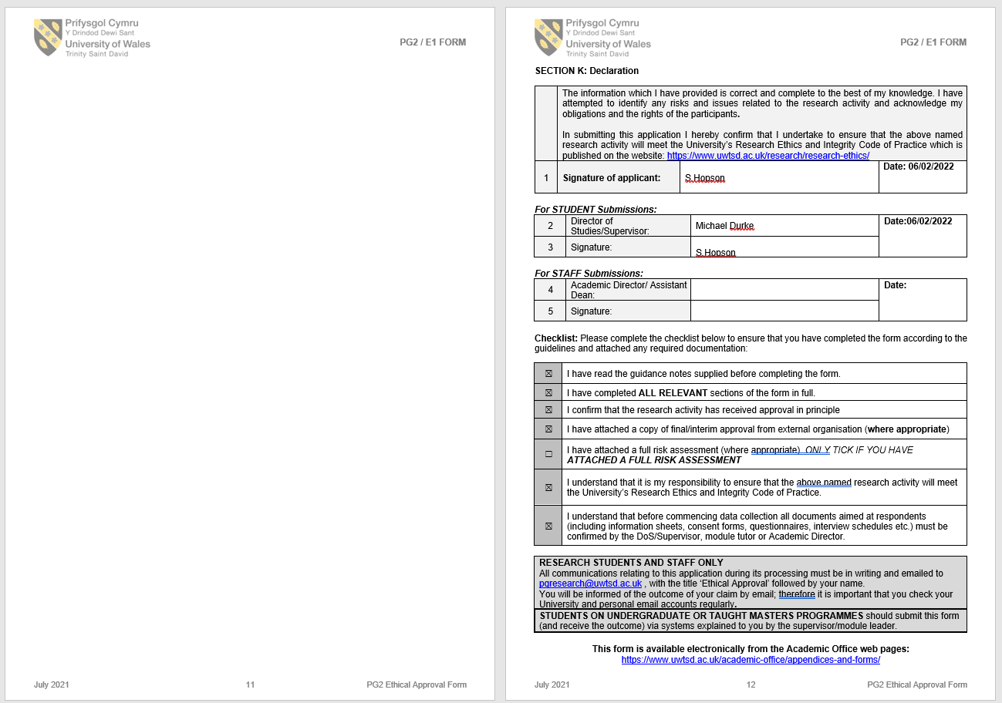
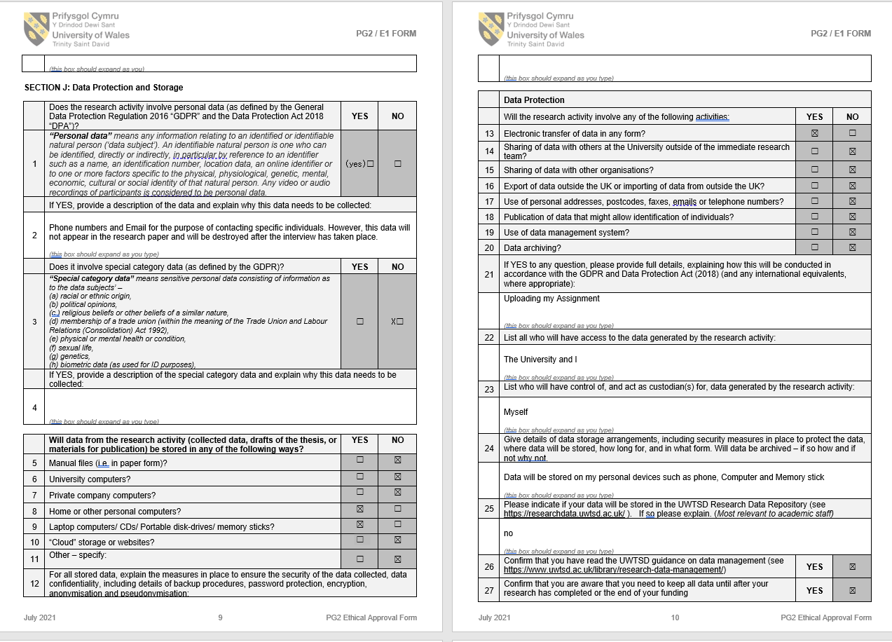

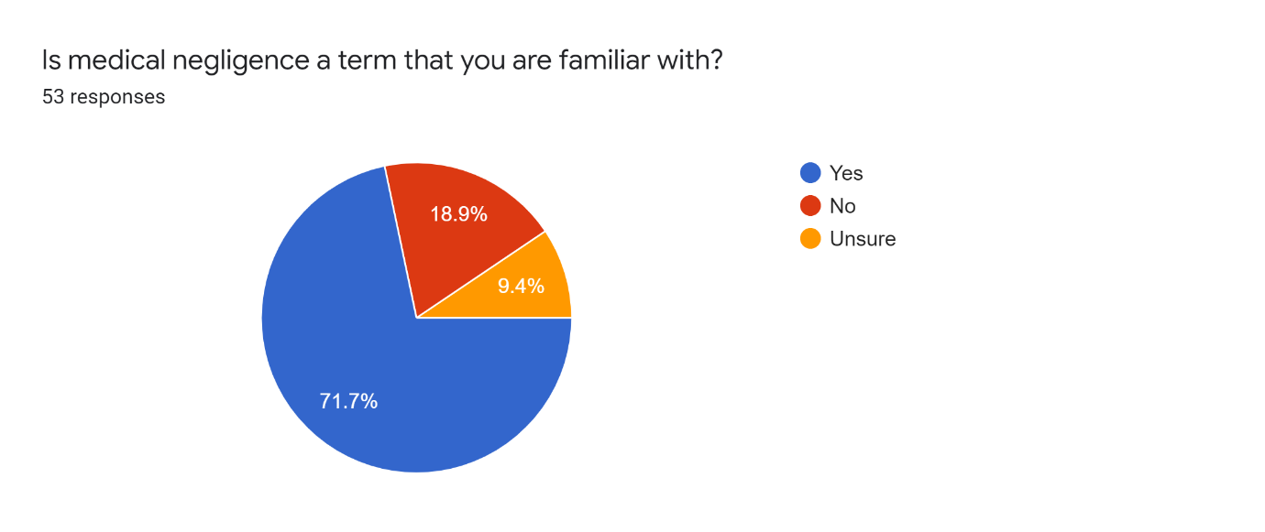
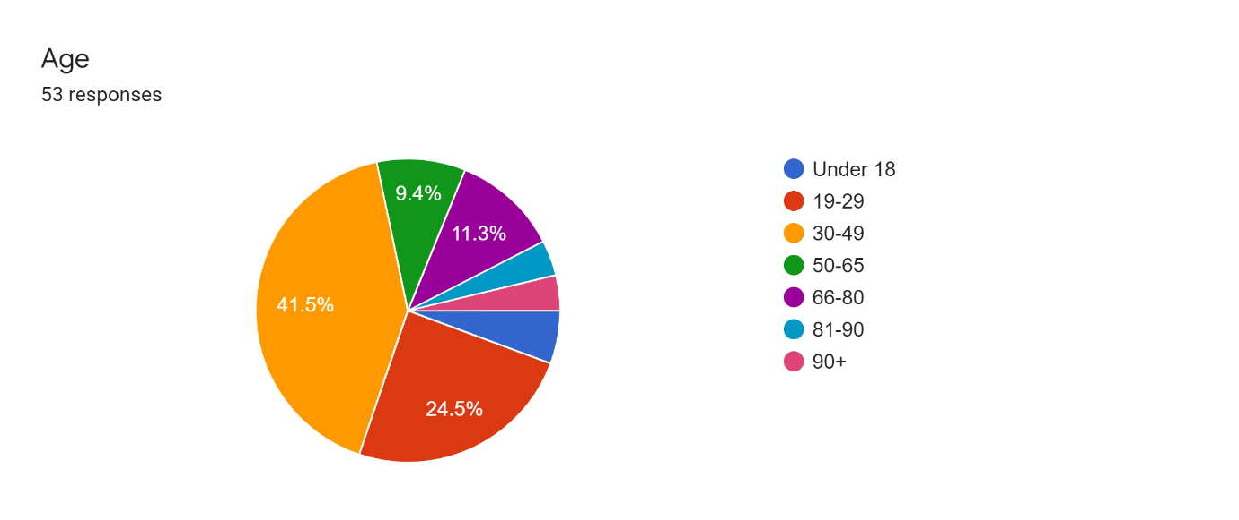
Questionnaire results

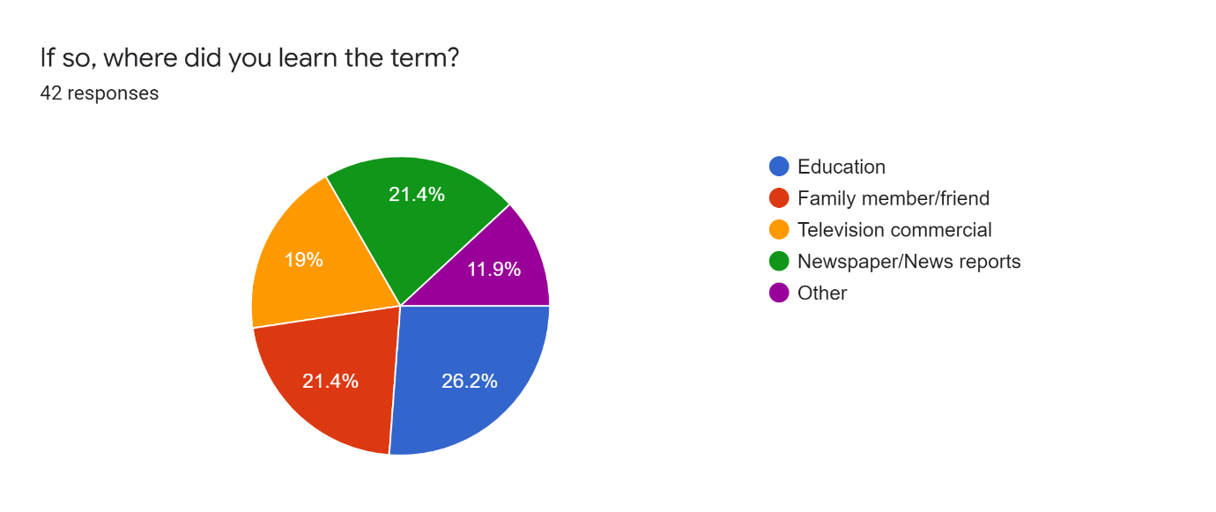

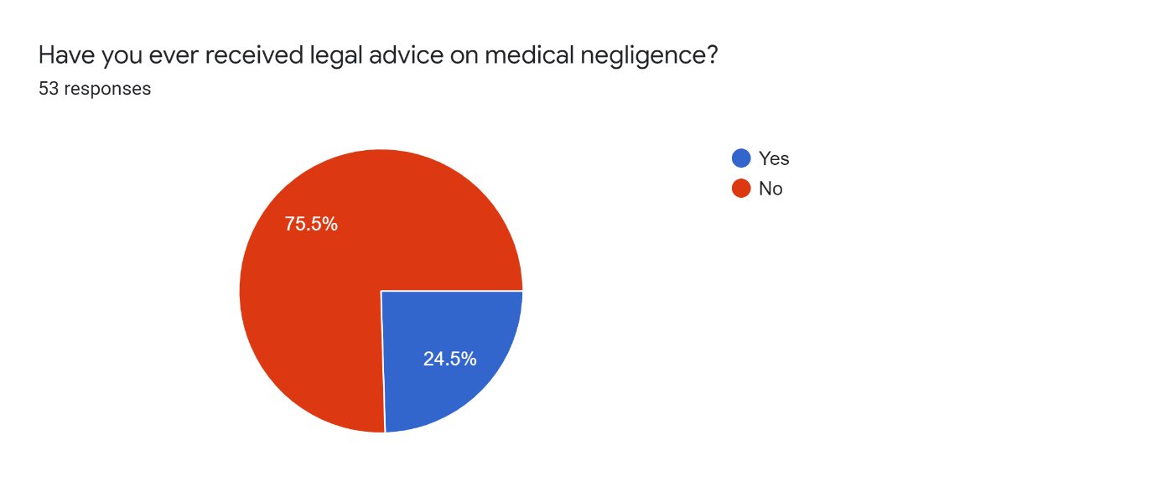
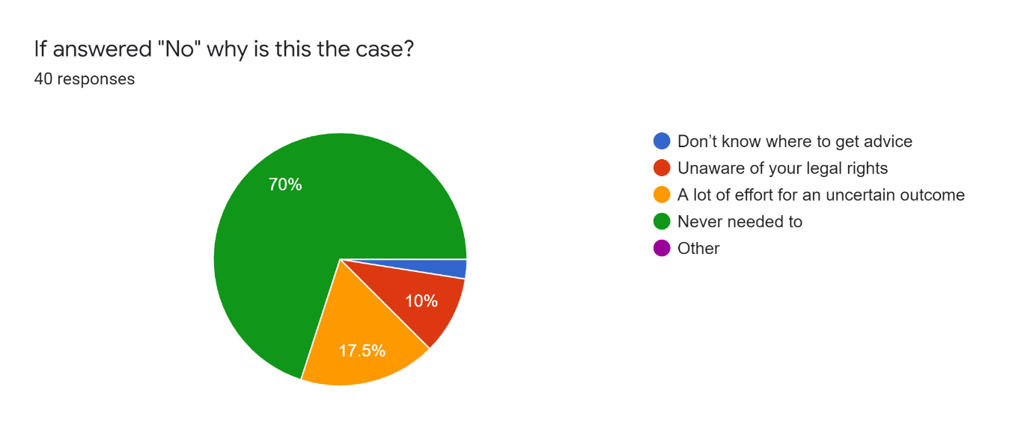
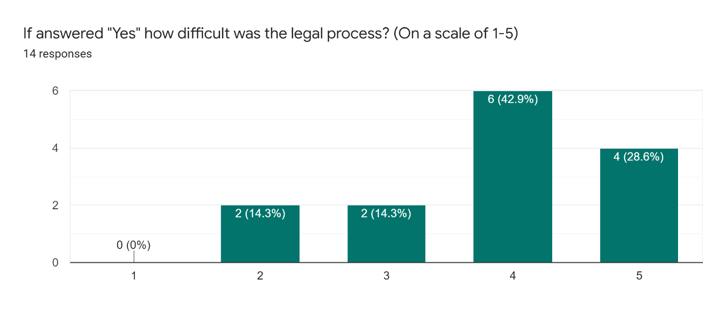
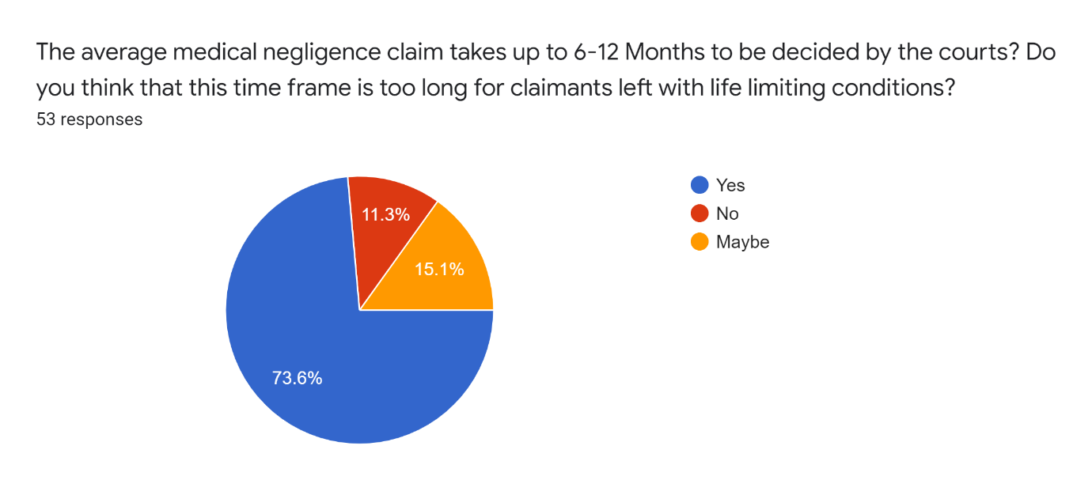
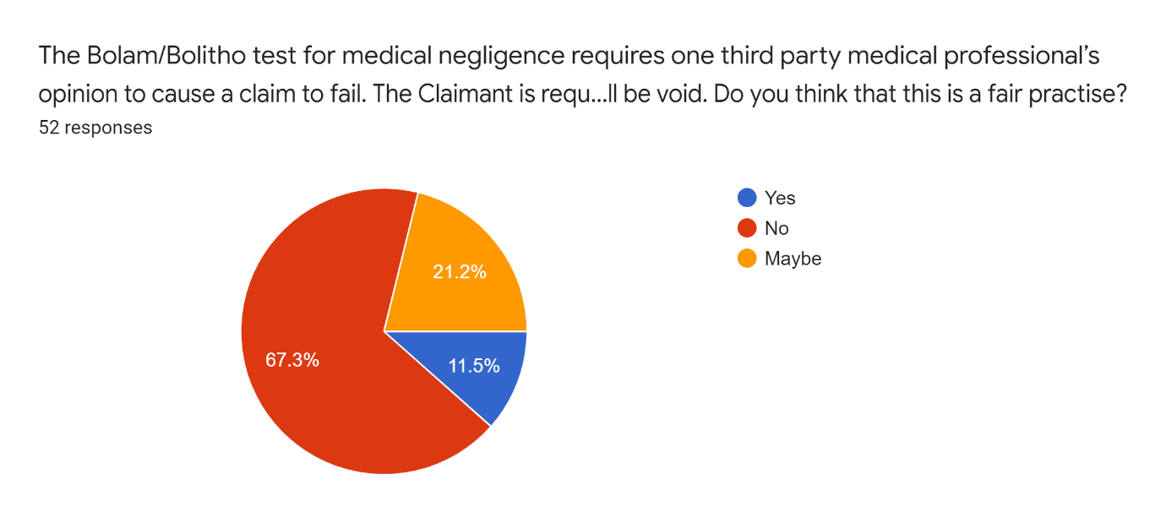
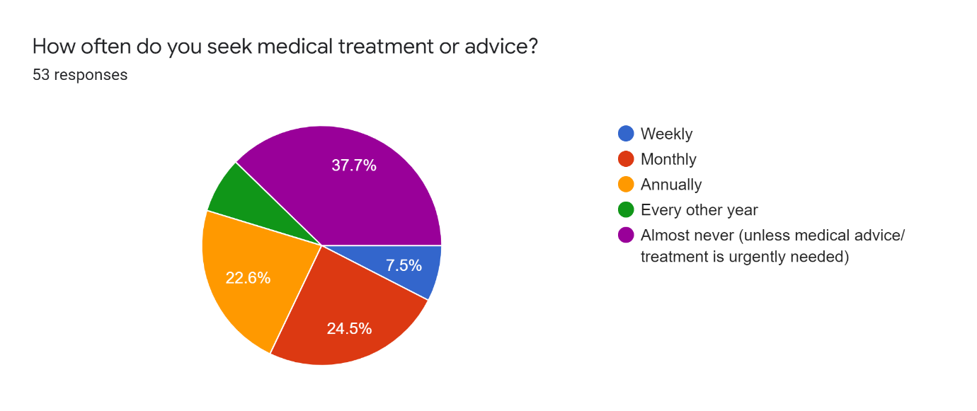

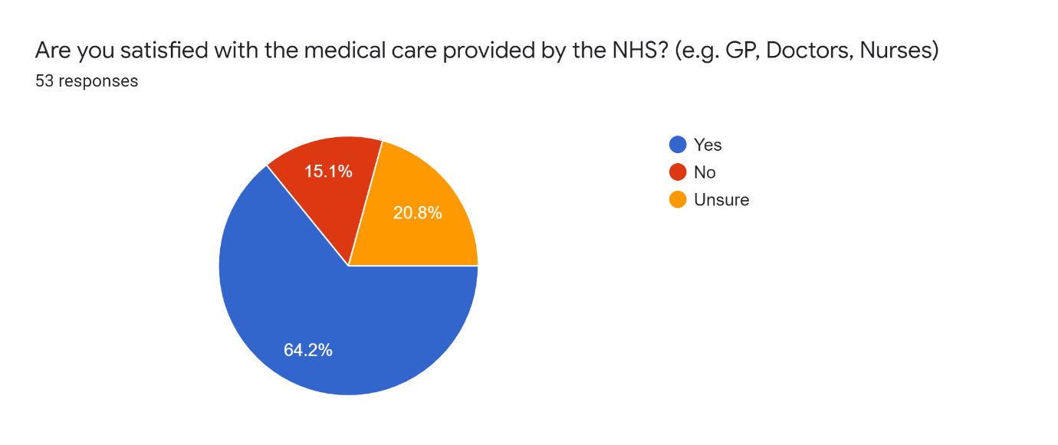
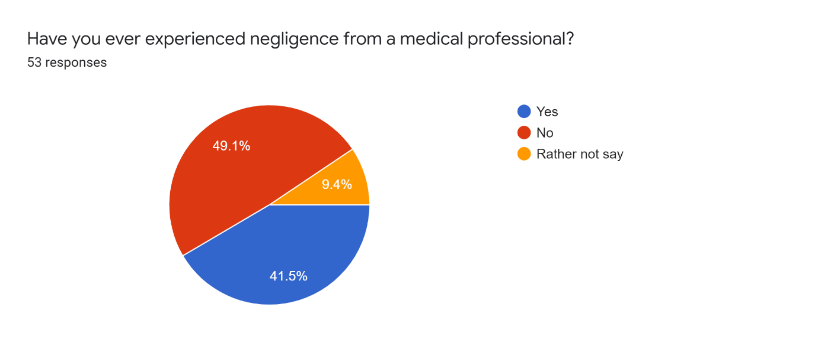
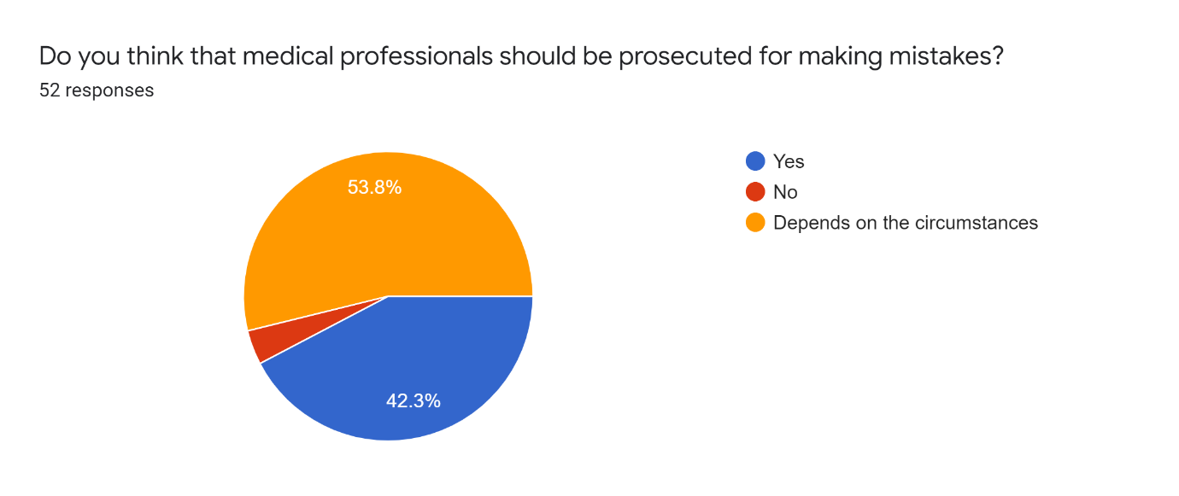

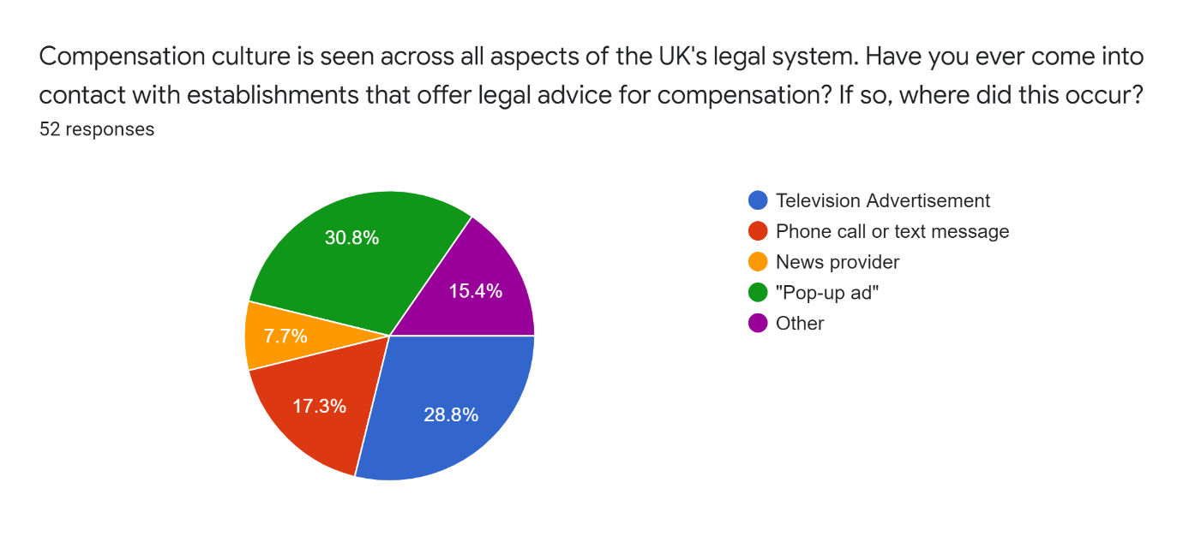
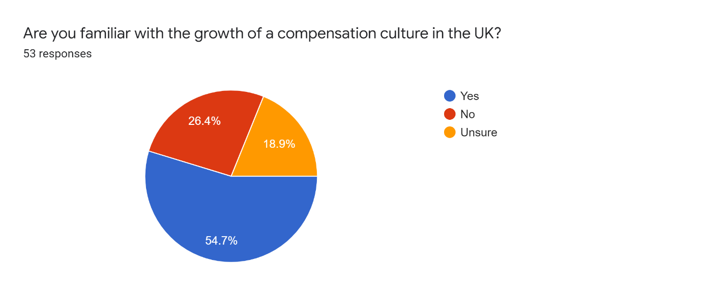
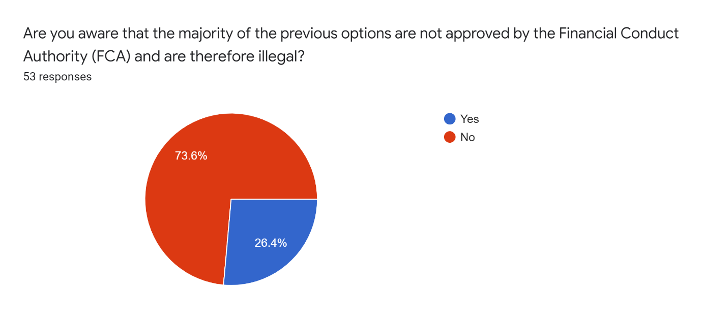

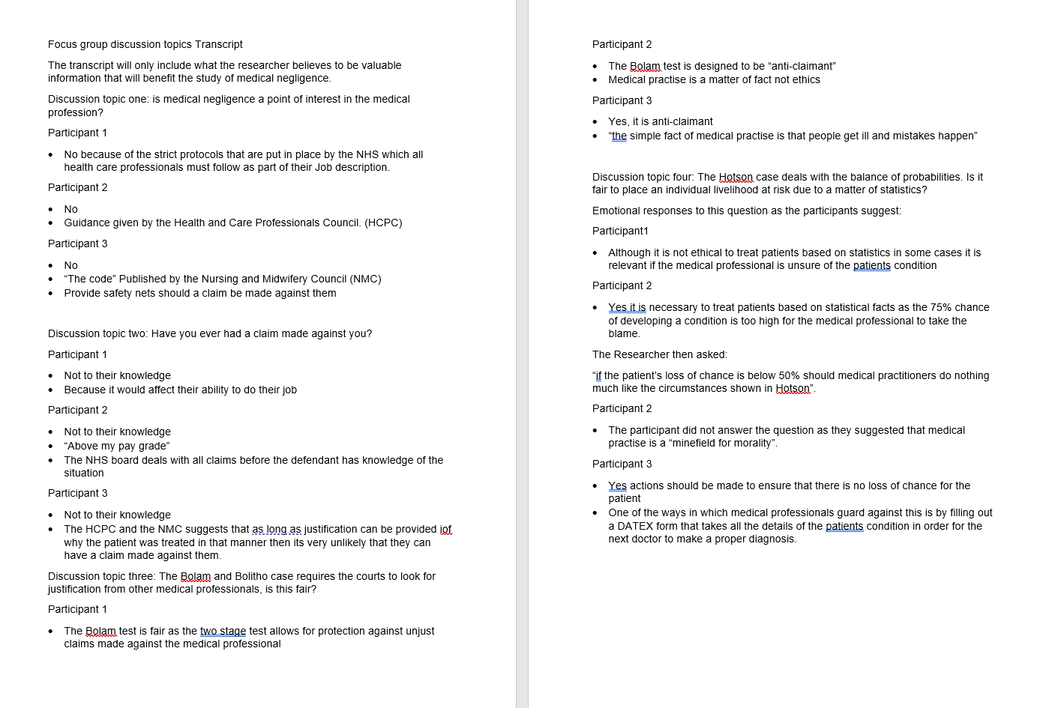
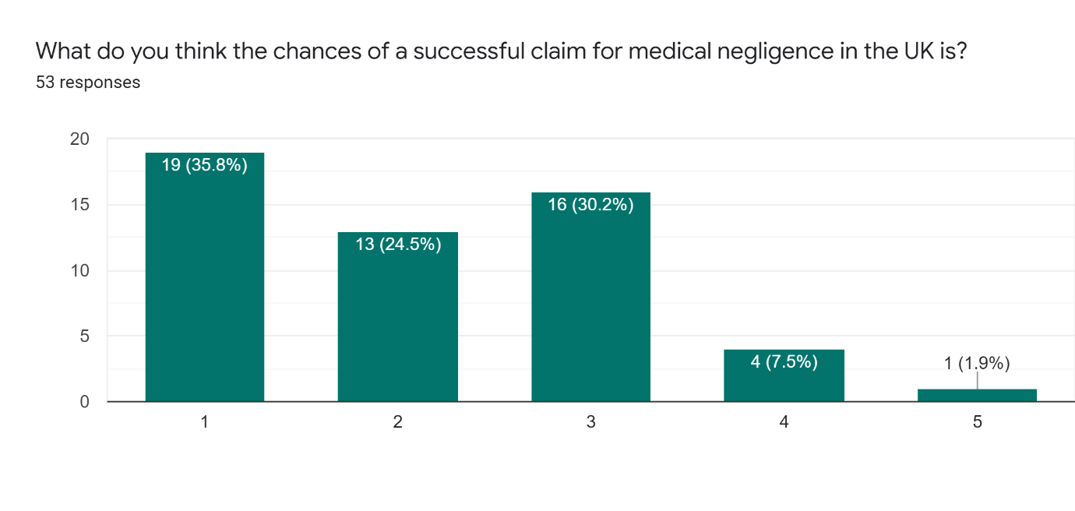
Transcript for the Focus Group Discussion topics

Transcript for the Interview with a Legal professional
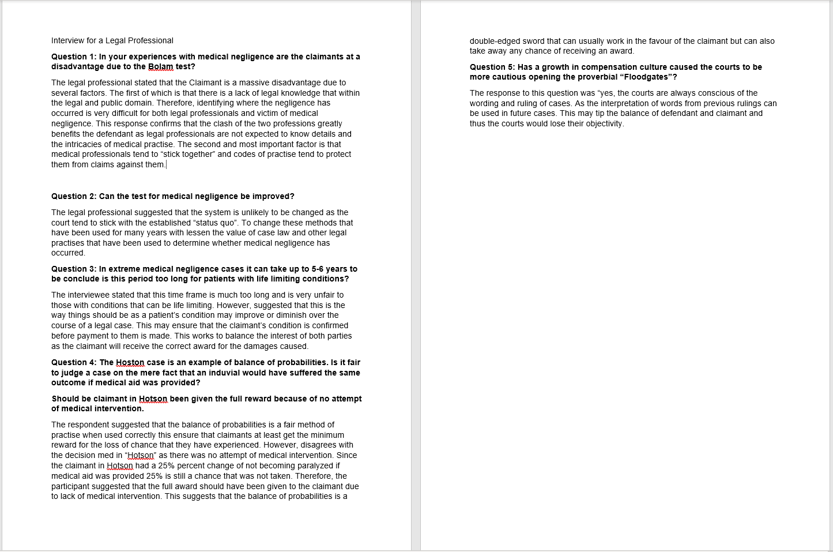

Transcript for the Interview with a Victim of Medical Negligence


