Appendix 1 – Ethic Form

APPLICATION FOR ETHICAL APPROVAL

RESEARCH STUDENTS
This form is to be completed by the student within SIX months for full-time students and TWELVE months for part time students, after the commencement of the research degree or following progression to Part Two of your course.

Once complete, submit this form via the MyTSD Doctoral College Portal at (https://mytsd.uwtsd.ac.uk).

This document is also available in Welsh.

RESEARCH STAFF ONLY
All communications relating to this application during its processing must be in writing and emailed to pgresearch@uwtsd.ac.uk , with the title ‘Ethical Approval’ followed by your name.

STUDENTS ON UNDERGRADUATE OR TAUGHT MASTERS PROGRAMMES should submit this form (and receive the outcome) via systems explained to you by the supervisor/module leader.

In order for research to result in benefit and minimise risk of harm, it must be conducted ethically. A researcher may not be covered by the University’s insurance if ethical approval has not been obtained prior to commencement.

The University follows the OECD Frascati manual definition of research activity: “creative work undertaken on a systematic basis in order to increase the stock of knowledge, including knowledge of man, culture and society, and the use of this stock of knowledge to devise new applications”. As such this covers activities undertaken by members of staff, postgraduate research students, and both taught postgraduate and undergraduate students working on dissertations/projects.

The individual undertaking the research activity is known as the “principal researcher”.

Ethical approval is not required for routine audits, performance reviews, quality assurance studies, testing within normal educational requirements, and literary or artistic criticism.

Please read the notes for guidance before completing ALL sections of the form.

This form must be completed and approved prior to undertaking any research activity. Please see Checklist for details of process for different categories of application.

SECTION A: About You (Principal Researcher)
1 | Full Name: |  | Lucy Mann
2 | Tick all boxes that apply: |  | Member of staff: | ☐ | Honorary research fellow: | ☐
 | Undergraduate Student | ☒ | Taught Postgraduate Student | ☐ | Postgraduate Research Student | ☐

3 | Institute/Academic Discipline/Centre: | Initial Teacher Education, Yr Athrofa
4 | Campus: | Carmarthen
5 | E-mail address: | 2200551@student.uwtsd.ac.uk
6 | Contact Telephone Number:
 | For students:
7 | Student Number: | 2200551
8 | Programme of Study: | BA Primary Education with QTS
9 | Director of Studies/Supervisor: | Dr Julia Hollaway

SECTION B: Approval for Research Activity
1 | Has the research activity received approval in principle?  (please check the Guidance Notes as to the appropriate approval process for different levels of research by different categories of individual) |  | YES | ☒ | NO | ☐
 |  |  |  |  | Date
2 | If Yes, please indicate source of approval (and date where known): Approval in principle must be obtained from the relevant source prior to seeking ethical approval | Research Degrees Committee |  | ☐
2 |  | Institute Research Committee |  | ☐
2 |  | Other (write in) ECAD5010 Module Tutor Dr Julia Hollaway |  | ☐ | 18.01.24

SECTION C: Internal and External Ethical Guidance Materials
 | Please list the core ethical guidance documents that have been referred to during the completion of this form (including any discipline-specific codes of research ethics, location-specific codes of research ethics, and also any specific ethical guidance relating to the proposed methodology). Please tick to confirm that your research proposal adheres to these codes and guidelines. You may add rows to this table if needed.
1 | UWTSD Research Ethics & Integrity Code of Practice | ☒
2 | UWTSD Research Data Management Policy | ☒
3 | BERA Guidelines 2018 and EWC Code of professional Conduct and Practise | ☒

SECTION D: External Collaborative Research Activity
If there are external collaborators then you should gain consent from the contact persons to share their personal data with the university. If there are no external collaborators then leave this section blank and continue to section E.
1 | Institution
2 | Contact person name
3 | Contact person e-mail address
4 | Is your research externally funded? |  | YES | ☐ | NO |  | ☐
5 | Are you in receipt of a KESS scholarship? |  | YES | ☐ | NO |  | ☐
6 | Are you specifically employed to undertake this research in either a paid or voluntary capacity? | Voluntary | YES | ☐ | NO | ☐
7 |  | Employed | YES | ☐ | NO | ☐
8 | Is the research being undertaken within an existing UWTSD Athrofa Professional Learning Partnership (APLP)? | If YES then the permission question below does not need to be answered. | YES | ☒ | NO |  | ☐
9 | Has permission to undertake the research has been provided by the partner organisation? | (If YES attach copy)  If NO the application cannot continue | YES | ☐ | NO |  | ☐

Where research activity is carried out in collaboration with an external organisation
10 | Does this organisation have its own ethics approval system? | YES | ☒ | NO | ☐
 | If Yes, please attach a copy of any final approval (or interim approval) from the organisation (this may be a copy of an email if appropriate).

SECTION E: Details of Research Activity
1 | Indicative title: | What are staff and Year 3 learners’ perceptions of peer and self- assessment.
2 | Proposed start date: | 24.01.24 | Proposed end date: | 19.02.24
Introduction to the Research (maximum 300 words per section)
Ensure that you write for a Non-Specialist Audience when outlining your response to the points below:
Purpose of Research Activity
- Proposed Research Question
- Aims of Research Activity
- Objectives of Research Activity
Demonstrate, briefly, how Existing Research has informed the proposed activity and explain.
- What the research activity will add to the body of knowledge
- How it addresses an area of importance.
3 | Purpose of Research Activity  The purpose of the research activity is to investigate an area of assessment for learning to improve your practise. To develop your research, I am trailing and evaluating a range of research tools.  (this box should expand as you type)
4 | Research Question  What are staff and Year 3 learners’ perceptions of peer and self-assessment.  (this box should expand as you type)
5 | Aims of Research Activity  - Further develop research skills by trailing different research tools and critically evaluating them.  - Also, to develop and build on professional classroom practise by gaining a deeper understand of Assessment for Learning.  - To explore and evaluate staff and learners’ views of Assessment for Learning.  (this box should expand as you type)
6 | Objectives of Research Activity  I will do this by conducting a mosaic approach to gather data from pupils and staff through surveys, questionnaires, and interviews.  (this box should expand as you type)
Proposed methods (maximum 600 words)
Provide a summary of all the methods that may be used in the research activity, making it clear what specific techniques may be used. If methods other than those listed in this section are deemed appropriate later, additional ethical approval for those methods will be needed. You do not need to justify the methods here but should instead describe how you intend to collect the data necessary for you to complete your project.
7 | Within this research investigation, a mosaic approach will be used. To complete this research investigation a range of research tools will be used. These include focused group interviews and questionnaires. Pupils will be involved in a semi- structured interview. In the interview pupils will be ask a variety of questions to respond to. Questions ask will focus and consider the impact that peer and self-assessment has on their learning. To ensure the interview is confidential, it will take place in a closed room in an informal setting. During the interview notes and audio recordings will be made to record all responses given by pupils. However, no names will be used when recording the responses. Furthermore, all participates will be made clearly aware that they do not have to answer any questions they wish not to and can leave the interview at any point. Participates will be frequently asked whether they are good to carry on. However, If it is not possible to interview pupils, then staff will be asked to be interviewed.  In addition, another research tool that will be used are questionnaires. The questionnaires will be completed by staff. The questionnaires will be carried out online. They will be asked a range of question on what their thoughts and opinions are peer and self-assessment.  (this box should expand as you type)
Location of research activity
Identify all locations where research activity will take place.
8 | Placement school. Medium size school in a semi-rural area.  (this box should expand as you type)
Research activity outside of the UK
If research activity will take place overseas, you are responsible for ensuring that local ethical considerations are complied with and that the relevant permissions are sought. Specify any local guidelines (e.g. from local professional associations/learned societies/universities) that exist and whether these involve any ethical stipulations beyond those usual in the UK (provide details of any licenses or permissions required). Also specify whether there are any specific ethical issues raised by the local context in which the research activity is taking place, for example, particular cultural and/or legal sensitivities or vulnerabilities of participants. If you live in the country where you will do the research then please state this.
9 | N/A  (this box should expand as you type)

10 | Use of documentation not in the public domain: Are any documents NOT publicly available? | NO | ☒
10 |  | YES | ☐
11 | If Yes, please provide details here of how you will gain access to specific documentation that is not in the public domain and that this is in accordance with the current data protection law of the country in question and that of England and Wales.  (this box should expand as you type)

 | Does your research relate to one or more of the seven aims of the Well-being of Future Generations (Wales) Act 2015? | YES | NO
12 | A prosperous Wales | ☒ | ☐
13 | A resilient Wales | ☒ | ☐
14 | A healthier Wales | ☐ | ☒
15 | A more equal Wales | ☐ | ☒
16 | A Wales of cohesive communities | ☐ | ☒
17 | A Wales of vibrant culture and thriving Welsh language | ☐ | ☒
18 | A globally responsible Wales | ☐ | ☒
19 | If YES to any of the above, please give details:
 | (this box should expand as you type)

SECTION F: Scope of Research Activity TICK ALL RELEVANT BOXES HERE
 | Will the research activity include: | YES | NO
1 | Use of a questionnaire or similar research instrument? | ☒ | ☐
2 | Use of interviews? | ☒ | ☐
3 | Use of focus groups? | ☒ | ☐
4 | Use of participant diaries? | ☐ | ☒
5 | Use of video or audio recording? | ☒ | ☐
6 | Use of computer-generated log files? | ☐ | ☒
7 | Participant observation with their knowledge? | ☐ | ☒
8 | Participant observation without their knowledge? | ☐ | ☒
9 | Access to personal or confidential information without the participants’ specific consent? | ☐ | ☒
10 | Administration of any questions, test stimuli, presentation that may be experienced as physically, mentally or emotionally harmful / offensive? | ☐ | ☒
11 | Performance of any acts which may cause embarrassment or affect self-esteem? | ☐ | ☒
12 | Investigation of participants involved in illegal activities? | ☐ | ☒
13 | Use of procedures that involve deception? | ☐ | ☒
14 | Administration of any substance, agent or placebo? | ☐ | ☒
15 | Working with live vertebrate animals? | ☐ | ☒
16 | Procedures that may have a negative impact on the environment? | ☐ | ☒
17 | Other primary data collection methods. Please indicate the type of data collection method(s) below. | ☐ | ☒
 | Details of any other primary data collection method:  (this box should expand as you type) | ☐ | ☒
If NO to every question, then the research activity is (ethically) low risk and may be exempt from some of the following sections (please refer to Guidance Notes).

If YES to any question, then no research activity should be undertaken until full ethical approval has been obtained.

SECTION G: Intended Participants TICK ALL RELEVANT BOXES HERE
If there are no participants then do not complete this section, but go directly to section H.

 | Who are the intended participants: | YES | NO
1 | Students or staff at the University? | ☐ | ☐
2 | Adults (over the age of 18 and competent to give consent)? | ☒ | ☐
3 | Vulnerable adults? | ☐ | ☐
4 | Children and Young People under the age of 18? (Consent from Parent, Carer or Guardian will be required) | ☒ | ☐
5 | Prisoners? | ☐ | ☐
6 | Young offenders? | ☐ | ☐
7 | Those who could be considered to have a particularly dependent relationship with the investigator or a gatekeeper? | ☐ | ☐
8 | People engaged in illegal activities? | ☐ | ☐
9 | Others. Please indicate the participants below, and specifically any group who may be unable to give consent. | ☐ | ☐
 | Details of any other participant groups:  (this box should expand as you type) | ☐ | ☐

Participant numbers and source
Provide an estimate of the expected number of participants. How will you identify participants and how will they be recruited?
10 | How many participants are expected? | 15 participants  (this box should expand as you type)
11 | Who will the participants be? | 10 teachers, within key stage 1 and 2. Approx. no. questionnaires 8  Pupils in year 3 aged 7-8.  (this box should expand as you type)
12 | How will you identify the participants? | Staff are identified as stakeholders within the school in which they will be asked to participate in a questionnaire.  A random sample of pupils will be selected by the support of the classroom teacher to participate in a semi-structured interview.  (this box should expand as you type)

 | Information for participants: | YES | NO | N/A
13 | Will you describe the main research procedures to participants in advance, so that they are informed about what to expect? | ☒ | ☐ | ☐
14 | Will you tell participants that their participation is voluntary? | ☒ | ☐ | ☐
15 | Will you obtain written consent for participation? | ☐ | ☐ | ☒
16 | Will you explain to participants that refusal to participate in the research will not affect their treatment or education (if relevant)? | ☒ | ☐ | ☐
17 | If the research is observational, will you ask participants for their consent to being observed? | ☐ | ☐ | ☒
18 | Will you tell participants that they may withdraw from the research at any time and for any reason? | ☒ | ☐ | ☐
19 | With questionnaires, will you give participants the option of omitting questions they do not want to answer? | ☒ | ☐ | ☐
20 | Will you tell participants that their data will be treated with full confidentiality and that, if published, it will not be identifiable as theirs? | ☒ | ☐ | ☐
21 | Will you debrief participants at the end of their participation, in a way appropriate to the type of research undertaken? | ☒ | ☐ | ☐
22 | If NO to any of above questions, please give an explanation
 | (this box should expand as you type)

 | Information for participants: | YES | NO | N/A
24 | Will participants be paid? | ☐ | ☒ | ☐
25 | Is specialist electrical or other equipment to be used with participants? | ☐ | ☒ | ☐
26 | Are there any financial or other interests to the investigator or University arising from this study? | ☐ | ☒ | ☐
27 | Will the research activity involve deliberately misleading participants in any way, or the partial or full concealment of the specific study aims? | ☐ | ☒ | ☐
28 | If YES to any question, please provide full details
 | (this box should expand as you type)

SECTION H: Anticipated Risks

Outline any anticipated risks that may adversely affect any of the participants, the researchers and/or the University, and the steps that will be taken to address them.

If you have completed a full risk assessment (for example as required by a laboratory, or external research collaborator) you may append that to this form.
1 | Full risk assessment completed and appended? |  | Yes | ☐
1 |  |  | No | ☒
2 | Risks to participants  For example: sector-specific health & safety, emotional distress, financial disclosure, physical harm, transfer of personal data, sensitive organisational information
 | Risk to participants:  - May feel obliged to participate in study due to power imbalance and feeling pressured to give the right answer.  - Safeguarding issues.  - Not feeling valued and effects pupils’ self-esteem.  (this box should expand as you type) | How you will mitigate the risk to participants:  - I would make them feel comfortable with body language. I would also ensure that at the start it will be made clear that they can leave at any time. I will allocate time at the start to introduce myself and explain that there is no right and wrong answer. They will also be made aware again of the purpose of the interview.  - Everything will be kept confidentially; however, they will be made aware that if something arises through the interview that because high risk, then the information will then be reported and passed on to safeguarding officers or relevant member of staff.  - Reassure them that names are picked at random. Also, show them that you value what they say by making sure everyone gets a turn in speaking. I will also ensure that every participate is fairly treated and as an equal chance to express themselves.  (this box should expand as you type)
3 | If research activity may include sensitive, embarrassing or upsetting topics (e.g. sexual activity, drug use) or issues likely to disclose information requiring further action (e.g. criminal activity), give details of the procedures to deal with these issues, including any support/advice (e.g. helpline numbers) to be offered to participants. Note that where applicable, consent procedures should make it clear that if something potentially or actually illegal is discovered in the course of a project, it may need to be disclosed to the proper authorities
N/A

(this box should expand as you type)
4 | Risks to the investigator  For example: personal health & safety, physical harm, emotional distress, risk of accusation of harm/impropriety, conflict of interest
 | Risk to the investigator:  - Possible claims for pupils in the classroom from the interview.  - You could be accused of favouritism.  - Conflict/ biased data from your relationship with pupils.  (this box should expand as you type) | How you will mitigate the risk to the investigator:  - To prevent this problem occurring, I might consider carrying out the interview in an open space. However, this will me the interview is not confidential.  - To try overcomethis risk, I will ensure that everyone is treated equally and that everyone responded is values the same.  - I might Potentially have another member if staff with me to ensure that I am not being biased to any pupils.  (this box should expand as you type)
5 | University/institutional risks  For example: adverse publicity, financial loss, data protection
 | Risk to the University:  - My behaviour could impact reputation of the university.  - Changing data collected that might impact the Universities standards and  (this box should expand as you type) | How you will mitigate the risk to the University:  - I will present myself and use professional behaviour whilst conducting my research.  - To prevent this, I will ensure that data is handled and used correctly and is not plagiarised.  (this box should expand as you type)
6 | Environmental risks  For example: accidental spillage of pollutants, damage to local ecosystems
 | Risk to the environment:  N/A  (this box should expand as you type) | How you will mitigate the risk to environment:  N/A  (this box should expand as you type)

 | Disclosure and Barring Service
 | If the research activity involves children or vulnerable adults, a Disclosure and Barring Service (DBS) certificate must be obtained before any contact with such participants. | YES | NO | N/A
7 | Does your research require you to hold a current DBS Certificate? | ☒ | ☐ | ☐
8 | If YES, please give the certificate number. If the certificate number is not available please write “Pending”; in this case any ethical approval will be subject to providing the appropriate certificate number.

SECTION I: Feedback, Consent and Confidentiality

1 | Feedback  What de-briefing and feedback will be provided to participants, how will this be done and when?
N/A

(this box should expand as you type)
2 | Informed consent  Describe the arrangements to inform potential participants, before providing consent, of what is involved in participating. Describe the arrangements for participants to provide full consent before data collection begins. If gaining consent in this way is inappropriate, explain how consent will be obtained and recorded in accordance with prevailing data protection legislation.
There will be a consent form handed out to be completed. Within the consent form, it will explain the purpose of the research and why it is being carried out. It will identify what the research will be used for. It will also explain that they can decide to not participate at any time throughout the interview or questionnaire.

(this box should expand as you type)
3 | Confidentiality / Anonymity  Set out how anonymity of participants and confidentiality will be ensured in any outputs. If anonymity is not being offered, explain why this is the case.
The school and participants would be identified. No names will be removed, and pseudonyms will be used. To keep confidentiality data collected will only be seen and read by the applicant and module supervisor.

(this box should expand as you type)

SECTION J: Data Protection and Storage NO NEED TO COMPLETE SECTION J

 | Does the research activity involve personal data (as defined by the General Data Protection Regulation 2016 “GDPR” and the Data Protection Act 2018 “DPA”)? | YES | NO
1 | “Personal data” means any information relating to an identified or identifiable natural person (‘data subject’). An identifiable natural person is one who can be identified, directly or indirectly, in particular by reference to an identifier such as a name, an identification number, location data, an online identifier or to one or more factors specific to the physical, physiological, genetic, mental, economic, cultural or social identity of that natural person. Any video or audio recordings of participants is considered to be personal data. | ☐ | ☐
 | If YES, provide a description of the data and explain why this data needs to be collected:
2 | (this box should expand as you type)
 | Does it involve special category data (as defined by the GDPR)? | YES | NO
3 | “Special category data” means sensitive personal data consisting of information as to the data subjects’ –  (a) racial or ethnic origin,  (b) political opinions,  (c ) religious beliefs or other beliefs of a similar nature,  (d) membership of a trade union (within the meaning of the Trade Union and Labour Relations (Consolidation) Act 1992),  (e) physical or mental health or condition,  (f) sexual life,  (g) genetics,  (h) biometric data (as used for ID purposes), | ☐ | ☐
 | If YES, provide a description of the special category data and explain why this data needs to be collected:
4 | (this box should expand as you type)

 | Will data from the research activity (collected data, drafts of the thesis, or materials for publication) be stored in any of the following ways? | YES | NO
5 | Manual files (i.e. in paper form)? | ☐ | ☐
6 | University computers? | ☐ | ☐
7 | Private company computers? | ☐ | ☐
8 | Home or other personal computers? | ☐ | ☐
9 | Laptop computers/ CDs/ Portable disk-drives/ memory sticks? | ☐ | ☐
10 | “Cloud” storage or websites? | ☐ | ☐
11 | Other – specify: | ☐ | ☐
12 | For all stored data, explain the measures in place to ensure the security of the data collected, data confidentiality, including details of backup procedures, password protection, encryption, anonymisation and pseudonymisation:
 | (this box should expand as you type)

 | Data Protection
 | Will the research activity involve any of the following activities: | YES | NO
13 | Electronic transfer of data in any form? | ☐ | ☐
14 | Sharing of data with others at the University outside of the immediate research team? | ☐ | ☐
15 | Sharing of data with other organisations? | ☐ | ☐
16 | Export of data outside the UK or importing of data from outside the UK? | ☐ | ☐
17 | Use of personal addresses, postcodes, faxes, emails or telephone numbers? | ☐ | ☐
18 | Publication of data that might allow identification of individuals? | ☐ | ☐
19 | Use of data management system? | ☐ | ☒
20 | Data archiving? | ☐ | ☐
21 | If YES to any question, please provide full details, explaining how this will be conducted in accordance with the GDPR and Data Protection Act (2018) (and any international equivalents, where appropriate):
N/A

(this box should expand as you type)
22 | List all who will have access to the data generated by the research activity:
 | (this box should expand as you type)
23 | List who will have control of, and act as custodian(s) for, data generated by the research activity:
 | (this box should expand as you type)
24 | Give details of data storage arrangements, including security measures in place to protect the data, where data will be stored, how long for, and in what form. Will data be archived – if so how and if not why not.
 | (this box should expand as you type)
25 | Please indicate if your data will be stored in the UWTSD Research Data Repository (see https://researchdata.uwtsd.ac.uk/ ). If so please explain. (Most relevant to academic staff)
N/A

(this box should expand as you type)
26 | Confirm that you have read the UWTSD guidance on data management (see https://www.uwtsd.ac.uk/library/research-data-management/) | YES | ☐
27 | Confirm that you are aware that you need to keep all data until after your research has completed or the end of your funding | YES | ☐

SECTION K: Declaration
The information which I have provided is correct and complete to the best of my knowledge. I have attempted to identify any risks and issues related to the research activity and acknowledge my obligations and the rights of the participants.

In submitting this application I hereby confirm that I undertake to ensure that the above named research activity will meet the University’s Research Ethics and Integrity Code of Practice which is published on the website: https://www.uwtsd.ac.uk/research/research-ethics/
1 | Signature of applicant: | Lucy Mann | Date:  18.01.2024

For STUDENT Submissions:
2 | Director of Studies/Supervisor: |  | Date:
3 | Signature: |  | Date:

For STAFF Submissions:
4 | Academic Director/ Assistant Dean: |  | Date:
5 | Signature: |  | Date:

Checklist: Please complete the checklist below to ensure that you have completed the form according to the guidelines and attached any required documentation:
☐ | I have read the guidance notes supplied before completing the form.
☐ | I have completed ALL RELEVANT sections of the form in full.
☐ | I confirm that the research activity has received approval in principle
☐ | I have attached a copy of final/interim approval from external organisation (where appropriate)
☐ | I have attached a full risk assessment (where appropriate) ONLY TICK IF YOU HAVE ATTACHED A FULL RISK ASSESSMENT
☐ | I understand that it is my responsibility to ensure that the above named research activity will meet the University’s Research Ethics and Integrity Code of Practice.
☐ | I understand that before commencing data collection all documents aimed at respondents (including information sheets, consent forms, questionnaires, interview schedules etc.) must be confirmed by the DoS/Supervisor, module tutor or Academic Director.

RESEARCH STUDENTS ONLY
Once complete, submit this form via the MyTSD Doctoral College Portal at (https://mytsd.uwtsd.ac.uk).

RESEARCH STAFF ONLY
All communications relating to this application during its processing must be in writing and emailed to pgresearch@uwtsd.ac.uk , with the title ‘Ethical Approval’ followed by your name.

STUDENTS ON UNDERGRADUATE OR TAUGHT MASTERS PROGRAMMES should submit this form (and receive the outcome) via systems explained to you by the supervisor/module leader.

Appendix 2 – Headteacher Consent Form



Research School Day
BA2
24/01/24

Rationale
Research Day in School is an important element of the ECAD5010 Module – Researching the Learning – what, how and why am I teaching? The aim of the module is to develop student teachers’ research skills by providing opportunities for them to create a questionnaire and interview questions and to trial these research methods in a school (i.e., PTE2 school).

The overarching research question is ‘What are learners and staff perceptions of AfL?” For the assignment, the student teachers will have to choose a particular aspect of AfL (e.g. feedback, questioning) and then design, trial and critically evaluate their research tools.

Before the Research Day in School the student teachers will have already designed their research tools (questionnaire and interview questions) and submitted an ethics form.

During the Research Day in School the student teacher should be able to carry out the following tasks:
- Distribute and collect questionnaires (school staff and/or pupils)
- Interview a group of children (from PTE2 class) and possibly some of the staff

Following the ‘Research Day in School’, the student teachers will critically evaluate these research tools. Their focus will not be on the data they collected but on the research design, i.e. the effectiveness of their research tools.

EWC Code of Conduct:
An expectation of professionalism as outlined in the EWC’s code of conduct is expected from all stakeholder participants throughout the Research Day.
https://www.ewc.wales/site/index.php/en/fitness-to-practise/code-of-professional-conduct-and-practice-pdf.html

They are also expected to adhere to the BERA Ethical Guidelines for Educational Research (2018) https://www.bera.ac.uk/publication/ethical-guidelines-for-educational-research-2018 and the UWTSD UWTSD Research Ethics & Integrity Code of Practice

ECAD5010 Consent Form

Student teachers must gain the following written consent of the head teacher before trialling their research tools.

To be completed by the school:

I agree to Lucy Mann as a representative of Yr Athrofa to:

-Take photographs (Tick accordingly)

-Interview

-Take video

-Observe

-Quote school policy documents

-Questionnaires

Name of Head teacher Mrs J Davies Signed A M Oakley (Senior Mentor)

Name of school Swiss Valley Community Primary School

To be completed by the student teacher:

If I am granted such permission, I agree to abide by the ethics embodied within the EWC Code of Conduct and BERA Ethical Guidelines (2018) and will not distribute any such material to audiences beyond the University authorities without their permission.

Name of student teacher: Lucy Mann Signed: LMann

Student teacher UWTSD e-mail address: 2200551@student.uwtsd.ac.uk

Programme (BA Education QTS/ Primary):

Date: 23.01.24

Appendix 3 – Parental Consent Form

CONSENT FORM (parents/Guardians)

PROJECT TITLE: What staff and Year 3 learners’ perceptions of peer and self- assessment?

Name of Researcher: Lucy Mann

Please initial box

1.I confirm that I have read and understand the information sheet dated 24/01/24 for the above study.

2. I understand that my child’s participation is voluntary and that I am free to withdraw my child from the study at any time, without giving any reason.

3. I understand that my child can choose to withdraw at any time, without giving a reason.

4. I understand that the information given by my child will be used in a university assignment.

5. I understand that my child’s name will not appear at any time.

6. I agree for my child to take part in the above study.

_____________________ _____________________________ __________
Child’s name Parent signature Date

When completed, please return in the envelope provided to xxxx by the 24th of January 2024.

Thank you.

INFORMATION sheet

PROJECT TITLE: What staff and Year 3 learners’ perceptions of peer and self- assessment?

Dear Parent / Guardian,

My name is Lucy Mann and I am studying for a BA Primary Education QTS qualification at Yr Athrofa, University of Wales Trinity Saint David. I am currently a student teacher within Swiss Valley Primary school and I am teaching in your child’s class.

I would like to invite your child to participate in my research project. The title of the project is What staff and Year 3 learners’ perceptions of peer and self- assessment? Through your child’s participation, I hope to develop my research skills by piloting my designed research tools (interviews and questionnaire). I would like your child to take part in a focus group interview.

Ensuring confidentiality and anonymity is essential for the research and BERA (2018) guidelines are followed throughout the research to ensure this. All names will be kept strictly confidential and will only be known by myself and my research partner. Your child’s participation in this study is completely voluntary so you or your child can withdraw from the study at any stage. Your child will also be asked to give their assent before the beginning of the study.

The results of the research will be discussed in a university assignment that will contribute to my BAEd course. The results of this study will be stored in the Microsoft 360 cloud with a password and dual-authentication and all raw data will be destroyed once the assessment has been marked.

I thank you in advance for your time. If any questions do arise, feel free to contact me at your convenience.

Yours sincerely,

Lucy Mann

Appendix 4 – Semi-structured focus group interview questions.

Focused grouped interview – (Pupils)

- Do you know what peer and self – assessment?
Notes – do you make your own work and your partner’s work.

- Do you like marking your own and your partners work?

- How does marking your own and your partner's work help you with your learning?
Note – can you give me an example?

- Do you ask your partner for help before asking your teacher?
Note – is there any reason why you ask them first.

- Who do you feel more comfortable asking for help with your work?
Note – could be the teacher, friend, teaching assistant

- Do you like showing your peers your work?

- Do you get to pick who peer marks your work?

Appendix 5 – Interview questions for staff.

- Do you feel that students Rely on their peers for support, more than they should?
Note: do you feel like they copy each other’s answers?

- How often do you use peer and self-assessment? What is your reason for this?

- Do you feel that students impact from peer and self- assessment and why?

- Do you face any challenges when using peer and self- assessment?
Note: Potentially misconceptions

- What peer and self-assessment strategies work well for you?

Appendix 6 – Questionnaire

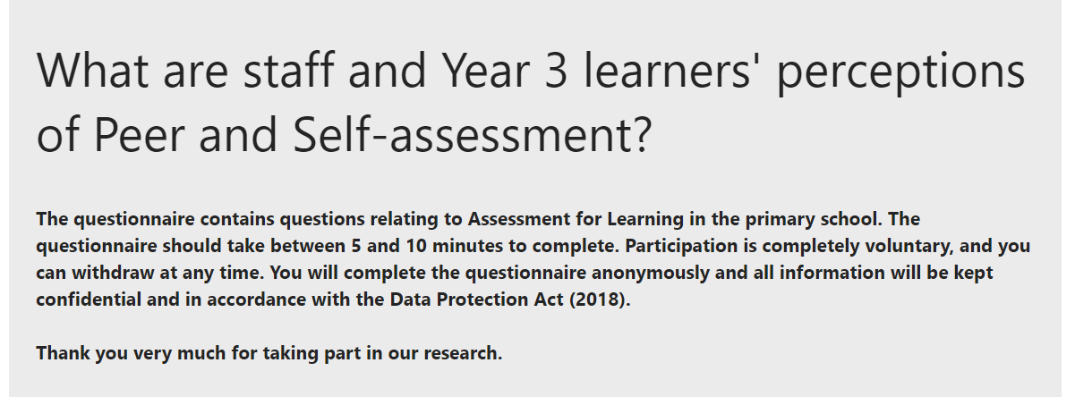

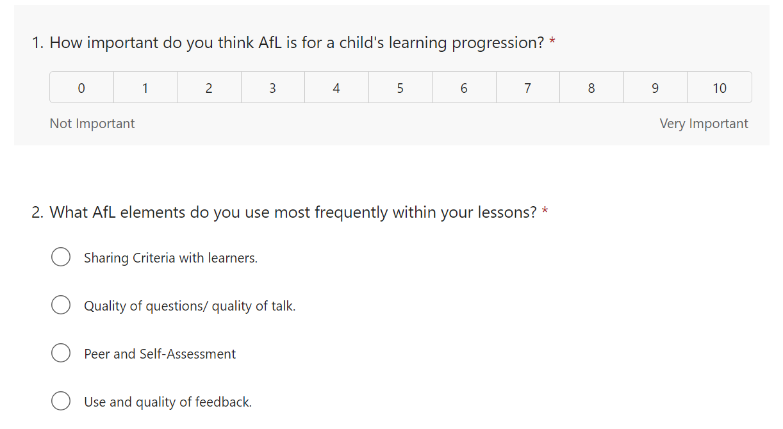

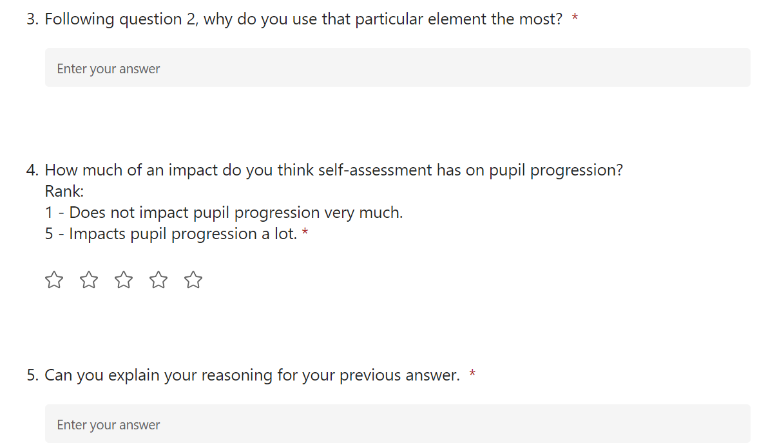

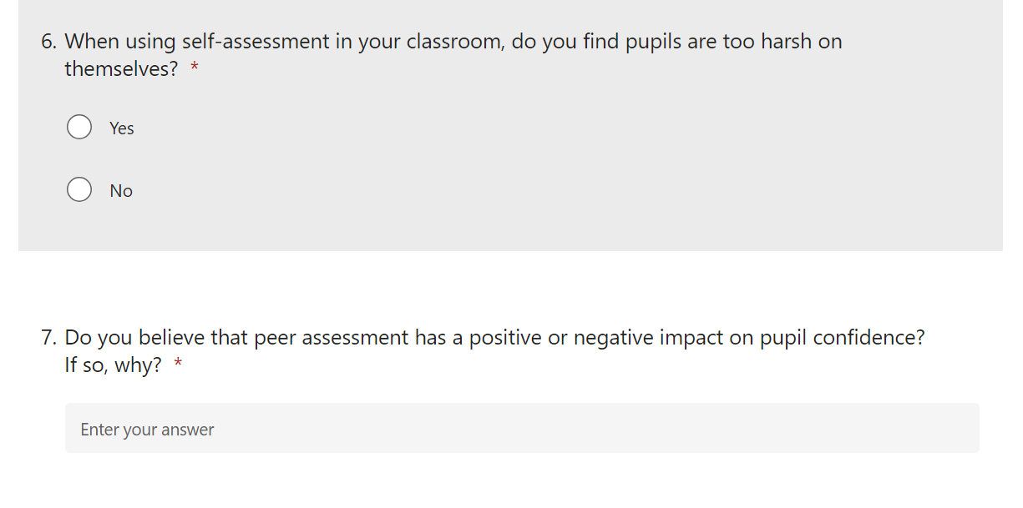

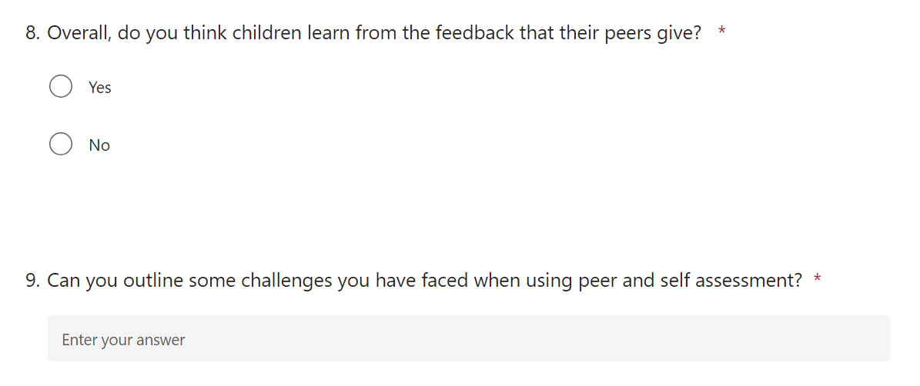

Appendix 7 – Interview Responses

Group 1
- Do you know what peer and self – assessment?
Notes – do you make your own work and your partner’s work.

- Was not sure what peer assessment being. - We do not do peer assessment
- Mark owns work often – Green pen.
- Miss normally marks our work.

- Do you like marking your own and your partners work?

- Prefers when miss or their self-mark their work
- Likes when they mark own work because it is fun to see if their work is right or not.
How do you know if it’s right or wrong – miss gives them the answers and checks after they have marked their own work.

- How does marking your own and your partner's work help you with your learning?
Note – can you give me an example?

- We can see what we have done wrong

- Do you ask your partner for help before asking your teacher?
Note – is there any reason why you ask them first.

- Yes – partner.
Strategy used:
Yourself – Partner – resources – miss

- Who do you feel more comfortable asking for help with your work?
Note – could be the teacher, friend, teaching assistant

- Teacher and friends they trust

- Do you like showing your peers your work?
No
- They copy my answers – then telling others the answer.

Yes
- Only like sharing with friends and people they trust because they are not silly and won’t share the answers with anyone. They give us more support.

- Do you get to pick who peer marks your work?
We always mark the person sitting next to us work.

Group 2
- Do you know what peer and self – assessment?
Notes – do you make your own work and your partner’s work.

- Do not mark each other work. Did not know what the term peer assessment meant.
- Help each other to see if answer are right before showing the teacher.
- Mark own mark for spelling and maths. (they use green pen)

- Do you like marking your own and your partners work?
- Prefer marking own work makes me feel like a teacher.
- Prefer miss marking their work – gives me more time to do other work.

- How does marking your own and your partner's work help you with your learning?
Note – can you give me an example?

- Partners are kind when marking, they say what they like about my work.
- I like knowing I am helping my friend.

- Do you ask your partner for help before asking your teacher?
Note – is there any reason why you ask them first.

Strategy used;
Yourself – Partner – resources – teacher

- Who do you feel more comfortable asking for help with your work?
Note – could be the teacher, friend, teaching assistant

- Teacher and my friends
- I prefer asking my teacher because I know they will not laugh at me and be silly

- Do you like showing your peers your work?

- Don’t feel confident with showing partner my work just in case they copy my answer.
- No, they might laugh if I get the answer wrong

- Do you get to pick who peer marks your work?

- Yes – I pick who I can trust.
- Can pick anyone but mainly who we sit next to

Appendix 8 – Questionnaire Responses



